# Load Required Packages: to be increased over the course

# Load Required Packages: to be increased over the course  
options(contrasts=c("contr.treatment","contr.treatment"))  
  
requiredPackages <- c("missMDA","chemometrics","mvoutlier","effects","FactoMineR","car", "factoextra","RColorBrewer","ggplot2","dplyr","ggmap","ggthemes","knitr","ggpubr", "corrplot")  
missingPackages <- requiredPackages[!(requiredPackages %in% installed.packages()[,"Package"])]  
  
if(length(missingPackages)) install.packages(missingPackages)  
lapply(requiredPackages, require, character.only = TRUE)

## Loading required package: missMDA

## Loading required package: chemometrics

## Loading required package: rpart

## Loading required package: mvoutlier

## Loading required package: sgeostat

## Registered S3 method overwritten by 'GGally':  
## method from   
## +.gg ggplot2

## sROC 0.1-2 loaded

## Loading required package: effects

## Loading required package: carData

## Registered S3 methods overwritten by 'lme4':  
## method from  
## cooks.distance.influence.merMod car   
## influence.merMod car   
## dfbeta.influence.merMod car   
## dfbetas.influence.merMod car

## lattice theme set by effectsTheme()  
## See ?effectsTheme for details.

## Loading required package: FactoMineR

## Loading required package: car

## Loading required package: factoextra

## Loading required package: ggplot2

## Welcome! Want to learn more? See two factoextra-related books at https://goo.gl/ve3WBa

## Loading required package: RColorBrewer

## Loading required package: dplyr

##   
## Attaching package: 'dplyr'

## The following object is masked from 'package:car':  
##   
## recode

## The following objects are masked from 'package:stats':  
##   
## filter, lag

## The following objects are masked from 'package:base':  
##   
## intersect, setdiff, setequal, union

## Loading required package: ggmap

## Google's Terms of Service: https://cloud.google.com/maps-platform/terms/.

## Please cite ggmap if you use it! See citation("ggmap") for details.

## Loading required package: ggthemes

## Loading required package: knitr

## Loading required package: ggpubr

## Loading required package: corrplot

## corrplot 0.84 loaded

## [[1]]  
## [1] TRUE  
##   
## [[2]]  
## [1] TRUE  
##   
## [[3]]  
## [1] TRUE  
##   
## [[4]]  
## [1] TRUE  
##   
## [[5]]  
## [1] TRUE  
##   
## [[6]]  
## [1] TRUE  
##   
## [[7]]  
## [1] TRUE  
##   
## [[8]]  
## [1] TRUE  
##   
## [[9]]  
## [1] TRUE  
##   
## [[10]]  
## [1] TRUE  
##   
## [[11]]  
## [1] TRUE  
##   
## [[12]]  
## [1] TRUE  
##   
## [[13]]  
## [1] TRUE  
##   
## [[14]]  
## [1] TRUE  
##   
## [[15]]  
## [1] TRUE

## Load Processed data

## null device   
## 1

## Modify Data

vars_dis <- c("VendorID", "Payment_type", "Store_and_fwd_flag", "RateCodeID", "f.Extra", "f.MTA_tax", "f.Improvement_surcharge", "lpep_pickup_period", "Trip_type", "lpep_pickup_date", "multiouts", "f.espeed", "f.tlenkm", "f.traveltime", "f.distHaversine", "AnyToll", "f.Fare_amount", "f.Passenger_count", "f.Total_amount")  
  
vars_con <- c( "Passenger_count", "tlenkm", "Pickup_longitude", "Pickup_latitude", "Dropoff_longitude", "Dropoff_latitude","Fare_amount", "espeed", "Tip_amount", "Tolls_amount", "lpep_pickup_time", "traveltime", "distHaversine")  
for( i in vars_dis){  
 df[,i] <- as.factor(df[,i])  
}  
  
vars_res <- c("AnyTip", "Total_amount")  
  
d1 <- dim(df)[1]  
d2 <- dim(df)[2]  
df[,d2-1] <- as.factor(df[,d2-1])

###### Principal Component Analysis (PCA)

res.pca<-PCA(df[,c(1:10,20:(d2-2),d2)],quali.sup=c(1:10),quanti.sup=c(13:16,24), ncp=4, ind.sup = which(df$multiouts==TRUE))

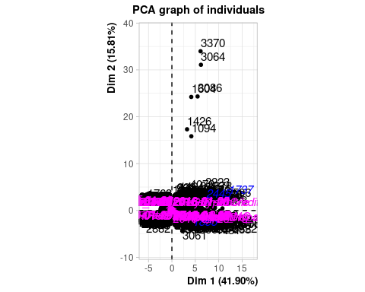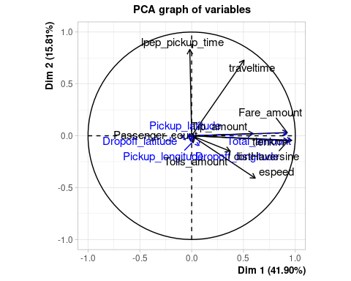 Para realizar PCA, hemos decidido decidido dividir el dataset en: -Variables numericas activas: Passenger_count, tlenkm, Fare_amount, espeed, Tip_amount, Tolls_amount, lpep_pickup_time, traveltime, distHaversine. -Variables numericas suplementarias:Pickup_longitude, Pickup_latitude, Dropoff_longitude, Dropoff_latitude, total_amount. -Variables categoricas suplementarias: VendorID, Payment_type, Store_and_fwd_flag, RateCodeID, f.Extra, f.MTA_tax, f.Improvement_surcharge, lpep_pickup_period, Trip_type, lpep_pickup_date. -Individuos activos: aquellos individuos sin outliers multivariante. -Individuos suplementarios: aquellos individuos con outliers multivariante. En este caso son los individuos cuyos indices en el dataset son 1737 1855 2445. ### Eigenvalues and dominant axes analysis.

summary(res.pca,nb.dec=2,nbind=1,nbelements=1000,ncp=4)

##   
## Call:  
## PCA(X = df[, c(1:10, 20:(d2 - 2), d2)], ncp = 4, ind.sup = which(df$multiouts ==   
## TRUE), quanti.sup = c(13:16, 24), quali.sup = c(1:10))   
##   
##   
## Eigenvalues  
## Dim.1 Dim.2 Dim.3 Dim.4 Dim.5 Dim.6 Dim.7 Dim.8  
## Variance 3.77 1.42 1.00 0.89 0.78 0.63 0.31 0.15  
## % of var. 41.90 15.81 11.13 9.90 8.63 7.02 3.46 1.67  
## Cumulative % of var. 41.90 57.72 68.84 78.75 87.38 94.40 97.86 99.53  
## Dim.9  
## Variance 0.04  
## % of var. 0.47  
## Cumulative % of var. 100.00  
##   
## Individuals (the 1 first)  
## Dist Dim.1 ctr cos2 Dim.2 ctr cos2   
## 1 | 1.91 | -0.27 0.00 0.02 | -1.07 0.02 0.31 |  
## Dim.3 ctr cos2 Dim.4 ctr cos2   
## 1 -0.40 0.00 0.04 | -0.36 0.00 0.04 |  
##   
## Supplementary individuals (the 1 first)  
## Dist Dim.1 cos2 Dim.2 cos2 Dim.3 cos2   
## 1737 | 16.38 | 11.96 0.53 | 2.57 0.02 | -0.32 0.00 |  
## Dim.4 cos2   
## 1737 -2.58 0.02 |  
##   
## Variables  
## Dim.1 ctr cos2 Dim.2 ctr cos2 Dim.3  
## Passenger_count | 0.02 0.01 0.00 | -0.07 0.31 0.00 | 0.99  
## tlenkm | 0.97 24.73 0.93 | -0.04 0.14 0.00 | -0.01  
## Fare_amount | 0.92 22.52 0.85 | 0.03 0.07 0.00 | 0.00  
## espeed | 0.61 9.97 0.38 | -0.41 11.72 0.17 | -0.04  
## Tip_amount | 0.59 9.35 0.35 | 0.02 0.03 0.00 | -0.04  
## Tolls_amount | 0.37 3.64 0.14 | -0.15 1.55 0.02 | 0.12  
## lpep_pickup_time | -0.02 0.01 0.00 | 0.83 48.67 0.69 | 0.04  
## traveltime | 0.51 6.77 0.26 | 0.73 37.34 0.53 | 0.04  
## distHaversine | 0.93 22.99 0.87 | -0.05 0.17 0.00 | -0.02  
## ctr cos2 Dim.4 ctr cos2   
## Passenger_count 97.69 0.98 | -0.12 1.62 0.01 |  
## tlenkm 0.02 0.00 | -0.11 1.32 0.01 |  
## Fare_amount 0.00 0.00 | -0.12 1.64 0.01 |  
## espeed 0.18 0.00 | -0.07 0.63 0.01 |  
## Tip_amount 0.18 0.00 | 0.08 0.65 0.01 |  
## Tolls_amount 1.53 0.02 | 0.90 90.83 0.81 |  
## lpep_pickup_time 0.17 0.00 | 0.13 2.02 0.02 |  
## traveltime 0.20 0.00 | -0.03 0.13 0.00 |  
## distHaversine 0.03 0.00 | -0.10 1.17 0.01 |  
##   
## Supplementary continuous variables  
## Dim.1 cos2 Dim.2 cos2 Dim.3 cos2 Dim.4  
## Pickup_longitude | 0.00 0.00 | -0.07 0.00 | 0.03 0.00 | -0.01  
## Pickup_latitude | -0.05 0.00 | -0.03 0.00 | -0.03 0.00 | 0.06  
## Dropoff_longitude | 0.08 0.01 | -0.10 0.01 | 0.02 0.00 | -0.02  
## Dropoff_latitude | -0.11 0.01 | -0.02 0.00 | -0.02 0.00 | 0.07  
## Total_amount | 0.93 0.87 | 0.03 0.00 | 0.00 0.00 | -0.03  
## cos2   
## Pickup_longitude 0.00 |  
## Pickup_latitude 0.00 |  
## Dropoff_longitude 0.00 |  
## Dropoff_latitude 0.00 |  
## Total_amount 0.00 |  
##   
## Supplementary categories  
## Dist Dim.1 cos2 v.test Dim.2 cos2  
## f.Vendor-Mobile | 0.18 | 0.02 0.01 0.35 | 0.02 0.01  
## f.Vendor-VeriFone | 0.05 | -0.01 0.01 -0.35 | -0.01 0.01  
## f.PayType-Cash | 0.68 | -0.45 0.44 -16.47 | -0.03 0.00  
## f.PayType-Credit card | 0.70 | 0.46 0.43 16.49 | 0.03 0.00  
## f.PayType-Others | 0.80 | -0.05 0.00 -0.12 | 0.09 0.01  
## FALSE | 0.00 | 0.00 0.28 0.56 | 0.00 0.11  
## TRUE | 0.50 | -0.26 0.28 -0.56 | -0.16 0.11  
## Others | 2.11 | 1.88 0.79 11.66 | -0.56 0.07  
## Standard rate | 0.06 | -0.05 0.79 -11.66 | 0.02 0.07  
## f.Extra-0 | 0.21 | 0.07 0.10 2.24 | -0.04 0.04  
## f.Extra-0.5 | 0.28 | 0.03 0.01 0.91 | -0.17 0.35  
## f.Extra-1 | 0.68 | -0.27 0.16 -4.26 | 0.52 0.60  
## f.MTA_tax_NO | 1.12 | 0.77 0.47 4.60 | -0.43 0.15  
## f.MTA_tax_YES | 0.03 | -0.02 0.47 -4.60 | 0.01 0.15  
## f.Improvement_surcharge_NO | 1.00 | 0.62 0.39 3.80 | -0.40 0.16  
## f.Improvement_surcharge_YES | 0.03 | -0.02 0.39 -3.80 | 0.01 0.16  
## Period afternoon | 0.64 | -0.21 0.10 -3.57 | 0.48 0.56  
## Period morning | 0.62 | 0.05 0.01 0.67 | -0.36 0.34  
## Period night | 0.27 | 0.09 0.12 2.97 | -0.16 0.37  
## Period valley | 0.21 | -0.03 0.02 -0.70 | 0.10 0.23  
## f.TripType-Dispatch | 1.23 | 0.88 0.51 5.02 | -0.45 0.13  
## f.TripType-Street-Hail | 0.03 | -0.02 0.51 -5.02 | 0.01 0.13  
## 2016-01-01 | 0.49 | 0.08 0.03 0.66 | -0.15 0.09  
## 2016-01-02 | 0.31 | 0.14 0.21 1.03 | -0.05 0.03  
## 2016-01-03 | 0.46 | 0.13 0.08 0.81 | -0.37 0.64  
## 2016-01-04 | 0.23 | 0.10 0.18 0.63 | -0.11 0.21  
## 2016-01-05 | 0.33 | -0.28 0.71 -1.70 | 0.10 0.09  
## 2016-01-06 | 0.29 | 0.21 0.52 1.33 | -0.01 0.00  
## 2016-01-07 | 0.31 | 0.21 0.45 1.27 | -0.04 0.02  
## 2016-01-08 | 0.17 | 0.05 0.10 0.37 | 0.10 0.39  
## 2016-01-09 | 0.32 | -0.23 0.49 -1.62 | -0.21 0.43  
## 2016-01-10 | 0.49 | 0.14 0.08 0.92 | -0.42 0.73  
## 2016-01-11 | 0.22 | 0.01 0.00 0.06 | -0.06 0.09  
## 2016-01-12 | 0.28 | -0.17 0.37 -1.10 | -0.04 0.02  
## 2016-01-13 | 0.24 | 0.12 0.23 0.76 | 0.09 0.14  
## 2016-01-14 | 0.28 | -0.18 0.41 -1.21 | 0.08 0.08  
## 2016-01-15 | 0.38 | -0.35 0.84 -2.45 | 0.01 0.00  
## 2016-01-16 | 0.13 | -0.01 0.00 -0.07 | -0.07 0.32  
## 2016-01-17 | 0.41 | 0.19 0.22 1.31 | -0.34 0.67  
## 2016-01-18 | 0.29 | -0.09 0.11 -0.54 | 0.00 0.00  
## 2016-01-19 | 0.29 | -0.22 0.57 -1.35 | 0.08 0.08  
## 2016-01-20 | 0.20 | -0.18 0.83 -1.18 | -0.01 0.00  
## 2016-01-21 | 0.33 | 0.22 0.44 1.50 | 0.13 0.15  
## 2016-01-22 | 0.30 | -0.08 0.08 -0.61 | 0.27 0.81  
## 2016-01-23 | 1.36 | 0.13 0.01 0.44 | -0.77 0.32  
## 2016-01-24 | 0.52 | -0.21 0.16 -0.99 | 0.36 0.49  
## 2016-01-25 | 0.48 | 0.03 0.00 0.22 | 0.27 0.32  
## 2016-01-26 | 0.46 | -0.05 0.01 -0.31 | 0.33 0.50  
## 2016-01-27 | 0.40 | -0.09 0.05 -0.58 | 0.26 0.42  
## 2016-01-28 | 0.25 | -0.10 0.15 -0.59 | 0.14 0.33  
## 2016-01-29 | 0.29 | 0.06 0.04 0.42 | 0.18 0.39  
## 2016-01-30 | 0.25 | 0.00 0.00 0.02 | 0.23 0.86  
## 2016-01-31 | 0.50 | 0.31 0.40 2.25 | -0.33 0.44  
## v.test Dim.3 cos2 v.test Dim.4 cos2  
## f.Vendor-Mobile 0.58 | -0.16 0.82 -5.95 | -0.01 0.00  
## f.Vendor-VeriFone -0.58 | 0.04 0.82 5.95 | 0.00 0.00  
## f.PayType-Cash -1.55 | 0.04 0.00 2.61 | -0.05 0.01  
## f.PayType-Credit card 1.49 | -0.04 0.00 -2.50 | 0.05 0.01  
## f.PayType-Others 0.40 | -0.14 0.03 -0.74 | -0.16 0.04  
## FALSE 0.57 | 0.00 0.29 1.12 | 0.00 0.00  
## TRUE -0.57 | -0.27 0.29 -1.12 | -0.03 0.00  
## Others -5.66 | -0.11 0.00 -1.31 | 0.00 0.00  
## Standard rate 5.66 | 0.00 0.00 1.31 | 0.00 0.00  
## f.Extra-0 -2.39 | -0.05 0.07 -3.57 | 0.01 0.00  
## f.Extra-0.5 -7.76 | 0.03 0.01 1.72 | -0.06 0.05  
## f.Extra-1 13.52 | 0.08 0.02 2.57 | 0.13 0.04  
## f.MTA_tax_NO -4.19 | -0.17 0.02 -1.94 | -0.15 0.02  
## f.MTA_tax_YES 4.19 | 0.00 0.02 1.94 | 0.00 0.02  
## f.Improvement_surcharge_NO -3.93 | -0.15 0.02 -1.76 | -0.15 0.02  
## f.Improvement_surcharge_YES 3.93 | 0.00 0.02 1.76 | 0.00 0.02  
## Period afternoon 13.55 | 0.06 0.01 1.91 | 0.08 0.01  
## Period morning -7.96 | -0.11 0.03 -2.95 | -0.04 0.01  
## Period night -8.46 | 0.02 0.01 1.46 | -0.06 0.05  
## Period valley 3.52 | -0.03 0.02 -1.14 | 0.06 0.09  
## f.TripType-Dispatch -4.20 | -0.16 0.02 -1.76 | -0.19 0.02  
## f.TripType-Street-Hail 4.20 | 0.00 0.02 1.76 | 0.00 0.02  
## 2016-01-01 -1.90 | 0.07 0.02 1.10 | -0.16 0.11  
## 2016-01-02 -0.62 | 0.04 0.02 0.62 | -0.04 0.01  
## 2016-01-03 -3.83 | 0.06 0.02 0.71 | -0.12 0.06  
## 2016-01-04 -1.10 | -0.03 0.01 -0.35 | 0.16 0.49  
## 2016-01-05 0.96 | -0.08 0.06 -0.99 | 0.00 0.00  
## 2016-01-06 -0.09 | -0.08 0.07 -0.95 | 0.05 0.03  
## 2016-01-07 -0.41 | -0.13 0.19 -1.59 | 0.14 0.21  
## 2016-01-08 1.18 | -0.03 0.02 -0.34 | 0.02 0.02  
## 2016-01-09 -2.47 | 0.00 0.00 0.04 | 0.02 0.00  
## 2016-01-10 -4.63 | 0.07 0.02 0.86 | -0.08 0.03  
## 2016-01-11 -0.70 | -0.08 0.14 -1.06 | -0.12 0.33  
## 2016-01-12 -0.43 | 0.11 0.15 1.37 | 0.11 0.15  
## 2016-01-13 0.97 | 0.14 0.36 1.83 | 0.01 0.00  
## 2016-01-14 0.85 | 0.04 0.02 0.48 | 0.15 0.30  
## 2016-01-15 0.09 | 0.03 0.01 0.42 | 0.11 0.09  
## 2016-01-16 -0.93 | -0.04 0.12 -0.67 | -0.06 0.21  
## 2016-01-17 -3.71 | 0.01 0.00 0.11 | -0.05 0.02  
## 2016-01-18 0.03 | -0.09 0.09 -0.96 | -0.07 0.07  
## 2016-01-19 0.81 | -0.11 0.15 -1.33 | 0.06 0.04  
## 2016-01-20 -0.10 | -0.02 0.01 -0.23 | 0.06 0.10  
## 2016-01-21 1.44 | 0.04 0.01 0.50 | 0.05 0.02  
## 2016-01-22 3.27 | -0.01 0.00 -0.21 | 0.06 0.03  
## 2016-01-23 -4.15 | 0.04 0.00 0.25 | -0.33 0.06  
## 2016-01-24 2.80 | 0.08 0.03 0.78 | -0.03 0.00  
## 2016-01-25 2.85 | -0.18 0.15 -2.30 | -0.10 0.04  
## 2016-01-26 3.31 | 0.06 0.02 0.73 | 0.00 0.00  
## 2016-01-27 2.83 | -0.01 0.00 -0.07 | -0.08 0.04  
## 2016-01-28 1.43 | 0.03 0.01 0.31 | -0.04 0.02  
## 2016-01-29 2.04 | -0.01 0.00 -0.18 | 0.09 0.10  
## 2016-01-30 3.09 | 0.04 0.03 0.63 | -0.04 0.03  
## 2016-01-31 -3.87 | 0.01 0.00 0.19 | 0.05 0.01  
## v.test   
## f.Vendor-Mobile -0.29 |  
## f.Vendor-VeriFone 0.29 |  
## f.PayType-Cash -3.87 |  
## f.PayType-Credit card 4.01 |  
## f.PayType-Others -0.92 |  
## FALSE 0.15 |  
## TRUE -0.15 |  
## Others -0.05 |  
## Standard rate 0.05 |  
## f.Extra-0 0.60 |  
## f.Extra-0.5 -3.76 |  
## f.Extra-1 4.16 |  
## f.MTA_tax_NO -1.87 |  
## f.MTA_tax_YES 1.87 |  
## f.Improvement_surcharge_NO -1.88 |  
## f.Improvement_surcharge_YES 1.88 |  
## Period afternoon 2.76 |  
## Period morning -1.22 |  
## Period night -3.81 |  
## Period valley 2.78 |  
## f.TripType-Dispatch -2.25 |  
## f.TripType-Street-Hail 2.25 |  
## 2016-01-01 -2.61 |  
## 2016-01-02 -0.55 |  
## 2016-01-03 -1.52 |  
## 2016-01-04 2.13 |  
## 2016-01-05 0.03 |  
## 2016-01-06 0.68 |  
## 2016-01-07 1.80 |  
## 2016-01-08 0.31 |  
## 2016-01-09 0.24 |  
## 2016-01-10 -1.18 |  
## 2016-01-11 -1.73 |  
## 2016-01-12 1.42 |  
## 2016-01-13 0.09 |  
## 2016-01-14 2.12 |  
## 2016-01-15 1.63 |  
## 2016-01-16 -0.96 |  
## 2016-01-17 -0.74 |  
## 2016-01-18 -0.89 |  
## 2016-01-19 0.75 |  
## 2016-01-20 0.86 |  
## 2016-01-21 0.72 |  
## 2016-01-22 0.86 |  
## 2016-01-23 -2.25 |  
## 2016-01-24 -0.31 |  
## 2016-01-25 -1.32 |  
## 2016-01-26 0.06 |  
## 2016-01-27 -1.06 |  
## 2016-01-28 -0.46 |  
## 2016-01-29 1.32 |  
## 2016-01-30 -0.68 |  
## 2016-01-31 0.68 |

fviz_eig(res.pca, choice = "eigenvalue", addlabels = TRUE)

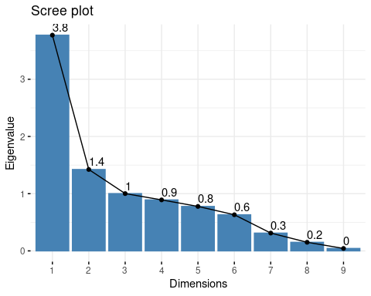

fviz_eig(res.pca, addlabels = TRUE)

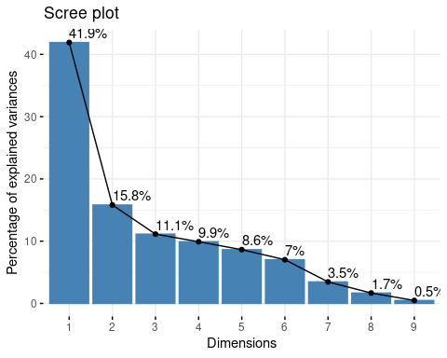 En esta imagen podemos ver los valores propios. Como podemos ver hasta la tercera dimensión tenemos un valor propio igual a 1. Según el criterio de Kaiser deberíamos eliminar todas las componentes con valor propio por debajo de 1, lo que significa que deberíamos coger hasta la tercera dimension. Segun la regla de Elbow, debemos coger hasta que no haya un descenso significativo, lo que significa que también se debería coger hasta la terecera dimensio. A pesar de todo, hemos decidido incluir hasta la cuarta dimensión, ya que nos facilita el estudio. Como podemos ver a partir del summary, hasta la cuarta dimensión encontramos una varianza acumulada del 78.75%. También podemos admirar como la primera dimensión contribuye mucho en el PCA, explicando un 41.9% de la varianza.

## Quality of representation

corrplot(res.pca$var$cos2, is.corr=FALSE)

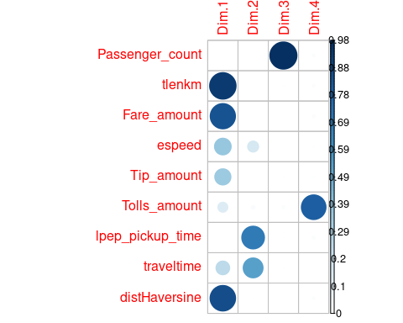

fviz_cos2(res.pca, choice = "var", axes = 1:2, top = 10)

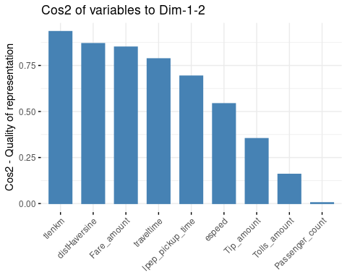

fviz_cos2(res.pca, choice = "var", axes = 3:4, top = 10)

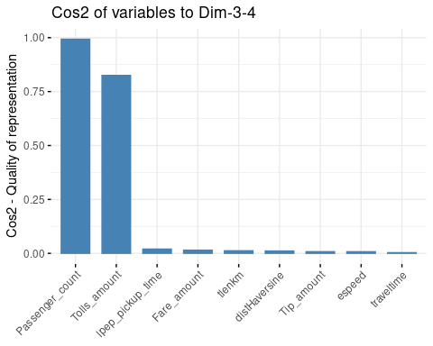

fviz_cos2(res.pca, choice = "ind", axes = 1:2, top = 10)

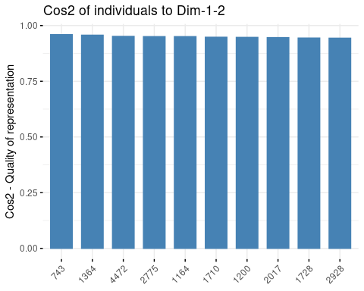

fviz_cos2(res.pca, choice = "ind", axes = 3:4, top = 10)

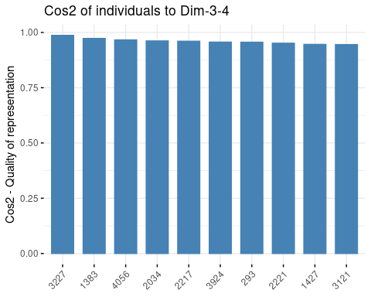 A partir de la suma del coseno al cuadrado de la primera dimensión más el coseno al cuadrado de la segunda dimensión podemos obtener cualidad de las variables en el primer plano factorial. Como podemos ver tlenkm y distHaversine son las dos variables que mejor se representan el primer plano factorial.

## Contribution

corrplot(res.pca$var$contrib, is.corr=FALSE)

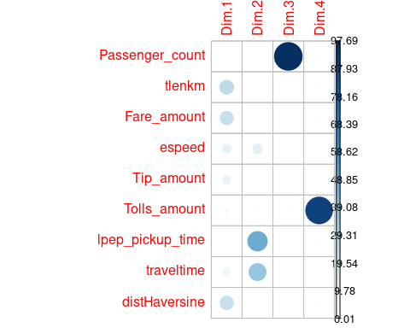

fviz_contrib(res.pca, choice = "var", axes = 1:2, top = 10)

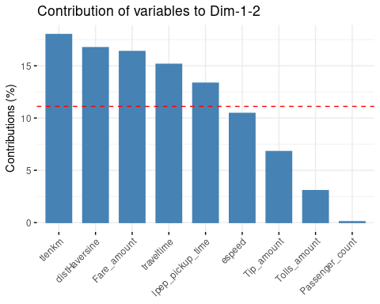

fviz_contrib(res.pca, choice = "var", axes = 3:4, top = 10)

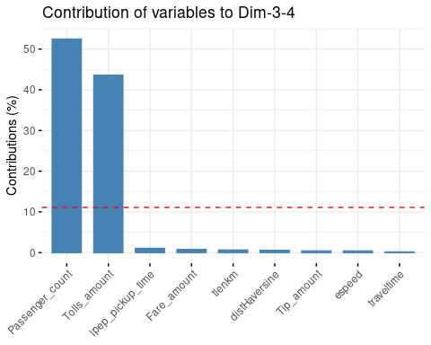

fviz_contrib(res.pca, choice = "ind", axes = 1:2, top = 10)

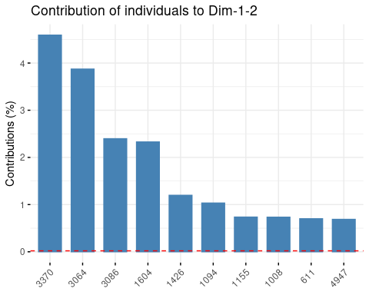

fviz_contrib(res.pca, choice = "ind", axes = 3:4, top = 10)

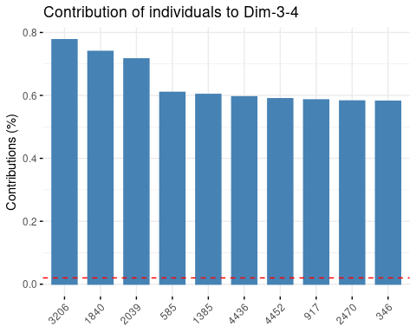 En este plot encontramos las 10 variables que contribuyen mas en el primer plano factorial. Como podemos ver la variable tlenkm es la variable que contribuye más junto con la variable distHaversine. Si vemos el segundo plano factorial, vemos que el numero total de pasajeros y el numero total de pagos por peajes influyen bastante en el segundo plano factorial. En este plot encontramos los 10 individuos que contribuyen más en el primer plano factorial. Como podemos ver el individuo 3370 es el individuo que contribuye más, junto con el individuo 3064 al primer plano factorial. Si vemos el segundo plano factorial, vemos que el individuo 3206 y el individuo 1840, son los individuos que contribuyen más el segundo plano factorial.

##### Interpreting the axes

### Variables numericas

plot.PCA(res.pca,choix=c("var"), axes=c(1,2))

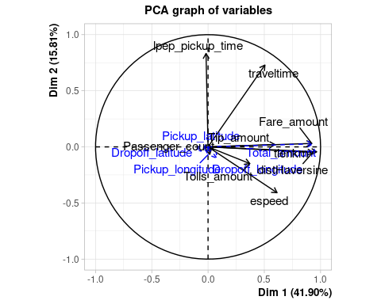

plot.PCA(res.pca,choix=c("var"), axes=c(3,4))

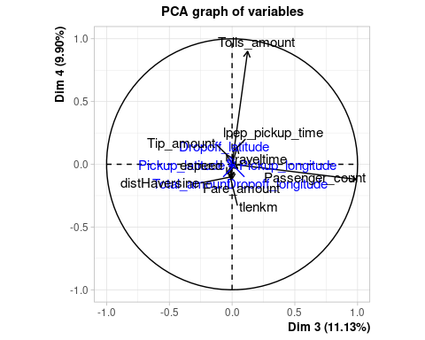

## Variables numericas activas

corrplot(res.pca$var$coord, is.corr=FALSE)

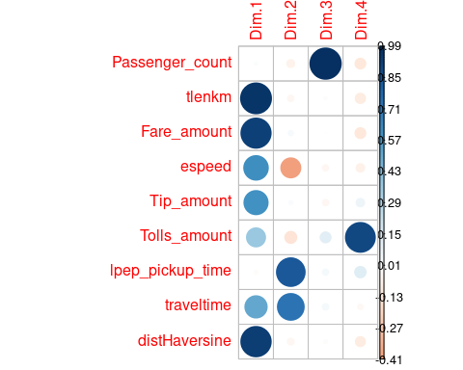

plot.PCA(res.pca,choix=c("var"),invisible=c("quanti.sup"), axes=c(1,2))

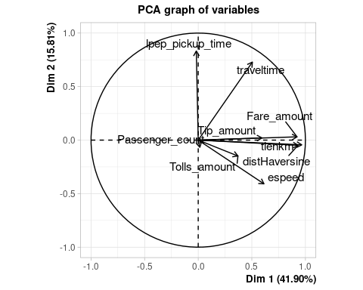

plot.PCA(res.pca,choix=c("var"),invisible=c("quanti.sup"), axes=c(3,4))

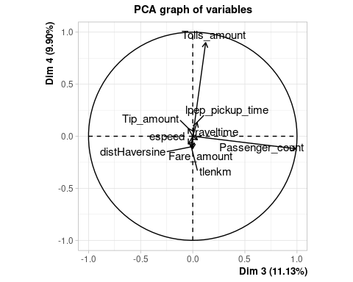

## Variables numericas suplementarias

corrplot(res.pca$quanti.sup$coord, is.corr=FALSE)

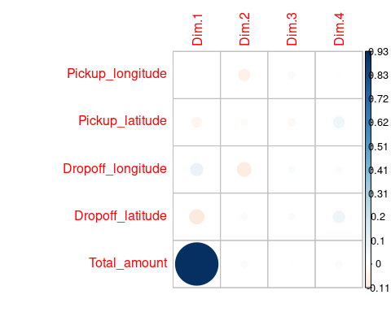

plot.PCA(res.pca,choix=c("var"),invisible=c("var"), axes=c(1,2))

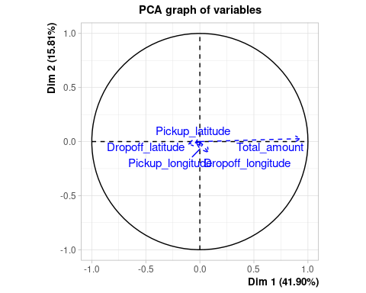

plot.PCA(res.pca,choix=c("var"),invisible=c("var"), axes=c(3,4))

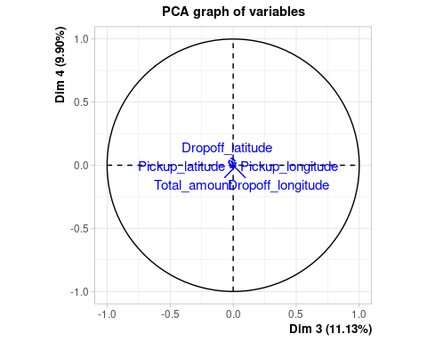 ### Variables categoricas suplementarias

plot.PCA(res.pca,choix=c("ind"), invisible = c("ind", "ind.sup"), axes=c(1,2))

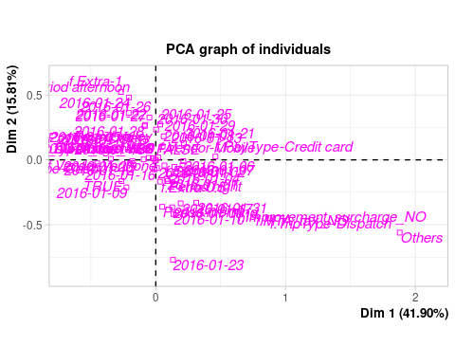

plot.PCA(res.pca,choix=c("ind"), invisible = c("ind", "ind.sup"), axes=c(3,4))

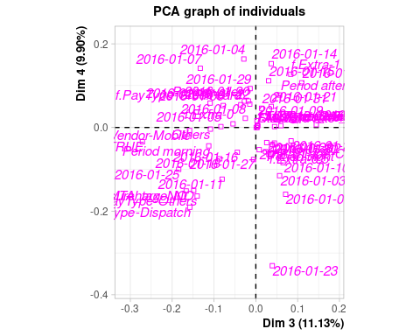

### Individuos

plot(res.pca,choix=c("ind"),invisible = c("ind.sup", "var", "quali"),select="contrib 10", axes=c(1,2))

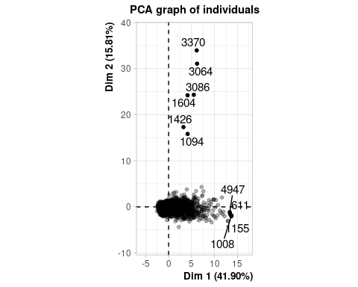

plot(res.pca,choix=c("ind"),invisible = c("ind.sup", "var", "quali"),select="contrib 10", axes=c(3,4))

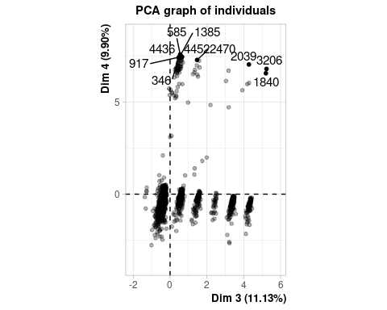 ### Individuos suplementarios

plot(res.pca,choix=c("ind"),invisible = c("ind", "var", "quali"), axes=c(1,2))

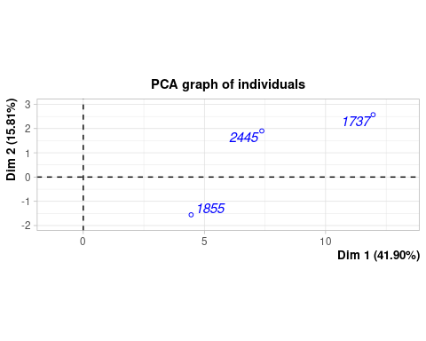

plot(res.pca,choix=c("ind"),invisible = c("ind", "var", "quali"), axes=c(3,4))

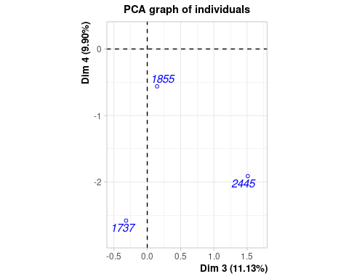

HCPC

res.pca<-PCA(df[,c(1:10,20:(d2-2),d2)],quali.sup=c(1:10),quanti.sup=c(13:16,24), ncp=4, graph= FALSE)  
res.hcpc<-HCPC(res.pca,nb.clust = -1,order=TRUE)

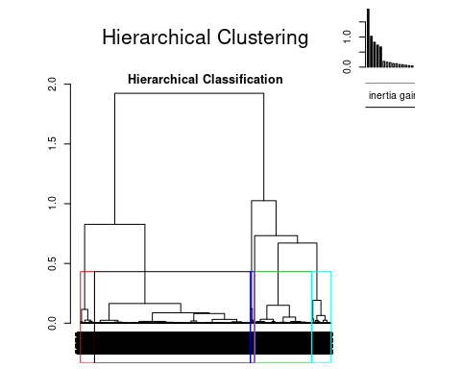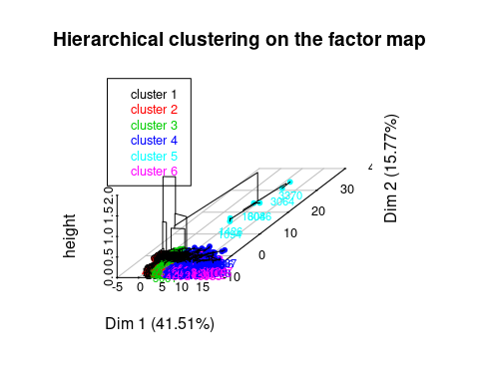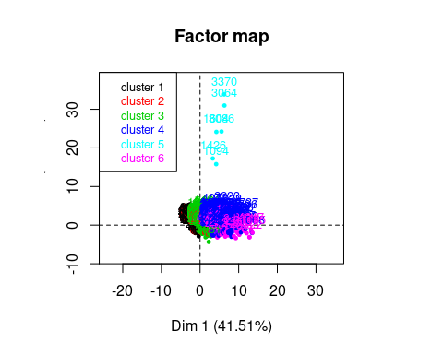

df$hcpck<-res.hcpc$data.clust$clust

Viendo la inertia gain (pérdida importante de ir entre n clusters a n+1 clusters) y aplicando Kaiser Rule podemos ver que el número de clusters óptimo es 6.

###### Interpretar los resultados de la clasificación

barplot(table(res.hcpc$data.clust$clust))

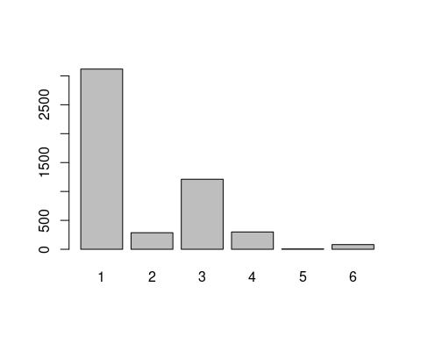

summary(res.hcpc$data.clust$clust)

## 1 2 3 4 5 6   
## 3117 286 1211 299 6 81

### A. The description of the clusters by the variables

### A.1. The categorical variables which characterizes the clusters

res.hcpc$desc.var$test.chi2

## p.value df  
## Payment_type 8.703621e-41 10  
## RateCodeID 7.823482e-15 5  
## VendorID 9.081168e-11 5  
## f.Extra 7.914188e-08 10  
## lpep_pickup_period 5.249054e-06 15  
## Trip_type 9.975894e-06 5  
## f.MTA_tax 2.966099e-05 5  
## f.Improvement_surcharge 2.904864e-04 5

### A.2. The description of each cluster by the categories

res.hcpc$desc.var$category

## $`1`  
## Cla/Mod Mod/Cla Global p.value  
## Payment_type=f.PayType-Cash 70.64220 56.817453 50.14 3.893540e-34  
## RateCodeID=Standard rate 62.94009 98.075072 97.14 6.026448e-07  
## f.Extra=f.Extra-1 68.17043 17.452679 15.96 1.855149e-04  
## lpep_pickup_period=Period afternoon 67.31813 19.890921 18.42 5.129457e-04  
## Trip_type=f.TripType-Street-Hail 62.64097 98.010908 97.54 6.556979e-03  
## lpep_pickup_date=2016-01-05 71.53285 3.144049 2.74 2.274727e-02  
## f.MTA_tax=f.MTA_tax_YES 62.57707 97.690087 97.32 3.959358e-02  
## lpep_pickup_date=2016-01-19 70.13889 3.240295 2.88 4.822322e-02  
## lpep_pickup_date=2016-01-31 55.31915 3.336542 3.76 4.502308e-02  
## f.MTA_tax=f.MTA_tax_NO 53.73134 2.309913 2.68 3.959358e-02  
## lpep_pickup_date=2016-01-17 54.16667 2.919474 3.36 2.799497e-02  
## Trip_type=f.TripType-Dispatch 50.40650 1.989092 2.46 6.556979e-03  
## f.Extra=f.Extra-0.5 59.43945 36.060314 37.82 9.855191e-04  
## lpep_pickup_period=Period night 58.53211 40.936798 43.60 1.065019e-06  
## RateCodeID=Others 41.95804 1.924928 2.86 6.026448e-07  
## Payment_type=f.PayType-Credit card 53.89610 42.605069 49.28 4.274103e-34  
## v.test  
## Payment_type=f.PayType-Cash 12.181644  
## RateCodeID=Standard rate 4.990368  
## f.Extra=f.Extra-1 3.737966  
## lpep_pickup_period=Period afternoon 3.473903  
## Trip_type=f.TripType-Street-Hail 2.718545  
## lpep_pickup_date=2016-01-05 2.277653  
## f.MTA_tax=f.MTA_tax_YES 2.057964  
## lpep_pickup_date=2016-01-19 1.975396  
## lpep_pickup_date=2016-01-31 -2.004439  
## f.MTA_tax=f.MTA_tax_NO -2.057964  
## lpep_pickup_date=2016-01-17 -2.197357  
## Trip_type=f.TripType-Dispatch -2.718545  
## f.Extra=f.Extra-0.5 -3.294628  
## lpep_pickup_period=Period night -4.879228  
## RateCodeID=Others -4.990368  
## Payment_type=f.PayType-Credit card -12.174037  
##   
## $`2`  
## Cla/Mod Mod/Cla Global  
## VendorID=f.Vendor-VeriFone 6.954067 94.7552448 77.94  
## f.Extra=f.Extra-0.5 6.980434 46.1538462 37.82  
## lpep_pickup_period=Period night 6.697248 51.0489510 43.60  
## f.Improvement_surcharge=f.Improvement_surcharge_YES 5.841218 99.3006993 97.24  
## Payment_type=f.PayType-Cash 6.501795 56.9930070 50.14  
## f.MTA_tax=f.MTA_tax_YES 5.836416 99.3006993 97.32  
## Trip_type=f.TripType-Street-Hail 5.823252 99.3006993 97.54  
## f.Extra=f.Extra-1 7.393484 20.6293706 15.96  
## RateCodeID=Standard rate 5.826642 98.9510490 97.14  
## lpep_pickup_date=2016-01-07 2.142857 1.0489510 2.80  
## RateCodeID=Others 2.097902 1.0489510 2.86  
## lpep_pickup_period=Period morning 3.953871 8.3916084 12.14  
## Trip_type=f.TripType-Dispatch 1.626016 0.6993007 2.46  
## lpep_pickup_date=2016-01-25 1.986755 1.0489510 3.02  
## Payment_type=f.PayType-Credit card 4.951299 42.6573427 49.28  
## f.MTA_tax=f.MTA_tax_NO 1.492537 0.6993007 2.68  
## lpep_pickup_period=Period valley 4.411765 19.9300699 25.84  
## f.Improvement_surcharge=f.Improvement_surcharge_NO 1.449275 0.6993007 2.76  
## f.Extra=f.Extra-0 4.110775 33.2167832 46.22  
## VendorID=f.Vendor-Mobile 1.359927 5.2447552 22.06  
## p.value v.test  
## VendorID=f.Vendor-VeriFone 8.701382e-16 8.043914  
## f.Extra=f.Extra-0.5 3.089559e-03 2.958684  
## lpep_pickup_period=Period night 9.268990e-03 2.601970  
## f.Improvement_surcharge=f.Improvement_surcharge_YES 1.470478e-02 2.439569  
## Payment_type=f.PayType-Cash 1.703725e-02 2.385903  
## f.MTA_tax=f.MTA_tax_YES 1.784021e-02 2.368918  
## Trip_type=f.TripType-Street-Hail 3.013982e-02 2.168248  
## f.Extra=f.Extra-1 3.102468e-02 2.156756  
## RateCodeID=Standard rate 4.158928e-02 2.037607  
## lpep_pickup_date=2016-01-07 4.729447e-02 -1.983654  
## RateCodeID=Others 4.158928e-02 -2.037607  
## lpep_pickup_period=Period morning 3.913031e-02 -2.062814  
## Trip_type=f.TripType-Dispatch 3.013982e-02 -2.168248  
## lpep_pickup_date=2016-01-25 2.938094e-02 -2.178337  
## Payment_type=f.PayType-Credit card 2.107704e-02 -2.306602  
## f.MTA_tax=f.MTA_tax_NO 1.784021e-02 -2.368918  
## lpep_pickup_period=Period valley 1.654204e-02 -2.396732  
## f.Improvement_surcharge=f.Improvement_surcharge_NO 1.470478e-02 -2.439569  
## f.Extra=f.Extra-0 4.527082e-06 -4.585589  
## VendorID=f.Vendor-Mobile 8.701382e-16 -8.043914  
##   
## $`3`  
## Cla/Mod Mod/Cla Global p.value  
## Payment_type=f.PayType-Credit card 29.82955 60.693642 49.28 5.929786e-20  
## lpep_pickup_period=Period night 26.60550 47.894302 43.60 5.533695e-04  
## f.Extra=f.Extra-0.5 26.22951 40.957886 37.82 9.942040e-03  
## lpep_pickup_date=2016-01-01 29.95595 5.615194 4.54 4.304996e-02  
## RateCodeID=Others 31.46853 3.715937 2.86 4.549479e-02  
## lpep_pickup_date=2016-01-19 17.36111 2.064410 2.88 4.637866e-02  
## RateCodeID=Standard rate 24.00659 96.284063 97.14 4.549479e-02  
## lpep_pickup_date=2016-01-12 16.99346 2.146986 3.06 2.980772e-02  
## lpep_pickup_date=2016-01-14 16.86747 2.312139 3.32 2.089799e-02  
## lpep_pickup_period=Period afternoon 20.52117 15.606936 18.42 3.327487e-03  
## f.Extra=f.Extra-1 18.67168 12.303881 15.96 4.570701e-05  
## Payment_type=f.PayType-Cash 18.74751 38.810900 50.14 1.065964e-19  
## v.test  
## Payment_type=f.PayType-Credit card 9.145603  
## lpep_pickup_period=Period night 3.453497  
## f.Extra=f.Extra-0.5 2.577839  
## lpep_pickup_date=2016-01-01 2.023225  
## RateCodeID=Others 2.000051  
## lpep_pickup_date=2016-01-19 -1.991931  
## RateCodeID=Standard rate -2.000051  
## lpep_pickup_date=2016-01-12 -2.172636  
## lpep_pickup_date=2016-01-14 -2.309822  
## lpep_pickup_period=Period afternoon -2.935744  
## f.Extra=f.Extra-1 -4.076559  
## Payment_type=f.PayType-Cash -9.082001  
##   
## $`4`  
## Cla/Mod Mod/Cla Global  
## Payment_type=f.PayType-Credit card 8.847403 72.909699 49.28  
## RateCodeID=Others 17.482517 8.361204 2.86  
## Trip_type=f.TripType-Dispatch 16.260163 6.688963 2.46  
## f.MTA_tax=f.MTA_tax_NO 15.671642 7.023411 2.68  
## f.Improvement_surcharge=f.Improvement_surcharge_NO 14.492754 6.688963 2.76  
## f.Extra=f.Extra-1 4.260652 11.371237 15.96  
## f.Improvement_surcharge=f.Improvement_surcharge_YES 5.738379 93.311037 97.24  
## f.MTA_tax=f.MTA_tax_YES 5.713111 92.976589 97.32  
## Trip_type=f.TripType-Street-Hail 5.720730 93.311037 97.54  
## RateCodeID=Standard rate 5.641342 91.638796 97.14  
## Payment_type=f.PayType-Cash 3.071400 25.752508 50.14  
## p.value v.test  
## Payment_type=f.PayType-Credit card 1.216693e-17 8.551338  
## RateCodeID=Others 1.043849e-06 4.883187  
## Trip_type=f.TripType-Dispatch 4.211775e-05 4.095544  
## f.MTA_tax=f.MTA_tax_NO 4.779382e-05 4.066161  
## f.Improvement_surcharge=f.Improvement_surcharge_NO 2.297538e-04 3.683832  
## f.Extra=f.Extra-1 2.134395e-02 -2.301844  
## f.Improvement_surcharge=f.Improvement_surcharge_YES 2.297538e-04 -3.683832  
## f.MTA_tax=f.MTA_tax_YES 4.779382e-05 -4.066161  
## Trip_type=f.TripType-Street-Hail 4.211775e-05 -4.095544  
## RateCodeID=Standard rate 1.043849e-06 -4.883187  
## Payment_type=f.PayType-Cash 8.539854e-19 -8.852737  
##   
## $`5`  
## Cla/Mod Mod/Cla Global p.value v.test  
## lpep_pickup_date=2016-01-01 1.3215859 50.00000 4.54 0.001725940 3.133739  
## lpep_pickup_period=Period night 0.2752294 100.00000 43.60 0.006842763 2.704401  
## lpep_pickup_date=2016-01-30 0.8403361 33.33333 4.76 0.031721963 2.147897  
##   
## $`6`  
## Cla/Mod Mod/Cla Global p.value  
## Payment_type=f.PayType-Credit card 2.3944805 72.839506 49.28 1.580726e-05  
## RateCodeID=Others 6.9930070 12.345679 2.86 1.039172e-04  
## f.Extra=f.Extra-0 2.1202942 60.493827 46.22 9.859179e-03  
## lpep_pickup_date=2016-01-04 4.0816327 7.407407 2.94 4.036183e-02  
## lpep_pickup_date=2016-01-31 3.7234043 8.641975 3.76 4.227456e-02  
## lpep_pickup_period=Period valley 2.2445820 35.802469 25.84 4.573573e-02  
## f.Extra=f.Extra-0.5 1.1105235 25.925926 37.82 2.397750e-02  
## RateCodeID=Standard rate 1.4618077 87.654321 97.14 1.039172e-04  
## Payment_type=f.PayType-Cash 0.8775429 27.160494 50.14 2.509186e-05  
## v.test  
## Payment_type=f.PayType-Credit card 4.317128  
## RateCodeID=Others 3.881259  
## f.Extra=f.Extra-0 2.580730  
## lpep_pickup_date=2016-01-04 2.050027  
## lpep_pickup_date=2016-01-31 2.030807  
## lpep_pickup_period=Period valley 1.997824  
## f.Extra=f.Extra-0.5 -2.257489  
## RateCodeID=Standard rate -3.881259  
## Payment_type=f.PayType-Cash -4.213972

Cluster 1

Por lo que hace a las categorías pertenecientes a las variables de tipo factor pertenecientes al cluster 1, y dado el tratamiento que hemos aplicado a nuestros datos, podemos observar como las dos categorías más características de este serían, por un lado el pago mediante efectivo. Este pago en efectivo tiene una representación global de un 50.15% cuando en el cluster 1 esta es de 56.78% por lo que podemos decir que esta categoría aparece sobrerepresentada en este cluster en concreto. Además, vemos como un 70.63% de todas las observaciones donde el pago es en efectivo, aparecen en el cluster 1, esto también pdría justificarse por el gran número de observaciones pertenecientes a este cluster en comparación a los demás.

Debido a esta sobrerrepresentación, podemos ver que, por el contrario, el pago con tarjeta está infrarepresentado pasando de una representación global del 49.29% al 42.64% dentro de este cluster. Y además, tenemos que del total de observaciones donde el pago se realiza mediante tarjeta de crédito, cerca de un 54% están en este cluster.

No solo són estas las categorías caracterizadas por este cluster ya que todas las que aparecen en el output de res.hcpccategory, aún así, són las más destacables.

Cluster 2

Para el cluster 2, la categoría que podemos destacar debido a su sobrerepresentación és la del VendorID = Verizone. Esta categoría representa un 77.95% de las observaciones globales cuando en este cluster número 2 estas observaciones ascienden a un 94.76%. Por el contrario, seguramente debido a las pocas observaciones pertenecientes a este cluster, las pertenecientes al cluster 2 con VendorID = Verizone solo representan cerca del 7% de las observaciones totales con este VendorID.

Por otro lado, como categoría infrarepresentada, como es obvio ya que se trata de un factor binario, tendríamos la perteneciente a las observaciones donde VendorID = Mobile que representan el complementario en cuanto a observaciones globales, un 22.05% así como a las pertenecientes al propio cluster, un 5.24%. Además podemos ver como las observaciones de esta categoría pertenecientes a este cluster, solo suponen un 1.36% de las observaciones totales.

Cluster 3

A diferencia del cluster 1, esta vez tenemos sobrerepresentada la categoría de pago mediante tarjeta de crédito. Esta presenta como ya hemos dicho un 49.29% de las observaciones globales y, en cambio, en este cluster ascienden hasta un 60.66% suponiendo un 29.8% las observaciones pertenecientes a este cluster del total de observaciones donde la tarjeta de crédito aparece como método de pago.

Por otro lado y como podemos suponer, tendremos como categoría infrarrepresentada la que denomina los pagos en efectivo de un 38.84% de observaciones dentro del cluster frente a un 50.15% de las observaciones globales. Finalmente mencionar que estas observaciones suponen un 18.75% de las observaciones totales de nuestra muestra donde los pagos son en efectivo.

Cluster 4

Debido al pequeño número de observaciones que tiene el cluster 4, cualquier categoría podría llegar a considerarse caracterizada. En este caso tendríamos la fecha de recogida 1/1/2016 que sufre una sobrerepresentación del 50% en este cluster frente al 4.54% de representación global que tiene. Las observaciones de esta fecha en el cluster 4 suponen un 1,32% de sus observaciones totales.

Después tendríamos el periodo de recogida de noche que también aparece sobrerepresentado en este cluster de un 43.61% de observaciones en las que aparece a un 100% dentro de este cluster número 4, por lo que todas las observaciones dentro de este cluster tendrán como periodo de recogida, que este ha sido por la noche. Debido a que este periodo supone unas 2180 observaciones de nuestra muestra, por mucho porcentaje de estas que aparezca en el cluster, el número de observaciones que lo componen es mínimo, por lo que solo acaba representando un 0.84% de las observaciones donde este periodo es la noche.

Y para terminar la fecha 30/1/2016 aparece también sobrerepresentada aumentando de un 4.76% de representación global hasta un 33.3% dentro de este cluster. Vemos también como la participación de esta fecha en el cluster número 4 solo supone un 0.84% del total de observaciones donde la fecha es la indicada.

Cluster 5

Para el cluster 5, las categorias más caracterizadas serían la de pago mediante tarjeta y mediante efectivo de nuevo. El pago con tarjeta está sobrerepresentado en este cluster(73.06%) respecto al porcentaje de observaciones totales de la misma categoria(49.29%). Además, las observaciones con la categoría Tarjeta de crédito dentro del cluster 5 suponen un 8.81% de las observaciones totales del tipo de pago Credit card. Y, por otro lado, el pago en efectivo se ve infrarepresentado pasando de un 50.15% de observaciones globales en toda nuestra muestra a un 25.93% dentro del cluster, lo que supone un 3.07% de las observaciones globales donde Tipo de pago es efectivo.

Cluster 6

Y para finalizar con el cluster 6 no tenemos dos/tres categorías que destaquen sobre el resto de las que nos presenta el desc.var$category. Vemos como el pago por tarjeta, el RateCodeID = Otros, el Extra 0, las fechas 4 y 31 de enero de 2016 así como el periodo de recogida del mediodía se ven sobrerepresentadas dentro de este último cluster. Y, por otro lado, el Extra = 0.5, la tarifa estándar y el tipo de pago en efectivo están infrarepresentadas dentro de este cluster número 6.

### A.3. The quantitative variables which characterizes the clusters

res.hcpc$desc.var$quanti.var

## Eta2 P-value  
## Passenger_count 0.798826768 0.000000e+00  
## tlenkm 0.701244237 0.000000e+00  
## Fare_amount 0.669365956 0.000000e+00  
## espeed 0.316696185 0.000000e+00  
## Tip_amount 0.272609209 0.000000e+00  
## Tolls_amount 0.990410306 0.000000e+00  
## traveltime 0.773024273 0.000000e+00  
## distHaversine 0.677446046 0.000000e+00  
## Total_amount 0.677248346 0.000000e+00  
## lpep_pickup_time 0.241495539 2.011289e-296  
## Dropoff_longitude 0.015093868 5.818893e-15  
## Dropoff_latitude 0.012869428 1.289390e-12  
## Pickup_latitude 0.010550394 3.388122e-10  
## Pickup_longitude 0.003714435 2.291007e-03

En el output de quanti.var podemos observar que dentro de las variables numéricas más asociadas a la muestra globalmente, las que predominan serían: Passenger_count Tip_amount tlenkm Tolls_amount Fare_amount Traveltime espeed distHaversine Total_amount lpep_pickup_time

### A.4. The description of each cluster by the quantitative variables

res.hcpc$desc.var$quanti

## $`1`  
## v.test Mean in category Overall mean sd in category  
## Dropoff_latitude 6.594838 40.7486743 40.74449280 0.0566303  
## Pickup_latitude 5.278030 40.7497472 40.74645114 0.0559643  
## Tolls_amount -11.891577 0.0000000 0.09183507 0.0000000  
## Passenger_count -22.260872 1.1154957 1.37460000 0.3826614  
## traveltime -26.744977 8.0004720 13.00095517 4.4246451  
## Tip_amount -27.556518 0.6337164 1.23015723 0.9610917  
## espeed -30.846707 17.8086743 20.97100764 5.4707493  
## Total_amount -45.656047 9.3705000 14.54115814 3.4276610  
## distHaversine -45.769105 1.6903393 3.21086535 0.8923275  
## tlenkm -45.784707 2.2503168 4.58146198 1.1219635  
## Fare_amount -46.386473 7.5429276 11.99993894 2.8486735  
## Overall sd p.value  
## Dropoff_latitude 0.05767784 4.257204e-11  
## Pickup_latitude 0.05680712 1.305799e-07  
## Tolls_amount 0.70251226 1.309107e-32  
## Passenger_count 1.05880822 8.850835e-110  
## traveltime 17.00805091 1.412584e-157  
## Tip_amount 1.96891907 3.697028e-167  
## espeed 9.32574766 6.201323e-209  
## Total_amount 10.30225573 0.000000e+00  
## distHaversine 3.02208211 0.000000e+00  
## tlenkm 4.63162829 0.000000e+00  
## Fare_amount 8.74051843 0.000000e+00  
##   
## $`2`  
## v.test Mean in category Overall mean sd in category  
## Passenger_count 63.023610 5.2062937 1.37460000 0.59961722  
## Pickup_latitude -2.269941 40.7390468 40.74645114 0.04718364  
## Tolls_amount -2.276588 0.0000000 0.09183507 0.00000000  
## Total_amount -2.311406 13.1738112 14.54115814 7.61900952  
## tlenkm -2.387720 3.9464421 4.58146198 3.11639710  
## distHaversine -2.470950 2.7820795 3.21086535 2.00794747  
## Tip_amount -2.839549 0.9091259 1.23015723 1.42164079  
## Overall sd p.value  
## Passenger_count 1.05880822 0.000000000  
## Pickup_latitude 0.05680712 0.023211182  
## Tolls_amount 0.70251226 0.022810838  
## Total_amount 10.30225573 0.020810452  
## tlenkm 4.63162829 0.016953252  
## distHaversine 3.02208211 0.013475468  
## Tip_amount 1.96891907 0.004517734  
##   
## $`3`  
## v.test Mean in category Overall mean sd in category  
## Fare_amount 24.305876 17.314863749 11.99993894 5.64395224  
## distHaversine 23.075943 4.955539729 3.21086535 1.75914169  
## Total_amount 22.699730 20.391775392 14.54115814 6.23967100  
## tlenkm 22.069923 7.138770810 4.58146198 2.28777504  
## espeed 15.722019 24.639103159 20.97100764 9.41146415  
## traveltime 14.118847 19.008574895 13.00095517 8.36123658  
## Tip_amount 13.046692 1.872810834 1.23015723 2.01981565  
## Pickup_longitude -3.756357 -73.939864649 -73.93586028 0.04267852  
## Pickup_latitude -3.938254 40.740854145 40.74645114 0.05809040  
## Dropoff_latitude -4.694268 40.737719103 40.74449280 0.05783748  
## Tolls_amount -4.958860 0.004681657 0.09183507 0.10449893  
## Dropoff_longitude -6.669336 -73.943347103 -73.93489420 0.05234703  
## Passenger_count -8.592768 1.146985962 1.37460000 0.43564971  
## Overall sd p.value  
## Fare_amount 8.74051843 1.699059e-130  
## distHaversine 3.02208211 8.076955e-118  
## Total_amount 10.30225573 4.507511e-114  
## tlenkm 4.63162829 6.149616e-108  
## espeed 9.32574766 1.068635e-55  
## traveltime 17.00805091 2.907098e-45  
## Tip_amount 1.96891907 6.636683e-39  
## Pickup_longitude 0.04261074 1.724048e-04  
## Pickup_latitude 0.05680712 8.207682e-05  
## Dropoff_latitude 0.05767784 2.675637e-06  
## Tolls_amount 0.70251226 7.090812e-07  
## Dropoff_longitude 0.05066108 2.569625e-11  
## Passenger_count 1.05880822 8.489897e-18  
##   
## $`4`  
## v.test Mean in category Overall mean sd in category  
## tlenkm 46.112918 16.559185 4.581462 6.79891777  
## distHaversine 44.253180 10.710994 3.210865 3.78962368  
## Fare_amount 43.840623 33.489714 11.999939 10.72037383  
## Total_amount 43.009015 39.390208 14.541158 13.15926915  
## espeed 29.466785 36.382134 20.971008 14.56778400  
## Tip_amount 28.593030 4.387386 1.230157 3.88197499  
## traveltime 19.402917 31.508105 13.000955 17.57953510  
## Dropoff_longitude 5.704871 -73.918686 -73.934894 0.09120726  
## lpep_pickup_time -3.121624 12.265912 13.633786 6.97177044  
## Pickup_latitude -3.472807 40.735387 40.746451 0.06566803  
## Dropoff_latitude -4.479670 40.730003 40.744493 0.06888997  
## Overall sd p.value  
## tlenkm 4.63162829 0.000000e+00  
## distHaversine 3.02208211 0.000000e+00  
## Fare_amount 8.74051843 0.000000e+00  
## Total_amount 10.30225573 0.000000e+00  
## espeed 9.32574766 7.673989e-191  
## Tip_amount 1.96891907 8.202595e-180  
## traveltime 17.00805091 7.291369e-84  
## Dropoff_longitude 0.05066108 1.164315e-08  
## lpep_pickup_time 7.81353684 1.798568e-03  
## Pickup_latitude 0.05680712 5.150458e-04  
## Dropoff_latitude 0.05767784 7.475845e-06  
##   
## $`5`  
## v.test Mean in category Overall mean sd in category  
## traveltime 55.286972 396.69444 13.00096 104.81932037  
## lpep_pickup_time 34.472241 123.54051 13.63379 31.04230913  
## Dropoff_latitude 2.302676 40.79869 40.74449 0.04491073  
## espeed -5.510714 0.00100 20.97101 0.00000000  
## Overall sd p.value  
## traveltime 17.00805091 0.000000e+00  
## lpep_pickup_time 7.81353684 2.091014e-260  
## Dropoff_latitude 0.05767784 2.129710e-02  
## espeed 9.32574766 3.573815e-08  
##   
## $`6`  
## v.test Mean in category Overall mean sd in category  
## Tolls_amount 70.362620 5.540000 0.09183507 0.00000000  
## Total_amount 21.758712 39.248148 14.54115814 15.31579586  
## distHaversine 18.784138 9.467659 3.21086535 6.11971400  
## tlenkm 18.653711 14.104012 4.58146198 7.96807766  
## Fare_amount 16.796420 28.181047 11.99993894 12.83914942  
## espeed 13.854973 35.212112 20.97100764 14.02499384  
## Tip_amount 13.187988 4.092099 1.23015723 3.83249289  
## traveltime 5.944239 24.144033 13.00095517 9.11695699  
## Pickup_latitude 3.273619 40.766948 40.74645114 0.04679207  
## Dropoff_longitude 2.600295 -73.920375 -73.93489420 0.06862972  
## lpep_pickup_time -2.212494 11.728395 13.63378632 5.85422153  
## Overall sd p.value  
## Tolls_amount 0.70251226 0.000000e+00  
## Total_amount 10.30225573 5.713080e-105  
## distHaversine 3.02208211 1.018264e-78  
## tlenkm 4.63162829 1.178083e-77  
## Fare_amount 8.74051843 2.592256e-63  
## espeed 9.32574766 1.187017e-43  
## Tip_amount 1.96891907 1.028943e-39  
## traveltime 17.00805091 2.777437e-09  
## Pickup_latitude 0.05680712 1.061797e-03  
## Dropoff_longitude 0.05066108 9.314357e-03  
## lpep_pickup_time 7.81353684 2.693253e-02

Cluster 1 Las variables más asociadas significativamente a este cluster son tlenkm, Fare_amount, distHaversine y Total_amount con medias inferiores en el propio cluster que las suyas en el global de las observaciones además de unas desviaciones inferiores también dentro del cluster que en general. Como ejemplo podemos considerar la variable de tlenkm cuya media global es de 4.56 vs la media dentro del cluster 1 que sería de 2.25, no solo significativa porque aparece en la lista sino que, observando la desviación estándar global que es 4.49 y la del provio cluster que sería de 1.12, está diferencia entre las medias de 4.55-2.25 = 2.3 representa más del 50% de la desviación total que sufre la variable en todas sus observaciones.

Cluster 2 La variable más asociada a este cluster es el número de pasajeros, también podríamos considerar el importe de propinas o incluso el distHaversine pero solo comentaremos la más significativa. Su media global se situa en 1.37 por lo que vemos que predominan los viajes con un solo pasajero, en cambio, en este cluster vemos que la media asciende hasta los 5.21 por lo que podemos considerar que si no son todas, la mayor parte de observaciones donde los pasajeros sean 6 y 5 estarán en este cluster.

Cluster 3 Las variables más asociadas al cluster 3 serían el Fare_amount seguida del distHaversine, el importe total y la distancia en km del trayecto. Observando la que nos indica el p valor que estaría más asociada(Fare_amount) podemos ver como existe una diferencia considerable entre la media global de sus observaciones(11.98) y la media dentro del cluster(17.32), de esto podemos deducir que seguramente el total_amount también tendrá una media mayor en este cluster y, por lo que podemos observar en el output del quanti para este cluster, esto es así y por tanto, podemos afirmar que los trayectos pertenecientes a este cluster son más caros que la media.

Cluster 4 Para este cluster, las variables más asociadas son la del tiempo de viaje y la de la hora de recogida. Destacar sobretodo la diferencia entre la media global de 12.97 y la media dentro del cluster de 396.69 del tiempo de trayecto, lo que nos muestra que los trayectos dentro de este cluster son los que a primera vista llevarán más tiempo de todos los demás.

Cluster 5 Las variables numéricas más asociadas a este cluster serían la distancia del trayecto en km, el distHaversine, el Fare_amount y el total_amount, seguidas por la velocidad efectiva y el importe de las propinas. Todas ellas con una media superior dentro del cluster respecto a su media global.

Cluster 6 La variable numérica más asociada dentro de este cluster sería la de Tolls_amount seguida del importe total. La media de la primera es de 0.092 mientras que dentro del cluster es de 5.54 siendo este el valor máximo de la misma, lo que da a entender que todas sus observaciones tendrán ese valor para dicha variable lo que da a entender que sean las mismas rutas, o almenos pasen por los mismos peajes durante todo el trayecto. ### B. The description of the clusters by the axes ###

res.hcpc$desc.axes$quanti.var

## Eta2 P-value  
## Dim.1 0.7884822 0  
## Dim.2 0.5287305 0  
## Dim.3 0.7975068 0  
## Dim.4 0.9183995 0

res.hcpc$desc.axes$quanti

## $`1`  
## v.test Mean in category Overall mean sd in category Overall sd  
## Dim.4 9.591899 0.09961012 -1.075662e-14 0.1759371 0.9446777  
## Dim.3 -20.500543 -0.22553032 8.124725e-14 0.3615423 1.0007472  
## Dim.1 -48.812113 -1.03717574 9.996892e-16 0.5153696 1.9329007  
## p.value  
## Dim.4 8.647845e-22  
## Dim.3 2.129044e-93  
## Dim.1 0.000000e+00  
##   
## $`2`  
## v.test Mean in category Overall mean sd in category Overall sd  
## Dim.3 62.126079 3.5700026 8.124725e-14 0.5651262 1.0007472  
## Dim.1 -2.527435 -0.2805174 9.996892e-16 1.2885576 1.9329007  
## Dim.2 -4.026021 -0.2754332 -8.128220e-15 0.8170000 1.1914342  
## Dim.4 -10.017118 -0.5433713 -1.075662e-14 0.3319542 0.9446777  
## p.value  
## Dim.3 0.000000e+00  
## Dim.1 1.148990e-02  
## Dim.2 5.672862e-05  
## Dim.4 1.281858e-23  
##   
## $`3`  
## v.test Mean in category Overall mean sd in category Overall sd  
## Dim.1 23.38942 1.1310390 9.996892e-16 0.8031352 1.9329007  
## Dim.3 -10.51682 -0.2633041 8.124725e-14 0.4145416 1.0007472  
## Dim.4 -13.50218 -0.3191069 -1.075662e-14 0.3046758 0.9446777  
## p.value  
## Dim.1 5.476832e-121  
## Dim.3 7.226890e-26  
## Dim.4 1.518167e-41  
##   
## $`4`  
## v.test Mean in category Overall mean sd in category Overall sd  
## Dim.1 45.358722 4.9168654 9.996892e-16 1.8809042 1.9329007  
## Dim.3 -4.979376 -0.2794585 8.124725e-14 0.8003215 1.0007472  
## Dim.4 -19.635577 -1.0402682 -1.075662e-14 0.5257768 0.9446777  
## p.value  
## Dim.1 0.000000e+00  
## Dim.3 6.378964e-07  
## Dim.4 7.680406e-86  
##   
## $`5`  
## v.test Mean in category Overall mean sd in category Overall sd  
## Dim.2 50.145927 24.378826 -8.128220e-15 6.5556423 1.1914342  
## Dim.1 6.294679 4.964668 9.996892e-16 1.1380037 1.9329007  
## Dim.4 3.485286 1.343474 -1.075662e-14 0.5237183 0.9446777  
## Dim.3 3.218768 1.314381 8.124725e-14 0.4511431 1.0007472  
## p.value  
## Dim.2 0.000000e+00  
## Dim.1 3.080358e-10  
## Dim.4 4.916113e-04  
## Dim.3 1.287427e-03  
##   
## $`6`  
## v.test Mean in category Overall mean sd in category Overall sd  
## Dim.4 63.356683 6.5967565 -1.075662e-14 0.6973826 0.9446777  
## Dim.1 25.699861 5.4751329 9.996892e-16 3.1462343 1.9329007  
## Dim.3 8.561362 0.9443252 8.124725e-14 1.1882627 1.0007472  
## Dim.2 -10.599461 -1.3919005 -8.128220e-15 0.8446560 1.1914342  
## p.value  
## Dim.4 0.000000e+00  
## Dim.1 1.173056e-145  
## Dim.3 1.115415e-17  
## Dim.2 2.997014e-26

### C. The description of the clusters by the individuals

res.hcpc$desc.ind$para

## Cluster: 1  
## 614 2365 309 1177 2370   
## 0.1064003 0.1119782 0.1123027 0.1129108 0.1168243   
## ------------------------------------------------------------   
## Cluster: 2  
## 1925 489 4637 3400 2338   
## 0.2753824 0.2974942 0.4020532 0.4290273 0.4316837   
## ------------------------------------------------------------   
## Cluster: 3  
## 571 3195 4327 335 1174   
## 0.1522776 0.1719850 0.1829518 0.1900481 0.1960585   
## ------------------------------------------------------------   
## Cluster: 4  
## 4296 2980 1642 3773 958   
## 0.3855326 0.4239927 0.4279999 0.4613002 0.4692869   
## ------------------------------------------------------------   
## Cluster: 5  
## 3086 1604 3064 1426 1094   
## 0.6453877 0.7867938 6.7635731 7.3350104 8.6874964   
## ------------------------------------------------------------   
## Cluster: 6  
## 2124 3567 4308 4912 1362   
## 0.6694620 0.6732434 0.6913602 0.7724103 0.8482448

res.hcpc$desc.ind$dist

## Cluster: 1  
## 1492 61 2218 892 4793   
## 3.807568 3.703017 3.606829 3.586440 3.577163   
## ------------------------------------------------------------   
## Cluster: 2  
## 1491 4761 2326 264 2141   
## 5.044255 5.042167 5.017142 4.998874 4.989451   
## ------------------------------------------------------------   
## Cluster: 3  
## 3061 1464 4414 1832 3588   
## 5.037140 4.183578 4.156900 4.106898 4.095190   
## ------------------------------------------------------------   
## Cluster: 4  
## 1008 1737 1092 3596 3547   
## 12.46691 11.10850 10.76103 10.63443 10.12683   
## ------------------------------------------------------------   
## Cluster: 5  
## 3370 3064 3086 1604 1426   
## 34.21923 31.32560 24.51992 24.40555 17.42830   
## ------------------------------------------------------------   
## Cluster: 6  
## 1155 611 4947 3322 985   
## 11.16362 10.82688 10.62862 10.58459 10.44658

#### Characteristic individuals

para1<-which(rownames(res.pca$ind$coord)%in%names(res.hcpc$desc.ind$para[[1]]))  
para2<-which(rownames(res.pca$ind$coord)%in%names(res.hcpc$desc.ind$para[[2]]))  
para3<-which(rownames(res.pca$ind$coord)%in%names(res.hcpc$desc.ind$para[[3]]))  
para4<-which(rownames(res.pca$ind$coord)%in%names(res.hcpc$desc.ind$para[[4]]))  
para5<-which(rownames(res.pca$ind$coord)%in%names(res.hcpc$desc.ind$para[[5]]))  
para6<-which(rownames(res.pca$ind$coord)%in%names(res.hcpc$desc.ind$para[[6]]))  
  
  
dist1<-which(rownames(res.pca$ind$coord)%in%names(res.hcpc$desc.ind$dist[[1]]))  
dist2<-which(rownames(res.pca$ind$coord)%in%names(res.hcpc$desc.ind$dist[[2]]))  
dist3<-which(rownames(res.pca$ind$coord)%in%names(res.hcpc$desc.ind$dist[[3]]))  
dist4<-which(rownames(res.pca$ind$coord)%in%names(res.hcpc$desc.ind$dist[[4]]))  
dist5<-which(rownames(res.pca$ind$coord)%in%names(res.hcpc$desc.ind$dist[[5]]))  
dist6<-which(rownames(res.pca$ind$coord)%in%names(res.hcpc$desc.ind$dist[[6]]))  
  
  
plot(res.pca,label="none",invisible=c("quali","ind.sup"))

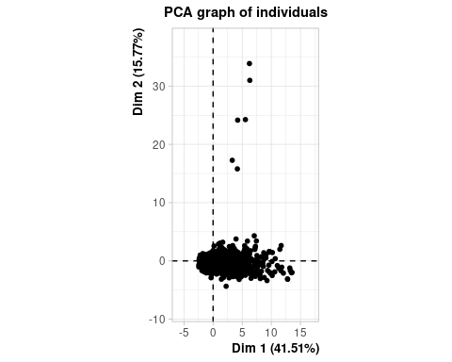

plot(res.pca$ind$coord[,1],res.pca$ind$coord[,2],col="grey80",cex=0.5,pch=16)  
points(res.pca$ind$coord[para1,1],res.pca$ind$coord[para1,2],col="blue",cex=2,pch=16)  
points(res.pca$ind$coord[dist1,1],res.pca$ind$coord[dist1,2],col="orange",cex=2,pch=16)  
points(res.pca$ind$coord[para2,1],res.pca$ind$coord[para2,2],col="blue",cex=2,pch=16)  
points(res.pca$ind$coord[dist2,1],res.pca$ind$coord[dist2,2],col="orange",cex=2,pch=16)  
points(res.pca$ind$coord[para3,1],res.pca$ind$coord[para3,2],col="blue",cex=2,pch=16)  
points(res.pca$ind$coord[dist3,1],res.pca$ind$coord[dist3,2],col="orange",cex=2,pch=16)  
points(res.pca$ind$coord[para4,1],res.pca$ind$coord[para4,2],col="blue",cex=2,pch=16)  
points(res.pca$ind$coord[dist4,1],res.pca$ind$coord[dist4,2],col="orange",cex=2,pch=16)  
points(res.pca$ind$coord[para5,1],res.pca$ind$coord[para5,2],col="blue",cex=2,pch=16)  
points(res.pca$ind$coord[dist5,1],res.pca$ind$coord[dist5,2],col="orange",cex=2,pch=16)  
points(res.pca$ind$coord[para6,1],res.pca$ind$coord[para6,2],col="blue",cex=2,pch=16)  
points(res.pca$ind$coord[dist6,1],res.pca$ind$coord[dist6,2],col="orange",cex=2,pch=16)

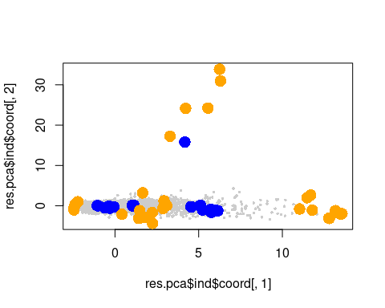

res.hcpc$data.clust[which(rownames(res.hcpc$data.clust)%in%names(res.hcpc$desc.ind$para[[1]])),]

## VendorID Payment_type Store_and_fwd_flag RateCodeID  
## 309 f.Vendor-VeriFone f.PayType-Cash FALSE Standard rate  
## 614 f.Vendor-VeriFone f.PayType-Cash FALSE Standard rate  
## 1177 f.Vendor-VeriFone f.PayType-Cash FALSE Standard rate  
## 2365 f.Vendor-VeriFone f.PayType-Cash FALSE Standard rate  
## 2370 f.Vendor-VeriFone f.PayType-Cash FALSE Standard rate  
## f.Extra f.MTA_tax f.Improvement_surcharge lpep_pickup_period  
## 309 f.Extra-0 f.MTA_tax_YES f.Improvement_surcharge_YES Period night  
## 614 f.Extra-0 f.MTA_tax_YES f.Improvement_surcharge_YES Period valley  
## 1177 f.Extra-0 f.MTA_tax_YES f.Improvement_surcharge_YES Period night  
## 2365 f.Extra-0 f.MTA_tax_YES f.Improvement_surcharge_YES Period valley  
## 2370 f.Extra-0 f.MTA_tax_YES f.Improvement_surcharge_YES Period valley  
## Trip_type lpep_pickup_date Passenger_count tlenkm  
## 309 f.TripType-Street-Hail 2016-01-01 1 2.446203  
## 614 f.TripType-Street-Hail 2016-01-04 1 2.574950  
## 1177 f.TripType-Street-Hail 2016-01-01 1 2.333549  
## 2365 f.TripType-Street-Hail 2016-01-15 1 2.639324  
## 2370 f.TripType-Street-Hail 2016-01-15 1 2.880726  
## Pickup_longitude Pickup_latitude Dropoff_longitude Dropoff_latitude  
## 309 -73.95614 40.69470 -73.97961 40.69614  
## 614 -73.95305 40.80684 -73.93969 40.82020  
## 1177 -73.92566 40.77220 -73.90671 40.76989  
## 2365 -73.94530 40.79366 -73.94392 40.77645  
## 2370 -73.94859 40.80878 -73.94301 40.79098  
## Fare_amount espeed Tip_amount Tolls_amount lpep_pickup_time traveltime  
## 309 8.0 17.07633 0 0 13.77690 8.879814  
## 614 8.0 17.86093 0 0 14.00000 8.650000  
## 1177 9.0 19.13190 0 0 13.93455 8.766875  
## 2365 8.5 15.10583 0 0 12.00000 10.483330  
## 2370 7.5 17.37121 0 0 13.00000 9.950000  
## distHaversine Total_amount clust  
## 309 1.987182 8.8 1  
## 614 1.864689 8.8 1  
## 1177 1.618292 9.8 1  
## 2365 1.919977 9.3 1  
## 2370 2.036805 8.3 1

res.hcpc$data.clust[which(rownames(res.hcpc$data.clust)%in%names(res.hcpc$desc.ind$dist[[1]])),]

## VendorID Payment_type Store_and_fwd_flag RateCodeID  
## 61 f.Vendor-VeriFone f.PayType-Cash FALSE Standard rate  
## 892 f.Vendor-VeriFone f.PayType-Cash FALSE Standard rate  
## 1492 f.Vendor-Mobile f.PayType-Cash FALSE Others  
## 2218 f.Vendor-VeriFone f.PayType-Cash FALSE Standard rate  
## 4793 f.Vendor-VeriFone f.PayType-Cash FALSE Standard rate  
## f.Extra f.MTA_tax f.Improvement_surcharge lpep_pickup_period  
## 61 f.Extra-0.5 f.MTA_tax_YES f.Improvement_surcharge_YES Period night  
## 892 f.Extra-0 f.MTA_tax_YES f.Improvement_surcharge_YES Period valley  
## 1492 f.Extra-0 f.MTA_tax_NO f.Improvement_surcharge_NO Period night  
## 2218 f.Extra-1 f.MTA_tax_YES f.Improvement_surcharge_YES Period valley  
## 4793 f.Extra-0.5 f.MTA_tax_YES f.Improvement_surcharge_YES Period night  
## Trip_type lpep_pickup_date Passenger_count tlenkm  
## 61 f.TripType-Street-Hail 2016-01-01 1 0.04828032  
## 892 f.TripType-Street-Hail 2016-01-06 1 0.06437376  
## 1492 f.TripType-Dispatch 2016-01-10 2 0.16093440  
## 2218 f.TripType-Street-Hail 2016-01-14 1 0.09656064  
## 4793 f.TripType-Street-Hail 2016-01-30 1 0.19312130  
## Pickup_longitude Pickup_latitude Dropoff_longitude Dropoff_latitude  
## 61 -73.88078 40.82846 -73.88282 40.82843  
## 892 -73.86945 40.73414 -73.86925 40.73481  
## 1492 -73.90463 40.85099 -73.90364 40.85223  
## 2218 -73.95387 40.81134 -73.95112 40.81020  
## 4793 -73.95201 40.80895 -73.94799 40.81446  
## Fare_amount espeed Tip_amount Tolls_amount lpep_pickup_time traveltime  
## 61 2.5 4.042073 0 0 3 0.7166667  
## 892 2.5 7.022592 0 0 14 0.5500000  
## 1492 0.0 7.333719 0 0 1 1.3166667  
## 2218 2.5 5.993419 0 0 16 0.9666667  
## 4793 3.0 7.556920 0 0 23 1.5333330  
## distHaversine Total_amount clust  
## 61 0.1716187 3.8 1  
## 892 0.0767317 3.3 1  
## 1492 0.1605865 0.0 1  
## 2218 0.2641138 4.3 1  
## 4793 0.7012892 4.3 1

res.hcpc$data.clust[which(rownames(res.hcpc$data.clust)%in%names(res.hcpc$desc.ind$para[[2]])),]

## VendorID Payment_type Store_and_fwd_flag RateCodeID  
## 489 f.Vendor-VeriFone f.PayType-Cash FALSE Standard rate  
## 1925 f.Vendor-VeriFone f.PayType-Cash FALSE Standard rate  
## 2338 f.Vendor-VeriFone f.PayType-Cash FALSE Standard rate  
## 3400 f.Vendor-VeriFone f.PayType-Credit card FALSE Standard rate  
## 4637 f.Vendor-VeriFone f.PayType-Credit card FALSE Standard rate  
## f.Extra f.MTA_tax f.Improvement_surcharge lpep_pickup_period  
## 489 f.Extra-0 f.MTA_tax_YES f.Improvement_surcharge_YES Period afternoon  
## 1925 f.Extra-1 f.MTA_tax_YES f.Improvement_surcharge_YES Period afternoon  
## 2338 f.Extra-0 f.MTA_tax_YES f.Improvement_surcharge_YES Period morning  
## 3400 f.Extra-1 f.MTA_tax_YES f.Improvement_surcharge_YES Period afternoon  
## 4637 f.Extra-0 f.MTA_tax_YES f.Improvement_surcharge_YES Period night  
## Trip_type lpep_pickup_date Passenger_count tlenkm  
## 489 f.TripType-Street-Hail 2016-01-03 5 4.876312  
## 1925 f.TripType-Street-Hail 2016-01-12 5 3.701491  
## 2338 f.TripType-Street-Hail 2016-01-15 5 3.653211  
## 3400 f.TripType-Street-Hail 2016-01-21 5 2.414016  
## 4637 f.TripType-Street-Hail 2016-01-30 5 3.669304  
## Pickup_longitude Pickup_latitude Dropoff_longitude Dropoff_latitude  
## 489 -73.89082 40.74651 -73.87373 40.76523  
## 1925 -73.94909 40.79419 -73.94024 40.82050  
## 2338 -73.96690 40.80415 -73.93933 40.80517  
## 3400 -73.94346 40.74673 -73.95760 40.73350  
## 4637 -73.94351 40.70168 -73.95590 40.73005  
## Fare_amount espeed Tip_amount Tolls_amount lpep_pickup_time traveltime  
## 489 11.5 29.20919 0.00 0 17 10.016667  
## 1925 9.0 26.97443 0.00 0 19 8.233333  
## 2338 10.5 17.12443 0.00 0 9 12.800000  
## 3400 6.5 30.81723 1.66 0 17 4.700000  
## 4637 10.5 16.78462 1.00 0 7 13.116670  
## distHaversine Total_amount clust  
## 489 2.533183 12.30 2  
## 1925 3.021841 10.80 2  
## 2338 2.326080 11.30 2  
## 3400 1.895628 9.96 2  
## 4637 3.326656 12.30 2

res.hcpc$data.clust[which(rownames(res.hcpc$data.clust)%in%names(res.hcpc$desc.ind$dist[[2]])),]

## VendorID Payment_type Store_and_fwd_flag RateCodeID  
## 264 f.Vendor-VeriFone f.PayType-Credit card FALSE Standard rate  
## 1491 f.Vendor-VeriFone f.PayType-Credit card FALSE Standard rate  
## 2141 f.Vendor-VeriFone f.PayType-Credit card FALSE Standard rate  
## 2326 f.Vendor-VeriFone f.PayType-Cash FALSE Standard rate  
## 4761 f.Vendor-VeriFone f.PayType-Credit card FALSE Standard rate  
## f.Extra f.MTA_tax f.Improvement_surcharge lpep_pickup_period  
## 264 f.Extra-0 f.MTA_tax_YES f.Improvement_surcharge_YES Period valley  
## 1491 f.Extra-0.5 f.MTA_tax_YES f.Improvement_surcharge_YES Period night  
## 2141 f.Extra-0.5 f.MTA_tax_YES f.Improvement_surcharge_YES Period night  
## 2326 f.Extra-0 f.MTA_tax_YES f.Improvement_surcharge_YES Period morning  
## 4761 f.Extra-0.5 f.MTA_tax_YES f.Improvement_surcharge_YES Period night  
## Trip_type lpep_pickup_date Passenger_count tlenkm  
## 264 f.TripType-Street-Hail 2016-01-02 6 13.148340  
## 1491 f.TripType-Street-Hail 2016-01-10 6 10.991820  
## 2141 f.TripType-Street-Hail 2016-01-14 6 14.725500  
## 2326 f.TripType-Street-Hail 2016-01-15 6 3.958986  
## 4761 f.TripType-Street-Hail 2016-01-30 6 9.881372  
## Pickup_longitude Pickup_latitude Dropoff_longitude Dropoff_latitude  
## 264 -73.97984 40.67737 -73.97252 40.74634  
## 1491 -73.90288 40.77547 -73.82043 40.78169  
## 2141 -73.88847 40.74707 -73.86604 40.68958  
## 2326 -73.83913 40.72534 -73.84893 40.75195  
## 4761 -73.89146 40.74667 -73.98812 40.76459  
## Fare_amount espeed Tip_amount Tolls_amount lpep_pickup_time traveltime  
## 264 25.5 37.15387 0.00 0 13 21.233333  
## 1491 22.5 33.93701 0.00 0 1 19.433333  
## 2141 33.5 19.54712 0.00 0 4 45.200000  
## 2326 8.5 50.18433 0.00 0 8 4.733333  
## 4761 25.0 17.83999 5.26 0 21 33.233330  
## distHaversine Total_amount clust  
## 264 7.702457 26.30 2  
## 1491 6.984618 23.80 2  
## 2141 6.674442 34.80 2  
## 2326 3.076015 9.30 2  
## 4761 8.391677 31.56 2

### Results for the hierarchical tree

### The suggested level to cut the tree

res.hcpc$call$t$nb.clust

## [1] 6

### Within inertias

res.hcpc$call$t$within[1:res.hcpc$call$t$nb.clust]

## [1] 7.049532 5.125513 4.100262 3.272633 2.539835 1.869059

### Ratio between within inertias

res.hcpc$call$t$quot[1:res.hcpc$call$t$nb.clust]

## [1] 0.7999712 0.7981521 0.7760833 0.7358976 0.8974407 0.9018483

### Inertia gain

res.hcpc$call$t$inert.gain[1:res.hcpc$call$t$nb.clust]

## [1] 1.9240191 1.0252503 0.8276295 0.7327972 0.6707766 0.1916894

# Partition quality

(res.hcpc$call$t$within[1]-res.hcpc$call$t$within[res.hcpc$call$t$nb.clust])/res.hcpc$call$t$within[1]

## [1] 0.7348677

## Classification

## K-Means: Partitioning in k=6

res.pca<-PCA(df[,c(1:10,20:(d2-2),d2)],quali.sup=c(1:10),quanti.sup=c(13:16,24), ncp=4, graph= FALSE)  
ppcc<-res.pca$ind$coord[,1:4]  
dist<-dist(ppcc)  
kc<-kmeans(dist,6, iter.max = 30, trace=T)

## KMNS(*, k=6): iter= 1, indx=2  
## QTRAN(): istep=5000, icoun=56  
## QTRAN(): istep=10000, icoun=8  
## QTRAN(): istep=15000, icoun=118  
## QTRAN(): istep=20000, icoun=121  
## QTRAN(): istep=25000, icoun=71  
## QTRAN(): istep=30000, icoun=514  
## KMNS(*, k=6): iter= 2, indx=24  
## QTRAN(): istep=5000, icoun=11  
## QTRAN(): istep=10000, icoun=7  
## QTRAN(): istep=15000, icoun=1193  
## QTRAN(): istep=20000, icoun=676  
## QTRAN(): istep=25000, icoun=22  
## QTRAN(): istep=30000, icoun=578  
## QTRAN(): istep=35000, icoun=440  
## QTRAN(): istep=40000, icoun=808  
## QTRAN(): istep=45000, icoun=4776  
## KMNS(*, k=6): iter= 3, indx=1992  
## KMNS(*, k=6): iter= 4, indx=5000

df$claKM<-factor(kc$cluster)

kc$betweenss/kc$totss

## [1] 0.7882527

## Profiling KM

i <- which(names(df)=="claKM")  
res.cat<-catdes(df,i)

#Global association variables numeric

res.cat$quanti.var

## Eta2 P-value  
## Passenger_count 0.444694791 0.000000e+00  
## tlenkm 0.603831600 0.000000e+00  
## Fare_amount 0.576696172 0.000000e+00  
## espeed 0.263490766 0.000000e+00  
## Tolls_amount 0.619167093 0.000000e+00  
## distHaversine 0.564957345 0.000000e+00  
## Total_amount 0.595040329 0.000000e+00  
## traveltime 0.233684977 2.464593e-285  
## lpep_pickup_time 0.230551028 6.439587e-281  
## Tip_amount 0.222218401 2.920709e-269  
## Dropoff_longitude 0.021909039 2.966999e-22  
## Dropoff_latitude 0.008728726 2.548210e-08  
## Pickup_latitude 0.006045956 1.290650e-05  
## Pickup_longitude 0.004354320 5.715964e-04

#Global association category categoricas

res.cat$quanti

## $`1`  
## v.test Mean in category Overall mean sd in category  
## Dropoff_longitude 2.705596 -73.9299273 -73.93489420 0.04270377  
## Pickup_longitude 2.547698 -73.9319264 -73.93586028 0.03978092  
## Tolls_amount -3.607465 0.0000000 0.09183507 0.00000000  
## Tip_amount -9.270140 0.5687535 1.23015723 0.90283721  
## traveltime -11.150620 6.1285920 13.00095517 3.28832146  
## tlenkm -14.494179 2.1488108 4.58146198 1.14987360  
## distHaversine -14.623896 1.6093841 3.21086535 0.88623093  
## Total_amount -16.052113 8.5485336 14.54115814 3.66900369  
## Fare_amount -16.658218 6.7237753 11.99993894 2.49596451  
## lpep_pickup_time -31.568368 4.6955400 13.63378632 5.06942330  
## Overall sd p.value  
## Dropoff_longitude 0.05066108 6.818201e-03  
## Pickup_longitude 0.04261074 1.084363e-02  
## Tolls_amount 0.70251226 3.092032e-04  
## Tip_amount 1.96891907 1.859024e-20  
## traveltime 17.00805091 7.110890e-29  
## tlenkm 4.63162829 1.318696e-47  
## distHaversine 3.02208211 1.977536e-48  
## Total_amount 10.30225573 5.525040e-58  
## Fare_amount 8.74051843 2.637671e-62  
## lpep_pickup_time 7.81353684 1.003687e-218  
##   
## $`2`  
## v.test Mean in category Overall mean sd in category  
## lpep_pickup_time 19.991048 16.1454493 13.63378632 4.47941641  
## Dropoff_latitude 5.511555 40.7496044 40.74449280 0.05650822  
## Pickup_latitude 4.061473 40.7501611 40.74645114 0.05605916  
## Tolls_amount -8.129737 0.0000000 0.09183507 0.00000000  
## Passenger_count -18.070622 1.0669418 1.37460000 0.25174904  
## traveltime -19.348218 7.7095177 13.00095517 3.92581030  
## Tip_amount -20.612334 0.5775781 1.23015723 0.88318866  
## espeed -28.488256 16.6990429 20.97100764 4.78955497  
## Total_amount -33.761969 8.9482429 14.54115814 2.82948643  
## Fare_amount -34.220223 7.1904585 11.99993894 2.37583417  
## tlenkm -34.234381 2.0318487 4.58146198 0.90988893  
## distHaversine -34.790326 1.5202574 3.21086535 0.72944165  
## Overall sd p.value  
## lpep_pickup_time 7.81353684 6.589655e-89  
## Dropoff_latitude 0.05767784 3.556765e-08  
## Pickup_latitude 0.05680712 4.876404e-05  
## Tolls_amount 0.70251226 4.302214e-16  
## Passenger_count 1.05880822 5.429824e-73  
## traveltime 17.00805091 2.110108e-83  
## Tip_amount 1.96891907 2.127234e-94  
## espeed 9.32574766 1.637649e-178  
## Total_amount 10.30225573 7.134769e-250  
## Fare_amount 8.74051843 1.209845e-256  
## tlenkm 4.63162829 7.448958e-257  
## distHaversine 3.02208211 3.406549e-265  
##   
## $`3`  
## v.test Mean in category Overall mean sd in category  
## Passenger_count 46.567793 3.5220126 1.37460000 2.10570696  
## Fare_amount 22.254258 20.4714885 11.99993894 13.07651024  
## distHaversine 21.227733 6.0048397 3.21086535 4.36243875  
## Total_amount 21.207526 24.0567296 14.54115814 14.81389736  
## tlenkm 21.203364 8.8585778 4.58146198 6.44443468  
## espeed 15.801924 27.3891029 20.97100764 14.77674556  
## Tip_amount 12.503896 2.3023818 1.23015723 2.94560349  
## traveltime 9.226373 19.8353187 13.00095517 14.95703358  
## Dropoff_longitude 3.324599 -73.9275588 -73.93489420 0.06657082  
## Pickup_longitude 2.245572 -73.9316929 -73.93586028 0.04788003  
## Tolls_amount -2.653446 0.0106499 0.09183507 0.16412591  
## lpep_pickup_time -3.064401 12.5909749 13.63378632 7.23467888  
## Dropoff_latitude -3.388413 40.7359811 40.74449280 0.05926113  
## Pickup_latitude -3.526299 40.7377268 40.74645114 0.05616276  
## Overall sd p.value  
## Passenger_count 1.05880822 0.000000e+00  
## Fare_amount 8.74051843 1.025760e-109  
## distHaversine 3.02208211 5.295615e-100  
## Total_amount 10.30225573 8.138191e-100  
## tlenkm 4.63162829 8.890774e-100  
## espeed 9.32574766 3.017646e-56  
## Tip_amount 1.96891907 7.108084e-36  
## traveltime 17.00805091 2.799518e-20  
## Dropoff_longitude 0.05066108 8.854573e-04  
## Pickup_longitude 0.04261074 2.473145e-02  
## Tolls_amount 0.70251226 7.967447e-03  
## lpep_pickup_time 7.81353684 2.181065e-03  
## Dropoff_latitude 0.05767784 7.029821e-04  
## Pickup_latitude 0.05680712 4.214106e-04  
##   
## $`4`  
## v.test Mean in category Overall mean sd in category  
## distHaversine 8.368848 3.913570e+00 3.21086535 1.11636717  
## Fare_amount 8.027703 1.394947e+01 11.99993894 3.33137049  
## Total_amount 7.468417 1.667893e+01 14.54115814 4.16121161  
## traveltime 6.496199 1.607079e+01 13.00095517 5.77794647  
## tlenkm 5.888034 5.339175e+00 4.58146198 1.32850693  
## lpep_pickup_time 4.942834 1.470685e+01 13.63378632 6.19402129  
## Tip_amount 4.800040 1.492744e+00 1.23015723 1.63391656  
## Pickup_latitude -2.580379 4.074238e+01 40.74645114 0.05898340  
## Dropoff_longitude -3.094581 -7.393925e+01 -73.93489420 0.04980421  
## Pickup_longitude -3.217817 -7.393967e+01 -73.93586028 0.04263275  
## Dropoff_latitude -3.450227 4.073896e+01 40.74449280 0.05873021  
## Tolls_amount -4.675589 5.728737e-04 0.09183507 0.01836773  
## Passenger_count -8.967635 1.110787e+00 1.37460000 0.35730644  
## Overall sd p.value  
## distHaversine 3.02208211 5.818427e-17  
## Fare_amount 8.74051843 9.931486e-16  
## Total_amount 10.30225573 8.116542e-14  
## traveltime 17.00805091 8.237461e-11  
## tlenkm 4.63162829 3.908171e-09  
## lpep_pickup_time 7.81353684 7.699507e-07  
## Tip_amount 1.96891907 1.586341e-06  
## Pickup_latitude 0.05680712 9.869208e-03  
## Dropoff_longitude 0.05066108 1.970914e-03  
## Pickup_longitude 0.04261074 1.291701e-03  
## Dropoff_latitude 0.05767784 5.601162e-04  
## Tolls_amount 0.70251226 2.931112e-06  
## Passenger_count 1.05880822 3.029493e-19  
##   
## $`5`  
## v.test Mean in category Overall mean sd in category  
## Tolls_amount 55.633797 3.461877 0.09183507 2.65949782  
## tlenkm 34.575806 18.390031 4.58146198 10.96442081  
## Total_amount 33.806675 44.572688 14.54115814 18.77537258  
## distHaversine 30.937505 11.272706 3.21086535 6.54220495  
## Fare_amount 29.587600 34.299155 11.99993894 16.05801588  
## traveltime 24.245395 48.558067 13.00095517 81.89915293  
## Tip_amount 21.786141 4.928872 1.23015723 4.64007434  
## espeed 19.037588 36.279706 20.97100764 16.95136008  
## Dropoff_longitude 7.304909 -73.902984 -73.93489420 0.08809632  
## lpep_pickup_time 4.857546 16.906494 13.63378632 25.00504030  
## Overall sd p.value  
## Tolls_amount 0.70251226 0.000000e+00  
## tlenkm 4.63162829 5.837763e-262  
## Total_amount 10.30225573 1.573501e-250  
## distHaversine 3.02208211 3.741411e-210  
## Fare_amount 8.74051843 2.157664e-192  
## traveltime 17.00805091 7.394687e-130  
## Tip_amount 1.96891907 3.140274e-105  
## espeed 9.32574766 8.327488e-81  
## Dropoff_longitude 0.05066108 2.774538e-13  
## lpep_pickup_time 7.81353684 1.188494e-06  
##   
## $`6`  
## v.test Mean in category Overall mean sd in category  
## Fare_amount 26.523537 21.613820 11.99993894 5.95924104  
## tlenkm 25.381329 9.456502 4.58146198 2.16340894  
## distHaversine 25.023467 6.346922 3.21086535 2.06401744  
## Total_amount 24.648529 25.071766 14.54115814 6.17563347  
## espeed 17.592674 27.774715 20.97100764 9.82586082  
## Tip_amount 13.969923 2.370806 1.23015723 2.45089394  
## traveltime 13.624028 22.610220 13.00095517 9.58552938  
## Dropoff_latitude -2.281254 40.739036 40.74449280 0.05701975  
## Tolls_amount -3.152278 0.000000 0.09183507 0.00000000  
## lpep_pickup_time -3.585188 12.472098 13.63378632 7.30173990  
## Passenger_count -3.635497 1.214971 1.37460000 0.58108910  
## Dropoff_longitude -6.123878 -73.947760 -73.93489420 0.05739395  
## Overall sd p.value  
## Fare_amount 8.74051843 5.188538e-155  
## tlenkm 4.63162829 4.054420e-142  
## distHaversine 3.02208211 3.395953e-138  
## Total_amount 10.30225573 3.816230e-134  
## espeed 9.32574766 2.803334e-69  
## Tip_amount 1.96891907 2.378825e-44  
## traveltime 17.00805091 2.882213e-42  
## Dropoff_latitude 0.05767784 2.253342e-02  
## Tolls_amount 0.70251226 1.620018e-03  
## lpep_pickup_time 7.81353684 3.368360e-04  
## Passenger_count 1.05880822 2.774450e-04  
## Dropoff_longitude 0.05066108 9.132509e-10

res.cat$test.chi2

## p.value df  
## f.tlenkm 0.000000e+00 10  
## f.traveltime 0.000000e+00 20  
## f.distHaversine 0.000000e+00 10  
## AnyToll 0.000000e+00 5  
## f.Fare_amount 0.000000e+00 15  
## f.Passenger_count 0.000000e+00 10  
## f.Total_amount 0.000000e+00 35  
## hcpck 0.000000e+00 25  
## f.espeed 1.998801e-282 10  
## lpep_pickup_period 6.478927e-115 15  
## f.Extra 1.929912e-86 10  
## AnyTip 2.328424e-42 5  
## Payment_type 1.311420e-35 10  
## lpep_pickup_date 8.734495e-21 150  
## RateCodeID 9.513616e-19 5  
## multiouts 7.109065e-10 5  
## VendorID 2.397221e-05 5  
## Trip_type 1.137969e-04 5  
## f.MTA_tax 3.822004e-04 5  
## f.Improvement_surcharge 2.412695e-03 5

# description of each category

res.cat$category

## $`1`  
## Cla/Mod Mod/Cla Global  
## f.traveltime=f.traveltime-[0,10] 22.9116945 87.1406959 50.28  
## hcpck=1 20.0513314 94.5537065 62.34  
## lpep_pickup_period=Period night 23.8990826 78.8199697 43.60  
## f.distHaversine=f.distHaversine-[0,5] 16.2049522 100.0000000 81.58  
## f.Extra=f.Extra-0.5 23.7440508 67.9273828 37.82  
## f.Fare_amount=f.Fare_amount-[0,6.5] 24.4897959 54.4629349 29.40  
## f.Total_amount=f.Total_amount-(1,8] 24.6411483 46.7473525 25.08  
## f.tlenkm=f.tlenkm-(1,5] 17.7419355 83.2072617 62.00  
## f.tlenkm=f.tlenkm-[0,1] 25.7211538 16.1875946 8.32  
## f.Total_amount=f.Total_amount-(8,11] 18.8908146 32.9803328 23.08  
## lpep_pickup_date=2016-01-23 51.2195122 3.1770045 0.82  
## f.Fare_amount=f.Fare_amount-(6.5,9] 18.6113790 29.1981846 20.74  
## AnyTip=AnyTip No 15.3363541 66.5658094 57.38  
## lpep_pickup_date=2016-01-01 25.5506608 8.7745840 4.54  
## Payment_type=f.PayType-Cash 15.6362186 59.3040847 50.14  
## AnyToll=AnyToll Yes 13.4541014 100.0000000 98.26  
## lpep_pickup_date=2016-01-10 25.4437870 6.5052950 3.38  
## lpep_pickup_date=2016-01-09 23.6559140 6.6565809 3.72  
## f.Passenger_count=f.Passenger_count-Others 19.2488263 12.4054463 8.52  
## lpep_pickup_date=2016-01-03 22.5165563 5.1437216 3.02  
## lpep_pickup_date=2016-01-16 18.4684685 6.2027231 4.44  
## f.Passenger_count=f.Passenger_count-2 17.1662125 9.5310136 7.34  
## f.Total_amount=f.Total_amount-[0,1] 33.3333333 0.9077156 0.36  
## lpep_pickup_date=2016-01-17 19.0476190 4.8411498 3.36  
## lpep_pickup_date=2016-01-29 8.0924855 2.1180030 3.46  
## lpep_pickup_date=2016-01-22 8.4577114 2.5718608 4.02  
## lpep_pickup_date=2016-01-21 8.0000000 2.1180030 3.50  
## lpep_pickup_date=2016-01-08 8.0000000 2.1180030 3.50  
## lpep_pickup_date=2016-01-27 7.3170732 1.8154312 3.28  
## lpep_pickup_date=2016-01-26 5.6338028 1.2102874 2.84  
## lpep_pickup_date=2016-01-24 3.5714286 0.4538578 1.68  
## hcpck=2 5.9440559 2.5718608 5.72  
## f.Passenger_count=f.Passenger_count-1 12.2652722 78.0635401 84.14  
## hcpck=6 0.0000000 0.0000000 1.62  
## AnyToll=AnyToll No 0.0000000 0.0000000 1.74  
## Payment_type=f.PayType-Credit card 10.8360390 40.3933434 49.28  
## AnyTip=AnyTip Yes 10.3707180 33.4341906 42.62  
## f.traveltime=f.traveltime-(40,548] 0.0000000 0.0000000 2.20  
## f.Total_amount=f.Total_amount-(40,95.5] 1.2903226 0.3025719 3.10  
## f.Total_amount=f.Total_amount-(11,18] 8.8778409 18.9107413 28.16  
## f.Fare_amount=f.Fare_amount-(9,14.5] 8.3201268 15.8850227 25.24  
## f.traveltime=f.traveltime-(30,40] 0.0000000 0.0000000 3.34  
## f.distHaversine=f.distHaversine-(10,26.1] 0.0000000 0.0000000 3.88  
## f.Total_amount=f.Total_amount-(18,20] 0.0000000 0.0000000 4.02  
## f.Total_amount=f.Total_amount-(30,40] 0.0000000 0.0000000 4.30  
## f.Extra=f.Extra-0 8.9138901 31.1649017 46.22  
## hcpck=4 0.0000000 0.0000000 5.98  
## f.traveltime=f.traveltime-(20,30] 0.0000000 0.0000000 10.96  
## f.traveltime=f.traveltime-(10,20] 5.1173992 12.8593041 33.22  
## f.Total_amount=f.Total_amount-(20,30] 0.1680672 0.1512859 11.90  
## lpep_pickup_period=Period valley 3.4055728 6.6565809 25.84  
## f.Extra=f.Extra-1 0.7518797 0.9077156 15.96  
## lpep_pickup_period=Period afternoon 1.3029316 1.8154312 18.42  
## f.distHaversine=f.distHaversine-(5,10] 0.0000000 0.0000000 14.54  
## hcpck=3 1.5689513 2.8744327 24.22  
## f.Fare_amount=f.Fare_amount-(14.5,71.5] 0.2437043 0.4538578 24.62  
## f.tlenkm=f.tlenkm-(5,67.9] 0.2695418 0.6051437 29.68  
## p.value v.test  
## f.traveltime=f.traveltime-[0,10] 1.803967e-101 21.385996  
## hcpck=1 3.688585e-94 20.585676  
## lpep_pickup_period=Period night 1.519574e-87 19.833848  
## f.distHaversine=f.distHaversine-[0,5] 6.411191e-64 16.879103  
## f.Extra=f.Extra-0.5 9.030489e-64 16.858866  
## f.Fare_amount=f.Fare_amount-[0,6.5] 8.503875e-48 14.524274  
## f.Total_amount=f.Total_amount-(1,8] 6.538640e-39 13.047826  
## f.tlenkm=f.tlenkm-(1,5] 7.243840e-37 12.684103  
## f.tlenkm=f.tlenkm-[0,1] 6.970576e-13 7.180011  
## f.Total_amount=f.Total_amount-(8,11] 3.846341e-10 6.260139  
## lpep_pickup_date=2016-01-23 5.932085e-09 5.818661  
## f.Fare_amount=f.Fare_amount-(6.5,9] 2.781394e-08 5.554668  
## AnyTip=AnyTip No 2.283644e-07 5.174629  
## lpep_pickup_date=2016-01-01 3.255861e-07 5.108000  
## Payment_type=f.PayType-Cash 4.048813e-07 5.066648  
## AnyToll=AnyToll Yes 3.911876e-06 4.616010  
## lpep_pickup_date=2016-01-10 1.419884e-05 4.340764  
## lpep_pickup_date=2016-01-09 8.089230e-05 3.941741  
## f.Passenger_count=f.Passenger_count-Others 2.529520e-04 3.659252  
## lpep_pickup_date=2016-01-03 1.486288e-03 3.177348  
## lpep_pickup_date=2016-01-16 2.351466e-02 2.264968  
## f.Passenger_count=f.Passenger_count-2 2.455120e-02 2.248392  
## f.Total_amount=f.Total_amount-[0,1] 2.956126e-02 2.175920  
## lpep_pickup_date=2016-01-17 3.031435e-02 2.165959  
## lpep_pickup_date=2016-01-29 3.477730e-02 -2.110942  
## lpep_pickup_date=2016-01-22 3.462204e-02 -2.112751  
## lpep_pickup_date=2016-01-21 3.033598e-02 -2.165676  
## lpep_pickup_date=2016-01-08 3.033598e-02 -2.165676  
## lpep_pickup_date=2016-01-27 1.673709e-02 -2.392433  
## lpep_pickup_date=2016-01-26 3.349495e-03 -2.933698  
## lpep_pickup_date=2016-01-24 3.324790e-03 -2.935996  
## hcpck=2 4.752268e-05 -4.067488  
## f.Passenger_count=f.Passenger_count-1 9.767824e-06 -4.422250  
## hcpck=6 9.302889e-06 -4.432773  
## AnyToll=AnyToll No 3.911876e-06 -4.616010  
## Payment_type=f.PayType-Credit card 8.842610e-07 -4.915788  
## AnyTip=AnyTip Yes 2.283644e-07 -5.174629  
## f.traveltime=f.traveltime-(40,548] 1.398190e-07 -5.265486  
## f.Total_amount=f.Total_amount-(40,95.5] 6.844369e-08 -5.395209  
## f.Total_amount=f.Total_amount-(11,18] 4.607042e-09 -5.860778  
## f.Fare_amount=f.Fare_amount-(9,14.5] 6.100326e-10 -6.187817  
## f.traveltime=f.traveltime-(30,40] 3.374182e-11 -6.629241  
## f.distHaversine=f.distHaversine-(10,26.1] 6.289181e-13 -7.194062  
## f.Total_amount=f.Total_amount-(18,20] 2.230882e-13 -7.334177  
## f.Total_amount=f.Total_amount-(30,40] 2.793282e-14 -7.607556  
## f.Extra=f.Extra-0 3.184399e-17 -8.439595  
## hcpck=4 9.363541e-20 -9.096098  
## f.traveltime=f.traveltime-(20,30] 1.258162e-36 -12.640770  
## f.traveltime=f.traveltime-(10,20] 2.257628e-37 -12.775133  
## f.Total_amount=f.Total_amount-(20,30] 6.760905e-38 -12.868609  
## lpep_pickup_period=Period valley 1.354543e-41 -13.510578  
## f.Extra=f.Extra-1 1.964500e-44 -13.983546  
## lpep_pickup_period=Period afternoon 1.289008e-45 -14.176050  
## f.distHaversine=f.distHaversine-(5,10] 2.119241e-49 -14.775138  
## hcpck=3 1.460200e-58 -16.134485  
## f.Fare_amount=f.Fare_amount-(14.5,71.5] 2.766741e-82 -19.215105  
## f.tlenkm=f.tlenkm-(5,67.9] 5.215612e-102 -21.443816  
##   
## $`2`  
## Cla/Mod Mod/Cla  
## hcpck=1 69.9711261 100.00000000  
## f.distHaversine=f.distHaversine-[0,5] 53.4689875 100.00000000  
## f.tlenkm=f.tlenkm-(1,5] 61.2903226 87.11600183  
## f.traveltime=f.traveltime-[0,10] 65.5529037 75.56166896  
## f.espeed=f.espeed-(1,25] 53.5741935 95.18569464  
## f.Fare_amount=f.Fare_amount-[0,6.5] 69.6598639 46.95093994  
## f.Total_amount=f.Total_amount-(8,11] 73.6568458 38.97294819  
## f.Total_amount=f.Total_amount-(1,8] 70.0159490 40.25676295  
## f.Fare_amount=f.Fare_amount-(6.5,9] 72.9990357 34.70884915  
## f.Passenger_count=f.Passenger_count-1 48.3242215 93.21412196  
## AnyTip=AnyTip No 49.8780063 65.61210454  
## AnyToll=AnyToll Yes 44.3924283 100.00000000  
## f.tlenkm=f.tlenkm-[0,1] 66.3461538 12.65474553  
## Payment_type=f.PayType-Cash 50.3390507 57.86336543  
## f.Extra=f.Extra-1 59.1478697 21.64144888  
## lpep_pickup_period=Period valley 54.8761610 32.50802384  
## lpep_pickup_period=Period afternoon 57.3289902 24.20907840  
## f.Extra=f.Extra-0 47.7282562 50.57313159  
## RateCodeID=Standard rate 44.2042413 98.44108207  
## lpep_pickup_date=2016-01-19 57.6388889 3.80559376  
## Trip_type=f.TripType-Street-Hail 43.9819561 98.34938102  
## lpep_pickup_date=2016-01-05 56.9343066 3.57634113  
## lpep_pickup_date=2016-01-14 54.8192771 4.17239798  
## lpep_pickup_date=2016-01-15 53.2608696 4.49335167  
## f.MTA_tax=f.MTA_tax_YES 43.9169749 97.98257680  
## f.Improvement_surcharge=f.Improvement_surcharge_YES 43.8914027 97.84502522  
## lpep_pickup_date=2016-01-24 55.9523810 2.15497478  
## lpep_pickup_date=2016-01-22 51.2437811 4.72260431  
## lpep_pickup_date=2016-01-18 52.4590164 2.93443375  
## hcpck=5 0.0000000 0.00000000  
## f.espeed=f.espeed-[0,1] 0.0000000 0.00000000  
## f.Improvement_surcharge=f.Improvement_surcharge_NO 34.0579710 2.15497478  
## f.MTA_tax=f.MTA_tax_NO 32.8358209 2.01742320  
## lpep_pickup_date=2016-01-03 32.4503311 2.24667584  
## lpep_pickup_date=2016-01-17 32.1428571 2.47592847  
## lpep_pickup_date=2016-01-31 32.4468085 2.79688216  
## Trip_type=f.TripType-Dispatch 29.2682927 1.65061898  
## lpep_pickup_date=2016-01-10 30.7692308 2.38422742  
## lpep_pickup_date=2016-01-23 9.7560976 0.18340211  
## RateCodeID=Others 23.7762238 1.55891793  
## lpep_pickup_date=2016-01-01 24.2290749 2.52177900  
## hcpck=6 0.0000000 0.00000000  
## Payment_type=f.PayType-Credit card 36.6883117 41.44887666  
## AnyToll=AnyToll No 0.0000000 0.00000000  
## AnyTip=AnyTip Yes 35.1947443 34.38789546  
## f.Fare_amount=f.Fare_amount-(9,14.5] 31.1410460 18.01925722  
## f.traveltime=f.traveltime-(40,548] 0.0000000 0.00000000  
## f.Total_amount=f.Total_amount-(11,18] 31.2500000 20.17423200  
## f.Total_amount=f.Total_amount-(40,95.5] 1.2903226 0.09170105  
## f.traveltime=f.traveltime-(10,20] 31.0054184 23.61302155  
## f.Extra=f.Extra-0.5 32.0465362 27.78541953  
## f.traveltime=f.traveltime-(30,40] 0.0000000 0.00000000  
## f.Total_amount=f.Total_amount-(18,20] 0.9950249 0.09170105  
## f.distHaversine=f.distHaversine-(10,26.1] 0.0000000 0.00000000  
## f.Total_amount=f.Total_amount-(30,40] 0.0000000 0.00000000  
## lpep_pickup_period=Period night 30.9633028 30.94910591  
## hcpck=2 0.0000000 0.00000000  
## hcpck=4 0.0000000 0.00000000  
## f.Passenger_count=f.Passenger_count-Others 0.2347418 0.04585053  
## f.traveltime=f.traveltime-(20,30] 3.2846715 0.82530949  
## f.Total_amount=f.Total_amount-(20,30] 0.1680672 0.04585053  
## f.espeed=f.espeed-(25,130] 9.3833780 4.81430536  
## f.distHaversine=f.distHaversine-(5,10] 0.0000000 0.00000000  
## hcpck=3 0.0000000 0.00000000  
## f.Fare_amount=f.Fare_amount-(14.5,71.5] 0.5686434 0.32095369  
## f.tlenkm=f.tlenkm-(5,67.9] 0.3369272 0.22925264  
## Global p.value  
## hcpck=1 62.34 0.000000e+00  
## f.distHaversine=f.distHaversine-[0,5] 81.58 1.786672e-264  
## f.tlenkm=f.tlenkm-(1,5] 62.00 3.473961e-245  
## f.traveltime=f.traveltime-[0,10] 50.28 2.343816e-225  
## f.espeed=f.espeed-(1,25] 77.50 1.134976e-175  
## f.Fare_amount=f.Fare_amount-[0,6.5] 29.40 6.447220e-128  
## f.Total_amount=f.Total_amount-(8,11] 23.08 3.468883e-123  
## f.Total_amount=f.Total_amount-(1,8] 25.08 9.326971e-106  
## f.Fare_amount=f.Fare_amount-(6.5,9] 20.74 7.653950e-103  
## f.Passenger_count=f.Passenger_count-1 84.14 3.570320e-58  
## AnyTip=AnyTip No 57.38 2.741467e-25  
## AnyToll=AnyToll Yes 98.26 1.237046e-22  
## f.tlenkm=f.tlenkm-[0,1] 8.32 2.182768e-22  
## Payment_type=f.PayType-Cash 50.14 6.617113e-22  
## f.Extra=f.Extra-1 15.96 7.674813e-22  
## lpep_pickup_period=Period valley 25.84 3.682033e-21  
## lpep_pickup_period=Period afternoon 18.42 2.314591e-20  
## f.Extra=f.Extra-0 46.22 5.683264e-08  
## RateCodeID=Standard rate 97.14 6.111820e-07  
## lpep_pickup_date=2016-01-19 2.88 6.412158e-04  
## Trip_type=f.TripType-Street-Hail 97.54 9.873377e-04  
## lpep_pickup_date=2016-01-05 2.74 1.580570e-03  
## lpep_pickup_date=2016-01-14 3.32 3.319566e-03  
## lpep_pickup_date=2016-01-15 3.68 7.629154e-03  
## f.MTA_tax=f.MTA_tax_YES 97.32 1.016094e-02  
## f.Improvement_surcharge=f.Improvement_surcharge_YES 97.24 2.093049e-02  
## lpep_pickup_date=2016-01-24 1.68 2.291102e-02  
## lpep_pickup_date=2016-01-22 4.02 2.702112e-02  
## lpep_pickup_date=2016-01-18 2.44 4.796229e-02  
## hcpck=5 0.12 3.204361e-02  
## f.espeed=f.espeed-[0,1] 0.12 3.204361e-02  
## f.Improvement_surcharge=f.Improvement_surcharge_NO 2.76 2.093049e-02  
## f.MTA_tax=f.MTA_tax_NO 2.68 1.016094e-02  
## lpep_pickup_date=2016-01-03 3.02 4.587077e-03  
## lpep_pickup_date=2016-01-17 3.36 2.063771e-03  
## lpep_pickup_date=2016-01-31 3.76 1.477158e-03  
## Trip_type=f.TripType-Dispatch 2.46 9.873377e-04  
## lpep_pickup_date=2016-01-10 3.38 5.223057e-04  
## lpep_pickup_date=2016-01-23 0.82 2.728843e-06  
## RateCodeID=Others 2.86 6.111820e-07  
## lpep_pickup_date=2016-01-01 4.54 5.781703e-10  
## hcpck=6 1.62 4.169675e-21  
## Payment_type=f.PayType-Credit card 49.28 1.730561e-22  
## AnyToll=AnyToll No 1.74 1.237046e-22  
## AnyTip=AnyTip Yes 42.62 2.741467e-25  
## f.Fare_amount=f.Fare_amount-(9,14.5] 25.24 1.393018e-25  
## f.traveltime=f.traveltime-(40,548] 2.20 1.631307e-28  
## f.Total_amount=f.Total_amount-(11,18] 28.16 6.515342e-29  
## f.Total_amount=f.Total_amount-(40,95.5] 3.10 3.271219e-36  
## f.traveltime=f.traveltime-(10,20] 33.22 1.476875e-37  
## f.Extra=f.Extra-0.5 37.82 1.939400e-38  
## f.traveltime=f.traveltime-(30,40] 3.34 2.996935e-43  
## f.Total_amount=f.Total_amount-(18,20] 4.02 5.337318e-48  
## f.distHaversine=f.distHaversine-(10,26.1] 3.88 2.589615e-50  
## f.Total_amount=f.Total_amount-(30,40] 4.30 7.614841e-56  
## lpep_pickup_period=Period night 43.60 1.772138e-57  
## hcpck=2 5.72 8.491253e-75  
## hcpck=4 5.98 2.605923e-78  
## f.Passenger_count=f.Passenger_count-Others 8.52 9.123628e-111  
## f.traveltime=f.traveltime-(20,30] 10.96 2.565279e-115  
## f.Total_amount=f.Total_amount-(20,30] 11.90 2.057220e-159  
## f.espeed=f.espeed-(25,130] 22.38 6.259326e-174  
## f.distHaversine=f.distHaversine-(5,10] 14.54 3.200797e-202  
## hcpck=3 24.22 0.000000e+00  
## f.Fare_amount=f.Fare_amount-(14.5,71.5] 24.62 0.000000e+00  
## f.tlenkm=f.tlenkm-(5,67.9] 29.68 0.000000e+00  
## v.test  
## hcpck=1 Inf  
## f.distHaversine=f.distHaversine-[0,5] 34.742698  
## f.tlenkm=f.tlenkm-(1,5] 33.441040  
## f.traveltime=f.traveltime-[0,10] 32.047960  
## f.espeed=f.espeed-(1,25] 28.258003  
## f.Fare_amount=f.Fare_amount-[0,6.5] 24.060721  
## f.Total_amount=f.Total_amount-(8,11] 23.604454  
## f.Total_amount=f.Total_amount-(1,8] 21.841676  
## f.Fare_amount=f.Fare_amount-(6.5,9] 21.532929  
## f.Passenger_count=f.Passenger_count-1 16.079187  
## AnyTip=AnyTip No 10.390419  
## AnyToll=AnyToll Yes 9.790482  
## f.tlenkm=f.tlenkm-[0,1] 9.732901  
## Payment_type=f.PayType-Cash 9.619470  
## f.Extra=f.Extra-1 9.604205  
## lpep_pickup_period=Period valley 9.441294  
## lpep_pickup_period=Period afternoon 9.246733  
## f.Extra=f.Extra-0 5.428491  
## RateCodeID=Standard rate 4.987650  
## lpep_pickup_date=2016-01-19 3.413553  
## Trip_type=f.TripType-Street-Hail 3.294110  
## lpep_pickup_date=2016-01-05 3.159469  
## lpep_pickup_date=2016-01-14 2.936483  
## lpep_pickup_date=2016-01-15 2.668056  
## f.MTA_tax=f.MTA_tax_YES 2.570304  
## f.Improvement_surcharge=f.Improvement_surcharge_YES 2.309236  
## lpep_pickup_date=2016-01-24 2.274915  
## lpep_pickup_date=2016-01-22 2.211213  
## lpep_pickup_date=2016-01-18 1.977702  
## hcpck=5 -2.143866  
## f.espeed=f.espeed-[0,1] -2.143866  
## f.Improvement_surcharge=f.Improvement_surcharge_NO -2.309236  
## f.MTA_tax=f.MTA_tax_NO -2.570304  
## lpep_pickup_date=2016-01-03 -2.834686  
## lpep_pickup_date=2016-01-17 -3.080898  
## lpep_pickup_date=2016-01-31 -3.179134  
## Trip_type=f.TripType-Dispatch -3.294110  
## lpep_pickup_date=2016-01-10 -3.469048  
## lpep_pickup_date=2016-01-23 -4.690240  
## RateCodeID=Others -4.987650  
## lpep_pickup_date=2016-01-01 -6.196270  
## hcpck=6 -9.428255  
## Payment_type=f.PayType-Credit card -9.756481  
## AnyToll=AnyToll No -9.790482  
## AnyTip=AnyTip Yes -10.390419  
## f.Fare_amount=f.Fare_amount-(9,14.5] -10.454794  
## f.traveltime=f.traveltime-(40,548] -11.076497  
## f.Total_amount=f.Total_amount-(11,18] -11.158400  
## f.Total_amount=f.Total_amount-(40,95.5] -12.565423  
## f.traveltime=f.traveltime-(10,20] -12.808110  
## f.Extra=f.Extra-0.5 -12.964719  
## f.traveltime=f.traveltime-(30,40] -13.788311  
## f.Total_amount=f.Total_amount-(18,20] -14.556160  
## f.distHaversine=f.distHaversine-(10,26.1] -14.916103  
## f.Total_amount=f.Total_amount-(30,40] -15.743472  
## lpep_pickup_period=Period night -15.979623  
## hcpck=2 -18.298594  
## hcpck=4 -18.734187  
## f.Passenger_count=f.Passenger_count-Others -22.362509  
## f.traveltime=f.traveltime-(20,30] -22.825409  
## f.Total_amount=f.Total_amount-(20,30] -26.902427  
## f.espeed=f.espeed-(25,130] -28.115915  
## f.distHaversine=f.distHaversine-(5,10] -30.342030  
## hcpck=3 -Inf  
## f.Fare_amount=f.Fare_amount-(14.5,71.5] -Inf  
## f.tlenkm=f.tlenkm-(5,67.9] -Inf  
##   
## $`3`  
## Cla/Mod Mod/Cla Global  
## hcpck=2 91.9580420 55.1362683 5.72  
## f.Passenger_count=f.Passenger_count-Others 66.1971831 59.1194969 8.52  
## hcpck=4 68.5618729 42.9769392 5.98  
## f.Total_amount=f.Total_amount-(30,40] 55.8139535 25.1572327 4.30  
## f.distHaversine=f.distHaversine-(10,26.1] 57.2164948 23.2704403 3.88  
## f.Fare_amount=f.Fare_amount-(14.5,71.5] 21.9333875 56.6037736 24.62  
## f.tlenkm=f.tlenkm-(5,67.9] 18.8005391 58.4905660 29.68  
## f.Total_amount=f.Total_amount-(40,95.5] 43.8709677 14.2557652 3.10  
## f.espeed=f.espeed-(25,130] 19.0348525 44.6540881 22.38  
## f.traveltime=f.traveltime-(40,548] 47.2727273 10.9014675 2.20  
## f.distHaversine=f.distHaversine-(5,10] 17.7441541 27.0440252 14.54  
## f.traveltime=f.traveltime-(30,40] 28.7425150 10.0628931 3.34  
## VendorID=f.Vendor-VeriFone 10.5978958 86.5828092 77.94  
## f.traveltime=f.traveltime-(20,30] 14.9635036 17.1907757 10.96  
## AnyTip=AnyTip Yes 11.1215392 49.6855346 42.62  
## Payment_type=f.PayType-Credit card 10.8360390 55.9748428 49.28  
## lpep_pickup_period=Period night 10.8256881 49.4758910 43.60  
## f.Extra=f.Extra-0.5 10.9465891 43.3962264 37.82  
## AnyToll=AnyToll Yes 9.6682272 99.5807128 98.26  
## RateCodeID=Others 14.6853147 4.4025157 2.86  
## RateCodeID=Standard rate 9.3885114 95.5974843 97.14  
## lpep_pickup_date=2016-01-05 4.3795620 1.2578616 2.74  
## f.tlenkm=f.tlenkm-[0,1] 6.4903846 5.6603774 8.32  
## lpep_pickup_period=Period valley 7.8173375 21.1740042 25.84  
## AnyToll=AnyToll No 2.2988506 0.4192872 1.74  
## Payment_type=f.PayType-Cash 8.2568807 43.3962264 50.14  
## f.Extra=f.Extra-0 8.1350065 39.4129979 46.22  
## AnyTip=AnyTip No 8.3652841 50.3144654 57.38  
## hcpck=6 0.0000000 0.0000000 1.62  
## f.Passenger_count=f.Passenger_count-2 3.8147139 2.9350105 7.34  
## VendorID=f.Vendor-Mobile 5.8023572 13.4171908 22.06  
## f.Total_amount=f.Total_amount-(8,11] 5.8925477 14.2557652 23.08  
## f.Fare_amount=f.Fare_amount-(9,14.5] 5.7844691 15.3039832 25.24  
## f.Fare_amount=f.Fare_amount-(6.5,9] 5.3037608 11.5303983 20.74  
## f.Total_amount=f.Total_amount-(11,18] 5.3977273 15.9329140 28.16  
## f.Total_amount=f.Total_amount-(1,8] 5.0239234 13.2075472 25.08  
## f.Fare_amount=f.Fare_amount-[0,6.5] 5.3741497 16.5618449 29.40  
## f.traveltime=f.traveltime-[0,10] 5.6085919 29.5597484 50.28  
## f.espeed=f.espeed-(1,25] 6.8129032 55.3459119 77.50  
## f.tlenkm=f.tlenkm-(1,5] 5.5161290 35.8490566 62.00  
## hcpck=3 0.7431874 1.8867925 24.22  
## f.distHaversine=f.distHaversine-[0,5] 5.8102476 49.6855346 81.58  
## f.Passenger_count=f.Passenger_count-1 4.3023532 37.9454927 84.14  
## hcpck=1 0.0000000 0.0000000 62.34  
## p.value v.test  
## hcpck=2 2.220430e-272 35.262332  
## f.Passenger_count=f.Passenger_count-Others 3.320893e-217 31.457441  
## hcpck=4 1.773696e-153 26.390234  
## f.Total_amount=f.Total_amount-(30,40] 5.791635e-70 17.681801  
## f.distHaversine=f.distHaversine-(10,26.1] 5.287061e-66 17.160047  
## f.Fare_amount=f.Fare_amount-(14.5,71.5] 3.875199e-56 15.786150  
## f.tlenkm=f.tlenkm-(5,67.9] 3.350105e-43 13.780271  
## f.Total_amount=f.Total_amount-(40,95.5] 2.457869e-30 11.446163  
## f.espeed=f.espeed-(25,130] 3.599792e-30 11.413027  
## f.traveltime=f.traveltime-(40,548] 3.438798e-25 10.368782  
## f.distHaversine=f.distHaversine-(5,10] 5.709894e-14 7.514569  
## f.traveltime=f.traveltime-(30,40] 7.171221e-13 7.176130  
## VendorID=f.Vendor-VeriFone 5.232447e-07 5.017587  
## f.traveltime=f.traveltime-(20,30] 1.627322e-05 4.310709  
## AnyTip=AnyTip Yes 1.102676e-03 3.262928  
## Payment_type=f.PayType-Credit card 2.114993e-03 3.073591  
## lpep_pickup_period=Period night 6.735369e-03 2.709653  
## f.Extra=f.Extra-0.5 8.779559e-03 2.620521  
## AnyToll=AnyToll Yes 9.597007e-03 2.590021  
## RateCodeID=Others 4.483787e-02 2.006172  
## RateCodeID=Standard rate 4.483787e-02 -2.006172  
## lpep_pickup_date=2016-01-05 2.605372e-02 -2.225410  
## f.tlenkm=f.tlenkm-[0,1] 2.191215e-02 -2.291887  
## lpep_pickup_period=Period valley 1.300914e-02 -2.483519  
## AnyToll=AnyToll No 9.597007e-03 -2.590021  
## Payment_type=f.PayType-Cash 1.954303e-03 -3.097090  
## f.Extra=f.Extra-0 1.664820e-03 -3.144305  
## AnyTip=AnyTip No 1.102676e-03 -3.262928  
## hcpck=6 2.773093e-04 -3.635623  
## f.Passenger_count=f.Passenger_count-2 1.903168e-05 -4.275958  
## VendorID=f.Vendor-Mobile 5.232447e-07 -5.017587  
## f.Total_amount=f.Total_amount-(8,11] 4.907158e-07 -5.029908  
## f.Fare_amount=f.Fare_amount-(9,14.5] 3.937940e-08 -5.493613  
## f.Fare_amount=f.Fare_amount-(6.5,9] 3.331335e-08 -5.523067  
## f.Total_amount=f.Total_amount-(11,18] 5.709385e-11 -6.551155  
## f.Total_amount=f.Total_amount-(1,8] 2.635056e-11 -6.665645  
## f.Fare_amount=f.Fare_amount-[0,6.5] 1.170622e-11 -6.783792  
## f.traveltime=f.traveltime-[0,10] 6.109023e-22 -9.627685  
## f.espeed=f.espeed-(1,25] 8.381524e-30 -11.339297  
## f.tlenkm=f.tlenkm-(1,5] 5.888596e-34 -12.147861  
## hcpck=3 5.633602e-47 -14.394122  
## f.distHaversine=f.distHaversine-[0,5] 1.961523e-63 -16.812953  
## f.Passenger_count=f.Passenger_count-1 5.631763e-134 -24.632762  
## hcpck=1 1.451715e-221 -31.774616  
##   
## $`4`  
## Cla/Mod Mod/Cla  
## hcpck=3 59.2898431 69.77648202  
## f.Total_amount=f.Total_amount-(11,18] 51.0653409 69.87366375  
## f.Fare_amount=f.Fare_amount-(9,14.5] 51.2678288 62.87657920  
## f.traveltime=f.traveltime-(10,20] 41.7218543 67.34693878  
## f.tlenkm=f.tlenkm-(5,67.9] 37.8706199 54.61613217  
## f.Total_amount=f.Total_amount-(18,20] 66.6666667 13.02235180  
## f.traveltime=f.traveltime-(20,30] 36.1313869 19.24198251  
## f.Fare_amount=f.Fare_amount-(14.5,71.5] 28.3509342 33.91642371  
## AnyTip=AnyTip Yes 25.5279212 52.86686103  
## Payment_type=f.PayType-Credit card 24.5535714 58.79494655  
## f.Passenger_count=f.Passenger_count-1 22.1060138 90.37900875  
## AnyToll=AnyToll Yes 20.9240790 99.90281827  
## f.Total_amount=f.Total_amount-(20,30] 25.5462185 14.77162293  
## f.distHaversine=f.distHaversine-[0,5] 21.2552096 84.25655977  
## RateCodeID=Standard rate 20.8153181 98.25072886  
## lpep_pickup_period=Period afternoon 23.4527687 20.99125364  
## f.MTA_tax=f.MTA_tax_YES 20.7768187 98.25072886  
## f.Improvement_surcharge=f.Improvement_surcharge_YES 20.7733443 98.15354713  
## f.Improvement_surcharge=f.Improvement_surcharge_NO 13.7681159 1.84645287  
## f.traveltime=f.traveltime-(30,40] 14.3712575 2.33236152  
## lpep_pickup_period=Period night 19.2201835 40.71914480  
## f.MTA_tax=f.MTA_tax_NO 13.4328358 1.74927114  
## RateCodeID=Others 12.5874126 1.74927114  
## lpep_pickup_date=2016-01-14 10.2409639 1.65208941  
## AnyToll=AnyToll No 1.1494253 0.09718173  
## hcpck=6 0.0000000 0.00000000  
## Payment_type=f.PayType-Cash 16.7530913 40.81632653  
## f.traveltime=f.traveltime-(40,548] 0.0000000 0.00000000  
## f.Total_amount=f.Total_amount-(40,95.5] 1.2903226 0.19436346  
## AnyTip=AnyTip No 16.9048449 47.13313897  
## f.Total_amount=f.Total_amount-(30,40] 1.3953488 0.29154519  
## f.distHaversine=f.distHaversine-(10,26.1] 0.0000000 0.00000000  
## f.Passenger_count=f.Passenger_count-Others 3.5211268 1.45772595  
## hcpck=2 0.0000000 0.00000000  
## hcpck=4 0.0000000 0.00000000  
## f.tlenkm=f.tlenkm-(1,5] 14.9354839 44.99514091  
## f.tlenkm=f.tlenkm-[0,1] 0.9615385 0.38872692  
## f.Fare_amount=f.Fare_amount-(6.5,9] 2.8929605 2.91545190  
## f.Total_amount=f.Total_amount-(8,11] 1.3864818 1.55490768  
## hcpck=1 9.9775425 30.22351798  
## f.Total_amount=f.Total_amount-(1,8] 0.1594896 0.19436346  
## f.Fare_amount=f.Fare_amount-[0,6.5] 0.2040816 0.29154519  
## f.traveltime=f.traveltime-[0,10] 4.5346062 11.07871720  
## Global p.value  
## hcpck=3 24.22 1.819693e-283  
## f.Total_amount=f.Total_amount-(11,18] 28.16 9.632734e-224  
## f.Fare_amount=f.Fare_amount-(9,14.5] 25.24 1.080350e-190  
## f.traveltime=f.traveltime-(10,20] 33.22 1.959106e-142  
## f.tlenkm=f.tlenkm-(5,67.9] 29.68 3.764863e-80  
## f.Total_amount=f.Total_amount-(18,20] 4.02 2.118537e-47  
## f.traveltime=f.traveltime-(20,30] 10.96 2.924760e-19  
## f.Fare_amount=f.Fare_amount-(14.5,71.5] 24.62 3.808824e-14  
## AnyTip=AnyTip Yes 42.62 1.173444e-13  
## Payment_type=f.PayType-Credit card 49.28 6.969972e-12  
## f.Passenger_count=f.Passenger_count-1 84.14 1.217629e-10  
## AnyToll=AnyToll Yes 98.26 4.048331e-08  
## f.Total_amount=f.Total_amount-(20,30] 11.90 1.794884e-03  
## f.distHaversine=f.distHaversine-[0,5] 81.58 1.193299e-02  
## RateCodeID=Standard rate 97.14 1.248760e-02  
## lpep_pickup_period=Period afternoon 18.42 1.823065e-02  
## f.MTA_tax=f.MTA_tax_YES 97.32 3.224636e-02  
## f.Improvement_surcharge=f.Improvement_surcharge_YES 97.24 3.877671e-02  
## f.Improvement_surcharge=f.Improvement_surcharge_NO 2.76 3.877671e-02  
## f.traveltime=f.traveltime-(30,40] 3.34 3.818734e-02  
## lpep_pickup_period=Period night 43.60 3.633092e-02  
## f.MTA_tax=f.MTA_tax_NO 2.68 3.224636e-02  
## RateCodeID=Others 2.86 1.248760e-02  
## lpep_pickup_date=2016-01-14 3.32 3.486417e-04  
## AnyToll=AnyToll No 1.74 4.048331e-08  
## hcpck=6 1.62 6.614535e-09  
## Payment_type=f.PayType-Cash 50.14 1.783672e-11  
## f.traveltime=f.traveltime-(40,548] 2.20 7.162857e-12  
## f.Total_amount=f.Total_amount-(40,95.5] 3.10 1.558352e-13  
## AnyTip=AnyTip No 57.38 1.173444e-13  
## f.Total_amount=f.Total_amount-(30,40] 4.30 3.296001e-18  
## f.distHaversine=f.distHaversine-(10,26.1] 3.88 1.420146e-20  
## f.Passenger_count=f.Passenger_count-Others 8.52 2.519668e-26  
## hcpck=2 5.72 2.637445e-30  
## hcpck=4 5.98 1.068552e-31  
## f.tlenkm=f.tlenkm-(1,5] 62.00 1.466132e-35  
## f.tlenkm=f.tlenkm-[0,1] 8.32 1.813242e-37  
## f.Fare_amount=f.Fare_amount-(6.5,9] 20.74 7.501269e-75  
## f.Total_amount=f.Total_amount-(8,11] 23.08 7.739287e-106  
## hcpck=1 62.34 6.238876e-123  
## f.Total_amount=f.Total_amount-(1,8] 25.08 4.159968e-143  
## f.Fare_amount=f.Fare_amount-[0,6.5] 29.40 8.638155e-172  
## f.traveltime=f.traveltime-[0,10] 50.28 5.393502e-194  
## v.test  
## hcpck=3 35.978422  
## f.Total_amount=f.Total_amount-(11,18] 31.931913  
## f.Fare_amount=f.Fare_amount-(9,14.5] 29.455189  
## f.traveltime=f.traveltime-(10,20] 25.409924  
## f.tlenkm=f.tlenkm-(5,67.9] 18.958391  
## f.Total_amount=f.Total_amount-(18,20] 14.461588  
## f.traveltime=f.traveltime-(20,30] 8.971510  
## f.Fare_amount=f.Fare_amount-(14.5,71.5] 7.567361  
## AnyTip=AnyTip Yes 7.419747  
## Payment_type=f.PayType-Credit card 6.858269  
## f.Passenger_count=f.Passenger_count-1 6.437118  
## AnyToll=AnyToll Yes 5.488730  
## f.Total_amount=f.Total_amount-(20,30] 3.122227  
## f.distHaversine=f.distHaversine-[0,5] 2.514120  
## RateCodeID=Standard rate 2.498057  
## lpep_pickup_period=Period afternoon 2.360900  
## f.MTA_tax=f.MTA_tax_YES 2.141343  
## f.Improvement_surcharge=f.Improvement_surcharge_YES 2.066549  
## f.Improvement_surcharge=f.Improvement_surcharge_NO -2.066549  
## f.traveltime=f.traveltime-(30,40] -2.072838  
## lpep_pickup_period=Period night -2.093204  
## f.MTA_tax=f.MTA_tax_NO -2.141343  
## RateCodeID=Others -2.498057  
## lpep_pickup_date=2016-01-14 -3.576187  
## AnyToll=AnyToll No -5.488730  
## hcpck=6 -5.800429  
## Payment_type=f.PayType-Cash -6.722717  
## f.traveltime=f.traveltime-(40,548] -6.854368  
## f.Total_amount=f.Total_amount-(40,95.5] -7.382080  
## AnyTip=AnyTip No -7.419747  
## f.Total_amount=f.Total_amount-(30,40] -8.700784  
## f.distHaversine=f.distHaversine-(10,26.1] -9.298819  
## f.Passenger_count=f.Passenger_count-Others -10.615675  
## hcpck=2 -11.440046  
## hcpck=4 -11.714949  
## f.tlenkm=f.tlenkm-(1,5] -12.446227  
## f.tlenkm=f.tlenkm-[0,1] -12.792176  
## f.Fare_amount=f.Fare_amount-(6.5,9] -18.305347  
## f.Total_amount=f.Total_amount-(8,11] -21.850200  
## hcpck=1 -23.579618  
## f.Total_amount=f.Total_amount-(1,8] -25.470740  
## f.Fare_amount=f.Fare_amount-[0,6.5] -27.940340  
## f.traveltime=f.traveltime-[0,10] -29.711878  
##   
## $`5`  
## Cla/Mod Mod/Cla Global  
## AnyToll=AnyToll No 96.55172414 64.1221374 1.74  
## hcpck=6 100.00000000 61.8320611 1.62  
## f.Total_amount=f.Total_amount-(40,95.5] 47.09677419 55.7251908 3.10  
## f.distHaversine=f.distHaversine-(10,26.1] 35.05154639 51.9083969 3.88  
## f.tlenkm=f.tlenkm-(5,67.9] 8.28840970 93.8931298 29.68  
## f.Fare_amount=f.Fare_amount-(14.5,71.5] 9.42323314 88.5496183 24.62  
## f.espeed=f.espeed-(25,130] 8.66845398 74.0458015 22.38  
## hcpck=4 14.71571906 33.5877863 5.98  
## f.traveltime=f.traveltime-(40,548] 26.36363636 22.1374046 2.20  
## f.traveltime=f.traveltime-(20,30] 8.39416058 35.1145038 10.96  
## f.traveltime=f.traveltime-(30,40] 14.97005988 19.0839695 3.34  
## f.Total_amount=f.Total_amount-(30,40] 12.09302326 19.8473282 4.30  
## hcpck=5 100.00000000 4.5801527 0.12  
## f.espeed=f.espeed-[0,1] 100.00000000 4.5801527 0.12  
## RateCodeID=Others 12.58741259 13.7404580 2.86  
## Payment_type=f.PayType-Credit card 3.85551948 72.5190840 49.28  
## AnyTip=AnyTip Yes 4.03566401 65.6488550 42.62  
## f.distHaversine=f.distHaversine-(5,10] 4.81430536 26.7175573 14.54  
## multiouts=TRUE 66.66666667 1.5267176 0.06  
## f.Extra=f.Extra-0 3.33189096 58.7786260 46.22  
## f.MTA_tax=f.MTA_tax_NO 5.97014925 6.1068702 2.68  
## f.MTA_tax=f.MTA_tax_YES 2.52774353 93.8931298 97.32  
## f.Extra=f.Extra-0.5 1.85087255 26.7175573 37.82  
## f.traveltime=f.traveltime-(10,20] 1.68573149 21.3740458 33.22  
## multiouts=FALSE 2.58154893 98.4732824 99.94  
## hcpck=2 0.00000000 0.0000000 5.72  
## f.tlenkm=f.tlenkm-[0,1] 0.00000000 0.0000000 8.32  
## f.Fare_amount=f.Fare_amount-(9,14.5] 1.03011094 9.9236641 25.24  
## AnyTip=AnyTip No 1.56849076 34.3511450 57.38  
## RateCodeID=Standard rate 2.32653902 86.2595420 97.14  
## Payment_type=f.PayType-Cash 1.35620263 25.9541985 50.14  
## f.Fare_amount=f.Fare_amount-(6.5,9] 0.09643202 0.7633588 20.74  
## f.Total_amount=f.Total_amount-(8,11] 0.17331023 1.5267176 23.08  
## f.Total_amount=f.Total_amount-(1,8] 0.07974482 0.7633588 25.08  
## f.Total_amount=f.Total_amount-(11,18] 0.14204545 1.5267176 28.16  
## hcpck=3 0.00000000 0.0000000 24.22  
## f.Fare_amount=f.Fare_amount-[0,6.5] 0.06802721 0.7633588 29.40  
## f.traveltime=f.traveltime-[0,10] 0.11933174 2.2900763 50.28  
## f.tlenkm=f.tlenkm-(1,5] 0.25806452 6.1068702 62.00  
## f.espeed=f.espeed-(1,25] 0.72258065 21.3740458 77.50  
## f.distHaversine=f.distHaversine-[0,5] 0.68644276 21.3740458 81.58  
## hcpck=1 0.00000000 0.0000000 62.34  
## AnyToll=AnyToll Yes 0.95664563 35.8778626 98.26  
## p.value v.test  
## AnyToll=AnyToll No 1.316343e-143 25.515807  
## hcpck=6 1.292006e-142 25.426277  
## f.Total_amount=f.Total_amount-(40,95.5] 5.019841e-82 19.184160  
## f.distHaversine=f.distHaversine-(10,26.1] 9.160764e-65 16.993589  
## f.tlenkm=f.tlenkm-(5,67.9] 4.297474e-56 15.779623  
## f.Fare_amount=f.Fare_amount-(14.5,71.5] 1.464522e-55 15.702042  
## f.espeed=f.espeed-(25,130] 3.732022e-37 12.735965  
## hcpck=4 1.173988e-22 9.795771  
## f.traveltime=f.traveltime-(40,548] 3.280431e-22 9.691387  
## f.traveltime=f.traveltime-(20,30] 1.039605e-13 7.435770  
## f.traveltime=f.traveltime-(30,40] 5.431779e-13 7.214035  
## f.Total_amount=f.Total_amount-(30,40] 2.840311e-11 6.654621  
## hcpck=5 2.888497e-10 6.304648  
## f.espeed=f.espeed-[0,1] 2.888497e-10 6.304648  
## RateCodeID=Others 2.456077e-08 5.576357  
## Payment_type=f.PayType-Credit card 4.893225e-08 5.455147  
## AnyTip=AnyTip Yes 8.549334e-08 5.355133  
## f.distHaversine=f.distHaversine-(5,10] 2.363192e-04 3.676648  
## multiouts=TRUE 2.026423e-03 3.086332  
## f.Extra=f.Extra-0 3.643155e-03 2.907513  
## f.MTA_tax=f.MTA_tax_NO 3.175043e-02 2.147539  
## f.MTA_tax=f.MTA_tax_YES 3.175043e-02 -2.147539  
## f.Extra=f.Extra-0.5 6.947937e-03 -2.699329  
## f.traveltime=f.traveltime-(10,20] 2.698460e-03 -3.000151  
## multiouts=FALSE 2.026423e-03 -3.086332  
## hcpck=2 4.011171e-04 -3.539348  
## f.tlenkm=f.tlenkm-[0,1] 9.763543e-06 -4.422345  
## f.Fare_amount=f.Fare_amount-(9,14.5] 9.237014e-06 -4.434304  
## AnyTip=AnyTip No 8.549334e-08 -5.355133  
## RateCodeID=Standard rate 2.456077e-08 -5.576357  
## Payment_type=f.PayType-Cash 1.221912e-08 -5.696641  
## f.Fare_amount=f.Fare_amount-(6.5,9] 1.419084e-12 -7.082176  
## f.Total_amount=f.Total_amount-(8,11] 6.319307e-13 -7.193409  
## f.Total_amount=f.Total_amount-(1,8] 9.899730e-16 -8.028096  
## f.Total_amount=f.Total_amount-(11,18] 1.170784e-16 -8.286043  
## hcpck=3 9.558426e-17 -8.310146  
## f.Fare_amount=f.Fare_amount-[0,6.5] 4.435775e-19 -8.925528  
## f.traveltime=f.traveltime-[0,10] 1.391244e-35 -12.450412  
## f.tlenkm=f.tlenkm-(1,5] 8.159439e-43 -13.715859  
## f.espeed=f.espeed-(1,25] 1.979431e-43 -13.818205  
## f.distHaversine=f.distHaversine-[0,5] 2.990507e-52 -15.210976  
## hcpck=1 1.498092e-57 -15.990092  
## AnyToll=AnyToll Yes 1.316343e-143 -25.515807  
##   
## $`6`  
## Cla/Mod Mod/Cla  
## f.Fare_amount=f.Fare_amount-(14.5,71.5] 39.48009748 93.2821497  
## f.tlenkm=f.tlenkm-(5,67.9] 34.43396226 98.0806142  
## f.distHaversine=f.distHaversine-(5,10] 55.15818432 76.9673704  
## f.Total_amount=f.Total_amount-(20,30] 60.16806723 68.7140115  
## hcpck=3 38.39801817 89.2514395  
## f.espeed=f.espeed-(25,130] 27.07774799 58.1573896  
## f.traveltime=f.traveltime-(20,30] 37.22627737 39.1554702  
## f.traveltime=f.traveltime-(30,40] 41.91616766 13.4357006  
## f.Total_amount=f.Total_amount-(30,40] 30.69767442 12.6679463  
## AnyTip=AnyTip Yes 13.74941342 56.2380038  
## Payment_type=f.PayType-Credit card 13.23051948 62.5719770  
## f.traveltime=f.traveltime-(40,548] 26.36363636 5.5662188  
## lpep_pickup_period=Period night 12.61467890 52.7831094  
## f.Total_amount=f.Total_amount-(18,20] 19.90049751 7.6775432  
## AnyToll=AnyToll Yes 10.60451862 100.0000000  
## RateCodeID=Others 20.97902098 5.7581574  
## hcpck=4 16.72240803 9.5969290  
## f.Extra=f.Extra-0.5 12.05711264 43.7619962  
## Trip_type=f.TripType-Dispatch 18.69918699 4.4145873  
## f.MTA_tax=f.MTA_tax_NO 17.16417910 4.4145873  
## lpep_pickup_date=2016-01-21 16.00000000 5.3742802  
## f.Improvement_surcharge=f.Improvement_surcharge_NO 16.66666667 4.4145873  
## lpep_pickup_period=Period valley 8.97832817 22.2648752  
## lpep_pickup_date=2016-01-15 5.97826087 2.1113244  
## f.Passenger_count=f.Passenger_count-Others 7.51173709 6.1420345  
## f.Improvement_surcharge=f.Improvement_surcharge_YES 10.24269848 95.5854127  
## f.Total_amount=f.Total_amount-(40,95.5] 5.16129032 1.5355086  
## f.MTA_tax=f.MTA_tax_YES 10.23427867 95.5854127  
## Trip_type=f.TripType-Street-Hail 10.21119541 95.5854127  
## RateCodeID=Standard rate 10.10912086 94.2418426  
## hcpck=6 0.00000000 0.0000000  
## f.Extra=f.Extra-1 6.76691729 10.3646833  
## AnyToll=AnyToll No 0.00000000 0.0000000  
## lpep_pickup_period=Period afternoon 6.73181325 11.9001919  
## hcpck=2 2.09790210 1.1516315  
## Payment_type=f.PayType-Cash 7.65855604 36.8522073  
## AnyTip=AnyTip No 7.94701987 43.7619962  
## f.tlenkm=f.tlenkm-[0,1] 0.48076923 0.3838772  
## f.Total_amount=f.Total_amount-(11,18] 3.26704545 8.8291747  
## f.Fare_amount=f.Fare_amount-(9,14.5] 2.45641838 5.9500960  
## f.Fare_amount=f.Fare_amount-(6.5,9] 0.09643202 0.1919386  
## f.Total_amount=f.Total_amount-(8,11] 0.00000000 0.0000000  
## f.Total_amount=f.Total_amount-(1,8] 0.07974482 0.1919386  
## f.Fare_amount=f.Fare_amount-[0,6.5] 0.20408163 0.5758157  
## f.espeed=f.espeed-(1,25] 5.62580645 41.8426104  
## f.traveltime=f.traveltime-[0,10] 1.27287192 6.1420345  
## f.tlenkm=f.tlenkm-(1,5] 0.25806452 1.5355086  
## f.distHaversine=f.distHaversine-[0,5] 2.57416033 20.1535509  
## hcpck=1 0.00000000 0.0000000  
## Global p.value  
## f.Fare_amount=f.Fare_amount-(14.5,71.5] 24.62 1.276484e-282  
## f.tlenkm=f.tlenkm-(5,67.9] 29.68 1.604257e-282  
## f.distHaversine=f.distHaversine-(5,10] 14.54 6.102045e-273  
## f.Total_amount=f.Total_amount-(20,30] 11.90 4.140799e-251  
## hcpck=3 24.22 1.037832e-250  
## f.espeed=f.espeed-(25,130] 22.38 2.541940e-79  
## f.traveltime=f.traveltime-(20,30] 10.96 3.452576e-74  
## f.traveltime=f.traveltime-(30,40] 3.34 3.212899e-27  
## f.Total_amount=f.Total_amount-(30,40] 4.30 4.919601e-17  
## AnyTip=AnyTip Yes 42.62 4.311698e-11  
## Payment_type=f.PayType-Credit card 49.28 1.264152e-10  
## f.traveltime=f.traveltime-(40,548] 2.20 1.851522e-06  
## lpep_pickup_period=Period night 43.60 8.892162e-06  
## f.Total_amount=f.Total_amount-(18,20] 4.02 4.613218e-05  
## AnyToll=AnyToll Yes 98.26 6.369381e-05  
## RateCodeID=Others 2.86 1.654853e-04  
## hcpck=4 5.98 5.790940e-04  
## f.Extra=f.Extra-0.5 37.82 3.373589e-03  
## Trip_type=f.TripType-Dispatch 2.46 5.254361e-03  
## f.MTA_tax=f.MTA_tax_NO 2.68 1.579333e-02  
## lpep_pickup_date=2016-01-21 3.50 2.034167e-02  
## f.Improvement_surcharge=f.Improvement_surcharge_NO 2.76 2.247872e-02  
## lpep_pickup_period=Period valley 25.84 4.683164e-02  
## lpep_pickup_date=2016-01-15 3.68 3.519065e-02  
## f.Passenger_count=f.Passenger_count-Others 8.52 3.451563e-02  
## f.Improvement_surcharge=f.Improvement_surcharge_YES 97.24 2.247872e-02  
## f.Total_amount=f.Total_amount-(40,95.5] 3.10 2.059279e-02  
## f.MTA_tax=f.MTA_tax_YES 97.32 1.579333e-02  
## Trip_type=f.TripType-Street-Hail 97.54 5.254361e-03  
## RateCodeID=Standard rate 97.14 1.654853e-04  
## hcpck=6 1.62 1.247337e-04  
## f.Extra=f.Extra-1 15.96 1.189150e-04  
## AnyToll=AnyToll No 1.74 6.369381e-05  
## lpep_pickup_period=Period afternoon 18.42 2.289863e-05  
## hcpck=2 5.72 2.881476e-08  
## Payment_type=f.PayType-Cash 50.14 1.238145e-10  
## AnyTip=AnyTip No 57.38 4.311698e-11  
## f.tlenkm=f.tlenkm-[0,1] 8.32 2.376659e-18  
## f.Total_amount=f.Total_amount-(11,18] 28.16 4.136107e-30  
## f.Fare_amount=f.Fare_amount-(9,14.5] 25.24 1.214841e-33  
## f.Fare_amount=f.Fare_amount-(6.5,9] 20.74 1.837580e-54  
## f.Total_amount=f.Total_amount-(8,11] 23.08 6.111195e-64  
## f.Total_amount=f.Total_amount-(1,8] 25.08 4.851251e-68  
## f.Fare_amount=f.Fare_amount-[0,6.5] 29.40 2.080348e-78  
## f.espeed=f.espeed-(1,25] 77.50 1.189952e-78  
## f.traveltime=f.traveltime-[0,10] 50.28 8.702670e-118  
## f.tlenkm=f.tlenkm-(1,5] 62.00 8.304128e-222  
## f.distHaversine=f.distHaversine-[0,5] 81.58 2.049029e-240  
## hcpck=1 62.34 4.268986e-244  
## v.test  
## f.Fare_amount=f.Fare_amount-(14.5,71.5] 35.924279  
## f.tlenkm=f.tlenkm-(5,67.9] 35.917921  
## f.distHaversine=f.distHaversine-(5,10] 35.298914  
## f.Total_amount=f.Total_amount-(20,30] 33.846107  
## hcpck=3 33.818973  
## f.espeed=f.espeed-(25,130] 18.857666  
## f.traveltime=f.traveltime-(20,30] 18.222007  
## f.traveltime=f.traveltime-(30,40] 10.806323  
## f.Total_amount=f.Total_amount-(30,40] 8.388601  
## AnyTip=AnyTip Yes 6.592951  
## Payment_type=f.PayType-Credit card 6.431423  
## f.traveltime=f.traveltime-(40,548] 4.768990  
## lpep_pickup_period=Period night 4.442495  
## f.Total_amount=f.Total_amount-(18,20] 4.074405  
## AnyToll=AnyToll Yes 3.998691  
## RateCodeID=Others 3.766601  
## hcpck=4 3.441222  
## f.Extra=f.Extra-0.5 2.931473  
## Trip_type=f.TripType-Dispatch 2.791012  
## f.MTA_tax=f.MTA_tax_NO 2.413657  
## lpep_pickup_date=2016-01-21 2.319985  
## f.Improvement_surcharge=f.Improvement_surcharge_NO 2.282180  
## lpep_pickup_period=Period valley -1.987820  
## lpep_pickup_date=2016-01-15 -2.106158  
## f.Passenger_count=f.Passenger_count-Others -2.113996  
## f.Improvement_surcharge=f.Improvement_surcharge_YES -2.282180  
## f.Total_amount=f.Total_amount-(40,95.5] -2.315368  
## f.MTA_tax=f.MTA_tax_YES -2.413657  
## Trip_type=f.TripType-Street-Hail -2.791012  
## RateCodeID=Standard rate -3.766601  
## hcpck=6 -3.836631  
## f.Extra=f.Extra-1 -3.848352  
## AnyToll=AnyToll No -3.998691  
## lpep_pickup_period=Period afternoon -4.234573  
## hcpck=2 -5.548490  
## Payment_type=f.PayType-Cash -6.434581  
## AnyTip=AnyTip No -6.592951  
## f.tlenkm=f.tlenkm-[0,1] -8.737813  
## f.Total_amount=f.Total_amount-(11,18] -11.400944  
## f.Fare_amount=f.Fare_amount-(9,14.5] -12.088500  
## f.Fare_amount=f.Fare_amount-(6.5,9] -15.540771  
## f.Total_amount=f.Total_amount-(8,11] -16.881932  
## f.Total_amount=f.Total_amount-(1,8] -17.430392  
## f.Fare_amount=f.Fare_amount-[0,6.5] -18.746173  
## f.espeed=f.espeed-(1,25] -18.775865  
## f.traveltime=f.traveltime-[0,10] -23.072715  
## f.tlenkm=f.tlenkm-(1,5] -31.792173  
## f.distHaversine=f.distHaversine-[0,5] -33.111221  
## hcpck=1 -33.366005

# Confusion table

df$hcpck<-factor(df$hcpck,labels=paste("kHP-",1:6))  
df$claKM<-factor(df$claKM,levels=c(3,6,2,1,5,4),labels=c("kKM-3","kKM-6","kKM-2","kKM-1","kKM-5","kKM-4"))  
tt<-table(df$hcpck,df$claKM)  
tt

##   
## kKM-3 kKM-6 kKM-2 kKM-1 kKM-5 kKM-4  
## kHP- 1 0 0 2181 625 0 311  
## kHP- 2 263 6 0 17 0 0  
## kHP- 3 9 465 0 19 0 718  
## kHP- 4 205 50 0 0 44 0  
## kHP- 5 0 0 0 0 6 0  
## kHP- 6 0 0 0 0 81 0

sum(diag(tt)/sum(tt))

## [1] 0.0024

Correspondence Analysis (CA)

### CA in the factor Total amount and Pick up period

tt<-table(df[,c("f.Total_amount","lpep_pickup_period")])  
tt

## lpep_pickup_period  
## f.Total_amount Period afternoon Period morning Period night  
## f.Total_amount-(1,8] 195 174 550  
## f.Total_amount-(11,18] 302 149 608  
## f.Total_amount-(18,20] 39 17 98  
## f.Total_amount-(20,30] 91 79 273  
## f.Total_amount-(30,40] 33 33 103  
## f.Total_amount-(40,95.5] 26 22 57  
## f.Total_amount-(8,11] 234 131 482  
## f.Total_amount-[0,1] 1 2 9  
## lpep_pickup_period  
## f.Total_amount Period valley  
## f.Total_amount-(1,8] 335  
## f.Total_amount-(11,18] 349  
## f.Total_amount-(18,20] 47  
## f.Total_amount-(20,30] 152  
## f.Total_amount-(30,40] 46  
## f.Total_amount-(40,95.5] 50  
## f.Total_amount-(8,11] 307  
## f.Total_amount-[0,1] 6

chisq.test(tt)

## Warning in chisq.test(tt): Chi-squared approximation may be incorrect

##   
## Pearson's Chi-squared test  
##   
## data: tt  
## X-squared = 44.632, df = 21, p-value = 0.001935

Como podemos ver el p-value es 0.001935, menor que 0.05, por lo tanto es estadisticamente significativa y podriamos rechazar la hipotesis nula: filas y columnas son independientes. Como podemos ver en la tabla de contingencia hay valores inferiores a 5, por lo que la aproximación de Pearson’s Chi-squares test puede ser incorrecta.

res.ca<-CA(tt)

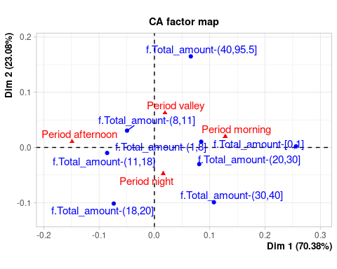

#lines(res.ca$row$coord[,1],res.ca$row$coord[,2],lwd=2,col="blue")

summary(res.ca,dig=2)

##   
## Call:  
## CA(X = tt)   
##   
## The chi square of independence between the two variables is equal to 44.63224 (p-value = 0.001934994 ).  
##   
## Eigenvalues  
## Dim.1 Dim.2 Dim.3  
## Variance 0.006 0.002 0.001  
## % of var. 70.377 23.079 6.543  
## Cumulative % of var. 70.377 93.457 100.000  
##   
## Rows  
## Iner*1000 Dim.1 ctr cos2 Dim.2 ctr  
## f.Total_amount-(1,8] | 1.822 | 0.085 28.570 0.985 | 0.010 1.297  
## f.Total_amount-(11,18] | 2.097 | -0.085 32.737 0.981 | -0.010 1.360  
## f.Total_amount-(18,20] | 0.809 | -0.073 3.457 0.268 | -0.102 20.164  
## f.Total_amount-(20,30] | 0.904 | 0.081 12.429 0.864 | -0.030 5.246  
## f.Total_amount-(30,40] | 1.097 | 0.108 7.916 0.453 | -0.099 20.558  
## f.Total_amount-(40,95.5] | 0.979 | 0.066 2.137 0.137 | 0.165 40.955  
## f.Total_amount-(8,11] | 0.780 | -0.049 8.998 0.725 | 0.030 10.419  
## f.Total_amount-[0,1] | 0.439 | 0.256 3.756 0.538 | 0.002 0.001  
## cos2 Dim.3 ctr cos2   
## f.Total_amount-(1,8] 0.015 | 0.001 0.028 0.000 |  
## f.Total_amount-(11,18] 0.013 | 0.007 2.196 0.006 |  
## f.Total_amount-(18,20] 0.513 | -0.066 30.228 0.218 |  
## f.Total_amount-(20,30] 0.120 | -0.011 2.615 0.017 |  
## f.Total_amount-(30,40] 0.386 | 0.064 30.092 0.160 |  
## f.Total_amount-(40,95.5] 0.862 | -0.005 0.128 0.001 |  
## f.Total_amount-(8,11] 0.275 | 0.001 0.021 0.000 |  
## f.Total_amount-[0,1] 0.000 | -0.237 34.693 0.462 |  
##   
## Columns  
## Iner*1000 Dim.1 ctr cos2 Dim.2 ctr  
## Period afternoon | 4.198 | -0.149 65.040 0.973 | 0.011 1.019  
## Period morning | 2.355 | 0.128 31.696 0.846 | 0.020 2.387  
## Period night | 1.128 | 0.016 1.768 0.098 | -0.047 47.292  
## Period valley | 1.246 | 0.019 1.496 0.075 | 0.063 49.303  
## cos2 Dim.3 ctr cos2   
## Period afternoon 0.005 | 0.022 15.521 0.022 |  
## Period morning 0.021 | 0.051 53.777 0.133 |  
## Period night 0.864 | -0.010 7.340 0.038 |  
## Period valley 0.815 | -0.023 23.362 0.110 |

names(res.ca)

## [1] "eig" "call" "row" "col" "svd"

fviz_eig(res.ca)

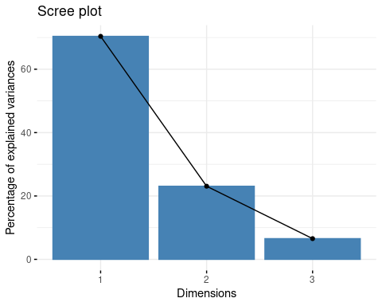

fviz_ca_biplot(res.ca,repel=TRUE)+theme_bw()

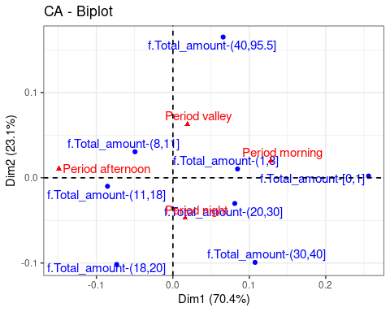

### CA in Total amount and travel time

tt<-table(df[,c("f.Total_amount","f.traveltime")])  
tt

## f.traveltime  
## f.Total_amount f.traveltime-(10,20] f.traveltime-(20,30]  
## f.Total_amount-(1,8] 6 0  
## f.Total_amount-(11,18] 1050 68  
## f.Total_amount-(18,20] 131 66  
## f.Total_amount-(20,30] 202 299  
## f.Total_amount-(30,40] 40 80  
## f.Total_amount-(40,95.5] 8 33  
## f.Total_amount-(8,11] 218 1  
## f.Total_amount-[0,1] 6 1  
## f.traveltime  
## f.Total_amount f.traveltime-(30,40] f.traveltime-(40,548]  
## f.Total_amount-(1,8] 0 2  
## f.Total_amount-(11,18] 0 3  
## f.Total_amount-(18,20] 1 2  
## f.Total_amount-(20,30] 71 10  
## f.Total_amount-(30,40] 54 34  
## f.Total_amount-(40,95.5] 40 56  
## f.Total_amount-(8,11] 0 2  
## f.Total_amount-[0,1] 1 1  
## f.traveltime  
## f.Total_amount f.traveltime-[0,10]  
## f.Total_amount-(1,8] 1246  
## f.Total_amount-(11,18] 287  
## f.Total_amount-(18,20] 1  
## f.Total_amount-(20,30] 13  
## f.Total_amount-(30,40] 7  
## f.Total_amount-(40,95.5] 18  
## f.Total_amount-(8,11] 933  
## f.Total_amount-[0,1] 9

chisq.test(tt)

## Warning in chisq.test(tt): Chi-squared approximation may be incorrect

##   
## Pearson's Chi-squared test  
##   
## data: tt  
## X-squared = 6148.5, df = 28, p-value < 2.2e-16

Como podemos ver en la tabla de contingencia hay valores inferiores a 5, por lo que la aproximación de Pearson’s Chi-squares test puede ser incorrecta. Si observamos el p-value 2.2e-16, es inferiror a 0.05 por lo tanto, podriamos rechazar la hipotesis nula.

res.ca<-CA(tt)

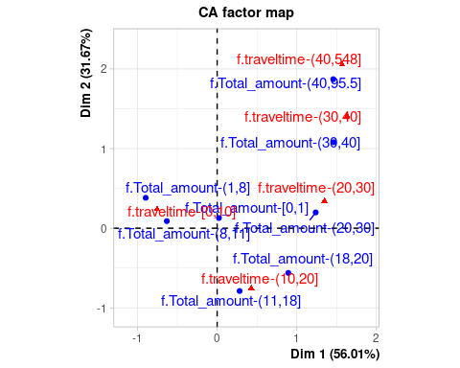 Si vemos el primer plano factorial vemos como los factores estan muy bien representados. Vemos que aquellos viajes que duran entre 40 y 548 minutos tienen un coste entre 40 y 95.5. Los viajes entre 11 y 40 minutos tiene un coste mediano, entre 15 y 50. Y los viajes con coste bajo tienen una duración entre 0 y 15 minutos.

plot(res.ca$row$coord[,1],res.ca$row$coord[,2],pch=19,col="blue",xlim=c(-1,3),ylim=c(-1,3),xlab="Axis 1",ylab="Axis 2",main="CA f.traveltime vs f.Total_amount")  
points(res.ca$col$coord[,1],res.ca$col$coord[,2],pch=19,lwd=2,col="red")  
#text(res.ca$row$coord[c(1,7,2,3,4,5,6),1],res.ca$row$coord[c(1,7,2,3,4,5,6),2],col="blue",labels=levels(df$f.traveltime))  
#text(res.ca$col$coord[c(3,1,2),1],res.ca$col$coord[c(3,1,2),2],col="red",labels=levels(df$f.Total_amount))  
lines(res.ca$row$coord[c(1,7,2:6),1],res.ca$row$coord[c(1,7,2:6),2],lwd=2,col="blue")  
lines(res.ca$col$coord[c(5,1:4),1],res.ca$col$coord[c(5,1:4),2],lwd=2,col="red")

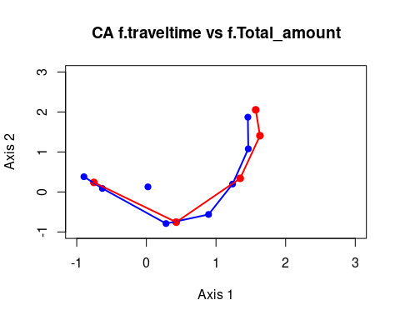

En este imagen podemos ver perfectamente el efecto Guttman que se forma a partir de aplica CA.

summary(res.ca)

##   
## Call:  
## CA(X = tt)   
##   
## The chi square of independence between the two variables is equal to 6148.456 (p-value = 0 ).  
##   
## Eigenvalues  
## Dim.1 Dim.2 Dim.3 Dim.4  
## Variance 0.689 0.389 0.144 0.007  
## % of var. 56.013 31.666 11.720 0.601  
## Cumulative % of var. 56.013 87.679 99.399 100.000  
##   
## Rows  
## Iner*1000 Dim.1 ctr cos2 Dim.2  
## f.Total_amount-(1,8] | 241.709 | -0.897 29.297 0.835 | 0.382  
## f.Total_amount-(11,18] | 219.139 | 0.282 3.256 0.102 | -0.789  
## f.Total_amount-(18,20] | 50.961 | 0.894 4.660 0.630 | -0.561  
## f.Total_amount-(20,30] | 248.846 | 1.238 26.461 0.732 | 0.198  
## f.Total_amount-(30,40] | 145.985 | 1.464 13.371 0.631 | 1.079  
## f.Total_amount-(40,95.5] | 228.642 | 1.458 9.564 0.288 | 1.871  
## f.Total_amount-(8,11] | 94.076 | -0.632 13.390 0.980 | 0.089  
## f.Total_amount-[0,1] | 0.333 | 0.022 0.000 0.005 | 0.128  
## ctr cos2 Dim.3 ctr cos2   
## f.Total_amount-(1,8] 9.375 0.151 | -0.116 2.342 0.014 |  
## f.Total_amount-(11,18] 44.978 0.799 | 0.275 14.827 0.098 |  
## f.Total_amount-(18,20] 3.252 0.248 | -0.278 2.159 0.061 |  
## f.Total_amount-(20,30] 1.201 0.019 | -0.721 42.951 0.249 |  
## f.Total_amount-(30,40] 12.855 0.343 | 0.149 0.663 0.007 |  
## f.Total_amount-(40,95.5] 27.855 0.474 | 1.309 36.876 0.232 |  
## f.Total_amount-(8,11] 0.469 0.019 | 0.002 0.001 0.000 |  
## f.Total_amount-[0,1] 0.015 0.178 | 0.270 0.182 0.789 |  
##   
## Columns  
## Iner*1000 Dim.1 ctr cos2 Dim.2  
## f.traveltime-(10,20] | 262.651 | 0.428 8.850 0.232 | -0.753  
## f.traveltime-(20,30] | 277.369 | 1.347 28.886 0.717 | 0.342  
## f.traveltime-(30,40] | 160.721 | 1.631 12.907 0.553 | 1.408  
## f.traveltime-(40,548] | 213.142 | 1.570 7.877 0.255 | 2.054  
## f.traveltime-[0,10] | 315.809 | -0.754 41.480 0.905 | 0.240  
## ctr cos2 Dim.3 ctr cos2   
## f.traveltime-(10,20] 48.436 0.718 | 0.198 9.058 0.050 |  
## f.traveltime-(20,30] 3.288 0.046 | -0.768 44.907 0.233 |  
## f.traveltime-(30,40] 17.005 0.412 | 0.145 0.489 0.004 |  
## f.traveltime-(40,548] 23.839 0.436 | 1.712 44.741 0.303 |  
## f.traveltime-[0,10] 7.433 0.092 | -0.048 0.805 0.004 |

Como podemos ver el estadistico de la chi square es igual a 6148.456 lo que significa que tienen una gran relación las dos variables.

mean(res.ca$eig[,1]) # Kaiser: how many dimensions to retain

## [1] 0.3074228

Segun el criterio de Kaiser deberiamos coger aquellas dimensiones que tienen un valor propio superior a 0.3074228. Por lo tanto deberíamos coger hasta la segunda dimension.

# Traditional analysis by contingency tables  
prop.table(tt,1);prop.table(table(df$f.tt))

## f.traveltime  
## f.Total_amount f.traveltime-(10,20] f.traveltime-(20,30]  
## f.Total_amount-(1,8] 0.0047846890 0.0000000000  
## f.Total_amount-(11,18] 0.7457386364 0.0482954545  
## f.Total_amount-(18,20] 0.6517412935 0.3283582090  
## f.Total_amount-(20,30] 0.3394957983 0.5025210084  
## f.Total_amount-(30,40] 0.1860465116 0.3720930233  
## f.Total_amount-(40,95.5] 0.0516129032 0.2129032258  
## f.Total_amount-(8,11] 0.1889081456 0.0008665511  
## f.Total_amount-[0,1] 0.3333333333 0.0555555556  
## f.traveltime  
## f.Total_amount f.traveltime-(30,40] f.traveltime-(40,548]  
## f.Total_amount-(1,8] 0.0000000000 0.0015948963  
## f.Total_amount-(11,18] 0.0000000000 0.0021306818  
## f.Total_amount-(18,20] 0.0049751244 0.0099502488  
## f.Total_amount-(20,30] 0.1193277311 0.0168067227  
## f.Total_amount-(30,40] 0.2511627907 0.1581395349  
## f.Total_amount-(40,95.5] 0.2580645161 0.3612903226  
## f.Total_amount-(8,11] 0.0000000000 0.0017331023  
## f.Total_amount-[0,1] 0.0555555556 0.0555555556  
## f.traveltime  
## f.Total_amount f.traveltime-[0,10]  
## f.Total_amount-(1,8] 0.9936204147  
## f.Total_amount-(11,18] 0.2038352273  
## f.Total_amount-(18,20] 0.0049751244  
## f.Total_amount-(20,30] 0.0218487395  
## f.Total_amount-(30,40] 0.0325581395  
## f.Total_amount-(40,95.5] 0.1161290323  
## f.Total_amount-(8,11] 0.8084922010  
## f.Total_amount-[0,1] 0.5000000000

## numeric(0)

prop.table(tt,2);prop.table(table(df$f.cost))

## f.traveltime  
## f.Total_amount f.traveltime-(10,20] f.traveltime-(20,30]  
## f.Total_amount-(1,8] 0.0036122818 0.0000000000  
## f.Total_amount-(11,18] 0.6321493076 0.1240875912  
## f.Total_amount-(18,20] 0.0788681517 0.1204379562  
## f.Total_amount-(20,30] 0.1216134859 0.5456204380  
## f.Total_amount-(30,40] 0.0240818784 0.1459854015  
## f.Total_amount-(40,95.5] 0.0048163757 0.0602189781  
## f.Total_amount-(8,11] 0.1312462372 0.0018248175  
## f.Total_amount-[0,1] 0.0036122818 0.0018248175  
## f.traveltime  
## f.Total_amount f.traveltime-(30,40] f.traveltime-(40,548]  
## f.Total_amount-(1,8] 0.0000000000 0.0181818182  
## f.Total_amount-(11,18] 0.0000000000 0.0272727273  
## f.Total_amount-(18,20] 0.0059880240 0.0181818182  
## f.Total_amount-(20,30] 0.4251497006 0.0909090909  
## f.Total_amount-(30,40] 0.3233532934 0.3090909091  
## f.Total_amount-(40,95.5] 0.2395209581 0.5090909091  
## f.Total_amount-(8,11] 0.0000000000 0.0181818182  
## f.Total_amount-[0,1] 0.0059880240 0.0090909091  
## f.traveltime  
## f.Total_amount f.traveltime-[0,10]  
## f.Total_amount-(1,8] 0.4956245028  
## f.Total_amount-(11,18] 0.1141607001  
## f.Total_amount-(18,20] 0.0003977725  
## f.Total_amount-(20,30] 0.0051710422  
## f.Total_amount-(30,40] 0.0027844073  
## f.Total_amount-(40,95.5] 0.0071599045  
## f.Total_amount-(8,11] 0.3711217184  
## f.Total_amount-[0,1] 0.0035799523

## numeric(0)

chisq.test(tt)

## Warning in chisq.test(tt): Chi-squared approximation may be incorrect

##   
## Pearson's Chi-squared test  
##   
## data: tt  
## X-squared = 6148.5, df = 28, p-value < 2.2e-16

# MCA using multivariant

res.mca<-MCA(df[,c(vars_dis,vars_res)],quali.sup=c(19,20),quanti.sup=21,ncp=35)

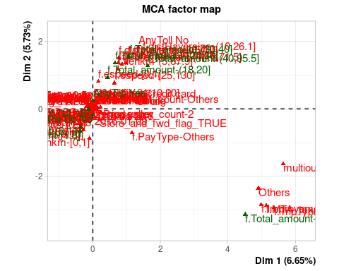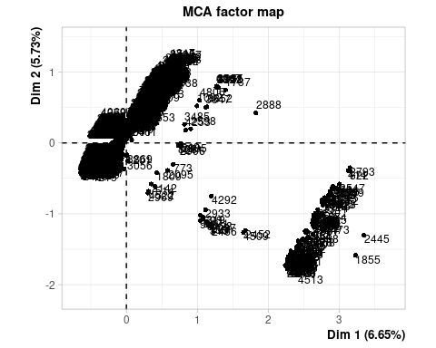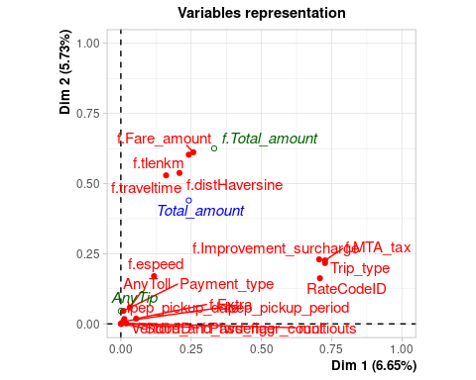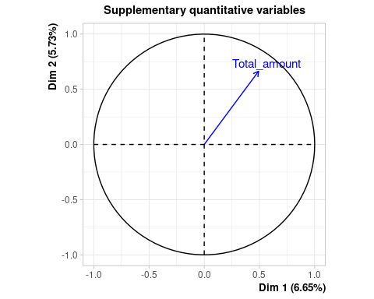

summary(res.mca)

##   
## Call:  
## MCA(X = df[, c(vars_dis, vars_res)], ncp = 35, quanti.sup = 21,   
## quali.sup = c(19, 20))   
##   
##   
## Eigenvalues  
## Dim.1 Dim.2 Dim.3 Dim.4 Dim.5 Dim.6 Dim.7  
## Variance 0.222 0.191 0.115 0.101 0.091 0.073 0.072  
## % of var. 6.654 5.735 3.437 3.025 2.741 2.186 2.152  
## Cumulative % of var. 6.654 12.389 15.826 18.851 21.592 23.778 25.930  
## Dim.8 Dim.9 Dim.10 Dim.11 Dim.12 Dim.13 Dim.14  
## Variance 0.069 0.068 0.064 0.063 0.060 0.059 0.059  
## % of var. 2.055 2.041 1.927 1.881 1.804 1.781 1.763  
## Cumulative % of var. 27.985 30.026 31.952 33.834 35.637 37.419 39.182  
## Dim.15 Dim.16 Dim.17 Dim.18 Dim.19 Dim.20 Dim.21  
## Variance 0.058 0.058 0.057 0.056 0.056 0.056 0.056  
## % of var. 1.749 1.731 1.718 1.692 1.685 1.684 1.678  
## Cumulative % of var. 40.931 42.662 44.380 46.072 47.757 49.441 51.118  
## Dim.22 Dim.23 Dim.24 Dim.25 Dim.26 Dim.27 Dim.28  
## Variance 0.056 0.056 0.056 0.056 0.056 0.056 0.056  
## % of var. 1.670 1.668 1.668 1.667 1.667 1.667 1.667  
## Cumulative % of var. 52.788 54.456 56.124 57.792 59.458 61.125 62.792  
## Dim.29 Dim.30 Dim.31 Dim.32 Dim.33 Dim.34 Dim.35  
## Variance 0.056 0.056 0.056 0.055 0.055 0.055 0.055  
## % of var. 1.667 1.667 1.666 1.662 1.658 1.650 1.642  
## Cumulative % of var. 64.459 66.125 67.791 69.453 71.111 72.761 74.403  
## Dim.36 Dim.37 Dim.38 Dim.39 Dim.40 Dim.41 Dim.42  
## Variance 0.054 0.054 0.054 0.053 0.053 0.052 0.051  
## % of var. 1.632 1.627 1.618 1.602 1.590 1.574 1.521  
## Cumulative % of var. 76.035 77.662 79.280 80.882 82.472 84.046 85.567  
## Dim.43 Dim.44 Dim.45 Dim.46 Dim.47 Dim.48 Dim.49  
## Variance 0.049 0.049 0.047 0.046 0.045 0.043 0.041  
## % of var. 1.480 1.469 1.421 1.389 1.352 1.301 1.219  
## Cumulative % of var. 87.047 88.515 89.936 91.325 92.677 93.978 95.197  
## Dim.50 Dim.51 Dim.52 Dim.53 Dim.54 Dim.55 Dim.56  
## Variance 0.039 0.035 0.020 0.017 0.015 0.010 0.009  
## % of var. 1.162 1.053 0.603 0.516 0.446 0.298 0.265  
## Cumulative % of var. 96.359 97.412 98.015 98.531 98.977 99.275 99.540  
## Dim.57 Dim.58 Dim.59 Dim.60  
## Variance 0.006 0.005 0.003 0.002  
## % of var. 0.172 0.164 0.078 0.046  
## Cumulative % of var. 99.712 99.876 99.954 100.000  
##   
## Individuals (the 10 first)  
## Dim.1 ctr cos2 Dim.2 ctr cos2 Dim.3  
## 1 | -0.196 0.003 0.022 | -0.052 0.000 0.002 | -0.433  
## 2 | 0.286 0.007 0.028 | 0.759 0.060 0.196 | -0.592  
## 3 | -0.264 0.006 0.040 | -0.218 0.005 0.027 | -0.521  
## 4 | 0.046 0.000 0.001 | 0.334 0.012 0.060 | -0.453  
## 5 | 0.056 0.000 0.002 | 0.388 0.016 0.081 | -0.455  
## 6 | 0.056 0.000 0.002 | 0.388 0.016 0.081 | -0.455  
## 7 | 0.172 0.003 0.014 | 0.625 0.041 0.179 | -0.457  
## 8 | -0.265 0.006 0.042 | -0.229 0.005 0.031 | -0.573  
## 9 | -0.264 0.006 0.040 | -0.218 0.005 0.027 | -0.521  
## 10 | 0.172 0.003 0.014 | 0.625 0.041 0.179 | -0.457  
## ctr cos2   
## 1 0.033 0.107 |  
## 2 0.061 0.119 |  
## 3 0.047 0.155 |  
## 4 0.036 0.110 |  
## 5 0.036 0.111 |  
## 6 0.036 0.111 |  
## 7 0.036 0.096 |  
## 8 0.057 0.197 |  
## 9 0.047 0.155 |  
## 10 0.036 0.096 |  
##   
## Categories (the 10 first)  
## Dim.1 ctr cos2 v.test Dim.2 ctr  
## f.Vendor-Mobile | 0.026 0.004 0.000 0.982 | 0.018 0.002  
## f.Vendor-VeriFone | -0.007 0.001 0.000 -0.982 | -0.005 0.001  
## f.PayType-Cash | -0.047 0.028 0.002 -3.338 | -0.203 0.602  
## f.PayType-Credit card | 0.034 0.014 0.001 2.388 | 0.215 0.663  
## f.PayType-Others | 1.159 0.195 0.008 6.259 | -0.709 0.085  
## Store_and_fwd_flag_FALSE | -0.001 0.000 0.000 -0.807 | 0.001 0.000  
## Store_and_fwd_flag_TRUE | 0.195 0.003 0.000 0.807 | -0.316 0.010  
## Others | 4.904 17.228 0.708 59.494 | -2.351 4.593  
## Standard rate | -0.144 0.507 0.708 -59.494 | 0.069 0.135  
## f.Extra-0 | 0.245 0.697 0.052 16.088 | -0.106 0.152  
## cos2 v.test Dim.3 ctr cos2 v.test   
## f.Vendor-Mobile 0.000 0.674 | 0.113 0.136 0.004 4.236 |  
## f.Vendor-VeriFone 0.000 -0.674 | -0.032 0.038 0.004 -4.236 |  
## f.PayType-Cash 0.042 -14.410 | 0.006 0.001 0.000 0.396 |  
## f.PayType-Credit card 0.045 14.993 | -0.006 0.001 0.000 -0.418 |  
## f.PayType-Others 0.003 -3.830 | 0.027 0.000 0.000 0.146 |  
## Store_and_fwd_flag_FALSE 0.000 1.305 | -0.001 0.000 0.000 -0.752 |  
## Store_and_fwd_flag_TRUE 0.000 -1.305 | 0.182 0.005 0.000 0.752 |  
## Others 0.163 -28.518 | -0.131 0.024 0.001 -1.584 |  
## Standard rate 0.163 28.518 | 0.004 0.001 0.001 1.584 |  
## f.Extra-0 0.010 -6.979 | 0.487 5.325 0.204 31.952 |  
##   
## Categorical variables (eta2)  
## Dim.1 Dim.2 Dim.3   
## VendorID | 0.000 0.000 0.004 |  
## Payment_type | 0.009 0.046 0.000 |  
## Store_and_fwd_flag | 0.000 0.000 0.000 |  
## RateCodeID | 0.708 0.163 0.001 |  
## f.Extra | 0.054 0.019 0.855 |  
## f.MTA_tax | 0.726 0.226 0.001 |  
## f.Improvement_surcharge | 0.705 0.230 0.001 |  
## lpep_pickup_period | 0.009 0.009 0.840 |  
## Trip_type | 0.726 0.217 0.001 |  
## lpep_pickup_date | 0.012 0.018 0.191 |  
##   
## Supplementary categories  
## Dim.1 cos2 v.test Dim.2 cos2 v.test   
## f.Total_amount-(1,8] | -0.372 0.046 -15.221 | -0.664 0.148 -27.179 |  
## f.Total_amount-(11,18] | -0.121 0.006 -5.334 | -0.007 0.000 -0.309 |  
## f.Total_amount-(18,20] | 0.439 0.008 6.347 | 0.936 0.037 13.546 |  
## f.Total_amount-(20,30] | 0.661 0.059 17.176 | 1.363 0.251 35.420 |  
## f.Total_amount-(30,40] | 1.070 0.051 16.030 | 1.549 0.108 23.208 |  
## f.Total_amount-(40,95.5] | 1.626 0.085 20.564 | 1.281 0.052 16.194 |  
## f.Total_amount-(8,11] | -0.354 0.038 -13.708 | -0.547 0.090 -21.190 |  
## f.Total_amount-[0,1] | 4.514 0.074 19.185 | -3.126 0.035 -13.284 |  
## AnyTip No | -0.001 0.000 -0.093 | -0.186 0.046 -15.224 |  
## AnyTip Yes | 0.002 0.000 0.093 | 0.250 0.046 15.224 |  
## Dim.3 cos2 v.test   
## f.Total_amount-(1,8] -0.242 0.020 -9.892 |  
## f.Total_amount-(11,18] 0.148 0.009 6.542 |  
## f.Total_amount-(18,20] 0.021 0.000 0.306 |  
## f.Total_amount-(20,30] 0.047 0.000 1.210 |  
## f.Total_amount-(30,40] 0.054 0.000 0.814 |  
## f.Total_amount-(40,95.5] 0.427 0.006 5.394 |  
## f.Total_amount-(8,11] -0.008 0.000 -0.324 |  
## f.Total_amount-[0,1] -0.274 0.000 -1.164 |  
## AnyTip No -0.006 0.000 -0.458 |  
## AnyTip Yes 0.008 0.000 0.458 |  
##   
## Supplementary categorical variables (eta2)  
## Dim.1 Dim.2 Dim.3   
## f.Total_amount | 0.332 0.625 0.027 |  
## AnyTip | 0.000 0.046 0.000 |  
##   
## Supplementary continuous variable  
## Dim.1 Dim.2 Dim.3   
## Total_amount | 0.492 | 0.663 | 0.116 |

Como podemos ver nos vuelve a aparecer que el total amount esta realcionado con el travel time tal como nos aparecio haciendo CA.

## Quality of representation

fviz_cos2(res.mca, choice = "var", axes = 1:2, top = 10)

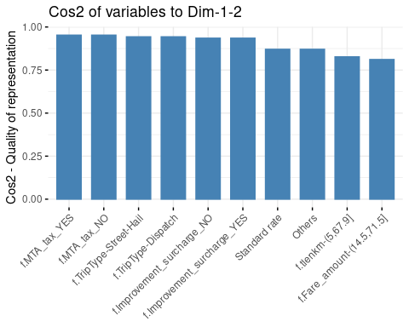

fviz_cos2(res.mca, choice = "var", axes = 3:4, top = 10)

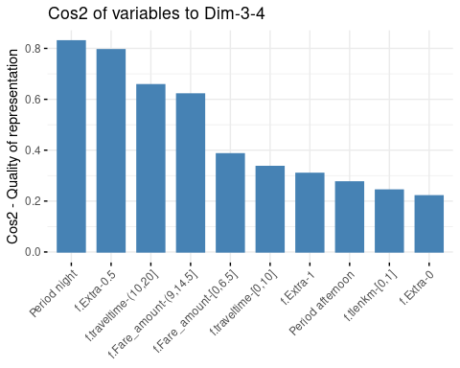

fviz_cos2(res.mca, choice = "ind", axes = 1:2, top = 10)

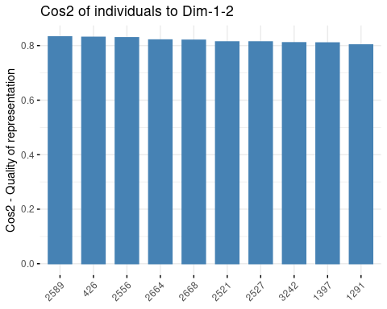

fviz_cos2(res.mca, choice = "ind", axes = 3:4, top = 10)

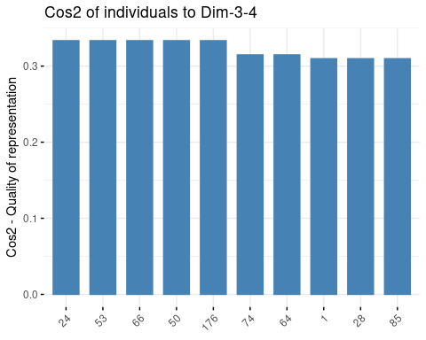

## Contribution

fviz_contrib(res.mca, choice = "var", axes = 1:2, top = 10)

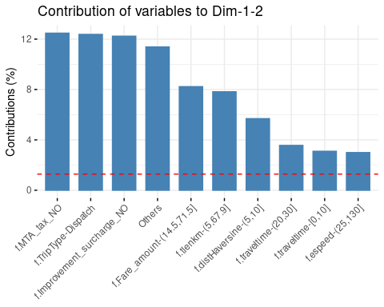

fviz_contrib(res.mca, choice = "var", axes = 3:4, top = 10)

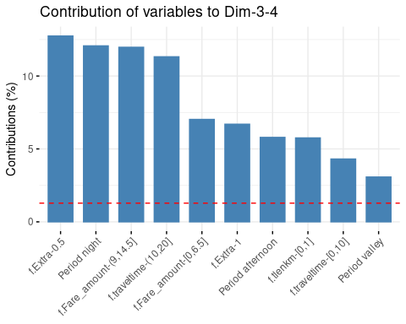

fviz_contrib(res.mca, choice = "ind", axes = 1:2, top = 10)

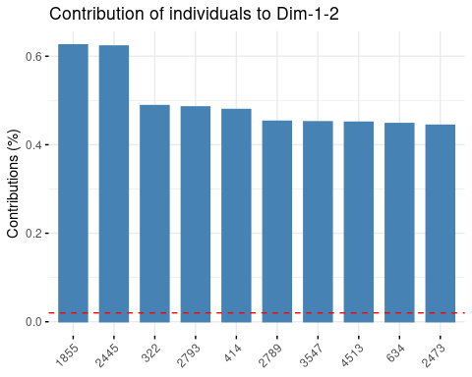

fviz_contrib(res.mca, choice = "ind", axes = 3:4, top = 10)

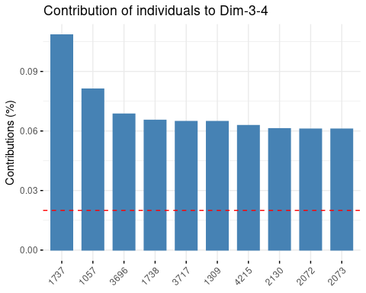

### Eigenvalues and dominant axes analysis.

summary(res.mca,nbelements=50,nbind=0)

##   
## Call:  
## MCA(X = df[, c(vars_dis, vars_res)], ncp = 35, quanti.sup = 21,   
## quali.sup = c(19, 20))   
##   
##   
## Eigenvalues  
## Dim.1 Dim.2 Dim.3 Dim.4 Dim.5 Dim.6 Dim.7  
## Variance 0.222 0.191 0.115 0.101 0.091 0.073 0.072  
## % of var. 6.654 5.735 3.437 3.025 2.741 2.186 2.152  
## Cumulative % of var. 6.654 12.389 15.826 18.851 21.592 23.778 25.930  
## Dim.8 Dim.9 Dim.10 Dim.11 Dim.12 Dim.13 Dim.14  
## Variance 0.069 0.068 0.064 0.063 0.060 0.059 0.059  
## % of var. 2.055 2.041 1.927 1.881 1.804 1.781 1.763  
## Cumulative % of var. 27.985 30.026 31.952 33.834 35.637 37.419 39.182  
## Dim.15 Dim.16 Dim.17 Dim.18 Dim.19 Dim.20 Dim.21  
## Variance 0.058 0.058 0.057 0.056 0.056 0.056 0.056  
## % of var. 1.749 1.731 1.718 1.692 1.685 1.684 1.678  
## Cumulative % of var. 40.931 42.662 44.380 46.072 47.757 49.441 51.118  
## Dim.22 Dim.23 Dim.24 Dim.25 Dim.26 Dim.27 Dim.28  
## Variance 0.056 0.056 0.056 0.056 0.056 0.056 0.056  
## % of var. 1.670 1.668 1.668 1.667 1.667 1.667 1.667  
## Cumulative % of var. 52.788 54.456 56.124 57.792 59.458 61.125 62.792  
## Dim.29 Dim.30 Dim.31 Dim.32 Dim.33 Dim.34 Dim.35  
## Variance 0.056 0.056 0.056 0.055 0.055 0.055 0.055  
## % of var. 1.667 1.667 1.666 1.662 1.658 1.650 1.642  
## Cumulative % of var. 64.459 66.125 67.791 69.453 71.111 72.761 74.403  
## Dim.36 Dim.37 Dim.38 Dim.39 Dim.40 Dim.41 Dim.42  
## Variance 0.054 0.054 0.054 0.053 0.053 0.052 0.051  
## % of var. 1.632 1.627 1.618 1.602 1.590 1.574 1.521  
## Cumulative % of var. 76.035 77.662 79.280 80.882 82.472 84.046 85.567  
## Dim.43 Dim.44 Dim.45 Dim.46 Dim.47 Dim.48 Dim.49  
## Variance 0.049 0.049 0.047 0.046 0.045 0.043 0.041  
## % of var. 1.480 1.469 1.421 1.389 1.352 1.301 1.219  
## Cumulative % of var. 87.047 88.515 89.936 91.325 92.677 93.978 95.197  
## Dim.50 Dim.51 Dim.52 Dim.53 Dim.54 Dim.55 Dim.56  
## Variance 0.039 0.035 0.020 0.017 0.015 0.010 0.009  
## % of var. 1.162 1.053 0.603 0.516 0.446 0.298 0.265  
## Cumulative % of var. 96.359 97.412 98.015 98.531 98.977 99.275 99.540  
## Dim.57 Dim.58 Dim.59 Dim.60  
## Variance 0.006 0.005 0.003 0.002  
## % of var. 0.172 0.164 0.078 0.046  
## Cumulative % of var. 99.712 99.876 99.954 100.000  
##   
## Categories (the 50 first)  
## Dim.1 ctr cos2 v.test Dim.2 ctr  
## f.Vendor-Mobile | 0.026 0.004 0.000 0.982 | 0.018 0.002  
## f.Vendor-VeriFone | -0.007 0.001 0.000 -0.982 | -0.005 0.001  
## f.PayType-Cash | -0.047 0.028 0.002 -3.338 | -0.203 0.602  
## f.PayType-Credit card | 0.034 0.014 0.001 2.388 | 0.215 0.663  
## f.PayType-Others | 1.159 0.195 0.008 6.259 | -0.709 0.085  
## Store_and_fwd_flag_FALSE | -0.001 0.000 0.000 -0.807 | 0.001 0.000  
## Store_and_fwd_flag_TRUE | 0.195 0.003 0.000 0.807 | -0.316 0.010  
## Others | 4.904 17.228 0.708 59.494 | -2.351 4.593  
## Standard rate | -0.144 0.507 0.708 -59.494 | 0.069 0.135  
## f.Extra-0 | 0.245 0.697 0.052 16.088 | -0.106 0.152  
## f.Extra-0.5 | -0.167 0.263 0.017 -9.189 | 0.176 0.339  
## f.Extra-1 | -0.316 0.399 0.019 -9.734 | -0.108 0.054  
## f.MTA_tax_NO | 5.136 17.709 0.726 60.262 | -2.867 6.403  
## f.MTA_tax_YES | -0.141 0.488 0.726 -60.262 | 0.079 0.176  
## f.Improvement_surcharge_NO | 4.985 17.181 0.705 59.382 | -2.846 6.498  
## f.Improvement_surcharge_YES | -0.141 0.488 0.705 -59.382 | 0.081 0.184  
## Period afternoon | -0.184 0.156 0.008 -6.176 | -0.163 0.142  
## Period morning | 0.100 0.030 0.001 2.617 | 0.016 0.001  
## Period night | 0.012 0.002 0.000 0.732 | 0.091 0.104  
## Period valley | 0.064 0.027 0.001 2.687 | -0.044 0.015  
## f.TripType-Dispatch | 5.366 17.745 0.726 60.257 | -2.932 6.147  
## f.TripType-Street-Hail | -0.135 0.448 0.726 -60.257 | 0.074 0.155  
## 2016-01-01 | -0.019 0.000 0.000 -0.297 | 0.138 0.025  
## 2016-01-02 | 0.066 0.004 0.000 0.915 | 0.041 0.002  
## 2016-01-03 | 0.062 0.003 0.000 0.778 | 0.063 0.003  
## 2016-01-04 | 0.062 0.003 0.000 0.760 | 0.011 0.000  
## 2016-01-05 | -0.186 0.024 0.001 -2.208 | -0.172 0.023  
## 2016-01-06 | 0.182 0.024 0.001 2.221 | 0.167 0.023  
## 2016-01-07 | -0.043 0.001 0.000 -0.511 | 0.059 0.003  
## 2016-01-08 | -0.022 0.000 0.000 -0.299 | 0.005 0.000  
## 2016-01-09 | 0.063 0.004 0.000 0.881 | -0.253 0.069  
## 2016-01-10 | -0.101 0.009 0.000 -1.337 | 0.044 0.002  
## 2016-01-11 | -0.049 0.002 0.000 -0.651 | 0.097 0.009  
## 2016-01-12 | -0.080 0.005 0.000 -1.003 | -0.146 0.019  
## 2016-01-13 | 0.059 0.003 0.000 0.747 | 0.009 0.000  
## 2016-01-14 | -0.044 0.002 0.000 -0.572 | -0.212 0.043  
## 2016-01-15 | -0.044 0.002 0.000 -0.611 | -0.281 0.084  
## 2016-01-16 | 0.242 0.065 0.003 3.685 | -0.109 0.015  
## 2016-01-17 | 0.100 0.008 0.000 1.313 | 0.095 0.009  
## 2016-01-18 | -0.028 0.000 0.000 -0.316 | -0.181 0.023  
## 2016-01-19 | -0.160 0.019 0.001 -1.952 | -0.147 0.018  
## 2016-01-20 | 0.002 0.000 0.000 0.020 | -0.093 0.008  
## 2016-01-21 | 0.223 0.044 0.002 3.009 | 0.049 0.002  
## 2016-01-22 | -0.041 0.002 0.000 -0.595 | -0.019 0.000  
## 2016-01-23 | -0.006 0.000 0.000 -0.036 | 0.166 0.007  
## 2016-01-24 | -0.243 0.025 0.001 -2.246 | -0.023 0.000  
## 2016-01-25 | 0.021 0.000 0.000 0.259 | 0.123 0.013  
## 2016-01-26 | -0.150 0.016 0.001 -1.814 | 0.121 0.012  
## 2016-01-27 | -0.031 0.001 0.000 -0.402 | -0.001 0.000  
## 2016-01-28 | -0.182 0.023 0.001 -2.184 | 0.085 0.006  
## cos2 v.test Dim.3 ctr cos2 v.test   
## f.Vendor-Mobile 0.000 0.674 | 0.113 0.136 0.004 4.236 |  
## f.Vendor-VeriFone 0.000 -0.674 | -0.032 0.038 0.004 -4.236 |  
## f.PayType-Cash 0.042 -14.410 | 0.006 0.001 0.000 0.396 |  
## f.PayType-Credit card 0.045 14.993 | -0.006 0.001 0.000 -0.418 |  
## f.PayType-Others 0.003 -3.830 | 0.027 0.000 0.000 0.146 |  
## Store_and_fwd_flag_FALSE 0.000 1.305 | -0.001 0.000 0.000 -0.752 |  
## Store_and_fwd_flag_TRUE 0.000 -1.305 | 0.182 0.005 0.000 0.752 |  
## Others 0.163 -28.518 | -0.131 0.024 0.001 -1.584 |  
## Standard rate 0.163 28.518 | 0.004 0.001 0.001 1.584 |  
## f.Extra-0 0.010 -6.979 | 0.487 5.325 0.204 31.952 |  
## f.Extra-0.5 0.019 9.678 | -1.134 23.564 0.782 -62.506 |  
## f.Extra-1 0.002 -3.314 | 1.274 12.570 0.308 39.269 |  
## f.MTA_tax_NO 0.226 -33.642 | -0.186 0.045 0.001 -2.184 |  
## f.MTA_tax_YES 0.226 33.642 | 0.005 0.001 0.001 2.184 |  
## f.Improvement_surcharge_NO 0.230 -33.905 | -0.160 0.034 0.001 -1.905 |  
## f.Improvement_surcharge_YES 0.230 33.905 | 0.005 0.001 0.001 1.905 |  
## Period afternoon 0.006 -5.477 | 1.097 10.744 0.272 36.848 |  
## Period morning 0.000 0.419 | 0.616 2.235 0.052 16.194 |  
## Period night 0.006 5.641 | -1.027 22.294 0.815 -63.838 |  
## Period valley 0.001 -1.853 | 0.661 5.481 0.152 27.603 |  
## f.TripType-Dispatch 0.217 -32.926 | -0.168 0.034 0.001 -1.892 |  
## f.TripType-Street-Hail 0.217 32.926 | 0.004 0.001 0.001 1.892 |  
## 2016-01-01 0.001 2.125 | -1.003 2.213 0.048 -15.459 |  
## 2016-01-02 0.000 0.563 | -0.046 0.004 0.000 -0.638 |  
## 2016-01-03 0.000 0.788 | -0.423 0.261 0.006 -5.272 |  
## 2016-01-04 0.000 0.141 | 0.289 0.119 0.003 3.554 |  
## 2016-01-05 0.001 -2.035 | 0.264 0.092 0.002 3.128 |  
## 2016-01-06 0.001 2.035 | 0.256 0.091 0.002 3.114 |  
## 2016-01-07 0.000 0.703 | 0.688 0.642 0.014 8.251 |  
## 2016-01-08 0.000 0.067 | 0.244 0.101 0.002 3.280 |  
## 2016-01-09 0.002 -3.512 | -0.590 0.628 0.013 -8.201 |  
## 2016-01-10 0.000 0.578 | -0.642 0.675 0.014 -8.486 |  
## 2016-01-11 0.000 1.287 | 0.169 0.047 0.001 2.235 |  
## 2016-01-12 0.001 -1.834 | 0.177 0.046 0.001 2.218 |  
## 2016-01-13 0.000 0.120 | 0.407 0.250 0.005 5.161 |  
## 2016-01-14 0.002 -2.773 | 0.488 0.383 0.008 6.389 |  
## 2016-01-15 0.003 -3.881 | 0.085 0.013 0.000 1.172 |  
## 2016-01-16 0.001 -1.657 | -0.234 0.118 0.003 -3.561 |  
## 2016-01-17 0.000 1.250 | -0.532 0.462 0.010 -7.018 |  
## 2016-01-18 0.001 -2.029 | 0.143 0.024 0.001 1.595 |  
## 2016-01-19 0.001 -1.787 | 0.641 0.574 0.012 7.806 |  
## 2016-01-20 0.000 -1.188 | 0.044 0.003 0.000 0.557 |  
## 2016-01-21 0.000 0.660 | 0.209 0.074 0.002 2.816 |  
## 2016-01-22 0.000 -0.270 | 0.158 0.049 0.001 2.293 |  
## 2016-01-23 0.000 1.069 | -1.413 0.793 0.016 -9.081 |  
## 2016-01-24 0.000 -0.209 | 0.254 0.053 0.001 2.348 |  
## 2016-01-25 0.000 1.529 | 0.388 0.221 0.005 4.842 |  
## 2016-01-26 0.000 1.461 | 0.416 0.239 0.005 5.033 |  
## 2016-01-27 0.000 -0.014 | 0.456 0.330 0.007 5.934 |  
## 2016-01-28 0.000 1.021 | 0.049 0.003 0.000 0.588 |  
##   
## Categorical variables (eta2)  
## Dim.1 Dim.2 Dim.3   
## VendorID | 0.000 0.000 0.004 |  
## Payment_type | 0.009 0.046 0.000 |  
## Store_and_fwd_flag | 0.000 0.000 0.000 |  
## RateCodeID | 0.708 0.163 0.001 |  
## f.Extra | 0.054 0.019 0.855 |  
## f.MTA_tax | 0.726 0.226 0.001 |  
## f.Improvement_surcharge | 0.705 0.230 0.001 |  
## lpep_pickup_period | 0.009 0.009 0.840 |  
## Trip_type | 0.726 0.217 0.001 |  
## lpep_pickup_date | 0.012 0.018 0.191 |  
## multiouts | 0.019 0.002 0.000 |  
## f.espeed | 0.118 0.170 0.056 |  
## f.tlenkm | 0.242 0.603 0.006 |  
## f.traveltime | 0.161 0.529 0.065 |  
## f.distHaversine | 0.209 0.538 0.003 |  
## AnyToll | 0.032 0.058 0.002 |  
## f.Fare_amount | 0.258 0.612 0.032 |  
## f.Passenger_count | 0.003 0.001 0.006 |  
##   
## Supplementary categories  
## Dim.1 cos2 v.test Dim.2 cos2 v.test  
## f.Total_amount-(1,8] | -0.372 0.046 -15.221 | -0.664 0.148 -27.179  
## f.Total_amount-(11,18] | -0.121 0.006 -5.334 | -0.007 0.000 -0.309  
## f.Total_amount-(18,20] | 0.439 0.008 6.347 | 0.936 0.037 13.546  
## f.Total_amount-(20,30] | 0.661 0.059 17.176 | 1.363 0.251 35.420  
## f.Total_amount-(30,40] | 1.070 0.051 16.030 | 1.549 0.108 23.208  
## f.Total_amount-(40,95.5] | 1.626 0.085 20.564 | 1.281 0.052 16.194  
## f.Total_amount-(8,11] | -0.354 0.038 -13.708 | -0.547 0.090 -21.190  
## f.Total_amount-[0,1] | 4.514 0.074 19.185 | -3.126 0.035 -13.284  
## AnyTip No | -0.001 0.000 -0.093 | -0.186 0.046 -15.224  
## AnyTip Yes | 0.002 0.000 0.093 | 0.250 0.046 15.224  
## Dim.3 cos2 v.test   
## f.Total_amount-(1,8] | -0.242 0.020 -9.892 |  
## f.Total_amount-(11,18] | 0.148 0.009 6.542 |  
## f.Total_amount-(18,20] | 0.021 0.000 0.306 |  
## f.Total_amount-(20,30] | 0.047 0.000 1.210 |  
## f.Total_amount-(30,40] | 0.054 0.000 0.814 |  
## f.Total_amount-(40,95.5] | 0.427 0.006 5.394 |  
## f.Total_amount-(8,11] | -0.008 0.000 -0.324 |  
## f.Total_amount-[0,1] | -0.274 0.000 -1.164 |  
## AnyTip No | -0.006 0.000 -0.458 |  
## AnyTip Yes | 0.008 0.000 0.458 |  
##   
## Supplementary categorical variables (eta2)  
## Dim.1 Dim.2 Dim.3   
## f.Total_amount | 0.332 0.625 0.027 |  
## AnyTip | 0.000 0.046 0.000 |  
##   
## Supplementary continuous variable  
## Dim.1 Dim.2 Dim.3   
## Total_amount | 0.492 | 0.663 | 0.116 |

fviz_eig(res.mca,ncp=35)

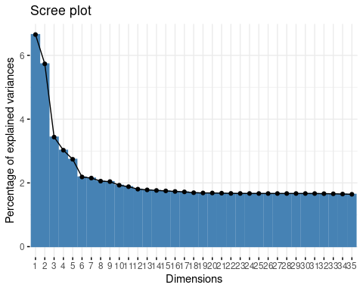

fviz_eig(res.mca, choice = "eigenvalue", addlabels = TRUE)

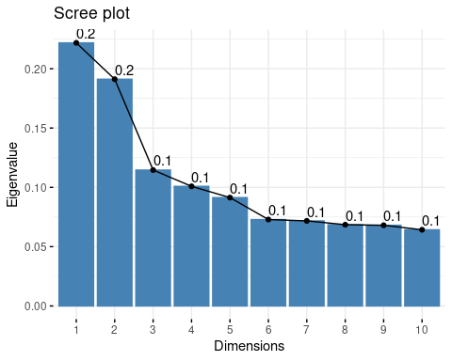

fviz_eig(res.mca, addlabels = TRUE)

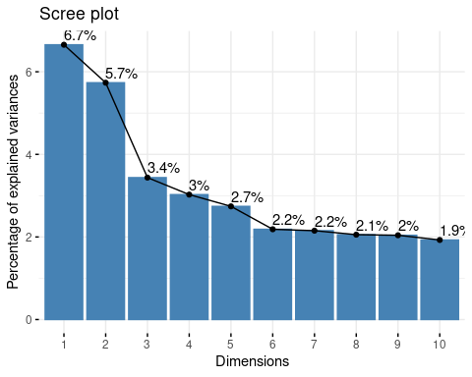 `

mean(res.mca$eig[,1])

## [1] 0.05555556

Segun el criterio de Kaiser generalizado deberíamos coger aquellas dimensiones cuyo valor propio sea superior a 0.055. Lo que significa que tendriamos que coger hasta la dimensión 35, esta dimensión proporciona un 74.4% de varianza acumulada. En contraposición si aplicamos la regla de Elbow deberíamos coger hasta la dimension 6.

### Individuos

plot(res.mca,choix=c("ind"),invisible = c("ind.sup", "var", "quali"),select="contrib 10", axes=c(1,2))

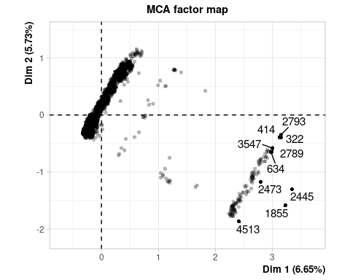

plot(res.mca,choix=c("ind"),invisible = c("ind.sup", "var", "quali"),select="contrib 10", axes=c(3,4))

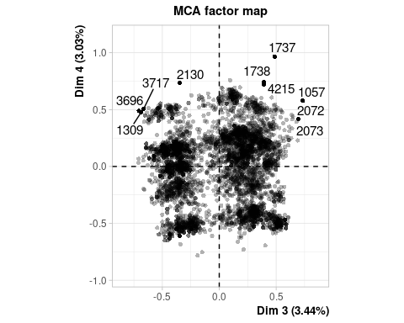

### Variables categoricas, variables numericas suplementarias y variables categoricas suplementarias

plot(res.mca,choix=c("ind"), invisible = c("ind"), axes=c(1,2))



plot(res.mca,choix=c("ind"), invisible = c("ind"), axes=c(3,4))

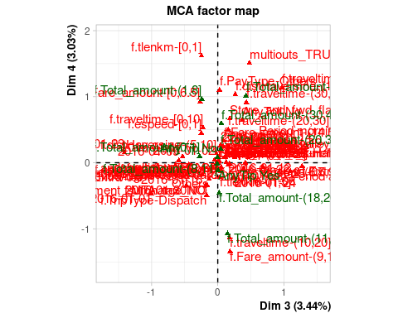

plot.MCA(res.mca,choix=c("var"),axes=c(1,2))

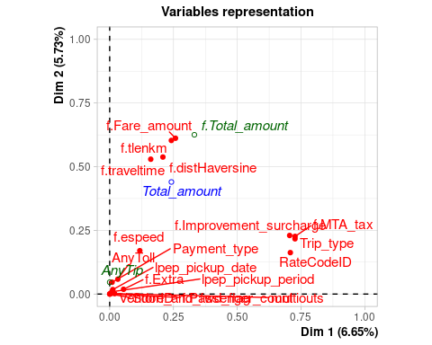

plot.MCA(res.mca,choix=c("var"),axes=c(3,4))

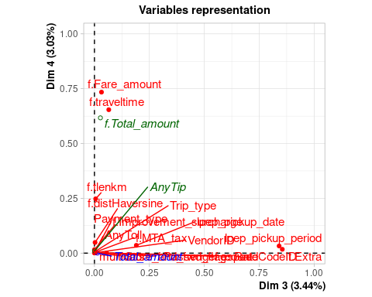

Synthesis through HCPC: Hierarchical Clustering

res.mca<-MCA(df[,c(vars_dis,vars_res)],quali.sup=c(19,20),quanti.sup=21,ncp=35)

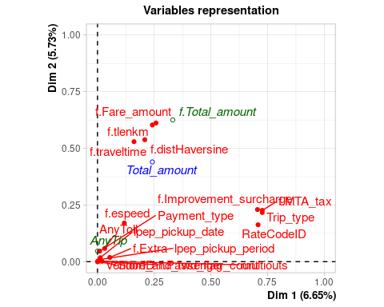

res.hcpc<-HCPC(res.mca,nb.clust=-1,order=TRUE)

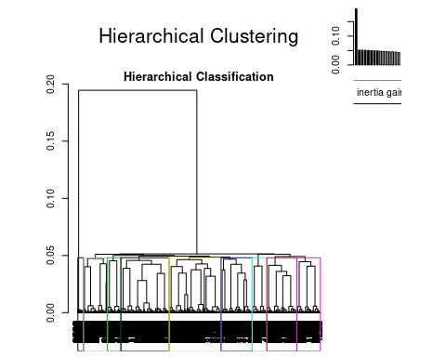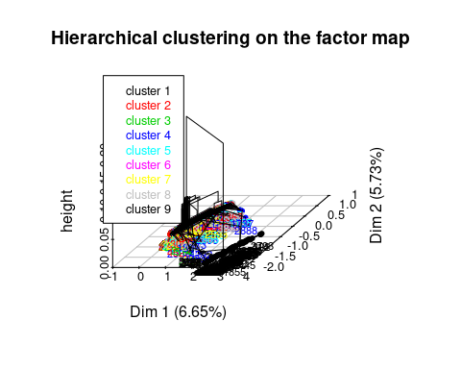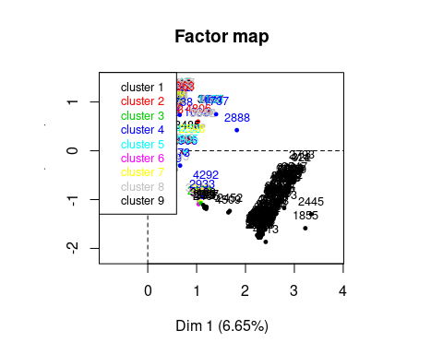

###### Interpretar los resultados de la clasificación

barplot(table(res.hcpc$data.clust$clust))

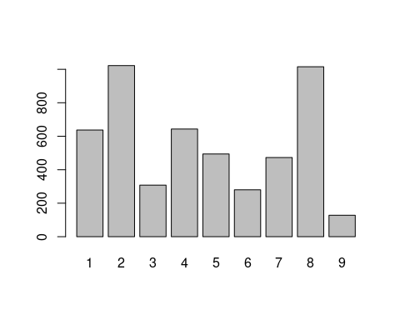

summary(res.hcpc$data.clust$clust)

## 1 2 3 4 5 6 7 8 9   
## 637 1022 308 643 494 280 473 1015 128

### A. The description of the clusters by the variables

### A.1. The categorical variables which characterizes the clusters

res.hcpc$desc.var$test.chi2

## p.value df  
## RateCodeID 0.000000e+00 8  
## f.MTA_tax 0.000000e+00 8  
## f.Improvement_surcharge 0.000000e+00 8  
## Trip_type 0.000000e+00 8  
## lpep_pickup_date 0.000000e+00 240  
## f.Total_amount 2.175017e-88 56  
## f.Extra 1.081069e-56 16  
## Payment_type 2.772605e-12 16  
## multiouts 1.917731e-08 8  
## f.tlenkm 3.940819e-07 16  
## AnyTip 5.725674e-06 8  
## f.espeed 1.363908e-05 16  
## f.Fare_amount 1.610297e-04 24  
## f.distHaversine 3.387161e-03 16  
## lpep_pickup_period 1.879570e-02 24  
## f.traveltime 2.752741e-02 32

### A.2. The description of each cluster by the categories

res.hcpc$desc.var$category

## $`1`  
## Cla/Mod Mod/Cla  
## lpep_pickup_date=2016-01-22 97.512438 30.7692308  
## lpep_pickup_date=2016-01-20 96.835443 24.0188383  
## lpep_pickup_date=2016-01-12 97.385621 23.3908948  
## lpep_pickup_date=2016-01-28 99.285714 21.8210361  
## f.Extra=f.Extra-1 21.177945 26.5306122  
## f.Improvement_surcharge=f.Improvement_surcharge_YES 13.101604 100.0000000  
## f.MTA_tax=f.MTA_tax_YES 13.090834 100.0000000  
## Trip_type=f.TripType-Street-Hail 13.061308 100.0000000  
## RateCodeID=Standard rate 13.073914 99.6860283  
## f.espeed=f.espeed-(1,25] 13.341935 81.1616954  
## f.distHaversine=f.distHaversine-(10,26.1] 8.247423 2.5117739  
## f.espeed=f.espeed-(25,130] 10.634495 18.6813187  
## lpep_pickup_date=2016-01-23 0.000000 0.0000000  
## lpep_pickup_date=2016-01-24 0.000000 0.0000000  
## RateCodeID=Others 1.398601 0.3139717  
## lpep_pickup_date=2016-01-18 0.000000 0.0000000  
## Trip_type=f.TripType-Dispatch 0.000000 0.0000000  
## f.Extra=f.Extra-0 9.909130 35.9497645  
## f.MTA_tax=f.MTA_tax_NO 0.000000 0.0000000  
## lpep_pickup_date=2016-01-05 0.000000 0.0000000  
## f.Improvement_surcharge=f.Improvement_surcharge_NO 0.000000 0.0000000  
## lpep_pickup_date=2016-01-07 0.000000 0.0000000  
## lpep_pickup_date=2016-01-26 0.000000 0.0000000  
## lpep_pickup_date=2016-01-19 0.000000 0.0000000  
## lpep_pickup_date=2016-01-06 0.000000 0.0000000  
## lpep_pickup_date=2016-01-04 0.000000 0.0000000  
## lpep_pickup_date=2016-01-25 0.000000 0.0000000  
## lpep_pickup_date=2016-01-03 0.000000 0.0000000  
## lpep_pickup_date=2016-01-13 0.000000 0.0000000  
## lpep_pickup_date=2016-01-27 0.000000 0.0000000  
## lpep_pickup_date=2016-01-14 0.000000 0.0000000  
## lpep_pickup_date=2016-01-17 0.000000 0.0000000  
## lpep_pickup_date=2016-01-11 0.000000 0.0000000  
## lpep_pickup_date=2016-01-10 0.000000 0.0000000  
## lpep_pickup_date=2016-01-29 0.000000 0.0000000  
## lpep_pickup_date=2016-01-21 0.000000 0.0000000  
## lpep_pickup_date=2016-01-08 0.000000 0.0000000  
## lpep_pickup_date=2016-01-15 0.000000 0.0000000  
## lpep_pickup_date=2016-01-02 0.000000 0.0000000  
## lpep_pickup_date=2016-01-09 0.000000 0.0000000  
## lpep_pickup_date=2016-01-31 0.000000 0.0000000  
## lpep_pickup_date=2016-01-16 0.000000 0.0000000  
## lpep_pickup_date=2016-01-01 0.000000 0.0000000  
## lpep_pickup_date=2016-01-30 0.000000 0.0000000  
## Global p.value  
## lpep_pickup_date=2016-01-22 4.02 7.751839e-180  
## lpep_pickup_date=2016-01-20 3.16 1.327982e-136  
## lpep_pickup_date=2016-01-12 3.06 4.134740e-134  
## lpep_pickup_date=2016-01-28 2.80 3.069308e-129  
## f.Extra=f.Extra-1 15.96 2.115516e-13  
## f.Improvement_surcharge=f.Improvement_surcharge_YES 97.24 5.131088e-09  
## f.MTA_tax=f.MTA_tax_YES 97.32 8.995552e-09  
## Trip_type=f.TripType-Street-Hail 97.54 4.201657e-08  
## RateCodeID=Standard rate 97.14 7.014536e-07  
## f.espeed=f.espeed-(1,25] 77.50 1.634648e-02  
## f.distHaversine=f.distHaversine-(10,26.1] 3.88 4.746356e-02  
## f.espeed=f.espeed-(25,130] 22.38 1.506478e-02  
## lpep_pickup_date=2016-01-23 0.82 3.655646e-03  
## lpep_pickup_date=2016-01-24 1.68 9.632405e-06  
## RateCodeID=Others 2.86 7.014536e-07  
## lpep_pickup_date=2016-01-18 2.44 4.832748e-08  
## Trip_type=f.TripType-Dispatch 2.46 4.201657e-08  
## f.Extra=f.Extra-0 46.22 2.115654e-08  
## f.MTA_tax=f.MTA_tax_NO 2.68 8.995552e-09  
## lpep_pickup_date=2016-01-05 2.74 5.904515e-09  
## f.Improvement_surcharge=f.Improvement_surcharge_NO 2.76 5.131088e-09  
## lpep_pickup_date=2016-01-07 2.80 3.874534e-09  
## lpep_pickup_date=2016-01-26 2.84 2.925335e-09  
## lpep_pickup_date=2016-01-19 2.88 2.208400e-09  
## lpep_pickup_date=2016-01-06 2.88 2.208400e-09  
## lpep_pickup_date=2016-01-04 2.94 1.448204e-09  
## lpep_pickup_date=2016-01-25 3.02 8.247264e-10  
## lpep_pickup_date=2016-01-03 3.02 8.247264e-10  
## lpep_pickup_date=2016-01-13 3.12 4.077136e-10  
## lpep_pickup_date=2016-01-27 3.28 1.318626e-10  
## lpep_pickup_date=2016-01-14 3.32 9.940936e-11  
## lpep_pickup_date=2016-01-17 3.36 7.493389e-11  
## lpep_pickup_date=2016-01-11 3.38 6.505540e-11  
## lpep_pickup_date=2016-01-10 3.38 6.505540e-11  
## lpep_pickup_date=2016-01-29 3.46 3.694596e-11  
## lpep_pickup_date=2016-01-21 3.50 2.783727e-11  
## lpep_pickup_date=2016-01-08 3.50 2.783727e-11  
## lpep_pickup_date=2016-01-15 3.68 7.775304e-12  
## lpep_pickup_date=2016-01-02 3.70 6.746885e-12  
## lpep_pickup_date=2016-01-09 3.72 5.854306e-12  
## lpep_pickup_date=2016-01-31 3.76 4.407359e-12  
## lpep_pickup_date=2016-01-16 4.44 3.464685e-14  
## lpep_pickup_date=2016-01-01 4.54 1.693633e-14  
## lpep_pickup_date=2016-01-30 4.76 3.497256e-15  
## v.test  
## lpep_pickup_date=2016-01-22 28.595005  
## lpep_pickup_date=2016-01-20 24.876759  
## lpep_pickup_date=2016-01-12 24.645282  
## lpep_pickup_date=2016-01-28 24.186721  
## f.Extra=f.Extra-1 7.341286  
## f.Improvement_surcharge=f.Improvement_surcharge_YES 5.842864  
## f.MTA_tax=f.MTA_tax_YES 5.748656  
## Trip_type=f.TripType-Street-Hail 5.482159  
## RateCodeID=Standard rate 4.960961  
## f.espeed=f.espeed-(1,25] 2.401086  
## f.distHaversine=f.distHaversine-(10,26.1] -1.982140  
## f.espeed=f.espeed-(25,130] -2.430818  
## lpep_pickup_date=2016-01-23 -2.906442  
## lpep_pickup_date=2016-01-24 -4.425265  
## RateCodeID=Others -4.960961  
## lpep_pickup_date=2016-01-18 -5.457357  
## Trip_type=f.TripType-Dispatch -5.482159  
## f.Extra=f.Extra-0 -5.602268  
## f.MTA_tax=f.MTA_tax_NO -5.748656  
## lpep_pickup_date=2016-01-05 -5.819440  
## f.Improvement_surcharge=f.Improvement_surcharge_NO -5.842864  
## lpep_pickup_date=2016-01-07 -5.889463  
## lpep_pickup_date=2016-01-26 -5.935734  
## lpep_pickup_date=2016-01-19 -5.981686  
## lpep_pickup_date=2016-01-06 -5.981686  
## lpep_pickup_date=2016-01-04 -6.050028  
## lpep_pickup_date=2016-01-25 -6.140094  
## lpep_pickup_date=2016-01-03 -6.140094  
## lpep_pickup_date=2016-01-13 -6.251046  
## lpep_pickup_date=2016-01-27 -6.425008  
## lpep_pickup_date=2016-01-14 -6.467847  
## lpep_pickup_date=2016-01-17 -6.510434  
## lpep_pickup_date=2016-01-11 -6.531635  
## lpep_pickup_date=2016-01-10 -6.531635  
## lpep_pickup_date=2016-01-29 -6.615835  
## lpep_pickup_date=2016-01-21 -6.657580  
## lpep_pickup_date=2016-01-08 -6.657580  
## lpep_pickup_date=2016-01-15 -6.842629  
## lpep_pickup_date=2016-01-02 -6.862916  
## lpep_pickup_date=2016-01-09 -6.883151  
## lpep_pickup_date=2016-01-31 -6.923462  
## lpep_pickup_date=2016-01-16 -7.579657  
## lpep_pickup_date=2016-01-01 -7.671979  
## lpep_pickup_date=2016-01-30 -7.871746  
##   
## $`2`  
## Cla/Mod Mod/Cla  
## lpep_pickup_date=2016-01-30 98.7394958 22.99412916  
## lpep_pickup_date=2016-01-15 96.1956522 17.31898239  
## lpep_pickup_date=2016-01-10 98.8165680 16.34050881  
## lpep_pickup_date=2016-01-29 96.5317919 16.34050881  
## lpep_pickup_date=2016-01-19 97.9166667 13.79647750  
## lpep_pickup_date=2016-01-05 98.5401460 13.20939335  
## f.MTA_tax=f.MTA_tax_YES 21.0028771 100.00000000  
## Trip_type=f.TripType-Street-Hail 20.9555054 100.00000000  
## f.Improvement_surcharge=f.Improvement_surcharge_YES 20.9995886 99.90215264  
## RateCodeID=Standard rate 21.0006177 99.80430528  
## f.Fare_amount=f.Fare_amount-(6.5,9] 23.3365477 23.67906067  
## f.distHaversine=f.distHaversine-[0,5] 21.0835989 84.14872798  
## f.Total_amount=f.Total_amount-(8,11] 22.5303293 25.44031311  
## lpep_pickup_period=Period afternoon 18.0238871 16.24266145  
## f.tlenkm=f.tlenkm-(5,67.9] 18.5309973 26.90802348  
## f.distHaversine=f.distHaversine-(5,10] 17.3314993 12.32876712  
## f.Fare_amount=f.Fare_amount-(14.5,71.5] 18.1153534 21.81996086  
## f.Total_amount=f.Total_amount-[0,1] 0.0000000 0.00000000  
## f.Total_amount=f.Total_amount-(18,20] 12.9353234 2.54403131  
## lpep_pickup_date=2016-01-23 0.0000000 0.00000000  
## lpep_pickup_date=2016-01-24 0.0000000 0.00000000  
## RateCodeID=Others 1.3986014 0.19569472  
## lpep_pickup_date=2016-01-18 0.0000000 0.00000000  
## f.Improvement_surcharge=f.Improvement_surcharge_NO 0.7246377 0.09784736  
## Trip_type=f.TripType-Dispatch 0.0000000 0.00000000  
## f.MTA_tax=f.MTA_tax_NO 0.0000000 0.00000000  
## lpep_pickup_date=2016-01-28 0.0000000 0.00000000  
## lpep_pickup_date=2016-01-07 0.0000000 0.00000000  
## lpep_pickup_date=2016-01-26 0.0000000 0.00000000  
## lpep_pickup_date=2016-01-06 0.0000000 0.00000000  
## lpep_pickup_date=2016-01-04 0.0000000 0.00000000  
## lpep_pickup_date=2016-01-25 0.0000000 0.00000000  
## lpep_pickup_date=2016-01-03 0.0000000 0.00000000  
## lpep_pickup_date=2016-01-12 0.0000000 0.00000000  
## lpep_pickup_date=2016-01-13 0.0000000 0.00000000  
## lpep_pickup_date=2016-01-20 0.0000000 0.00000000  
## lpep_pickup_date=2016-01-27 0.0000000 0.00000000  
## lpep_pickup_date=2016-01-14 0.0000000 0.00000000  
## lpep_pickup_date=2016-01-17 0.0000000 0.00000000  
## lpep_pickup_date=2016-01-11 0.0000000 0.00000000  
## lpep_pickup_date=2016-01-21 0.0000000 0.00000000  
## lpep_pickup_date=2016-01-08 0.0000000 0.00000000  
## lpep_pickup_date=2016-01-02 0.0000000 0.00000000  
## lpep_pickup_date=2016-01-09 0.0000000 0.00000000  
## lpep_pickup_date=2016-01-31 0.0000000 0.00000000  
## lpep_pickup_date=2016-01-22 0.0000000 0.00000000  
## lpep_pickup_date=2016-01-16 0.0000000 0.00000000  
## lpep_pickup_date=2016-01-01 0.0000000 0.00000000  
## Global p.value  
## lpep_pickup_date=2016-01-30 4.76 6.393184e-167  
## lpep_pickup_date=2016-01-15 3.68 6.455276e-117  
## lpep_pickup_date=2016-01-10 3.38 6.518664e-117  
## lpep_pickup_date=2016-01-29 3.46 7.258449e-111  
## lpep_pickup_date=2016-01-19 2.88 4.716405e-96  
## lpep_pickup_date=2016-01-05 2.74 3.024228e-93  
## f.MTA_tax=f.MTA_tax_YES 97.32 3.091449e-14  
## Trip_type=f.TripType-Street-Hail 97.54 4.119787e-13  
## f.Improvement_surcharge=f.Improvement_surcharge_YES 97.24 4.659979e-13  
## RateCodeID=Standard rate 97.14 2.949846e-12  
## f.Fare_amount=f.Fare_amount-(6.5,9] 20.74 1.019080e-02  
## f.distHaversine=f.distHaversine-[0,5] 81.58 1.636199e-02  
## f.Total_amount=f.Total_amount-(8,11] 23.08 4.620768e-02  
## lpep_pickup_period=Period afternoon 18.42 4.241879e-02  
## f.tlenkm=f.tlenkm-(5,67.9] 29.68 2.886766e-02  
## f.distHaversine=f.distHaversine-(5,10] 14.54 2.284340e-02  
## f.Fare_amount=f.Fare_amount-(14.5,71.5] 24.62 1.893066e-02  
## f.Total_amount=f.Total_amount-[0,1] 0.36 1.618388e-02  
## f.Total_amount=f.Total_amount-(18,20] 4.02 5.034459e-03  
## lpep_pickup_date=2016-01-23 0.82 8.129709e-05  
## lpep_pickup_date=2016-01-24 1.68 3.798210e-09  
## RateCodeID=Others 2.86 2.949846e-12  
## lpep_pickup_date=2016-01-18 2.44 5.211701e-13  
## f.Improvement_surcharge=f.Improvement_surcharge_NO 2.76 4.659979e-13  
## Trip_type=f.TripType-Dispatch 2.46 4.119787e-13  
## f.MTA_tax=f.MTA_tax_NO 2.68 3.091449e-14  
## lpep_pickup_date=2016-01-28 2.80 7.507122e-15  
## lpep_pickup_date=2016-01-07 2.80 7.507122e-15  
## lpep_pickup_date=2016-01-26 2.84 4.681522e-15  
## lpep_pickup_date=2016-01-06 2.88 2.918807e-15  
## lpep_pickup_date=2016-01-04 2.94 1.436330e-15  
## lpep_pickup_date=2016-01-25 3.02 5.575943e-16  
## lpep_pickup_date=2016-01-03 3.02 5.575943e-16  
## lpep_pickup_date=2016-01-12 3.06 3.473017e-16  
## lpep_pickup_date=2016-01-13 3.12 1.706516e-16  
## lpep_pickup_date=2016-01-20 3.16 1.062330e-16  
## lpep_pickup_date=2016-01-27 3.28 2.559356e-17  
## lpep_pickup_date=2016-01-14 3.32 1.591825e-17  
## lpep_pickup_date=2016-01-17 3.36 9.898372e-18  
## lpep_pickup_date=2016-01-11 3.38 7.804801e-18  
## lpep_pickup_date=2016-01-21 3.50 1.873455e-18  
## lpep_pickup_date=2016-01-08 3.50 1.873455e-18  
## lpep_pickup_date=2016-01-02 3.70 1.729192e-19  
## lpep_pickup_date=2016-01-09 3.72 1.362165e-19  
## lpep_pickup_date=2016-01-31 3.76 8.451426e-20  
## lpep_pickup_date=2016-01-22 4.02 3.776632e-21  
## lpep_pickup_date=2016-01-16 4.44 2.442680e-23  
## lpep_pickup_date=2016-01-01 4.54 7.328520e-24  
## v.test  
## lpep_pickup_date=2016-01-30 27.536661  
## lpep_pickup_date=2016-01-15 22.985865  
## lpep_pickup_date=2016-01-10 22.985441  
## lpep_pickup_date=2016-01-29 22.372714  
## lpep_pickup_date=2016-01-19 20.795878  
## lpep_pickup_date=2016-01-05 20.483456  
## f.MTA_tax=f.MTA_tax_YES 7.594432  
## Trip_type=f.TripType-Street-Hail 7.251566  
## f.Improvement_surcharge=f.Improvement_surcharge_YES 7.234863  
## RateCodeID=Standard rate 6.980093  
## f.Fare_amount=f.Fare_amount-(6.5,9] 2.569287  
## f.distHaversine=f.distHaversine-[0,5] 2.400739  
## f.Total_amount=f.Total_amount-(8,11] 1.993491  
## lpep_pickup_period=Period afternoon -2.029388  
## f.tlenkm=f.tlenkm-(5,67.9] -2.185289  
## f.distHaversine=f.distHaversine-(5,10] -2.276044  
## f.Fare_amount=f.Fare_amount-(14.5,71.5] -2.346894  
## f.Total_amount=f.Total_amount-[0,1] -2.404742  
## f.Total_amount=f.Total_amount-(18,20] -2.804821  
## lpep_pickup_date=2016-01-23 -3.940544  
## lpep_pickup_date=2016-01-24 -5.892750  
## RateCodeID=Others -6.980093  
## lpep_pickup_date=2016-01-18 -7.219662  
## f.Improvement_surcharge=f.Improvement_surcharge_NO -7.234863  
## Trip_type=f.TripType-Dispatch -7.251566  
## f.MTA_tax=f.MTA_tax_NO -7.594432  
## lpep_pickup_date=2016-01-28 -7.775633  
## lpep_pickup_date=2016-01-07 -7.775633  
## lpep_pickup_date=2016-01-26 -7.835185  
## lpep_pickup_date=2016-01-06 -7.894329  
## lpep_pickup_date=2016-01-04 -7.982299  
## lpep_pickup_date=2016-01-25 -8.098241  
## lpep_pickup_date=2016-01-03 -8.098241  
## lpep_pickup_date=2016-01-12 -8.155652  
## lpep_pickup_date=2016-01-13 -8.241088  
## lpep_pickup_date=2016-01-20 -8.297603  
## lpep_pickup_date=2016-01-27 -8.465099  
## lpep_pickup_date=2016-01-14 -8.520269  
## lpep_pickup_date=2016-01-17 -8.575120  
## lpep_pickup_date=2016-01-11 -8.602427  
## lpep_pickup_date=2016-01-21 -8.764657  
## lpep_pickup_date=2016-01-08 -8.764657  
## lpep_pickup_date=2016-01-02 -9.029208  
## lpep_pickup_date=2016-01-09 -9.055281  
## lpep_pickup_date=2016-01-31 -9.107227  
## lpep_pickup_date=2016-01-22 -9.438636  
## lpep_pickup_date=2016-01-16 -9.953173  
## lpep_pickup_date=2016-01-01 -10.072246  
##   
## $`3`  
## Cla/Mod Mod/Cla  
## lpep_pickup_date=2016-01-14 96.9879518 52.2727273  
## lpep_pickup_date=2016-01-03 97.3509934 47.7272727  
## RateCodeID=Standard rate 6.3413630 100.0000000  
## f.MTA_tax=f.MTA_tax_YES 6.3296342 100.0000000  
## Trip_type=f.TripType-Street-Hail 6.2948534 99.6753247  
## f.Total_amount=f.Total_amount-(1,8] 7.7352472 31.4935065  
## f.Improvement_surcharge=f.Improvement_surcharge_YES 6.2731386 99.0259740  
## f.Improvement_surcharge=f.Improvement_surcharge_NO 2.1739130 0.9740260  
## lpep_pickup_date=2016-01-24 0.0000000 0.0000000  
## Trip_type=f.TripType-Dispatch 0.8130081 0.3246753  
## lpep_pickup_date=2016-01-18 0.0000000 0.0000000  
## f.MTA_tax=f.MTA_tax_NO 0.0000000 0.0000000  
## lpep_pickup_date=2016-01-05 0.0000000 0.0000000  
## lpep_pickup_date=2016-01-28 0.0000000 0.0000000  
## lpep_pickup_date=2016-01-07 0.0000000 0.0000000  
## lpep_pickup_date=2016-01-26 0.0000000 0.0000000  
## RateCodeID=Others 0.0000000 0.0000000  
## lpep_pickup_date=2016-01-19 0.0000000 0.0000000  
## lpep_pickup_date=2016-01-06 0.0000000 0.0000000  
## lpep_pickup_date=2016-01-04 0.0000000 0.0000000  
## lpep_pickup_date=2016-01-25 0.0000000 0.0000000  
## lpep_pickup_date=2016-01-12 0.0000000 0.0000000  
## lpep_pickup_date=2016-01-13 0.0000000 0.0000000  
## lpep_pickup_date=2016-01-20 0.0000000 0.0000000  
## lpep_pickup_date=2016-01-27 0.0000000 0.0000000  
## lpep_pickup_date=2016-01-17 0.0000000 0.0000000  
## lpep_pickup_date=2016-01-11 0.0000000 0.0000000  
## lpep_pickup_date=2016-01-10 0.0000000 0.0000000  
## lpep_pickup_date=2016-01-29 0.0000000 0.0000000  
## lpep_pickup_date=2016-01-21 0.0000000 0.0000000  
## lpep_pickup_date=2016-01-08 0.0000000 0.0000000  
## lpep_pickup_date=2016-01-15 0.0000000 0.0000000  
## lpep_pickup_date=2016-01-02 0.0000000 0.0000000  
## lpep_pickup_date=2016-01-09 0.0000000 0.0000000  
## lpep_pickup_date=2016-01-31 0.0000000 0.0000000  
## lpep_pickup_date=2016-01-22 0.0000000 0.0000000  
## lpep_pickup_date=2016-01-16 0.0000000 0.0000000  
## lpep_pickup_date=2016-01-01 0.0000000 0.0000000  
## lpep_pickup_date=2016-01-30 0.0000000 0.0000000  
## Global p.value  
## lpep_pickup_date=2016-01-14 3.32 4.391053e-208  
## lpep_pickup_date=2016-01-03 3.02 8.459319e-189  
## RateCodeID=Standard rate 97.14 9.827260e-05  
## f.MTA_tax=f.MTA_tax_YES 97.32 1.771046e-04  
## Trip_type=f.TripType-Street-Hail 97.54 3.737761e-03  
## f.Total_amount=f.Total_amount-(1,8] 25.08 8.752571e-03  
## f.Improvement_surcharge=f.Improvement_surcharge_YES 97.24 3.243622e-02  
## f.Improvement_surcharge=f.Improvement_surcharge_NO 2.76 3.243622e-02  
## lpep_pickup_date=2016-01-24 1.68 4.575980e-03  
## Trip_type=f.TripType-Dispatch 2.46 3.737761e-03  
## lpep_pickup_date=2016-01-18 2.44 3.877338e-04  
## f.MTA_tax=f.MTA_tax_NO 2.68 1.771046e-04  
## lpep_pickup_date=2016-01-05 2.74 1.455521e-04  
## lpep_pickup_date=2016-01-28 2.80 1.196059e-04  
## lpep_pickup_date=2016-01-07 2.80 1.196059e-04  
## lpep_pickup_date=2016-01-26 2.84 1.049249e-04  
## RateCodeID=Others 2.86 9.827260e-05  
## lpep_pickup_date=2016-01-19 2.88 9.204078e-05  
## lpep_pickup_date=2016-01-06 2.88 9.204078e-05  
## lpep_pickup_date=2016-01-04 2.94 7.561143e-05  
## lpep_pickup_date=2016-01-25 3.02 5.816282e-05  
## lpep_pickup_date=2016-01-12 3.06 5.100796e-05  
## lpep_pickup_date=2016-01-13 3.12 4.188719e-05  
## lpep_pickup_date=2016-01-20 3.16 3.672933e-05  
## lpep_pickup_date=2016-01-27 3.28 2.475494e-05  
## lpep_pickup_date=2016-01-17 3.36 1.902417e-05  
## lpep_pickup_date=2016-01-11 3.38 1.781154e-05  
## lpep_pickup_date=2016-01-10 3.38 1.781154e-05  
## lpep_pickup_date=2016-01-29 3.46 1.368431e-05  
## lpep_pickup_date=2016-01-21 3.50 1.199352e-05  
## lpep_pickup_date=2016-01-08 3.50 1.199352e-05  
## lpep_pickup_date=2016-01-15 3.68 6.620649e-06  
## lpep_pickup_date=2016-01-02 3.70 6.197235e-06  
## lpep_pickup_date=2016-01-09 3.72 5.800818e-06  
## lpep_pickup_date=2016-01-31 3.76 5.082218e-06  
## lpep_pickup_date=2016-01-22 4.02 2.148409e-06  
## lpep_pickup_date=2016-01-16 4.44 5.319222e-07  
## lpep_pickup_date=2016-01-01 4.54 3.811469e-07  
## lpep_pickup_date=2016-01-30 4.76 1.828424e-07  
## v.test  
## lpep_pickup_date=2016-01-14 30.783252  
## lpep_pickup_date=2016-01-03 29.306946  
## RateCodeID=Standard rate 3.894818  
## f.MTA_tax=f.MTA_tax_YES 3.749617  
## Trip_type=f.TripType-Street-Hail 2.899485  
## f.Total_amount=f.Total_amount-(1,8] 2.621570  
## f.Improvement_surcharge=f.Improvement_surcharge_YES 2.138993  
## f.Improvement_surcharge=f.Improvement_surcharge_NO -2.138993  
## lpep_pickup_date=2016-01-24 -2.835460  
## Trip_type=f.TripType-Dispatch -2.899485  
## lpep_pickup_date=2016-01-18 -3.548295  
## f.MTA_tax=f.MTA_tax_NO -3.749617  
## lpep_pickup_date=2016-01-05 -3.798538  
## lpep_pickup_date=2016-01-28 -3.846932  
## lpep_pickup_date=2016-01-07 -3.846932  
## lpep_pickup_date=2016-01-26 -3.878912  
## RateCodeID=Others -3.894818  
## lpep_pickup_date=2016-01-19 -3.910669  
## lpep_pickup_date=2016-01-06 -3.910669  
## lpep_pickup_date=2016-01-04 -3.957901  
## lpep_pickup_date=2016-01-25 -4.020143  
## lpep_pickup_date=2016-01-12 -4.050960  
## lpep_pickup_date=2016-01-13 -4.096816  
## lpep_pickup_date=2016-01-20 -4.127146  
## lpep_pickup_date=2016-01-27 -4.217022  
## lpep_pickup_date=2016-01-17 -4.276046  
## lpep_pickup_date=2016-01-11 -4.290694  
## lpep_pickup_date=2016-01-10 -4.290694  
## lpep_pickup_date=2016-01-29 -4.348866  
## lpep_pickup_date=2016-01-21 -4.377706  
## lpep_pickup_date=2016-01-08 -4.377706  
## lpep_pickup_date=2016-01-15 -4.505533  
## lpep_pickup_date=2016-01-02 -4.519546  
## lpep_pickup_date=2016-01-09 -4.533522  
## lpep_pickup_date=2016-01-31 -4.561365  
## lpep_pickup_date=2016-01-22 -4.738938  
## lpep_pickup_date=2016-01-16 -5.014425  
## lpep_pickup_date=2016-01-01 -5.078140  
## lpep_pickup_date=2016-01-30 -5.215986  
##   
## $`4`  
## Cla/Mod Mod/Cla Global  
## lpep_pickup_date=2016-01-09 95.698925 27.682737 3.72  
## lpep_pickup_date=2016-01-11 98.816568 25.972006 3.38  
## lpep_pickup_date=2016-01-07 98.571429 21.461897 2.80  
## lpep_pickup_date=2016-01-18 98.360656 18.662519 2.44  
## lpep_pickup_date=2016-01-23 97.560976 6.220840 0.82  
## Trip_type=f.TripType-Street-Hail 13.184335 100.000000 97.54  
## f.Improvement_surcharge=f.Improvement_surcharge_YES 13.163307 99.533437 97.24  
## f.MTA_tax=f.MTA_tax_YES 13.152487 99.533437 97.32  
## RateCodeID=Standard rate 13.094503 98.911353 97.14  
## VendorID=f.Vendor-VeriFone 13.471901 81.648523 77.94  
## f.traveltime=f.traveltime-[0,10] 13.922037 54.432348 50.28  
## f.Total_amount=f.Total_amount-(30,40] 7.906977 2.643857 4.30  
## VendorID=f.Vendor-Mobile 10.698096 18.351477 22.06  
## f.traveltime=f.traveltime-(30,40] 6.586826 1.710731 3.34  
## RateCodeID=Others 4.895105 1.088647 2.86  
## f.MTA_tax=f.MTA_tax_NO 2.238806 0.466563 2.68  
## lpep_pickup_date=2016-01-24 0.000000 0.000000 1.68  
## f.Improvement_surcharge=f.Improvement_surcharge_NO 2.173913 0.466563 2.76  
## Trip_type=f.TripType-Dispatch 0.000000 0.000000 2.46  
## lpep_pickup_date=2016-01-05 0.000000 0.000000 2.74  
## lpep_pickup_date=2016-01-28 0.000000 0.000000 2.80  
## lpep_pickup_date=2016-01-26 0.000000 0.000000 2.84  
## lpep_pickup_date=2016-01-19 0.000000 0.000000 2.88  
## lpep_pickup_date=2016-01-06 0.000000 0.000000 2.88  
## lpep_pickup_date=2016-01-04 0.000000 0.000000 2.94  
## lpep_pickup_date=2016-01-25 0.000000 0.000000 3.02  
## lpep_pickup_date=2016-01-03 0.000000 0.000000 3.02  
## lpep_pickup_date=2016-01-12 0.000000 0.000000 3.06  
## lpep_pickup_date=2016-01-13 0.000000 0.000000 3.12  
## lpep_pickup_date=2016-01-20 0.000000 0.000000 3.16  
## lpep_pickup_date=2016-01-27 0.000000 0.000000 3.28  
## lpep_pickup_date=2016-01-14 0.000000 0.000000 3.32  
## lpep_pickup_date=2016-01-17 0.000000 0.000000 3.36  
## lpep_pickup_date=2016-01-10 0.000000 0.000000 3.38  
## lpep_pickup_date=2016-01-29 0.000000 0.000000 3.46  
## lpep_pickup_date=2016-01-21 0.000000 0.000000 3.50  
## lpep_pickup_date=2016-01-08 0.000000 0.000000 3.50  
## lpep_pickup_date=2016-01-15 0.000000 0.000000 3.68  
## lpep_pickup_date=2016-01-02 0.000000 0.000000 3.70  
## lpep_pickup_date=2016-01-31 0.000000 0.000000 3.76  
## lpep_pickup_date=2016-01-22 0.000000 0.000000 4.02  
## lpep_pickup_date=2016-01-16 0.000000 0.000000 4.44  
## lpep_pickup_date=2016-01-01 0.000000 0.000000 4.54  
## lpep_pickup_date=2016-01-30 0.000000 0.000000 4.76  
## p.value v.test  
## lpep_pickup_date=2016-01-09 1.527403e-156 26.655937  
## lpep_pickup_date=2016-01-11 1.696790e-154 26.478890  
## lpep_pickup_date=2016-01-07 7.988389e-126 23.859924  
## lpep_pickup_date=2016-01-18 2.253776e-108 22.115266  
## lpep_pickup_date=2016-01-23 2.877537e-35 12.392277  
## Trip_type=f.TripType-Street-Hail 3.538842e-08 5.512444  
## f.Improvement_surcharge=f.Improvement_surcharge_YES 8.419061e-06 4.454241  
## f.MTA_tax=f.MTA_tax_YES 1.365545e-05 4.349329  
## RateCodeID=Standard rate 1.552561e-03 3.164675  
## VendorID=f.Vendor-VeriFone 1.373415e-02 2.464142  
## f.traveltime=f.traveltime-[0,10] 2.412855e-02 2.255076  
## f.Total_amount=f.Total_amount-(30,40] 2.050218e-02 -2.317029  
## VendorID=f.Vendor-Mobile 1.373415e-02 -2.464142  
## f.traveltime=f.traveltime-(30,40] 8.752631e-03 -2.621568  
## RateCodeID=Others 1.552561e-03 -3.164675  
## f.MTA_tax=f.MTA_tax_NO 1.365545e-05 -4.349329  
## lpep_pickup_date=2016-01-24 8.571322e-06 -4.450393  
## f.Improvement_surcharge=f.Improvement_surcharge_NO 8.419061e-06 -4.454241  
## Trip_type=f.TripType-Dispatch 3.538842e-08 -5.512444  
## lpep_pickup_date=2016-01-05 4.875301e-09 -5.851373  
## lpep_pickup_date=2016-01-28 3.185555e-09 -5.921739  
## lpep_pickup_date=2016-01-26 2.398315e-09 -5.968237  
## lpep_pickup_date=2016-01-19 1.805397e-09 -6.014413  
## lpep_pickup_date=2016-01-06 1.805397e-09 -6.014413  
## lpep_pickup_date=2016-01-04 1.178881e-09 -6.083090  
## lpep_pickup_date=2016-01-25 6.675368e-10 -6.173597  
## lpep_pickup_date=2016-01-03 6.675368e-10 -6.173597  
## lpep_pickup_date=2016-01-12 5.022220e-10 -6.218409  
## lpep_pickup_date=2016-01-13 3.276601e-10 -6.285092  
## lpep_pickup_date=2016-01-20 2.464376e-10 -6.329199  
## lpep_pickup_date=2016-01-27 1.047677e-10 -6.459907  
## lpep_pickup_date=2016-01-14 7.875728e-11 -6.502955  
## lpep_pickup_date=2016-01-17 5.919690e-11 -6.545752  
## lpep_pickup_date=2016-01-10 5.131950e-11 -6.567057  
## lpep_pickup_date=2016-01-29 2.897864e-11 -6.651670  
## lpep_pickup_date=2016-01-21 2.177173e-11 -6.693619  
## lpep_pickup_date=2016-01-08 2.177173e-11 -6.693619  
## lpep_pickup_date=2016-01-15 6.003086e-12 -6.879576  
## lpep_pickup_date=2016-01-02 5.201594e-12 -6.899963  
## lpep_pickup_date=2016-01-31 3.383286e-12 -6.960807  
## lpep_pickup_date=2016-01-22 5.229168e-13 -7.219207  
## lpep_pickup_date=2016-01-16 2.532234e-14 -7.620230  
## lpep_pickup_date=2016-01-01 1.228879e-14 -7.713006  
## lpep_pickup_date=2016-01-30 2.497317e-15 -7.913759  
##   
## $`5`  
## Cla/Mod Mod/Cla  
## lpep_pickup_date=2016-01-08 97.714286 34.6153846  
## lpep_pickup_date=2016-01-17 97.023810 32.9959514  
## lpep_pickup_date=2016-01-27 97.560976 32.3886640  
## f.Improvement_surcharge=f.Improvement_surcharge_YES 10.160428 100.0000000  
## f.MTA_tax=f.MTA_tax_YES 10.152076 100.0000000  
## Trip_type=f.TripType-Street-Hail 10.129178 100.0000000  
## RateCodeID=Standard rate 10.088532 99.1902834  
## f.Total_amount=f.Total_amount-(18,20] 14.427861 5.8704453  
## lpep_pickup_date=2016-01-23 0.000000 0.0000000  
## RateCodeID=Others 2.797203 0.8097166  
## lpep_pickup_date=2016-01-24 0.000000 0.0000000  
## lpep_pickup_date=2016-01-18 0.000000 0.0000000  
## Trip_type=f.TripType-Dispatch 0.000000 0.0000000  
## f.MTA_tax=f.MTA_tax_NO 0.000000 0.0000000  
## lpep_pickup_date=2016-01-05 0.000000 0.0000000  
## f.Improvement_surcharge=f.Improvement_surcharge_NO 0.000000 0.0000000  
## lpep_pickup_date=2016-01-28 0.000000 0.0000000  
## lpep_pickup_date=2016-01-07 0.000000 0.0000000  
## lpep_pickup_date=2016-01-26 0.000000 0.0000000  
## lpep_pickup_date=2016-01-19 0.000000 0.0000000  
## lpep_pickup_date=2016-01-06 0.000000 0.0000000  
## lpep_pickup_date=2016-01-04 0.000000 0.0000000  
## lpep_pickup_date=2016-01-25 0.000000 0.0000000  
## lpep_pickup_date=2016-01-03 0.000000 0.0000000  
## lpep_pickup_date=2016-01-12 0.000000 0.0000000  
## lpep_pickup_date=2016-01-13 0.000000 0.0000000  
## lpep_pickup_date=2016-01-20 0.000000 0.0000000  
## lpep_pickup_date=2016-01-14 0.000000 0.0000000  
## lpep_pickup_date=2016-01-11 0.000000 0.0000000  
## lpep_pickup_date=2016-01-10 0.000000 0.0000000  
## lpep_pickup_date=2016-01-29 0.000000 0.0000000  
## lpep_pickup_date=2016-01-21 0.000000 0.0000000  
## lpep_pickup_date=2016-01-15 0.000000 0.0000000  
## lpep_pickup_date=2016-01-02 0.000000 0.0000000  
## lpep_pickup_date=2016-01-09 0.000000 0.0000000  
## lpep_pickup_date=2016-01-31 0.000000 0.0000000  
## lpep_pickup_date=2016-01-22 0.000000 0.0000000  
## lpep_pickup_date=2016-01-16 0.000000 0.0000000  
## lpep_pickup_date=2016-01-01 0.000000 0.0000000  
## lpep_pickup_date=2016-01-30 0.000000 0.0000000  
## Global p.value  
## lpep_pickup_date=2016-01-08 3.50 1.853040e-178  
## lpep_pickup_date=2016-01-17 3.36 1.075258e-167  
## lpep_pickup_date=2016-01-27 3.28 9.766050e-166  
## f.Improvement_surcharge=f.Improvement_surcharge_YES 97.24 4.715499e-07  
## f.MTA_tax=f.MTA_tax_YES 97.32 7.236958e-07  
## Trip_type=f.TripType-Street-Hail 97.54 2.345865e-06  
## RateCodeID=Standard rate 97.14 1.206959e-03  
## f.Total_amount=f.Total_amount-(18,20] 4.02 3.579829e-02  
## lpep_pickup_date=2016-01-23 0.82 1.379797e-02  
## RateCodeID=Others 2.86 1.206959e-03  
## lpep_pickup_date=2016-01-24 1.68 1.483846e-04  
## lpep_pickup_date=2016-01-18 2.44 2.610203e-06  
## Trip_type=f.TripType-Dispatch 2.46 2.345865e-06  
## f.MTA_tax=f.MTA_tax_NO 2.68 7.236958e-07  
## lpep_pickup_date=2016-01-05 2.74 5.248678e-07  
## f.Improvement_surcharge=f.Improvement_surcharge_NO 2.76 4.715499e-07  
## lpep_pickup_date=2016-01-28 2.80 3.805861e-07  
## lpep_pickup_date=2016-01-07 2.80 3.805861e-07  
## lpep_pickup_date=2016-01-26 2.84 3.071410e-07  
## lpep_pickup_date=2016-01-19 2.88 2.478461e-07  
## lpep_pickup_date=2016-01-06 2.88 2.478461e-07  
## lpep_pickup_date=2016-01-04 2.94 1.796274e-07  
## lpep_pickup_date=2016-01-25 3.02 1.169010e-07  
## lpep_pickup_date=2016-01-03 3.02 1.169010e-07  
## lpep_pickup_date=2016-01-12 3.06 9.429309e-08  
## lpep_pickup_date=2016-01-13 3.12 6.829616e-08  
## lpep_pickup_date=2016-01-20 3.16 5.507523e-08  
## lpep_pickup_date=2016-01-14 3.32 2.326959e-08  
## lpep_pickup_date=2016-01-11 3.38 1.683865e-08  
## lpep_pickup_date=2016-01-10 3.38 1.683865e-08  
## lpep_pickup_date=2016-01-29 3.46 1.093592e-08  
## lpep_pickup_date=2016-01-21 3.50 8.811865e-09  
## lpep_pickup_date=2016-01-15 3.68 3.330547e-09  
## lpep_pickup_date=2016-01-02 3.70 2.988917e-09  
## lpep_pickup_date=2016-01-09 3.72 2.682266e-09  
## lpep_pickup_date=2016-01-31 3.76 2.159966e-09  
## lpep_pickup_date=2016-01-22 4.02 5.273285e-10  
## lpep_pickup_date=2016-01-16 4.44 5.359996e-11  
## lpep_pickup_date=2016-01-01 4.54 3.105104e-11  
## lpep_pickup_date=2016-01-30 4.76 9.323025e-12  
## v.test  
## lpep_pickup_date=2016-01-08 28.483924  
## lpep_pickup_date=2016-01-17 27.601239  
## lpep_pickup_date=2016-01-27 27.437609  
## f.Improvement_surcharge=f.Improvement_surcharge_YES 5.037541  
## f.MTA_tax=f.MTA_tax_YES 4.954894  
## Trip_type=f.TripType-Street-Hail 4.721088  
## RateCodeID=Standard rate 3.237230  
## f.Total_amount=f.Total_amount-(18,20] 2.099211  
## lpep_pickup_date=2016-01-23 -2.462480  
## RateCodeID=Others -3.237230  
## lpep_pickup_date=2016-01-24 -3.793757  
## lpep_pickup_date=2016-01-18 -4.699327  
## Trip_type=f.TripType-Dispatch -4.721088  
## f.MTA_tax=f.MTA_tax_NO -4.954894  
## lpep_pickup_date=2016-01-05 -5.016992  
## f.Improvement_surcharge=f.Improvement_surcharge_NO -5.037541  
## lpep_pickup_date=2016-01-28 -5.078420  
## lpep_pickup_date=2016-01-07 -5.078420  
## lpep_pickup_date=2016-01-26 -5.119012  
## lpep_pickup_date=2016-01-19 -5.159322  
## lpep_pickup_date=2016-01-06 -5.159322  
## lpep_pickup_date=2016-01-04 -5.219272  
## lpep_pickup_date=2016-01-25 -5.298276  
## lpep_pickup_date=2016-01-03 -5.298276  
## lpep_pickup_date=2016-01-12 -5.337392  
## lpep_pickup_date=2016-01-13 -5.395597  
## lpep_pickup_date=2016-01-20 -5.434095  
## lpep_pickup_date=2016-01-14 -5.585748  
## lpep_pickup_date=2016-01-11 -5.641693  
## lpep_pickup_date=2016-01-10 -5.641693  
## lpep_pickup_date=2016-01-29 -5.715535  
## lpep_pickup_date=2016-01-21 -5.752144  
## lpep_pickup_date=2016-01-15 -5.914416  
## lpep_pickup_date=2016-01-02 -5.932206  
## lpep_pickup_date=2016-01-09 -5.949949  
## lpep_pickup_date=2016-01-31 -5.985296  
## lpep_pickup_date=2016-01-22 -6.210748  
## lpep_pickup_date=2016-01-16 -6.560577  
## lpep_pickup_date=2016-01-01 -6.641498  
## lpep_pickup_date=2016-01-30 -6.816585  
##   
## $`6`  
## Cla/Mod Mod/Cla  
## lpep_pickup_date=2016-01-26 99.2957746 50.3571429  
## lpep_pickup_date=2016-01-06 96.5277778 49.6428571  
## f.Extra=f.Extra-1 9.1478697 26.0714286  
## RateCodeID=Standard rate 5.7648754 100.0000000  
## Trip_type=f.TripType-Street-Hail 5.7412344 100.0000000  
## f.Improvement_surcharge=f.Improvement_surcharge_YES 5.7383793 99.6428571  
## f.MTA_tax=f.MTA_tax_YES 5.7336621 99.6428571  
## f.Fare_amount=f.Fare_amount-(14.5,71.5] 6.9861901 30.7142857  
## f.espeed=f.espeed-(1,25] 5.9612903 82.5000000  
## f.espeed=f.espeed-(25,130] 4.3789097 17.5000000  
## f.traveltime=f.traveltime-[0,10] 4.8926014 43.9285714  
## lpep_pickup_date=2016-01-24 0.0000000 0.0000000  
## f.MTA_tax=f.MTA_tax_NO 0.7462687 0.3571429  
## f.Improvement_surcharge=f.Improvement_surcharge_NO 0.7246377 0.3571429  
## lpep_pickup_date=2016-01-18 0.0000000 0.0000000  
## Trip_type=f.TripType-Dispatch 0.0000000 0.0000000  
## lpep_pickup_date=2016-01-05 0.0000000 0.0000000  
## lpep_pickup_date=2016-01-28 0.0000000 0.0000000  
## lpep_pickup_date=2016-01-07 0.0000000 0.0000000  
## RateCodeID=Others 0.0000000 0.0000000  
## lpep_pickup_date=2016-01-19 0.0000000 0.0000000  
## lpep_pickup_date=2016-01-04 0.0000000 0.0000000  
## lpep_pickup_date=2016-01-25 0.0000000 0.0000000  
## lpep_pickup_date=2016-01-03 0.0000000 0.0000000  
## lpep_pickup_date=2016-01-12 0.0000000 0.0000000  
## lpep_pickup_date=2016-01-13 0.0000000 0.0000000  
## lpep_pickup_date=2016-01-20 0.0000000 0.0000000  
## lpep_pickup_date=2016-01-27 0.0000000 0.0000000  
## lpep_pickup_date=2016-01-14 0.0000000 0.0000000  
## lpep_pickup_date=2016-01-17 0.0000000 0.0000000  
## lpep_pickup_date=2016-01-11 0.0000000 0.0000000  
## lpep_pickup_date=2016-01-10 0.0000000 0.0000000  
## lpep_pickup_date=2016-01-29 0.0000000 0.0000000  
## lpep_pickup_date=2016-01-21 0.0000000 0.0000000  
## lpep_pickup_date=2016-01-08 0.0000000 0.0000000  
## lpep_pickup_date=2016-01-15 0.0000000 0.0000000  
## lpep_pickup_date=2016-01-02 0.0000000 0.0000000  
## lpep_pickup_date=2016-01-09 0.0000000 0.0000000  
## lpep_pickup_date=2016-01-31 0.0000000 0.0000000  
## lpep_pickup_date=2016-01-22 0.0000000 0.0000000  
## lpep_pickup_date=2016-01-16 0.0000000 0.0000000  
## lpep_pickup_date=2016-01-01 0.0000000 0.0000000  
## lpep_pickup_date=2016-01-30 0.0000000 0.0000000  
## Global p.value  
## lpep_pickup_date=2016-01-26 2.84 4.922040e-193  
## lpep_pickup_date=2016-01-06 2.88 1.775953e-183  
## f.Extra=f.Extra-1 15.96 8.253107e-06  
## RateCodeID=Standard rate 97.14 2.331491e-04  
## Trip_type=f.TripType-Street-Hail 97.54 7.624867e-04  
## f.Improvement_surcharge=f.Improvement_surcharge_YES 97.24 3.272053e-03  
## f.MTA_tax=f.MTA_tax_YES 97.32 4.047670e-03  
## f.Fare_amount=f.Fare_amount-(14.5,71.5] 24.62 1.710881e-02  
## f.espeed=f.espeed-(1,25] 77.50 3.569604e-02  
## f.espeed=f.espeed-(25,130] 22.38 4.012441e-02  
## f.traveltime=f.traveltime-[0,10] 50.28 2.885648e-02  
## lpep_pickup_date=2016-01-24 1.68 7.576642e-03  
## f.MTA_tax=f.MTA_tax_NO 2.68 4.047670e-03  
## f.Improvement_surcharge=f.Improvement_surcharge_NO 2.76 3.272053e-03  
## lpep_pickup_date=2016-01-18 2.44 8.089191e-04  
## Trip_type=f.TripType-Dispatch 2.46 7.624867e-04  
## lpep_pickup_date=2016-01-05 2.74 3.328451e-04  
## lpep_pickup_date=2016-01-28 2.80 2.785881e-04  
## lpep_pickup_date=2016-01-07 2.80 2.785881e-04  
## RateCodeID=Others 2.86 2.331491e-04  
## lpep_pickup_date=2016-01-19 2.88 2.197084e-04  
## lpep_pickup_date=2016-01-04 2.94 1.838452e-04  
## lpep_pickup_date=2016-01-25 3.02 1.449382e-04  
## lpep_pickup_date=2016-01-03 3.02 1.449382e-04  
## lpep_pickup_date=2016-01-12 3.06 1.286813e-04  
## lpep_pickup_date=2016-01-13 3.12 1.076398e-04  
## lpep_pickup_date=2016-01-20 3.16 9.555434e-05  
## lpep_pickup_date=2016-01-27 3.28 6.682681e-05  
## lpep_pickup_date=2016-01-14 3.32 5.931166e-05  
## lpep_pickup_date=2016-01-17 3.36 5.263896e-05  
## lpep_pickup_date=2016-01-11 3.38 4.958869e-05  
## lpep_pickup_date=2016-01-10 3.38 4.958869e-05  
## lpep_pickup_date=2016-01-29 3.46 3.905068e-05  
## lpep_pickup_date=2016-01-21 3.50 3.465121e-05  
## lpep_pickup_date=2016-01-08 3.50 3.465121e-05  
## lpep_pickup_date=2016-01-15 3.68 2.022310e-05  
## lpep_pickup_date=2016-01-02 3.70 1.904734e-05  
## lpep_pickup_date=2016-01-09 3.72 1.793970e-05  
## lpep_pickup_date=2016-01-31 3.76 1.591331e-05  
## lpep_pickup_date=2016-01-22 4.02 7.292232e-06  
## lpep_pickup_date=2016-01-16 4.44 2.057799e-06  
## lpep_pickup_date=2016-01-01 4.54 1.521293e-06  
## lpep_pickup_date=2016-01-30 4.76 7.817994e-07  
## v.test  
## lpep_pickup_date=2016-01-26 29.637450  
## lpep_pickup_date=2016-01-06 28.886273  
## f.Extra=f.Extra-1 4.458511  
## RateCodeID=Standard rate 3.680093  
## Trip_type=f.TripType-Street-Hail 3.366065  
## f.Improvement_surcharge=f.Improvement_surcharge_YES 2.940952  
## f.MTA_tax=f.MTA_tax_YES 2.874423  
## f.Fare_amount=f.Fare_amount-(14.5,71.5] 2.384361  
## f.espeed=f.espeed-(1,25] 2.100373  
## f.espeed=f.espeed-(25,130] -2.052466  
## f.traveltime=f.traveltime-[0,10] -2.185442  
## lpep_pickup_date=2016-01-24 -2.670376  
## f.MTA_tax=f.MTA_tax_NO -2.874423  
## f.Improvement_surcharge=f.Improvement_surcharge_NO -2.940952  
## lpep_pickup_date=2016-01-18 -3.349725  
## Trip_type=f.TripType-Dispatch -3.366065  
## lpep_pickup_date=2016-01-05 -3.588297  
## lpep_pickup_date=2016-01-28 -3.634437  
## lpep_pickup_date=2016-01-07 -3.634437  
## RateCodeID=Others -3.680093  
## lpep_pickup_date=2016-01-19 -3.695206  
## lpep_pickup_date=2016-01-04 -3.740239  
## lpep_pickup_date=2016-01-25 -3.799586  
## lpep_pickup_date=2016-01-03 -3.799586  
## lpep_pickup_date=2016-01-12 -3.828969  
## lpep_pickup_date=2016-01-13 -3.872692  
## lpep_pickup_date=2016-01-20 -3.901612  
## lpep_pickup_date=2016-01-27 -3.987310  
## lpep_pickup_date=2016-01-14 -4.015533  
## lpep_pickup_date=2016-01-17 -4.043590  
## lpep_pickup_date=2016-01-11 -4.057557  
## lpep_pickup_date=2016-01-10 -4.057557  
## lpep_pickup_date=2016-01-29 -4.113026  
## lpep_pickup_date=2016-01-21 -4.140525  
## lpep_pickup_date=2016-01-08 -4.140525  
## lpep_pickup_date=2016-01-15 -4.262413  
## lpep_pickup_date=2016-01-02 -4.275775  
## lpep_pickup_date=2016-01-09 -4.289102  
## lpep_pickup_date=2016-01-31 -4.315651  
## lpep_pickup_date=2016-01-22 -4.484975  
## lpep_pickup_date=2016-01-16 -4.747664  
## lpep_pickup_date=2016-01-01 -4.808418  
## lpep_pickup_date=2016-01-30 -4.939857  
##   
## $`7`  
## Cla/Mod Mod/Cla  
## lpep_pickup_date=2016-01-16 94.5945946 44.3974630  
## lpep_pickup_date=2016-01-02 96.7567568 37.8435518  
## lpep_pickup_date=2016-01-24 100.0000000 17.7589852  
## f.Extra=f.Extra-0 12.1592384 59.4080338  
## Trip_type=f.TripType-Street-Hail 9.6985852 100.0000000  
## RateCodeID=Standard rate 9.7179329 99.7885835  
## f.Improvement_surcharge=f.Improvement_surcharge_YES 9.7079391 99.7885835  
## f.MTA_tax=f.MTA_tax_YES 9.6999589 99.7885835  
## lpep_pickup_period=Period afternoon 11.6178067 22.6215645  
## f.traveltime=f.traveltime-(40,548] 3.6363636 0.8456660  
## lpep_pickup_date=2016-01-23 0.0000000 0.0000000  
## lpep_pickup_period=Period morning 5.9308072 7.6109937  
## f.MTA_tax=f.MTA_tax_NO 0.7462687 0.2114165  
## f.Improvement_surcharge=f.Improvement_surcharge_NO 0.7246377 0.2114165  
## RateCodeID=Others 0.6993007 0.2114165  
## lpep_pickup_date=2016-01-18 0.0000000 0.0000000  
## Trip_type=f.TripType-Dispatch 0.0000000 0.0000000  
## lpep_pickup_date=2016-01-05 0.0000000 0.0000000  
## lpep_pickup_date=2016-01-28 0.0000000 0.0000000  
## lpep_pickup_date=2016-01-07 0.0000000 0.0000000  
## lpep_pickup_date=2016-01-26 0.0000000 0.0000000  
## lpep_pickup_date=2016-01-19 0.0000000 0.0000000  
## lpep_pickup_date=2016-01-06 0.0000000 0.0000000  
## lpep_pickup_date=2016-01-04 0.0000000 0.0000000  
## lpep_pickup_date=2016-01-25 0.0000000 0.0000000  
## lpep_pickup_date=2016-01-03 0.0000000 0.0000000  
## lpep_pickup_date=2016-01-12 0.0000000 0.0000000  
## lpep_pickup_date=2016-01-13 0.0000000 0.0000000  
## lpep_pickup_date=2016-01-20 0.0000000 0.0000000  
## lpep_pickup_date=2016-01-27 0.0000000 0.0000000  
## lpep_pickup_date=2016-01-14 0.0000000 0.0000000  
## lpep_pickup_date=2016-01-17 0.0000000 0.0000000  
## lpep_pickup_date=2016-01-11 0.0000000 0.0000000  
## lpep_pickup_date=2016-01-10 0.0000000 0.0000000  
## lpep_pickup_date=2016-01-29 0.0000000 0.0000000  
## lpep_pickup_date=2016-01-21 0.0000000 0.0000000  
## lpep_pickup_date=2016-01-08 0.0000000 0.0000000  
## lpep_pickup_date=2016-01-15 0.0000000 0.0000000  
## lpep_pickup_date=2016-01-09 0.0000000 0.0000000  
## lpep_pickup_date=2016-01-31 0.0000000 0.0000000  
## lpep_pickup_date=2016-01-22 0.0000000 0.0000000  
## lpep_pickup_date=2016-01-01 0.0000000 0.0000000  
## lpep_pickup_date=2016-01-30 0.0000000 0.0000000  
## f.Extra=f.Extra-1 0.8771930 1.4799154  
## Global p.value  
## lpep_pickup_date=2016-01-16 4.44 7.741813e-219  
## lpep_pickup_date=2016-01-02 3.70 5.158844e-189  
## lpep_pickup_date=2016-01-24 1.68 7.441096e-90  
## f.Extra=f.Extra-0 46.22 1.590821e-09  
## Trip_type=f.TripType-Street-Hail 97.54 4.188845e-06  
## RateCodeID=Standard rate 97.14 9.447959e-06  
## f.Improvement_surcharge=f.Improvement_surcharge_YES 97.24 1.526126e-05  
## f.MTA_tax=f.MTA_tax_YES 97.32 2.237197e-05  
## lpep_pickup_period=Period afternoon 18.42 1.534696e-02  
## f.traveltime=f.traveltime-(40,548] 2.20 2.262132e-02  
## lpep_pickup_date=2016-01-23 0.82 1.670997e-02  
## lpep_pickup_period=Period morning 12.14 8.804624e-04  
## f.MTA_tax=f.MTA_tax_NO 2.68 2.237197e-05  
## f.Improvement_surcharge=f.Improvement_surcharge_NO 2.76 1.526126e-05  
## RateCodeID=Others 2.86 9.447959e-06  
## lpep_pickup_date=2016-01-18 2.44 4.638635e-06  
## Trip_type=f.TripType-Dispatch 2.46 4.188845e-06  
## lpep_pickup_date=2016-01-05 2.74 1.002181e-06  
## lpep_pickup_date=2016-01-28 2.80 7.372213e-07  
## lpep_pickup_date=2016-01-07 2.80 7.372213e-07  
## lpep_pickup_date=2016-01-26 2.84 6.006908e-07  
## lpep_pickup_date=2016-01-19 2.88 4.894018e-07  
## lpep_pickup_date=2016-01-06 2.88 4.894018e-07  
## lpep_pickup_date=2016-01-04 2.94 3.598446e-07  
## lpep_pickup_date=2016-01-25 3.02 2.387329e-07  
## lpep_pickup_date=2016-01-03 3.02 2.387329e-07  
## lpep_pickup_date=2016-01-12 3.06 1.944253e-07  
## lpep_pickup_date=2016-01-13 3.12 1.428700e-07  
## lpep_pickup_date=2016-01-20 3.16 1.163281e-07  
## lpep_pickup_date=2016-01-27 3.28 6.275992e-08  
## lpep_pickup_date=2016-01-14 3.32 5.108231e-08  
## lpep_pickup_date=2016-01-17 3.36 4.157379e-08  
## lpep_pickup_date=2016-01-11 3.38 3.750417e-08  
## lpep_pickup_date=2016-01-10 3.38 3.750417e-08  
## lpep_pickup_date=2016-01-29 3.46 2.483257e-08  
## lpep_pickup_date=2016-01-21 3.50 2.020385e-08  
## lpep_pickup_date=2016-01-08 3.50 2.020385e-08  
## lpep_pickup_date=2016-01-15 3.68 7.976378e-09  
## lpep_pickup_date=2016-01-09 3.72 6.486383e-09  
## lpep_pickup_date=2016-01-31 3.76 5.274244e-09  
## lpep_pickup_date=2016-01-22 4.02 1.371588e-09  
## lpep_pickup_date=2016-01-01 4.54 9.169081e-11  
## lpep_pickup_date=2016-01-30 4.76 2.905505e-11  
## f.Extra=f.Extra-1 15.96 4.613020e-28  
## v.test  
## lpep_pickup_date=2016-01-16 31.576583  
## lpep_pickup_date=2016-01-02 29.323796  
## lpep_pickup_date=2016-01-24 20.099587  
## f.Extra=f.Extra-0 6.034879  
## Trip_type=f.TripType-Street-Hail 4.601785  
## RateCodeID=Standard rate 4.429437  
## f.Improvement_surcharge=f.Improvement_surcharge_YES 4.324883  
## f.MTA_tax=f.MTA_tax_YES 4.239799  
## lpep_pickup_period=Period afternoon 2.424086  
## f.traveltime=f.traveltime-(40,548] -2.279770  
## lpep_pickup_date=2016-01-23 -2.393028  
## lpep_pickup_period=Period morning -3.326176  
## f.MTA_tax=f.MTA_tax_NO -4.239799  
## f.Improvement_surcharge=f.Improvement_surcharge_NO -4.324883  
## RateCodeID=Others -4.429437  
## lpep_pickup_date=2016-01-18 -4.580501  
## Trip_type=f.TripType-Dispatch -4.601785  
## lpep_pickup_date=2016-01-05 -4.891210  
## lpep_pickup_date=2016-01-28 -4.951293  
## lpep_pickup_date=2016-01-07 -4.951293  
## lpep_pickup_date=2016-01-26 -4.990995  
## lpep_pickup_date=2016-01-19 -5.030422  
## lpep_pickup_date=2016-01-06 -5.030422  
## lpep_pickup_date=2016-01-04 -5.089059  
## lpep_pickup_date=2016-01-25 -5.166332  
## lpep_pickup_date=2016-01-03 -5.166332  
## lpep_pickup_date=2016-01-12 -5.204590  
## lpep_pickup_date=2016-01-13 -5.261519  
## lpep_pickup_date=2016-01-20 -5.299173  
## lpep_pickup_date=2016-01-27 -5.410754  
## lpep_pickup_date=2016-01-14 -5.447501  
## lpep_pickup_date=2016-01-17 -5.484033  
## lpep_pickup_date=2016-01-11 -5.502219  
## lpep_pickup_date=2016-01-10 -5.502219  
## lpep_pickup_date=2016-01-29 -5.574441  
## lpep_pickup_date=2016-01-21 -5.610247  
## lpep_pickup_date=2016-01-08 -5.610247  
## lpep_pickup_date=2016-01-15 -5.768957  
## lpep_pickup_date=2016-01-09 -5.803709  
## lpep_pickup_date=2016-01-31 -5.838280  
## lpep_pickup_date=2016-01-22 -6.058779  
## lpep_pickup_date=2016-01-01 -6.480052  
## lpep_pickup_date=2016-01-30 -6.651282  
## f.Extra=f.Extra-1 -10.983008  
##   
## $`8`  
## Cla/Mod Mod/Cla  
## lpep_pickup_date=2016-01-01 97.7973568 21.87192118  
## lpep_pickup_date=2016-01-31 97.8723404 18.12807882  
## lpep_pickup_date=2016-01-21 95.4285714 16.45320197  
## lpep_pickup_date=2016-01-25 98.0132450 14.58128079  
## lpep_pickup_date=2016-01-13 96.7948718 14.87684729  
## lpep_pickup_date=2016-01-04 97.2789116 14.08866995  
## Trip_type=f.TripType-Street-Hail 20.8119746 100.00000000  
## f.Improvement_surcharge=f.Improvement_surcharge_YES 20.8556150 99.90147783  
## f.MTA_tax=f.MTA_tax_YES 20.8384710 99.90147783  
## RateCodeID=Standard rate 20.7535516 99.31034483  
## f.tlenkm=f.tlenkm-(5,67.9] 22.5741240 33.00492611  
## f.Fare_amount=f.Fare_amount-(14.5,71.5] 22.8269699 27.68472906  
## f.Total_amount=f.Total_amount-(20,30] 24.0336134 14.08866995  
## f.traveltime=f.traveltime-(10,20] 22.2155328 36.35467980  
## lpep_pickup_period=Period night 21.7889908 46.79802956  
## f.distHaversine=f.distHaversine-(5,10] 23.3837689 16.74876847  
## f.Extra=f.Extra-0.5 21.8402961 40.68965517  
## f.espeed=f.espeed-(1,25] 19.6903226 75.17241379  
## f.Fare_amount=f.Fare_amount-(6.5,9] 18.0327869 18.42364532  
## f.Total_amount=f.Total_amount-[0,1] 0.0000000 0.00000000  
## f.distHaversine=f.distHaversine-[0,5] 19.6371660 78.91625616  
## lpep_pickup_period=Period afternoon 17.2638436 15.66502463  
## f.traveltime=f.traveltime-[0,10] 18.1384248 44.92610837  
## lpep_pickup_date=2016-01-23 0.0000000 0.00000000  
## RateCodeID=Others 4.8951049 0.68965517  
## lpep_pickup_date=2016-01-24 0.0000000 0.00000000  
## f.MTA_tax=f.MTA_tax_NO 0.7462687 0.09852217  
## lpep_pickup_date=2016-01-18 0.0000000 0.00000000  
## f.Improvement_surcharge=f.Improvement_surcharge_NO 0.7246377 0.09852217  
## Trip_type=f.TripType-Dispatch 0.0000000 0.00000000  
## lpep_pickup_date=2016-01-05 0.0000000 0.00000000  
## lpep_pickup_date=2016-01-28 0.0000000 0.00000000  
## lpep_pickup_date=2016-01-07 0.0000000 0.00000000  
## lpep_pickup_date=2016-01-26 0.0000000 0.00000000  
## lpep_pickup_date=2016-01-19 0.0000000 0.00000000  
## lpep_pickup_date=2016-01-06 0.0000000 0.00000000  
## lpep_pickup_date=2016-01-03 0.0000000 0.00000000  
## lpep_pickup_date=2016-01-12 0.0000000 0.00000000  
## lpep_pickup_date=2016-01-20 0.0000000 0.00000000  
## lpep_pickup_date=2016-01-27 0.0000000 0.00000000  
## lpep_pickup_date=2016-01-14 0.0000000 0.00000000  
## lpep_pickup_date=2016-01-17 0.0000000 0.00000000  
## lpep_pickup_date=2016-01-11 0.0000000 0.00000000  
## lpep_pickup_date=2016-01-10 0.0000000 0.00000000  
## lpep_pickup_date=2016-01-29 0.0000000 0.00000000  
## lpep_pickup_date=2016-01-08 0.0000000 0.00000000  
## lpep_pickup_date=2016-01-15 0.0000000 0.00000000  
## lpep_pickup_date=2016-01-02 0.0000000 0.00000000  
## lpep_pickup_date=2016-01-09 0.0000000 0.00000000  
## lpep_pickup_date=2016-01-22 0.0000000 0.00000000  
## lpep_pickup_date=2016-01-16 0.0000000 0.00000000  
## lpep_pickup_date=2016-01-30 0.0000000 0.00000000  
## Global p.value  
## lpep_pickup_date=2016-01-01 4.54 2.303963e-154  
## lpep_pickup_date=2016-01-31 3.76 5.690690e-127  
## lpep_pickup_date=2016-01-21 3.50 7.780280e-109  
## lpep_pickup_date=2016-01-25 3.02 1.156642e-101  
## lpep_pickup_date=2016-01-13 3.12 5.742471e-101  
## lpep_pickup_date=2016-01-04 2.94 1.705184e-96  
## Trip_type=f.TripType-Street-Hail 97.54 5.131686e-13  
## f.Improvement_surcharge=f.Improvement_surcharge_YES 97.24 5.916016e-13  
## f.MTA_tax=f.MTA_tax_YES 97.32 1.465677e-12  
## RateCodeID=Standard rate 97.14 1.276323e-07  
## f.tlenkm=f.tlenkm-(5,67.9] 29.68 9.911001e-03  
## f.Fare_amount=f.Fare_amount-(14.5,71.5] 24.62 1.186900e-02  
## f.Total_amount=f.Total_amount-(20,30] 11.90 1.764242e-02  
## f.traveltime=f.traveltime-(10,20] 33.22 1.813900e-02  
## lpep_pickup_period=Period night 43.60 2.163498e-02  
## f.distHaversine=f.distHaversine-(5,10] 14.54 2.726924e-02  
## f.Extra=f.Extra-0.5 37.82 3.530615e-02  
## f.espeed=f.espeed-(1,25] 77.50 4.830132e-02  
## f.Fare_amount=f.Fare_amount-(6.5,9] 20.74 3.999676e-02  
## f.Total_amount=f.Total_amount-[0,1] 0.36 1.670537e-02  
## f.distHaversine=f.distHaversine-[0,5] 81.58 1.536959e-02  
## lpep_pickup_period=Period afternoon 18.42 1.025758e-02  
## f.traveltime=f.traveltime-[0,10] 50.28 1.328247e-04  
## lpep_pickup_date=2016-01-23 0.82 8.740550e-05  
## RateCodeID=Others 2.86 1.276323e-07  
## lpep_pickup_date=2016-01-24 1.68 4.409556e-09  
## f.MTA_tax=f.MTA_tax_NO 2.68 1.465677e-12  
## lpep_pickup_date=2016-01-18 2.44 6.480032e-13  
## f.Improvement_surcharge=f.Improvement_surcharge_NO 2.76 5.916016e-13  
## Trip_type=f.TripType-Dispatch 2.46 5.131686e-13  
## lpep_pickup_date=2016-01-05 2.74 1.946969e-14  
## lpep_pickup_date=2016-01-28 2.80 9.644523e-15  
## lpep_pickup_date=2016-01-07 2.80 9.644523e-15  
## lpep_pickup_date=2016-01-26 2.84 6.036390e-15  
## lpep_pickup_date=2016-01-19 2.88 3.777282e-15  
## lpep_pickup_date=2016-01-06 2.88 3.777282e-15  
## lpep_pickup_date=2016-01-03 3.02 7.308732e-16  
## lpep_pickup_date=2016-01-12 3.06 4.568969e-16  
## lpep_pickup_date=2016-01-20 3.16 1.410403e-16  
## lpep_pickup_date=2016-01-27 3.28 3.435485e-17  
## lpep_pickup_date=2016-01-14 3.32 2.144597e-17  
## lpep_pickup_date=2016-01-17 3.36 1.338467e-17  
## lpep_pickup_date=2016-01-11 3.38 1.057312e-17  
## lpep_pickup_date=2016-01-10 3.38 1.057312e-17  
## lpep_pickup_date=2016-01-29 3.46 4.114763e-18  
## lpep_pickup_date=2016-01-08 3.50 2.566091e-18  
## lpep_pickup_date=2016-01-15 3.68 3.056726e-19  
## lpep_pickup_date=2016-01-02 3.70 2.412503e-19  
## lpep_pickup_date=2016-01-09 3.72 1.903949e-19  
## lpep_pickup_date=2016-01-22 4.02 5.427087e-21  
## lpep_pickup_date=2016-01-16 4.44 3.649728e-23  
## lpep_pickup_date=2016-01-30 4.76 7.941827e-25  
## v.test  
## lpep_pickup_date=2016-01-01 26.467352  
## lpep_pickup_date=2016-01-31 23.970196  
## lpep_pickup_date=2016-01-21 22.163210  
## lpep_pickup_date=2016-01-25 21.406724  
## lpep_pickup_date=2016-01-13 21.331902  
## lpep_pickup_date=2016-01-04 20.844631  
## Trip_type=f.TripType-Street-Hail 7.221766  
## f.Improvement_surcharge=f.Improvement_surcharge_YES 7.202404  
## f.MTA_tax=f.MTA_tax_YES 7.077699  
## RateCodeID=Standard rate 5.282213  
## f.tlenkm=f.tlenkm-(5,67.9] 2.578919  
## f.Fare_amount=f.Fare_amount-(14.5,71.5] 2.516015  
## f.Total_amount=f.Total_amount-(20,30] 2.373039  
## f.traveltime=f.traveltime-(10,20] 2.362768  
## lpep_pickup_period=Period night 2.296716  
## f.distHaversine=f.distHaversine-(5,10] 2.207642  
## f.Extra=f.Extra-0.5 2.104829  
## f.espeed=f.espeed-(1,25] -1.974708  
## f.Fare_amount=f.Fare_amount-(6.5,9] -2.053782  
## f.Total_amount=f.Total_amount-[0,1] -2.393129  
## f.distHaversine=f.distHaversine-[0,5] -2.423551  
## lpep_pickup_period=Period afternoon -2.567023  
## f.traveltime=f.traveltime-[0,10] -3.821161  
## lpep_pickup_date=2016-01-23 -3.923131  
## RateCodeID=Others -5.282213  
## lpep_pickup_date=2016-01-24 -5.868048  
## f.MTA_tax=f.MTA_tax_NO -7.077699  
## lpep_pickup_date=2016-01-18 -7.189981  
## f.Improvement_surcharge=f.Improvement_surcharge_NO -7.202404  
## Trip_type=f.TripType-Dispatch -7.221766  
## lpep_pickup_date=2016-01-05 -7.654083  
## lpep_pickup_date=2016-01-28 -7.743857  
## lpep_pickup_date=2016-01-07 -7.743857  
## lpep_pickup_date=2016-01-26 -7.803185  
## lpep_pickup_date=2016-01-19 -7.862106  
## lpep_pickup_date=2016-01-06 -7.862106  
## lpep_pickup_date=2016-01-03 -8.065248  
## lpep_pickup_date=2016-01-12 -8.122442  
## lpep_pickup_date=2016-01-20 -8.263856  
## lpep_pickup_date=2016-01-27 -8.430719  
## lpep_pickup_date=2016-01-14 -8.485681  
## lpep_pickup_date=2016-01-17 -8.540323  
## lpep_pickup_date=2016-01-11 -8.567527  
## lpep_pickup_date=2016-01-10 -8.567527  
## lpep_pickup_date=2016-01-29 -8.675572  
## lpep_pickup_date=2016-01-08 -8.729143  
## lpep_pickup_date=2016-01-15 -8.966649  
## lpep_pickup_date=2016-01-02 -8.992691  
## lpep_pickup_date=2016-01-09 -9.018665  
## lpep_pickup_date=2016-01-22 -9.400565  
## lpep_pickup_date=2016-01-16 -9.913145  
## lpep_pickup_date=2016-01-30 -10.288482  
##   
## $`9`  
## Cla/Mod Mod/Cla  
## f.MTA_tax=f.MTA_tax_NO 95.52238806 100.00000  
## f.Improvement_surcharge=f.Improvement_surcharge_NO 92.75362319 100.00000  
## Trip_type=f.TripType-Dispatch 99.18699187 95.31250  
## RateCodeID=Others 83.91608392 93.75000  
## f.Extra=f.Extra-0 5.45218520 98.43750  
## f.Total_amount=f.Total_amount-[0,1] 83.33333333 11.71875  
## AnyTip=AnyTip No 3.65981178 82.03125  
## f.espeed=f.espeed-(25,130] 4.91510277 42.96875  
## Payment_type=f.PayType-Others 27.58620690 6.25000  
## f.Total_amount=f.Total_amount-(40,95.5] 10.32258065 12.50000  
## f.Fare_amount=f.Fare_amount-(14.5,71.5] 4.22420796 40.62500  
## f.tlenkm=f.tlenkm-[0,1] 5.76923077 18.75000  
## f.tlenkm=f.tlenkm-(5,67.9] 3.90835580 45.31250  
## f.distHaversine=f.distHaversine-(10,26.1] 7.21649485 10.93750  
## multiouts=multiouts_TRUE 66.66666667 1.56250  
## f.Total_amount=f.Total_amount-(30,40] 5.58139535 9.37500  
## lpep_pickup_date=2016-01-16 5.40540541 9.37500  
## Payment_type=f.PayType-Cash 3.07140008 60.15625  
## f.Passenger_count=f.Passenger_count-2 4.35967302 12.50000  
## f.Total_amount=f.Total_amount-(11,18] 1.77556818 19.53125  
## f.Total_amount=f.Total_amount-(1,8] 1.67464115 16.40625  
## f.traveltime=f.traveltime-(10,20] 1.80614088 23.43750  
## f.Passenger_count=f.Passenger_count-1 2.30568101 75.78125  
## f.Fare_amount=f.Fare_amount-[0,6.5] 1.56462585 17.96875  
## multiouts=multiouts_FALSE 2.52151291 98.43750  
## Payment_type=f.PayType-Credit card 1.74512987 33.59375  
## f.espeed=f.espeed-(1,25] 1.88387097 57.03125  
## f.Extra=f.Extra-1 0.12531328 0.78125  
## AnyTip=AnyTip Yes 1.07930549 17.96875  
## f.tlenkm=f.tlenkm-(1,5] 1.48387097 35.93750  
## f.Extra=f.Extra-0.5 0.05288207 0.78125  
## RateCodeID=Standard rate 0.16471073 6.25000  
## Trip_type=f.TripType-Street-Hail 0.12302645 4.68750  
## f.Improvement_surcharge=f.Improvement_surcharge_YES 0.00000000 0.00000  
## f.MTA_tax=f.MTA_tax_YES 0.00000000 0.00000  
## Global p.value  
## f.MTA_tax=f.MTA_tax_NO 2.68 4.853662e-248  
## f.Improvement_surcharge=f.Improvement_surcharge_NO 2.76 3.342807e-243  
## Trip_type=f.TripType-Dispatch 2.46 1.549633e-236  
## RateCodeID=Others 2.86 1.151660e-206  
## f.Extra=f.Extra-0 46.22 2.266220e-40  
## f.Total_amount=f.Total_amount-[0,1] 0.36 4.444113e-22  
## AnyTip=AnyTip No 57.38 2.306268e-09  
## f.espeed=f.espeed-(25,130] 22.38 1.577598e-07  
## Payment_type=f.PayType-Others 0.58 4.280359e-07  
## f.Total_amount=f.Total_amount-(40,95.5] 3.10 1.862226e-06  
## f.Fare_amount=f.Fare_amount-(14.5,71.5] 24.62 5.580251e-05  
## f.tlenkm=f.tlenkm-[0,1] 8.32 1.476255e-04  
## f.tlenkm=f.tlenkm-(5,67.9] 29.68 1.615250e-04  
## f.distHaversine=f.distHaversine-(10,26.1] 3.88 4.949379e-04  
## multiouts=multiouts_TRUE 0.06 1.934714e-03  
## f.Total_amount=f.Total_amount-(30,40] 4.30 1.166462e-02  
## lpep_pickup_date=2016-01-16 4.44 1.500571e-02  
## Payment_type=f.PayType-Cash 50.14 2.183613e-02  
## f.Passenger_count=f.Passenger_count-2 7.34 3.569699e-02  
## f.Total_amount=f.Total_amount-(11,18] 28.16 2.440109e-02  
## f.Total_amount=f.Total_amount-(1,8] 25.08 1.804066e-02  
## f.traveltime=f.traveltime-(10,20] 33.22 1.521369e-02  
## f.Passenger_count=f.Passenger_count-1 84.14 1.301922e-02  
## f.Fare_amount=f.Fare_amount-[0,6.5] 29.40 2.881109e-03  
## multiouts=multiouts_FALSE 99.94 1.934714e-03  
## Payment_type=f.PayType-Credit card 49.28 3.017900e-04  
## f.espeed=f.espeed-(1,25] 77.50 1.913855e-07  
## f.Extra=f.Extra-1 15.96 4.265938e-09  
## AnyTip=AnyTip Yes 42.62 2.306268e-09  
## f.tlenkm=f.tlenkm-(1,5] 62.00 1.776169e-09  
## f.Extra=f.Extra-0.5 37.82 1.169719e-25  
## RateCodeID=Standard rate 97.14 1.151660e-206  
## Trip_type=f.TripType-Street-Hail 97.54 1.549633e-236  
## f.Improvement_surcharge=f.Improvement_surcharge_YES 97.24 3.342807e-243  
## f.MTA_tax=f.MTA_tax_YES 97.32 4.853662e-248  
## v.test  
## f.MTA_tax=f.MTA_tax_NO 33.636857  
## f.Improvement_surcharge=f.Improvement_surcharge_NO 33.304324  
## Trip_type=f.TripType-Dispatch 32.840636  
## RateCodeID=Others 30.677058  
## f.Extra=f.Extra-0 13.301582  
## f.Total_amount=f.Total_amount-[0,1] 9.660334  
## AnyTip=AnyTip No 5.974620  
## f.espeed=f.espeed-(25,130] 5.243265  
## Payment_type=f.PayType-Others 5.056047  
## f.Total_amount=f.Total_amount-(40,95.5] 4.767828  
## f.Fare_amount=f.Fare_amount-(14.5,71.5] 4.029892  
## f.tlenkm=f.tlenkm-[0,1] 3.795030  
## f.tlenkm=f.tlenkm-(5,67.9] 3.772647  
## f.distHaversine=f.distHaversine-(10,26.1] 3.483481  
## multiouts=multiouts_TRUE 3.100075  
## f.Total_amount=f.Total_amount-(30,40] 2.522131  
## lpep_pickup_date=2016-01-16 2.432241  
## Payment_type=f.PayType-Cash 2.293206  
## f.Passenger_count=f.Passenger_count-2 2.100362  
## f.Total_amount=f.Total_amount-(11,18] -2.250755  
## f.Total_amount=f.Total_amount-(1,8] -2.364783  
## f.traveltime=f.traveltime-(10,20] -2.427252  
## f.Passenger_count=f.Passenger_count-1 -2.483243  
## f.Fare_amount=f.Fare_amount-[0,6.5] -2.980146  
## multiouts=multiouts_FALSE -3.100075  
## Payment_type=f.PayType-Credit card -3.613759  
## f.espeed=f.espeed-(1,25] -5.207516  
## f.Extra=f.Extra-1 -5.873537  
## AnyTip=AnyTip Yes -5.974620  
## f.tlenkm=f.tlenkm-(1,5] -6.017057  
## f.Extra=f.Extra-0.5 -10.471343  
## RateCodeID=Standard rate -30.677058  
## Trip_type=f.TripType-Street-Hail -32.840636  
## f.Improvement_surcharge=f.Improvement_surcharge_YES -33.304324  
## f.MTA_tax=f.MTA_tax_YES -33.636857

### A.3. The quantitative variables which characterizes the clusters

res.hcpc$desc.var$quanti.var

## Eta2 P-value  
## Total_amount 0.009828872 5.500138e-08

### A.4. The description of each cluster by the quantitative variables

res.hcpc$desc.var$quanti

## $`1`  
## NULL  
##   
## $`2`  
## NULL  
##   
## $`3`  
## NULL  
##   
## $`4`  
## NULL  
##   
## $`5`  
## NULL  
##   
## $`6`  
## NULL  
##   
## $`7`  
## NULL  
##   
## $`8`  
## v.test Mean in category Overall mean sd in category Overall sd  
## Total_amount 2.358116 15.22199 14.54116 10.31011 10.30226  
## p.value  
## Total_amount 0.01836796  
##   
## $`9`  
## v.test Mean in category Overall mean sd in category Overall sd  
## Total_amount 5.861209 19.81014 14.54116 19.65805 10.30226  
## p.value  
## Total_amount 4.595097e-09

### B. The description of the clusters by the axes

res.hcpc$desc.axes$quanti.var

## Eta2 P-value  
## Dim.1 0.727918214 0.000000e+00  
## Dim.18 0.353309184 0.000000e+00  
## Dim.20 0.303053242 0.000000e+00  
## Dim.22 0.322545020 0.000000e+00  
## Dim.25 0.719919645 0.000000e+00  
## Dim.26 0.266482654 0.000000e+00  
## Dim.27 0.715287165 0.000000e+00  
## Dim.28 0.311929639 0.000000e+00  
## Dim.29 0.263460262 0.000000e+00  
## Dim.32 0.279374898 0.000000e+00  
## Dim.33 0.479225254 0.000000e+00  
## Dim.35 0.270360757 0.000000e+00  
## Dim.23 0.262401514 6.422853e-323  
## Dim.34 0.231376769 2.028220e-278  
## Dim.2 0.230281825 6.978305e-277  
## Dim.16 0.216846631 3.307120e-258  
## Dim.14 0.167953504 6.619825e-193  
## Dim.21 0.162558146 6.073560e-186  
## Dim.12 0.130466555 1.791780e-145  
## Dim.31 0.118944256 2.513154e-131  
## Dim.24 0.117358633 2.145391e-129  
## Dim.19 0.095274529 6.981981e-103  
## Dim.30 0.094960041 1.645706e-102  
## Dim.17 0.091253375 3.929648e-98  
## Dim.10 0.084177289 7.870667e-90  
## Dim.13 0.063011831 1.918135e-65  
## Dim.5 0.044531439 1.003785e-44  
## Dim.15 0.041132416 5.595225e-41  
## Dim.9 0.022554477 5.927310e-21  
## Dim.11 0.019516025 8.949093e-18  
## Dim.8 0.016163390 2.578638e-14  
## Dim.7 0.015018656 3.788756e-13  
## Dim.6 0.012637181 9.494333e-11  
## Dim.3 0.011788196 6.628388e-10  
## Dim.4 0.008515226 9.973206e-07

res.hcpc$desc.axes$quanti

## $`1`  
## v.test Mean in category Overall mean sd in category Overall sd  
## Dim.32 21.534475 0.18761153 1.708616e-17 0.09858242 0.2353661  
## Dim.35 18.958902 0.16418525 8.461881e-17 0.15975351 0.2339589  
## Dim.27 18.198062 0.15877563 1.185683e-17 0.09888804 0.2357097  
## Dim.16 17.512141 0.15571866 4.539607e-17 0.15164206 0.2402260  
## Dim.28 17.430335 0.15207537 -3.601425e-17 0.29985724 0.2357066  
## Dim.21 12.891064 0.11283973 5.946953e-17 0.23148687 0.2364787  
## Dim.14 12.339005 0.11072818 3.749527e-17 0.17880639 0.2424358  
## Dim.34 10.731964 0.09317382 5.112768e-17 0.29853286 0.2345489  
## Dim.22 10.408642 0.09090302 1.185172e-17 0.19464071 0.2359407  
## Dim.5 9.732107 0.10888215 -9.204503e-17 0.31373009 0.3022515  
## Dim.26 7.680876 0.06701730 4.401043e-17 0.17259219 0.2357191  
## Dim.13 7.278859 0.06564886 -8.979024e-17 0.21746193 0.2436590  
## Dim.30 5.922371 0.05167035 -1.796350e-18 0.23881309 0.2357027  
## Dim.17 5.638673 0.04994496 -4.629153e-17 0.14165397 0.2392949  
## Dim.23 4.832991 0.04218626 -2.837400e-17 0.18600865 0.2358163  
## Dim.33 3.484731 0.03032330 -1.438953e-19 0.25069442 0.2350855  
## Dim.3 3.148809 0.03945259 -2.778476e-16 0.32990017 0.3384916  
## Dim.11 2.104986 0.01951178 -2.103318e-17 0.29930391 0.2504185  
## Dim.9 -2.969563 -0.02866868 -1.090312e-16 0.25157716 0.2608157  
## Dim.12 -4.513846 -0.04097004 1.151924e-16 0.16244903 0.2452101  
## Dim.31 -4.925928 -0.04296491 -2.782997e-17 0.05327214 0.2356376  
## Dim.1 -5.433931 -0.09472643 -3.949063e-17 0.22715505 0.4709511  
## Dim.18 -5.654775 -0.04971137 -4.293657e-18 0.19061487 0.2374975  
## Dim.19 -8.986293 -0.07882353 2.550980e-17 0.06359238 0.2369703  
## Dim.24 -10.004138 -0.08731441 2.305447e-18 0.22872654 0.2357898  
## Dim.25 -15.605788 -0.13617557 2.193527e-17 0.14934412 0.2357394  
## Dim.29 -25.093951 -0.21893615 3.286416e-17 0.21961173 0.2357041  
## Dim.20 -26.862255 -0.23556274 8.599098e-17 0.13107301 0.2369097  
## p.value  
## Dim.32 7.402843e-103  
## Dim.35 3.728489e-80  
## Dim.27 5.346648e-74  
## Dim.16 1.157574e-68  
## Dim.28 4.856052e-68  
## Dim.21 5.054193e-38  
## Dim.14 5.584147e-35  
## Dim.34 7.204796e-27  
## Dim.22 2.264282e-25  
## Dim.5 2.199879e-22  
## Dim.26 1.580040e-14  
## Dim.13 3.366543e-13  
## Dim.30 3.173329e-09  
## Dim.17 1.713653e-08  
## Dim.23 1.344971e-06  
## Dim.33 4.926317e-04  
## Dim.3 1.639373e-03  
## Dim.11 3.529250e-02  
## Dim.9 2.982233e-03  
## Dim.12 6.366241e-06  
## Dim.31 8.396101e-07  
## Dim.1 5.512604e-08  
## Dim.18 1.560508e-08  
## Dim.19 2.557104e-19  
## Dim.24 1.461592e-23  
## Dim.25 6.648358e-55  
## Dim.29 5.790089e-139  
## Dim.20 6.066442e-159  
##   
## $`2`  
## v.test Mean in category Overall mean sd in category Overall sd  
## Dim.33 37.464325 0.24575882 -1.438953e-19 0.21518170 0.2350855  
## Dim.19 13.094447 0.08658577 2.550980e-17 0.25021230 0.2369703  
## Dim.29 11.917949 0.07838519 3.286416e-17 0.20785414 0.2357041  
## Dim.21 10.198717 0.06729811 5.946953e-17 0.10450622 0.2364787  
## Dim.16 9.188921 0.06159564 4.539607e-17 0.17839491 0.2402260  
## Dim.9 7.995590 0.05819017 -1.090312e-16 0.25204032 0.2608157  
## Dim.27 7.599545 0.04998392 1.185683e-17 0.08758493 0.2357097  
## Dim.24 5.082395 0.03343942 2.305447e-18 0.16208011 0.2357898  
## Dim.31 4.888530 0.03214313 -2.782997e-17 0.18664453 0.2356376  
## Dim.13 3.529630 0.02399811 -8.979024e-17 0.26763228 0.2436590  
## Dim.6 3.392762 0.02555491 -1.639730e-17 0.26346693 0.2699328  
## Dim.30 2.980581 0.01960337 -1.796350e-18 0.15867182 0.2357027  
## Dim.14 2.876070 0.01945636 3.749527e-17 0.23341013 0.2424358  
## Dim.3 -2.027100 -0.01914645 -2.778476e-16 0.33973020 0.3384916  
## Dim.5 -2.165317 -0.01826229 -9.204503e-17 0.30448971 0.3022515  
## Dim.34 -2.209245 -0.01445915 5.112768e-17 0.21092013 0.2345489  
## Dim.7 -2.251398 -0.01682431 -8.034216e-17 0.25477391 0.2678056  
## Dim.8 -3.612651 -0.02638512 1.951209e-16 0.25233348 0.2617385  
## Dim.10 -4.121723 -0.02914733 -6.646619e-17 0.24581599 0.2534280  
## Dim.32 -4.457791 -0.02927716 1.708616e-17 0.21136529 0.2353661  
## Dim.18 -5.469777 -0.03624884 -4.293657e-18 0.28228402 0.2374975  
## Dim.22 -6.478048 -0.04264935 1.185172e-17 0.22912239 0.2359407  
## Dim.1 -6.815051 -0.08955921 -3.949063e-17 0.22349437 0.4709511  
## Dim.20 -8.351183 -0.05520726 8.599098e-17 0.16500945 0.2369097  
## Dim.15 -8.403846 -0.05662132 1.209251e-16 0.22229151 0.2414552  
## Dim.17 -11.874347 -0.07928820 -4.629153e-17 0.24710567 0.2392949  
## Dim.26 -13.154438 -0.08652318 4.401043e-17 0.14064692 0.2357191  
## Dim.28 -23.169303 -0.15238779 -3.601425e-17 0.18368503 0.2357066  
## Dim.23 -24.117639 -0.15869890 -2.837400e-17 0.09182629 0.2358163  
## Dim.35 -27.998680 -0.18278585 8.461881e-17 0.26494014 0.2339589  
## p.value  
## Dim.33 3.510989e-307  
## Dim.19 3.542467e-39  
## Dim.29 9.542860e-33  
## Dim.21 2.009084e-24  
## Dim.16 3.968016e-20  
## Dim.9 1.289546e-15  
## Dim.27 2.971741e-14  
## Dim.24 3.727059e-07  
## Dim.31 1.015917e-06  
## Dim.13 4.161419e-04  
## Dim.6 6.919162e-04  
## Dim.30 2.877020e-03  
## Dim.14 4.026598e-03  
## Dim.3 4.265222e-02  
## Dim.5 3.036343e-02  
## Dim.34 2.715758e-02  
## Dim.7 2.436033e-02  
## Dim.8 3.030827e-04  
## Dim.10 3.760491e-05  
## Dim.32 8.280860e-06  
## Dim.18 4.506019e-08  
## Dim.22 9.291707e-11  
## Dim.1 9.423041e-12  
## Dim.20 6.758239e-17  
## Dim.15 4.320893e-17  
## Dim.17 1.608848e-32  
## Dim.26 1.604730e-39  
## Dim.28 9.289226e-119  
## Dim.23 1.632625e-128  
## Dim.35 1.686041e-172  
##   
## $`3`  
## v.test Mean in category Overall mean sd in category Overall sd  
## Dim.25 38.553428 0.50171517 2.193527e-17 0.02262921 0.2357394  
## Dim.26 24.484219 0.31859809 4.401043e-17 0.22699518 0.2357191  
## Dim.34 16.439945 0.21286085 5.112768e-17 0.13860441 0.2345489  
## Dim.22 10.649998 0.13871216 1.185172e-17 0.07072194 0.2359407  
## Dim.35 10.284373 0.13282491 8.461881e-17 0.07739464 0.2339589  
## Dim.24 10.258953 0.13353344 2.305447e-18 0.06359943 0.2357898  
## Dim.28 7.791899 0.10138582 -3.601425e-17 0.06705241 0.2357066  
## Dim.12 7.036806 0.09525241 1.151924e-16 0.12326795 0.2452101  
## Dim.8 5.699432 0.08234957 1.951209e-16 0.24834505 0.2617385  
## Dim.33 5.285059 0.06858635 -1.438953e-19 0.03940267 0.2350855  
## Dim.13 4.352713 0.05854699 -8.979024e-17 0.20408117 0.2436590  
## Dim.15 2.473708 0.03297213 1.209251e-16 0.31396947 0.2414552  
## Dim.29 2.460303 0.03201237 3.286416e-17 0.20676204 0.2357041  
## Dim.1 -2.755625 -0.07164039 -3.949063e-17 0.24060787 0.4709511  
## Dim.31 -2.841004 -0.03695544 -2.782997e-17 0.21229532 0.2356376  
## Dim.7 -3.376373 -0.04991513 -8.034216e-17 0.22756619 0.2678056  
## Dim.14 -4.883233 -0.06535310 3.749527e-17 0.20249895 0.2424358  
## Dim.30 -6.012799 -0.07823540 -1.796350e-18 0.10576256 0.2357027  
## Dim.17 -7.116557 -0.09400813 -4.629153e-17 0.18828204 0.2392949  
## Dim.32 -7.757504 -0.10079245 1.708616e-17 0.08044517 0.2353661  
## Dim.16 -9.259964 -0.12279805 4.539607e-17 0.19808427 0.2402260  
## Dim.18 -10.498998 -0.13764773 -4.293657e-18 0.15145700 0.2374975  
## Dim.19 -10.548940 -0.13799549 2.550980e-17 0.19094592 0.2369703  
## Dim.23 -12.437248 -0.16190495 -2.837400e-17 0.05010994 0.2358163  
## Dim.20 -17.142215 -0.22418772 8.599098e-17 0.42369281 0.2369097  
## Dim.21 -17.618489 -0.22999729 5.946953e-17 0.04578866 0.2364787  
## Dim.27 -23.141584 -0.30111511 1.185683e-17 0.05840855 0.2357097  
## p.value  
## Dim.25 0.000000e+00  
## Dim.26 2.175520e-132  
## Dim.34 9.900912e-61  
## Dim.22 1.743690e-26  
## Dim.35 8.287950e-25  
## Dim.24 1.078701e-24  
## Dim.28 6.600945e-15  
## Dim.12 1.966967e-12  
## Dim.8 1.202071e-08  
## Dim.33 1.256644e-07  
## Dim.13 1.344632e-05  
## Dim.15 1.337190e-02  
## Dim.29 1.388196e-02  
## Dim.1 5.858011e-03  
## Dim.31 4.497181e-03  
## Dim.7 7.344818e-04  
## Dim.14 1.043606e-06  
## Dim.30 1.823467e-09  
## Dim.17 1.106566e-12  
## Dim.32 8.661734e-15  
## Dim.16 2.045013e-20  
## Dim.18 8.730223e-26  
## Dim.19 5.137330e-26  
## Dim.23 1.640592e-35  
## Dim.20 7.186034e-66  
## Dim.21 1.776871e-69  
## Dim.27 1.767026e-118  
##   
## $`4`  
## v.test Mean in category Overall mean sd in category Overall sd  
## Dim.22 25.436586 0.22095737 1.185172e-17 0.21800624 0.2359407  
## Dim.23 24.626350 0.21380632 -2.837400e-17 0.18429689 0.2358163  
## Dim.18 18.558996 0.16227826 -4.293657e-18 0.18072034 0.2374975  
## Dim.20 16.742310 0.14603095 8.599098e-17 0.15882181 0.2369097  
## Dim.27 13.874569 0.12040475 1.185683e-17 0.14847116 0.2357097  
## Dim.17 12.233515 0.10777832 -4.629153e-17 0.23513720 0.2392949  
## Dim.28 12.050853 0.10457704 -3.601425e-17 0.14372576 0.2357066  
## Dim.10 9.816288 0.09159010 -6.646619e-17 0.25085699 0.2534280  
## Dim.11 6.556757 0.06045081 -2.103318e-17 0.28698525 0.2504185  
## Dim.33 6.351667 0.05497437 -1.438953e-19 0.06128781 0.2350855  
## Dim.25 5.367820 0.04658829 2.193527e-17 0.18832727 0.2357394  
## Dim.29 5.054555 0.04386285 3.286416e-17 0.27281503 0.2357041  
## Dim.34 4.846003 0.04184694 5.112768e-17 0.28650474 0.2345489  
## Dim.8 3.342500 0.03220964 1.951209e-16 0.27662131 0.2617385  
## Dim.4 3.013417 0.03523176 -7.755554e-17 0.30808126 0.3175619  
## Dim.35 -2.163446 -0.01863513 8.461881e-17 0.16867250 0.2339589  
## Dim.7 -2.876767 -0.02836424 -8.034216e-17 0.28890478 0.2678056  
## Dim.5 -3.225616 -0.03589450 -9.204503e-17 0.30470366 0.3022515  
## Dim.1 -3.794852 -0.06579870 -3.949063e-17 0.26014065 0.4709511  
## Dim.15 -4.307166 -0.03828908 1.209251e-16 0.27398125 0.2414552  
## Dim.31 -8.986366 -0.07796063 -2.782997e-17 0.32806121 0.2356376  
## Dim.21 -9.068567 -0.07895459 5.946953e-17 0.31572249 0.2364787  
## Dim.12 -10.445991 -0.09430500 1.151924e-16 0.31563494 0.2452101  
## Dim.30 -11.213526 -0.09730909 -1.796350e-18 0.28022869 0.2357027  
## Dim.24 -13.241074 -0.11494627 2.305447e-18 0.26627624 0.2357898  
## Dim.26 -16.048212 -0.13927341 4.401043e-17 0.16430481 0.2357191  
## Dim.14 -17.603441 -0.15712345 3.749527e-17 0.24832529 0.2424358  
## Dim.32 -24.784820 -0.21477138 1.708616e-17 0.21856181 0.2353661  
## p.value  
## Dim.22 9.936206e-143  
## Dim.23 6.596786e-134  
## Dim.18 6.898114e-77  
## Dim.20 6.443877e-63  
## Dim.27 9.033463e-44  
## Dim.17 2.058357e-34  
## Dim.28 1.919530e-33  
## Dim.10 9.580681e-23  
## Dim.11 5.499052e-11  
## Dim.33 2.129934e-10  
## Dim.25 7.969410e-08  
## Dim.29 4.313943e-07  
## Dim.34 1.259738e-06  
## Dim.8 8.302724e-04  
## Dim.4 2.583240e-03  
## Dim.35 3.050686e-02  
## Dim.7 4.017719e-03  
## Dim.5 1.257017e-03  
## Dim.1 1.477317e-04  
## Dim.15 1.653592e-05  
## Dim.31 2.555410e-19  
## Dim.21 1.205925e-19  
## Dim.12 1.528505e-25  
## Dim.30 3.499673e-29  
## Dim.24 5.081658e-40  
## Dim.26 5.883446e-58  
## Dim.14 2.318024e-69  
## Dim.32 1.306930e-135  
##   
## $`5`  
## v.test Mean in category Overall mean sd in category Overall sd  
## Dim.18 18.813396 0.19086086 -4.293657e-18 0.13857276 0.2374975  
## Dim.34 15.053562 0.15082147 5.112768e-17 0.14965802 0.2345489  
## Dim.31 12.465130 0.12546770 -2.782997e-17 0.24333231 0.2356376  
## Dim.23 10.766265 0.10844995 -2.837400e-17 0.29115669 0.2358163  
## Dim.24 7.069808 0.07120707 2.305447e-18 0.02215659 0.2357898  
## Dim.13 6.552542 0.06819977 -8.979024e-17 0.16524320 0.2436590  
## Dim.35 4.942421 0.04939352 8.461881e-17 0.10305855 0.2339589  
## Dim.17 3.677630 0.03759171 -4.629153e-17 0.10210641 0.2392949  
## Dim.20 3.547715 0.03590229 8.599098e-17 0.24678358 0.2369097  
## Dim.32 2.825995 0.02841226 1.708616e-17 0.23738741 0.2353661  
## Dim.2 2.513724 0.04694727 1.681100e-16 0.37910591 0.4372222  
## Dim.9 -2.555110 -0.02846649 -1.090312e-16 0.22597490 0.2608157  
## Dim.6 -2.563607 -0.02955954 -1.639730e-17 0.21416707 0.2699328  
## Dim.15 -2.688127 -0.02772533 1.209251e-16 0.24137079 0.2414552  
## Dim.14 -2.838972 -0.02940007 3.749527e-17 0.22323935 0.2424358  
## Dim.1 -2.992713 -0.06020483 -3.949063e-17 0.24115255 0.4709511  
## Dim.33 -3.730185 -0.03745819 -1.438953e-19 0.08114241 0.2350855  
## Dim.12 -4.940913 -0.05175307 1.151924e-16 0.20121710 0.2452101  
## Dim.26 -6.830557 -0.06877673 4.401043e-17 0.19164211 0.2357191  
## Dim.30 -7.545545 -0.07597062 -1.796350e-18 0.34930424 0.2357027  
## Dim.10 -10.181574 -0.11021990 -6.646619e-17 0.21406178 0.2534280  
## Dim.22 -14.356580 -0.14469199 1.185172e-17 0.24639146 0.2359407  
## Dim.28 -14.775837 -0.14876969 -3.601425e-17 0.25255354 0.2357066  
## Dim.16 -15.809755 -0.16223172 4.539607e-17 0.10067295 0.2402260  
## Dim.29 -21.481257 -0.21628049 3.286416e-17 0.15729795 0.2357041  
## Dim.25 -23.132546 -0.23294111 2.193527e-17 0.10900591 0.2357394  
## Dim.27 -39.299886 -0.39569379 1.185683e-17 0.07594406 0.2357097  
## p.value  
## Dim.18 5.865688e-79  
## Dim.34 3.271379e-51  
## Dim.31 1.156826e-35  
## Dim.23 4.967449e-27  
## Dim.24 1.551477e-12  
## Dim.13 5.656563e-11  
## Dim.35 7.715830e-07  
## Dim.17 2.354107e-04  
## Dim.20 3.885881e-04  
## Dim.32 4.713403e-03  
## Dim.2 1.194639e-02  
## Dim.9 1.061542e-02  
## Dim.6 1.035907e-02  
## Dim.15 7.185415e-03  
## Dim.14 4.525912e-03  
## Dim.1 2.765100e-03  
## Dim.33 1.913393e-04  
## Dim.12 7.775743e-07  
## Dim.26 8.458551e-12  
## Dim.30 4.504006e-14  
## Dim.10 2.396530e-24  
## Dim.22 9.689160e-47  
## Dim.28 2.097364e-49  
## Dim.16 2.665013e-56  
## Dim.29 2.331113e-102  
## Dim.25 2.178881e-118  
## Dim.27 0.000000e+00  
##   
## $`6`  
## v.test Mean in category Overall mean sd in category Overall sd  
## Dim.25 36.031378 0.49324586 2.193527e-17 0.13767034 0.2357394  
## Dim.27 23.473479 0.32129597 1.185683e-17 0.01796090 0.2357097  
## Dim.31 15.859004 0.21700557 -2.782997e-17 0.28689198 0.2356376  
## Dim.35 13.530208 0.18382075 8.461881e-17 0.07276142 0.2339589  
## Dim.18 10.834408 0.14942206 -4.293657e-18 0.06981443 0.2374975  
## Dim.20 9.820833 0.13510815 8.599098e-17 0.13204695 0.2369097  
## Dim.14 9.453486 0.13308806 3.749527e-17 0.20780292 0.2424358  
## Dim.17 8.293381 0.11524324 -4.629153e-17 0.27985819 0.2392949  
## Dim.3 5.752904 0.11307991 -2.778476e-16 0.32093570 0.3384916  
## Dim.29 5.456351 0.07468266 3.286416e-17 0.14028094 0.2357041  
## Dim.5 4.905046 0.08609184 -9.204503e-17 0.33061890 0.3022515  
## Dim.32 4.288638 0.05861567 1.708616e-17 0.06824885 0.2353661  
## Dim.7 3.708126 0.05766663 -8.034216e-17 0.24277596 0.2678056  
## Dim.2 3.414443 0.08669069 1.681100e-16 0.39815098 0.4372222  
## Dim.16 3.029616 0.04226278 4.539607e-17 0.10129204 0.2402260  
## Dim.13 2.926442 0.04140691 -8.979024e-17 0.30318355 0.2436590  
## Dim.21 2.819340 0.03871594 5.946953e-17 0.44122116 0.2364787  
## Dim.15 2.684734 0.03764335 1.209251e-16 0.23648299 0.2414552  
## Dim.6 -2.719815 -0.04263294 -1.639730e-17 0.23734525 0.2699328  
## Dim.30 -2.820999 -0.03861161 -1.796350e-18 0.25103151 0.2357027  
## Dim.12 -3.134985 -0.04464000 1.151924e-16 0.16647090 0.2452101  
## Dim.34 -3.464539 -0.04718774 5.112768e-17 0.07707675 0.2345489  
## Dim.26 -5.954285 -0.08150324 4.401043e-17 0.07545589 0.2357191  
## Dim.9 -6.384721 -0.09669992 -1.090312e-16 0.22882126 0.2608157  
## Dim.24 -7.371587 -0.10093373 2.305447e-18 0.10027114 0.2357898  
## Dim.10 -8.585458 -0.12634802 -6.646619e-17 0.22012388 0.2534280  
## Dim.19 -10.942225 -0.15057402 2.550980e-17 0.18238148 0.2369703  
## Dim.33 -18.237746 -0.24897021 -1.438953e-19 0.20022259 0.2350855  
## Dim.28 -19.052113 -0.26077467 -3.601425e-17 0.14048693 0.2357066  
## Dim.22 -24.931997 -0.34159413 1.185172e-17 0.28553032 0.2359407  
## p.value  
## Dim.25 2.699629e-284  
## Dim.27 7.612521e-122  
## Dim.31 1.218106e-56  
## Dim.35 1.037298e-41  
## Dim.18 2.364902e-27  
## Dim.20 9.158380e-23  
## Dim.14 3.277301e-21  
## Dim.17 1.100744e-16  
## Dim.3 8.772321e-09  
## Dim.29 4.860199e-08  
## Dim.5 9.340547e-07  
## Dim.32 1.797721e-05  
## Dim.7 2.087989e-04  
## Dim.2 6.391266e-04  
## Dim.16 2.448648e-03  
## Dim.13 3.428635e-03  
## Dim.21 4.812255e-03  
## Dim.15 7.258751e-03  
## Dim.6 6.531852e-03  
## Dim.30 4.787430e-03  
## Dim.12 1.718630e-03  
## Dim.34 5.311420e-04  
## Dim.26 2.612110e-09  
## Dim.9 1.717099e-10  
## Dim.24 1.686090e-13  
## Dim.10 9.047520e-18  
## Dim.19 7.240109e-28  
## Dim.33 2.589187e-74  
## Dim.28 6.310255e-81  
## Dim.22 3.348081e-137  
##   
## $`7`  
## v.test Mean in category Overall mean sd in category Overall sd  
## Dim.12 22.496593 0.24137274 1.151924e-16 0.20555650 0.2452101  
## Dim.27 19.989401 0.20616278 1.185683e-17 0.20964279 0.2357097  
## Dim.32 18.961989 0.19528141 1.708616e-17 0.34822976 0.2353661  
## Dim.26 17.565843 0.18117445 4.401043e-17 0.14187366 0.2357191  
## Dim.18 14.468746 0.15035682 -4.293657e-18 0.09810792 0.2374975  
## Dim.10 13.182226 0.14617611 -6.646619e-17 0.18653965 0.2534280  
## Dim.24 11.921666 0.12299713 2.305447e-18 0.22357558 0.2357898  
## Dim.15 10.976336 0.11596503 1.209251e-16 0.26656106 0.2414552  
## Dim.35 7.785792 0.07970316 8.461881e-17 0.10108077 0.2339589  
## Dim.19 7.180774 0.07445577 2.550980e-17 0.21135768 0.2369703  
## Dim.28 4.758773 0.04907948 -3.601425e-17 0.20868971 0.2357066  
## Dim.20 4.154170 0.04306259 8.599098e-17 0.10650802 0.2369097  
## Dim.9 2.775594 0.03167545 -1.090312e-16 0.23584473 0.2608157  
## Dim.4 -2.252507 -0.03129879 -7.755554e-17 0.30570420 0.3175619  
## Dim.1 -2.283794 -0.04706150 -3.949063e-17 0.23415603 0.4709511  
## Dim.8 -2.885636 -0.03304778 1.951209e-16 0.23464285 0.2617385  
## Dim.7 -2.938774 -0.03443650 -8.034216e-17 0.22257216 0.2678056  
## Dim.33 -4.174249 -0.04293755 -1.438953e-19 0.19359348 0.2350855  
## Dim.30 -5.298003 -0.05463989 -1.796350e-18 0.27099090 0.2357027  
## Dim.6 -5.604216 -0.06619171 -1.639730e-17 0.16673370 0.2699328  
## Dim.13 -6.055864 -0.06456420 -8.979024e-17 0.18773388 0.2436590  
## Dim.11 -6.109870 -0.06694704 -2.103318e-17 0.16800310 0.2504185  
## Dim.23 -6.674530 -0.06886960 -2.837400e-17 0.37910612 0.2358163  
## Dim.22 -6.780464 -0.06999958 1.185172e-17 0.11396347 0.2359407  
## Dim.17 -8.217222 -0.08603825 -4.629153e-17 0.13805219 0.2392949  
## Dim.5 -9.712913 -0.12845502 -9.204503e-17 0.21942041 0.3022515  
## Dim.21 -14.167162 -0.14659122 5.946953e-17 0.19888698 0.2364787  
## Dim.14 -15.001496 -0.15913451 3.749527e-17 0.20468518 0.2424358  
## Dim.25 -15.404834 -0.15889941 2.193527e-17 0.16085527 0.2357394  
## Dim.16 -20.431186 -0.21475672 4.539607e-17 0.18370939 0.2402260  
## Dim.34 -20.585575 -0.21126593 5.112768e-17 0.09058302 0.2345489  
## p.value  
## Dim.12 4.481935e-112  
## Dim.27 6.810907e-89  
## Dim.32 3.515944e-80  
## Dim.26 4.499597e-69  
## Dim.18 1.909208e-47  
## Dim.10 1.110650e-39  
## Dim.24 9.126548e-33  
## Dim.15 4.966595e-28  
## Dim.35 6.927809e-15  
## Dim.19 6.931772e-13  
## Dim.28 1.947731e-06  
## Dim.20 3.264707e-05  
## Dim.9 5.510093e-03  
## Dim.4 2.429028e-02  
## Dim.1 2.238365e-02  
## Dim.8 3.906234e-03  
## Dim.7 3.295128e-03  
## Dim.33 2.989702e-05  
## Dim.30 1.170762e-07  
## Dim.6 2.091994e-08  
## Dim.13 1.396657e-09  
## Dim.11 9.971251e-10  
## Dim.23 2.480260e-11  
## Dim.22 1.197907e-11  
## Dim.17 2.082706e-16  
## Dim.5 2.656355e-22  
## Dim.21 1.462933e-45  
## Dim.14 7.178328e-51  
## Dim.25 1.518779e-53  
## Dim.16 8.833092e-93  
## Dim.34 3.696271e-94  
##   
## $`8`  
## v.test Mean in category Overall mean sd in category Overall sd  
## Dim.30 16.202218 0.10702335 -1.796350e-18 0.11995616 0.2357027  
## Dim.20 15.504683 0.10294027 8.599098e-17 0.18012208 0.2369097  
## Dim.29 15.088550 0.09966764 3.286416e-17 0.16150913 0.2357041  
## Dim.28 12.457972 0.08229221 -3.601425e-17 0.14298354 0.2357066  
## Dim.14 11.858515 0.08056874 3.749527e-17 0.21820485 0.2424358  
## Dim.16 8.250414 0.05554377 4.539607e-17 0.32503062 0.2402260  
## Dim.2 6.949463 0.08515165 1.681100e-16 0.39817093 0.4372222  
## Dim.21 6.339832 0.04201547 5.946953e-17 0.19080879 0.2364787  
## Dim.7 6.175220 0.04634594 -8.034216e-17 0.27930901 0.2678056  
## Dim.6 3.545190 0.02681851 -1.639730e-17 0.33347574 0.2699328  
## Dim.8 3.444098 0.02526288 1.951209e-16 0.26586271 0.2617385  
## Dim.23 3.281519 0.02168644 -2.837400e-17 0.18452477 0.2358163  
## Dim.15 2.437163 0.01649152 1.209251e-16 0.19262006 0.2414552  
## Dim.4 -2.350552 -0.02091885 -7.755554e-17 0.32476377 0.3175619  
## Dim.1 -2.604138 -0.03436998 -3.949063e-17 0.25320741 0.4709511  
## Dim.3 -2.778156 -0.02635385 -2.778476e-16 0.34839049 0.3384916  
## Dim.11 -4.997941 -0.03507495 -2.103318e-17 0.19222077 0.2504185  
## Dim.32 -6.552090 -0.04321787 1.708616e-17 0.14990571 0.2353661  
## Dim.25 -7.381852 -0.04876824 2.193527e-17 0.06380131 0.2357394  
## Dim.35 -8.701921 -0.05705508 8.461881e-17 0.26739658 0.2339589  
## Dim.31 -11.049561 -0.07296745 -2.782997e-17 0.19547011 0.2356376  
## Dim.13 -14.204289 -0.09699326 -8.979024e-17 0.22327161 0.2436590  
## Dim.34 -14.971393 -0.09840907 5.112768e-17 0.16461192 0.2345489  
## Dim.27 -19.293120 -0.12744401 1.185683e-17 0.13619630 0.2357097  
## Dim.18 -29.450401 -0.19601528 -4.293657e-18 0.15772640 0.2374975  
## Dim.33 -32.929915 -0.21694818 -1.438953e-19 0.11940667 0.2350855  
## p.value  
## Dim.30 4.864024e-59  
## Dim.20 3.225020e-54  
## Dim.29 1.926304e-51  
## Dim.28 1.265483e-35  
## Dim.14 1.943925e-32  
## Dim.16 1.578472e-16  
## Dim.2 3.666788e-12  
## Dim.21 2.300165e-10  
## Dim.7 6.607143e-10  
## Dim.6 3.923300e-04  
## Dim.8 5.729670e-04  
## Dim.23 1.032494e-03  
## Dim.15 1.480299e-02  
## Dim.4 1.874558e-02  
## Dim.1 9.210579e-03  
## Dim.3 5.466841e-03  
## Dim.11 5.794566e-07  
## Dim.32 5.673741e-11  
## Dim.25 1.561032e-13  
## Dim.35 3.263123e-18  
## Dim.31 2.202886e-28  
## Dim.13 8.617282e-46  
## Dim.34 1.129312e-50  
## Dim.27 6.135698e-83  
## Dim.18 1.244146e-190  
## Dim.33 8.203005e-238  
##   
## $`9`  
## v.test Mean in category Overall mean sd in category Overall sd  
## Dim.1 60.233950 2.47527930 -3.949063e-17 0.3947522 0.4709511  
## Dim.5 3.909768 0.10311612 -9.204503e-17 0.1697916 0.3022515  
## Dim.3 -2.003401 -0.05917289 -2.778476e-16 0.2089540 0.3384916  
## Dim.8 -2.808430 -0.06414138 1.951209e-16 0.3030536 0.2617385  
## Dim.4 -4.605315 -0.12761297 -7.755554e-17 0.3080606 0.3175619  
## Dim.2 -33.492991 -1.27780111 1.681100e-16 0.3754580 0.4372222  
## p.value  
## Dim.1 0.000000e+00  
## Dim.5 9.238484e-05  
## Dim.3 4.513430e-02  
## Dim.8 4.978376e-03  
## Dim.4 4.118421e-06  
## Dim.2 6.096284e-246

### C. The description of the clusters by the individuals

res.hcpc$desc.ind$para

## Cluster: 1  
## 3512 3514 3639 3518 3495   
## 0.8576857 0.8576857 0.9027251 0.9085873 0.9141346   
## ------------------------------------------------------------   
## Cluster: 2  
## 4617 4714 4433 4738 4693   
## 0.9145876 0.9258714 0.9274272 0.9458336 0.9459306   
## ------------------------------------------------------------   
## Cluster: 3  
## 2150 2151 2155 2152 2146   
## 0.8529079 0.8529079 0.8823018 0.8832984 0.8868233   
## ------------------------------------------------------------   
## Cluster: 4  
## 1672 1732 1666 1742 1712   
## 0.7977751 0.8054915 0.8446869 0.8605560 0.8822962   
## ------------------------------------------------------------   
## Cluster: 5  
## 4128 4115 4123 4176 4126   
## 0.9765045 0.9924954 1.0001770 1.0195250 1.0202325   
## ------------------------------------------------------------   
## Cluster: 6  
## 3977 844 951 3979 4035   
## 0.9994747 1.0344457 1.0510604 1.0546510 1.0566825   
## ------------------------------------------------------------   
## Cluster: 7  
## 2643 2531 2534 2623 2532   
## 0.8730572 0.8789068 0.8843558 0.9067109 0.9090557   
## ------------------------------------------------------------   
## Cluster: 8  
## 123 125 130 164 145   
## 0.8137648 0.8137648 0.8137648 0.8319371 0.8377049   
## ------------------------------------------------------------   
## Cluster: 9  
## 1718 3506 177 3513 2556   
## 1.015144 1.034629 1.046913 1.088714 1.091816

res.hcpc$desc.ind$dist

## Cluster: 1  
## 3086 3580 1970 3167 4360   
## 5.880496 3.477650 3.393150 2.812441 2.767522   
## ------------------------------------------------------------   
## Cluster: 2  
## 1426 3064 1548 748 1623   
## 5.901797 5.901797 3.595177 3.585883 3.569674   
## ------------------------------------------------------------   
## Cluster: 3  
## 2130 2138 504 442 421   
## 2.755134 2.521348 2.337688 2.297393 2.276615   
## ------------------------------------------------------------   
## Cluster: 4  
## 1737 1745 1719 1736 1299   
## 8.831304 3.746658 3.692850 3.683498 3.373953   
## ------------------------------------------------------------   
## Cluster: 5  
## 1200 2792 1155 4215 1201   
## 3.642556 3.552226 2.939792 2.778944 2.639065   
## ------------------------------------------------------------   
## Cluster: 6  
## 4037 934 838 3984 900   
## 3.779844 2.898203 2.895079 2.345227 2.287018   
## ------------------------------------------------------------   
## Cluster: 7  
## 323 2653 2567 3736 296   
## 3.742177 2.765941 2.715674 2.403082 2.313759   
## ------------------------------------------------------------   
## Cluster: 8  
## 1094 1604 3370 595 4870   
## 5.960834 5.903940 5.889621 3.533667 3.376209   
## ------------------------------------------------------------   
## Cluster: 9  
## 2445 1855 57 3714 4513   
## 8.006804 7.807207 4.449768 3.969799 3.945591

#### Characteristic individuals

para1<-which(rownames(res.pca$ind$coord)%in%names(res.hcpc$desc.ind$para[[1]]))  
para2<-which(rownames(res.pca$ind$coord)%in%names(res.hcpc$desc.ind$para[[2]]))  
para3<-which(rownames(res.pca$ind$coord)%in%names(res.hcpc$desc.ind$para[[3]]))  
para4<-which(rownames(res.pca$ind$coord)%in%names(res.hcpc$desc.ind$para[[4]]))  
para5<-which(rownames(res.pca$ind$coord)%in%names(res.hcpc$desc.ind$para[[5]]))  
para6<-which(rownames(res.pca$ind$coord)%in%names(res.hcpc$desc.ind$para[[6]]))  
  
  
dist1<-which(rownames(res.pca$ind$coord)%in%names(res.hcpc$desc.ind$dist[[1]]))  
dist2<-which(rownames(res.pca$ind$coord)%in%names(res.hcpc$desc.ind$dist[[2]]))  
dist3<-which(rownames(res.pca$ind$coord)%in%names(res.hcpc$desc.ind$dist[[3]]))  
dist4<-which(rownames(res.pca$ind$coord)%in%names(res.hcpc$desc.ind$dist[[4]]))  
dist5<-which(rownames(res.pca$ind$coord)%in%names(res.hcpc$desc.ind$dist[[5]]))  
dist6<-which(rownames(res.pca$ind$coord)%in%names(res.hcpc$desc.ind$dist[[6]]))  
  
  
plot(res.pca,label="none",invisible=c("quali","ind.sup"))



plot(res.pca$ind$coord[,1],res.pca$ind$coord[,2],col="grey80",cex=0.5,pch=16)  
points(res.pca$ind$coord[para1,1],res.pca$ind$coord[para1,2],col="blue",cex=2,pch=16)  
points(res.pca$ind$coord[dist1,1],res.pca$ind$coord[dist1,2],col="orange",cex=2,pch=16)  
points(res.pca$ind$coord[para2,1],res.pca$ind$coord[para2,2],col="blue",cex=2,pch=16)  
points(res.pca$ind$coord[dist2,1],res.pca$ind$coord[dist2,2],col="orange",cex=2,pch=16)  
points(res.pca$ind$coord[para3,1],res.pca$ind$coord[para3,2],col="blue",cex=2,pch=16)  
points(res.pca$ind$coord[dist3,1],res.pca$ind$coord[dist3,2],col="orange",cex=2,pch=16)  
points(res.pca$ind$coord[para4,1],res.pca$ind$coord[para4,2],col="blue",cex=2,pch=16)  
points(res.pca$ind$coord[dist4,1],res.pca$ind$coord[dist4,2],col="orange",cex=2,pch=16)  
points(res.pca$ind$coord[para5,1],res.pca$ind$coord[para5,2],col="blue",cex=2,pch=16)  
points(res.pca$ind$coord[dist5,1],res.pca$ind$coord[dist5,2],col="orange",cex=2,pch=16)  
points(res.pca$ind$coord[para6,1],res.pca$ind$coord[para6,2],col="blue",cex=2,pch=16)  
points(res.pca$ind$coord[dist6,1],res.pca$ind$coord[dist6,2],col="orange",cex=2,pch=16)

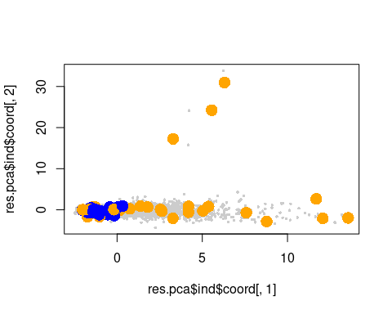

res.hcpc$data.clust[which(rownames(res.hcpc$data.clust)%in%names(res.hcpc$desc.ind$para[[1]])),]

## VendorID Payment_type Store_and_fwd_flag  
## 3495 f.Vendor-VeriFone f.PayType-Cash Store_and_fwd_flag_FALSE  
## 3512 f.Vendor-VeriFone f.PayType-Cash Store_and_fwd_flag_FALSE  
## 3514 f.Vendor-VeriFone f.PayType-Cash Store_and_fwd_flag_FALSE  
## 3518 f.Vendor-VeriFone f.PayType-Cash Store_and_fwd_flag_FALSE  
## 3639 f.Vendor-VeriFone f.PayType-Credit card Store_and_fwd_flag_FALSE  
## RateCodeID f.Extra f.MTA_tax f.Improvement_surcharge  
## 3495 Standard rate f.Extra-0.5 f.MTA_tax_YES f.Improvement_surcharge_YES  
## 3512 Standard rate f.Extra-0 f.MTA_tax_YES f.Improvement_surcharge_YES  
## 3514 Standard rate f.Extra-0 f.MTA_tax_YES f.Improvement_surcharge_YES  
## 3518 Standard rate f.Extra-0 f.MTA_tax_YES f.Improvement_surcharge_YES  
## 3639 Standard rate f.Extra-0.5 f.MTA_tax_YES f.Improvement_surcharge_YES  
## lpep_pickup_period Trip_type lpep_pickup_date multiouts  
## 3495 Period night f.TripType-Street-Hail 2016-01-22 multiouts_FALSE  
## 3512 Period night f.TripType-Street-Hail 2016-01-22 multiouts_FALSE  
## 3514 Period night f.TripType-Street-Hail 2016-01-22 multiouts_FALSE  
## 3518 Period morning f.TripType-Street-Hail 2016-01-22 multiouts_FALSE  
## 3639 Period night f.TripType-Street-Hail 2016-01-22 multiouts_FALSE  
## f.espeed f.tlenkm f.traveltime f.distHaversine  
## 3495 f.espeed-(1,25] f.tlenkm-(1,5] f.traveltime-[0,10] f.distHaversine-[0,5]  
## 3512 f.espeed-(1,25] f.tlenkm-(1,5] f.traveltime-[0,10] f.distHaversine-[0,5]  
## 3514 f.espeed-(1,25] f.tlenkm-(1,5] f.traveltime-[0,10] f.distHaversine-[0,5]  
## 3518 f.espeed-(1,25] f.tlenkm-(1,5] f.traveltime-(10,20] f.distHaversine-[0,5]  
## 3639 f.espeed-(1,25] f.tlenkm-(1,5] f.traveltime-(10,20] f.distHaversine-[0,5]  
## AnyToll f.Fare_amount f.Passenger_count  
## 3495 AnyToll Yes f.Fare_amount-(6.5,9] f.Passenger_count-1  
## 3512 AnyToll Yes f.Fare_amount-(6.5,9] f.Passenger_count-1  
## 3514 AnyToll Yes f.Fare_amount-(6.5,9] f.Passenger_count-1  
## 3518 AnyToll Yes f.Fare_amount-(6.5,9] f.Passenger_count-1  
## 3639 AnyToll Yes f.Fare_amount-(6.5,9] f.Passenger_count-1  
## f.Total_amount AnyTip Total_amount clust  
## 3495 f.Total_amount-(8,11] AnyTip No 8.80 1  
## 3512 f.Total_amount-(8,11] AnyTip No 8.30 1  
## 3514 f.Total_amount-(1,8] AnyTip No 7.80 1  
## 3518 f.Total_amount-(8,11] AnyTip No 8.80 1  
## 3639 f.Total_amount-(11,18] AnyTip Yes 12.88 1

res.hcpc$data.clust[which(rownames(res.hcpc$data.clust)%in%names(res.hcpc$desc.ind$dist[[1]])),]

## VendorID Payment_type Store_and_fwd_flag  
## 1970 f.Vendor-Mobile f.PayType-Credit card Store_and_fwd_flag_TRUE  
## 3086 f.Vendor-VeriFone f.PayType-Cash Store_and_fwd_flag_FALSE  
## 3167 f.Vendor-VeriFone f.PayType-Credit card Store_and_fwd_flag_FALSE  
## 3580 f.Vendor-Mobile f.PayType-Cash Store_and_fwd_flag_TRUE  
## 4360 f.Vendor-Mobile f.PayType-Others Store_and_fwd_flag_FALSE  
## RateCodeID f.Extra f.MTA_tax f.Improvement_surcharge  
## 1970 Standard rate f.Extra-0.5 f.MTA_tax_YES f.Improvement_surcharge_YES  
## 3086 Standard rate f.Extra-1 f.MTA_tax_YES f.Improvement_surcharge_YES  
## 3167 Others f.Extra-0 f.MTA_tax_YES f.Improvement_surcharge_YES  
## 3580 Standard rate f.Extra-0 f.MTA_tax_YES f.Improvement_surcharge_YES  
## 4360 Standard rate f.Extra-1 f.MTA_tax_YES f.Improvement_surcharge_YES  
## lpep_pickup_period Trip_type lpep_pickup_date multiouts  
## 1970 Period night f.TripType-Street-Hail 2016-01-12 multiouts_FALSE  
## 3086 Period night f.TripType-Street-Hail 2016-01-22 multiouts_FALSE  
## 3167 Period night f.TripType-Street-Hail 2016-01-20 multiouts_FALSE  
## 3580 Period valley f.TripType-Street-Hail 2016-01-22 multiouts_FALSE  
## 4360 Period afternoon f.TripType-Street-Hail 2016-01-28 multiouts_FALSE  
## f.espeed f.tlenkm f.traveltime  
## 1970 f.espeed-(1,25] f.tlenkm-(1,5] f.traveltime-[0,10]  
## 3086 f.espeed-[0,1] f.tlenkm-(5,67.9] f.traveltime-(40,548]  
## 3167 f.espeed-(25,130] f.tlenkm-(5,67.9] f.traveltime-(30,40]  
## 3580 f.espeed-(1,25] f.tlenkm-(1,5] f.traveltime-[0,10]  
## 4360 f.espeed-(1,25] f.tlenkm-(1,5] f.traveltime-[0,10]  
## f.distHaversine AnyToll f.Fare_amount  
## 1970 f.distHaversine-[0,5] AnyToll Yes f.Fare_amount-[0,6.5]  
## 3086 f.distHaversine-[0,5] AnyToll Yes f.Fare_amount-(14.5,71.5]  
## 3167 f.distHaversine-(10,26.1] AnyToll No f.Fare_amount-(14.5,71.5]  
## 3580 f.distHaversine-[0,5] AnyToll Yes f.Fare_amount-[0,6.5]  
## 4360 f.distHaversine-[0,5] AnyToll Yes f.Fare_amount-(6.5,9]  
## f.Passenger_count f.Total_amount AnyTip Total_amount clust  
## 1970 f.Passenger_count-1 f.Total_amount-(1,8] AnyTip No 7.30 1  
## 3086 f.Passenger_count-1 f.Total_amount-(18,20] AnyTip No 18.80 1  
## 3167 f.Passenger_count-1 f.Total_amount-(40,95.5] AnyTip Yes 68.34 1  
## 3580 f.Passenger_count-1 f.Total_amount-(1,8] AnyTip No 6.30 1  
## 4360 f.Passenger_count-1 f.Total_amount-(8,11] AnyTip No 8.80 1

res.hcpc$data.clust[which(rownames(res.hcpc$data.clust)%in%names(res.hcpc$desc.ind$para[[2]])),]

## VendorID Payment_type Store_and_fwd_flag  
## 4433 f.Vendor-VeriFone f.PayType-Cash Store_and_fwd_flag_FALSE  
## 4617 f.Vendor-VeriFone f.PayType-Cash Store_and_fwd_flag_FALSE  
## 4693 f.Vendor-VeriFone f.PayType-Credit card Store_and_fwd_flag_FALSE  
## 4714 f.Vendor-VeriFone f.PayType-Cash Store_and_fwd_flag_FALSE  
## 4738 f.Vendor-VeriFone f.PayType-Credit card Store_and_fwd_flag_FALSE  
## RateCodeID f.Extra f.MTA_tax f.Improvement_surcharge  
## 4433 Standard rate f.Extra-0 f.MTA_tax_YES f.Improvement_surcharge_YES  
## 4617 Standard rate f.Extra-0.5 f.MTA_tax_YES f.Improvement_surcharge_YES  
## 4693 Standard rate f.Extra-0 f.MTA_tax_YES f.Improvement_surcharge_YES  
## 4714 Standard rate f.Extra-0 f.MTA_tax_YES f.Improvement_surcharge_YES  
## 4738 Standard rate f.Extra-0 f.MTA_tax_YES f.Improvement_surcharge_YES  
## lpep_pickup_period Trip_type lpep_pickup_date multiouts  
## 4433 Period night f.TripType-Street-Hail 2016-01-29 multiouts_FALSE  
## 4617 Period night f.TripType-Street-Hail 2016-01-30 multiouts_FALSE  
## 4693 Period valley f.TripType-Street-Hail 2016-01-30 multiouts_FALSE  
## 4714 Period afternoon f.TripType-Street-Hail 2016-01-30 multiouts_FALSE  
## 4738 Period afternoon f.TripType-Street-Hail 2016-01-30 multiouts_FALSE  
## f.espeed f.tlenkm f.traveltime f.distHaversine  
## 4433 f.espeed-(25,130] f.tlenkm-(1,5] f.traveltime-[0,10] f.distHaversine-[0,5]  
## 4617 f.espeed-(1,25] f.tlenkm-(1,5] f.traveltime-[0,10] f.distHaversine-[0,5]  
## 4693 f.espeed-(1,25] f.tlenkm-(1,5] f.traveltime-[0,10] f.distHaversine-[0,5]  
## 4714 f.espeed-(1,25] f.tlenkm-(1,5] f.traveltime-[0,10] f.distHaversine-[0,5]  
## 4738 f.espeed-(1,25] f.tlenkm-(1,5] f.traveltime-[0,10] f.distHaversine-[0,5]  
## AnyToll f.Fare_amount f.Passenger_count  
## 4433 AnyToll Yes f.Fare_amount-[0,6.5] f.Passenger_count-1  
## 4617 AnyToll Yes f.Fare_amount-(9,14.5] f.Passenger_count-1  
## 4693 AnyToll Yes f.Fare_amount-[0,6.5] f.Passenger_count-1  
## 4714 AnyToll Yes f.Fare_amount-[0,6.5] f.Passenger_count-1  
## 4738 AnyToll Yes f.Fare_amount-[0,6.5] f.Passenger_count-1  
## f.Total_amount AnyTip Total_amount clust  
## 4433 f.Total_amount-(1,8] AnyTip No 6.8 2  
## 4617 f.Total_amount-(8,11] AnyTip No 10.8 2  
## 4693 f.Total_amount-(1,8] AnyTip Yes 7.0 2  
## 4714 f.Total_amount-(1,8] AnyTip No 5.3 2  
## 4738 f.Total_amount-(1,8] AnyTip Yes 6.8 2

res.hcpc$data.clust[which(rownames(res.hcpc$data.clust)%in%names(res.hcpc$desc.ind$dist[[2]])),]

## VendorID Payment_type Store_and_fwd_flag  
## 748 f.Vendor-Mobile f.PayType-Cash Store_and_fwd_flag_TRUE  
## 1426 f.Vendor-VeriFone f.PayType-Credit card Store_and_fwd_flag_FALSE  
## 1548 f.Vendor-Mobile f.PayType-Credit card Store_and_fwd_flag_TRUE  
## 1623 f.Vendor-Mobile f.PayType-Credit card Store_and_fwd_flag_TRUE  
## 3064 f.Vendor-VeriFone f.PayType-Credit card Store_and_fwd_flag_FALSE  
## RateCodeID f.Extra f.MTA_tax f.Improvement_surcharge  
## 748 Standard rate f.Extra-0 f.MTA_tax_YES f.Improvement_surcharge_YES  
## 1426 Standard rate f.Extra-0 f.MTA_tax_YES f.Improvement_surcharge_YES  
## 1548 Standard rate f.Extra-0 f.MTA_tax_YES f.Improvement_surcharge_YES  
## 1623 Standard rate f.Extra-0.5 f.MTA_tax_YES f.Improvement_surcharge_YES  
## 3064 Standard rate f.Extra-0 f.MTA_tax_YES f.Improvement_surcharge_YES  
## lpep_pickup_period Trip_type lpep_pickup_date multiouts  
## 748 Period valley f.TripType-Street-Hail 2016-01-05 multiouts_FALSE  
## 1426 Period night f.TripType-Street-Hail 2016-01-30 multiouts_FALSE  
## 1548 Period morning f.TripType-Street-Hail 2016-01-10 multiouts_FALSE  
## 1623 Period night f.TripType-Street-Hail 2016-01-10 multiouts_FALSE  
## 3064 Period night f.TripType-Street-Hail 2016-01-30 multiouts_FALSE  
## f.espeed f.tlenkm f.traveltime  
## 748 f.espeed-(25,130] f.tlenkm-[0,1] f.traveltime-[0,10]  
## 1426 f.espeed-[0,1] f.tlenkm-(1,5] f.traveltime-(40,548]  
## 1548 f.espeed-(1,25] f.tlenkm-(1,5] f.traveltime-[0,10]  
## 1623 f.espeed-(25,130] f.tlenkm-(5,67.9] f.traveltime-[0,10]  
## 3064 f.espeed-[0,1] f.tlenkm-(1,5] f.traveltime-(40,548]  
## f.distHaversine AnyToll f.Fare_amount  
## 748 f.distHaversine-[0,5] AnyToll Yes f.Fare_amount-[0,6.5]  
## 1426 f.distHaversine-[0,5] AnyToll Yes f.Fare_amount-(9,14.5]  
## 1548 f.distHaversine-[0,5] AnyToll Yes f.Fare_amount-(6.5,9]  
## 1623 f.distHaversine-[0,5] AnyToll Yes f.Fare_amount-(9,14.5]  
## 3064 f.distHaversine-[0,5] AnyToll Yes f.Fare_amount-(9,14.5]  
## f.Passenger_count f.Total_amount AnyTip Total_amount  
## 748 f.Passenger_count-1 f.Total_amount-(1,8] AnyTip No 4.80  
## 1426 f.Passenger_count-1 f.Total_amount-(11,18] AnyTip Yes 12.96  
## 1548 f.Passenger_count-Others f.Total_amount-(8,11] AnyTip Yes 9.30  
## 1623 f.Passenger_count-1 f.Total_amount-(20,30] AnyTip Yes 25.80  
## 3064 f.Passenger_count-1 f.Total_amount-(11,18] AnyTip Yes 12.36  
## clust  
## 748 2  
## 1426 2  
## 1548 2  
## 1623 2  
## 3064 2

### Results for the hierarchical tree

### The suggested level to cut the tree

res.hcpc$call$t$nb.clust

## [1] 9

### Within inertias

res.hcpc$call$t$within[1:res.hcpc$call$t$nb.clust]

## [1] 2.480116 2.285618 2.234215 2.183077 2.132006 2.081945 2.032450 1.983323  
## [9] 1.934686

### Ratio between within inertias

res.hcpc$call$t$quot[1:res.hcpc$call$t$nb.clust]

## [1] 0.9775104 0.9771113 0.9766060 0.9765191 0.9762269 0.9758285 0.9754768  
## [8] 0.9754845 NA

### Inertia gain

res.hcpc$call$t$inert.gain[1:res.hcpc$call$t$nb.clust]

## [1] 0.19449854 0.05140255 0.05113830 0.05107095 0.05006133 0.04949422 0.04912733  
## [8] 0.04863734 0.04742985

# Partition quality

(res.hcpc$call$t$within[1]-res.hcpc$call$t$within[res.hcpc$call$t$nb.clust])/res.hcpc$call$t$within[1]

## [1] 0.2199214