Pico Kiosk Mode

Version：v_1.0.0

Pico Technology Co., Ltd

**Contents**

1 Introduction 3

2 Applicable Products 3

3 AndroidManifest.xml Modification 3

4 Achieve Pico System Level Signature 4



# **Introduction**

# Kiosk mode is a way to show a VR experience in the most foolproof way by only allowing a VR headset to run one specific app, which automatically starts when you boot the headset. This prevents users from accidentally exiting the app and getting lost in the Home environment.

# **Applicable Products**

# Supported devices as follow:

# Goblin

# Pico Neo

# G2

# G2 4K

# **AndroidManifest.xml Modification**

The Android Manifest is an XML file which contains important metadata about the Android app. This includes the package name, activity names, main activity (the entry point to the app), configurations, Android version support, hardware features support, and permissions.

* + **Step1: Modify package name**

Change the package name of launcher application to “***com.picovrtob.vrlauncher***”, and change VersionCode to a large value, such as 3000, as shown below:

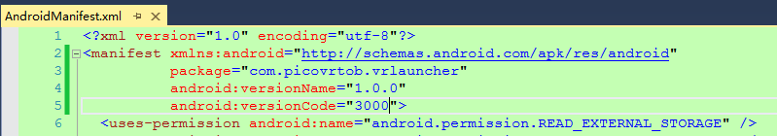

* + **Step2: Modify Main Activity**

Change the categories of Main Activity as codes shown below:

*<category android:name="android.intent.category.HOME" />*

*<category android:name="android.intent.category.DEFAULT" />*

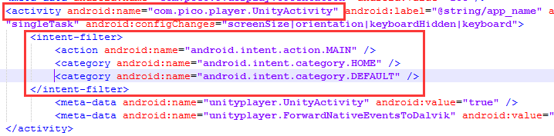

* + **Step3: Unity Packaging**

For Unity packaging, the package name and version number in Player Settings must be consistent with AndroidManifest file.

* + **Step4: Install New Launcher**

After built the application, install and press Home button, the new launcher would be started.

# **Achieve Pico System Level Signature**

# Some developers may want to implement features such as reboot/power off device, change system configuration, which need system level permission. To satisfy this kind of requirement, Pico specially made an Online Signature Tool, which allows developers to sign their apps to achieve system level permission.

# Here are the steps to sign the apps with Pico Online Tool,

* + **Step1: Apply for an account**

Please contact Pico technical support (support.tob@picovr.com) for account and password.

* + **Step2: Login Signature System**

Open Pico online signature system ( <http://signature.picovr.com:9999/login> ), enter account and password to login. You will see "Signature List" after successful login.

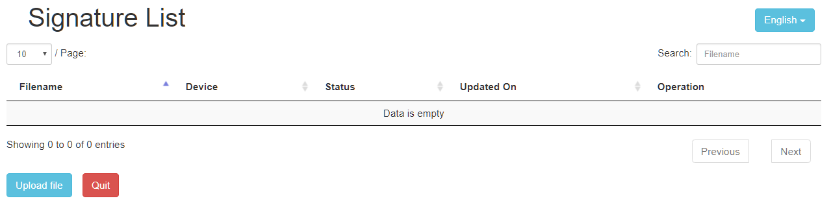

* + **Step3: Upload Signature Application**

Click on "Upload File", enter the upload file interface; Click "Select File" to select the application to be signed;

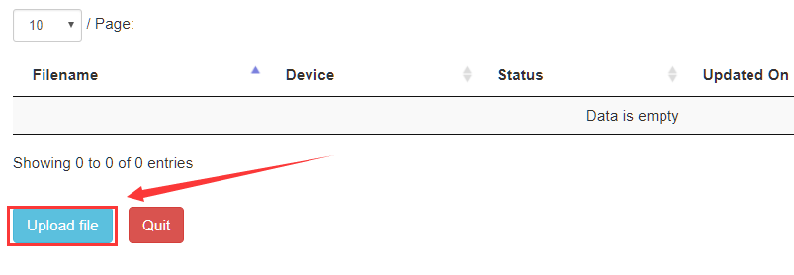

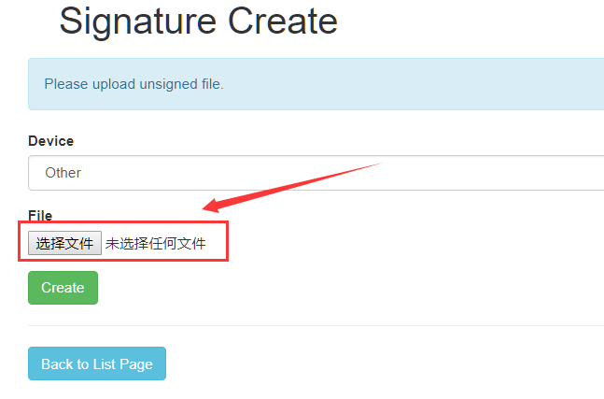

* + **Step4: Select Device Type**

For Goblin, Neo, G2 and G2 4K, please select "Other", then click "Create" button.

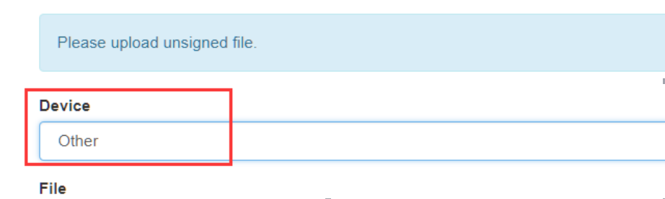

* + **Step5: View Signature Results**

Click "Back to list page"

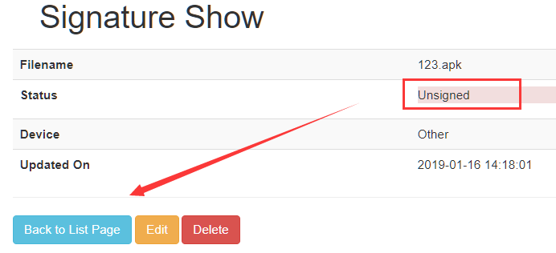

On the list page you can see the uploaded APK, and the status here is unsigned.

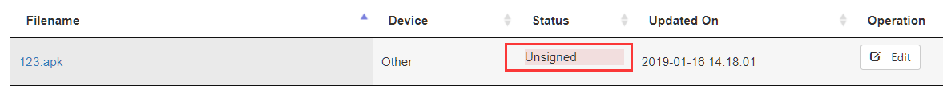

* + **Step6: Get Signed APK**

Normally in 5-10 minutes the system will complete signature work automatically. Refresh list page, you can see the application signature status is "signed". Click "signed" button to download signed APK.



Note: The launcher with package name “com.picovrtob.vrlauncher” will be recognized as the default launcher by the system. To switch default launcher, users can change home app to Pico launcher or other custom launcher in 2D Settings:

*For Goblin: Select system default launcher in “2D settings* *→ home page” (To enter 2D settings, hold “Confirm” and “Volume -” as a combination key);*

*For Pico Neo, G2 and G2 4K: 2D settings → Apps & Notification → Advanced → Default apps → Home app → Choose home screen; (To enter 2D settings, hold “Confirm” and “Volume -” at the same time as a combination key);*