**FIT 2099 Assignment 2**

Work Breakdown Agreement

Group Name: Tute08Team139

Members: Tan Jin En, Vernise Ang Veng Yan

|  |  |  |  |  |
| --- | --- | --- | --- | --- |
| No. | Task Description | Person in charge | Date done | Date reviewed |
| 1 | Work Breakdown Agreement | Jin En | 03/05/2021 | 03/05/2021 |
| 2 | Ammend Class diagram for Vending Machine and items | Vernise | 06/05/2021 | 06/05/2021 |
| 3 | Ammend Class diagram of Dinosaurs | Vernise | 06/05/2021 | 06/05/2021 |
| 4 | Ammend Class diagram of Fruit, Tree, Dirt and Bush | Vernise | 06/05/2021 | 06/05/2021 |
| 13 | Implementation of Lakes, water, rain | Vernise | 07/05/2021 | 07/05/2021 |
| 14 | Implementation of Thirsty Dinosaurs | Vernise | 08/05/2021 | 08/05/2021 |
| 15 | Implementation of Pterodactyls | Vernise | 08/05/2021 | 08/05/2021 |
| 16 | Implementation of Second Map | Jin En | 08/05/2021 | 08/05/2021 |
| 17 | Implementation of game driver | Jin En | 08/05/2021 | 08/05/2021 |
| 18 | Recommendations for extensions to the game engine | Jin En | 08/05/2021 | 08/05/2021 |
| 19 | Generating Java Document | Jin En | 08/05/2021 | 08/05/2021 |
| 20 | Update Design Rationale | Both | 08/05/2021 | 08/05/2021 |

Accepted by:

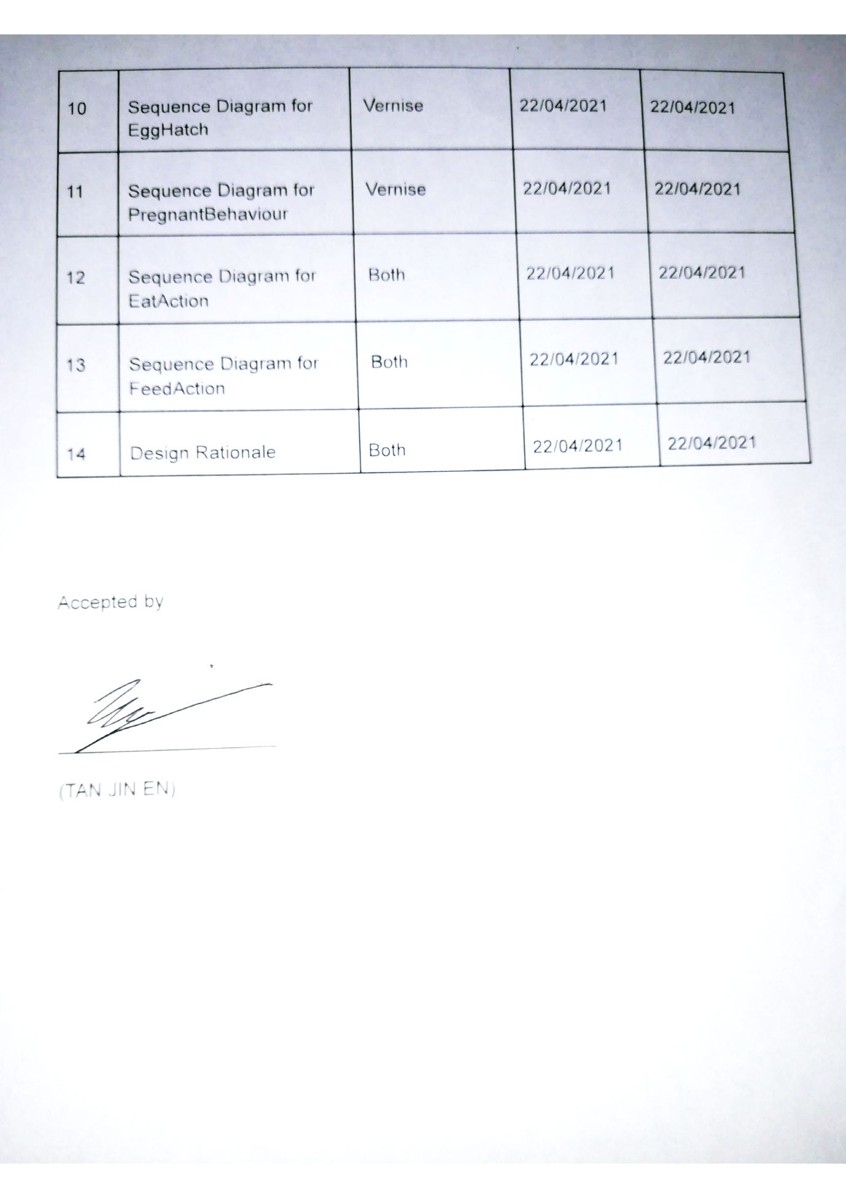

(TAN JIN EN)