Develop a program to perform Bias Audit on pre-trained word embeddings to
Identify gender or racial stereotypes using the Word Embedding Association Test (WEAT).

Aim:
To develop a predictive text system using N-Gram and HMM (Hidden Markov Models) to predict the next word based on previous context.
Pretrained embedding : glove-wiki-gigaword-50
Step 1: Install required library
!pip install genism
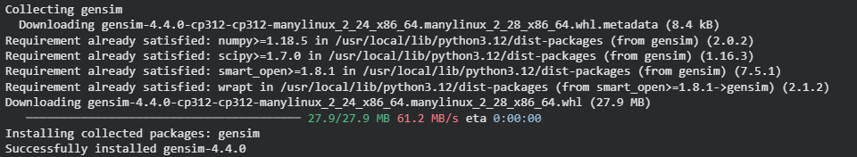
Step 2: Import libraries
import gensim.downloader as api
import numpy as np
Step 3: Load pre-trained embeddings
model = api.load("glove-wiki-gigaword-50")
Step 4: Define gender target words
male = ["man","boy","he","father","son"]
female = ["woman","girl","she","mother","daughter"]
Step 5: Define attribute words
career = ["doctor","engineer","scientist","manager","lawyer"]
family = ["home","children","family","parents","marriage"]

Step 6: Get vectors for one example word
man_vec = model["man"]
doctor_vec = model["doctor"]
Step 7: Calculate similarity example
sim1 = np.dot(man_vec , doctor_vec)
norm1 = np.linalg.norm(man_vec)
norm2 = np.linalg.norm(doctor_vec)
cos_sim = sim1 / (norm1 * norm2)
print(cos_sim)
Step 8: Check similarity for male with career
m1 = model["man"]
m2 = model["boy"]
c1 = model["doctor"]
c2 = model["engineer"]
s1 = np.dot(m1,c1)/(np.linalg.norm(m1)*np.linalg.norm(c1))
s2 = np.dot(m2,c2)/(np.linalg.norm(m2)*np.linalg.norm(c2))
male_score = (s1 + s2) / 2
print(male_score)
Step 9: Check similarity for female with family
f1 = model["woman"]
f2 = model["girl"]
fa1 = model["home"]
fa2 = model["children"]

s3 = np.dot(f1,fa1)/(np.linalg.norm(f1)*np.linalg.norm(fa1))
s4 = np.dot(f2,fa2)/(np.linalg.norm(f2)*np.linalg.norm(fa2))
female_score = (s3 + s4) / 2
print(female_score)
Step 10: Bias result
bias = male_score - female_score
print("Bias Score:", bias)
if bias > 0:
print("Gender bias toward career for male")
else:
print("Gender bias toward family for female")
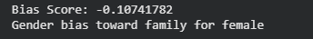

Result:
N-gram model achieved about 10% accuracy, as it predicts the next word based on frequent word sequences in the corpus. HMM model showed 0% accuracy, since it predicts words based on POS patterns, which rarely match the exact next word in the dataset.

