Author: Jason Edwards

Submission that models the classes and relationships of the South Wales Hire and Haulage (SWHH) hire system.
CSF2702: Object Oriented Design– Coursework
Due: 14:00am, 21st October 2026

Contents
Class Diagram 0
Class Description and Responsibilities 0
HireSystem 0
Customer 2
DrivingLicence 2
Vehicle (Abstract Superclass) 3
StandardVan 3
LutonVan 4
ArticulatedLorry 4
Trailer (If ArticulatedLorry - Obtion B) 5
Rental 5
DamageReport 7
Summary of Relationships and Multiplicities 8

Class Diagram 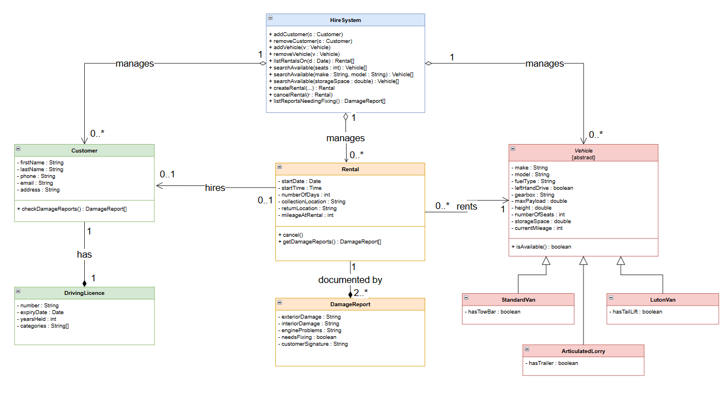

Class Description and Responsibilities

HireSystem
The HireSystem class is the central controller of the model and represents the system boundary through which the company's staff interact with the stored information. It directly satisfies requirement 5 by providing the operations
+ addCustomer(c : Customer),
+ removeCustomer(c : Customer),
+ addVehicle(v : Vehicle),
+ removeVehicle(v : Vehicle) and
+ listRentalsOn(d : Date) : Rental[],
the last of which produces the list of rentals that begin or end on a given date. It also carries requirement 6's search behaviour through
+ searchAvailable(seats : int) : Vehicle[],
+ searchAvailable(make : String, model : String) : Vehicle[] and
+ searchAvailable(storageSpace : double) : Vehicle[],
letting the user find available vehicles by number of seats, by make or model, or by available storage space in m³.
Rental lifecycle control is provided by
+ createRental(...) and
+ cancelRental(r : Rental) (requirements 7 and 8), and
The damage-reporting requirement is served by
+ listReportsNeedingFixing() : DamageReport[].
Because the system owns and manages the whole-of-life of these records, it holds aggregation relationships to Customer (1 HireSystem aggregates 0..* Customer), to Vehicle (1 to 0..* Vehicle) and to Rental (1 to 0..* Rental): these parts are grouped together under the system but conceptually exist in their own right, which is why aggregation (unfilled diamond) rather than composition is chosen, following the resources' rule that an aggregated part can exist independently of the whole.
Updated version
The HireSystem class is the central controller of the model and represents the system boundary through which the company's staff interact with the stored information. It directly satisfies requirement 5 by providing the operations
+ addCustomer(c : Customer),
+ removeCustomer(c : Customer),
+ addVehicle(v : Vehicle),
+ removeVehicle(v : Vehicle) and
+ listRentalsOn(d : Date) : Rental[], the last of which produces the list of rentals that begin or end on a given date.
It also carries requirement 6's search behaviour through
+ searchAvailable(seats : int) : Vehicle[],
+ searchAvailable(make : String, model : String) : Vehicle[] and
+ searchAvailable(storageSpace : double) : Vehicle[],
letting the user find available vehicles by number of seats, by make or model, or by available storage space in m³.
Rental lifecycle control is provided by
+ createRental(...) and
+ cancelRental(r : Rental) (requirements 7 and 8),
and the damage-reporting requirement is served by
+ listReportsNeedingFixing() : DamageReport[].
Because the system owns and manages the whole-of-life of these records, it holds aggregation relationships to Customer (1 HireSystem aggregates 0..* Customer), to Vehicle (1 to 0..* Vehicle) and to Rental (1 to 0..* Rental): these parts are grouped together under the system but conceptually exist in their own right, which is why aggregation (unfilled diamond at the HireSystem end) rather than composition is chosen. To demonstrate the navigability notation from the module material, these three aggregations are additionally marked as navigable from HireSystem towards each part (an open arrowhead at the Customer, Vehicle and Rental ends): this reflects the fact that the system holds collection attributes referencing those objects and can therefore navigate to them at run time, whereas the parts do not need to navigate back to the system. (By the resource's rule that an owned end is always navigable, these navigable ends are also the ends owned by HireSystem.) Navigability has been applied only here and on the Rental associations, where it carries real design meaning, rather than throughout the diagram.

Customer
The Customer class models a person who hires vehicles from SWHH and is drawn directly from requirement 1, which states that each customer has names, contact information and driver's licence information. Its attributes are
- firstName : String,
- lastName : String,
- phone : String,
- email : String and
- address : String,
grouping the "names" and "contact information" into concrete, typed, private fields in keeping with the encapsulation guidance. The useful operations are
+ checkDamageReports() : DamageReport[], which satisfies the requirement that customers be able to check the damage reports associated with their rental, together with the mutators needed to maintain contact details. A Customer holds exactly one driving licence, so it has a composition relationship to DrivingLicence with multiplicity 1 at the licence end: the licence has no meaning independently of the customer it belongs to and should be destroyed with the customer, which matches the composition semantics (filled diamond, part's lifetime controlled by the whole, part included in at most one composite). The constraint in requirement 8 that "a customer can only hire one vehicle" is captured on the relationship between Customer and Rental: a Customer is associated with 0..1 active Rental, enforcing that at any time a customer has at most one current hire.

DrivingLicence
The DrivingLicence class is identified from requirement 2 and holds the licence data for a customer. Its attributes are
- number : String,
- expiryDate : Date,
- yearsHeld : int and
- categories : String[],
representing respectively the licence number, the expiry date (using the assumed Date data type, so no Date class is created), the number of years the licence has been held, and the categories of vehicles that can be driven.
The Date type is used directly as an attribute type as permitted by the brief. As described under Customer, this class is the dependent part of a composition: one DrivingLicence belongs to exactly one Customer, giving it a multiplicity of 1..1 on the owning end, consistent with the resources' statement that the part in a composition should be included in at most one composite.

Vehicle (Abstract Superclass)
The Vehicle class is an abstract class (name in italics / {abstract}) that generalises the three concrete vehicle types and factors out the attributes requirement 4 says all vehicles share. It is abstract because the company never hires a generic "vehicle" — only one of the three specific kinds — so, following the resources, it should not be instantiable. Its common attributes are
- fuelType : String,
- leftHandDrive : boolean (true for left-hand drive, false for right),
- gearbox : String (automatic or manual),
- maxPayload : double,
- height : double,
together with
- make : String,
- model : String,
- numberOfSeats : int,
- storageSpace : double and
- currentMileage : int,
the last four of which are required to support the search criteria in requirement 6 and the mileage recorded on a rental in requirement 7.
It provides the operation
+ isAvailable() : boolean used by the search methods.
Vehicle acts as the superclass in a specialisation/generalisation relationship (unfilled triangle) with ArticulatedLorry, LutonVan and StandardVan as subclasses, each of which "is a type of" Vehicle and inherits all of its attributes and operations.

StandardVan
The StandardVan class is a subclass of Vehicle representing one of the three hired vehicle types in requirement 3.
It specialises the superclass by adding the attribute
- hasTowBar : boolean,
modelling requirement 4's statement that Standard Vans have the option of a tow bar attachment; because the tow bar is a simple yes/no option rather than a separate component, it is represented as a boolean attribute rather than as a related class. It inherits all common vehicle attributes and operations from Vehicle through generalisation and therefore participates in rentals in the same way as any other vehicle.

LutonVan
The LutonVan class is likewise a subclass of Vehicle and corresponds to the Luton Van type in requirement 3. Its specialisation is the attribute
- hasTailLift : boolean,
capturing requirement 4's statement that Luton Vans optionally have a tail lift.
As with the Standard Van, this optional feature is a simple boolean because it is a built-in option of the van rather than a distinct hireable part, and all shared vehicle data and behaviour are inherited from the abstract Vehicle superclass.

ArticulatedLorry
Option A:
The ArticulatedLorry class is the third subclass of Vehicle and models the Articulated Lorry type identified in requirement 3. It specialises the abstract superclass by adding the single attribute
- hasTrailer : boolean,
which captures requirement 4's statement that an articulated lorry "can optionally be hired out with a trailer."
This optional feature is modelled as a boolean flag rather than as a separate Trailer class because the specification gives a trailer no attributes, operations or independent behaviour of its own — the only business fact the system needs to record is whether or not a given lorry is hired with a trailer.
Introducing a distinct Trailer class would, by the resources' definitions, imply an aggregation whose part "can exist in its own right," yet the brief grants a trailer no such independent existence; adding one would therefore contravene both the "keep it simple" guidance and the brief's explicit instruction not to model features beyond the stated business processes.
Representing the option as a boolean also keeps the three vehicle subtypes consistent with one another, mirroring StandardVan +hasTowBar and LutonVan +hasTailLift.
Like its sibling subclasses, ArticulatedLorry inherits all common attributes and operations (make, model, fuel type, drive side, gearbox, maximum payload, height, seats, storage space, current mileage and isAvailable()) from Vehicle through the specialisation/generalisation relationship, and therefore participates in rentals in exactly the same way as any other vehicle.
Option B:
The ArticulatedLorry class is the third subclass of Vehicle, modelling the Articulated Lorry type from requirement 3. Requirement 4 states that an articulated lorry can optionally be hired out with a trailer, and because a trailer is a tangible component that is grouped with the lorry yet can sensibly exist in its own right, it is modelled as a related Trailer class via an aggregation with multiplicity 0..1 at the trailer end (an unfilled diamond on the lorry): the "optional" nature is expressed by the 0..1 multiplicity, meaning a lorry may be hired with zero or one trailer. The lorry inherits all common attributes and operations from Vehicle.

Trailer (If ArticulatedLorry - Obtion B)
The Trailer class exists to model the optional trailer that may accompany an articulated lorry, as described in requirement 4. It is kept deliberately minimal in line with the brief's instruction not to add unnecessary detail; it is the "part" in the aggregation with ArticulatedLorry and can exist independently of any particular lorry, which is precisely why aggregation (part exists in its own right) was chosen over composition. Its multiplicity on the lorry side is 0..1, consistent with the resources' guidance that a part in an aggregation may belong to at most one whole at a time in this context.

Rental
The Rental class is the core transactional class drawn from requirement 7 and records a single hire of a vehicle by a customer. Its attributes are
- startDate : Date,
- startTime : Time,
- numberOfDays : int,
- collectionLocation : String,
- returnLocation : String and
- mileageAtRental : int,
which together capture the date and time the rental begins (using the assumed Date and Time types), how many days the rental is for, the collection and return locations, and the vehicle's current mileage at the point of hire.
It provides
+ cancel() to satisfy requirement 8's requirement that a rental can be cancelled, and
+ getDamageReports() : DamageReport[] to support the customer's ability to review reports.
Rental has an association to exactly one Vehicle (1), modelling "the vehicle that is being rented", and an association back to exactly one Customer (1), while the Customer end carries the 0..1 multiplicity that enforces the single-active-hire rule.
Navigability/ownership can be marked so that a Rental owns its ends and can navigate to its vehicle and customer, reflecting that the rental record holds references to both.

Updated version
The Rental class is the core transactional class drawn from requirement 7 and records a single hire of a vehicle by a customer. Its attributes are
- startDate : Date,
- startTime : Time,
- numberOfDays : int,
- collectionLocation : String,
- returnLocation : String and
- mileageAtRental : int,
which together capture the date and time the rental begins (using the assumed Date and Time types), how many days the rental is for, the collection and return locations, and the vehicle's current mileage at the point of hire.
It provides
+ cancel() to satisfy requirement 8's requirement that a rental can be cancelled, and
+ getDamageReports() : DamageReport[] to support the customer's ability to review reports.
Rental has an association to exactly one Vehicle (1), modelling "the vehicle that is being rented", and an association back to one Customer, where the Customer end carries the 0..1 multiplicity that enforces the single-active-hire rule from requirement 8. Both of these associations are marked as navigable from Rental (an open arrowhead at the Vehicle and Customer ends), reflecting that a Rental object holds references to its vehicle and its customer and can navigate to them, which mirrors how the class would be implemented in Java; the reverse direction is left unspecified. A composition (filled diamond on Rental) links it to DamageReport with a multiplicity of 2..*, enforcing the brief's requirement that every rental has at least two damage reports — one at the start and one at the end — while allowing more if needed.

DamageReport
The DamageReport class is introduced to satisfy the Damage Reports section of the brief. Its attributes are
- exteriorDamage : String,
- interiorDamage : String,
- engineProblems : String,
- needsFixing : boolean and
- customerSignature : String,
storing the exterior, interior and engine descriptions as textual descriptions, a flag recording whether the damage needs to be fixed, and the customer signature.
It is linked to Rental by a composition (filled diamond on Rental) because a damage report has no existence outside the rental it documents and should be destroyed with it.
The multiplicity on the report end is 2..*, which enforces the requirement that every rental has at least two damage reports — one at the beginning and one at the end — while still allowing additional reports if more damage is recorded. The company's requirement to "produce a list of damage reports that need fixing" is met at the system level by HireSystem.listReportsNeedingFixing(), which filters reports whose needsFixing flag is true, and the customer's ability to check their reports is met through Customer.checkDamageReports() navigating via their Rental.

Summary of Relationships and Multiplicities
- HireSystem 1 — aggregates — 0..* Customer, 0..* Vehicle, 0..* Rental (unfilled diamond; parts exist in their own right).
- Customer 1 — composition — 1 DrivingLicence (filled diamond; licence lifetime tied to customer).
- Customer 0..1 ← association → 0..1 Rental (enforces "a customer can only hire one vehicle").
- Vehicle (abstract) ◁— generalisation —◁ StandardVan, LutonVan, ArticulatedLorry (unfilled triangle; "is a type of").
- ArticulatedLorry 1 — aggregation — 0..1 Trailer (optional trailer, exists independently).
- Rental 1 ← association → 1 Vehicle; Rental 1 ← association → 1 Customer.
- Rental 1 — composition — 2..* DamageReport (filled diamond; at least two reports, destroyed with the rental).
This design covers every stated requirement — customer, vehicle and rental storage; licence details; the three vehicle subtypes with their optional features; the add/remove/list/search/create/cancel operations; the single-hire constraint; and the damage-reporting rules — using only the UML constructs (classes, abstract classes, attributes with visibility and types, operations, associations, aggregations, compositions, specialisation/generalisation, and multiplicities) presented in the module's resources, and would be implementable in Java if given to a programmer.

