Author: Jason Edwards

Submission that models the classes and relationships of the South Wales Hire and Haulage (SWHH) hire system.
CSF2702: Object Oriented Design– Coursework
Due: 14:00am, 21st October 2026

Table of Contents
Class Diagram 2
Class Description and Responsibilities 3
HireSystem 3
Customer 4
DrivingLicence 5
Vehicle (Abstract Superclass) 5
StandardVan 6
LutonVan 6
ArticulatedLorry 6
Trailer (If ArticulatedLorry - Obtion B) 7
Rental 8
DamageReport 9
Summary of Relationships and Multiplicities 11

Class Diagram 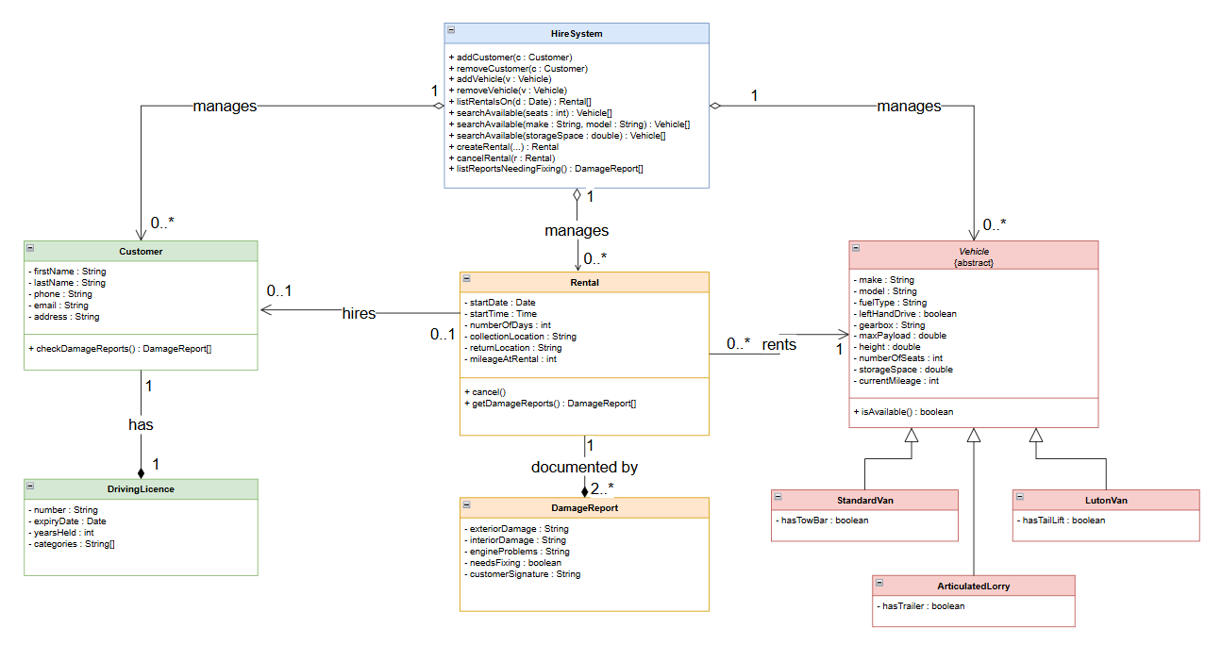

Class Description and Responsibilities

HireSystem
The HireSystem class controls the system and provides company staff with access to the information stored within it. It provides these operations

Operation | Purpose
+ addCustomer (c : Customer) | Adds a new customer to the system.
+ removeCustomer (c : Customer) | Removes an existing customer from the system.
+ addVehicle (v : Vehicle) | Adds a new vehicle to the system.
+ removeVehicle (v : Vehicle) | Removes an existing vehicle from the system.
+ listRentalsOn (d : Date) : Rental[] | Returns a list of rentals that start or end on the specified date.
+ searchAvailable (seats : int) : Vehicle[] | Returns available vehicles that match the specified number of seats.
+ searchAvailable (make : String, model : String) : Vehicle[] | Returns available vehicles that match the specified make or model.
+ searchAvailable (storageSpace : double) : Vehicle[] | Returns available vehicles with the required storage space (m³).

Rental lifecycle control is provided
Operation | Purpose
+ createRental(…) | Creates a new rental and records it in the system.
+ cancelRental(r : Rental) | Cancels the specified rental and updates the system records.
+ listReportsNeedingFixing() : DamageReport[] | Returns a list of damage reports for vehicles that require repairs or maintenance.

As HireSystem manages the lifetime of all customer, vehicle and rental records it has aggregation relationships with Customer, Vehicle and Rental (1 HireSystem to 0..* of each type). Aggregation is appropriate to use instead of composition because these objects can exist independently of HireSystem, even though they are managed by it.
The relationships are shown as navigable from HireSystem to Customer, Vehicle and Rental, meaning the system stores references to these objects and can access them when needed. The reverse navigation is not required because these objects do not need to access the HireSystem directly.

Customer
The Customer class models a person who hires vehicles from SWHH and is drawn directly from requirement 1, which states that each customer has names, contact information and driver's licence information. Customer has the following attributes which are private fields to maintain encapsulation:
Attribute | Purpose
- firstName : String | Stores the customer's first name
- lastName : String | Stores the customer's last name
- phone : String | Stores the customer's contact phone number
- email : String | Stores the customer's email address
- address : String | Stores the customer's postal address

Customer has this operation:
Operation | Purpose
+ checkDamageReports() : DamageReport[], | Returns a list of damage reports associated with the customer's rental.

A Customer has exactly one DrivingLicence, so the relationship is modelled as a composition. This means the driving licence belongs to that customer and does not exist independently. If the customer is removed, the driving licence is removed as well.
Requirement 8 states that a customer can only hire one vehicle at a time. This is represented by the relationship between Customer and Rental, where a customer can have 0..1 active rental, ensuring they can have at most one current hire at any given time.

DrivingLicence
The DrivingLicence class is identified from requirement 2 and holds the licence data for a customer. Its attributes are
Attribute | Purpose
- number : String | Stores the driving licence number
- expiryDate : Date | Stores the driving licence expiry date
- yearsHeld : Integer | Stores the number of years the licence has been held
- categories : String[] | Stores the categories of vehicles that can be driven

DrivingLicence is the dependent part of a composition with Customer. Each licence belongs to one customer and cannot be shared between multiple customers.

Vehicle
Vehicle is an abstract class that represents the common features shared by the three specific vehicle types (Standard Van, Luton Van, Articulated Lorry). It is abstract because the SWHH company only hires out these specific vehicle types, not a generic vehicle, so Vehicle itself cannot be instantiated. The class contains the attributes that all vehicles have in common. The attributes are:

Attribute | Purpose
- fuelType : String, | Stores the vehicle fuel type
- leftHandDrive : boolean | true for left-hand drive, false for right
- gearbox : String | Stores the vehicle bearbox type (automatic or manual)
- maxPayload : double | Stores vehicle payload
- height : double | Stores vehicle height
- make : String | Stores vehicle make
- model : String | Stores vehicle model
- numberOfSeats : Integer | Stores vehicle number of seat
- storageSpace : Double | Stores vehicle storage space
- currentMileage : Integer | Stores the vehicle mileage

the last four of which are required to support the search criteria in requirement 6 and the mileage recorded on a rental in requirement 7.
Vehicle has this operation
Operation | Purpose
+ isAvailable() : boolean | used by the search methods

StandardVan
The StandardVan class is a subclass of Vehicle representing one of the three hired vehicle types.
StandardVan inherits all common vehicle attributes and operations from Vehicle through generalisation and has the additional attribute of:
Attribute | Purpose
- hasTowBar : boolean | true for has a tow bar, false for has no tow bar

As the option of a tow bar attachment is a yes/no option it is represented as a boolean attribute rather than as a related class.

LutonVan
The LutonVan class is a subclass of Vehicle representing one of the three hired vehicle types.
LutonVan inherits all common vehicle attributes and operations from Vehicle through generalisation and has the additional attribute of:
Attribute | Purpose
- hasTailLift : boolean | true for has a tail lift, false for has no tail lift

As the tail lift is likely to be a built-in option and vehicle manufacture it is represented as a boolean attribute rather than as a related class.

ArticulatedLorry
ArticulatedLorry class is a subclass of Vehicle representing one of the three hired vehicle types.
ArticulatedLorry inherits all common vehicle attributes and operations from Vehicle through generalisation and has the additional attribute of:
Attribute | Purpose
- hasTrailer : boolean | true for has a trailer, false for has no trailer

This optional feature is modelled as a boolean flag rather than as a separate Trailer class because the specification gives a trailer no attributes, operations or independent behaviour of its own. Introducing a distinct Trailer class was considered but as the system needs only to record whether or not a given lorry is hired with a trailer was not implemented.
ArticulatedLorry inherits all common attributes and operations from Vehicle through the specialisation/generalisation relationship.

Rental
The Rental class records a single hire of a vehicle by a customer. Its attributes are
Attribute | Purpose
- startDate : Date | Stores rental start date
- startTime : Time | Stores rental start time
- numberOfDays : int | Stores the number of days of rental
- collectionLocation : String | Stores the location of vehicle after rental
- returnLocation : String | Stores the location of vehicle after rental
- mileageAtRental : int | Stores mileage of vehicle at rental

It provides
Operation | Purpose
+ cancel() | a rental can be cancelled
+ getDamageReports() : DamageReport[] | The vehicle damage reports

Rental has an association to exactly one Vehicle (1), modelling "the vehicle that is being rented", and an association back to exactly one Customer (1), while the Customer end carries the 0..1 multiplicity that enforces the single-active-hire rule.
Both of these associations are marked as navigable from Rental (an open arrowhead at the Vehicle and Customer ends), reflecting that a Rental object holds references to its vehicle and its customer and can navigate to them, which mirrors how the class would be implemented in Java; the reverse direction is left unspecified. A composition (filled diamond on Rental) links it to DamageReport with a multiplicity of 2..*, enforcing the brief's requirement that every rental has at least two damage reports — one at the start and one at the end — while allowing more if needed.

DamageReport
The DamageReport class is introduced to satisfy the Damage Reports section of the brief. Its attributes are
Attribute | Purpose
- exteriorDamage : String | Stores the exterior damage description
- interiorDamage : String | Stores the interior damage description
- engineProblems : String | Stores the engine problems description
- needsFixing : boolean | true for needs fixing, false for does not need fixing
- customerSignature : String | Stores the customer signature

DamageReport is linked to Rental by a composition (filled diamond on Rental) because a damage report has no existence outside the rental it documents and should be destroyed with it.
The multiplicity on the report end is 2..*, which enforces the requirement that every rental has at least two damage reports — one at the beginning and one at the end — while still allowing additional reports if more damage is recorded. The company's requirement to "produce a list of damage reports that need fixing" is met at the system level by HireSystem.listReportsNeedingFixing(), which filters reports whose needsFixing flag is true, and the customer's ability to check their reports is met through Customer.checkDamageReports() navigating via their Rental.

Summary of Relationships and Multiplicities
- HireSystem 1 — aggregates — 0..* Customer, 0..* Vehicle, 0..* Rental (unfilled diamond; parts exist in their own right).
- Customer 1 — composition — 1 DrivingLicence (filled diamond; licence lifetime tied to customer).
- Customer 0..1 ← association → 0..1 Rental (enforces "a customer can only hire one vehicle").
- Vehicle (abstract) ◁— generalisation —◁ StandardVan, LutonVan, ArticulatedLorry (unfilled triangle; "is a type of").
- ArticulatedLorry 1 — aggregation — 0..1 Trailer (optional trailer, exists independently).
- Rental 1 ← association → 1 Vehicle; Rental 1 ← association → 1 Customer.
- Rental 1 — composition — 2..* DamageReport (filled diamond; at least two reports, destroyed with the rental).
This design covers every stated requirement — customer, vehicle and rental storage; licence details; the three vehicle subtypes with their optional features; the add/remove/list/search/create/cancel operations; the single-hire constraint; and the damage-reporting rules — using only the UML constructs (classes, abstract classes, attributes with visibility and types, operations, associations, aggregations, compositions, specialisation/generalisation, and multiplicities) presented in the module's resources, and would be implementable in Java if given to a programmer.

