COURSEWORK DESIGN EXAMPLE

South Wales Hire & Haulage
Essential Functionality and Damage Reports — UML Class Design
CSF2702 Object Oriented Design | Essential Functionality (20) + Damage Reports (5) | 25 marks

Purpose and scope
This revised worked design example follows the five marking criteria in the coursework brief and now covers both the Essential Functionality (20 marks) and Damage Reports (5 marks). It models customers, driving licences, the three hire vehicle types, rentals and their damage reports. The scope is restricted to these stated business requirements; no Java code is supplied.

How to read this report
- Section 1 identifies the classes, subclasses and their responsibilities, including DamageReport.
- Section 2 lists attributes and operations, including their data types, visibility and the damage-reporting functions.
- Section 3 justifies associations, aggregation, composition and generalisation, including Rental–DamageReport.
- Section 4 explains association-end multiplicities and the single-concurrent-hire and damage-report constraints.
- Section 5 presents coordinated UML views and verifies Essential Functionality and Damage Reports against the model.

Modelling conventions
The notation follows the supplied Week 1–3 lecture PDFs: “–” is private visibility, “+” public, “/” indicates a derived attribute, {abstract} an abstract superclass, a hollow triangle generalisation, a hollow diamond aggregation, and a filled diamond composition. The operations use the lecture syntax operation(parameter: Type): ReturnType. In this report, every visible signature has a corresponding fully written version in the operations table.
Boundary of the example
The model does not introduce payment, pricing, insurance, accounts, scheduling services, trailer stock management, repair workflow or any other additional business features. Damage Reports are included because they are expressly required. Identifiers, typed fields and internal checks serve only to make the specified functions implementable.
Source basis (exclusively the supplied PDFs): CSF2702 Coursework (1).pdf, pp. 1–2; Introduction & Objects recap (1).pdf (Week 1); Introduction to UML and Class Diagrams.pdf (Week 2); Class Diagram Part 2.pdf (Week 3).

1 Identifying sensible classes and subclasses
The classes below arise from the entities and responsibilities described in the entire coursework specification. Vehicle is abstract, avoiding duplicate common attributes; DamageReport is an additional concrete entity needed for the required beginning/end inspections and repair-needed listing.
Class | Kind | Responsibility
HireSystem | Concrete coordinating class | Maintains customer, vehicle and rental collections; performs the specified management operations, availability searches and date-based rental queries.
Customer | Concrete entity | Stores identifying and contact information for a hirer and is associated with that customer’s rentals.
DriversLicence | Concrete entity | Stores the customer’s licence data, including categories of vehicle they are licensed to drive.
Vehicle | Abstract superclass | Holds the fields common to all three hire-vehicle categories and provides a reusable criteria-matching operation.
StandardVan | Concrete subclass of Vehicle | Represents a standard van and records whether it has a tow bar.
LutonVan | Concrete subclass of Vehicle | Represents a Luton van and records whether it has a tail lift.
ArticulatedLorry | Concrete subclass of Vehicle | Represents an articulated lorry and records the optional trailer with a Boolean attribute.
Rental | Concrete entity | Links one customer and one vehicle to a hire period and retains damage reports and cancellation state.
DamageReport | Concrete entity | Stores the rental inspection stage, exterior/interior/engine findings, whether fixing is needed and the customer signature.

Why this decomposition works
HireSystem coordinates the collections and system-wide actions: adding/removing customers and vehicles, availability searching, creating rentals, listing rentals by their start or end dates, obtaining a customer’s rental reports, and listing reports needing attention. Customer stores a hirer’s identity/contact details; DriversLicence groups licence number, expiry, years held and permitted categories. Rental represents an individual transaction rather than a permanent attachment between a customer and vehicle.
Vehicle centralises specifications common to StandardVan, LutonVan and ArticulatedLorry, and the three concrete subclasses inherit those details. Each subclass adds the Boolean equipment option named in the specification: hasTowBar, hasTailLift or hasTrailer. The trailer is therefore modelled on ArticulatedLorry (as clarified for this design), not as a rental attribute or independent equipment-inventory class.
DamageReport is a separate class because several reports belong to a rental and every report has its own exterior, interior, engine, repair-needed and signature information. Its reportStage distinguishes the required START and END inspections. No separate classes are added for DamageType, Signature, Trailer, Location or LicenceCategory: the specification gives none of those independent lifecycle or behaviour.

DamageReport belongs to its parent Rental as an information record. The association can therefore express the quantity of reports and their required stages without embedding repeating sets of damage fields directly into Rental.

2 Well-chosen attributes and useful operations
The attributes listed below account for all classes in the full coursework. Shared Vehicle fields appear only once in the abstract superclass; each subclass adds only its named optional equipment flag. All stored fields are private (“–”) to support encapsulation, with one derived Rental attribute denoted “–/”. No final attribute is required merely to satisfy the mark scheme; making values immutable without a requirement could obstruct updates.

2.1 Attributes by class

HireSystem
Attribute | Data type | UML | Purpose
customers | List<Customer> | – | Customer records held by the system; the aggregation is also drawn in the UML.
vehicles | List<Vehicle> | – | The heterogeneous fleet, using the Vehicle superclass as the collection type.
rentals | List<Rental> | – | Historical, current and scheduled rental records.

The three collections operationalise the system’s ability to manage multiple records. Their UML aggregation lines in Section 5 describe these same associations; the attributes do not create a second set of objects.

Customer
Attribute | Data type | UML | Purpose
customerId | String | – | Technical identifier so the required removal operation can unambiguously select a customer.
firstName | String | – | Customer’s given name.
lastName | String | – | Customer’s family name.
email | String | – | An item of contact information.
telephone | String | – | A second contact channel.
contactAddress | String | – | Postal/contact address; no address-management subsystem is introduced.

Personal and contact fields are kept private in keeping with the Week 1 encapsulation recap. The licence itself is related through a one-to-one composition rather than copied into the customer’s attributes.

DriversLicence
Attribute | Data type | UML | Purpose
licenceNumber | String | – | Licence number; String avoids assuming an arithmetic format.
expiryDate | Date | – | Licence expiry, using the permitted Date type.
yearsHeld | int | – | Number of years the customer has held the licence, as requested.
permittedCategories | List<String> | – | One or more licence vehicle categories; actual category names are not specified.

Categories are a collection because the specification uses the plural. The model stores yearsHeld explicitly because no original issue date is supplied from which it could safely be derived.

Vehicle
Attribute | Data type | UML | Purpose
vehicleId | String | – | Technical identifier distinguishing vehicles in the fleet.
make | String | – | Make against which availability searches can filter.
model | String | – | Model against which availability searches can filter.
numberOfSeats | int | – | Number of passenger seats, used by the search.
storageSpaceM3 | double | – | Available storage volume in cubic metres.
fuelType | String | – | Fuel type (the brief gives no closed list).
steeringSide | String | – | Restricted to left or right.
gearboxType | String | – | Restricted to automatic or manual.
maximumPayloadKg | double | – | Maximum payload weight; kilograms adopted as a documented unit assumption.
heightM | double | – | Vehicle height; metres adopted as a documented unit assumption.
currentMileage | double | – | Current vehicle mileage, copied to Rental.startingMileage when a rental is created.

All search-related fields belong in Vehicle because all three concrete vehicle types may be searched. String is used for unspecified fuel categories; the values of steeringSide and gearboxType are constrained by the stated alternatives. The adopted units for weight and height are assumptions, not additional data requirements.

StandardVan
Attribute | Data type | UML | Purpose
hasTowBar | boolean | – | Whether this particular van has the optional tow-bar attachment.

A Boolean accurately represents whether the specified optional tow bar is fitted; separate TowBar objects would be unwarranted.

LutonVan
Attribute | Data type | UML | Purpose
hasTailLift | boolean | – | Whether this particular van has the optional tail lift.

The Boolean flag records whether a tail lift is fitted, without introducing equipment-maintenance behaviour.

ArticulatedLorry
Attribute | Data type | UML | Purpose
hasTrailer | boolean | – | Whether this articulated lorry has the optional trailer available for hire, matching the Boolean equipment style used in both van subclasses.
ArticulatedLorry inherits all shared Vehicle fields and adds hasTrailer: boolean, consistent with StandardVan.hasTowBar and LutonVan.hasTailLift. The trailer is not modelled as an independent object.
The Boolean records the articulated-lorry trailer option. Its true/false value is a property of the particular lorry within this model; it is not a per-rental selection.

Rental
Attribute | Data type | UML | Purpose
rentalId | String | – | Technical identifier for a rental record.
startDate | Date | – | Calendar date the hire starts.
startTime | Time | – | Time of day the hire starts.
durationDays | int | – | Hire length in whole days; must be greater than zero.
startingMileage | double | – | Snapshot of the vehicle’s current mileage when the hire is created.
collectionLocation | String | – | Location at which the vehicle is collected.
returnLocation | String | – | Location at which the vehicle is returned.
cancelled | boolean | – | False on creation; becomes true after cancellation.
damageReports | List<DamageReport> | – | Report records attached to this Rental through the composition relationship, including START and END inspections.
/endDate | Date | –/ | Derived from startDate and durationDays, not separately stored.

Each Rental records one hire period, including its starting mileage snapshot, both locations and cancellation status. The computed /endDate avoids duplicating information already represented by startDate and durationDays. Historical rentals remain attached to their customer and vehicle, while a business constraint prevents overlapping active hires. Trailer availability is defined only by ArticulatedLorry.hasTrailer.

DamageReport
Attribute | Data type | UML | Purpose
reportStage | String | – | Distinguishes an inspection at the START of a rental from one at the END; allowed values are START or END.
exteriorDamage | String | – | Text describing any exterior damage; an empty description means no issue was recorded.
interiorDamage | String | – | Text describing any interior damage.
engineProblems | String | – | Text describing any engine problems.
needsFixing | boolean | – | True when this report identifies damage that needs to be fixed.
customerSignature | String | – | Stores the customer signature associated with this inspection; the brief does not specify a digital-signature format.
This class is owned by its Rental and does not need an independent customer or vehicle association: those are already available through the Rental links. The three description fields remain textual, matching the brief exactly. reportStage is a restricted String because the only stated stages are the beginning and end of a rental; no extra lifecycle class is required.

2.2 Operations (including parameters and return types)
Only operations needed for the stated business processes and implementation of the required constraints are listed. The existing search and rental operations remain, while report recording, customer report retrieval and the repair-needed list are integrated. Routine constructors, setters and getters are omitted where they do not add useful class-diagram information, consistent with the lecture notes.
Owner | UML operation signature | Purpose / behaviour
HireSystem | + addCustomer(customer: Customer): void | Add the given customer to the managed customer collection.
HireSystem | + removeCustomer(customerId: String): boolean | Remove an identified customer, returning false if removal would leave invalid linked records.
HireSystem | + addVehicle(vehicle: Vehicle): void | Register a standard van, Luton van or articulated lorry through the common Vehicle type.
HireSystem | + removeVehicle(vehicleId: String): boolean | Remove an identified vehicle, returning false if existing rentals depend on it.
HireSystem | + getRentalsStartingOn(date: Date): List<Rental> | Retrieve rentals whose startDate matches the requested date.
HireSystem | + getRentalsEndingOn(date: Date): List<Rental> | Retrieve rentals whose derived endDate matches the requested date.
HireSystem | + searchAvailableVehicles(seats: Integer, make: String, model: String, minStorageM3: Double, startDate: Date, startTime: Time, durationDays: int): List<Vehicle> | Apply optional vehicle search criteria, then reject vehicles with overlapping uncancelled rentals.
HireSystem | + createRental(customer: Customer, vehicle: Vehicle, startDate: Date, startTime: Time, durationDays: int, collectionLocation: String, returnLocation: String): Rental | Create only when customer and vehicle have no conflicting uncancelled rental; capture starting vehicle mileage.
HireSystem | – isAvailableFor(vehicle: Vehicle, startDate: Date, startTime: Time, durationDays: int): boolean | Internal availability test reused by search and rental creation.
HireSystem | – customerHasOverlappingRental(customer: Customer, startDate: Date, startTime: Time, durationDays: int): boolean | Internal check enforcing one concurrent vehicle per customer.
Vehicle | + matchesCriteria(seats: Integer, make: String, model: String, minStorageM3: Double): boolean | Check only the non-null search criteria against shared vehicle fields.
Rental | + getEndDate(): Date | Calculate the derived endDate; when durations are whole days, the end clock time is startTime.
Rental | + overlaps(startDate: Date, startTime: Time, durationDays: int): boolean | Test whether the rental’s time interval overlaps a proposed interval.
Rental | + cancel(): void | Set the cancellation flag; the rental remains in the recorded history.
Rental | + addDamageReport(report: DamageReport): boolean | Attach a START or END inspection to this rental; check that the report stage is valid.
Rental | + getDamageReports(): List<DamageReport> | Return the inspection records associated with this rental.
HireSystem | + getRentalDamageReports(customer: Customer, rental: Rental): List<DamageReport> | Give a customer the reports for a rental associated with that customer, without creating a user-account system.
HireSystem | + listDamageReportsNeedingFixing(): List<DamageReport> | Find and return all Rental-owned reports whose needsFixing flag is true.

Operations and visibility rationale
Public (+) HireSystem operations provide the required record management, rental querying, vehicle search, rental creation and customer/report queries. Rental is responsible for its own cancellation, date calculations and attached damage reports. The private (–) HireSystem methods support availability and the single-vehicle-at-a-time constraint. A report is created at a relevant inspection stage; no repair process or customer-login mechanism is added.
The Integer and Double wrapper parameter types in search operations denote optional filters: a null value means “not specified”, while required startDate, startTime and durationDays are always provided. This implementation convention is explicitly a design assumption. All attributes remain private, including inherited vehicle fields, and the public methods expose only purposeful behaviour.

2.3 Derived, final and abstract notation
Rental./endDate is derived because the start date and rental duration already determine it. Vehicle is abstract because only the specified three vehicle categories are instantiated. The Week 2 notes mention capitalised “final” items, but there is no reason to mark the variable business fields final here: customers’ contact details, vehicle mileage, cancelled state and inspection records may change as the required process runs. DamageReport.needsFixing is ordinary stored Boolean data, not a derived or final member.

3 Well-chosen relationships between classes
Each relationship below serves a distinct purpose. The UML uses ordinary association for independently existing customer/vehicle hire participants, shared aggregation for system-managed collections, composition for licence information owned in the model and for damage-report records owned by Rental, and generalisation for the vehicle subclasses.
Connected classes | UML relationship | How shown | Why it fits
HireSystem — Customer | Shared aggregation | Open diamond at HireSystem | The system groups and manages customer records. A customer remains a domain entity rather than a physical part of the system.
HireSystem — Vehicle | Shared aggregation | Open diamond at HireSystem | The system manages a collection of independently existing vehicles.
HireSystem — Rental | Shared aggregation | Open diamond at HireSystem | The system maintains rental records; the link denotes organised records, not ownership of a physical vehicle.
Customer — DriversLicence | Composition (of stored record) | Filled diamond at Customer | The DriversLicence object is treated as an owned information record attached to one customer; this does not claim the real-world licence ceases to exist if data is deleted.
Customer — Rental | Association | Solid line | One customer is linked to each rental; their rental history can have many entries.
Vehicle — Rental | Association | Solid line | One vehicle is used per rental; it survives beyond any particular rental.
Rental — DamageReport | Composition | Filled diamond at Rental | A DamageReport is an inspection record of one Rental; reports have no independent role in the stated hire business.
StandardVan — Vehicle | Generalisation | Solid line; hollow triangle points to Vehicle | StandardVan inherits shared vehicle characteristics.
LutonVan — Vehicle | Generalisation | Solid line; hollow triangle points to Vehicle | LutonVan inherits shared vehicle characteristics.
ArticulatedLorry — Vehicle | Generalisation | Solid line; hollow triangle points to Vehicle | ArticulatedLorry inherits shared fields, and its type permits the trailer option.

Relationship reasoning
HireSystem uses shared aggregation to group Customer, Vehicle and Rental records; the model does not imply that deleting the HireSystem destroys those business entities. Customer–DriversLicence uses composition for the licence-information record maintained with a customer, not for legal ownership of the physical driving licence. Rental–DamageReport uses composition because each report is specifically associated with a rental and its inspection stages.
Customer–Rental and Vehicle–Rental are associations because customers and vehicles outlive individual hires. Historical rentals may accumulate without allowing overlapping uncancelled hires. Rental–DamageReport instead uses composition for inspections belonging to one rental.
Vehicle specialisations use hollow-triangle generalisation arrows: StandardVan, LutonVan and ArticulatedLorry inherit common characteristics. Each subclass then provides its own Boolean equipment flag. There is no separate Trailer association and no DamageReport–Customer shortcut because the already-modelled Customer–Rental–DamageReport path suffices.

4 Appropriate multiplicities and constraints
The numbers in the two “end” columns attach to the named class at that end. For Customer–Rental, 1 at Customer means each rental has one customer; 0..* at Rental permits a customer to retain many transactions over time. For Rental–DamageReport, 1 at Rental means each report belongs to one rental; 2..* at DamageReport is the completed-record requirement, interpreted with the lifecycle note immediately below.
Class A — Class B | At A | At B | Reading
HireSystem — Customer | 1 | 0..* | One managing system has zero or more customer records; each managed record belongs to one system.
HireSystem — Vehicle | 1 | 0..* | One system manages zero or more vehicles.
HireSystem — Rental | 1 | 0..* | One system records zero or more rentals.
Customer — DriversLicence | 1 | 1 | Each modelled customer has exactly one stored licence information record.
Customer — Rental | 1 | 0..* | Each rental belongs to one customer; a customer can accumulate a rental history.
Vehicle — Rental | 1 | 0..* | Each rental concerns one vehicle; a vehicle may appear in successive rentals.
Rental — DamageReport | 1 | 2..* | Each damage report belongs to exactly one rental; a completed rental has at least two reports, including a START and an END report.
StandardVan → Vehicle | — | — | Inheritance is an is-a relationship, not an association whose ends need 0..* multiplicities.
LutonVan → Vehicle | — | — | Inheritance uses a generalisation arrow, rather than association multiplicities.
ArticulatedLorry → Vehicle | — | — | Inheritance uses a generalisation arrow, rather than association multiplicities.

Why historical multiplicity and active hire differ
The user-confirmed business rule is that a customer can hire only one vehicle at any one time, while accumulating multiple rental transactions historically. Customer 1 — 0..* Rental captures the history. HireSystem.customerHasOverlappingRental(...) ensures that, when a new rental is created, the same customer has no other uncancelled rental overlapping that period. Vehicle availability is tested separately, so two customers cannot hire the same vehicle for overlapping times either.

Additional model constraints
- Rental.durationDays > 0; rental startDate and startTime are required.
- For any Customer or Vehicle, no two uncancelled rentals may overlap the same period. This enforces a single active vehicle for each customer and avoids vehicle double-booking.
- The optional trailer attribute is ArticulatedLorry.hasTrailer: boolean; StandardVan.hasTowBar and LutonVan.hasTailLift use the same modelling approach. No per-rental trailer-selection constraint remains.
- Completed rentals must contain 2..* DamageReports, with at least one START and one END; an active hire receives its END inspection only on return.
- Each report stores a customer signature; the fixing list selects reports with needsFixing = true. No repair workflow is introduced.

5 Complete UML design and requirements validation
The four figures below are coordinated views of one UML design. Figure 1 shows all nine classes and their relationships; Figures 2–4 expand management/rental, vehicle specialisation and damage inspection. Tables in Section 2 supply complete operation signatures wherever a diagram abbreviates long parameters. DamageReport has no unrequested repair or signing workflow.

5.1 Overall class structure
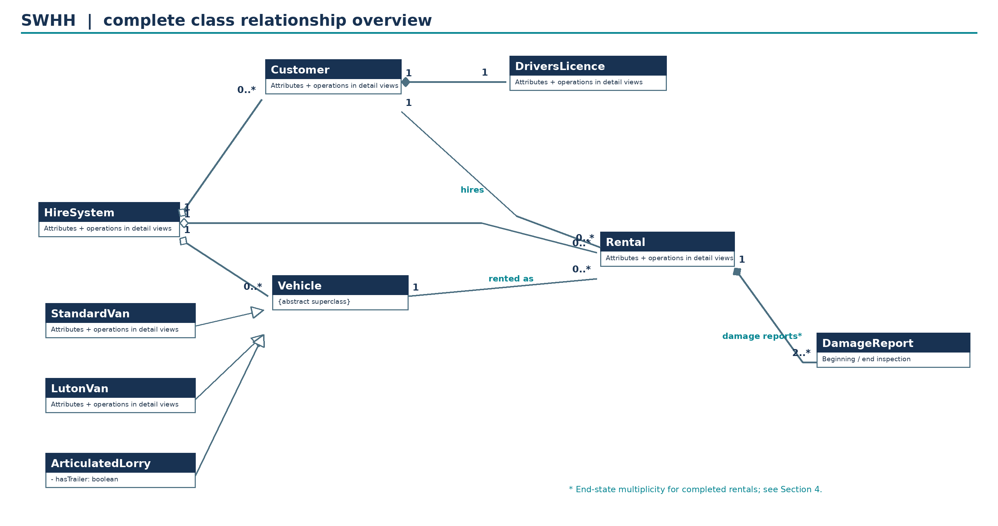
Figure 1. Overall UML class structure, including the Rental–DamageReport composition. The “2..*” end-state requirement applies to completed rentals, as explained in Section 4.

5.2 Detailed rental and management classes
This view details HireSystem, Customer, DriversLicence and Rental. HireSystem now exposes the customer-report and needs-fixing queries, while Rental owns addDamageReport and getDamageReports. Vehicle and DamageReport are shown through their links in Figures 1, 3 and 4.
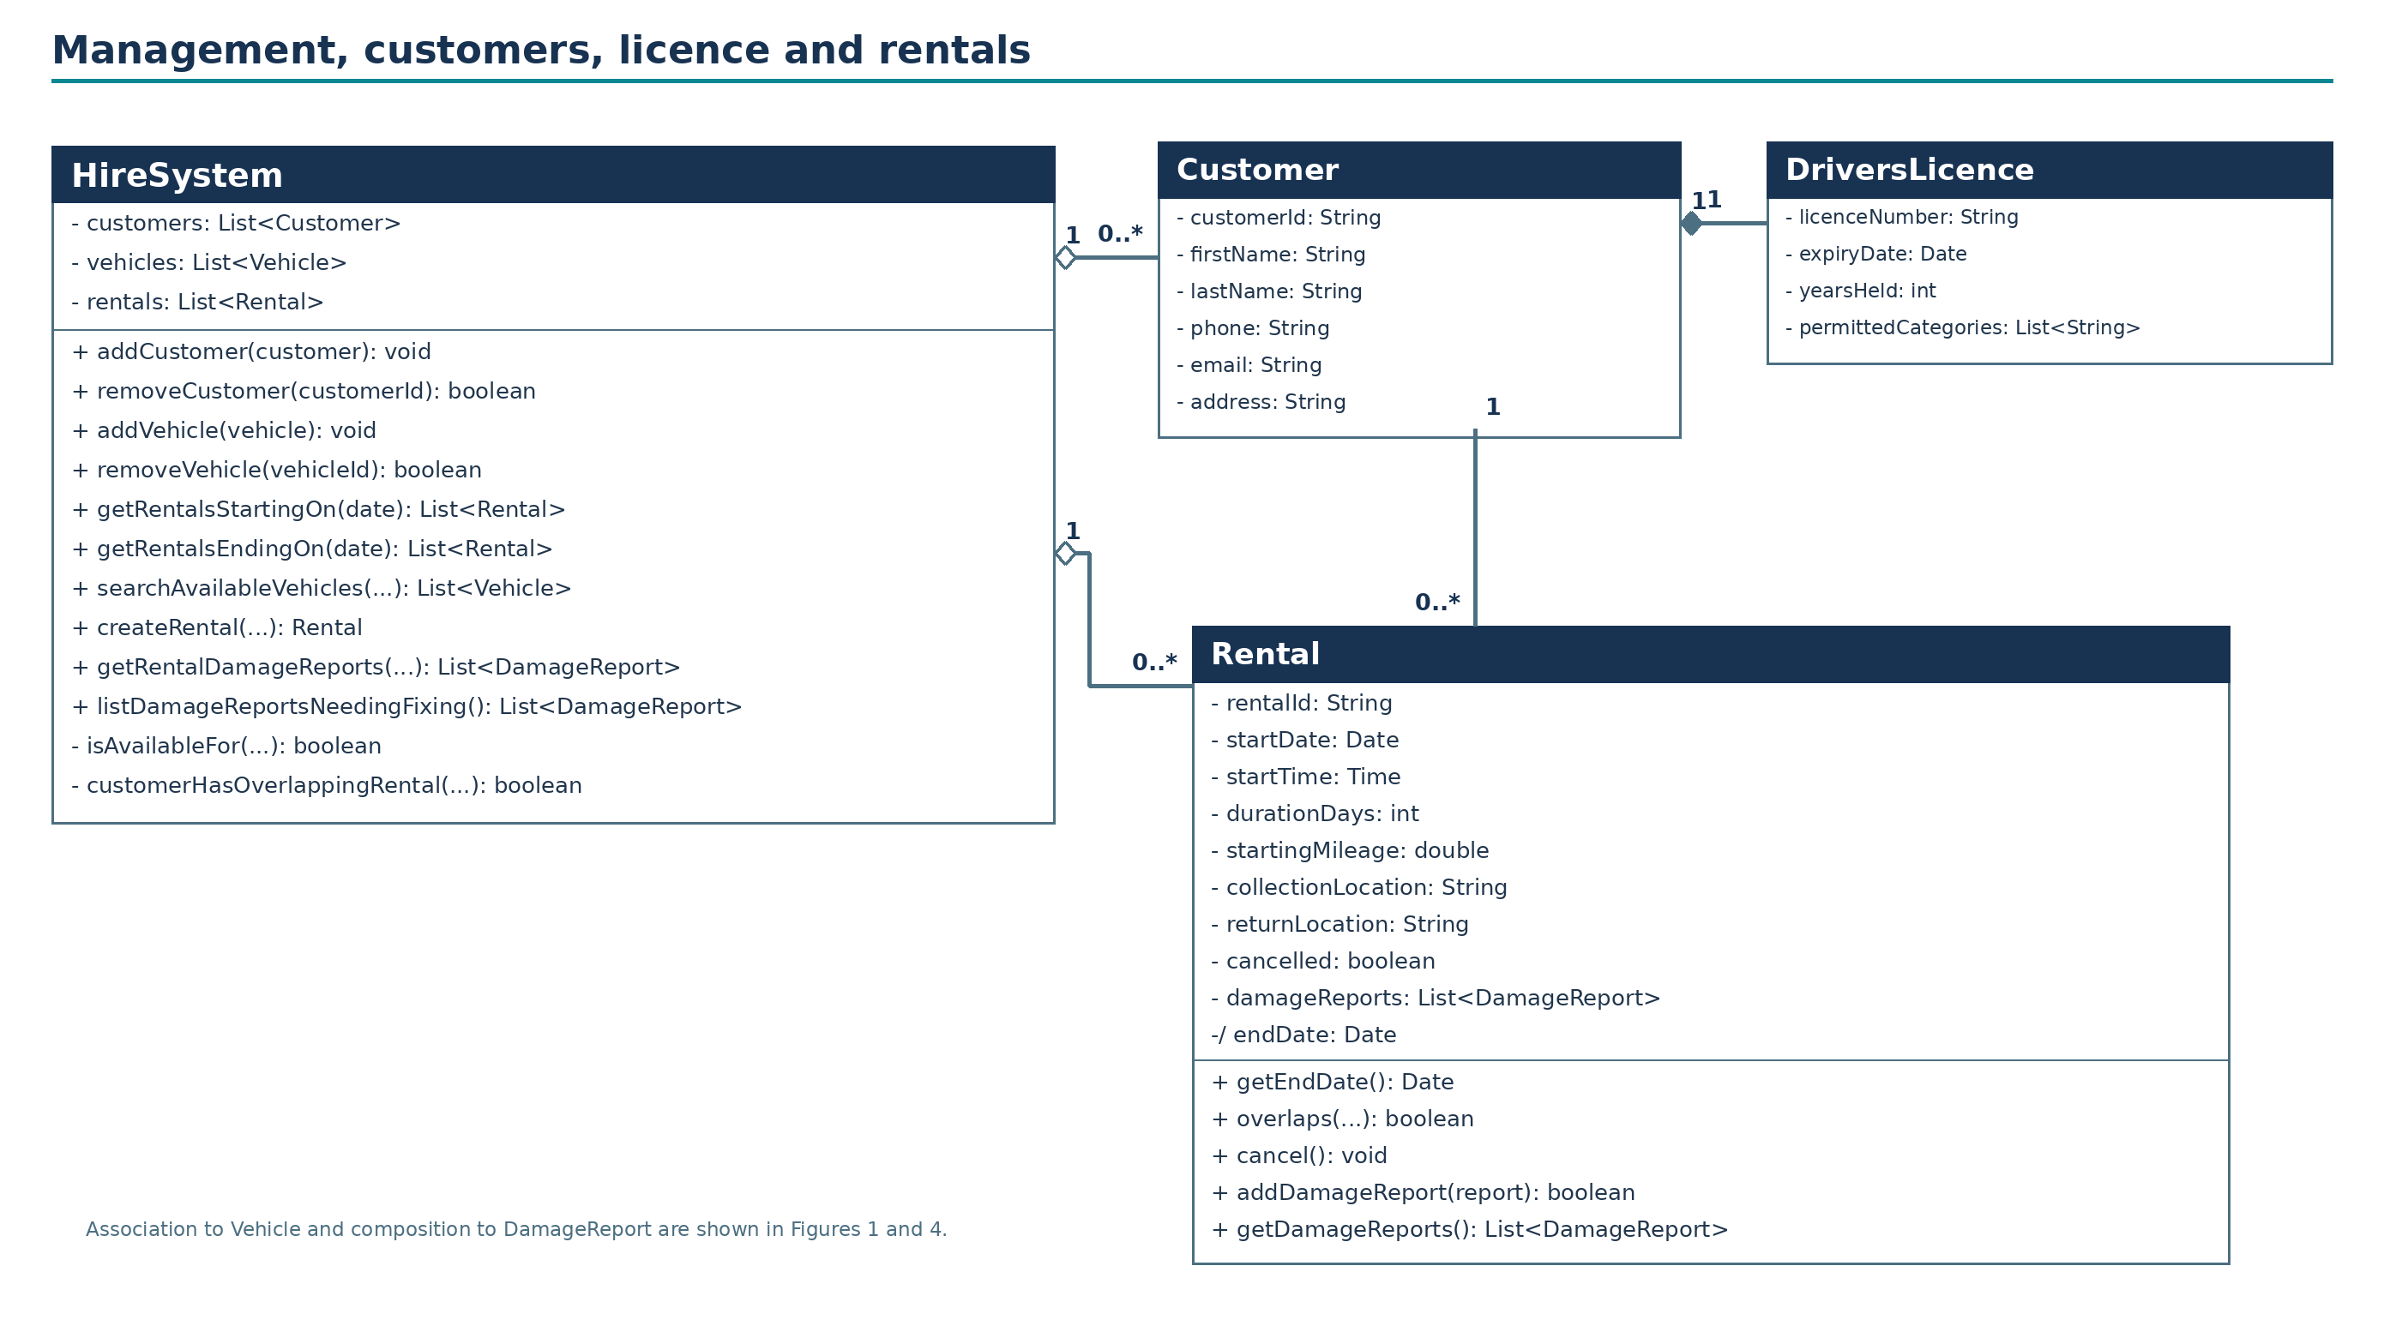
Figure 2. Detailed rental and management classes. Long operation parameter lists are abbreviated visually; their full signatures are in Section 2.2.

5.3 Detailed vehicle hierarchy
The three named concrete vehicle classes inherit Vehicle attributes. StandardVan, LutonVan and ArticulatedLorry each have one optional-equipment Boolean: hasTowBar, hasTailLift and hasTrailer respectively. There is no withTrailer field on Rental.
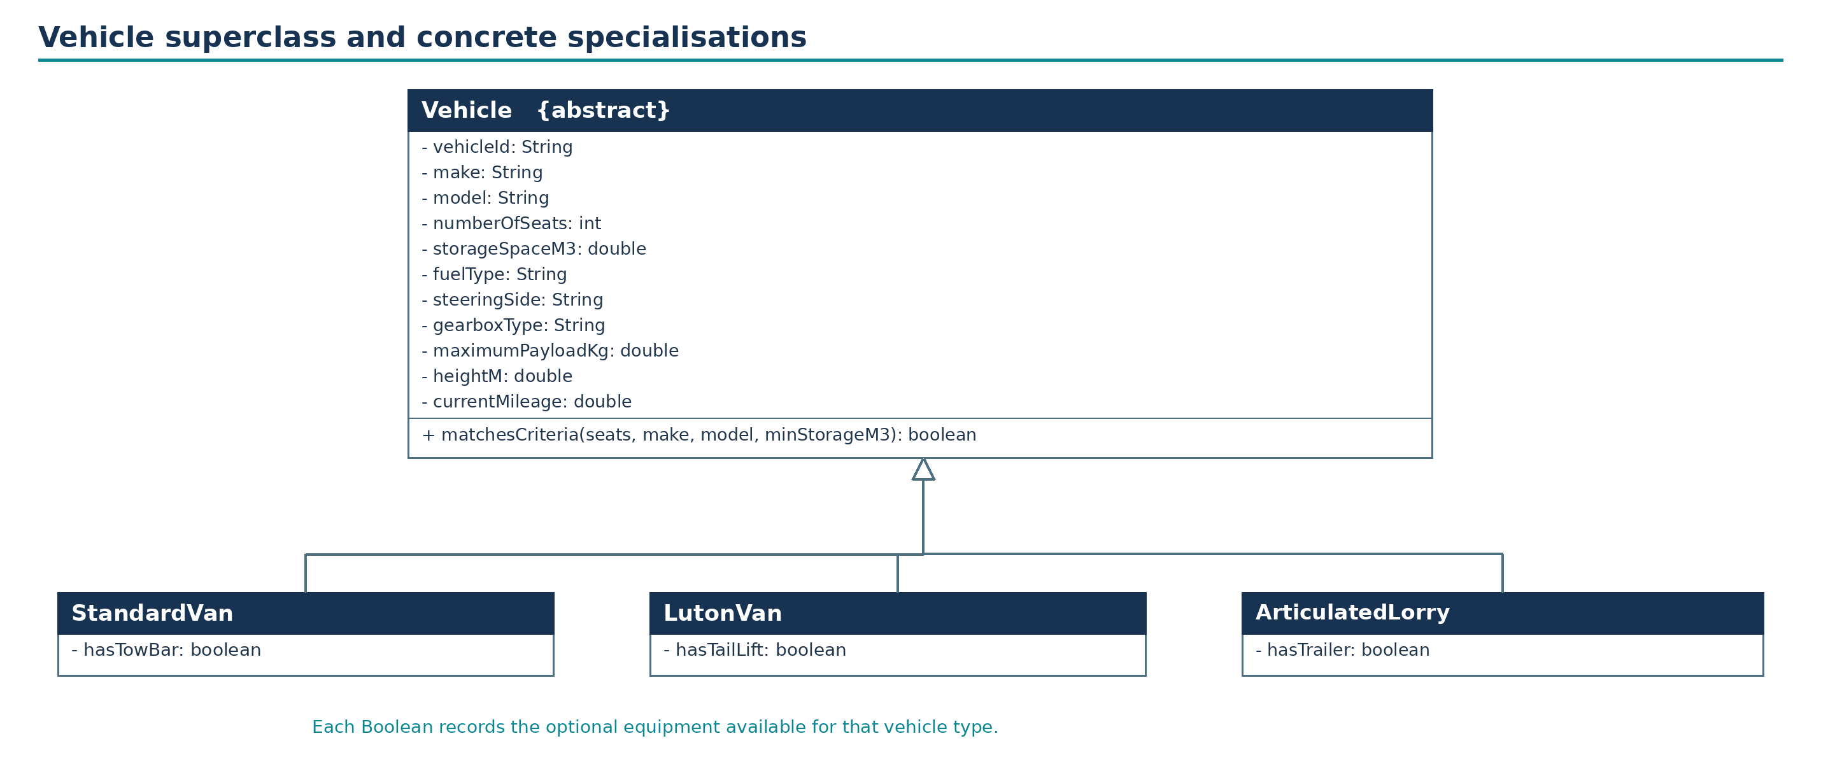
Figure 3. Abstract Vehicle hierarchy with matching Boolean equipment attributes on all three subclasses.

5.4 Rental damage inspection records
The DamageReport class contains the three textual problem descriptions, the needsFixing Boolean and the customerSignature. reportStage distinguishes START and END reports without introducing an extra class. Rental owns the report collection through composition; HireSystem supplies the system-wide query that locates reports requiring fixing.
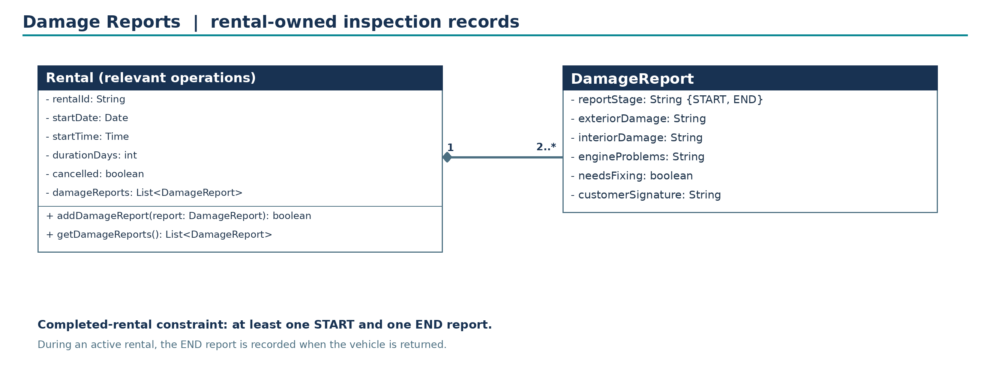
Figure 4. Rental-owned DamageReport records. Multiplicity 2..* describes a completed rental; the stage and inspection timing conditions are explained in Section 4.

5.5 Requirement-by-requirement verification
The following table connects each of the eight Essential Functionality requirements (20 marks) and the Damage Reports requirement (5 marks) to named classes and operations. It is intended as a check that the design covers the supplied scope, not a list of future system features.
Req. | Classes concerned | How the model meets it
1 | Customer; DriversLicence | Names and contact fields in Customer; separate required licence information linked 1–1.
2 | DriversLicence | licenceNumber, expiryDate, yearsHeld and permittedCategories are represented explicitly.
3 | Vehicle; three concrete subclasses | Vehicle is abstract and has precisely the three named concrete subtypes.
4 | Vehicle; StandardVan; LutonVan; ArticulatedLorry | Shared fuel, steering, gearbox, payload, height and search fields reside in Vehicle; all three subclasses expose the corresponding optional-equipment Boolean, including ArticulatedLorry.hasTrailer.
5 | HireSystem; Rental | Add/remove operations and queries on rental start and derived end dates are present.
6 | HireSystem; Vehicle | Search supports seats, make, model and minimum storage space plus dates needed to determine availability.
7 | Rental; Customer; Vehicle | One rental references one customer and one vehicle; records starting mileage, beginning date/time, duration and both locations.
8 | Rental; HireSystem; Customer | cancel() records cancellation, and createRental checks that no conflicting rental exists for a customer.
Damage Reports (5 marks) | Rental; DamageReport; HireSystem | Rental owns beginning and end reports, with exterior/interior/engine descriptions, needsFixing and customerSignature; customers can retrieve their rental reports; HireSystem lists reports needing fixing.

5.6 Operational walkthrough
Adding a customer or vehicle places a typed object in the corresponding HireSystem collection. Removal locates the record by technical identifier and rejects deletion when recorded rentals still refer to it. Queries compare supplied dates against Rental.startDate and derived /endDate; they do not require an independent date or location class.
To search for an available vehicle, HireSystem filters all Vehicle subclasses by the optional seat, make, model and required minimum storage criteria, and then eliminates vehicles having an overlapping uncancelled rental for the requested start and duration. The same overlap check is used during rental creation so that search and creation agree. Hire periods start inclusively and end exclusively; a rental lasting n whole days finishes n calendar days after startDate at the same startTime.
When creating a rental, the system checks the selected Customer and Vehicle have no conflicting uncancelled rental, copies Vehicle.currentMileage to Rental.startingMileage, and records the required beginning date/time, duration and collection/return locations. A customer may have earlier rentals in history but cannot have a second simultaneously active hire. On collection the START DamageReport is recorded; on return an END report is recorded. Rental.getDamageReports provides the records for that rental, while HireSystem.getRentalDamageReports verifies the requesting customer is attached to it. HireSystem.listDamageReportsNeedingFixing traverses existing rentals and returns reports marked needsFixing.

5.7 Explicit assumptions and exclusions
- User clarification: a customer may have many rentals across their history but may hire only one vehicle at a time; this is enforced through overlap checks on uncancelled rentals.
- User clarification: ArticulatedLorry.hasTrailer is the Boolean trailer option, aligned with StandardVan.hasTowBar and LutonVan.hasTailLift. There is no Rental.withTrailer attribute.
- Customer–DriversLicence composition describes the stored licence-information record, not ownership of a legally issued licence. Rental–DamageReport composition describes the inspection record attached to a rental.
- Search availability is evaluated for a specified period; optional fields use null to mean no criterion. Seat count uses equality; storageSpaceM3 means a minimum required volume.
- All weight and height units not stated in the brief are labelled kilograms/metres as modelling choices.
- Dates are compared as local Date and Time values; durationDays is a positive whole number; the rental interval end is exclusive.
- Damage Reports: 2..* is the completed-rental invariant with at least one START and one END report. A rental still in progress cannot have its end inspection yet; a rental cancelled before collection may have no inspection reports. The specification does not resolve these lifecycle cases, so they are documented rather than hidden.
- Signature is represented as String because the requirement requests a signature but does not prescribe a digital representation. Damage descriptions are stored as text exactly as required. The report can have needsFixing true or false; no repair action is modelled.
- No price/payment, insurance, trailer stock management, repair scheduling, digital identity service, maintenance system or other functionality outside the uploaded coursework requirements is included.

