Author: Jason Edwards

Submission that models the classes and relationships of the South Wales Hire and Haulage (SWHH) hire system.
CSF2702: Object Oriented Design– Coursework
Due: 14:00am, 21st October 2026

Contents
Diagram 2
Class Description and Responsibilities 2
HireSystem 2
Customer 2
DriversLicence 3
Vehicle (Abstract Superclass) 3
StandardVan 4
LutonVan 4
ArticulatedLorry 4
Rental 4
Overall Design Rationale 5

Diagram
[Place diagram here]

Class Description and Responsibilities
How the Classes Were Identified
Class | Type | Responsible for
HireSystem | Concrete co-ordinating class | - Maintain customer, vehicle and rental collections.  - Performs the specified management operations, availability searches and date-based rental queries.
Customer | Concrete entity | - Store identifying and contact information for the person hiring a vehicle
DrivingLicense | Concrete entity | - Stores the customer driver licence details
Vehicle | Abstract superclass | Holds the fields common to all three vehicle categories and provides a reusable criteria-matching operation
StandardVan | Concrete subclass of Vehicle | Represents a stand van object with or without a tow bar
LutonVan | Concrete subclass of Vehicle | Represents a Luton van object with or without a tail lift
ArticulatedVan | Concrete subclass of Vehicle | Represents a articulated van object with or without a trailer
Rental | Concrete entity | Links one customer to one vehicle to a hire period and retains damage reports and cancellation state
DamageReport | Concrete entity | Stores the rental inspection details prior to hire and post hire

HireSystem coordinates the collections and system-wide actions: adding/removing customers and vehicles, availability searching, creating rentals, listing rentals by their start or end dates, obtaining a customer’s rental reports, and listing reports needing attention. Customer stores a hirer’s identity/contact details; DriversLicence groups licence number, expiry, years held and permitted categories. Rental represents an individual transaction rather than a permanent attachment between a customer and vehicle.
Vehicle centralises specifications common to StandardVan, LutonVan and ArticulatedLorry, and the three concrete subclasses inherit those details. Each subclass adds the Boolean equipment option named in the specification: hasTowBar, hasTailLift or hasTrailer. The trailer is therefore modelled on ArticulatedLorry (as clarified for this design), not as a rental attribute or independent equipment-inventory class.
DamageReport is a separate class because several reports belong to a rental and every report has its own exterior, interior, engine, repair-needed and signature information. Its reportStage distinguishes the required START and END inspections. No separate classes are added for DamageType, Signature, Trailer, Location or LicenceCategory: the specification gives none of those independent lifecycle or behaviour.

DamageReport belongs to its parent Rental as an information record. The association can therefore express the quantity of reports and their required stages without embedding repeating sets of damage fields directly into Rental.

One of the recurring themes in the PDFs is the identification of objects and classes from the problem domain.
Looking through the requirements, the main nouns are:
- Customer
- Driver's Licence
- Vehicle
- Articulated Lorry
- Luton Van
- Standard Van
- Rental
These represent objects that the business needs to store information about and therefore become obvious candidate classes.
The requirements also specify functions such as:
- Add customer
- Remove customer
- Add vehicle
- Remove vehicle
- Search vehicle
- Produce rental list
The UML material explains that behaviour should be allocated to classes that have responsibility for it. This leads to the introduction of a HireSystem controller class that provides those system-level operations.

HireSystem
The HireSystem class acts as the main controller class for the application and is responsible for managing the collections of customers, vehicles and rentals that exist within the system. Rather than representing a real-world entity, it represents the overall software system and provides the operations required by requirements 5 and 6. The class would typically aggregate multiple Customer, Vehicle and Rental objects, shown through aggregation relationships because these objects can exist independently of the HireSystem itself. The multiplicity between HireSystem and each managed class is 1 to 0..*, meaning one HireSystem manages many customers, vehicles and rentals. The operations such as addCustomer(), removeCustomer(), addVehicle(), removeVehicle(), searchVehicleBySeats(), and getRentalsStartingOnDate() encapsulate the primary business functions identified in the requirements. Navigability would typically be from HireSystem to the managed classes because the system needs to access and maintain these objects.
Background
Why HireSystem Was Introduced
Decision Process
Requirement 5 says:
add customers
remove customers
add vehicles
remove vehicles
Requirement 6 says:
search vehicles
These are not naturally responsibilities of:
- Customer
- Vehicle
- Rental
Instead they represent system behaviour.
Responsibility Allocation
The UML/Object-Oriented Design material emphasises assigning behaviour to the class responsible for it.
Therefore introducing a:
HireSystem
class is reasonable.
Aggregation
The system contains collections of:
Customers
Vehicles
Rentals
but these objects could theoretically exist independently.
Therefore aggregation rather than composition is appropriate.
HireSystem o-- Customer
HireSystem o-- Vehicle
HireSystem o-- Rental
Navigability Decisions
The PDFs likely discuss navigability as indicating which class needs awareness of another.
Customer → DriversLicence
Customer needs access to licence details.
Customer ---> DriversLicence
Rental ↔ Customer
Both may need knowledge of each other.
Rental <----> Customer
Rental ↔ Vehicle
The rental must know the vehicle.
The vehicle may need knowledge of rentals.
Rental <----> Vehicle
HireSystem
The system needs access to everything.
HireSystem --> Customer
HireSystem --> Vehicle
HireSystem --> Rental

Customer
The Customer class represents an individual who hires vehicles from South Wales Hire and Haulage. Its responsibility is to maintain personal and contact information required to identify and communicate with the customer. Typical attributes include customerId, firstName, lastName, phoneNumber, email, and address. The Customer class participates in a composition relationship with the DriversLicence class because the licence details form an essential part of the customer record within the system. The multiplicity between Customer and DriversLicence is 1 to 1, indicating that every customer must possess exactly one driver's licence record.
The Customer class is also associated with the Rental class. A customer may make several rentals over time, therefore the multiplicity is 1 to 0..*. Each Rental must belong to one specific customer. Navigability is typically from Customer to Rental and vice versa, as both objects need to be aware of the relationship. The Customer class may also contain operations such as createRental() and cancelRental() which represent actions that customers can perform within the system.
Background
Decision Process
Requirement 1 states:
Each customer has various details associated with them such as names, contact information and drivers licence information.
The term "customer" represents a tangible business entity for which information must be stored.
According to the object identification guidance from the lectures, anything that has:
- identity
- state
- behaviour
is a strong candidate for a class.
Customer satisfies all three.

Relationships
The Customer participates in two relationships:

Customer → DriversLicence
The requirements state:
Each customer has drivers licence information.
This suggests a strong ownership relationship.
A licence record only exists because a customer exists.
Therefore composition is justified.
Customer ♦──── DriversLicence
Multiplicity:
Customer 1 ----- 1 DriversLicence
because every customer must have exactly one licence.

Customer → Rental
Requirement 7 states:
The system should be able to create a rental
and requirement 8 states:
A customer can only hire one vehicle.
A rental must be associated with a customer.
Therefore
Customer ----- Rental
is a necessary association.

DriversLicence
The DriversLicence class models the driving licence information required for vehicle hire. Separating licence details into their own class follows good object-oriented design principles by grouping related information together and avoiding an overly large Customer class. The attributes specified directly by the requirements include licenceNumber, expiryDate, yearsHeld, and categories.
The DriversLicence class exists as part of a Customer and therefore is modelled using composition. The composition relationship indicates a strong ownership relationship in which the licence information cannot meaningfully exist in the system without being associated with a customer. The multiplicity of 1 to 1 ensures that every Customer possesses exactly one stored licence record and every licence belongs to exactly one customer. A useful operation such as isValid() could be included to determine whether the licence has expired.

Background
Why DriversLicence Became a Separate Class
Decision Process
A common mistake students make is placing all licence details directly into Customer.
However the lecture material discusses grouping related data together and creating separate classes when a concept has its own attributes.
The licence has:
licenceNumber
expiryDate
yearsHeld
categories
This is enough information to justify a dedicated object.
Benefits
Instead of:
Customer
---------
firstName
lastName
licenceNumber
expiryDate
yearsHeld
categories
we get:
Customer
|
DriversLicence
This improves cohesion because licence data is grouped together.
Relationship
The strongest interpretation is composition.
Why?
Because the system specification never treats licences independently.
A licence only exists as part of a customer record.
Therefore:
Customer *-- DriversLicence
is stronger than a normal association.

Vehicle (Abstract Superclass)
The Vehicle class acts as an abstract superclass that captures the common characteristics shared by all vehicle types. The requirements clearly identify three specialised vehicle types that share a number of attributes, making inheritance an appropriate modelling technique. Common attributes include vehicleId, make, model, fuelType, driveSide, gearboxType, maxPayloadWeight, height, numberOfSeats, and storageSpace.
Vehicle participates in a generalisation/inheritance hierarchy where the subclasses StandardVan, LutonVan, and ArticulatedLorry inherit these shared properties. This avoids duplication and promotes maintainability. The Vehicle class is associated with the Rental class because vehicles are the assets being hired. The multiplicity is Vehicle 0.. to Rental 1*, meaning a vehicle may appear in many rentals over its lifetime, while each rental involves exactly one vehicle.
A possible operation such as isAvailable() supports the searching functionality required by the system. Navigability between Vehicle and Rental would normally be bidirectional because it may be necessary to determine which vehicle belongs to a rental and which rentals have involved a particular vehicle.

Background
Why Vehicle Became an Abstract Superclass
Decision Process
Requirement 3 states:
The three types of vehicle they hire are:
- Articulated Lorries
- Luton Vans
- Standard Vans
Requirement 4 then states all three share:
fuel type
drive side
gearbox type
payload weight
height
The UML slides discuss identifying common characteristics.
When several classes share common attributes, inheritance should be considered.
Alternative Approach
Without inheritance:
StandardVan
LutonVan
ArticulatedLorry
would all contain duplicate attributes.
This violates good OO design.
Better Approach
Create:
Vehicle
as a superclass.
Then:
Vehicle
^
|
-------------------------------------
| | |
Standard Luton Articulated
Van Van Lorry
This allows all common attributes to be defined once.
Why Abstract?
The requirements never say:
A customer rents a generic vehicle.
Instead they rent a particular type.
Therefore Vehicle is really a general concept used to share characteristics.
It would make sense to model it as abstract.

StandardVan
The StandardVan class is a specialised form of Vehicle and inherits all common vehicle attributes and behaviours from the Vehicle superclass. Its additional responsibility is to represent the specific feature unique to standard vans, namely the availability of a tow bar attachment. This is represented by the attribute towBar : boolean.
The relationship between StandardVan and Vehicle is an inheritance (generalisation) relationship. The subclass does not require a separate association with Rental because it inherits the Vehicle associations and can therefore participate in rentals in exactly the same way as any other vehicle type. The multiplicities and navigability associated with Vehicle are inherited by StandardVan.
Background
Why StandardVan, LutonVan and ArticulatedLorry Became Subclasses
Decision Process
Requirement 4 identifies unique characteristics.
StandardVan
tow bar attachment
Inheritance Rationale
Each vehicle type:
- shares common vehicle data
- has unique features
This is exactly the scenario where the UML lectures introduce generalisation/specialisation.

LutonVan
The LutonVan class is another specialised subclass of Vehicle. It represents a vehicle that may optionally include a tail lift, which is captured by the attribute tailLift : boolean. Like StandardVan, LutonVan inherits all common vehicle attributes such as make, model, fuel type and seating capacity from Vehicle.
The relationship between LutonVan and Vehicle is a generalisation relationship. This subclass exists to model behaviour and characteristics unique to Luton vans while maintaining common functionality within the Vehicle superclass. The inherited relationships with Rental mean that Luton vans can be selected, searched for and rented in the same manner as other vehicle types.
Background
Background
Why StandardVan, LutonVan and ArticulatedLorry Became Subclasses
Decision Process
Requirement 4 identifies unique characteristics.
LutonVan
tail lift
Inheritance Rationale
Each vehicle type:
- shares common vehicle data
- has unique features
This is exactly the scenario where the UML lectures introduce generalisation/specialisation.

ArticulatedLorry
The ArticulatedLorry class represents the third vehicle type identified in the requirements. It inherits all common vehicle information from the Vehicle superclass and introduces the additional attribute trailerIncluded : boolean, reflecting the requirement that articulated lorries can optionally be hired with a trailer.
The class participates in the same inheritance hierarchy as StandardVan and LutonVan. Through inheritance it acquires all Vehicle attributes, operations and associations. This design ensures consistency whilst still allowing vehicle-specific characteristics to be represented. ArticulatedLorry instances can therefore participate in rental relationships through the inherited Vehicle association.
Background
Why StandardVan, LutonVan and ArticulatedLorry Became Subclasses
Decision Process
Requirement 4 identifies unique characteristics.
optional trailer
Inheritance Rationale
Each vehicle type:
- shares common vehicle data
- has unique features
This is exactly the scenario where the UML lectures introduce generalisation/specialisation.

Rental
The Rental class is one of the most important classes in the model because it represents the transaction that links a customer to a vehicle. It acts as an associative class that captures information specific to a particular hire agreement. Attributes derived directly from the requirements include rentalId, currentMileage, startDateTime, durationDays, collectionLocation, returnLocation, and status.
The Rental class is associated with exactly one Customer and exactly one Vehicle. The multiplicity between Customer and Rental is 1 to 0.., allowing customers to make multiple rentals over time. The multiplicity between Rental and Vehicle is 1 to 1, meaning each rental concerns a single vehicle. Conversely, a Vehicle can participate in 0.. rentals over its lifetime.
The Rental class is also responsible for supporting requirement 8. The operation cancel() allows a hire agreement to be cancelled, while a suitable status value such as Active, Completed or Cancelled tracks its state. A method such as getEndDate() can calculate the end date from the start date and rental duration. Navigability is typically bidirectional between Rental and both Customer and Vehicle because the rental needs to know the customer making the booking and the vehicle being hired.

Background
Why Rental Became a Class
Decision Process
Rental is perhaps the most important class.
Requirement 7 introduces information such as:
- current mileage
- start date
- duration
- collection location
- return location
These attributes do not belong to Customer.
They do not belong to Vehicle.
They belong to the specific act of hiring.
Association Class Thinking
The lectures discuss that relationships sometimes need their own information.
Customer and Vehicle are related through a hire.
The hire itself contains data.
Therefore:
Rental
must become its own class.
Relationships
Rental ↔ Customer
A rental belongs to one customer.
Rental 1 ----- Customer
Rental ↔ Vehicle
A rental involves one vehicle.
Rental 1 ----- Vehicle
Multiplicity Discussion
This is where assessors often look for justification.
Vehicle Side
One rental involves:
1 vehicle
So
Rental ----- 1 Vehicle
Rental History
A vehicle can be rented many times.
Vehicle ----- 0..* Rental
This supports historical records.
Customer Side
There are two possible interpretations.
Interpretation 1
Customer ----- 0..1 Rental
This enforces the wording:
customer can only hire one vehicle
literally.
Interpretation 2 (Usually Better)
Customer ----- 0..* Rental
with a constraint:
Only one active rental at a time.
This allows historical rentals.
This is usually the stronger design because real rental records should not disappear.

Overall Design Rationale
The model uses several key object-oriented design principles. Inheritance is used to represent the three specialised vehicle types while avoiding duplication of common vehicle data. Composition is used between Customer and DriversLicence to represent strong ownership. Aggregation is used by HireSystem to manage collections of customers, vehicles and rentals. Associations connect Rental with Customer and Vehicle because rentals represent the relationship between those business entities. Appropriate multiplicities ensure that the design reflects the business requirements whilst remaining realistic and implementable in Java. The resulting class model provides sufficient detail for a programmer to create classes, fields, methods and object relationships directly from the UML design.

Background
Summary of UML Concepts Used
UML Concept | Where Applied | Reason
Class Identification | Customer, Vehicle, Rental, DriversLicence | These are key business entities mentioned in the requirements
Attributes | All classes | Derived directly from information specified in requirements
Operations | HireSystem, Rental, Customer | Derived from required system behaviour
Association | Customer-Rental, Rental-Vehicle | Objects need to interact
Composition | Customer-DriversLicence | Strong ownership relationship
Aggregation | HireSystem-managed collections | System manages but does not own lifecycle
Inheritance | Vehicle hierarchy | Shared vehicle information with specialised differences
Multiplicity | All relationships | Models business rules and constraints
Navigability | System and Rental relationships | Indicates object awareness and access

If I were writing this up for submission, I'd explicitly state that every class, attribute and relationship can be traced directly back to one or more requirements and modelled using the UML concepts introduced in the three lecture PDFs, which demonstrates that the design was derived from the analysis rather than additional assumptions or future enhancements.

A requirement-to-class traceability table is an excellent addition because it demonstrates to stakeholders that every element of the design can be justified from the specification. It also helps show that no unnecessary classes or features have been introduced.
Requirement-to-Class Traceability Table
Requirement | Identified Class(es) | Reasoning
The system needs to store information on customers, vehicles and rentals. | Customer, Vehicle, Rental | These are the primary business entities explicitly identified in the requirements and therefore become core classes within the model.
Each customer has various details associated with them such as names, contact information and drivers licence information. | Customer, DriversLicence | Customer stores personal and contact details. DriversLicence is separated because it has its own distinct attributes and represents a separate concept.
A drivers licence has a number, an expiry date, number of years held and categories of vehicles that can be driven. | DriversLicence | All specified licence-related details become attributes of the DriversLicence class.
The three types of vehicle they hire are Articulated Lorries, Luton Vans and Standard Vans. | Vehicle, ArticulatedLorry, LutonVan, StandardVan | The common concept of Vehicle becomes a superclass. The three vehicle types become subclasses using inheritance.
All vehicles have a fuel type, left or righthand drive, gearbox type, maximum payload weight and height. | Vehicle | These characteristics are common to all vehicle types and therefore belong in the Vehicle superclass.
Standard Vans have the option of a tow bar attachment. | StandardVan | Tow bar is unique to Standard Vans and therefore becomes a subclass attribute.
Luton Vans have the option of a tail lift. | LutonVan | Tail lift is unique to Luton Vans and becomes a subclass attribute.
Articulated Lorries can optionally be hired with a trailer. | ArticulatedLorry | Trailer availability is unique to articulated lorries and therefore belongs in this subclass.
The system should add customers. | HireSystem | Represents a system-level operation and therefore belongs within the system controller class.
The system should remove customers. | HireSystem | Administrative functionality performed by the system.
The system should add vehicles. | HireSystem | Administrative functionality performed by the system.
The system should remove vehicles. | HireSystem | Administrative functionality performed by the system.
Produce a list of rentals that begin or end on a given date. | HireSystem, Rental | HireSystem performs the search operation while Rental stores the relevant dates.
Search for available vehicles by seats, make, model or storage space. | HireSystem, Vehicle | Vehicle stores searchable information. HireSystem performs the search operation across vehicles.
Create a rental containing vehicle, mileage, date/time, duration and locations. | Rental, Customer, Vehicle | Rental stores all hire-specific information and links the customer to the selected vehicle.
A rental should be able to be cancelled. | Rental | Cancellation is behaviour specific to the Rental object.
A customer can only hire one vehicle. | Customer, Rental, Vehicle | This business rule influences multiplicities and association constraints between these classes.

Relationship Traceability Table
This table is often worth including because it explains exactly where each relationship came from.
Relationship | UML Type | Requirement Justification
Customer ♦─ DriversLicence | Composition | The requirements describe licence information as belonging to a customer. The licence is not treated independently elsewhere in the requirements.
Customer ─ Rental | Association | A rental must be created for a customer.
Rental ─ Vehicle | Association | Every rental involves a specific vehicle.
Vehicle | -- StandardVan | Inheritance
Vehicle | -- LutonVan | Inheritance
Vehicle | -- ArticulatedLorry | Inheritance
HireSystem o─ Customer | Aggregation | The system manages collections of customers.
HireSystem o─ Vehicle | Aggregation | The system manages collections of vehicles.
HireSystem o─ Rental | Aggregation | The system manages collections of rentals.

Attribute Traceability Table
Class | Attribute | Requirement Source
Customer | firstName, lastName | Customer names
Customer | phoneNumber, email, address | Contact information
DriversLicence | licenceNumber | Licence number
DriversLicence | expiryDate | Licence expiry date
DriversLicence | yearsHeld | Number of years licence held
DriversLicence | categories | Vehicle categories permitted
Vehicle | fuelType | Fuel type
Vehicle | driveSide | Left/right hand drive
Vehicle | gearboxType | Automatic/manual gearbox
Vehicle | maxPayloadWeight | Maximum payload weight
Vehicle | height | Vehicle height
Vehicle | numberOfSeats | Search requirement
Vehicle | storageSpace | Search requirement
StandardVan | towBar | Optional tow bar attachment
LutonVan | tailLift | Optional tail lift
ArticulatedLorry | trailerIncluded | Optional trailer
Rental | currentMileage | Rental creation requirement
Rental | startDateTime | Rental start requirement
Rental | durationDays | Rental duration requirement
Rental | collectionLocation | Collection location
Rental | returnLocation | Return location
Rental | status | Supports cancellation and rental state

Multiplicity Traceability Table
Relationship | Multiplicity | Justification
Customer - DriversLicence | 1 .. 1 | Each customer has one licence record and each licence belongs to one customer.
Customer - Rental | 1 .. 0..* | Customers may make multiple rentals over time.
Rental - Vehicle | 1 .. 1 | Each rental concerns exactly one vehicle.
Vehicle - Rental | 0..* .. 1 | Vehicles may participate in multiple rentals throughout their lifetime.
HireSystem - Customer | 1 .. 0..* | System manages many customers.
HireSystem - Vehicle | 1 .. 0..* | System manages many vehicles.
HireSystem - Rental | 1 .. 0..* | System manages many rentals.

Strong justification for your report
A concise statement you could include is:
The requirements were analysed to identify key domain concepts, resulting in the classes Customer, DriversLicence, Vehicle, StandardVan, LutonVan, ArticulatedLorry and Rental. The system operations specified in requirements 5 and 6 led to the introduction of the HireSystem controller class. Inheritance was applied where multiple vehicle types shared common attributes and behaviour. Composition was used between Customer and DriversLicence to represent strong ownership, whilst aggregation was used between HireSystem and the managed collections of business objects. All attributes, operations, associations and multiplicities can be directly traced to one or more stated requirements, ensuring the model remains aligned to the specification and does not introduce functionality beyond the scope of the problem domain.

1 Identifying sensible classes and subclasses
The classes below arise from the entities and responsibilities described in the entire coursework specification. Vehicle is abstract, avoiding duplicate common attributes; DamageReport is an additional concrete entity needed for the required beginning/end inspections and repair-needed listing.
Class | Kind | Responsibility
HireSystem | Concrete coordinating class | Maintains customer, vehicle and rental collections; performs the specified management operations, availability searches and date-based rental queries.
Customer | Concrete entity | Stores identifying and contact information for a hirer and is associated with that customer’s rentals.
DriversLicence | Concrete entity | Stores the customer’s licence data, including categories of vehicle they are licensed to drive.
Vehicle | Abstract superclass | Holds the fields common to all three hire-vehicle categories and provides a reusable criteria-matching operation.
StandardVan | Concrete subclass of Vehicle | Represents a standard van and records whether it has a tow bar.
LutonVan | Concrete subclass of Vehicle | Represents a Luton van and records whether it has a tail lift.
ArticulatedLorry | Concrete subclass of Vehicle | Represents an articulated lorry and records the optional trailer with a Boolean attribute.
Rental | Concrete entity | Links one customer and one vehicle to a hire period and retains damage reports and cancellation state.
DamageReport | Concrete entity | Stores the rental inspection stage, exterior/interior/engine findings, whether fixing is needed and the customer signature.

Why this decomposition works
HireSystem coordinates the collections and system-wide actions: adding/removing customers and vehicles, availability searching, creating rentals, listing rentals by their start or end dates, obtaining a customer’s rental reports, and listing reports needing attention. Customer stores a hirer’s identity/contact details; DriversLicence groups licence number, expiry, years held and permitted categories. Rental represents an individual transaction rather than a permanent attachment between a customer and vehicle.
Vehicle centralises specifications common to StandardVan, LutonVan and ArticulatedLorry, and the three concrete subclasses inherit those details. Each subclass adds the Boolean equipment option named in the specification: hasTowBar, hasTailLift or hasTrailer. The trailer is therefore modelled on ArticulatedLorry (as clarified for this design), not as a rental attribute or independent equipment-inventory class.
DamageReport is a separate class because several reports belong to a rental and every report has its own exterior, interior, engine, repair-needed and signature information. Its reportStage distinguishes the required START and END inspections. No separate classes are added for DamageType, Signature, Trailer, Location or LicenceCategory: the specification gives none of those independent lifecycle or behaviour.

DamageReport belongs to its parent Rental as an information record. The association can therefore express the quantity of reports and their required stages without embedding repeating sets of damage fields directly into Rental.

2 Well-chosen attributes and useful operations
The attributes listed below account for all classes in the full coursework. Shared Vehicle fields appear only once in the abstract superclass; each subclass adds only its named optional equipment flag. All stored fields are private (“–”) to support encapsulation, with one derived Rental attribute denoted “–/”. No final attribute is required merely to satisfy the mark scheme; making values immutable without a requirement could obstruct updates.

2.1 Attributes by class

HireSystem
Attribute | Data type | UML | Purpose
customers | List<Customer> | – | Customer records held by the system; the aggregation is also drawn in the UML.
vehicles | List<Vehicle> | – | The heterogeneous fleet, using the Vehicle superclass as the collection type.
rentals | List<Rental> | – | Historical, current and scheduled rental records.

The three collections operationalise the system’s ability to manage multiple records. Their UML aggregation lines in Section 5 describe these same associations; the attributes do not create a second set of objects.

Customer
Attribute | Data type | UML | Purpose
customerId | String | – | Technical identifier so the required removal operation can unambiguously select a customer.
firstName | String | – | Customer’s given name.
lastName | String | – | Customer’s family name.
email | String | – | An item of contact information.
telephone | String | – | A second contact channel.
contactAddress | String | – | Postal/contact address; no address-management subsystem is introduced.

Personal and contact fields are kept private in keeping with the Week 1 encapsulation recap. The licence itself is related through a one-to-one composition rather than copied into the customer’s attributes.

DriversLicence
Attribute | Data type | UML | Purpose
licenceNumber | String | – | Licence number; String avoids assuming an arithmetic format.
expiryDate | Date | – | Licence expiry, using the permitted Date type.
yearsHeld | int | – | Number of years the customer has held the licence, as requested.
permittedCategories | List<String> | – | One or more licence vehicle categories; actual category names are not specified.

Categories are a collection because the specification uses the plural. The model stores yearsHeld explicitly because no original issue date is supplied from which it could safely be derived.

Vehicle
Attribute | Data type | UML | Purpose
vehicleId | String | – | Technical identifier distinguishing vehicles in the fleet.
make | String | – | Make against which availability searches can filter.
model | String | – | Model against which availability searches can filter.
numberOfSeats | int | – | Number of passenger seats, used by the search.
storageSpaceM3 | double | – | Available storage volume in cubic metres.
fuelType | String | – | Fuel type (the brief gives no closed list).
steeringSide | String | – | Restricted to left or right.
gearboxType | String | – | Restricted to automatic or manual.
maximumPayloadKg | double | – | Maximum payload weight; kilograms adopted as a documented unit assumption.
heightM | double | – | Vehicle height; metres adopted as a documented unit assumption.
currentMileage | double | – | Current vehicle mileage, copied to Rental.startingMileage when a rental is created.

All search-related fields belong in Vehicle because all three concrete vehicle types may be searched. String is used for unspecified fuel categories; the values of steeringSide and gearboxType are constrained by the stated alternatives. The adopted units for weight and height are assumptions, not additional data requirements.

StandardVan
Attribute | Data type | UML | Purpose
hasTowBar | boolean | – | Whether this particular van has the optional tow-bar attachment.

A Boolean accurately represents whether the specified optional tow bar is fitted; separate TowBar objects would be unwarranted.

LutonVan
Attribute | Data type | UML | Purpose
hasTailLift | boolean | – | Whether this particular van has the optional tail lift.

The Boolean flag records whether a tail lift is fitted, without introducing equipment-maintenance behaviour.

ArticulatedLorry
Attribute | Data type | UML | Purpose
hasTrailer | boolean | – | Whether this articulated lorry has the optional trailer available for hire, matching the Boolean equipment style used in both van subclasses.
ArticulatedLorry inherits all shared Vehicle fields and adds hasTrailer: boolean, consistent with StandardVan.hasTowBar and LutonVan.hasTailLift. The trailer is not modelled as an independent object.
The Boolean records the articulated-lorry trailer option. Its true/false value is a property of the particular lorry within this model; it is not a per-rental selection.

Rental
Attribute | Data type | UML | Purpose
rentalId | String | – | Technical identifier for a rental record.
startDate | Date | – | Calendar date the hire starts.
startTime | Time | – | Time of day the hire starts.
durationDays | int | – | Hire length in whole days; must be greater than zero.
startingMileage | double | – | Snapshot of the vehicle’s current mileage when the hire is created.
collectionLocation | String | – | Location at which the vehicle is collected.
returnLocation | String | – | Location at which the vehicle is returned.
cancelled | boolean | – | False on creation; becomes true after cancellation.
damageReports | List<DamageReport> | – | Report records attached to this Rental through the composition relationship, including START and END inspections.
/endDate | Date | –/ | Derived from startDate and durationDays, not separately stored.

Each Rental records one hire period, including its starting mileage snapshot, both locations and cancellation status. The computed /endDate avoids duplicating information already represented by startDate and durationDays. Historical rentals remain attached to their customer and vehicle, while a business constraint prevents overlapping active hires. Trailer availability is defined only by ArticulatedLorry.hasTrailer.

DamageReport
Attribute | Data type | UML | Purpose
reportStage | String | – | Distinguishes an inspection at the START of a rental from one at the END; allowed values are START or END.
exteriorDamage | String | – | Text describing any exterior damage; an empty description means no issue was recorded.
interiorDamage | String | – | Text describing any interior damage.
engineProblems | String | – | Text describing any engine problems.
needsFixing | boolean | – | True when this report identifies damage that needs to be fixed.
customerSignature | String | – | Stores the customer signature associated with this inspection; the brief does not specify a digital-signature format.
This class is owned by its Rental and does not need an independent customer or vehicle association: those are already available through the Rental links. The three description fields remain textual, matching the brief exactly. reportStage is a restricted String because the only stated stages are the beginning and end of a rental; no extra lifecycle class is required.

2.2 Operations (including parameters and return types)
Only operations needed for the stated business processes and implementation of the required constraints are listed. The existing search and rental operations remain, while report recording, customer report retrieval and the repair-needed list are integrated. Routine constructors, setters and getters are omitted where they do not add useful class-diagram information, consistent with the lecture notes.
Owner | UML operation signature | Purpose / behaviour
HireSystem | + addCustomer(customer: Customer): void | Add the given customer to the managed customer collection.
HireSystem | + removeCustomer(customerId: String): boolean | Remove an identified customer, returning false if removal would leave invalid linked records.
HireSystem | + addVehicle(vehicle: Vehicle): void | Register a standard van, Luton van or articulated lorry through the common Vehicle type.
HireSystem | + removeVehicle(vehicleId: String): boolean | Remove an identified vehicle, returning false if existing rentals depend on it.
HireSystem | + getRentalsStartingOn(date: Date): List<Rental> | Retrieve rentals whose startDate matches the requested date.
HireSystem | + getRentalsEndingOn(date: Date): List<Rental> | Retrieve rentals whose derived endDate matches the requested date.
HireSystem | + searchAvailableVehicles(seats: Integer, make: String, model: String, minStorageM3: Double, startDate: Date, startTime: Time, durationDays: int): List<Vehicle> | Apply optional vehicle search criteria, then reject vehicles with overlapping uncancelled rentals.
HireSystem | + createRental(customer: Customer, vehicle: Vehicle, startDate: Date, startTime: Time, durationDays: int, collectionLocation: String, returnLocation: String): Rental | Create only when customer and vehicle have no conflicting uncancelled rental; capture starting vehicle mileage.
HireSystem | – isAvailableFor(vehicle: Vehicle, startDate: Date, startTime: Time, durationDays: int): boolean | Internal availability test reused by search and rental creation.
HireSystem | – customerHasOverlappingRental(customer: Customer, startDate: Date, startTime: Time, durationDays: int): boolean | Internal check enforcing one concurrent vehicle per customer.
Vehicle | + matchesCriteria(seats: Integer, make: String, model: String, minStorageM3: Double): boolean | Check only the non-null search criteria against shared vehicle fields.
Rental | + getEndDate(): Date | Calculate the derived endDate; when durations are whole days, the end clock time is startTime.
Rental | + overlaps(startDate: Date, startTime: Time, durationDays: int): boolean | Test whether the rental’s time interval overlaps a proposed interval.
Rental | + cancel(): void | Set the cancellation flag; the rental remains in the recorded history.
Rental | + addDamageReport(report: DamageReport): boolean | Attach a START or END inspection to this rental; check that the report stage is valid.
Rental | + getDamageReports(): List<DamageReport> | Return the inspection records associated with this rental.
HireSystem | + getRentalDamageReports(customer: Customer, rental: Rental): List<DamageReport> | Give a customer the reports for a rental associated with that customer, without creating a user-account system.
HireSystem | + listDamageReportsNeedingFixing(): List<DamageReport> | Find and return all Rental-owned reports whose needsFixing flag is true.

Operations and visibility rationale
Public (+) HireSystem operations provide the required record management, rental querying, vehicle search, rental creation and customer/report queries. Rental is responsible for its own cancellation, date calculations and attached damage reports. The private (–) HireSystem methods support availability and the single-vehicle-at-a-time constraint. A report is created at a relevant inspection stage; no repair process or customer-login mechanism is added.
The Integer and Double wrapper parameter types in search operations denote optional filters: a null value means “not specified”, while required startDate, startTime and durationDays are always provided. This implementation convention is explicitly a design assumption. All attributes remain private, including inherited vehicle fields, and the public methods expose only purposeful behaviour.

2.3 Derived, final and abstract notation
Rental./endDate is derived because the start date and rental duration already determine it. Vehicle is abstract because only the specified three vehicle categories are instantiated. The Week 2 notes mention capitalised “final” items, but there is no reason to mark the variable business fields final here: customers’ contact details, vehicle mileage, cancelled state and inspection records may change as the required process runs. DamageReport.needsFixing is ordinary stored Boolean data, not a derived or final member.

3 Well-chosen relationships between classes
Each relationship below serves a distinct purpose. The UML uses ordinary association for independently existing customer/vehicle hire participants, shared aggregation for system-managed collections, composition for licence information owned in the model and for damage-report records owned by Rental, and generalisation for the vehicle subclasses.
Connected classes | UML relationship | How shown | Why it fits
HireSystem — Customer | Shared aggregation | Open diamond at HireSystem | The system groups and manages customer records. A customer remains a domain entity rather than a physical part of the system.
HireSystem — Vehicle | Shared aggregation | Open diamond at HireSystem | The system manages a collection of independently existing vehicles.
HireSystem — Rental | Shared aggregation | Open diamond at HireSystem | The system maintains rental records; the link denotes organised records, not ownership of a physical vehicle.
Customer — DriversLicence | Composition (of stored record) | Filled diamond at Customer | The DriversLicence object is treated as an owned information record attached to one customer; this does not claim the real-world licence ceases to exist if data is deleted.
Customer — Rental | Association | Solid line | One customer is linked to each rental; their rental history can have many entries.
Vehicle — Rental | Association | Solid line | One vehicle is used per rental; it survives beyond any particular rental.
Rental — DamageReport | Composition | Filled diamond at Rental | A DamageReport is an inspection record of one Rental; reports have no independent role in the stated hire business.
StandardVan — Vehicle | Generalisation | Solid line; hollow triangle points to Vehicle | StandardVan inherits shared vehicle characteristics.
LutonVan — Vehicle | Generalisation | Solid line; hollow triangle points to Vehicle | LutonVan inherits shared vehicle characteristics.
ArticulatedLorry — Vehicle | Generalisation | Solid line; hollow triangle points to Vehicle | ArticulatedLorry inherits shared fields, and its type permits the trailer option.

Relationship reasoning
HireSystem uses shared aggregation to group Customer, Vehicle and Rental records; the model does not imply that deleting the HireSystem destroys those business entities. Customer–DriversLicence uses composition for the licence-information record maintained with a customer, not for legal ownership of the physical driving licence. Rental–DamageReport uses composition because each report is specifically associated with a rental and its inspection stages.
Customer–Rental and Vehicle–Rental are associations because customers and vehicles outlive individual hires. Historical rentals may accumulate without allowing overlapping uncancelled hires. Rental–DamageReport instead uses composition for inspections belonging to one rental.
Vehicle specialisations use hollow-triangle generalisation arrows: StandardVan, LutonVan and ArticulatedLorry inherit common characteristics. Each subclass then provides its own Boolean equipment flag. There is no separate Trailer association and no DamageReport–Customer shortcut because the already-modelled Customer–Rental–DamageReport path suffices.

4 Appropriate multiplicities and constraints
The numbers in the two “end” columns attach to the named class at that end. For Customer–Rental, 1 at Customer means each rental has one customer; 0..* at Rental permits a customer to retain many transactions over time. For Rental–DamageReport, 1 at Rental means each report belongs to one rental; 2..* at DamageReport is the completed-record requirement, interpreted with the lifecycle note immediately below.
Class A — Class B | At A | At B | Reading
HireSystem — Customer | 1 | 0..* | One managing system has zero or more customer records; each managed record belongs to one system.
HireSystem — Vehicle | 1 | 0..* | One system manages zero or more vehicles.
HireSystem — Rental | 1 | 0..* | One system records zero or more rentals.
Customer — DriversLicence | 1 | 1 | Each modelled customer has exactly one stored licence information record.
Customer — Rental | 1 | 0..* | Each rental belongs to one customer; a customer can accumulate a rental history.
Vehicle — Rental | 1 | 0..* | Each rental concerns one vehicle; a vehicle may appear in successive rentals.
Rental — DamageReport | 1 | 2..* | Each damage report belongs to exactly one rental; a completed rental has at least two reports, including a START and an END report.
StandardVan → Vehicle | — | — | Inheritance is an is-a relationship, not an association whose ends need 0..* multiplicities.
LutonVan → Vehicle | — | — | Inheritance uses a generalisation arrow, rather than association multiplicities.
ArticulatedLorry → Vehicle | — | — | Inheritance uses a generalisation arrow, rather than association multiplicities.

Why historical multiplicity and active hire differ
The user-confirmed business rule is that a customer can hire only one vehicle at any one time, while accumulating multiple rental transactions historically. Customer 1 — 0..* Rental captures the history. HireSystem.customerHasOverlappingRental(...) ensures that, when a new rental is created, the same customer has no other uncancelled rental overlapping that period. Vehicle availability is tested separately, so two customers cannot hire the same vehicle for overlapping times either.

Additional model constraints
- Rental.durationDays > 0; rental startDate and startTime are required.
- For any Customer or Vehicle, no two uncancelled rentals may overlap the same period. This enforces a single active vehicle for each customer and avoids vehicle double-booking.
- The optional trailer attribute is ArticulatedLorry.hasTrailer: boolean; StandardVan.hasTowBar and LutonVan.hasTailLift use the same modelling approach. No per-rental trailer-selection constraint remains.
- Completed rentals must contain 2..* DamageReports, with at least one START and one END; an active hire receives its END inspection only on return.
- Each report stores a customer signature; the fixing list selects reports with needsFixing = true. No repair workflow is introduced.

5 Complete UML design and requirements validation
The four figures below are coordinated views of one UML design. Figure 1 shows all nine classes and their relationships; Figures 2–4 expand management/rental, vehicle specialisation and damage inspection. Tables in Section 2 supply complete operation signatures wherever a diagram abbreviates long parameters. DamageReport has no unrequested repair or signing workflow.

5.1 Overall class structure
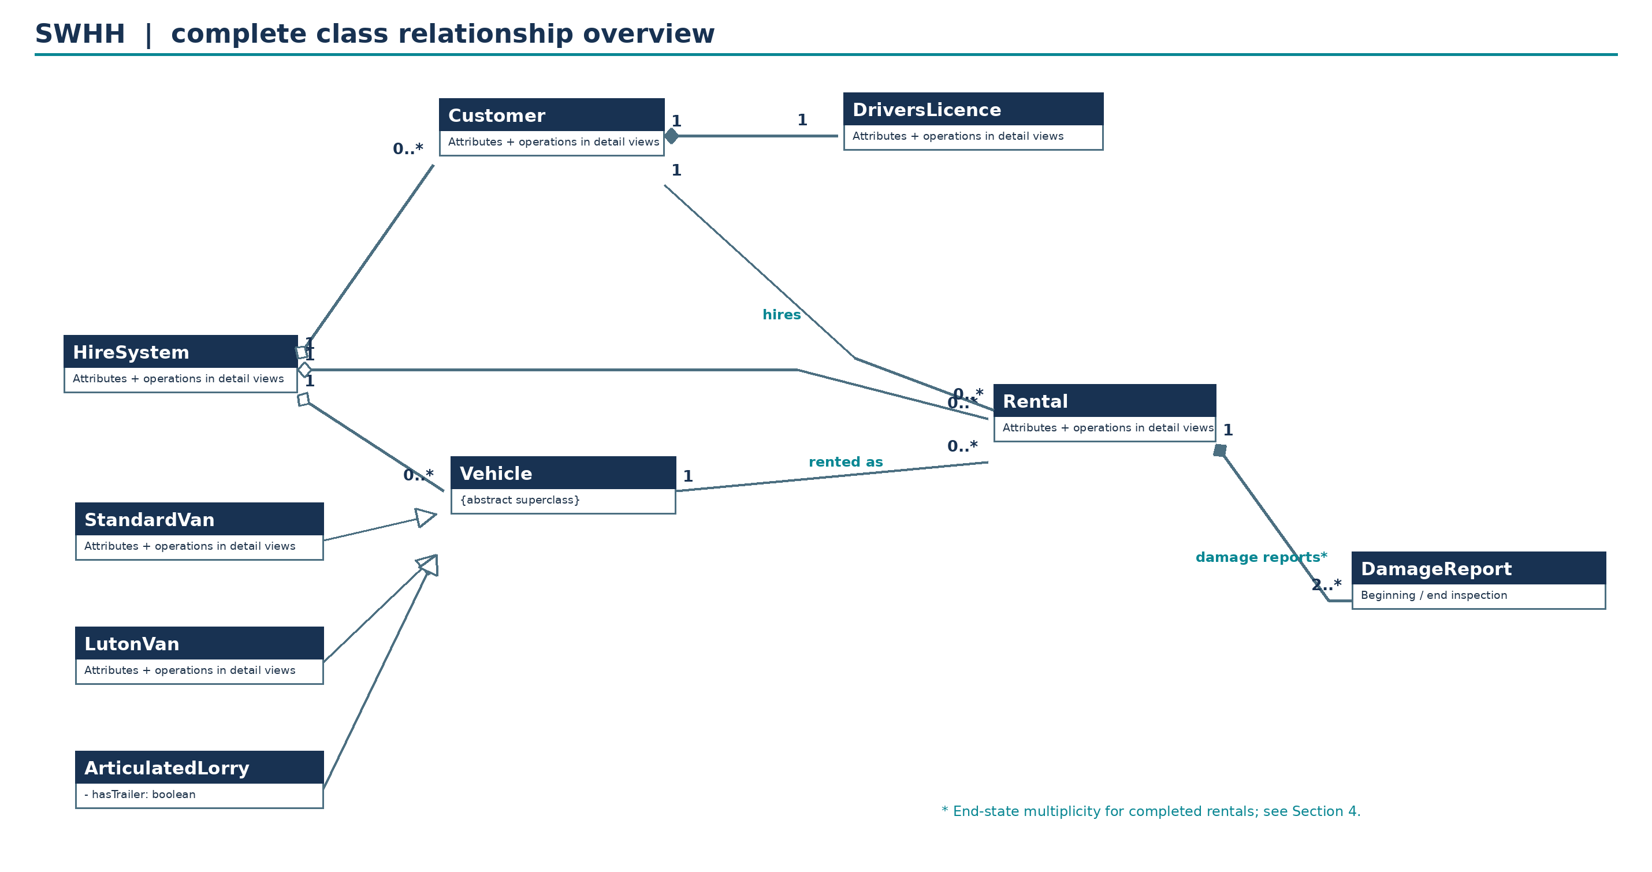
Figure 1. Overall UML class structure, including the Rental–DamageReport composition. The “2..*” end-state requirement applies to completed rentals, as explained in Section 4.

5.2 Detailed rental and management classes
This view details HireSystem, Customer, DriversLicence and Rental. HireSystem now exposes the customer-report and needs-fixing queries, while Rental owns addDamageReport and getDamageReports. Vehicle and DamageReport are shown through their links in Figures 1, 3 and 4.
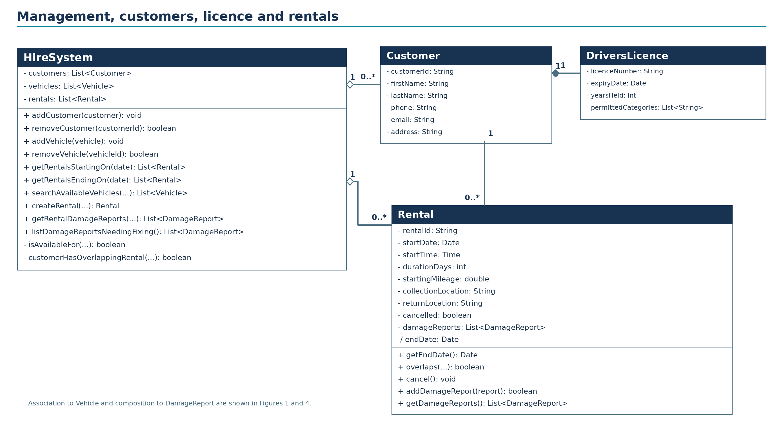
Figure 2. Detailed rental and management classes. Long operation parameter lists are abbreviated visually; their full signatures are in Section 2.2.

5.3 Detailed vehicle hierarchy
The three named concrete vehicle classes inherit Vehicle attributes. StandardVan, LutonVan and ArticulatedLorry each have one optional-equipment Boolean: hasTowBar, hasTailLift and hasTrailer respectively. There is no withTrailer field on Rental.
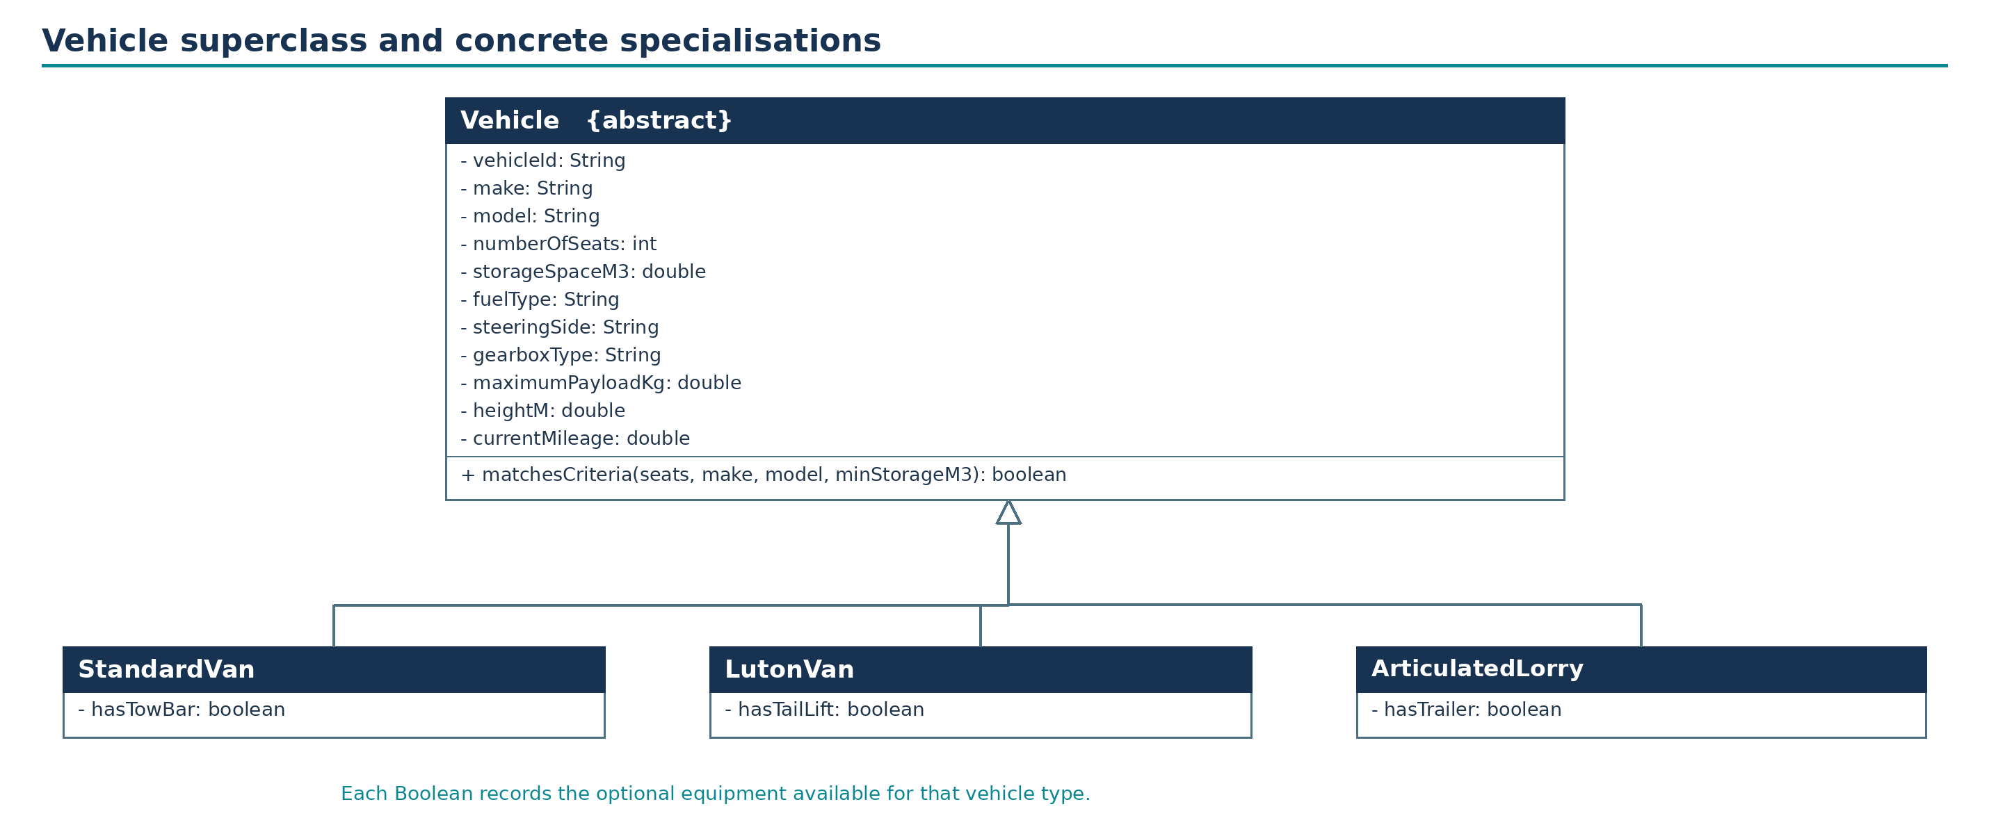
Figure 3. Abstract Vehicle hierarchy with matching Boolean equipment attributes on all three subclasses.

5.4 Rental damage inspection records
The DamageReport class contains the three textual problem descriptions, the needsFixing Boolean and the customerSignature. reportStage distinguishes START and END reports without introducing an extra class. Rental owns the report collection through composition; HireSystem supplies the system-wide query that locates reports requiring fixing.
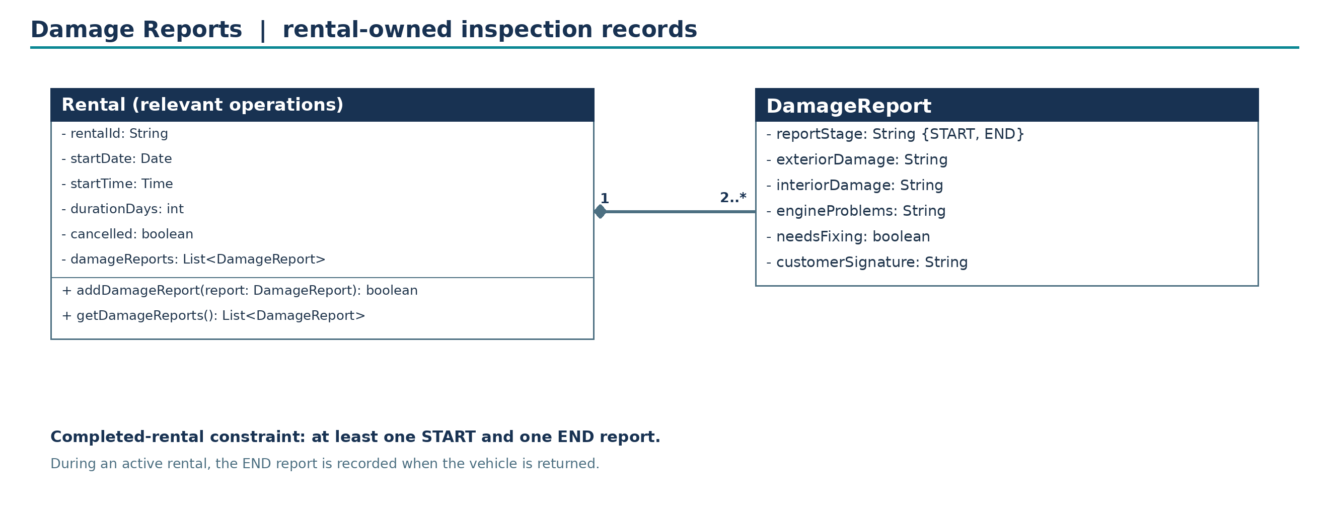
Figure 4. Rental-owned DamageReport records. Multiplicity 2..* describes a completed rental; the stage and inspection timing conditions are explained in Section 4.

5.5 Requirement-by-requirement verification
The following table connects each of the eight Essential Functionality requirements (20 marks) and the Damage Reports requirement (5 marks) to named classes and operations. It is intended as a check that the design covers the supplied scope, not a list of future system features.
Req. | Classes concerned | How the model meets it
1 | Customer; DriversLicence | Names and contact fields in Customer; separate required licence information linked 1–1.
2 | DriversLicence | licenceNumber, expiryDate, yearsHeld and permittedCategories are represented explicitly.
3 | Vehicle; three concrete subclasses | Vehicle is abstract and has precisely the three named concrete subtypes.
4 | Vehicle; StandardVan; LutonVan; ArticulatedLorry | Shared fuel, steering, gearbox, payload, height and search fields reside in Vehicle; all three subclasses expose the corresponding optional-equipment Boolean, including ArticulatedLorry.hasTrailer.
5 | HireSystem; Rental | Add/remove operations and queries on rental start and derived end dates are present.
6 | HireSystem; Vehicle | Search supports seats, make, model and minimum storage space plus dates needed to determine availability.
7 | Rental; Customer; Vehicle | One rental references one customer and one vehicle; records starting mileage, beginning date/time, duration and both locations.
8 | Rental; HireSystem; Customer | cancel() records cancellation, and createRental checks that no conflicting rental exists for a customer.
Damage Reports (5 marks) | Rental; DamageReport; HireSystem | Rental owns beginning and end reports, with exterior/interior/engine descriptions, needsFixing and customerSignature; customers can retrieve their rental reports; HireSystem lists reports needing fixing.

5.6 Operational walkthrough
Adding a customer or vehicle places a typed object in the corresponding HireSystem collection. Removal locates the record by technical identifier and rejects deletion when recorded rentals still refer to it. Queries compare supplied dates against Rental.startDate and derived /endDate; they do not require an independent date or location class.
To search for an available vehicle, HireSystem filters all Vehicle subclasses by the optional seat, make, model and required minimum storage criteria, and then eliminates vehicles having an overlapping uncancelled rental for the requested start and duration. The same overlap check is used during rental creation so that search and creation agree. Hire periods start inclusively and end exclusively; a rental lasting n whole days finishes n calendar days after startDate at the same startTime.
When creating a rental, the system checks the selected Customer and Vehicle have no conflicting uncancelled rental, copies Vehicle.currentMileage to Rental.startingMileage, and records the required beginning date/time, duration and collection/return locations. A customer may have earlier rentals in history but cannot have a second simultaneously active hire. On collection the START DamageReport is recorded; on return an END report is recorded. Rental.getDamageReports provides the records for that rental, while HireSystem.getRentalDamageReports verifies the requesting customer is attached to it. HireSystem.listDamageReportsNeedingFixing traverses existing rentals and returns reports marked needsFixing.

