Author: Jason Edwards

Submission that models the classes and relationships of the South Wales Hire and Haulage (SWHH) hire system.
CSF2702: Object Oriented Design– Coursework

Table of Contents
Class Diagram Updated 2
Class Description and Responsibilities 3
HireSystem 3
Customer 4
DrivingLicence 5
Vehicle 5
StandardVan 7
LutonVan 7
ArticulatedLorry 8
Rental 8
DamageReport 10

Class Diagram Updated
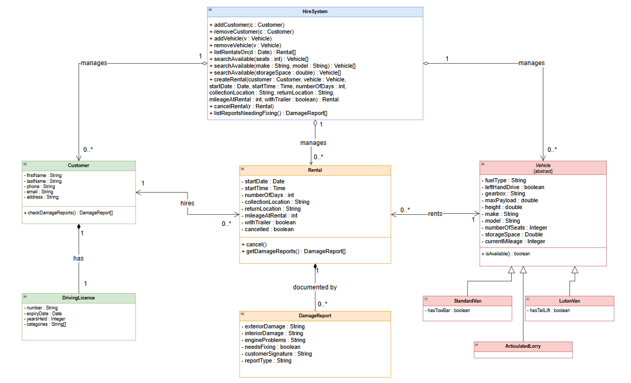

Class Description and Responsibilities

HireSystem
The HireSystem class manages the customer, vehicle and rental records held by South Wales Hire and Haulage (SWHH). It provides operations to add and remove customers and vehicles, search for available vehicles, manage rentals and retrieve damage reports requiring attention.

The HireSystem class provides the following operations:

Operation | Purpose
+ addCustomer (c : Customer) | Adds a new customer to the system.
+ removeCustomer (c : Customer) | Removes an existing customer from the system.
+ addVehicle (v : Vehicle) | Adds a new vehicle to the system.
+ removeVehicle (v : Vehicle) | Removes an existing vehicle from the system.
+ listRentalsOn (d : Date) : Rental[] | Returns a list of rentals that start or end on the specified date.
+ searchAvailable (seats : int) : Vehicle[] | Returns available vehicles that match the specified number of seats.
+ searchAvailable (make : String, model : String) : Vehicle[] | Returns available vehicles that match the specified make or model.
+ searchAvailable (storageSpace : double) : Vehicle[] | Returns available vehicles with the required storage space (m³).

Rental management is provided through the following operations:

Operation | Purpose
+ createRental(customer : Customer, vehicle : Vehicle, startDate : Date, startTime : Time, numberOfDays : int, collectionLocation : String, returnLocation : String, mileageAtRental : int, withTrailer: boolean) : Rental | Creates and records a rental using the specified customer, vehicle, start date and time, rental duration, collection and return locations, and mileage at the start of hire. Before creating the rental, the system checks that the customer is not already hiring another vehicle and that the selected vehicle is available and whether a trailer is included
+ cancelRental(r : Rental) | Cancels the specified rental, ensuring it no longer prevents the customer or vehicle from being used in another hire.
+ listReportsNeedingFixing() : DamageReport[] | Returns a list of damage reports where the needsFixing attribute is true, identifying vehicles that require repairs or maintenance.
Relationships and Multiplicities
HireSystem has aggregation relationships with Customer, Vehicle and Rental, with one HireSystem managing zero or more objects (0..*) of each type. Aggregation is appropriate rather than composition because these objects represent distinct records that can exist independently of the HireSystem object, even though they are managed by it.
The relationships are shown as navigable from HireSystem to Customer, Vehicle and Rental, indicating that the system maintains references to these objects and can access them when performing its operations. Reverse navigation is not required because these objects do not need to access HireSystem directly.

Customer
The Customer class models a person who hires vehicles from SWHH.
Customer has the following private attributes to maintain encapsulation:
Attribute | Purpose
- firstName : String | Stores the customer's first name
- lastName : String | Stores the customer's last name
- phone : String | Stores the customer's contact phone number
- email : String | Stores the customer's email address
- address : String | Stores the customer's postal address

The Customer class provides the following operations:

Operation | Purpose
+ checkDamageReports() : DamageReport[] | Returns damage reports associated with all the customer's previous and current rentals, including reports completed before and after each hire.

Relationships and Multiplicities
Customer–DrivingLicence
Each Customer has exactly one DrivingLicence, modelled using a composition relationship (1 to 1). This means the driving licence belongs to that customer and does not exist independently. If the customer is removed, the driving licence is removed as well.
Customer–Rental
A Customer can be associated with zero or more Rental objects (0..*), allowing the same customer to hire vehicles on multiple occasions. Each Rental is associated with exactly one Customer (1).
The HireSystem.createRental() operation enforces the restriction that a customer can hire only one vehicle at a time by checking that the customer does not already have an active hire before creating another rental.
The association allows the customer to access their rental records, from which the checkDamageReports() operation can retrieve the corresponding damage reports.

DrivingLicence
The DrivingLicence class represents the driving licence information associated with a customer.
The DrivingLicence class contains the following private attributes:
Attribute | Purpose
- number : String | Stores the customer driving licence number
- expiryDate : Date | Stores the driving licence expiry date
- yearsHeld : Integer | Stores the number of years the licence has been held by the customer
- categories : String[] | Stores the categories of vehicles that the customer can drive

Relationships and Multiplicities
DrivingLicence is the dependent part of a composition relationship with Customer. Each Customer has exactly one DrivingLicence record (1), and each DrivingLicence record belongs to exactly one Customer (1).
The composition represents ownership of the driving licence information within the system. If a customer record is removed, its associated driving licence record is also removed.
No additional operations are required because the class is responsible for storing the licence information.

Vehicle
Vehicle is an abstract class that represents the common features shared by the three specific vehicle types (Standard Van, Luton Van, Articulated Lorry). It is abstract because the SWHH company only hires out these specific vehicle types, not a generic vehicle, so Vehicle itself cannot be instantiated. The class contains the attributes that all vehicles have in common.

The Vehicle class contains the following private attributes:

Attribute | Purpose
- fuelType : String | Stores the vehicle fuel type
- leftHandDrive : boolean | true for left-hand drive, false for right
- gearbox : String | Stores the vehicle gearbox type (automatic or manual)
- maxPayload : double | Stores vehicle maximum payload
- height : double | Stores vehicle height
- make : String | Stores vehicle make
- model : String | Stores vehicle model
- numberOfSeats : Integer | Stores number of seats of the vehicle
- storageSpace : Double | Stores vehicle storage space
- currentMileage : Integer | Stores the vehicle mileage

The make, model, numberOfSeats and storageSpace attributes support the vehicle search criteria. The currentMileage can be used to record mileage before rental starts.
Vehicle class provides the following operation:
Operation | Purpose
+ isAvailable() : boolean | Indicates whether the vehicle is currently available for hire. A vehicle is unavailable while it is being hired

Relationships and Inheritance
Vehicle is the superclass of StandardVan, LutonVan and ArticulatedLorry. These relationships are modelled using generalisation, indicating that each subclass is a specialised type of Vehicle.
Each subclass inherits the common vehicle attributes and the isAvailable() operation, while defining any additional attributes required for its specific vehicle type.
A Vehicle can be associated with zero or more Rental objects over time (0..*), as the same vehicle may be hired on different occasions. Each Rental involves exactly one Vehicle (1).
A vehicle cannot be hired by more than one customer at the same time. This restriction is enforced when HireSystem.createRental() checks that the selected vehicle is available before recording the rental.

StandardVan
The StandardVan class is a subclass of Vehicle representing one of the three hired vehicle types.
StandardVan inherits all common vehicle attributes and operations from Vehicle through generalisation and has the additional attribute of:
Attribute | Purpose
- hasTowBar : boolean | true for has a tow bar, false for has no tow bar

As the option of a tow bar attachment is a yes/no option it is represented as a boolean attribute rather than a separate class.
Relationships and Inheritance
StandardVan has a generalisation relationship with Vehicle, indicating that it is a specialised type of vehicle.
It inherits the common vehicle attributes and the isAvailable() operation, while the hasTowBar attribute represents the additional feature specific to standard vans.

LutonVan
The LutonVan class is a subclass of Vehicle representing one of the three hired vehicle types.
LutonVan inherits all common vehicle attributes and operations from Vehicle through generalisation and has the additional attribute of:
Attribute | Purpose
- hasTailLift : boolean | true for has a tail lift, false for has no tail lift

As the option of a tail lift is a yes/no option it is represented as a boolean attribute rather than as a separate class.
Relationships and Inheritance
LutonVan has a generalisation relationship with Vehicle, indicating that it is a specialised type of vehicle.
It inherits the common vehicle attributes and the isAvailable() operation, while the hasTailLift attribute represents the additional feature specific to Luton vans.

ArticulatedLorry
ArticulatedLorry class is a subclass of Vehicle representing one of the three hired vehicle types.
ArticulatedLorry inherits all common vehicle attributes and operations from Vehicle through generalisation.
As an articulated lorry can be hired with a trailer, this option is represented by a boolean attribute within the Rental class and not as an attribute in the ArticulatedLorry class.
A separate Trailer class is unnecessary because the specification does not require individual trailer details to be stored or trailers to be managed independently.
Relationships and Inheritance
ArticulatedLorry has a generalisation relationship with Vehicle, indicating that it is a specialised type of vehicle.
It inherits all common vehicle attributes and the isAvailable() operation. No additional attributes or operations are required within ArticulatedLorry, as the optional trailer selection is recorded against the individual rental.

Rental
The Rental class records a single hire of a vehicle by a customer. Each rental is associated with exactly one Customer and one Vehicle.
The Rental class contains the following private attributes:
Attribute | Purpose
- startDate : Date | Stores rental start date
- startTime : Time | Stores rental start time
- numberOfDays : int | Stores the number of days of rental
- collectionLocation : String | Stores the location of vehicle for collection
- returnLocation : String | Stores the location of vehicle after rental
- mileageAtRental : int | Stores mileage of vehicle at rental
- withTrailer : boolean | true if a vehicle hired with a trailer, false if vehicle not hired with a trailer
- cancelled : boolean | true if a rental has been cancelled, false if a rental has not been cancelled

The Rental class provides the following operations:
Operation | Purpose
+ cancel() | Sets cancelled to true
+ getDamageReports() : DamageReport[] | Returns the vehicle damage reports associated with that rental

Relationships and Multiplicities
Rental–Customer
Each Rental is associated with exactly one Customer (1). A Customer may be associated with zero or more Rental objects (0..*) over time, allowing the same customer to hire vehicles on different occasions.
Requirement 8 restricts a customer to hiring only one vehicle at a time. This is treated as a business constraint rather than limiting the total number of rental records associated with a customer.
The HireSystem.createRental() operation enforces this restriction by ensuring that the customer does not already have an active hire before creating another rental.
The relationship allows the customer to access their associated rentals so that Customer.checkDamageReports() can retrieve damage reports from previous and current hires.
Rental–Vehicle
Each Rental is associated with exactly one Vehicle (1). A Vehicle may be associated with zero or more Rental objects (0..*) over time because the same vehicle can be hired on multiple occasions.
A vehicle cannot be hired by more than one customer simultaneously.
The Vehicle.isAvailable() operation determines whether the vehicle is currently available by considering its associated rental records, including whether the relevant hire period is current and whether the rental has been cancelled.
HireSystem.createRental() uses this availability information to ensure that a vehicle is not hired to multiple customers at the same time.
Rental–DamageReport
Rental has a composition relationship with DamageReport because each damage report belongs to a particular rental and documents the condition of the vehicle during that hire.
The specification requires at least two damage reports for each completed rental: one completed before the vehicle is hired and another completed after it is returned. Additional reports may also be associated with the same rental.
A rental may initially have fewer than two completed damage reports because the final inspection cannot take place until the vehicle is returned. The required reports must be present once the rental has been completed.
The getDamageReports() operation retrieves the damage reports associated with the individual rental. These reports can also be accessed through Customer.checkDamageReports(), which retrieves reports across all the customer's rentals.

DamageReport
The DamageReport class represents a report recording the condition of a vehicle in connection with an individual rental.
The DamageReport class contains the following private attributes:
Attribute | Purpose
- exteriorDamage : String | Stores the exterior damage description
- interiorDamage : String | Stores the interior damage description
- engineProblems : String | Stores the engine problems description
- needsFixing : boolean | true for needs fixing, false for does not need fixing
- customerSignature : String | Stores the customer signature
- reportType : String | Identifies whether the report is a pre-hire (PRE_HIRE) or post-hire (POST_HIRE) inspection.

Relationships and Multiplicities
Rental–DamageReport
DamageReport has a composition relationship with Rental, with the filled diamond positioned at the Rental end. Each DamageReport belongs to exactly one Rental (1) and documents the condition of the vehicle associated with that hire.
Composition is appropriate because each damage report forms part of a specific rental record and is not shared between different rentals.
The specification requires at least two damage reports for each completed rental: one before the hire and one after the vehicle is returned. Additional reports may also be associated with the same rental.
During the rental process, the number of completed damage reports may be fewer than two because the post-hire inspection cannot be completed until the vehicle has been returned.
The relationship therefore allows zero or more damage reports (0..*) during the rental lifecycle, subject to the requirement that a completed rental must have at least two reports (2..*), including at least one PRE_HIRE and one POST_HIRE report.
Damage Report Retrieval
The company's requirement to identify vehicles needing repairs or maintenance is supported by HireSystem.listReportsNeedingFixing(), which retrieves damage reports where needsFixing is true.
The Rental.getDamageReports() operation retrieves the reports associated with an individual hire.
The Customer.checkDamageReports() operation enables customers to access damage reports from all their previous and current rentals by navigating through their associated rental records.

