**NOTE: Fill this document according to the requirements that you have identified in your analysis and brain storming.**

Software Requirements Specification

for

Kabesa de Barangay: Boat repair and rental with GPS integration

**Version 1.0 approved**

**Prepared by Placio, Calvin John V.**

**Bauyon, John Eroh A.**

**Papaya Yacht Charter and Service inc.**

**08/07/2021**

**Table of Contents**

**Table of Contents ii**

**Revision History ii**

**1. Introduction 1**

1.1 Purpose 1

1.2 Document Conventions 1

1.3 Intended Audience and Reading Suggestions 1

1.4 Project Scope 1

1.5 References 1

**2. Overall Description 2**

2.1 Product Perspective 2

2.2 Product Features 2

2.3 User Classes and Characteristics 2

2.4 Operating Environment 2

2.5 Design and Implementation Constraints 2

2.6 User Documentation 2

2.7 Assumptions and Dependencies 3

**3. System Features 3**

3.1 System Feature 1 3

3.2 System Feature 2 (and so on) 4

**4. External Interface Requirements 4**

4.1 User Interfaces 4

4.2 Hardware Interfaces 4

4.3 Software Interfaces 4

4.4 Communications Interfaces 4

**5. Other Nonfunctional Requirements 5**

5.1 Performance Requirements 5

5.2 Safety Requirements 5

5.3 Security Requirements 5

5.4 Software Quality Attributes 5

**6. Other Requirements 5**

**Appendix A: Glossary 5**

**Appendix B: Analysis Models 6**

**Appendix C: Issues List 6**

**Revision History**

|  |  |  |  |
| --- | --- | --- | --- |
| **Name** | **Date** | **Reason For Changes** | **Version** |
|  | 07-08-2021 | Initial Version | 1.0 |
|  |  |  |  |

# Introduction

## Purpose

The purpose of this document is to give a detailed information about the system application. That will explain the use of every features of the system application, the system interfaces can do , and how the system works. This document is intended in both stakeholders and the developers of the system.

## Document Conventions

*The following are the list of the conventions and acronyms used in this document and the project as well:*

**Staff**: or admin representing a user with user administration previleges to the software

**User**: A general login ID assigned to users

**Client**: Intented user of the software.

**Tester**: Checks the system and gives result

**Intended Audience and Reading Suggestions**

This project is a prototype for the yacht charter management system and it is restricted within the brgy. Papaya. This has been implemented under the guidance of college professors. This project is useful for the yacht charter to promote tourism in brgy papaya and to gain more tourist and customers.

## Project Scope

The system has four types of users the client/tourists, Yacht charter Owner, Local boat owner and Admin of local boat owner it is composed of modules; login, signup, add/update and cancel repair/reservation, yacht repair status update, transaction management and report generation module.

## References

* Test case
* Work breakdown Structure and gant chart.

# Overall Description

## Product Perspective

Yacht Service Cluster(YSC) is one of the silent industry because this type of service are said to be luxurious or need a lot of money to operate, with that the Yacht repair and maintenance market is very wide to the point that the target market are from outside border of the business location, Papaya yacht charter service incorporated mostly have their customer outside their location some are from other country or foreign yacht owners, with their current manual system that notifies the owners with the use of calling and messaging the manager may find it very hard to manage different yacht record, in addition to that the transaction record are only written on the log books with this it gives constraints to consume more time in producing a report. With their current website on the web but has no other features to offer on the side of the customer such as invoicing. The business is in need of a web application with a repository for transactions so that tracking, invoicing and email notification for yacht updates will be easy for the customer to deal with, in addition to that the ability of the web app to create reports will also provide the management of repairs and feedbacks to be easy on the managerial side. Also boat owners and tourist need an uber style boat app that will make it easy for the both side to manage the services.

## Product Features

The web is a good place to market a service and product because with the web it is almost touching the service you need, with the benefits of using the system without installing any software , just need a browser and access it online another benefits of it is the data redundancy is reduced (maybe eliminated), not needing paper records because the transactions are recorded to the database real-time and can be used for later such as generating info graphics report such as sales or income report that can be illustrate using graphs and charts. The report can be downloaded online with the use of digital formats good example is pdf. The owner doesn’t need to call or message the owner of the yacht or boat because the system will automatically send them an email notification about the update on the repairs of the yacht or boat. The system offers the following benefits:

* Reduce in time on generating reports; reduce on the usage of paper such as log books.
* Keep in touch with the customers view their feedbacks for service improvement .
* Transaction automation and data centralized because all data will go on one database.
* Can be access on any device just need a browser no need to install anything.

## Justification

The migration of yacht management system to the web application will benefits both the customer or client and the business owner on the side of business owner reports can be easily analyzed, feedbacks collection is another good example to make the service improved. Because it is a web application many people will see this and if they are one of the specified target market of Yacht cluster service you can keep in touch to them and advertise the business more just like other ecommerce sites around the web.

Initial estimates for the WP Project are:

* 10% decrease in record management
* 50% immediate decrease in time to generate reports such as sales and feedbacks
* 25% immediate decrease in the amount of workload such as notifying the clients for status updates

## User Classes and Characteristics

Yacht Charter Owner

* Can change the current status of the service
* Can generate reports of every transactions
* Can view feedbacks from clients

Boat Owner

* Can add Destination.
* Read Client reviews.
* Edit their profile.
* Receive email notification.

Yacht Owner/Tourist

* Can choose and insert a transaction repair
* Can send feedback to staffs.
* Rent a boat and choose a destination such as islands.
* Add or reserve boat in a destination.

## Operating Environment

*The system or product will be working on the marina business which is composed of boat repairs and rentals such as cove tours and island hopping. As example is the Papaya yacht club is a small yacht charter that offers repair and maintenance on different kind of boats and yacht but as time goes by the charter became famous on its service, transaction became very hard to manage because they are only using flat database and log books for transaction that may be hard to manage because the data is not centralized or spread out different records, this project intend to create a web application that will make it easy for the clients and business owner to manage data and became notified with email messages about the status of transactions.*

## Design and Implementation Constraints

The following constraints apply to the Yacht mailer Project. As project planning begins and more constraints are identified, they will be added accordingly.

* There are limited IT resources available to support the Yacht mailer Project and other, ongoing, IT initiatives.
* The staff of Yacht charter does not have an ICT maintenance and technician
* As implementation will be done internally and not by the product developers or vendors, there will be limited support from the hardware/software providers.

## User Documentation

*<List the user documentation components (such as user manuals, on-line help, and tutorials) that will be delivered along with the software. Identify any known user documentation delivery formats or standards.>*

## Assumptions and Dependencies

* The Client must have an android device and internet connection to access to application.
* The client must have an OS that can support Internet browsing.

# System Features

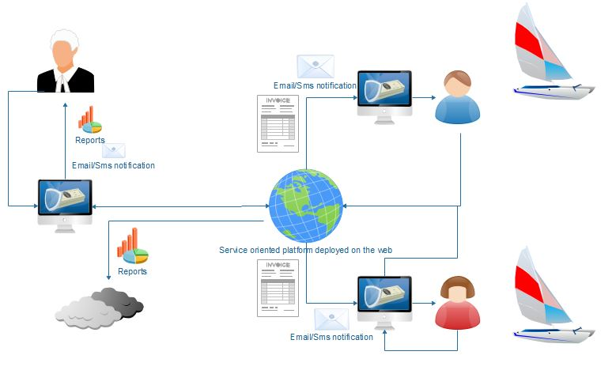

## Add Repair/Edit and Cancel Boat Repair

3.1.1 Description and Priority

*These operation on the repair transaction of the client is the very vital part of the system or product without these transaction there are no data the System admin to manage and to notify. In addition to that this data or information are needed to create reports that the business firm is needed such as status report and number of boat per status in a specific timeframe (Weekly, monthly and yearly).*

3.1.2 Stimulus/Response Sequences

* *The user will login first.*
* *After that they can add transaction such as boat photo, details and appointment date.*
* *If there are transaction already exist they can edit or delete it the admin will be notified if there are some changes in the transaction via email.*

3.1.3 Functional Requirements

REQ-1: Add transaction.

REQ-2: Store boat owner’s photo to be repaired.

REQ-3: Validation rules all information needed must filled up.

REQ-4: Cancel repair or edit repair.

REQ-5: Notify user via email or sms if possible

## Receive email notification and invoice attachments

3.2.1 Description and Priority

*Email notification just like the SMS notification is a good way of notifying the user’s about their transaction when they are not interacting with the system. Because this is the type of system that deals with transaction status this is vital and needed for the system to work in an effective manner.*

3.2.2 Stimulus/Response Sequences

* *The user will sign up and the email will be send.*
* *If the email exist in the forgot password module an email notification with recovery code will be sended.*
* *Status updates in the boat repair module thru email notification has pdf format invoice.*

3.2.3 Functional Requirements

* Send automated email to the user’s email address as the transaction changes.
* Send recovery key code to the email if the user forgot his /her password
* Send email notification as the user sign up.

## Print reports

3.2.1 Description and Priority

*Reports are the things needed by the business why does they need the system some examples f report are invoices and sales report the system can report boat statuses in the access of the admin control, it can also be categorized In year, Week and monthly.*

3.2.2 Stimulus/Response Sequences

* *If the admin is login he/she can view reports when the button is click.*
* *The report can be viewed and also can be print to be saved in a PDF format.*

3.2.3 Functional Requirements

* Report can be viewed and print.
* The report is a dynamic report can be filtered in different manner.
* Report is dynamic and will change behavior according to the amount of data it is handling.

## Add Repair/Edit and Cancel Boat Destination.

3.1.1 Description and Priority

*This features are only available on the access of the boat owners they can add the destinations they want, because this is the type of Uber styled boat app, but it is in the different manner that the boat owners decide what are the only possible destination.*

3.1.2 Stimulus/Response Sequences

* *The user will login first.*
* *After that they can add destination such as destination photo, details, Latitude and longitude.*
* *If there are destinations that already exist they can edit or delete it the admin will be notified if there are some changes in the transaction via email.*

3.1.3 Functional Requirements

REQ-1: Add Destination details.

REQ-2: Store photo of the destinations.

REQ-3: Validation rules all information needed must filled up.

## Add Repair/Edit and Cancel Boat trip appointment.

3.1.1 Description and Priority

*These operation on the repair transaction of the client is the very vital part of the system or product without these transaction there are no data the System admin to manage and to notify. In addition to that this data or information are needed to create reports that the business firm is needed such as status report and number of boat per status in a specific timeframe (Weekly, monthly and yearly).*

3.1.2 Stimulus/Response Sequences

* *The user will login first.*
* *After that they can add boat transaction such as number of packs and appointment date.*
* *If there are transaction already exist they can view the map view with the markers where the user’s current position is, the boat driver’s position and the destination to go such as island.*
* *If the user chooses to cancel they need to fill up the form what is the reason why they are canceling and the boat driver assigned for that client will be notified in the form of email.*

3.1.3 Functional Requirements

REQ-1: Add transaction.

REQ-2: Cancel transaction.

REQ-3: Add ratings and feedback.

REQ-4: Report misbehavior.

# External Interface Requirements

## User Interfaces

* Front-end software: Notepad++ or Sublime
* Back-end software: Apache web server and Mysql

## Hardware Interfaces

* GPs – save different classes of user and interact it with the API of the Google maps.

.

## Software Interfaces

|  |  |
| --- | --- |
| **Software Used** | **Description** |
| Operating system | We chose Windows OS to support user-friendliness |
| Database | We chose to use My SQL to save the data on every transaction. |
| PHP | We chose PHP IDE to support user interactions. |

## Communications Interfaces

*The project will only support android devices. We are using an automated form to fill up every transaction.*

# Other Nonfunctional Requirements

## Performance Requirements

* The system can be used by 50 users continuously.
* If there are many users are accessing the system the notification features can be delayed by up to 5-10 seconds.

## Safety Requirements

* The password that the user enter are stored in hashes in the database.
* The Email notification is sended in a safe manner with the help of SMTP and TLS.
* The access of the user’s location are not used in a malicious manner but rather use only for the user to view the holistic map view of the boat driver and the destination he/she have chosen.

## Security Requirements

User of this system will receive notification only in their email and on the side of the admin to provide the privacy for them on the transaction that they do. Hashes are used to store password specifically the MD5 hash.

## Software Quality Attributes

The product is in the form of web app and mobile app, the web app can be access in desktop and mobile because it has mobile responsive characteristics. There is also a mobile app version but is almost same with the web view version of the system.

# Other Requirements

*The database uses a combination of many to many and one to one cardinality to create a multi join queries and avoid data misplacements. Unique identifiers are also needed in data such as transaction to deal with deletion and updating. ID are not created by the users but rather auto generated and provided by the system. Due to lack of Project budget to buy email on web hosting the developer use external smtp server to be specific is the google mail service.*

**Appendix A: Glossary**

* *SMTP- Simple mail transfer protocol.*
* *Mobile responsive- Web apps that can adjust to the device they are being access.*
* *Hashes- Translating a plain text into a combination of unreadable characters.*

**Appendix B: Analysis Models**

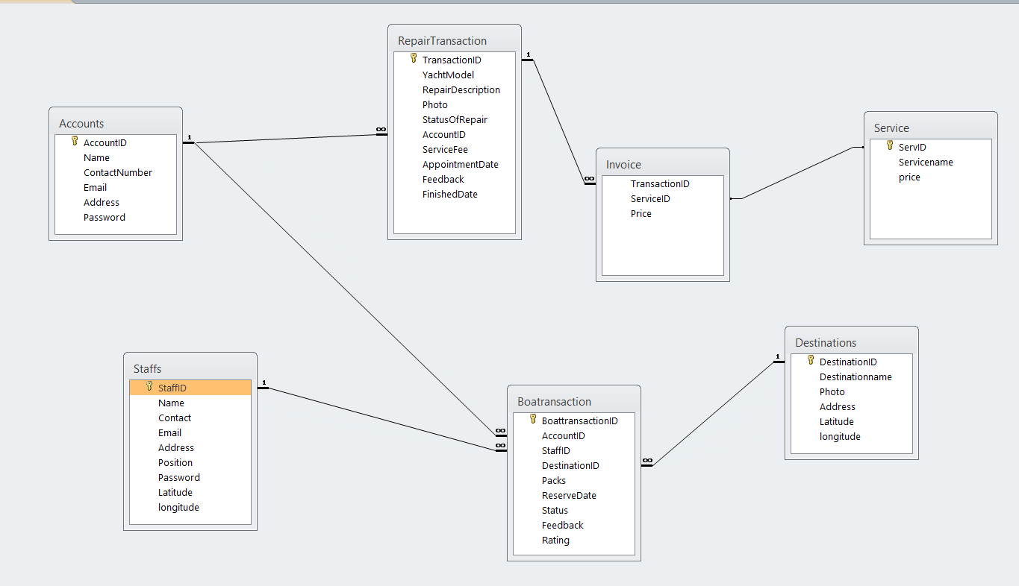**Appendix C: Issues List**