- Founding leadership
Propelled by her Christian faith, Dorcas Hildah Obonde founded Ang’olo Mennonite Church Congregation at Ang’olo Village of the then SIAYA District in 1982.
On founding the congregation, Dorcas formed an Ang’olo Church Development Committee (ACDC) to facilitate a wholistic church work. Working with this committee DORCAS proceeded to establish an Ang’olo Christian Development Centre (ACDC) on a three (3) acre piece of Land set aside by her husband (JASON OBONDE) for that purpose. In their quest for a wholistic Christian development Dorcas and Jason established an Ang’olo Community Development Centre (ACDC) on the land and constructed; - a Community service hall, Water tank and Poultry house.
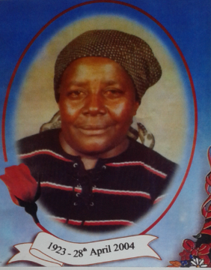
ACDC’s Founder
Dorcas H. Obonde

In 1988 the Late Dorcas Hildah Obonde mobilized a group of women and formed a Self-Help Group called Ang’olo Women Group (AWG). The Initiative was later registered as a CBO aimed at poverty eradication and better livelihood among the poor rural families of Ang’olo Village of MADIANY DIVISION. In between 1988 to 1995 the CBO undertook among other things:-
- Mobilization and recruitment of members for self-help group development activities.
- Environmental conservation practices through development of tree nurseries and promotion of Agro-forestry
- Income generating activities (IGAs) for group members through Crop husbandry and rabbit keeping projects
- Promotion of a revolving Women Savings and Credit Scheme linked with Women Entrepreneurship
- Purchase of a canoe and launching a Fishing Business
In 1996, Dorcas Initiative acquired a new legal status as ACDC, a Not-for-Profit entity registered under Companies Act, Cap 486 with strict Charitable Articles of Association. The organization has since evolved through different phases over the years to a cross-national development facilitator with its Management Secretariat (Head office) transferred from the village to Nairobi’s Central Business District, Baghwanji Building, 2nd Floor of Biashara Street in Nairobi.
 |  | 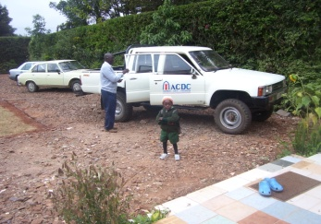
Founder member- Jason Obonde | ACDC’s Logo Brand | ACDC-First Vehicle By Dorcas Endowment Fund

- THE Period from Year 1996 to Year 2006
Under the leadership of National Programs Coordinator, Ms Pamela Amoiya Obonde, ACDC’s expanded strategy and catchment’s scope necessitated organizational restructuring into two programmatic focus areas namely:-
  - Capacity Building Program (CBP) – (Skills’ tapping IGA/Sustainability Initiative). CBP is the strategic long-term financier to the Women Development Programs.
  - Women Development Program (WDP) – (socio-economic development focusing on children, Youth and Women). The WDP has since mobilized, promoted and established several CBOs with whom the organization is implementing the following programs among others:-
- Women empowerment towards the abandonment of Female Genital Mutilation (FGM)/FEM among the Maasai communities

Pamela Amoiya Obonde
ACDC’s National Programs Coordinator
- Women empowerment towards engagement in sustainable economic development initiatives. In this endeavor ACDC has purchased a plot and established a Women Business Centre in Saikeri of Kajiado District.
- Promotion and acceleration of education of the Girl-child
- Rescue, rehabilitation and empowerment of domestic child workers and girls in FEM.
- HIV AIDs prevention and sexual /reproductive health interventions.
- Rescue, rehabilitation, empowerment and support of the at-risk Youth.
- THE PERIOD from Year 2007 To-date
In this period the ACDC Board launched a new strategic plan which established the ACDC-Women Development Program Belgium, Antwerpen Chapter and the following programs:-

Program name |  | 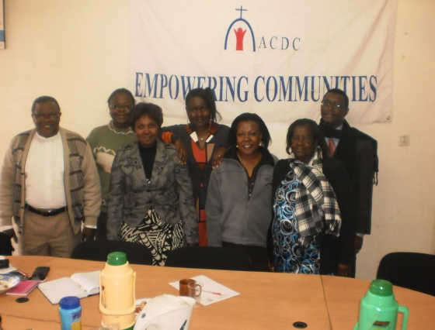  ACDC – Board of Directors
P1 | Child Development & Education
P2 | Girl Child Empowerment
P3 | Women Leadership & Enterprise
P4 | Water, Sanitation, Health & Environment
P5 | Youth Peace & Enterprise
P6 | Leadership Education
P7 | Peace Missions International
P8 | Retreat & Corporate Conferencing

