To Do List

Setting up PyCharm

Nothing really new here. I opened up Pycharm, set up a new project called ‘Assignment 7’. Next I opened up a new .py file and put the admin data on the top.

Coding the assignment

I began with importing the pickle module. Then, I built my error handling block. I ask the user for an animal and its color. If the user uses numbers as the input, then the code will raise a general exception error and ask them to not use numbers.

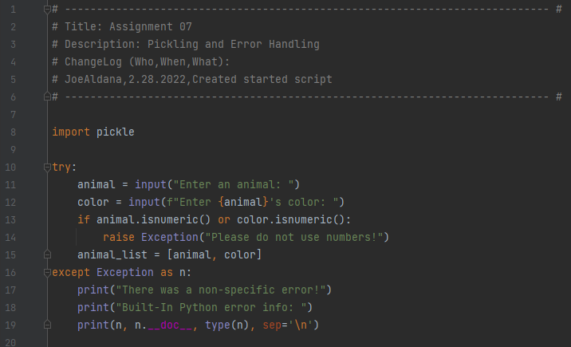

Next, I set up my pickling functions. The 1st one is one for writing data to a file and the second one is for reading from a pickled file. Lastly there is some print calls to let the user know to look at the pickled file and that the code as read from the pickled file.

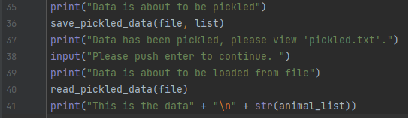

Final Thoughts

I had a really tough time with this assignment. I tried to start from a blank file but I found out really quickly trying to build code in the Variables, Processing and Presentation style is difficult because its very easy to get very complex. I found myself trying to build classes but got really confused when the arguments I was passing to them didn’t work. So, after trying that for a while I decided to just use the starter lab and try to just keep it very simple. I still don’t think the code is completely right. I can’t seem to get the read pickle function to capture the whole of the list in the text file. I am looking forward to seeing the answer key for some insight on this.