Classes

Setting up PyCharm

For this assignment we were given a starter template. I went ahead and just created a new project in Pycharm and set up a folder with the starter code and with a txt file.

Coding the assignment

I begin with changing the admin data on top. I just added my name, date and that I am adding code. From there I worked on the Product class. I started by making the constructor. I coded the init method so that it has two hidden attributes; product name, and product price.

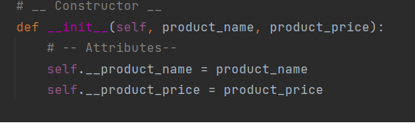

Next, I set up the getter and setter for each attribute. First was the product name. The getter just added the title method and the setter has a small check for whether numbers were used as a name.Product price is similar. The getter is just a title method but this time the setter checks to see if letters were used in place of a number.

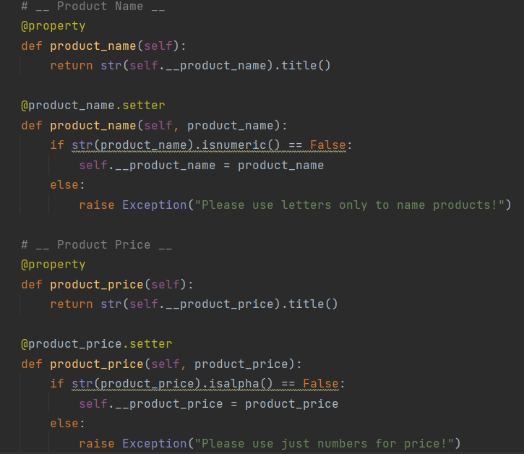

Lastly for the Product class I changed the str method. I changed it so that when called it returns the product name with the price separated by a comma.

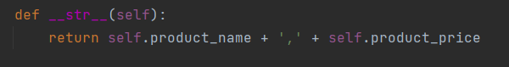

Next up is the FileProcessor class. This class will be used for processing and therefor will only have methods. First, I made a file reader method. It just opens the txt file and then loads the data from the file into a list for processing. File writer is a method that opens a file and then attempts to write the list in memory to the file.

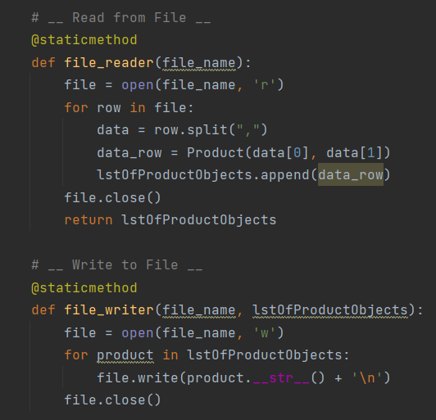

IO is a class designed to capture user input and present data to the user. The first method shows the menu of options to the user. Next is a method that asked the user for their menu option and then stores the choice. After that, the current lists method shows the user the current list of products in memory. Lastly there is a method that asks the user for new product and price data and then stores it.

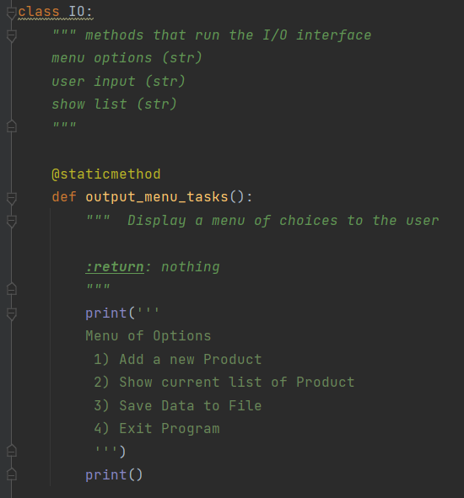

The last bit of code is the actually running of code. It starts with opening the text file and loading data from the text file using the File Processor class. After that a While loop runs the user into the menu with the IO class. Depending on what the user chooses they are routed different options in the IO class and the appropriate method is called.

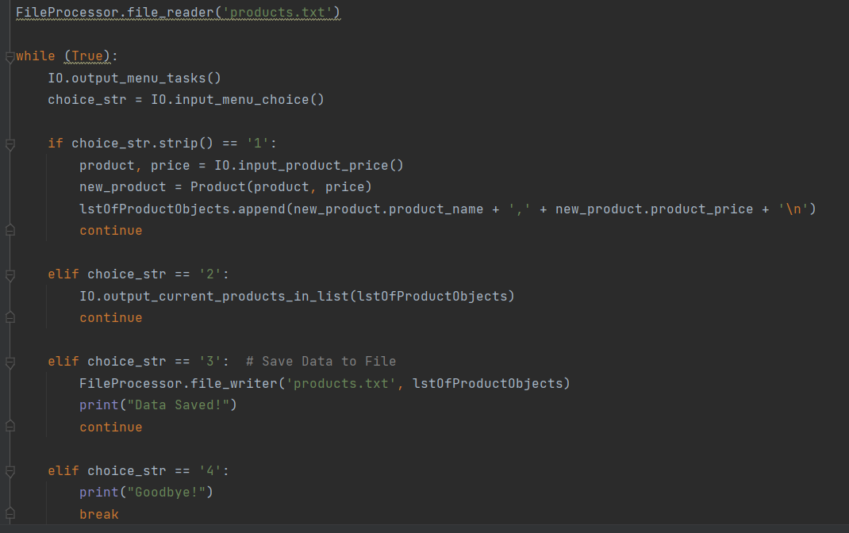

Final Thoughts

I am still struggling with the error handling and I know I need to add some more to this code. If time allows, I will try to do that before being graded. I find that I got a pretty good grasp of how conceptual classes work but I struggle with the syntax. Specifically, the biggest problem I had was trying to get the user options to be stored into correctly into the new object Product I was trying to make in line 155 and line 156. I used the debugger to see that the syntax I was using would capture the user data but wasn’t loading into the new class as an argument and it took me a few hours to realize what was wrong. I figured that just calling the IO method in 155 was enough but the variables in the IO method wouldn’t load into the product class arguments in line 156. I had to store the output of the IO class in two new variables and then load those into line 156. I think this was an issue with local variables? Either way I was able to get the code to run and enjoyed this assignment although I wish I could have dedicated more time to it.