To Do List

Setting up PyCharm

This week’s assignment was a little different. We had to start from a starter template that already had some code in it. I therefore started a new file called assignment 5 and then added the starter template to it. Then I opened the PyCharm and opened the starter. For the starter code to work there had to be a .txt file made before hand so I went ahead and made the ToDoList.txt

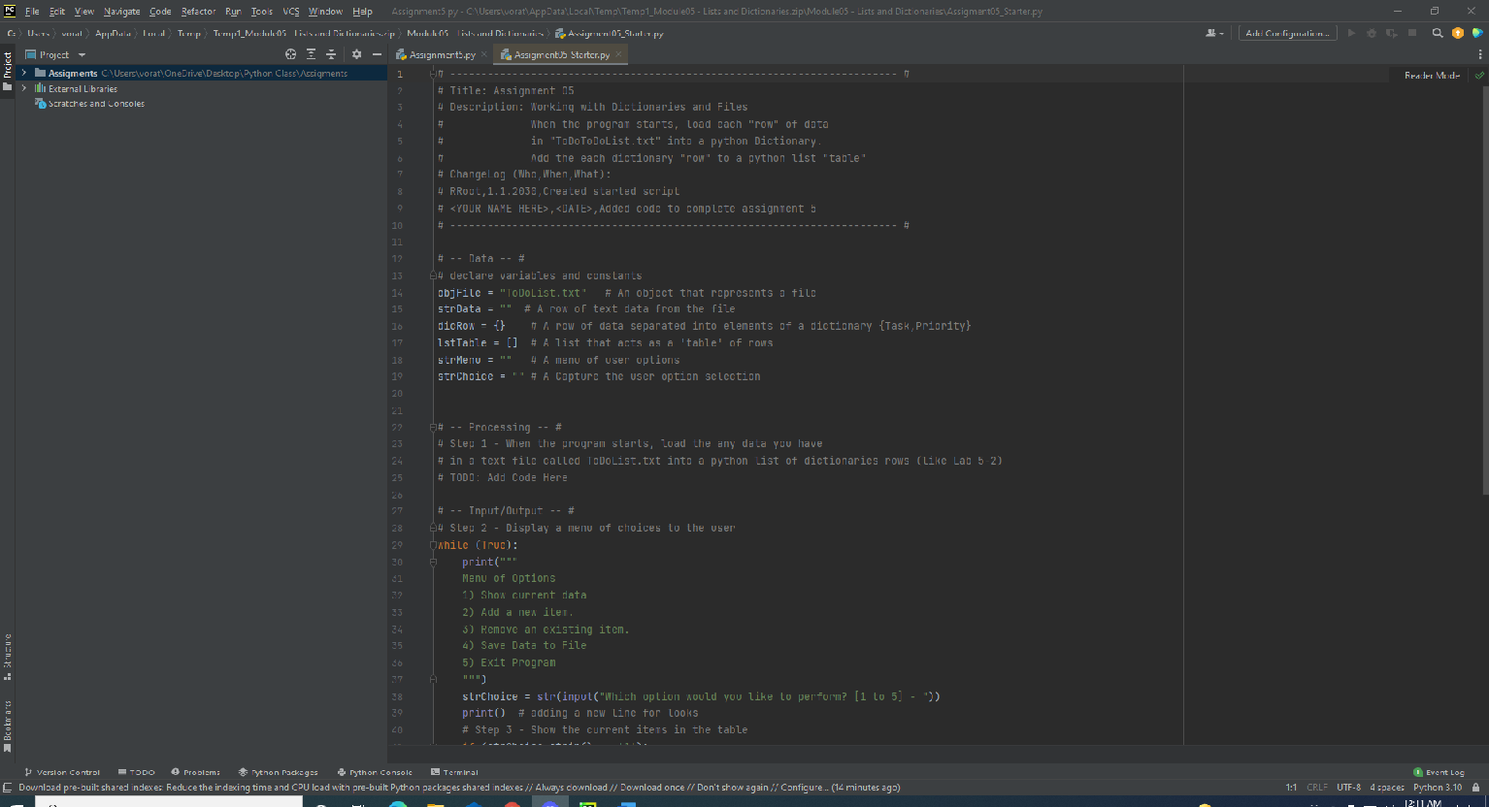

Coding the assignment

The first thing to code was getting data from a file to work with. I believe this is where the program breaks if the .txt file isn’t already made. I went ahead and coded so that Python opens the text file and the used a for loop to gather data by row into a list and then converted those lists into dictionaries with the keys “Task” and “Priority”.

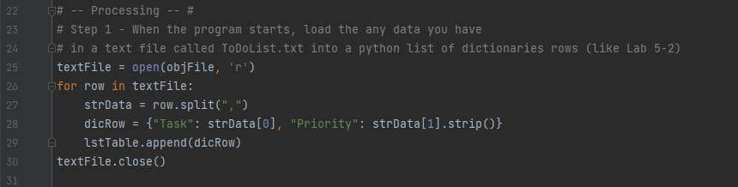

Next the starter code already had the code for going through the menu options so I mostly had to just code for every option. For option 1, I just used a for loop and the print function to display the current list of dictionaries pairs in memory. Option 2 is for adding new items to the list. I went ahead and used a while loop that begins with asking the user for the task and priority, they want to add in. Then I just used the append method to add their input in as a dictionary pair. After that I ask for user if they want to continue, if not the code breaks out back to the menu.

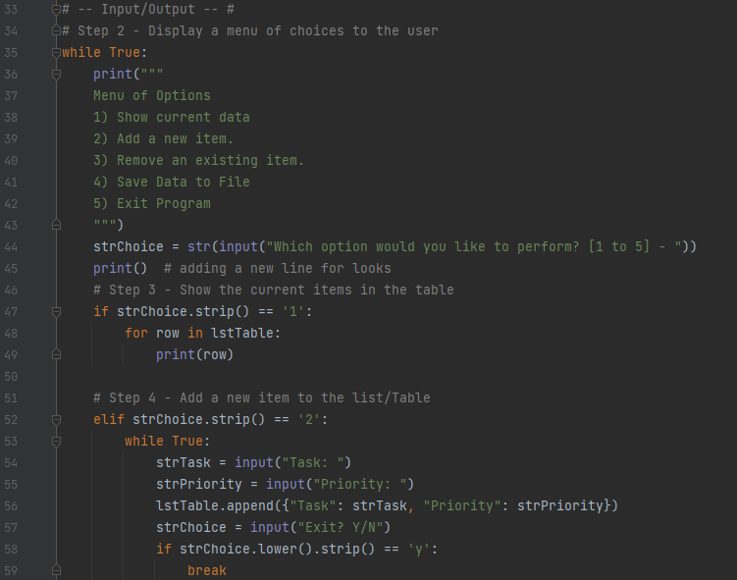

Option 3 is for removing items. Again, I start with a while loop and ask the user for the name of the task they want remove. Nested in the while loop I made a for loop that checks the lowercased version of the user input against the lowercased version of the current list in memory. As coded, the for loop will check each row and then if it doesn’t match will print out that the task wasn’t found and print out the list, then it will check the next row and keep doing this until it reaches the end or finds a match. If it does find a match then it removes that row for the current list. Once the for loop ends the user can decide to break back to the menu options.

Option 4 saved the current list to the text file. Here I just open the text file and make a for loop that write by row to the text file. The write method requires that the dictionary pairs be converted into string data. The last option is just to end the program so its just a break command.

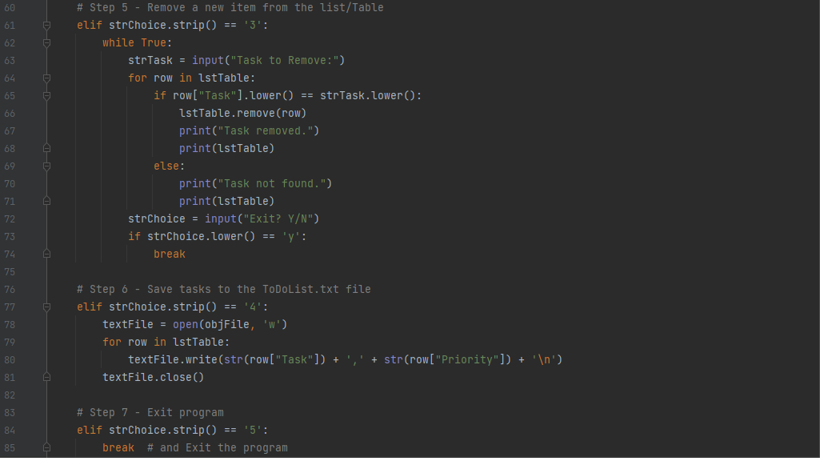

Final thoughts

When I started the project, I thought I was had to ONLY use the variables given at the top. I struggled a bit trying to do that but then decided it was impossible. Once I opened it up so that I can make my own variables I was able to do most of the coding. I am not happy with the remove task portion. I don’t like how it says task not found after every check on the row. As coded if the list had like 50 rows and you wanted to delete the last row, you would get 49 tasks not found and 49 list prints. I couldn’t find a simple solution to this problem because every thing I tried seem to get more errors. I think the answer is a while loop with a nested for loop?