Power usage of the components

19mA - Arduino nano

50-150mA - 128x64 Oled Display

<15mA - HC-SR04 Ultrasonic Sensor

0.2-200mA - Micro SD Card Adapter Module

70mA - NodeMCU ESP8266

2-4uA - (4pcs) TTP223 Capacitive Touch Sensor Module

5.1 mA - MPU6050

<30mA - Laser Red Dot

**Reference**

- https://www.digikey.com/en/resources/conversion-calculators/conversion-calculator-battery-life

- https://store.arduino.cc/products/arduino-nano

- https://learn.adafruit.com/2-7-monochrome-128x64-oled-display-module/overview

- https://components101.com/sensors/ultrasonic-sensor-working-pinout-datasheet

- https://components101.com/modules/micro-sd-card-module-pinout-features-datasheet-alternatives

- https://temperosystems.com.au/products/ttp223-capacitive-touch-sensor-module-red/

- https://wolles-elektronikkiste.de/en/mpu6050-accelerometer-and-gyroscope

- https://www.aiminglaser.com/product/650nm-5mw-visible-red-dot-laser-modules-ttl/

- https://matts-electronics.com/wp-content/uploads/2018/06/SX1308.pdf

**Calculation**

Arduino Nano: (19mA)

128x64 OLED Display: 50-150mA (average 100mA)

HC-SR04 Ultrasonic Sensor: <15mA (15mA)

Micro SD Card Adapter Module: 0.2-200mA (average 100.1mA)

NodeMCU ESP8266: (70mA)

TTP223 Capacitive Touch Sensor Module (4pcs): 2-4uA (average 3uA 0.003)

MPU6050: (5.1mA)

Laser Red Dot: <30mA (30mA)

Total current = 19 + 100 + 15 + 100.1 + 70 + 0.012 + 5.1 + 30 = 339.212 mA

**Without the SX1308 Boost Converter**

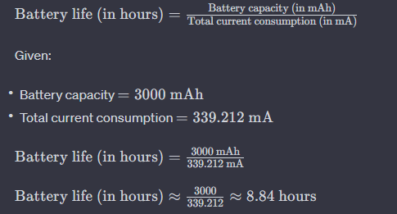

Battery life (in hours) = Battery capacity (in mAh) / Adjusted total current consumption (in mA)

Total Current consumption: 19 + 100 + 15 + 100.1 + 70 + 4 * 0.003 + 5.1 + 30 = 339.212 mA

Battery life (in hours) = 3000mAh / 339.212 mA

Battery life (in hours) = 8.84hrs or 8 hours and 50.4 minutes

**With the SX1308 Boost Converter**

Adjusted total current consumption = Total current consumption / Efficiency of boost converter

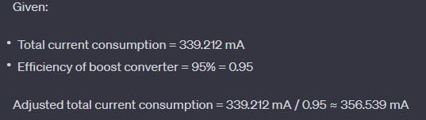

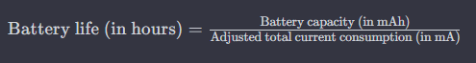

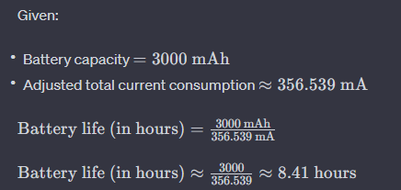

Battery life (in hours) = 8.41hrs or 8 hours and 24.6 minutes.

The SX1308 Boost Converter has an efficiency that can be as high as 95%. (based on the reference below) The efficiency of the boost converter affects the actual current drawn from the battery. The current drawn from the battery will be higher than the current consumed by your devices due to this efficiency. You can calculate the adjusted total current consumption with the boost converter as follows:

COMPONENTS

* Arduino nano
* 128x64 Oled Display
* HC-SR04 Ultrasonic Sensor
* Micro SD Card Adapter Module
* NodeMCU ESP8266
* (4pcs) TTP223 Capacitive Touch Sensor Module
* MPU6050
* Laser Red Dot
* SPDT Switch
* 3.7v Lithium-ion Battery
* DC-DC 2A Step Up Module
* Voltage Detection Sensor Module 25V
* Jumper Wires