# Difference between Binary Tree and Binary Search Tree

**Binary Tree Data Structure**

A tree whose elements have at most 2 children is called a binary tree. Since each element in a binary tree can have only 2 children, we typically name them the left and right child.

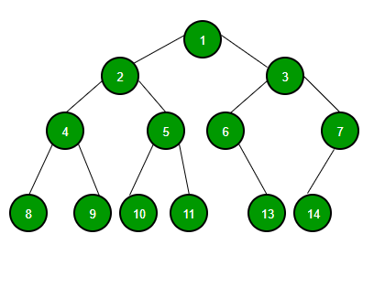

**Binary Search Tree Data Structure**

Binary Search Tree is a node-based binary tree data structure which has the following properties:

* The left subtree of a node contains only nodes with keys lesser than the node’s key.
* The right subtree of a node contains only nodes with keys greater than the node’s key.
* The left and right subtree each must also be a binary search tree.
* There must be no duplicate nodes.



<https://www.youtube.com/watch?v=5a9NUeRsBPo>

