Home Exercise Design

Introduction
The following describes the solution to the ESB candidate take home project.

Project Description
A number of vendors provide price information for traded instruments; a traded instrument will have different prices from different vendors. Price data from each vendor is to be cached in a local data store and then distributed to interested downstream systems. The cache will have services to allow clients to publish and retrieve data from the store. Clients are interested in getting all prices from a particular vendor or prices for a single instrument from various vendors. Prices older than 30 days must be removed from the cache.

Actors
There are three Actors:
- Vendors who provide price information for traded instruments
- Clients who retrieve prices from a particular vendor or prices for a single instrument from various vendors
- Downstream systems who subscribe for data

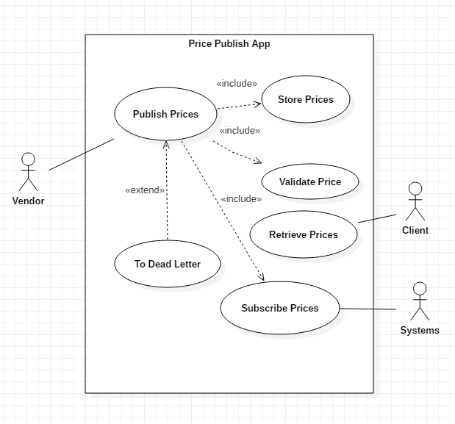

Design Approach
High Level Diagram

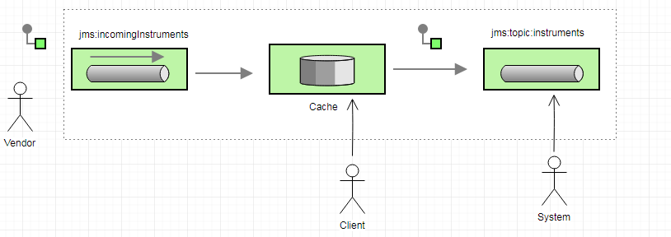

Enterprise Integration Patterns (EIPs) are used extensively to solve this problem. EIPs
use a common vocabulary that support effective communication and raise the level of abstraction at which we can describe recurring integration problems.

This solution uses a JMS queue and JMS topic for integration between the sub systems of the overall system. Furthermore, a DBMS (H2) forms part of the design along with a suite of restful web services.

An event driven consumer listens on the incoming instrument queue, receives messages sent by vendors, and sends them to be processed. The processing involves storing the price information from the message in to a cache and then publishing the price messages to a JMS topic. Interested down stream parties can subscribe to this topic. The solution also includes a Dead Letter Channel EIP which supports moving failed messages to a dedicated error queue.

Clients can retrieve all prices from a particular vendor by making a restful call such as:
http://<host>:<port>/api/vendor/prices?v=Fidessa

To retrieve prices for a single instrument from various vendors, clients would make a call such as:
http://<host>:<port>/api/instrument/prices?q=BBG009BHXGK6

Eviction of stale data is implemented using a polling consumer that is scheduled to run every 24H and evict stale prices that are older than 30 days.

The technology stack used is Apache Camel, Java 8, Spring Boot, H2 and Maven.

Assumptions
- Vendors can only submit instrument prices to the application by sending XML messages to a JMS queue (incoming instruments) that is outside of their domain. The structure of the messages must adhere to a contract.
- The vendors have sufficient authentication and authorization policies to be able to access the incoming instruments queue.
- The mechanism by which vendors send messages to the incoming instruments queue is outside of the scope of the design.

Possible Future Enhancements
- Support of different incoming instrument message formats. This could be implemented using a Content Based Router EIP that routes messages to separate queues depending on the content of the message
- A service that validates incoming instrument messages
- An application that connects to the dead-letter queue and decides what action to take with defunct messages.

Domain Model and Cache Implementation
The domain model consists of a single flat table containing price, vendor, figi and date timestamp.

Figi is the financial instrument global identifier and date is a timestamp indicating the point at which the instrument data was persisted to the cache.

There will be duplication of figi and vendor data. This may or may not lead to performance issue for this project. Extensive database performance tests need to be undertaken in a pre-production environment using anticipated data volumes and key performance indicators (KPIs). If such tests indicate problems then the table may need to be redesigned to support a relational model with figi and vendor each having separate tables.

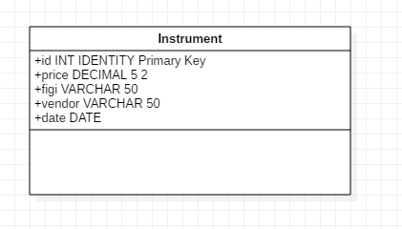

The cache is hidden behind an interface so that it can easily be swapped out for a different industry standard RDMS or hand crafted in memory cache implemented using concurrent Maps or other.

The price being sent to the cache will either be a new price for a vendor and figi pair or, an update to an existing price.

The solution doesn’t use the Java Persistence API (JPA) since the sql is straight forward.

Transactions
Some methods in the service layer have been annotated with spring’s @Transactional annotation. The service layer may call different DAOs to perform DB operations. Let’s assume a situation where there are 3 DAO operations in a service method. If the first DAO operation fails but the other two pass then the database will be in an inconsistent state. Annotating the service layer can save you from such situations.

The apace camel routes have been marked as transacted which instructs it to use transacted acknowledge mode. Also, a JmsTransactionManager bean has been configured that manages transactions when using JMS messaging.

If a message from the incoming messages queue is sent to the database but the connection to the database fails, then the message is sent to the dead letter queue and not back to the incoming message. This ensures that the broker won’t be fated by poison messages that would cause arriving messages to stack up on the queue.

Fault Tolerance.
Should an error occur anywhere in any of the routes that make up the system, then failed message will be sent to a dead letter.

Testing
To run unit and integration tests from the command line navigation to the root directory of the application and run

mvn clean verify

Additional tests required:
- A test that verifies that messages are sent to the dead letter when a consumer tries to send price information to the cache, but the connection to the cache fails. To test a camel route with using transactions would require live resources such as a real JMS broker. Simulating no connection to the database would then require code like this:

interceptSendToEndpoint(“jdbc:*”)
.throwsException( new ConnectException(“Cannot connect”));

Running Application
To run the application from the command line navigation to the root directory of the application and run

mvn spring-boot:run

Problems
Most of the issues faced where resolved by the answers given to the questions submitted to the team
Here are the questions along with supplied answers:

Could you give me an example of the format of individual elements of a record? I have decided to model instrument_id, instrument price and vendor_id.
You’re free to craft your own data model. Specify this in your documentation.

Can both clients and vendors update existing prices as well as publish new ones?
Assume vendors provide price updates and clients consume this data and publish price updates to interested parties downstream.
There are no NFRs mentioned in the design spec and as such I haven't tried to measure throughput or response times. I plan to touch on an approach to performance testing in my design brief. Out of interest, how many message per second do Vendors send?
Your design should be scalable and cater for high volume transactions although for this exercise, you don’t need to demonstrate much load.
My solution includes a jms queue and cache. Messages are consumed from the queue and sent to the cache. I plan to use some form of transaction management to prevent lost messages should the db connection fail after a message has been consumed from the queue. Do you encourage such refactoring and resilience enhancement?
Guaranteed delivery is a definite requirement so please detail in your documentation and implement a solution to facilitate this.

Is the technical stack completely my own choice?
Please use Maven for dependency management and avoid any technology which require libraries not available via Maven.

