- Total # of record holders
Go to the last row and subtract 1 since there is a header. In this example, # record holders = 2482
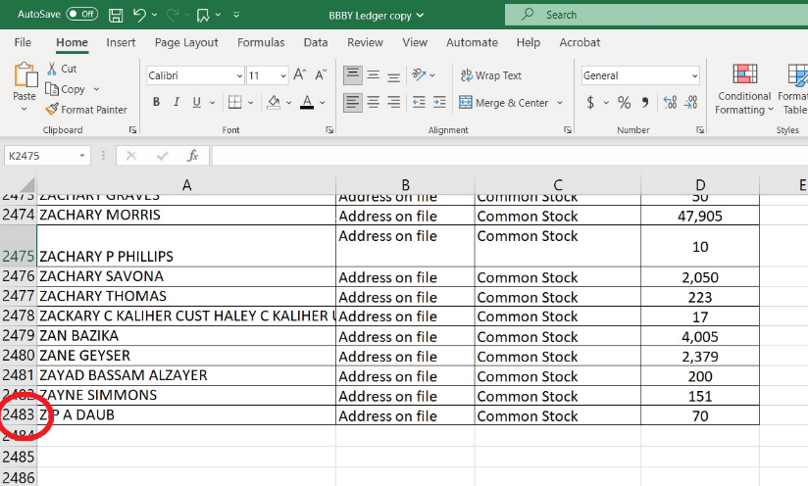
- Total # of shares
Click on the cell below the last recorded position and then click Autosum and hit enter. Record Total # of shares
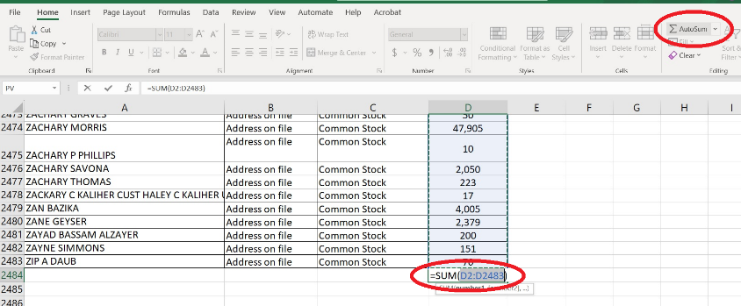

- Record the number of Cede shares and sum up the number of Cede shares. In this example, there are 3 Cede Accounts
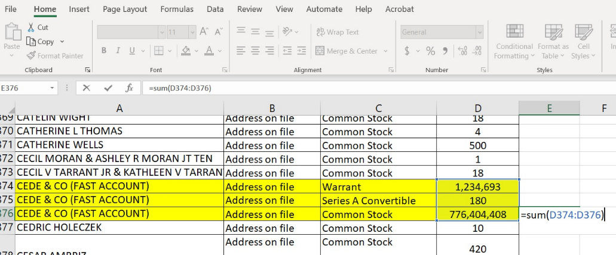

- THIS STEP CAN BE DONE AFTER VIEWING THE LEDGER =
Average Shares per Account = (Total shares – Cede shares)/(# of record holders – # Cede accounts)

- Total # of individual investors
  - Use the following function in Excel to quantify the number of unique holders
Click on the cell below the last record holder and type:
=SUMPRODUCT(1/COUNTIF(RANGE of Holders, Range of Holders))
Range of Holders here is A2:A2483, so
=SUMPRODUCT(1/COUNTIF(A2:A2483,A2:A2483))
If Holders is Column A, GameStop Range of Holders will be something like
=SUMPRODUCT(1/COUNTIF(A2:A198000,A2:A198000)) then hit enter
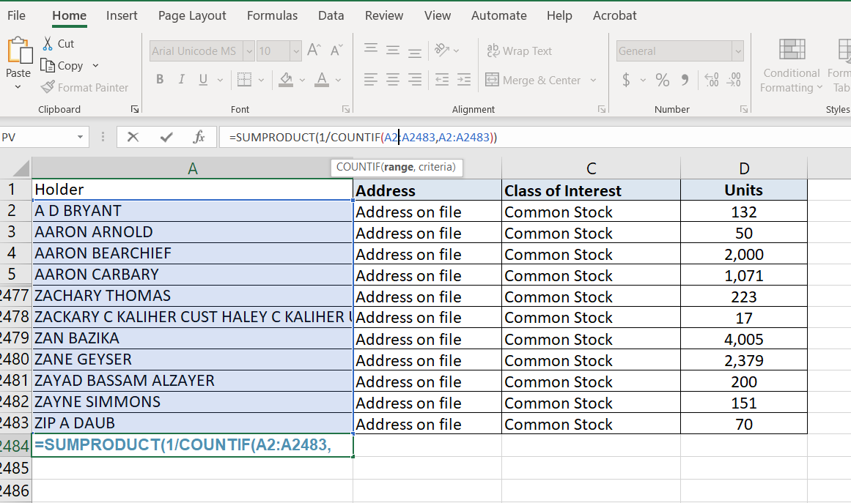
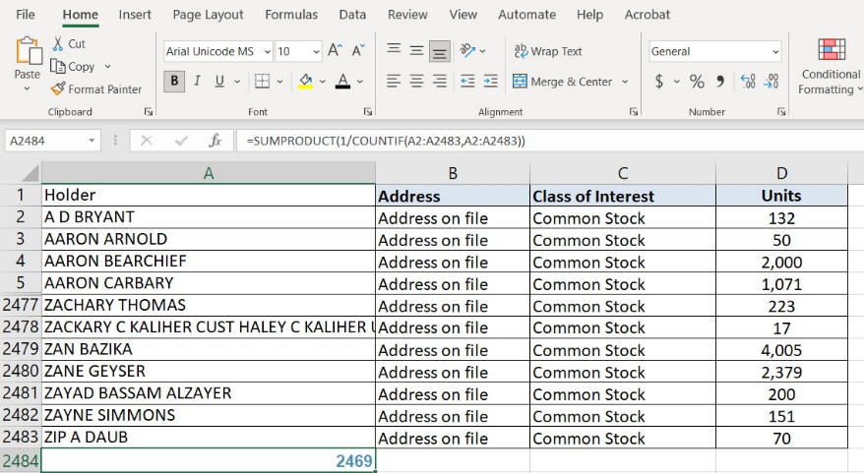
In this case, unique record holders is 2,469, but this includes Cede, so there are 2,468 individual investors in this ledger.

- Average Accounts per Investor (THIS CAN BE DONE AFTER LEDGER VIEWING)
Average Accounts per Investor = (Total # of Accounts – Total # Cede Accounts)/(Total number of Unique Accounts – Cede Account)
In this example,
Average Accounts per Investor = (2482 – 3)/(2469 – 1) = 1.00446

- Average Shares per Investor (THIS CAN BE DONE AFTER LEDGER VIEWING)
Average Shares per Investor = (Total Number of Shares – Total Number of Cede Shares)/(Number of Individual Investors – Cede Account)

THE FOLLOWING STATISTICS WILL REQUIRE NOTING THE CELLS FOR CEDE POSITION(S) AND EXCLUDING THEM IN THE FORMULAS

-So, note the row the data starts on (probably 2) and which row(s) Cede is/are in

- Average, Median, Mode, Standard Deviation
In this example, Cede positions are D374, D375 and D376 or D374:D376. These cells will be omitted from the following statistics
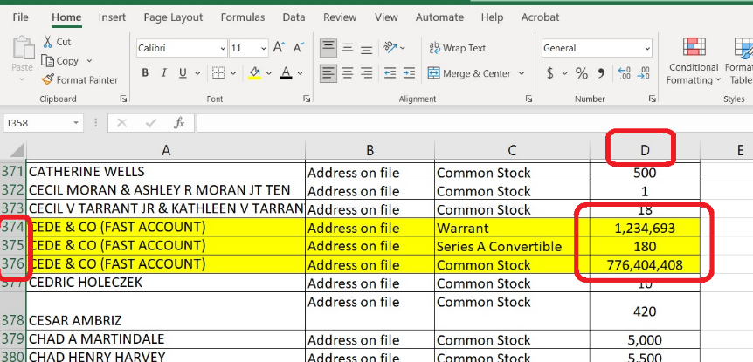
- Average
The GME database is going to be too big to hide the middle rows like I did for this, so it’s important to note Cede cells ahead of time.

Click on the cell below the last position and type:
=AVERAGE(Range above Cede position, Range below Cede position), in this example it’s
=AVERAGE(D2:D373,D377:D2483) and hit enter

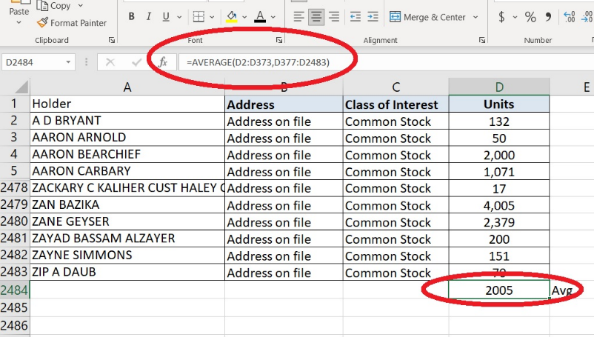
Write down the average number you just got, because you’re going to simply replace AVERAGE in the formula above with MEDIAN (leave everything else as is).

- Median
Click on the cell below the last position and type:
=MEDIAN(Range above Cede position, Range below Cede position), in this example it’s
=MEDIAN(D2:D373,D377:D2483) and hit enter

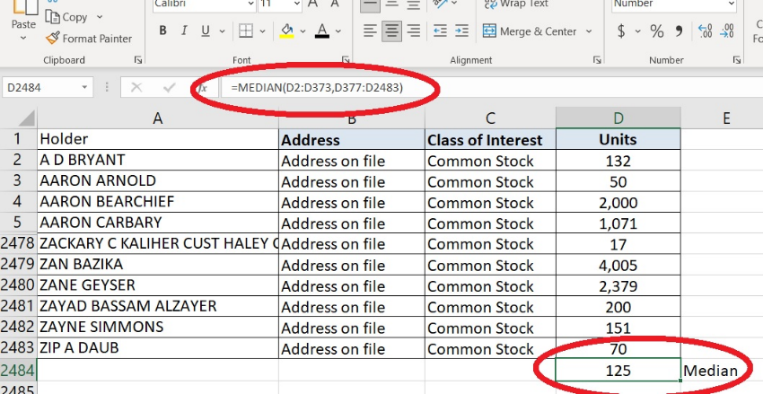

Write down the median number you just got, because you’re going to simply replace MEDIAN in the formula above with STDEV.P (leave everything else as is).

- Standard Deviation
There are two options here, standard deviation of a sample and standard deviation of population. We are dealing with the entire dataset, so we will use population (STDEV.P)

Click on the cell below the last position and type:
=STDEV.P(Range above Cede position, Range below Cede position), in this example it’s
=STDEV.P(D2:D373,D377:D2483) and hit enter

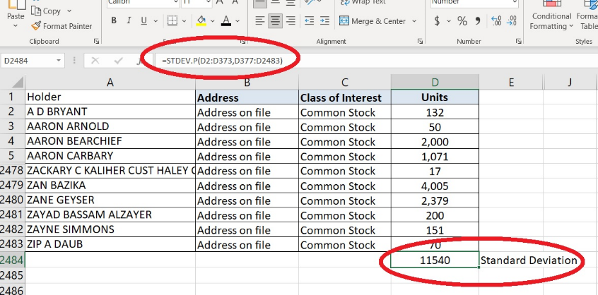

Write down the median number you just got, because you’re going to simply replace STDEV.P in the formula above with MODE (leave everything else as is).

- Mode

Click on the cell below the last position and type:
=MODE(Range above Cede position, Range below Cede position), in this example it’s
=MODE(D2:D373,D377:D2483) and hit enter
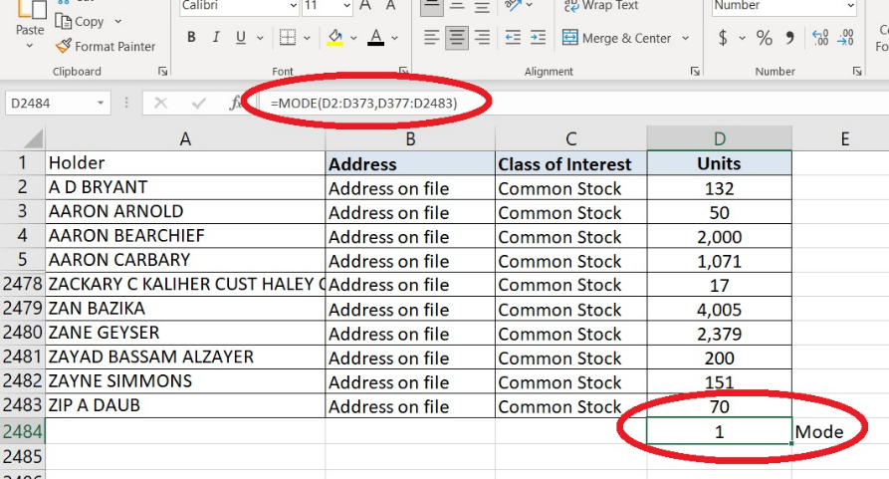
Write down the mode number you just got

