Nine to Noon

The Secret Workday of Uber-Wealthy Americans

By John Wooten

For the student, friend, and classmate who showed me that it was all worth it.

Thank you Jake Crapster
For the invaluable help editing, thank you
- Lydia Adams
- Gus Beaumont
- Brittany Blitstein
- Tristan Boggess
- Jenna Carter
- Ryan Creel
- Hannah Gorski
- Lucas Holzen
- Jenna Johnson
- Jacob King
- Willy Leung
- Kenneth Long
- Anthony Love
- Caroline Macfee
- Emma McElroy
- Alvin Mutongi
- Ashley Pehan
- Jack Podielsky
- Kailee Queen
- Keily Stiles
- Christian Sturt
- Annie Thomas
- Joseph Wessler
- Davis Wilder
- Kailee Zeltner

Published on January 29, 2019 in association with



This book has been one of the most difficult projects I have worked on in my life. I see it as a transformative work from my childhood to adulthood, and I hope it will inspire financial change in many brilliant minds. Sale of this book without a front cover may be unauthorized. If this book is coverless, neither the author nor the publisher have received payment for it. For all the painstaking 30-hour school weekends and writing-filled “breaks” that went into this book, I implore you to support this work’s official release. Thank you.

Copyright © John F. Wooten, IV

All rights reserved.

Full disclaimer at end of book.

ISBN-10:
ISBN-13: 978-X-XXXX-XXXX-X
Table of Contents

Preface ()

- The Day ()
- Starting to Get There ()
- Why should I trade stocks? ()
- Fundamentals ()
- Following the Rules to Wealth ()
- Retirement Funds & Taxes ()
- College ()
- Do Your Taxes ()
- A Quick Note on Debt ()
- Discovering the Stock Market ()
- Reading Stock Charts ()
- Bulls, Bears, and Shares ()
- News and Principles ()
- Selling Short ()
- Breaking Down Key Statistics ()
- Long-Term Low-Management Investing ()
- ETFs and Mutual Funds ()
- Commodities and Currencies ()
- Order Types ()
- Active Trader Status ()
- Options ()
- Bonds & Interest Rates ()

Technical Analysis ()

- Charts Expanded ()
- Draw on Your Charts ()
- Trendlines ()
- Triangles and Wedges ()
- Consolidation and Flags ()
- The ABCD Setup ()
- The Head-and-Shoulders Setup ()
- Candlestick Setups ()
- Moving Averages and MACD ()
- RSI, Stochastics, and Bollinger Bands ()
- VWAP and Circuit Breakers ()
- Combining Trendlines and Indicators ()
- Diversification ()
- Stock Screeners ()
- Brokers ()
- The Mentality ()

J. Wooten ()

Acknowledgments ()

Works Cited ()

Preface

This book is intended to give anyone a solid grasp on their financial future. Working nine-to-noon is ludicrously profitable, but it is not for everyone. However, you deserve to retire with as much money as you want. You deserve to grow your savings as much as you want. You can be the dictator of your own financial future by using the knowledge and everyday techniques of the uber-wealthy. America is a powerful economic machine that gives a huge tailwind to any equity investor; take advantage of it!

This book starts by going through the workday that so few truly master, the workday that opens the floodgates holding back unimaginable opportunities. Then, we dive into the basic techniques and tougher technicals behind long-term investing. We run through many account setups and fundamental analysis. This section starts off assuming you know absolutely nothing about the markets. Next, we dive into patterns, setups, indicators, and everything else you can use to master active trading and strengthen your long-term trading. By the end of this book, you will ask yourself why you ever thought of hiring a financial advisor when the stock market makes so much sense to you!

I truly hope that this book inspires a few people to embrace the nine-to-noon workday, no matter their current wealth.

Enjoy,
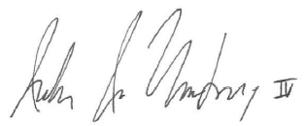

Chapter 1
The Day

It’s nine in the morning; you sit down. You don’t know what the approaching trading day has in store, but you are ready to tackle anything the market throws at you.
You aren’t in an office building. You aren’t on Wall Street. You aren’t even fully dressed. But none of that matters. You sit at your computer this morning eager to work because you want to reap the rewards. You work from anywhere with an internet connection, linking you directly into the greatest financial market this world has ever seen.
First thing’s first: premarket screeners. You scan through twenty gapping stocks as quickly as you can. You carefully analyze volume, price range, and percent change on the fly. Tickers fly down your screen as you pick your favorite movers. Everything you see has crossed your eyes a thousand times before.
15% gainer?
24% gainer?
62% gainer? With that volume?
Is that $TOPS?
You see all the same things over and over every day, but somehow it’s always different. You never remember the tickers that never stay around, yet you always come back to find more. The potential is here, and you can see it.

9:05

You get your favorite movers up on the charts; each stock needs to be decoded. You zoom out, looking at both the last week and years into the past. You find a double-top resistance, a short-term trendline, and a head-and-shoulders setup from last year. Great news! You know that these price levels will be high tension points for the movement today, and you draw them on your chart accordingly. Next, you zoom back into the real game: the short-term. You’ve drawn your historical support and resistance lines, and now you have a better idea of where this stock can soar to.

9:10

You grab another preferred stock off the screener and repeat. It’s all about opportunity. You don’t know what today’s biggest mover will be, but you do know that everything happens quickly in this game. You type the ticker into a chart and look for historical resistance levels. These might be your sell targets today if the stock can manage to go high enough. You know that your early price outlining will pay off in today’s rapid trading by giving you a slight edge over everyone else, an edge that tells you when to sell when they hold into a pullback.

9:15

You keep charting long-term price levels for all the stocks you like on your premarket-gainers screener. As long as you see the volume to support a trade intraday, you see the need to mark historical price levels. There are different movers every morning, and you have to chart every day to stay on top of the game. Everything moves once we hit the bell.

9:25

You finish marking supports and resistances for all your favorite premarket gainers, and you know you’ve done the best you can with what you have. If anything had a serious run-up before this morning, you know about it. Now, you move on to catalysts. Starting with your most promising picks, you run a quick news scan to see if anything could really shoot the stock price up today. You look for anything that could bring the stock price climbing today, and then you see it.
FDA approval!
New patents!
Stellar earnings!
New executives!
You never care what the news is because you look at everything the same. If anything brings others to the stock, then you are happy to cut them into the game. Higher volume means even more attention, liquidity, and implied volatility, and you wake up every morning for those three.

9:28

You refresh all your screeners and look for any new last-second movers you may have glanced over earlier. If you find any, you draw in historical price levels and hope to see the stock approach them. You play everything off the charts; candlesticks are your portal into the game.
You make sure that you go into today’s market with the best information you could find. Your twelve different charts are simultaneously polling market backends, begging to see today’s first candle. You know that the floodgates are about to open, and you are almost ready.

9:29

You prefill all your order boxes with the number of shares needed to make up your intended individual position cash sizes. You never thought you could punch numbers into a calculator this quickly before, but you know that everything needs to be perfect when you hear—

9:30

DING DING DING

The sound never gets old. Every time you hear the opening bell, you know that the American economy is open for business. Premarket orders flood the world’s largest exchanges faster than you can push send on your market buy. Everything starts moving, and it’s finally time to start trading.

You know that the next half hour is the most volatile time in the market, and you are instantly ready to cash in on its movement. The first thing you do is watch for quick price action in the stocks you’ve identified. You jump onto short-term swings to catch some early-market momentum. If you see a setup, you go straight to your principles.
You use technical analysis to enter a position.
You have no bias for any one stock.
You are conditioned to buy and sell based on facts.
You avoid low volume trades without substantial upside.
You only trade cheap stocks when there’s not insane volatility
You always sell when you have profits with no backbone
You stick to hard stop-losses to mitigate risk
You never get stuck on one stock
You only use market orders in a fast-moving market
You play everything off the charts
Your principles develop as you trade and always cater to your specific style. They keep you disciplined, taking smart profits and cutting losers quickly. You know the patterns and breakouts that you trade, and you only take trades you can predict.

9:45

Time is a blur sitting idly behind the excitement, pressure, and dopamine embedded in this morning’s early trades. You’ve made you quickest trades for the day. If anything was going to pop rapidly from premarket activity, it has. You follow the gainers for the day in hopes of a continuation of momentum. If you are still in any positions because they look promising, you start calculating how long it is safe to stay in before exiting with profits. You move your stop-losses according to how confident you are in positive movement. You understand the risk and price levels to watch out for in your positions.
If you are not actively in more than two or three trades, you pull up your live scanners to find any new stocks collecting momentum and making new highs for the day. You are always ready to find new opportunities and quickly analyze new movers.

10:00

You continue watching for setups in the day’s leading stocks. You analyze the movement in the long list of stocks on your screens and quickly weed out bad picks. You pull up the rest on different charts until you find a good setup to trade. You never forget early movers in the day that might have possible setups later on. You are carefully and calculatedly splitting your limited attention between everything.
Open positions
Possible setups
Order boxes
Order size
Unfilled positions
Both old and newly formed trend line patterns
Indicator movement
New gainers on the screener
Catalysts for intraday movement
Drawing and analyzing historical support and resistance levels
The pressure is on by ten because you are either looking to make big gains after a slow open or trying to close out your massive profits for the day before morning volatility fades away.

10:15

You listen to the markets and see how quickly everything is moving. You pounce on stocks with the most volume and lowest spreads as soon as you see great setups. You never hesitate to submit an order when you see a surefire trade, but you also never forget to consider the downside. You know that you will be fine as long as you keep your winners large and your losers small.

10:45

By this time, most of you biggest trades have gone through. You’re looking to make a little off quick setups here and there when the market presents them to you. You might start running through the most popular stocks for the day one last time to spot any last minute breakouts or continuations. You treat any open positions normally and sell at your sell targets or adapt to new prices if necessary. You look for any closing trades to end your active session.

11:00

You start to finish up your active trading and begin closing out all your positions. This morning was energetic and swift. You took what you could from the markets or gave some back. You never hold anything past the close and rarely see setups as you near lunchtime. It’s time to move onto long-term portfolio management.
The first thing you do is check to see how your long-term portfolio performed this morning. You compare your percent change to that of the three major American indices. Your long-term portfolio goal is to beat all three indices every day. You know that you will have extremely strong long-term growth if your picks can consistently beat the average market return percentage. If any of your positions have large movements, you look at those first. You are constantly analyzing the long-term potential in all of your picks and potential picks. After reading up on larger daily catalysts such as big news, you take one more look over your actual portfolio. You also check the progress of any swing trades that you may want to exit. You want to make sure that everything you own is performing give or take how you expect it to.

11:15

Once you are totally done with morning active trading, you start looking at potential stocks to add to your long-term portfolio. You stick with your standard researching and go over your potential buys watchlists. You perform some technical analysis on a few promising picks. If you see something you like and have been watching for a while take a significant drop, you may put an order in for it. You are always quick to reinvest dividends and profits because you know that reinvesting compounding gains is the quickest way to grow your account.
If your portfolios do not stack up to the average market return in the long run, you analyze the factors behind your underperformance and consider ways to rebalance your portfolios to accelerate growth. Additionally, you spend this time to consider how diversified you are between independent markets as you constantly strive to diversify your holdings.

11:45

At this point, you have looked at a few long-term stocks that you own or may soon own. You have thought about the potential in the companies and weighed the technicals and public perception to come up with an opinion about the stocks at their current price levels. If you like a position, you enter it when you see a good opportunity or with an average cost spread across a longer period of time.

11:50

You look for larger companies that moved a lot today. You see what made the market move on the greater scale and consider the economic implementations for your portfolio. You also add any stocks you learn about and like to a watchlist for the future.

11:55

Nearing the end of the morning, you acknowledge your gains for the day and make sure all your orders settled with your broker. You check for any open orders and close out of all your trading software. You shut down your scanners and finish and last minute long-term analysis.

Noon

You enjoy a well-deserved lunch.

Chapter 2
Starting to Get There

The nine-to-noon day might sound tough. Do not worry. People work for years to master their morning trading. Let’s start out with a distinct division we must make.

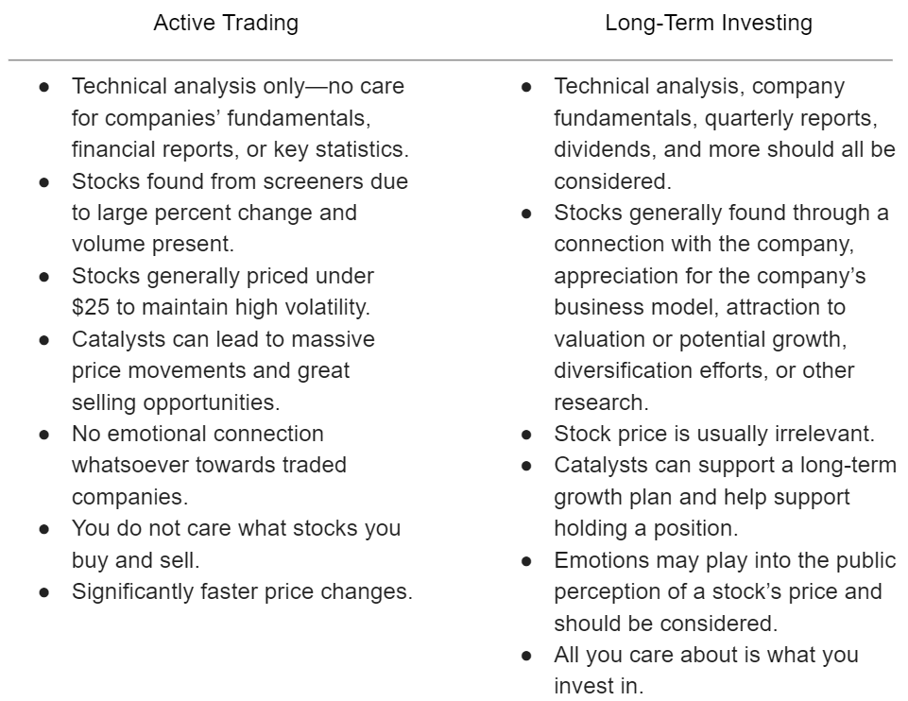

Of course, there is a middle ground between active trading and long-term investing: swing trading. Swing trading primarily uses technical analysis to identify medium-term movement potential in a reputable stock. The stock needs to be reputable so that your position does not lose significant value in premarket trading. This potential loss is the primary reason you close out active trades before the end of the market day. Most of the smaller stocks you actively trade are unknown and could have potentially adverse downward moves in after-hours trading. So, when you make a medium-term call on a swing trade, you want the stock you trade to stay predictable for the next few weeks or so, depending on the time frame of the setup you identify.
When you swing trade, you should usually research and check on your positions during the end of your nine-to-noon session once active trading volatility has died down.

Swing trading will often yield medium to high returns when done correctly. Active trading generally yields higher returns, and long-term investing generally yields lower returns. However, it is important to find a good balance between active and long-term trading in order to stabilize your income and mitigate risk. Remember that some days may be unprofitable, but you will succeed in the long run as long as you win more than you lose.

Chapter 3
Why should I trade stocks?

Before we talk about the stock market, I want you to understand what builds wealth. When you buy something, you can either buy an asset or a liability. When you buy a liability, that purchase takes money out of your bank account repetitively. Say, for example, you buy a house. Now, you have to pay for your bills, possibly your mortgage, utility issues, paint, and more. This house is a liability because it takes money out of your pocket after you buy it. On the other hand, if you buy a house and rent it out to somebody, it's an asset you as long as the money you take in covers your expenses. When you make money from buying something that pays you back over time, you have an asset! I want you to make asset your new favorite word, because purchasing assets and minimizing liabilities is the key to growing your wealth.
The three main types of assets are real estate, paper assets, and
alternative investments or businesses. I focus on paper assets for long-term growth because real estate investing (buying, renovating, selling, renting houses, etc.) is a very different approach to wealth management. Many real estate investments beat the average stock market return, but these investments usually require much more time, attention, management, maintenance, and operational skills that are completely unneeded in the stock market.
Primary paper assets can be CDs, bonds, stocks, or cryptocurrencies. Cryptocurrencies represent a significant chunk of my personal investments, but I will not go into great depth about them in this book. Cryptocurrencies are very new in the public investment space and, even though I personally manage crypto, I understand if some investors avoid this new technology.

However, for those who embrace and trade crypto, I want you to know that everything you learn about technical analysis in Part Two of this book directly applies to swing trading and long-term investing in cryptocurrencies.

With that said, let’s talk about CDs. Also known as certificates of deposit, CDs are the least risky of the three main paper assets. CDs lock up your money for a predetermined amount of time in exchange for a predetermined return. CDs are sold by banks, credit unions, investment firms, and credit companies who use the locked up money to fund lending ventures. Because CDs are insured for up to $250,000 by the FDIC or NCUA, you are guaranteed your returns with a CD.¹ All you have to do is determine how long you want to lock up your money, longer terms yielding higher returns. Most CD providers offer a wide range of CD terms to satisfy any investor while still giving the bank a reasonable term.
If you withdraw your money or cancel a CD before the CD term expires, you will pay a hefty fee and take a loss.² Otherwise, these investments are as safe as bank accounts. Because CDs bear the least possible risk out of all paper assets, they pay the lowest return.
CD return rates change a lot depending on the economy, inflation, and other current trends in the banking sector.³ Average CD rates have been steadily declining for around the past forty years as the value of the US dollar steadily declines.⁴ With that said, you can usually expect to receive anywhere from half a percent to a little over two percent return per year on today’s average CDs.⁵ What that means is that, if you put in $100, you'll get $100 and an extra dollar or two back in interest. These rates used to be higher and they used to be lower.⁴
Now, the thing about CDs is inflation on average is 2 percent a year.⁶ This number has been sporadic in the past, but the last few decades have averaged out the inflation rate to 2 percent.⁶ Additionally, the federal reserve now targets a 2 percent inflation rate.⁷ So, every year when your money sits in your bank account, you usually get paid around 0.01 percent or something to let the bank loan and invest your money at substantially higher rates.⁸ While your money sits around, you lose 2 percent of your purchasing power every single year because the government prints away 2 percent of the US dollar’s purchasing power. This basically means that, every single year, the same dollar is worth 2 percent less than it was the year prior even though it has the same face value. By not having your money in assets making you money, your money is just sitting there losing purchasing power every year.

Bonds are a medium risk investment that are great for diversification, but bad at making you much money. Although there are many different types of bonds to invest in, most of them only pay you about 4 to 5 percent annual returns for your money, about 2 to 3 percent after inflation.⁹ Some sought-after bonds pay much more than this, and they can serve as good, safe investments for you if the company issuing the bonds is reputable. To get a bond, you loan a company money to spend on internal improvements, corporate investments, etc. The company then pays the money back to you over a predetermined amount of time with a certain return per year, half-year, month etc. depending on the bond issuer. At the end of the payback period, you finally recoup your initial investment plus all earned interest.¹⁰ Bonds are less risky than stocks because the only way to lose money with a bond is if the borrowing business stops paying the bond which can only happen if they go bankrupt (even then, sale of corporate assets goes to paying bondholders first). So, as long as you try to pick reputable businesses, bonds are usually a medium risks investment that yields you medium returns.
A special kind of bond to look out for is a convertible bond. Companies that issue convertible bonds usually pay lower bond return rates compared to their normal bonds, but these bonds can be converted to shares of a company’s stock at a future date for a predetermined number of shares.¹¹ You can use a convertible bond to start with a lower-risk investment and then have the option in the future to cash in on gains if a company’s stock price rises significantly.
Another special kind of bond to know about is a Treasury bond. These assets are also called Treasury bills and Treasury notes depending on their maturity length.¹³ Treasury bonds are issued by the United States to anyone who wants to buy them directly online via TreasuryDirect or through a brokerage account.¹² When you buy a Treasury bond, you select a period of time that you will lock your money up in the bond.¹² Just like a CD, the longer you leave your money with the Treasury, the higher percent return you can expect from your bond. Finally, Treasury bonds are CDFI Bond Guarantee securities, meaning that they are guaranteed by the government just like CDs are guaranteed by financial institutions.¹⁴ Because of their similar risk level to CDs, treasury bonds almost always offer you lower rates than corporate bonds. The U.S. Department of the Treasury constantly changes treasury bonds’ returns according to how they think the rates should change according to the economy.¹³
Unlike CDs, Treasury bond returns are exempt from state and local income taxes.¹⁶ Additionally, you can sell your treasury bonds on secondary markets at any time to liquidize your position with no early-withdrawal fees. However, your bonds may lose much of their value in a secondary market if newly-issued treasury bonds offer increased returns.¹⁷ Nonetheless, you can still hold your bonds until maturity, receiving semi-annual interest payments from the Treasury.¹⁹ Because of the tax benefits of Treasury bonds, comparing them to CD rates is unfair because CDs generally offer returns that are fairly similar to Treasury bonds.¹⁸ Treasury bond rates have been historically volatile, but returns for the past decade average out to pay you about 1 to 3 percent annually pre-inflation.²⁰
Treasury Inflation Protected Securities (TIPS), Series I bonds, and Series EE bonds offer you guaranteed returns on top of inflation.²¹ ²⁹ ³¹They all function similarly to Treasury bonds, but they generally offer lower returns because of their decreased risk.
TIPS pay their interest-rate coupons semiannually just like Treasury bonds, but the actual face value of the bond (that interest is paid on) increases each half-year depending on inflation, measured by the Consumer Price Index for All Urban Consumers.²² ²⁴ ²⁸ For the last decade or so, TIPS have paid around one percent or less on top of inflation per annum.²³ You may even see negative interest rates in exchange for protection against inflation, through you can simply avoid buying TIPS when rates are extremely low, as you lock your fixed rate in (plus inflation or minus deflation) when you purchase the bond.²⁶ ²⁷ Note that inflation increases in principal are taxable for the year in which they occur.²⁵ All interest and gains are exempt from state and local taxes.²⁵
Series I bonds are like TIPS but they do not pay interest coupons, acting rather as zero-coupon bonds (which we’ll talk more about in Chapter 22).²⁹ You buy into a set return rate when you commit to the non-marketable Series I bond plus a variable inflation rate, both of which are added biannually to the redemption value of the bond.²⁷ Unlike TIPS, you won’t lose interest if deflation occurs.³⁰ You can pay federal taxes on capital gains exclusively at redemption date or annually on unrealized gains as you bond gains value over time.²⁷ ²⁹ You can only purchase $10,000 of these bonds per year per Social Security number.³² Interest returns on top of inflation over the past decade range from 0 to 0.7 percent.³³
Series EE bonds currently yield 0.1 percent annually (added monthly and compounded semiannually, 2018), but they differ from most investment bonds in that it only really makes sense to buy them for extremely long time periods.³⁶ We’ll look more at bond specifically for diversification soon, but the key with Series EE bonds is that the government guarantees that your bond will double in future dollars after 20 years (a 3.526 annual percent return before inflation).³⁴ ³⁵ The Treasury simply makes a one-time capital-gain adjustment at the 20 year anniversary of the bond's issue date to make up the difference between the initially-agreed-upon interest rate and twice the bond purchase price.³⁷ So, a $100 investment, assuming a constant 2 percent inflation rate, turns into a federally-guaranteed $133.52 in today’s dollars after 20 years ($2000.98²⁰). Similar to Series I bonds, you can choose to pay federal taxes exclusively on interest income and possible capital gains each year or at redemption.³⁴
The last special kind of bond to know about are municipal bonds. You can purchase these bonds from state and local governments to finance local government projects. In return for your money, you will not pay federal taxes and most state and local taxes on your earned interest.¹⁶ Unlike TIPS which are adjusted monthly for inflation or deflation, Series I bonds cannot lose value and will always pay at least the earning interest rate.²⁷ ³⁰

The last low-return investment to know about is money market accounts or funds. Money market accounts and funds are usually managed by banks, credit unions, and other financial institutions.³⁸ These managers invest your money into any combination of short-term low-risk assets listed previously to gain returns.⁴⁰ Money market accounts are FDIC insured, but money market funds are not.³⁹ Because of their general illiquidity in low-risk investments, money market accounts generally carry minimum required balances for managers to invest.⁴¹ However, you can still withdraw your cash from these accounts at any time.⁴² Money market account and fund returns used to be much higher when CD rates and savings rates were higher.⁴ However, in the past decade, returns generally pay you around .5 to 2 percent annually, depending heavily on the account or fund manager. These accounts are great if you want to earn a little more interest on money that you might immediately need (e.g. part of your rainy day fund) without locking up your money in a bond or risking a short-term stock decline.⁴¹ ⁴³

Now that the low-return markets are out of the way, let’s jump into our best friend, the stock market. When you buy stock in a company, you now own part of that company. This happens because the company you invest in decided to issue shares or parts of the company on a public market to raise capital. Now, you can buy these shares from a previous shareholder and their value will change over time depending on the public perception of the company.⁴⁴ The value of your portion of the company changes based on what other people are willing to pay for it in the market; price movement depends on how market buyers and sellers react to financial reports, breaking news, industry movements, and more.
The Standard & Poor's 500 Index is a weighted index of the largest 500 companies in the market. We will talk more about indices in Chapter 16, but the important thing to know about this fund is that it covers 80 percent of the market’s total capitalization (i.e. money!) and is used as a comprehensive baseline for measuring US market performance.⁴⁵ The average return for this collection of stocks is around 9 to 11 percent a year, which goes down to 7 to 9 percent after inflation.⁴⁶ ⁴⁷ On the conservative end, a fully-diversified stock market portfolio based on the S&P 500 Index should make you a 7 percent post-inflation cash return in the long-term.⁴⁸
7 percent is a big number for just parking your money in the American economy. All you have to do is earn your return in the long run is send your money into an account that invests in everyday companies and *BAM* your money grows more the longer you leave it in the economy! Market crashes, huge run-ups, and long periods of stability all happen in the market, but, in the long term, the market and your investments continue to grow because the companies behind your stocks make more money to fuel your portfolio.
Now, I do not know your income or your wealth, but I do know that compound interest can help anyone no matter their income. Let’s say you are fresh out of high school at 18 years old and you get a paycheck every month for X much money. Assuming you make a living at some kind of work, let’s say you find room in your carefully planned budget to invest $417 a month, adding up to $5,004 a year. Now, let’s assume that you earn the same amount of money for the rest of your life. I know that rarely happens, but I want to emphasize this example by assuming that you can only put away $417 a month every month until the government-defined retirement age of 66 (soon to be 67).⁴⁹ To compensate for this unchanged contribution amount, let's add a seed investment fund of $5,004 to put in at the very beginning of your investment lifetime. From 18 to 67, you have 48 years to let your money earn you more money and grow. Keep in mind, once you put your money into this sort of investment account, you are completely hands-off. You can check your balances as much as you’d like to, but you leave everything in funds (which we’ll discuss in Chapter 17) and never touch your money once you put it in. So, you invest $5,004 a year after an initial $5,004 investment every year for 48 years, your whole working life! First of all, that commitment is a feat in and of itself. With that said, let’s first look at a visual representation of how your money will grow from the average stock market return of 7 percent after inflation.
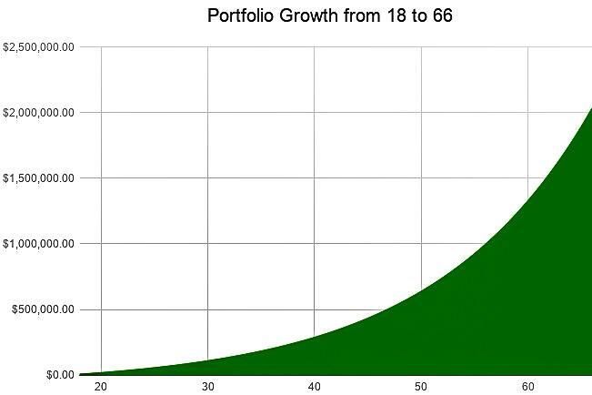
Ignore the numbers to the left for just a moment and look at the curve that we created above. I’m sure you know that what your seeing is the compounding effect. At the beginning of your investing career, your account grew at a much lower rate while you kept funding it. Then, as your money started to earn more money, your account started to grow faster because your newly realized gains get reinvested back into your portfolio while you continue to add to it. This leads your account to grow faster than ever before because now your new money earns you more money alongside the money you put in previously in addition to the money you contribute on top of everything else! In the example we set up, contributing just $5,004 a year after a $5,004 initial investment, our ending retirement account at 66 turned out to contain $2,020,254.44! Remember, that 2 million figure is in today’s money, calculated with today’s purchasing power. In reality, a 9 percent annual return would show a real future cash balance of $4,045,488.23. Plus, you only put in $5,00449=$245,196 to get this money.

The following work shows the basic compounding idea behind our portfolio’s massive growth in numbers with an average market return adjusted for inflation. We turn this growth principle into an equation in the next chapter.

As your money grows, its earnings continue to add to your capital base each year, further growing as you accumulate more interest to create massive long-term growth. Remember, to achieve these gains, you never have to work nine-to-noon or learn any of the technical skills talked about in Part Two of this book. All you do to realize these gains is work hard at your occupation, put a little away every month, and enjoy your life while the capitalism-fueled American economy works hard to grow your money for you (we’ll explore long-term low-management investing in Chapters 16 and 17).

Now that we’ve made you a millionaire (if you weren’t already one), let’s step back and look at the three main factors behind building your investment wealth alongside some important concepts to remember.

Chapter 4
Fundamentals

Considering that you decided to pick up a book about the stock market and read it, I’m confident that you can become a millionaire (if you aren’t already one). Being a
millionaire becomes incredibly simple with consistent dedication, doing the same thing over and over, year after year. When you keep buying paper assets over time, the money you earn from those assets makes it difficult to be poor! By the time your wealth starts compounding at rapid rates, you can’t help but keep making more money.
The three main factors behind growing your long-term portfolio are:
- Cash invested,
  - Depends on your career, lifestyle spending, and investing habits
- Percent return received, and
  - Depends on overall economic market performance and how much time you invest in trading to beat market returns
- Time
  - Everyone has 24 hours in a day

The amount of money most people invest in the market usually depends on their income. Now, I’m not here to tell you how to budget your life, which coffee shop to skip in the morning, or how much money you should give away every year. Additionally, I don’t know how you can make yourself more money by working either for yourself or for someone else. The responsibility of budgeting and increasing your income rests on your shoulders. You can make as much money through investments as you want, and it’s up to you to put away the amount of money you want to meet your retirement goals, the maximum amount of money you can physically invest in America, or a mix between the two.
To see if you are on track to meet your goals, look up an online “compound interest calculator” or use the following formula (which assumes annual additions at the beginning of each year rather than monthly contributions) with your current investment amounts.

¹
Replace all 7s (representing a 7 percent average market return) in the above equation with 9s to get a conservative average estimate of your retirement balance in actual future dollar amounts after inflation.
Many rising students choose to go to college to increase the amount of money they think they can make. Because it can be tough to work, invest, study, and excel in college all at the same time, many college students do not start investing until they finish their degree programs. This degree should allow them to earn more money in the job market, which hopefully allows graduates to contribute more to their retirement funds! Use your compound-interest calculator to figure out how much you should invest if you expect to only receive the average market return. We will talk more about college in Chapter 7.

The percent return you receive from your long-term portfolio can be difficult to increase if you only invest in indices, funds, and more diversified groups of stocks that we will discuss later. To increase your percent return consistently and by significant margins, your best bet is to master the trading principles we discuss later and to apply them to medium-term swing trade positions or long-term technical analysis trades. The more you search for trading opportunities in the market, the more opportunities you’ll find to beat the average market return. You can capitalize on opportunities you find in individual stocks by making your own proactive trades. We’ll dive into the fundamentals behind your own trading later in this book.

The amount of time you have to grow your money is one of the hardest things to change, but it is one of the most important factors for long-term portfolio growth with little active management. Investing early on is one of the best things you can do. If you slack off and start your $5,004/year retirement fund at 26 to retire at 66 with an initial investment of $5,004, our 2 million (current) dollar retirement fund turns into $1,143,834.47!² We only removed eight years from our investing (about 16.66 percent of our initial 48 investing years), but our end retirement balance decreased by about 43.38 percent! The money you save at the beginning of your investing has the greatest impact on your savings at the end. To show the truth behind this statement, let’s look at three examples.
Billy graduates high school at 18 and starts working immediately. He is lucky enough to have $5,004 saved up from summer jobs. He starts a retirement account and funds it with $417 a month every month while he works very hard to bring in enough to provide for himself. He gets better at his job as time goes by and uses his extra money to support other ventures. By the time he gets to 66, Billy has never missed a single investment, and Billy’s market positions have performed at the historical average return. Billy has an account with $4,045,488.23 inflated dollars ($2,020,254.44 current purchasing power).²
Bob goes to college right after high school to get a four-year degree. Bob works very hard during summers and when he finds time during the school year to work and make enough money to pay for all his college expenses. After graduating, Bob excels in his field and manages to put away $10,008 a year or $834 a month with no initial investment since he used all his spare money to pay for college. He works from age 22 to 66, using raises he receives to fund other ventures. With average returns, Bob retires with an inflated $5,252,786.21 ($2,849,771.10 current purchasing power).²
Joe is very smart and loves the criminal justice system. Joe goes to an undergrad school for four years after high school and then completes three years of law school. To fund his schooling, Joe trades nine-to-noon before his classes and during the summer. However, Joe struggles on the Bar Exam, so he takes one extra year of law school to get him ready for practice. At age 26, Joe receives his license to practice and starts saving for his retirement! Joe invests $20,016 a year or $1,668 a month until retirement age with no initial investment because he used all of his stock profits to pay for his last year of law school. Under the same market conditions as Billy and Bob, Joe retires with an inflated $7,371,729.97 ($4,275,609.15 current purchasing power).²

Billy, Bob, and Joe all have very respectable retirements, but they all lived very different lives because of the educational paths and careers they embraced. One very important thing to remember is the importance of graduating from college without debt. In fact, I’d say most people should avoid all debt entirely unless investing in real estate or settling down in a home. Student loans, unpaid credit cards, missed car payments, etc. all compound just like stock appreciation. However, unlike stocks, these liabilities compound negatively, increasing your debt by creating more debt with the debt you (may) already have. Living below your means for a short period of time will help you learn to avoid debts and maximize early investments in assets. Always eradicate any debts you unfortunately encounter as quickly as possible, since the money you use to pay those back could go into your investing account, building your future up rather than destroying it.
Speaking of living below your means, let’s look at one simple example of spending discretionary income instead of investing it. Let’s say you get a paycheck
and eagerly go to the store to buy the newest $200 pair of shoes everyone is talking about. I think a better way to look at this purchase is to ask yourself a simple question. What would that $200 be if you put it in the stock market for 35 years? That $200 could turn into $2,135.32 in your retirement fund post-inflation.² With that investment, you can
now buy almost 11 pairs of $200 shoes in future money! That’s the importance of investing early.

Chapter 5
Following the Rules to Wealth

When you buy stocks, you go through brokerages to get them. These companies connect to the big-name exchanges you hear about all over Wall Street. We’ll talk about brokers later, but you should remember one thing about these corporations: they all have to listen to the SEC. The SEC is the U.S. Security and Exchange Commission, an independent federal agency created by the Securities Exchange Act of 1934.¹ The SEC regulates the whole stock market, and they're important because they set all the rules of trading. You need to remember a few of the SEC’s rules when you're investing or else you risk a frozen brokerage account or cash liquidity issues. Brokers usually inform you about the most important SEC rules right before you break them, so you don’t have to worry too much about actually researching them. With that said, there are two SEC-identified circumstances that many people have trouble with.
The first issues you will run into very quickly if you start active trading in a cash account are cash liquidation violations, good-faith violations, and free-ride violations.² These violations occur in a cash account because the SEC allows one to three days for a stock trade to clear, payments to settle, and shares to be transferred after a market trade (three days used to be standard, down from a historic 5-business-day settlement).³ In these settlement days, you will run into serious problems if you try to:
- Sell shares you recently purchased before payments are cleared by the SEC,
- Make a trade with money from a recent and uncleared sell or short trade (see Chapter 14), or
- Cover the cost of a stock by selling it quickly after purchasing it to pay for the purchasing trade.

Thankfully, the SEC recently enacted T+2 settlement on most securities in September 2017, expediting your trading in cash accounts.⁴ Nonetheless, you should avoid these three activities anyway, but some traders incur violations accidentally when trading quickly even though they will have plenty of cash to fill their orders once their T+3/T+2 balances settle. These violations usually result in long account restrictions and tons of investigative work that you want to avoid at all costs.
To avoid this problem, ask your broker to open up a margin account if you start actively trading short-term or medium-term picks. When you trade on margin, you trade with the broker’s money, essentially creating trading debt, which you should avoid at all costs. However, if you only use the margin your broker gives you to pay for trades that you can afford once all your trades clear, using margin becomes perfectly safe and allows you to avoid to tedious and inefficient clearing methods that govern cash accounts. We’ll talk more about brokers in Chapter 37.
Trading on margin is almost like buying things with a credit card; you will be fine as long as you only spend the money you have. If you spend a broker’s money on a trade and lose money on the trade, you will owe the broker any money that you lost just like a normal cash trade. However, if you lost more than you can pay in your account, then you will have to deposit more money to pay your debts or else they will grow with interest.⁵
Significant margin losses happen more easily when you trade with leverage. If a broker grants you leverage with your margin account, you will be permitted to trade a certain multiple of your actual account value off margin-lent money. This increases your trade upside, but it also allows you to demolish your account with large losses. Trading on margin and leverage with money you don’t have is risky debt business that should be avoided at all costs. However, trading on non-leveraged margin is almost required for active trading and lets you get the best fills and quickest orders possible. Just trade like you’re trading with a cash account, and margin trading will be your best friend.

The last SEC rule you ought remember is the PDT rule. You will be marked as a pattern day trader if you make four or more round-trip buy-and-sell trades on the same day in five business days (one trading week) with an account worth less than $25,000 in equity.⁶ Positions you hold for over one day do not count as round-trip trades and do not count towards your 5-day limit.⁶ You will face PDT restrictions anytime your account net liquidation value falls under $25,000, and your account can get frozen after multiple violations of the rule.⁷ To avoid these punishments, remember to count your day trades when you’re first growing your account. Long-term investors need not worry about this rule.

Chapter 6
Retirement Funds & Taxes

The SEC also regulates retirement investing accounts. As a quick reference, here is a brief summary of the Internal Revenue Service’s most popular current tax-preferred investing accounts.

Individual Retirement Account (IRA)
Who can open?
Individuals
Contribution limits?
Change yearly. Currently significantly lower than 401(k) plan limits. If you’re over 50, you can make additional contributions.
Investment limitations?
You can invest in stocks, bonds, CDs, mutual funds, ETFs, commodities, and other investment funds (we will discuss these more in Chapters 17, 18, and 22).
Tax benefits?
You can put money into this account from earned income without paying tax on it. You only pay taxes once you retire and start taking money out of the account! We’ll talk more about tax implications in a second.
Maturity date?
Retirement age
¹ ² ³ ⁴ ⁵ ⁹
Roth IRA
Same as IRA, but you pay taxes on your earned income before you invest it. You pay no taxes once you sell your positions in retirement. Essentially, your money grows and your profits are never taxed. You can effectively contribute more to a Roth IRA because after-tax dollars are worth more than pre-tax dollars.
These accounts are ideal for young adults in low tax brackets or anyone else with post-tax cash, and they are the only individual trading account that can be opened independently by a minor (see UGMA/UTMA accounts later for joint accounts). If you think you will be in a higher tax bracket when you retire, this account can decrease your overall tax liability.
⁵ ⁶ ⁷ ⁸ ⁹ ⁵⁰
401(k) Plan
Who can open?
Employers
Contribution limits?
Change yearly. Currently one of the highest out of all plans.
If you’re over 50, you can make additional contributions. Some employers will match or partially match your investment contributions.
Investment limitations?
You can only hold investment choices made by your employer. This can severely limit your personalized investing and individual stock trading. However, most employers supply market-tracking funds that will historically follow the market and mimic its long-term returns. Investment limitations depend a lot on your employer.
Tax benefits?
You can put money in from earned income without paying tax on it. You pay tax when you sell your positions in retirement.
Some employers match contributions to a 401(k) plan. This is a terrific benefit and you should fully-utilize your plan limits when your employer matches.
Maturity date?
Retirement age
¹⁰ ¹¹ ¹² ¹³ ¹⁴ ¹⁵
Roth 401(k)
Same as 401(k) but you pay taxes on earned income that you invest. You pay no taxes when you sell your positions in retirement.
¹³
457(b) Plan
Very similar to 401(k) in terms of contribution limits, investment limitations, tax benefits, and maturity dates. These plans must be established by state or local governments. If you invest under this plan, you will receive the ability to invest more money than 401(k) investors after the age of 50. Additionally, this plan allows independent contractors that serve governments to participate.
¹⁵ ¹⁶ ¹⁷
Roth 457(b)
457(b) plan except tax is collected at the beginning of investing rather than during retirement.
¹⁹
403(b) Plan
Very similar to 401(k) in terms of contribution limits, investment limitations, tax benefits, and maturity dates. These plans must be established by public schools, colleges, universities, churches, or certain tax-exempt charities. They offer abatements that lower administration costs compared to a 401(k). This saved money gives employers more funds to match your contributions!
²⁰ ²¹ ²²
Roth 403(b)
403(b) plan except tax is collected at the beginning of investing rather than during retirement.
¹⁹
Simplified Employee Pension Plan (SEP)
Who can open?
Employers of any size, including self-employed individuals
Contribution limits?
Change yearly. Currently almost triple the 401(k) plan limit, up to 25 percent of your compensation (slightly lower percentage for self-employed individuals). This plan has no catch-up contribution bonus.
Employers must pay all SEP plan participants the same income percentage compensation.
Investment limitations?
You open a SEP IRA with your bank or other qualified institution which then funds employees’ traditional IRAs. You can hold your own offered investment choices.
Tax benefits?
Put money in from earned income without paying tax on it. Pay tax when you sell positions in retirement.
Maturity date?
Retirement age
¹⁵ ²³ ²⁴ ²⁵ ²⁶ ²⁷
Savings Incentive Match Plan for Employees Plan (SIMPLE IRA)
This plan is very similar to the 401(k) plan in terms of tax benefits and contribution limits (just slightly lower). Simultaneously, this plan resembles the SEP plan in terms of who opens the plan and investment limitations. However, the plan has slightly lower contribution limits because employers can deduct matching contributions.
This plan is aimed at smaller employers to help you save for retirement. Administrative costs are lower in this plan, just like the SEP plan. This gives your employer more money to contribute towards you instead of a management firm.
¹⁵ ³⁰ ³¹
Thrift Savings Plan (TSP)
Almost identical to a 401(k). This plan is used by the federal government.
Sometimes, these retirement plans are called tax-sheltered annuities (TSAs) because they allow you to contribute pre-tax income towards your retirement. Use them to your advantage to maximize any and all asset growth.
¹⁸ ²⁸ ²⁹
Because of the tax benefits of these plans, they usually carry substantial penalties for withdrawing funds early, punishing those who take their money out of the economy on a tax-preferred basis before retirement age.²⁸ These penalties are completely removed from 457(b) plans and increased significantly for withdrawals from SIMPLE IRA plans made within the first two years of investing.³² ³³ ³⁴ Check with your account provider to see how these penalties can affect your investments if you take an “unqualified distribution” from your account. Often, individuals find that their early-withdrawal fees are waived for immediate emergency expenses, home purchases, and for other extenuating circumstances. Refer to the following IRS chart for a full list of exemptions to the penalty on early distributions (2018). Note that you must wait 5 years to withdraw Roth earnings tax-free.³⁵ Remember that you may still pay income taxes on distributions from taxable (non-Roth) accounts even when the additionally penalty is waived.
“Most retirement plan distributions are subject to income tax and may be subject to an additional 10 percent tax.
Generally, the amounts an individual withdraws from an IRA or retirement plan before reaching age 59½ are called ‘early’ or ‘premature’ distributions. Individuals must pay an additional 10 percent early withdrawal tax unless an exception applies.”³⁶
The distribution will NOT be subject to the 10 percent additional early distribution tax in the following circumstances: | Exception to 10 Percent Additional Tax
 | Qualified Plans  (401(k), etc.) | IRA, SEP, SIMPLE IRA* and SARSEP Plans
Age
After participant/IRA owner reaches age 59½ | Yes | Yes
Automatic Enrollment
Permissive withdrawals from a plan with auto enrollment features | Yes | yes for SIMPLE IRAs and SARSEPs (SARSEP Plans are no longer in use)³⁷
Corrective Distributions
Corrective distributions (and associated earnings) of excess contributions, excess aggregate contributions and excess deferrals, made timely | Yes | n/a
Death
After death of the participant/IRA owner | Yes | Yes
Disability
Total and permanent disability of the participant/IRA owner | Yes | Yes
Domestic Relations
To an alternate payee under a Qualified Domestic Relations Order | Yes | n/a
Education
Qualified higher education expenses | No | Yes
Equal Payments
Series of substantially equal payments | Yes | Yes
Employee Stock Ownership Plans
Dividend pass through from an ESOP | Yes | n/a
Homebuyers
Qualified first-time homebuyers, up to $10,000 | No | Yes
Legal seizure of your property to satisfy a tax debt
Because of an IRS levy of the plan | Yes | Yes
Medical
Amount of unreimbursed medical expenses (greater than 7.5 percent AGI; 10 percent if under age 65) | Yes | Yes
Health insurance premiums paid while unemployed | No | Yes
Military
Certain distributions to qualified military reservists called to active duty | Yes | Yes
Returned IRA Contributions
If withdrawn by extended due date of return | n/a | Yes
Earnings on these returned contributions | n/a | No
Rollovers
In-plan Roth rollovers or eligible distributions contributed to another retirement plan or IRA within 60 days (where you move funds from one plan to another for simplicity’s sake or perhaps to a new financial institution for lower fees and better investment options) | Yes | Yes
Separation from Service
The employee separates from service during or after the year the employee reaches age 55 (age 50 for public safety employees of a state, or political subdivision of a state, in a governmental defined benefit plan)** | Yes | No
“Nonqualified 457(b) plans: Governmental 457(b) distributions are not subject to the 10 percent additional tax except for distributions attributable to rollovers from another type of plan or IRA.”
*SIMPLE IRA distributions incur a 25 percent additional tax instead of 10 percent if made within the first 2 years of participation
**Qualified public safety employees:
The exception for public safety employees who are age 50 or over includes specified federal law enforcement officers, customs and border protection officers, federal firefighters and air traffic controllers. An exemption is allowed for distributions from defined contribution plans or other types of governmental plans, such as the TSP.
³⁶
Despite all of these penalty-free reasons to withdraw from your retirement account(s) early, remember why you establish these plans: long-term growth. Try to only invest long-term money that you know you won’t need until retirement.

The Universal Gifts to Minors Act (UGMA) and Universal Transfers to Minors Act (UTMA) allow you to start investing jointly with your parents as a minor.³⁸ These accounts can be great for minors if you do not have earned income, you exceed your Roth IRA contribution limit, or you plan to spend your money in the short- to medium-term. Remember, you can withdraw contributions early tax and penalty-free from a Roth while saving for an overarching retirement, but the point of UGMA/UTMAs is to leave the money to grow until the minor reaches transfer age (discussed soon).
In a UGMA account, a minor and their parent can jointly hold securities and cash. At the maturity age of the minor, all of the cash and assets in the account transfer to the minor.³⁸ These accounts offer slight tax advantages but are generally taxed like normal investment accounts. However, for investors just starting off, these tax advantages give a great opportunity for you to start practicing your investing.³⁹ Currently, the first $1,050 in gains that you realize in this account per annum are tax-free.⁴⁰ The next $1,050 are taxed at your capital gains tax rate as the minor.⁴⁰ This tax rate, as discussed earlier, is usually low because of most children's relatively low earned incomes. After the first $2,100 in gains per year, your account’s unearned income is taxed at the higher of your parent’s tax rate and yours.⁴¹
UTMA accounts are very similar to UGMA accounts except for the more diverse range of assets they can hold and their maturity age, an age set by the state an account is opened in that determined when the assets transfer from a custodial to a beneficiary.⁴¹ UTMA accounts can hold securities, cash, patents, real estate, fine art, and other assets.³⁸
For stock-market investing, these two accounts will both hold the same paper assets. However, the irrevocable transfer of funds and assets from these accounts to their minor beneficiaries occurs at different time periods depending on where you live and establish your account, as shown by this state-by-state chart (updated early 2016, please check with your local institutions):³⁸
State | UGMA | UTMA | State | UGMA | UTMA
Alabama | 19 | 21 | Missouri | 21 | 21
Alaska | 18 | 21 | Montana | 18 | 21
Arizona | 18 | 21 | Nebraska | 19 | 21
Arkansas | 21 | 21 | Nevada | 18 | 18
California | 18 | 18 | New Hampshire | 21 | 21
Colorado | 21 | 21 | New Jersey | 21 | 21
Connecticut | 21 | 21 | New Mexico | 21 | 21
Delaware | 18 | 21 | New York | 18 | 21
District of Columbia | 18 | 18 | North Carolina | 18 | 21
Florida | 18 | 21 | North Dakota | 18 | 21
Georgia | 21 | 21 | Ohio | 18 | 21
Guam & Virgin Islands | 21 | N/A | Oklahoma | 21 | 18
Hawaii | 18 | 21 | Oregon | 21 | 21
Idaho | 18 | 21 | Pennsylvania | 21 | 21
Illinois | 21 | 21 | Rhode Island | 21 | 21
Indiana | 18 | 21 | South Carolina | 18 | N/A
Iowa | 21 | 21 | South Dakota | 18 | 18
Kansas | 18 | 21 | Tennessee | 18 | 21
Kentucky | 21 | 18 | Texas | 18 | 21
Louisiana | 18 | 18 | Utah | 21 | 21
Maine | 21 | 18 | Vermont | 18 | N/A
Maryland | 18 | 21 | Virginia | 18 | 18
Massachusetts | 18 | 21 | Washington | 21 | 21
Michigan | 18 | 18 | West Virginia | 18 | 21
Minnesota | 18 | 21 | Wisconsin | 18 | 21
Mississippi | 21 | 21 | Wyoming | 18 | 21
⁴²
Note that boxes marked with N/A may be states that do not allow for UGMA or UTMA accounts. Almost all states will allow at least one of these account types. As an investing minor, check with your local regulations, and try to open an account that will mature when you turn 18, the age when you can open a normal brokerage account or put excess money into a Roth IRA or other retirement account. Since most parents outearn their young children, they are subject to a much higher capital gains tax rate that you do not want to pay after your first $2,100 in gains per year.
When you start investing in a UGMA/UTMA account as a minor, you give your parents post-tax money to invest for you under their name. Because this money and any assets you purchase transfer to your name when you come of age, you may have unfavorable financial aid considerations when applying to colleges. Additionally, your parent may owe gift taxes on your portfolio if its total value exceeds the yearly gift tax allowance.⁴³ We will talk more about college savings and UGMA/UTMA account implementations later.
When you invest in ordinary brokerage accounts, you use money that you already paid income taxes on. When you make profits in normal trading accounts, you are taxed on the money you make. The tax rate on these gains depends on how long you hold your positions and your income. If you hold a position for less than a year (buy-to-sell ownership period), then you will pay the higher short-term capital gains tax rate. If you hold a position for over a year, then you will pay lower long-term capital gains taxes. These tax rates change through the years, and they increase when your gross income reaches certain tax bracket levels. These two tax rates have historically been significantly lower than income tax rates.⁴⁴ ⁴⁵
In any of the normal retirement accounts we just talked about, you don’t have to pay income, Social Security, or Medicare taxes on your initial investments since they come out of your pre-tax pay. You can use this to your advantage if you think you’ll be in a lower tax bracket when you retire compared to while you work. However, your gains are taxed differently in these investment accounts.⁴⁶
You pay income tax on distributions in retirement.⁴⁶ Income tax rates, no matter the tax bracket, are substantially higher than long-term capital gains tax rates.⁴⁴ ⁴⁵ Additionally, you have to pay income taxes on all of your distributed money in a retirement account rather than just the capital gains in a traditional account.²⁸ ⁴⁶
If you sell short-term positions, they will also be taxed as income tax. This closes the gap between the income tax rate and long-term-capital-gains tax rate because the short-term capital gains tax rate is historically much closer to the income tax rate.⁴⁷

Roth retirement accounts, on the other hand, pay no taxes on their gains or their initial principle when it is withdrawn for retirement. You can fund these accounts with post-tax income just like normal accounts.¹⁹ ⁴⁸
Remember that you can sell and buy any positions you can trade in a retirement account without worrying about paying taxes when you make money. You only pay taxes when you withdraw your cash.⁴⁷ This means that you can actively trade in these accounts without having to worry about taxes until you retire. The only limitation to trading in retirement accounts is that the IRS usually prohibits you from having short positions (we will talk about shorting in Chapter 14).⁴⁹

Retirement accounts are great if you are worried that you’ll be tempted to take some of your profits out before retirement. These accounts force you to follow the rules of disciplined long-term investing for fear of paying early withdrawal fees. Plus, you can very easily set up automatic account contribution with your employers to guarantee that you put away enough money every paycheck.
On the flip side, retirement accounts limit your financial liquidity in case you want to rebalance your portfolio into an emerging sector that you can’t access in your retirement account (direct real estate, cryptocurrencies, business ventures, etc.).

The best thing you can do for your financial future is to put your money into assets. If you own a lot of assets, then you will find it very tough to not be rich. If you buy lots of liabilities, then being poor is really easy. The stubborn market pays you more and more through dividends and long-term capital appreciation when you own assets. Let it.

Chapter 7
College

College savings plans help you pay for higher education by using tax-advantaged asset growth to compound your college fund over time. For students and parents alike, the four main tax-abated college savings plans to remember are UGMA/UTMA accounts, 529 College Savings Plans, 529 Prepaid Tuition Plans, and Coverdell Education Savings Accounts (ESAs).
To save for college, some parents open UGMA/UTMA accounts for their children when they are still young. These parents can invest their own money into assets that will grow as their children grow up. As we talked about earlier, these accounts only offer tax advantages up to the first few thousand dollars in annual gains, gains that are taxed at the minor’s capital gains tax rate which is almost always lower than the custodian’s tax rate since your child rarely outearns you in their teenage years. Afterwards, these accounts act as normal brokerage accounts used solely for the benefit of the child. Any money withdrawn from the account must be spent on something that directly benefits the account’s minor.¹ Additionally, the minor can spend the money in the account on anything once they mature and receive ownership of the account.² These accounts are called Universal “Gifts” and Universal “Transfers” to Minors Acts. Parents who put money in these accounts are giving their children money down the road. Moreover, you cannot change the beneficiary of a UGMA/UTMA account.³
Since parents can withdraw money from UGMA/UTMA accounts at any time for the benefit of the minor, you can always invest a little money in an account to save on your taxes for the first few thousand dollars your account makes. As your child nears college age, you can safely withdraw the account funds and put them into any other college savings plan directed at the minor.⁴
Why would you want to keep money away from minors as they near college age and UGMA/UTMA account transfer age? Aside from transferring large sums of money to young children who may not be the best investment managers (at least before reading this book), UGMA/UTMA accounts significantly hurt children’s financial aid prospects.⁵ Any money or assets in UGMA/UTMA accounts at any age are considered the student’s property.⁶
The Free Application for Federal Student Aid (FAFSA) is the baseline application for college aid among incoming freshman. This application gives students access to free federal college aid and is sent to individual schools to determine scholarship awards.⁷ In the FAFSA, a distinct division is made between student and parent assets.⁸ UGMA/UTMA accounts are seen as student assets, whereas other college savings plans are parent assets.⁸ All the qualified tax-deferred retirement plans we talked about earlier are not considered by the FAFSA and are exempt from aid calculations (IRAs, 401(k)s, etc.).⁹
The FAFSA and other college aid programs look at student and parent income and assets. FAFSA parental income expected contribution brackets range from 22 percent to 47 percent of available income minus allowances, with significant financial aid available to low-income or multi-college-student households.¹⁰ FAFSA student income expected contribution is a flat 50 percent after an asset protection allowance that shelters dependent student income.¹¹ Need-based work-study programs are not included in this income.¹² All data from the time of writing, 2018.
The U.S. Department of Education currently expects students to use 20 percent of their assets and cash to pay for college. Parents are only expected to pay 5.64 percent at most after an asset protection allowance that almost always lowers your expected contribution.¹² Therefore, students with UGMA/UTMA accounts funded by parents can expect to receive significantly less financial aid because of UGMA/UTMA account balances that increase your Expected Family Contribution (EFC).¹¹

If you have already funded a UGMA/UTMA account as a parent, empty out your account one or two years ahead of when the minor will be a high-school senior completing the FAFSA to increase your available federal and institutional financial aid.⁶ You can empty out a parent-funded UGMA/UTMA account into another college planning such as a 529 Plan for your child well before they approach college age to prevent scholarship committees from seeing bulk withdrawals as a clumsy attempt to qualify for more aid.¹³ Additionally, some states prohibit you from closing UGMA/UTMA accounts just before maturity age.²
Finally, remember that UGMA/UTMA accounts are generally filed on a minor’s tax return, and children must sign their return with you.¹⁴ However, you can elect to report an account on a parent’s return if a child is under 19 or a full-time student under 24 at the end of the tax year and their only income is unearned by filing Form 8814.³

529 College Savings Plans (or simply 529 Plans), like Roth IRAs, offer tax-free asset growth for expected higher-education costs.¹⁵ However, unlike Roth accounts, 529 Plans are included in FAFSA EFC calculations since they are expected to be used for college expenses.¹⁶ However, these plans’ expected contributions are calculated at the lower parental allocation rate capped at a maximum of 5.64 percent rather than a flat 20 percent for student assets in UGMA/UTMA or personal accounts (rates from 2018).¹⁷ Investing in 529 Plans offers tax-advantaged asset growth that can be used to directly pay for student expenses without adversely affecting aid more than traditional investment accounts.¹⁶ Investment-savvy students who open 529 Plans before college or for later graduate school in their own name can still take advantage of tax-free asset growth, though they will contribute assets at their higher FAFSA investment allocation rate, lowering potential financial aid.¹⁸
529 College Savings Plans are set up with U.S. states and qualified investment institutions, and they make sense for almost anyone planning for college or a family member’s college. You can invest in any state 529 Plan, although most states offer local tax incentives varying from state income deductions and income-tax exemptions for investing in local 529 Plans.¹⁹ Check with your state to see how they handle 529-Plan contributions. You could receive state income tax deductions for contributing to your child’s 529 Plan or even your grandchild’s 529 Plan.¹⁹ Remember that one child can have as many 529 Plans as you want, so you can set up a deductible parent account alongside a deductible grandparent plan to maximize local state income deductions and college investing.²⁰
529 Plans are managed like 401(k)s, as discussed earlier, with set investment options and funds managed by “professionals.”²¹ You can decide which fund option to invest in and change your fund twice a year with most plans, but remember that your options are limited to the options given by the 529 Plan.²² Look around for the best state or institutional 529 Plan to fit your needs. Most fund managers adjust your portfolio risk levels depending on when the intended beneficiary begins college, decreasing overall risk as college nears.²³
When creating an account, you can name anyone of any age, including yourself, as the beneficiary of a 529 Plan.²⁴ Unlike UGMA/UTMA accounts, you can change the beneficiary of a 529 Plan at any time by changing the Taxpayer Identification Number in the 529 Plan.²⁵ This flexibility not only allows you to transfer a college fund to a new child when little Johnny decides not to go to college but also allows you to start an account in your own name and transfer it to an expected child once they are born and given a Social Security Number.²⁶
All eligible family members that can receive a 529 Plan transfer without triggering a non-qualified withdrawal are the designated beneficiary’s
- Child,
- Natural or legally adopted children,
- Parents or ancestors of parents,
- Siblings or step-siblings,
- Stepchildren,
- Stepparents,
- Nieces or nephews,
- Aunts or uncles,
- The spouse of any of the individuals listed above,
- Spouse,
- First cousin, or
- Any individual for whom the home of the designated beneficiary is their primary home for the entire tax year.¹⁵ ²⁷
Note that money spent on non-school expenses is also treated as non-qualified withdrawals which are taxed for federal, state, and local income taxes alongside a 10 percent federal penalty on earnings.²⁸ If you have extra money in an account after completing college and do not plan to attend graduate school, then consider transferring the account to another qualified family member.²⁹ If you do not want to transfer the account to another family member, you can also roll your 529 account investments into another 529 Plan but not a Coverdell ESA (we’ll talk about this plan soon).³⁰ You can use these new plans to invest in your future children’s college costs using long-term compounding. Otherwise, feel free to cash your money out of a tax-free-growth account after spending a big chunk on college with a small penalty (plus income taxes) considering your tax-free investment realized gains and dividend income.³²
Remember that tax-free scholarships, Pell grants, tax-free employer education assistance programs, and Lifetime Learning Credits awarded to students allow you to withdraw up to the aid amount without paying the 10 percent penalty.³¹ Additionally, you will pay no taxes when withdrawing contributions in this scenario, only paying income taxes on any gains which, as we talked about earlier, is generally higher than capital gains taxes from traditional gains.³³ Long story short, use 529 Plans to pay for college and graduate school. Your Plan can (strictly) pay for tuition and fees, room and board, books and supplies, special services, and even computers and related equipment.³¹ For students living off-campus but still enrolled half-time or more, room and board withdrawals from a 529 Plan that exceed campus housing costs are non-qualified withdrawals.³⁴

529 Prepaid Plans are the forgotten little brother of 529 College Savings Plans.³² Prepaid Plans are only offered by a handful of states and private institutions today because of their low popularity, flexibility, and returns compared to 529 College Savings Plans.³⁵ State-Sponsored Prepaid Plans let in-state residents prepay part or all of an in-state school’s future tuition and mandatory fees at the current price, almost like an option or futures contract for tuition (we’ll talk about these financial tools in Chapters 18 and 21).³⁶ The Private College 529 plan, the only 529 plan not run by a state, allow you to lock in tuition and mandatory fee prices with a large group of nearly 300 diverse schools.³⁷
If you prepay into a plan, but your child attends an out-of-state, private, or otherwise unqualified institution, then plans usually award you either the amount you contributed to the prepaid tuition plan, your contributions plus a laughably small amount of interest (up to 2 percent for the Private College 529 Plan as of 2018), or the equivalent value of a state plan based on average applicable tuition rates that you can use to pay for other schools.³⁶ ³⁸ ³⁹ This last option gives you the flexibility to invest into a safer plan even if you worry that your (possibly very young) children may not go to a plan-specified state school, but you will likely pay the difference between in and out-of-state tuition rates if a plan offers this option. Check with your local plans to see how they handle plan withdrawals and unused credits.
With 529 Prepaid Plans, you can purchase credits with bulk or installment payments that cover the future cost of a public state college year, unit percentage credits that cover a percent cost of future state college year, or universal vouchers from the Private College 529 Plan that cover a differing tuition percentages depending on each participating institution.⁴⁰ ⁴¹ ⁴²
State-sponsored prepaid plans may be guaranteed by the full force of the state behind them or they may not be guaranteed at all.⁴³ In guaranteed plans, the state will bail out investors and fulfill their promised credits even if the state’s plan underperforms and cannot cover its promised returns. In unguaranteed plans, investors risk losing value in their prepaid credits if a state fund cannot pay for rising tuition costs with market returns.⁴⁴ For example, an in-state credit may be prepaid for a full year or say $12,000 in tuition. However, the state fund may have underperformed in the time period in question and only left prepayers with $8,000 to spend. Guaranteed plans use state funds to supplement this difference, whereas unguaranteed plans would leave you to pay extra for your prepaid tuition.⁴⁵
When examining available state plans stick with state-backed plans to guarantee higher education when you prepay. The Private College 529 Plan is guaranteed by its member institutions.⁴⁰

Remember, 529 Prepaid Plans only cover tuition; students must still pay for room and board, textbooks, computers, and other related educational expenses, expenses easily paid for with tax-free asset growth in 529 College Savings Plans.
Like 529 College Savings Plans, 529 Prepaid Plans can only have one beneficiary, a beneficiary that you can easily change to another member of the beneficiary’s family (limited via the generation-skipping tax which we will talk about later).⁴⁶

If you expect college prices to grow significantly more than the stock market in the coming years, then prepaid savings accounts can be a great way to lock in or hedge a tuition price for your future college student. Let’s look at historical college inflation to see if 529 Prepaid Plans make sense for you.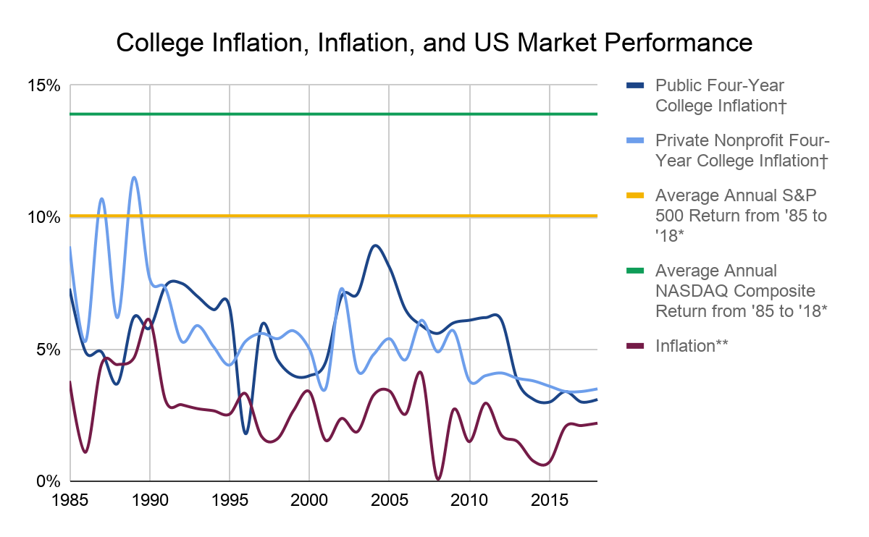
From highest to lowest final percent value, we see the Average Annual NASDAQ Composite Return from ‘85 to ‘18, Average Annual S&P 500 Return from ‘85 to ‘18, Private Nonprofit Four-Year College Inflation, Public Four-Year College Inflation, and Inflation.

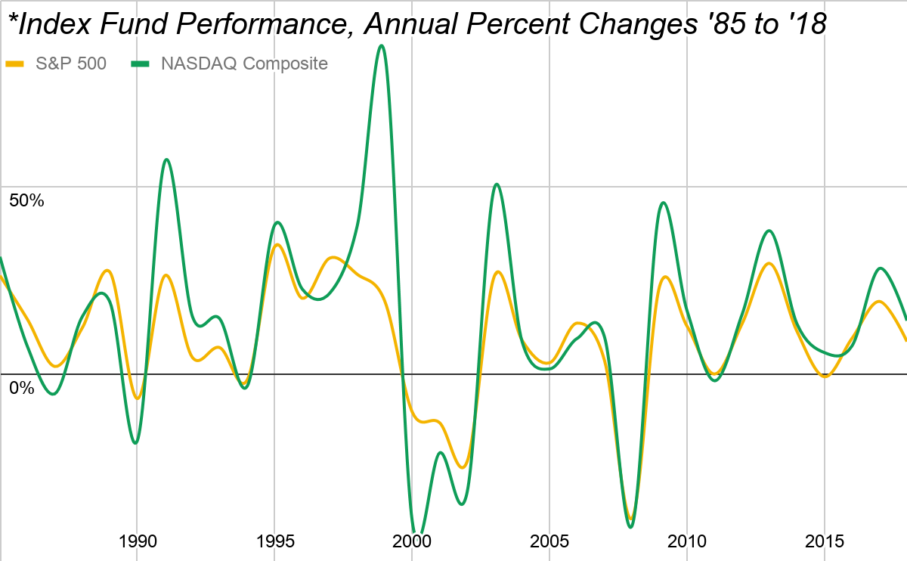⁴⁹ ⁵⁰
From highest to lowest final percent value, we see the NASDAQ Composite and S&P 500.

† College inflation data from The College Board’s publically released metrics. Rates reflect national average annual price changes in tuition and fees plus room and board in the given year’s dollar. Tuition and mandatory-fee inflation alone averages 0.3 percent higher for private four-year schools and around 1 percent higher for public four-year schools in this time period compared to the reported tuition and fees plus room and board inflation rates. Note that public two-year institutions had significantly more volatile tuition and fee inflation changes during this time period, but these changes averaged out to just under 6 percent annual increases.⁴⁸
**Inflation calculated using CPI, the Consumer Price Index. This common measure of inflation tracks the purchasing power of the US Dollar by calculating the cost of a common basket of everyday goods. Quarterly-calculated price changes of this basket of goods are used to track USD inflation. Data in this chart looks at percent change in the fourth quarter CPI price of any year compared to the previous year’s fourth quarter Index price.⁴⁷

No doubt, educational costs rise faster than general consumer goods as demand for schooling steadily increases over time. However, does this increased cost warrant prepaid tuition? You can see that effective college inflation, hovering around an average of 5.5 percent per annum for both public and private schools, stands significantly above USD inflation. Subtract an average 2.6 inflation rate from this time period, and you realize around a 3 percent average tuition increase accounting for inflation. Remember, our conservative long-term S&P 500 return is 9 percent before and 7 percent after inflation.
College inflation almost never historically increases more than major, diversified US index funds, the basis of 529 College Savings Plans.⁴⁷ ⁴⁸ In the long term, stock market investing in truly valuable companies allows you to earn more future money to spend on all college costs rather than prepaying tuition to hedge against college inflation.
With that said, there are some uses for prepaid plans. Stock investments are inherently volatile, as shown in the second graph. As a student nears college age, you can lower your overall short-term portfolio risk by turning towards prepaid tuition plans. At this later stage of schooling, students may start thinking about where they want to go to college, so you can prepay for tuition at a prospective university with confidence. Many investors utilize prepaid plans alongside corporate bonds at the end of a students’ primary schooling to offset the risk of a portfolio downturn after significant long-term growth.⁵¹ Often, the realized prepaid college tuition gains from inflation in the last few years of 529 investing yield higher returns than similarly safe corporate bonds.⁵² Prepaid tuition plans should not be the long-term basis of most well-planned portfolios because of their lower overall return on capital, but they can act as safe investments that decrease your overall portfolio risk as college approaches and you want to actually spend your money.⁵¹

Remember, prepaid plans are not available everywhere, and many restrict when you can purchase tuition credits. Research state plans or the Private College 529 Plan if they make sense for your prospective schools. See if your prospective plan imposes a student age limit for prepaid tuition. Try to only sell off assets to purchase prepaid credits when the market is up and you can take significant long-term gains.

Coverdell Education Savings Accounts (ESA) are the last primary tax-advantaged investment account that utilizes compound interest to help you pay for education.⁵³ Here are the main points of Coverdell ESAs:
- Your money grows tax-free as long as you use it pay for qualified educational expenses
- You can pay for primary and secondary school expenses (e.g. private school) unlike college-only 529 Plans
- Your contributions are not tax-deductible like some state 529 Plan investment tax incentives
- Your Account must be opened before its beneficiary turns 18 (no age requirements for 529 Plans)
- You must spend or withdraw the full Account balance or roll the account onto a new beneficiary before the original beneficiary turns 30
- Beneficiaries can only receive $2,000 in contributions per year for all of their Coverdell Accounts (excess contributions are currently hit with a 6 percent penalty)
- Contributions can be invested in virtually any stock, bond, or fund (ESAs are administered financial institutions, not states)
- Contribution limits are much lower than those of 529 Plans (we will talk about 529 Plan contribution limits later as we explore gift taxes)
- Your individual Modified Adjusted Gross Income (MAGI) must be below a constantly-changing threshold
¹⁵ ⁵⁴ ⁵⁵ ⁵⁶ ⁵⁷ ⁵⁸ ⁵⁹
You can follow these steps to calculate your MAGI:
- Take your Adjusted Gross Income (AGI) on your latest 1040(x) tax return. This is essentially your sum income less deductions. (We will talk more about tax forms in Chapter 8)
    - Form 1040 AGI is on line 37
    - Form 1040A AGI is on line 21
    - Form 1040EZ AGI is on line 4
(2017 line numbers. Different form types are phasing out in 2018. See Chapter 8)⁶¹
- Add your tax-exempt interest income to this figure (e.g. municipal or federal bonds, as we mentioned earlier)
- Add your Individual Retirement Account contributions
- Add in any excluded-income portions of Social Security benefits
- Tack on any tax-free foreign earned income and earned income exclusions
- Add any other tax-return-specific deductions such as
    - Student loan interest
    - Tuition and fee expense deductions
    - One-half of self-employment tax
    - Passive loss or passive income
    - The exclusion under 137 for adoption expenses
    - Rental loss deductions
    - Health Savings Account Contributions
    - Any overall loss from a publicly traded partnership
⁶² ⁶³ ⁶⁴
Your MAGI is your AGI plus any deductions or tax-free gross income, and it changes every year as you make more and more money with assets. However, unrealized gains will not change your MAGI.
Beneficiaries of a Coverdell ESA can receive contributions from parents, grandparents, other relatives, friends, organizations, corporations, and themselves.⁵⁷ Family members contributing to an Account must have an individual or joint MAGI below certain changing thresholds.⁵⁴ As of 2018, you cannot contribute to an ESA if your MAGI exceeds $110,000 individually or $220,000 jointly.⁶⁵ Note that the amount you can contribute to a beneficiary decreases from the maximum $2,000 per annum as you near these income thresholds. Corporate or organizational ESA donors are not subject to income limits.
Coverdell ESAs do not have preventative contribution limitations like Roth IRAs which require the investor to have earned income to contribute to an account.⁶⁰ Some investors above the income threshold workaround tax laws by gifting their children $2,000 which the children in turn invests into their ESA on their own behalf since they are below the income threshold.⁶⁷ Keep in mind that these contributions must still be made with post-tax dollars no matter their source.⁵⁵
Coverdell ESAs can be transferred to new beneficiaries at any time.⁶⁷ Since control remains in the hands of the Account administrator, ESAs are treated as parental assets just like 529 Plans on the FAFSA, and investments contribute to a student’s Expected Family Contribution at the lower parental asset allocation rate.⁶⁸ If students finish their higher education with money leftover in a Coverdell ESA, they can either transfer the account to another qualified family member (same as 529 Plan family members) or withdraw the remaining balance. Account managers can easily change the beneficiaries of Coverdell ESAs without requiring a full funds withdrawal and rollover.⁶⁰ Remember, any non-qualified earnings withdrawals are subject to income taxes plus a 10 percent penalty, mimicking the penalty for Roth IRA unqualified earnings withdrawals.⁶⁹ ⁵⁹ Qualified tax-free Coverdell ESA withdrawals cover the same expenses as 529 Plans plus K-12 variations of such expenses.¹⁵

Although they carry significantly lower contribution limits compared to 529 Plans, Coverdell ESAs can be a great way to save for a private primary education and later college expenses. You can spend traditional 529 College Savings Plans on private primary educations. However, 529 Plans are limited to spending $10,000 a year on tuition and other required fees only. However, you can spend ESAs on K-12 tuition, tutoring, special learning services, books, supplies, equipment, computers, internet access, and other possibly-required expenses such as room and board, uniforms, transportation, and more.⁷³
Note that you have until April 15th after the end of any year to make a contribution to a Coverdell ESA for that tax year just as with Individual Retirement Accounts.⁷⁰ ⁷¹ Any additional contributions over the $2,000 per person limit will be taxed at a 6 percent excess tax unless withdrawn from the Account by June 1st.⁷² Additionally, you can rollover ESA funds into a 529 Plan without penalties.⁷⁴

Coverdell ESAs use compound tax-deferred asset growth to send your child through private primary school and college. However, always ensure that you have ample college savings before opening a new 529 Plan or Coverdell ESA to pay for private K-12 (to keep prioritized college and secondary K-12 school funds separate).
The flexibility you receive with self-directed ESA investments allows you to utilize the technical analysis skills you will learn later in this book to outperform most fund-based 529 Plans with your own stock trades. Although you might not receive state or local contribution tax incentives, you should consider Coverdell Education Savings Accounts as part of your overall college-investing plan.

Savings plans for college gift money to growing children to invest in their educational futures. Because of this, you should remember estate, gift, and generation-skipping tax laws to avoid unnecessary taxes.
You pay estate taxes on assets transferred after your death if you exceed your exemption. Every American gets an estate tax exclusion of $11,180,000 (2018 amount) from the assets they leave their family.⁷⁶ The estate tax allows for unlimited deductions for transfers to a surviving spouse and to charities, including unrealized capital gains. Once a stock or other asset is transferred due to a death, the asset’s price basis for the newfound owner is its value on the day of distribution, thereby giving unrealized gains to beneficiaries without taxes (e.g. you buy a stock for $50 and it is transferred post-mortem to your spouse at $100 who immediately sells it, attaining no capital gains taxes).⁷⁵
If you leave more than your exemption and deductions to your family, it will be taxed according to the following 2018 table.
Taxable Estate/Gift | Rate | Taxable Estate/Gift | Rate
$0 – $10,000 | 18% | $100,001 – $150,000 | 30%
$10,001 – $20,000 | 20% | $150,001 – $250,000 | 32%
$20,001 – $40,000 | 22% | $250,001 – $500,000 | 34%
$40,001 – $60,000 | 24% | $500,001 – $750,000 | 37%
$60,001 – $80,000 | 26% | $750,001 – $1,000,000 | 39%
$80,001 – $100,000 | 28% | $1,000,001 + | 40%
⁷⁶
You pay gift taxes when you transfer property and assets while living. You receive a lifetime gift tax exemption of $11,180,000 in 2018. However, this credit is unified with your estate tax exemption.⁷⁵ If married, you can split gifts with your spouse to minimize gift-tax outputs, and you can make unlimited gift-tax-free transfers to your spouse (unless your spouse in a noncitizen. In 2018, the annual exclusion of a non-citizen spouse is $152,000).⁷⁶ When you make gifts over the yearly gift allowance, the excess deducts credit from your unified gift and estate tax credit. If that credit reaches zero, you pay the same tax rates on non-exempt gifts as the estate tax rates above.⁷⁶
You can give up to $15,000 a year per gift receiver in 2018 without deducting from your lifetime combined gift and estate exemption.⁷⁶ Contributions to Coverdell ESAs and 529 Plans count as gifts and add towards your yearly annual and lifetime exemption.⁷⁷ However, the 529 Plan specifically allows you to make an early 5-year lump contribution of $75,000 ($15,0005 years) gift-tax free rather than 5 yearly contributions provided no other contributions are made in the 5-year prior.⁷⁷ Married couples can gift up to $150,000 in a lump-sum or $30,000 a year since gift limits are individualized.⁷⁸
On top of this, cash you pay for tuition and medical expenses gift-tax-free as long as you pay directly to a qualifying school or medical provider.⁷⁹ Still, do not fear to contribute extra money towards college-savings plans because of gift taxes, as you have the overarching lifetime gift-tax exemption.⁷⁶
You pay the additional generation-skipping tax when you skip a generation to transfer property and assets for gifts and estates. Generation-skipping taxes apply to gift and estate transfers to recipients who are two or more generations younger than the donor.⁸⁰ This tax specifically applies to grandparents opening or transferring a 529 Plan or Coverdell ESA to a grandchild. On top of the generation rule, this tax also applies to wealth transfers made to individuals who are at least 37.5 years younger than the donor.⁸⁰ However, you also receive the same $11,180,000 per individual (doubled when married and contributing jointly) generation-skipping tax exemption to buffer your generation-skipping contributions (2018).⁸¹ The additional generation-skipping tax in 2018 is 40 percent.⁸¹ You can avoid this tax by transferring wealth to direct descendants only who can later pass it down your family through gifts or their estate.
To report gift and generation-skipping taxes, use IRS Form 709. For estate and generation-skipping taxes, use Form 706. You must only report gift taxes against your lifetime deduction and possibly pay taxes once you exceed the annual allowance per individual.⁸² Watch out for state-specific inheritance and estate taxes. In 2018, 12 states and the District of Columbia impose an estate tax and 6 states collect an inheritance tax.⁸³ Estate taxes are calculated based on the value of an estate, whereas state inheritance taxes are calculated based on and paid by asset recipients unless a will specifies estate payment.⁸⁴ Some states loosely follow the federal tax rates while others independently deviate.⁸² Check with your local institutions to optimize your asset-management plans.

Chapter 8
Do Your Taxes

As you accumulate assets and increase your wealth, it’s important to pay the correct amount of taxes and no more. Let’s go over some basic tax form terminology to set up your financial future. With this information, you’ll never need to hire a tax professional again.

Form 1040
Who is this for?
Everyone! This is where you tally your income and deductions to calculate how much tax you owe.
Are there variations of this form?
Form 1040
For everyone. You can itemize deductions and claim all allowable credits. This is the longest 1040 at a nimble yet dense two pages.
Form 1040A (Phasing out! 2018 returns will use the 1040 exclusively alongside newfound Schedule 1 to 6 supplements in place of the full 1040.¹)
Simpler version of the 1040 that you can use if your taxable income is below $100,000 (2018). You cannot itemize deductions, but you can claim popular tax credits, deduct student loan interest, deduct IRA contributions, and more.
Form 1040EZ (Phasing out! 2018 returns will use the 1040 exclusively alongside newfound Schedule 1 to 6 supplements in place of the full 1040.¹ Many taxpayers will not need to file schedules.⁴)
Simplest version of the 1040 at only one page long. This form is for individuals under 65 with a taxable income under $100,000 and interest income under $1,500 who will not claim any credits or itemized deductions besides the Earned Income Credit (we will talk more about tax credits and itemized deductions later).
Can I fill out this form?
Yes! You can download any version of the 1040 directly from the IRS online. Most boxes in your tax return explain themselves and walk you through calculating your tax liability. Just plug in income as reported in some of the following forms and claim your deductions. However, each form also has its own respective instructions to help you through any complex directions or calculations.
Once you finish the math in your return, you can file it online directly to the IRS or mail it to a local individual processing center. You can pay taxes with an electronic funds withdrawal, direct deposit, credit or debit card, mailed check, or Electronic Federal Tax Payment. If you overpay your yearly taxes through withholding or estimated tax payments, you can receive your refund through direct deposit or mailed check.
² ³ ⁴ ⁵
Form W-2
Who is this for?
Everyone! If you have a job, your employer will give you this document annually to report your gross income (wages, salaries, tips, etc.) alongside any federal-income, state-and-local-income, Social Security, and Medicare taxes withheld from your pay. This form is also used to report nontaxable combat pay.
Are there variations of this form?
Form W-2G
Used to report certain gambling winnings to ensure taxes are paid on them.
Form W-3
This form contains the same information as your W-2. It is completed by your employer and sent to the IRS to validate your federal tax return.
Can I fill out this form?
Your employer fills out this form, and you use its information in your 1040 return.
⁶ ⁷ ⁸ ⁹ ¹⁰
Form 1099
Who is this for?
Everyone! The IRS uses this form to track large payments outside of your job alongside payments to independent contractors.
Are there variations of this form?
There are currently 20 1099 variants. The most common and applicable ones for you are as follows:
Form 1099-DIV
When you receive dividend payments, your broker will send you and the IRS this statement every year you earn more than $10 through dividend income (we will talk more about growing your wealth through dividends in Chapter 15 and beyond). These dividends are included in your Adjusted Gross Income.
Form 1099-MISC
If you run a business, you use this to report miscellaneous payments over $600 to others for non-employee compensation. This is the most general 1099 variant that can be used by employers to pay for miscellaneous work and compensations. You can fill this form out if you make a large payment to an independent contractor for work, but you will generally only receive this when you get paid by someone else.
Form 1099-B
Your brokerage will send you this report yearly to state realized (sold) capital gains or losses which you transfer to your 1040 Supplement Schedule D. This supplement separates your short and long-term capital gains to streamline your tax liability calculations. Your commodity broker should also send a form 1099-B to you, stating marked-to-market unrealized profits and losses from the year’s commodity contracts.
Form 1099-INT
You will receive this report from any bank, broker-dealer, government, or other institution that pays you over $10 in interest income. This income could come from bond interest, checking and savings account interest, Treasury bills, and more. As stated earlier, Treasury bills are exempt from state and local federal income tax, whereas municipal bonds are exempt from federal income tax alongside state income tax in many cases. Aside from these lower-interest-bearing investments, the government includes taxable interest income in your Adjusted Gross Income. Interest and ordinary dividends from Form 1099-DIV can be tallied on Form 1040 supplement Schedule B. You’ll use Schedule B to report all of your taxable interest and dividends even if they are reinvested.
Form 1099-Q
You receive this form at the end of any year you take a distribution out of a 529 College Savings Plan or Coverdell ESA. You can match this report up with your receipts for qualified educational expenses and 1098-T to qualify your withdrawals (we talk about the 1098-T soon). If the distribution amounts exceed qualified educational expenses, then you must report the excess as “other income” on your 1040.
Form 1099-R
This form is issued by employer-sponsored retirement plans and other financial institutions to report account rollovers and withdrawals over $10. You receive this report if you withdraw cash from annuities, profit-sharing plans, retirement plans, IRAs, insurance contracts, or pensions. Remember that an institution-direct or withdrawn-and-reinvested-within-60-days rollover in a retirement plan or IRA is not taxable, whereas retirement-plan distributions, IRA distributions, annuities, and more are taxable. 1099-Rs should state the amount of a distribution that is taxable along with any federal income tax already withheld.
Can I fill out this form?
These forms help ensure Americans pay the right amount of taxes by sending both the IRS and you a copy of large payments or some investment income to reference when you file your return. You will generally only use this form as a reference for when you fill out your taxes to ensure you calculate tax liabilities correctly. Since 1099s are sent to both the IRS and you when they are issued by businesses, you need not submit your 1099s to the IRS.
¹¹ ¹² ¹³ ¹⁴ ¹⁵ ¹⁶
Form 1098
Who is this for?
Everyone! Variations of this form range from reporting mortgage interest to donating planes.
Are there variations of this form?
Form 1098
When you make mortgage interest payments of at least $600 in a given year, your financial institution will issue this report. You can use this information in your Schedule A to itemized deductions when your total itemizable deductions exceed the standard deduction (we’ll talk more about itemizing deductions soon).
Form 1098-T
Your college uses this form to report tuition and other educational fees you paid over the year. You can use this to validate your qualified college-savings plan distributions and educations credits (which we talk about soon).
Form 1098-E
If you receive at least $600 of student loan interest, then you file this form and provide a statement to the borrower.
Form 1098-C
You can use this to account for any tax-deductible donations of motor vehicles, boats, and airplanes.
Form 1098-Q
You send this form to the IRS and beneficiary to report when you issue a Qualifying Longevity Annuity Contract. This Contract provides guaranteed monthly payments until death for elder investors, shielding them from stock-market downturns.
Can I fill out this form?
You receive this form from institutions, companies, private organizations, etc. as a record of large payments. As an informational reference to help you with your return, you neither fill out these forms nor send them the IRS.
¹⁷ ¹⁸ ¹⁹ ²⁰ ²¹ ²²
Form W-4
Who is this for?
Everyone! If you get a new job, your employer should ask you to fill this form out alongside its local state counterpart.
Are there variations of this form?
Form W-4
This is your “Employee’s Withholding Allowance Certificate.” It tells your employer how much to withhold from your paychecks to pay for your federal income taxes. You fill this report and its state equivalents with simple information about your personal allowances and deductions which you claim on your 1040 return. Simply follow the step-by-step instruction in this document to ensure the right amount of tax gets withheld from your pay.
Form NC-4, VA-4, M-4, etc. (State W-4 Equivalents)
This tells your employer how much state and local income tax to withhold from your paychecks.
Note that some states like Oregon and South Carolina use the Federal W-4 form for state taxes. Simply write “STATE” at the top of the Federal W-4 when you submit it. For states like South Dakota and Wyoming that do not charge state income taxes, you need not file a state W-4 equivalent (2018).
Can I fill out this form?
You fill this form out to help your employer determine how much money gets withheld from your paycheck. By accurately completing your W-4, your employer should withhold cash from your paycheck that equals your federal-income, state-income, local-income, Social Security, and Medicare tax liability at the end of the year. If you get a refund, then your employer withheld too much and you should alter your yearly W-4 and state equivalent. If you pay a tax bill, then your employer withheld too little and you should alter your yearly W-4 and state equivalent. You can ask your employer to withhold additional taxes from your pay in W-4 box six (“additional amount”) or Form W-4V so that you don’t have an unexpected tax bill at the end of the year. If you have multiple jobs, ensure that your employer does not withhold too much Social Security or Medicare tax from your paychecks. These taxes should be withheld at 6.2 percent and 1.45 percent respectively, with taxable limits up to $128,400 (*0.062=$7,960.80) for Social Security taxes and no limit for the 1.45 percent Medicare tax (which adds an additional 0.9 percent after the first $200,000 of taxable income). If you have more than $7,960.80 withheld for Social Security from all your jobs, you can file Form 843 at the end of the year for a Social Security overpayment refund (2018 maximum and tax percentages).
²³ ²⁴ ²⁵ ²⁶ ²⁷

When you file your 1040 return using electronic free fillable forms with direct deposit, you are guaranteed the fastest possible processing time by the IRS.²⁸ As of 2018, you can even use free commercial tax-preparation software from the IRS if your income is below $66,000 through the e-file program.²⁹ You can do your own taxes! The best way to learn about taxes is to simply follow the IRS instructions and submit your own return to the best of your ability.

When you file your taxes, you have the option to take a standard deduction or to itemize deductions against your taxable income. In 2018, the standard deduction against income is $12,000 for individuals, $18,000 for heads of household, and $24,000 for married couples filing jointly and widow(er)s.³⁰ If your itemized deductions exceed the standard deduction, claim them! However, it is much easier and efficient to take the standard deduction if you don’t have any large itemizable deductions. If you think you’ll deduct more by itemizing deductions, use IRS Schedule A to supplement your 1040.³⁰ Americans with larger incomes generally itemize deductions more than others.³¹ Of those who do itemize, the most popular deductions are state and local income taxes, mortgage interest, and charitable contributions.³³ A 2017 White-House study reported that 90 percent of taxpayers plan to claim the standard deduction.³² You can itemize:
- State and local property taxes (max. $10,000 or $5,000 if married filing separately in 2018³⁴),
- Sales taxes OR state and local income taxes,
- Home mortgage interest,
- Casualty and theft losses due to a federally-declared disaster,
- Recorded charitable donations,
- Medical and dental expenses that exceed 7.5 to 10 percent of your AGI (percentage changes relatively frequently),
- Investment interest expenses (e.g. fees and advising services) as long as they are lower than investment income, and
- Miscellaneous deductions—you can deduct the amount of these expenses that exceed 2 percent of your AGI.
  - Unreimbursed business expenses,
  - Expenses for uniforms,
  - Tax preparation fees,
  - Business use of your home,
  - Subscriptions to professional journals, and
  - Job-hunting expenses.
(Phasing out! Miscellaneous deductions are no longer allowed in 2018.³⁴ This affects you as an investor and strengthens Active Trader Status, as we’ll explore in Chapter 20.)
³³ ³⁴ ³⁶ ³⁷

In addition to the standard deduction, you may qualify for the refundable Earned Income Credit (EIC). The amount of the EIC depends on your taxable earned income and number of children. The EIC’s maximum value in 2018 is:

Number of Qualifying Children
Zero | One | Two | Three or more
$519 | $3,461 | $5,716 | $6,431
³⁸
The chart below shows the value of the EIC depending on your income and number of qualifying children. The data uses the 2017 metrics for maximum refundable credit amounts and income limitations (which we talk about soon). The percentage phase-ins and phase-outs change the value of your EIC when your AGI falls outside of the maximum credit income range. For example, a 45 percent phase-in, increases the value of the credit by 45 cents for every dollar of taxable earned income up to the maximum credit limit. After passing the income threshold for your maximum credit, the value of the EIC fades out in the same manner: a 21.06 percent phase-out will decrease the value of the credit by 21.06 cents for every surplus taxable dollar of earned income.

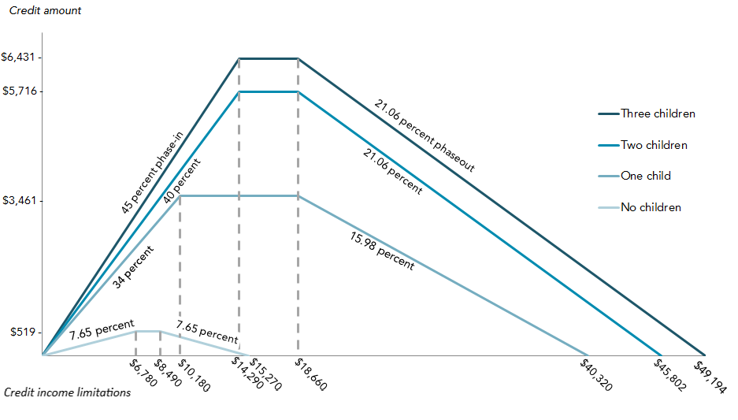³⁹
From highest to lowest maximum EIC, we see three children (or more), two children, one child, and no children. For married couples filing jointly, the credit begins to phase out at an income $5,690 higher than shown.³⁹

To claim the EIC, you must:
- Have a Social Security number (and your spouse if filing jointly),
- Claim qualifying children on Form 1040 supplement Schedule EIC (this document walks you through reporting your children),
  - Your children must have Social Security numbers (we will talk more about this form and child qualifications soon).
- Have earned income,
  - From employers,
  - Owning a farm, or
  - Running a business
- Not file separately if married,
- Be a US Citizen or resident alien all year,
  - Exemptions available for nonresident aliens married to US citizens or resident aliens
- Not be another person’s qualifying child,
- Not report foreign earned income through Forms 2555 or 2555 EZ,
- Have a qualifying child (defined soon), and
  - Or be at least age 25 but under 65 at the end of the year,
  - Live in the US for more than half the year, and
  - Not be a dependent (as defined soon).
- Have an earned income and AGI lower than the following statistics which change based on the number of qualified children you claim. Note that these 2018 maximums change each tax year.
Filing  Status | Qualifying Children Claimed
Filing  Status | Zero | One | Two | Three or more
Single, Head of Household, or Widowed | $15,270 | $40,320 | $45,802 | $49,194
Married Filing Jointly | $20,950 | $46,010 | $51,492 | $54,884
⁴⁰ ⁴¹ ⁴² ⁴³ ⁴⁴ ⁴⁵ ⁴⁶

In addition to these income limitations, your investment income must be $3,500 or less for the tax year (2018 limit).⁴⁷ Investment income includes interest payments, dividends, capital gains, and any other profit made through an investment vehicle.⁴³ Once you start accumulating assets that pay dividends, this investment income limitation may stop you from claiming the EIC. However, making more money through assets is good! You can still claim the EIC in years where you realize few capital gains as long as you meet the above criteria. This credit can is a great way for you to lower your initial tax liability while you start accumulating assets, freeing up more cash to invest.

For reference,
A dependent can be:
- A qualifying child or
- A qualifying relative (e.g. an older or younger family member that you support)
All dependents must:
- Be US citizen, a US national, a US resident, or a resident of Canada or Mexico;
- Be claimed as a dependent on only one US tax return per year;
- File a tax return without claimed dependents; and
- Not file a joint tax return
Additionally, a qualifying child meets the following qualifications and is:
- Age qualifications
  - Under age 19 at the end of the year, under your age, and under the age of your spouse if filing jointly;
  - A full-time student during at least five months of the year, under age 24 at the end of the year, and younger than you or your spouse if filing jointly; or
  - Permanently and totally disabled at any time during the year at any age
- Relationship qualifications
  - Biological child, stepchild, eligible foster child, adopted child, any other child placed with you for legal adoption by an authorized adoption agency, or a descendant of any of these individuals
Or
  - Your sibling, half-sibling, step-sibling, or a descendant of any of these individuals
- Residency qualifications
  - Living with you or your spouse if filing jointly for more than half of the year
- Joint-Return Qualifications
  - Not filing a joint return or
  - Only filing a joint return to claim and refund and is not required to file
- Financial Support Qualifications
  - Parents provide the dependent with financial support equal to or greater than half of their annual income.
These qualifications are key for claiming the child tax credit, child and dependent care credit, educational credits, and more.
⁴⁸ ⁴⁹ ⁵⁰ ⁵¹ ⁵³

For both Roth IRAs and the Earned Income Credit, remember that earned income only includes taxable wages earned from an employer or income from running a business or farm; your stock dividends and long-term asset sales do not count.⁵² For the EIC, you can choose to include the entirety of your nontaxable combat pay in your taxable earned income to claim the EIC if this increases your refund or reduces your tax liability.⁵³ If your spouse also has nontaxable combat pay, you can both choose which way is best for you.⁵³

As you grow your net worth and dividend income through asset accumulation and compound interest, this credit may phase out of your reach. However, it can still help you get off your feet by freeing up money to invest in the market early-on, the best time to invest.

Alongside the Earned Income Credit, you can claim the Saver’s Tax Credit when you make contributions to your retirement plans.⁵⁴ To qualify for this terrific credit, you must:
- Be 18 or older,
- Not be a full-time student, and
- Not be claimed as another’s dependent.⁵⁴
Once you meet these qualifications, simply make contributions any retirement plan, IRA, 401(k), employer plan, personal ABLE account, etc. (we will talk more about ABLE accounts soon).⁵⁵ Your contribution must be made in the tax year that you file for. The maximum credit amount is $2,000 ($4,000 if married filing jointly) directly off your tax bill.⁵⁴ You can calculate your credit by simply multiplying your qualifying contributions (not rollovers) by your credit rate as determined based on your Adjusted Gross Income.⁵⁴ Remember that retirement-plan contributions decrease your AGI, too.⁵⁶
Credit Rate (2019) | Single, Married Filing Separately, or Qualifying Widow(er) (2019) | Married Filing Jointly (2019) | Head of Household (2019)
50% of your contribution | AGI less than $19,250 | AGI less than $38,500 | AGI less than $28,875
20% of your contribution | AGI between $19,251 - $20,750 | AGI between $38,501 - $41,500 | AGI between $28,876 - $31,125
10% of your contribution | AGI between $20,751 - $32,000 | AGI between $41,501 - $64,000 | AGI between $31,126 - $48,000
0% of your contribution | AGI over $32,000 | AGI over $64,000 | AGI over $48,000
⁵⁴
If you meet in income limitations above, then the government wants to help you save for retirement. Use Form 1040 supplement Form 8880 to calculate your Saver’s Credit.⁵⁷ This can be a great way to free up extra cash early on to put in pre-tax-paid plans like Roth IRAs or 529 Plans.

The Tuition and Fees Deduction for qualified higher education expenses is a separate deduction directly from your taxable income even if you take the standard deduction.⁵⁸ ⁶¹ If you or your dependent child pay for college tuition and mandatory fees like textbooks, you can take a direct deduction up to $4,000 of such expenses as long as your MAGI is under $80,000 ($160,000 if married filing jointly) or up to $2,000 if your MAGI is under $90,000 ($180,000 jointly) (2018).⁶⁰ ⁶²
You cannot claim the Tuition and Fees Deduction as well as an education credit.⁵⁹ Additionally, you cannot take this deduction or either of the following tax credits if you are a dependent, married filing separately, or classified as a nonresident alien (we talk about dependency soon).⁵⁹ The two education credits available are:
- The American Opportunity (Tax) Credit (AOTC)
A maximum annual credit of $2,500 for qualified educational expenses paid for the first four years of higher education.⁶³ To claim this credit, you, your child, or your spouse must:
- Be pursuing a degree or other recognized education credential,
- Be enrolled at least half-time for at least one academic period beginning in the tax year,
- Not have finished the first four years of higher education at the beginning of the tax year,
- Not have claimed the AOTC or the former Hope credit for more than four tax years, and
- Not have a felony drug conviction at the end of the tax year (only educational credit or deductions with this requirement).⁶³ ⁶⁴
You can claim multiple credits for multiple children in college as a parent.⁶⁵ However, you can claim the credit if you are a dependent (i.e. you do not get credit for your parents paying for college, but you can claim your children).

The American Opportunity Credit value is:
100 percent of the first $2,000 of qualified education expenses
Plus
25 percent of the next $2,000 of qualified education expenses
(=$2,500 maximum)⁶³
Where qualified education expenses are:
- Tuition,
- Fees, and
- Related required fees for enrollment.
And are not:
- Room and board,
- Insurance,
- Medical expenses including student health fees,
- Transportation, or
- Similar personal living or family expenses.⁶³
The American Opportunity Credit also uniquely considers books and other required supplies and course equipment as a qualified educational expense unlike traditional tax definitions and other educational credits and deductions. These costs are included in your credit calculation no matter who sells the supplies (i.e. you can buy a textbook online as a qualified expense).⁶⁵ Note that you cannot claim this credit at all if your MAGI exceeds $90,000 individually or $180,000 jointly, and your credit amount gradually decreases as you near these thresholds.⁶³ You will get a refund of 40 percent of your credit (up to $1,000) if the American Opportunity Credit lowers your tax liability below zero.⁶³

and
2. The Lifetime Learning Credit
The Lifetime Learning Credit is worth 20 percent of the first $10,000 of qualified education expenses paid by you, your spouse, or a student who you claim as a dependent.⁶⁶ So, the 2018 maximum of $2,000 sits $500 lower than the AOTC’s maximum, and you must spend more than twice as much on tuition, fees, and mandatory expenses for the non-refundable tax credit. You cannot claim the Lifetime Learning Credit if your MAGI is above $66,000 individually or $132,000 if you are married filing jointly, and you will receive reduced benefits as you near this threshold.⁶⁷ Additionally, you cannot claim more than one Lifetime Learning Credit per return.⁶⁶
The Lifetime Learning Credit is more flexible than the AOTC since it can be used for all years of post-secondary education and for courses to acquire or improve job skills rather than the first four years exclusively (i.e. usable in graduate school).⁶⁸ You are not required to pursue a degree or other recognized educational credential for the Lifetime Learning Credit, so you can study industry or job-specific classes outside of an accredited curriculum-based course and claim this tax credit.⁶⁷ Note that the Tuition and Fees Deduction can also be used for unlimited years of post-secondary education, but this Deduction requires you to take accredited courses at federally-recognized institutions.
Use IRS Form 8863 to claim these two educational credits or Form 8917 to claim the Tuition and Fees Deduction.⁶⁹ ⁵⁹ Both of these Forms compliment your 1040.

However, the IRS will not let you spend 529 Plan or Coverdell ESA distributions on these tax credits or deduction; the same expenses cannot be used for two tax savings.⁶⁶ To qualify for a tax credit or deduction, you must spend money outside of a college savings plan on qualified educational expenses.⁶⁷ Let’s look at a quick example to make sure you get the most out of your college-savings plans and tax deductions.

The following statistics come from Harvard University’s published 2018-2019 expected cost of attendance.
Tuition | $46,340
Fees | $4,080
Room | $10,609
Board | $6,551
Estimated personal expenses  (including $800-$1,200 for books) | $4,070
Estimated travel costs | $0-$5,000
Health insurance (unless you are covered under your family's health plan) | $3,364
Sum (no travel costs) | $75,014
⁷⁰

Now that you’re in Harvard, let’s look at how you can pay for your education. Let’s say your parents (or you!) contributed to both a 529 College Savings Plan and a Coverdell ESA. If your account is significantly overfunded and can easily pay for four years of college, congratulations! You may not want to claim educational credits or tuition deductions at all, as you cannot spend tax-benefited college-fund investments on qualified educational expenses for credits or deductions. You can claim a credit or deduction only if you spend other cash from either income, savings, or other normally-taxed assets. This is your ideal scenario wherein you put enough of your money into assets that in turn, over the long run, pay for your full college cost.
If you are in this scenario, consider the taxes you can avoid by following a college budget (coming up soon) wherein you spend normally-taxed cash or investments on tuition to claim deductions which could outweigh 529 Plan unqualified distribution penalties and income taxes by lowering your annual tax liabilities. If you know for certain that you will have an extra $16,000 in a 529 Plan by the time your child finishes college, then you can take a $4,000 distribution from the account every year and claim the Tuition and Fees Deduction (or American Opportunity Credit if you have multiple children in college, increasing your overall yearly tax savings).
The IRS waives the 10 percent penalty if you do claim these credits or deductions, only charging you income taxes on earnings.⁷¹ However, you could avoid these taxes altogether by paying for one child’s entire education and then rolling over an account to another child, thereby allowing your investments to continue growing tax-free to pay for your next child’s college. Nonetheless, please do not let fear of fees stop you from contributing more than $250 a month to your child’s college fund as long as you balance your investments across your other retirement funds and savings-goal assets (or more than $363.33 adjusted for inflation, as we talk about soon).

$300,056 ($75,0144 years) is a lot of money to pay assuming you get no financial aid scholarships. Let’s say you put $250 away a month for your child, totaling $3,000 a year, from the day your child is born to the time they reach 18 and finish high school. Since you know that your kid is the best, you also decide to deposit an initial investment of $3,000 in your child’s future early on so that the principal can have the most time possible to compound value. In the earlier graph comparing college inflation, inflation, and US market index performance, we see that the average inflation over the 34 cited years for private non-profit four-year schools is 5.45 percent (5.45588 percent for public four-year schools).⁷² Knowing this, you decide to put your $250 monthly investments and initial $3,000 deposit into a NASDAQ-Composite-tracking ETF which averaged a 13.9097 percent return during this 34-year period (we will talk about ETFs in Chapter 17). However, you slowly moved some of your money into corporate bonds as your child went through high school to decrease the risk of your capital significantly dropping in the market right before you need to spend it. Because of this intelligent diversification and risk-avoidance, you decide to move 25 percent of your portfolio into bonds that average you a 5 percent average return for the remainder of your child’s high-school education every year (25 percent during the first year, 50 during the second, and so on until you are fully in bonds during your child’s senior year). This is a fairly conservative portfolio management strategy that many embrace when they fear that the overall market may be overvalued.⁷³ You may decide to leave your investments in riskier stocks if you see significantly higher potential returns in equities versus corporate bonds or vice versa in uncertain markets.
Using this strategy, your average predicted return turns out to be around 13.91 percent for the first 14 years of NASDAQ investing and 11.6825, 9.4550, 7.2275, and 5 percent for the last four. Your $250 a month (totaling $57,000 after 18 years plus your initial deposit) turns into $204,908.21 using the compound interest calculator or formula from earlier in this book (using percentage numbers from “College Inflation, Inflation, and US Market Performance” graph in Chapter 7 that looks at the average annual NASDAQ Composite return from ‘85 to ‘18).⁷² This amount was calculated with using yearly interest compounding like earlier in this book because it is very difficult for most investors to time index fund investments. Due to this short-term index unpredictability, you can use yearly compounding to account for monthly downtrend buys and uptrend buys, averaging short-term monthly gains and losses into an overall yearly average percent gain (we will talk more about indices in Chapter 16).

Great job! You have just under $205,000. The College Board lists the following statistics about the comprehensive 2018 to 2019 yearly cost of college. These figures include tuition and fees, on-campus room and board, books and supplies, transportation, and “other expenses” (aka. everything your terrific 529 Plan and Coverdell ESA will pay for).
- 4-year private nonprofit college average cost: $52,500 (4 years = $210,000)
- 4-year public college in-state average cost: $25,890 (4 years = $103,560)
- 4-year public college out-of-state average cost: $41,950 (4 years = $167,800)⁷³

Since we are looking at today’s college costs, we must remember that you saved $250 in past money in this example. Eighteen years ago, $250 had the same buying power as $363.33 today.⁷⁴ So, in today’s 2018 dollars, you would put away $363.33 a month or $363.3312 months = $4,359.96 a year for this same savings plan. As time goes on, the actual purchasing power of the cash you invest decreases while your earlier investments accrue more interest. By investing a little over four grand a year today, you can fully pay for an average in-state and out-of-state public four-year degree and only need to pay about $5,000 for all four years at an average private nonprofit college tomorrow.⁷³

By considering how much college will cost in the future, you can figure out how much to put away today. Note that transportation and travel, college supplies, and other expenses included in the above cost figures are more likely to inflate at the standard Consumer Price Index inflation rates rather than higher college inflation rates which are used in the following calculations to extrapolate potential future college costs.⁷⁵ However, textbook prices rise significantly faster than standard inflation.⁷⁶ Since professors dictate exactly which book and volume of said book students need, they artificially allow publishers to increase prices to absurd levels since students generally have no choice but to purchase the required texts which are often updated yearly to keep new books in circulation.⁷⁷ With that said, many online used-book sellers help students find cheaper textbooks to save on college costs. The following calculations use the standard college inflation rate for expenses beyond tuition, fees, room, and board because of overall hastened increases in textbook prices but lower increases in other supplies, transportation, computer technology, and other expenses. Using the current 5.45 percent average private college inflation rate and 5.45588 percent average public college inflation rate from our Chapter 7 graph, we can extrapolate the following future compounding college costs after 18 years:
- Private: $52,500(1.0545)¹⁸ = $13,6457.62 (4 years = 545,830.48 future 2036 dollars)
- Public in-state: $25,890(1.0545588)¹⁸ = $67,360.68 (4 years = 269,442.72 future 2036 dollars)
- Public out-of-state: $41,950(1.0545588)¹⁸ = $109,145.63 (4 years = 436,582.52 future 2036 dollars)⁷³
You may want to recompute these figures with current expected college costs and inflation rates, data readily available from The College Board. These calculations assume that college rates in America will keep rising at their historical rates for the next 18 years after your have a child. Many individuals suspect that the United States is in a higher-education bubble.⁷⁸ ⁷⁹ This macro interpretation of the American debt-fueled education system argues against students taking on too much debt to get potentially unworthwhile degrees at abhorrent prices.⁸⁰ However, you need not worry much about debt since you have at least $205,000 in today’s dollars to spend on your child’s college after investing for 18 years.

Back to Harvard, we see a total projected annual cost of $75,014.00 a year or $300,056 for four years. You’ll have to pay $95,147.79 ($300,056 cost - $204,908.21 from assets) for a Harvard degree assuming we don’t invest more cash early on (the best time to invest) or take riskier, higher-returning investments. To best balance tax-deferred college-savings investments, tax deductions, tax credits, personal spending, and student aid, we can follow this spending table.

Paying for Harvard
 | Tuition & Fees  ($50,420) | Room & Board  ($17,160) | Estimated personal expenses including $800-$1200 for books  ($4,070) | Estimated travel costs ($0-$5,000) | Health insurance unless you are under your family's health plan  ($3,364.00)
Freshman Year  $65,650 spend from college savings  About $9,364 spent from savings, cash, job, etc. | Pay $46,420 from 529 Plan / ESA  Pay $4,000 cash and claim the Tuition and Fees Deduction/ AOTC | Pay $17,160 from 529 Plan / ESA | Pay about $2,070 or more from 529 Plan / ESA to cover qualified educational expenses  Pay $2,000 cash for other misc. expenses | Varies for different students | Pay $3,364.00 from savings, as this is not a qualified educational expense
Sophomore Year  $65,650 spend from college investments  $9,364 spent from savings, cash, job, etc. | Pay $46,420.00 from 529 Plan / ESA  Pay $4,000 cash and claim the Tuition and Fees Deduction/ AOTC | Pay $17,160 from 529 Plan / ESA | Pay $2,070 or more from 529 Plan / ESA to cover qualified expenses  Pay $2,000 cash for other misc. expenses | Varies for different students | Pay $3,364.00 cash
Junior Year  Remaining $58,341.07 from college investments  $12,672.93 spent from savings, cash, job, etc. | Pay $46,420.00 from 529 Plan / ESA  Pay $4,000 cash and claim the Tuition and Fees Deduction/ AOTC | Pay $11,921.07  Pay $5,238.93 cash | Pay $4,070 cash | Varies for different students | Pay $3,364.00 cash
Senior Year  $75,014.00 spent from savings, cash, job, etc. | Pay $50,420 cash and claim the Tuition and Fees Deduction/ AOTC | Pay $17,160 cash | Pay $4,070 cash | Varies for different students | Pay $3,364.00 cash

For a Harvard degree, you paid $189,641.07 from your college savings plans (in which you deposited only $2,640 + $22012 months18 years = $50,160) and $106,415 from savings, work, etc assuming no financial aid whatsoever. You could increase your monthly and initial contributions to cover this deficit or trade proactively to increase your percent return through strategies explained later in this book. We did not adjust for inflating college costs after freshman year because our unspent college funds can remain in corporate bonds accruing an average 5 percent interest annually. In these bond investments, our funds will rise slightly above the historical average college inflation rate with minimal risk while we wait to pay for the remaining years of college. We’ll further explore bonds in Chapter 22.

If you have two or more dependent children in college at once, then you can claim the larger American Opportunity Tax Credit against your tax liability (owed tax) since you can claim multiple $2,500 AOTCs when you spend $4,000 on tuition unlike the once-per-return Tuition and Fees Deduction against AGI (income).⁶⁰ ⁶³ ⁶⁵ ⁶⁹ Review your return with both options to see which one works best for you. The Lifetime Learning Credit is also a once-per-tax-return credit against your tax liability.⁶⁷

You can pay for anything you want as long as you plan for it. College, retirements, savings goals, and more are all within your grasp thanks to the power of the long-term American economy. By planning and investing in your child’s college today, you can give them the best possible start in their adult lives without debt.

Chapter 9
A Quick Note on Debt

We talked about how debt compounds earlier, but I want you to really understand how much debt can hurt you.

The conservative average stock market return is 9 percent annually.¹ This return lowers to 7 percent per annum after an average inflation rate of 2 percent.¹ With this return, you can grow your money over time to grow as much wealth as you want.
Debt interest rates vary a lot depending on the economy, Treasury-bond rates, demand for debt, and much more.² At the time of writing,
- Average student loans for the past decade charge you around 4 to 7 percent annual interest.³
- Credit card interest rates are increasing; the average borrowing rate for the past decade is around 15 to 16 percent. You can expect to see even higher rates as a new card applicant.⁴ ⁵
- The average American 30-year mortgage charges you 4 to 5 percent annually. Mortgage rates in particular have changed a lot over time, significantly decreasing in the past few decades.⁶ ⁷
- Car loan rates have decreased a lot in the last decade too, now charging you around 4 to 5 percent annually.⁸ ⁹ ¹⁰
- Average personal loans from financial institutions charge you 10 to 30 percent annually.¹¹ ¹² ¹³
30 percent! If you put $5,004 into an investment account for 35 years that yielded a 30 percent annual return, you’d have $48,678,213.57!¹⁴ The massive growth of even the smallest debts can destroy any hopes you have of putting money away for investing.

This book isn’t about how to avoid debt through budgeting or frugality, but I hope that you now realize the importance of avoiding debt to free up your money for investing. To figure out how much your debt can really cost you, use the same compound interest formula or calculator from earlier in this book using interest rates that apply to you. For most people, living below your means is much more financially sustainable than ever taking on debt.

One exception to debt avoidance appears in real estate investments where you can have debt at 4 percent and an annual return of 10 percent. In this scenario, you turn your investment into an asset by taking in enough rent money to cover your mortgage payments, build your equity in your property, allow for appreciation, etc. so that the money you take in covers all of your expenses and debt payments.¹⁵ In these scenarios, it often makes sense to keep long-term debt even when you can pay it off because your percent returns on your investment significantly exceed your mortgage interest rate, and the extra money in your pocket allows you to reinvest into new assets that outperform your debt.¹⁵ However, in financial markets, avoid trading on debt or margin at all costs. Losing more than you have to bet on a position and indebting yourself to a broker is as bad as taking out a loan for a Hawaiian vacation (around 10 percent at some brokers).¹⁶

Chapter 10
Discovering the Stock Market

Where you go to look at stocks really doesn’t matter too much as long as you can get the information and charts you need. We’ll talk more about the different types of stock charts and key statistics in Chapters 11 and 15.
Yahoo Finance is great for researching stocks because they give you all the tools you need to analyze any stock for any type of trading for free through the online Yahoo Finance website and mobile Yahoo Finance application. However, you can’t enter and exit positions directly through Yahoo Finance unless you link a real brokerage account to your Yahoo Finance account (we’ll talk more about brokerages in Chapter 37).¹
For the rest of this book, we will use Yahoo Finance to develop our stock trading skills.

Let’s pull up a company on Yahoo Finance and look at the initial basics of stock research.
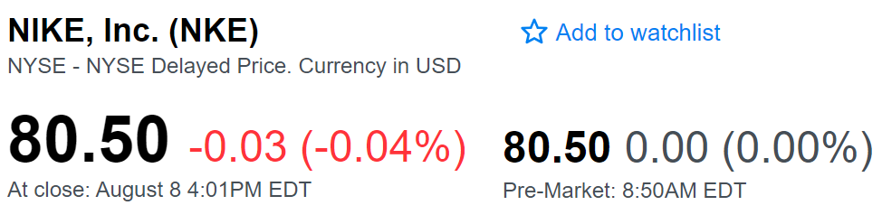²
To find this stock, we can type in this company’s full name, NIKE, Inc., or we can type this company’s ticker, $NKE (without the dollar sign), in Yahoo Finance’s search bar. All publicly traded companies have tickers to represent their company in a shorter, unique way.³ It’s much easier for you to type in $CPB for Campbell Soup Company rather than the full company name.⁴ You will learn companies’ tickers over time once you start researching them. Remembering these ticker helps significantly speed up stock research and short-term trading by keeping you moving between different stocks rapidly.
The previous snippet was taken during pre-market trading hours. In a live market day, the price of $NKE changes constantly because the value of the stock is the last price an order or transaction occurred at. For $NKE, $80.50 is what the last person paid to buy one share of NIKE, Inc. on August 8th right before the market closed.⁵
Next to a company’s price per share, you’ll see a price change in dollars and a price change in percent change. The price change in dollars shows how much a stock has moved from the last trading day’s closing price. For $NKE, the price per share went down three cents on August 8th compared to August 7th.²
Next to the daily dollar price change, you can see the percent change for the day, calculated using the company's per-share price and dollar movement. We can see that the three-cent decline in NIKE, Inc.’s share price brought the value of $NKE stock down .04 percent from the prior close, a minute change.² You should care more about percent changes than dollar price movements in the long-run because percent change lets you compare stock performances directly to one another. I’d love to invest in a $20 stock that could go up to $10, but I might be less excited by a $400 stock that could rally $10. Stock price doesn’t matter when you make trades because you can just buy as many shares in a company as you want to reach your desired position value.⁶ Then, your percent change will dictate how well your position performs. Focus on percent changes, and your overall trading discipline and returns should improve.

Judging positions based on percent change rather than price movements also helps you become a better trader once you start managing more money because you will be psychologically conditioned to only look at percent changes instead of viewing positions as “money lost” or “money gained.” By taking emotion out of your head and looking at percent changes in an overall position, you will have a much easier time looking at specific price targets based on facts rather than emotions. Disconnecting yourself from trades is key to extremely strong active-management performance. Remember, you want consistent percent gains in your portfolio over the long run. Never limit yourself to X much money every year. When your account starts growing, fight for higher percent returns rather than settling for lower percent returns with higher cash value, if possible.

Here’s a refresher image of our $NKE quote in case you forgot what we were talking about.
²
This snippet was taken at 8:50 AM. The stock market opens every business day at 9:30 in the morning Eastern Time (New York) and it closes at 4 o'clock.⁷ Right after the 9:30 opening bell is usually the most volatile period of the trading day.⁹ This volatility sets the tone for the rest of the trading day by around 10:00 depending on whether the market moves up or down.
Before 9:30 is pre-market trading and after 4 o'clock is after-hours trading.⁷ Trading outside of market hours is possible through some brokerage accounts which take extra time and effort to set up.⁸ In these accounts, you can submit orders outside of the trading day just like normal orders. However, after-hours and pre-market trading usually carries much less liquidity than normal hours because of significantly less trading volume than normal hours.⁸ This lack of volume also causes much larger bid-ask spreads which hurts your ability to enter and exit positions at good prices (we will talk more about the bid-ask spread in Chapter 15).⁵
Since comparatively few people trade outside of market hours, stocks do not generally change prices too much after they close for the day.⁸ However, news, earnings reports, and other catalysts can all cause large movements in premarket stock prices since these can come out at any time of the day, triggering buyers and sellers to enter or exit positions as soon as possible.¹⁰ Large premarket movements are especially good indicators for even bigger movement potential in the following trading day.¹⁰ These movements, combined with the initial volatility when the market first opens at 9:30, create stellar opportunities for nine-to-noon active traders.
As a long-term investor, you can expect to see large premarket movements in your positions every once and a while when large news comes out about a company you invested in. These movements will generally carry into your normal day’s gains and losses as if the stock moved during trading hours. Watch out for quarterly reports, though! Every quarter, public companies release their financials to the public, and you may see large price movements depending on whether a company beat or missed a predicted earnings expectation, subscriber projection, etc.¹¹ Additionally, companies release larger annual reports at the end of each business year (which may not be the calendar year) that go into more detail about their operations, strategic growth, and future outlooks, among other things.¹² Reading a company’s annual report will give you superb insight into their potential performance, and reading quarterly reports will help you continually understand a company's financials (we’ll look more at companies’ annual reports in Chapter 23).¹³

Chapter 11
Reading Stock Charts

Stock charts are your gateway into technical analysis. Let’s jump into the basics of reading charts and making calls. When you pull up any stock on Yahoo Finance, you’ll instantly see a condensed chart. Simply click “expand graph” to fullscreen the graph (or click the graph in the Yahoo Finance app). Here is the five-year price line chart for $HD, The Home Depot, Inc. 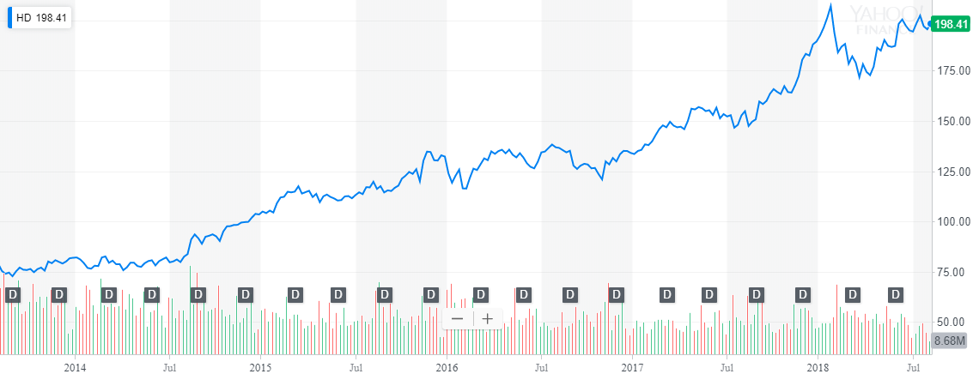¹
The chart shows the past performance and price changes of $HD for five years. You can see the stock’s per-share trading price in dollars on the vertical axis. At the bottom of almost every single stock chart, you'll see time. In this chart, we see labels that span out across five years. The amount of time your chart covers heavily influences your trading style. Across the bottom of the chart, we see “D” for dividend, representing any time when this stock paid dividends to shareholders (i.e. the company pays you from their earnings to own their stock. We’ll further explore dividends in Chapter 15).¹ Also across the bottom of this chart, you can see red and green volume bars. These bars are red when the price decreases from the trading period prior and green when the price increases.²
As a general rule of thumb, increased volume (how many shares of a stock are traded in any given period) usually means there's more attention around a stock, more people getting into a stock, and more people profiting from a stock as it swings up or down. Volume is almost always good because it keeps liquidity up and keeps attention on a stock.³ Volume usually increases over time because more people enter the market and see successful stocks. Especially for nine-to-noon trading, you should gravitate towards stocks with more volume that provide higher liquidity, making it easier for you to smoothly enter and exit positions.

Because $HD has performed very well in the past five years relative to the S&P 500 (164 percent return vs. 73 percent), you might say that this stock is on an uptrend, and many investors may buy into the stock in hopes that its gains continue.¹ ⁴ Another way you can predict future growth for well-established companies like The Home Depot, Inc. is by looking into the stock’s price history, analyzing its very long-term performance.⁵

When you start trading (if you haven’t already been trading), you’ll need more accuracy than a simple line graph. Let’s look at a candlestick chart for $HD. To switch to this chart in Yahoo Finance, simply click the drop-down box that says “Line” by default and select “Candle.”

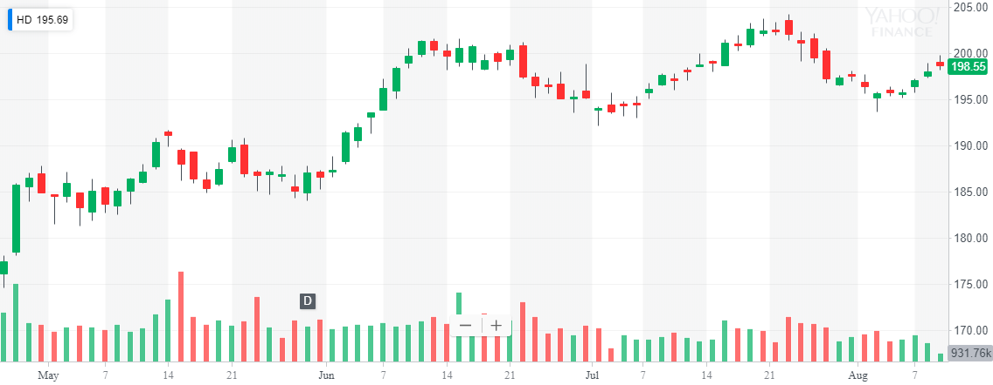¹

Candlesticks are terrific for any kind of charting because they show stock movement and volatility simultaneously. Each of the candlesticks in the above chart represents one trading day.¹ Green candlesticks closed higher than they opened for the day, and red candlesticks closed lower than they opened.⁶ The bottom of each candlesticks’ bottom “wick” is the lowest price $HD traded at for that candle’s trading day, and the top of the top wick is the highest price $HD traded at.⁶ Not all candlesticks have top and bottom wicks because their minimum and maximum prices are inside the candlestick body. The candlestick body for green candlesticks starts at the open price of the candle and ends at the close price for the candle, gaining value. Red candlesticks’ bodies start at the open price and end at the close price, losing value over the candle’s time period.⁶ Open prices often differ slightly in daily candles from previous days because of after-hours trading.
For almost any type of trading, you should stick to using candlesticks to keep your trades informed and accurate. Keep in mind that your charts may look very slightly different than Yahoo Finance’s charts depending on which brokerage you use and their provided software.

Chapter 12
Bulls, Bears, and Shares

Now that you know how to read stock charts, let's talk about prolonged market periods that we’ll see in longer-term charts. To demonstrate these market conditions, let’s look at the last decade of the S&P 500.
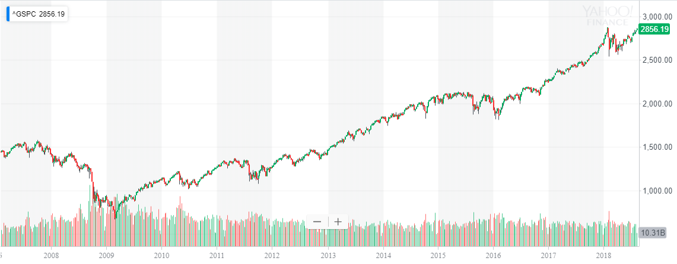¹

You can see market conditions just by looking at charts. Long run-ups are called bull markets. In a bull market, you can expect to see more stocks go up than down as the whole market collectively increases in value. In our snippet of the S&P, we can see bull market conditions from 2010 to 2015 and mid-2016 to 2018.
Extended downtrends indicate bear markets.² You can see bear market conditions from 2007 to 2009 when more stocks declined in value than appreciated, bringing the overall market down.² As a long term-investor, timing bull and bear markets can be difficult and sometimes unprofitable for long-term outcomes.³ With that said, you should always be skeptical about the companies you invest in and ensure that they perform up to your standards as a shareholder.
Constant price stability with no strong movement up or down indicates sideways markets. We see little price movement across the overall market from 2015 to 2016, indicating a sideways market where overall stock values fluctuate but do not move up or down together. For active traders, sideways markets present many opportunities to buy supports and sell resistances, as we’ll explore in Chapter 24.

You can quickly start building a long-term portfolio by looking at brands that you already use in your daily life. Ask yourself which companies you know of that you think make a killing by providing value through goods or services to the marketplace. Then, if the company is public, investigate their financial releases, previous growth, current management, and future goals.⁴
You should always know a lot about an underlying company if you're going to hold a stock for 10 years or more (outside of an index. See Chapter 16). If you believe in Chipotle Mexican Grill, Inc. more than any other company, then a few closed stores won’t hurt your long-term prospects. Remember that some news outlets will summarize major points in big companies’ quarterly reports, 10-Qs, and annual reports, 10-Ks. With that said, it is still important to recognize where and how much money flows through a business to determine their long-term potential and safety as an investment by reviewing individual financial data sheet releases periodically.⁵ If you commit your time to studying the operational finances of an individual business, then you can expect higher returns as your masterfully understand the companies in your portfolio and avoid potentially-unsustainable companies. Additionally, financial reports frequently have forward-thinking plans embedded in them for shareholders.
Aside from exciting sixty-page annual reports, you will also be invited to shareholder meetings when you invest in a company. Shareholder meetings can be held in-person or online, and sometimes you can vote for what the company should do in the short or medium term at these meetings after they report some company news.⁶ Shareholder votes are frequently used to bring in new executives with shareholders’ approval.⁷ These meetings let you see how hard companies are working to bring in profits for their shareholders (aka you!). Though none of these meetings are required or even meaningful in some cases, they show a company’s dedication to shareholders. Annual meetings in particular are major events for companies like Berkshire Hathaway Inc. This sort of long-term involvement goes beyond charts and numbers and lets you look holistically at a company and their stock.

Chapter 13
News and Principles

Remember that a stock is priced at what other people think it’s worth.¹ If masses of people want to buy a stock because they get a new patent, it’s price will increase. If you see a huge price movement in the market, you can usually expect news behind it.¹ You can use Yahoo Finance to see news about a stock right under its quote.² A lot of trading platforms also have some sort of news feed for stocks, and Google always comes in handy as a last resort. Quickly glancing over quick news can help you figure out whether or not a significant price movement is justified.
For cheaper, active stocks, use news as fuel for potential growth and expect more market buyers like yourself when good news comes out or sellers when bad news comes out.⁴
For long-term investing, stay aware of news about overall market trends and economic shifts. With that said, you should always have a long-term plan going into your investments so that you are not too surprised by short-term moves and news. However, larger moves like the 2001 dot-com bubble and 2008 housing market crash were publicly predicted by many smart investors.⁵ ⁶ Listening to news about their opinions and weighing their perspective against yours ensures that you attack the market to the best of your ability.
You may have to act quickly in volatile markets when news comes out to enter or exit a position at an optimal time. If this happens, always stop and tell yourself your reason for entering a position. Then, make sure the decision you are going to make aligns with your investment goals and philosophies. A single poor quarterly report for The Home Depot, Inc. doesn’t mean that everyone suddenly likes Lowe’s Companies, Inc. more. However, Amazon, Inc. seriously entering the home improvement space could hurt $HD in the long run.
You’ll be fine as long as you stay informed about the news and don’t watch too much of it. A great source of news if Yahoo Finance on both their desktop and mobile platforms. On both platforms, you can see stock-specific news by scrolling down beneath a quote.² ⁷ These stories are time stamped and many large news stories on specific companies can cause large price swings.² On Yahoo FInance’s mobile platform in particular, you can get real-time updates on the price, earnings, and news for all the stocks in your watchlists through notifications.⁷ The app also offers the same superb technical analysis tools available online, which we’ll explore in Part Two.

For long-term investing, you can use the “maximum” charts to see how certain stocks have performed over the past fifty years or more for well-established companies.² Then, you can slowly work your way down to 10-year, 5-year, 2-year, 1-year, and Year-to-Date charts to predict future price movements. Your candlesticks should start out as weekly candles and eventually become daily candles with this chart-based price research. By looking at the long-term performance of a company you already know a little bit about, you can understand the sorts of returns you can expect from an investment in the company and the risks of the investment based on previous downtrends.
For active trading, start off looking at long-term charts for historical supports and resistances (which we talk about in Chapter 24) just like a long-term investor.⁸ Then, zoom in to monthly, daily, and hourly charts looking for price levels to trade. Finally, for nine-to-noon trading, use one-minute candles and use your technical analysis skills to make smart, fast trades.

For long-term and medium-term trades alike, you can use recent price dips along with other indicators that we’ll discuss to find good entry points into new positions. Similarly, you can compare historical highs to current movements to predict good selling points for medium-term trades. For long-term trades, consider further investigating the underlying company and buy them based on your faith in the company and what it does in the marketplace.

Chapter 14
Selling Short

I’m sure you knew before picking up this book that you can buy a stock when it’s “low” and sell it when it’s “high.” But what about in bear markets? Or what about when you think a company will lose money because of a new competitor? What about that one stock that just went up 400 percent? Let me introduce you to shorting stocks.
When you buy and sell a stock, your profit or loss is the difference between the purchase price and sales price of that stock.¹ The same principles apply to funds and commodities which we’ll explore in Chapters 17 and 18. Another name for this kind of investing is “going long.” You go long in most long-term positions and retirement-building positions because you believe that your positions will go up in the long-term.¹
When you short a stock, you sell the stock first and then buy your shares back or “cover” your position.² The difference between what you sold the stock for and bought it back at is your profit or loss.²
Brokers almost always require you to have a margin account with them to issue you stock to borrow, and you might have to specifically ask to short stocks.⁴ When you short sell a stock, you first borrow stock from your broker and sell it instantly on the open market.³ You receive the funds from your short sale instantly and owe your broker the number of shares you borrowed.³ ⁴ Shorting will show up just like any other order option (buy, sell, stop-limit, etc.) on your trading platform (check with your broker).³ You can continue to borrow outstanding shares for as long as you want with no penalty as long as you don’t borrow and lose a broker’s money on margin. There are no general rules regarding how long a short sale can last before being closed out.⁵
Once you cover your short position, you will realize your gains and loses by returning the borrowed stock that you just bought to your broker. In order to do this, you execute a “cover” order to buy back shorted shares from the market.¹ Any money you make from the short to cover change is yours to keep. In essence, you make money when the stock goes down.

Shorting allows you to make money when you’re skeptical about a stock, and you should use it as a tool in your trading to take advantage of opportunities as they present themselves.

Chapter 15
Breaking Down Key Statistics

Key statistics are vital when you look at the long-term profitability and potential company performance. These statistics simplify a important long-term factors in a few simple numbers. You can use key statistics to help you decide whether or not you might still like a stock in a decade or so. When you look up a stock on Yahoo Finance, you’ll see these statistics formatted like the photo below. On other sites, the format of these statistics may look different, but the important statistics still mean the same thing.
Here are the key statistics for International Business Machines Corporation, $IBM.
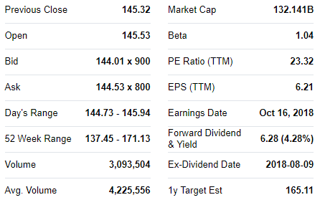¹
The first thing you’ll see is the previous close price. This is the price that the last transaction occurred at for the market day prior. This is what daily price and percent change for the day is based off.²
Next, you’ll see the stock’s open price for the day. The difference between this price an the previous close is your premarket change. Big differences between previous close prices and open prices draws a lot of attention to a stock.³ As we talked about earlier, this attention is great for nine-to-noon trading because it significantly increases early-morning volatility. Besides acting as an early indicator for huge potential momentums, a large difference between the previous close and open price can indicate very high days where the price may go up a lot and then sell off and drop.³ For long-term investors and medium-term trades, this could provide a great time for you to sell part of a position and lock in some gains to reinvest into another stock. For active traders trading the right stocks, this presents you with opportunities for massive gains (we’ll talk more about trading premarket gainers in Chapter 36).
For stocks that open significantly lower than they previously close (say over 5 percent), the attention they get is a little different than gainers. Whereas gainers attract brand new buyers, losers attract sellers. However, these are different sellers; these are usually existing shareholders liquidating a position out of fear, uncertainty, doubt, changed company mentality, etc. For this reason, losing stocks typically don’t attract as much volume or volatility as gaining stocks.⁴ This makes actively trading losing stocks a fairly difficult venture because prices usually stay relatively flat when volatility decreases, charts simply trending sideways. However, losing stocks present terrific buying opportunities for you to enter long-term and medium-term positions, buying up “cheap” shares midday.⁴
Our next key statistics are the bid and the ask. These two statistics represent a very important part of active trading: level 2. Level 2 shows all the limit-buy and limit-sell orders that are not filled at market price. We’ll talk more about different order types in Chapter 19, but the important thing to know is that these orders are set for a specific price.⁵ In the level 2, you see all the “bidders” willing to pay a price for a stock and all the “askers” willing to sell a stock at a price. The level 2 makes a list of all open orders and sorts bids in ascending order and asks in descending order.⁶ This means that the highest bid and lowest ask show up on the top of the level 2.⁵ These two numbers, the highest-paying unfilled buy order and the lowest-priced unfilled sell order, are what Yahoo Finance puts in front of the “x” in their bid and ask numbers.¹ ⁶
When you submit an order at a specific price that doesn’t immediately get filled, you can instantly see your order and number of shares added into in the level 2.⁶ You can also see unfilled orders in the order book. The order book records all unfilled orders and can put on a graph to show the depth of a market.⁷ You can constantly see a stock’s level 2 change as new bidders and askers put in orders, bidders and askers get filled, and general price movement in any direction occurs.⁷ The same is true for the order book’s market depth chart. Here is a rough example of an order book’s market depth chart. The more shares in this chart at different price levels, the more liquid a market is.⁸ Liquidity (how easily you can enter and exit a trade) is extremely important if you trade actively because the last thing you want is to be forced to sell at lower prices due to low market liquidity.
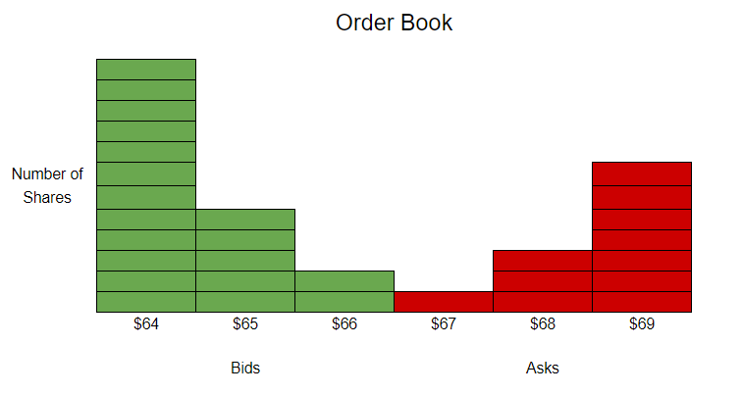
There are fewer orders between buyers and sellers where their prices meet because this is close to the last transaction price, the price that is displayed for a stock. When you approach this price as a buyer or seller, there is a good chance that your order will be filled in a liquid market and your order will disappear from the order book, entering a transaction history.⁹
Yahoo Finance does not show you the full level 2 or order book for stocks, but rather they display an often-delayed National Best Bid and Offer.¹⁰ ¹¹ You can find these essential tools through your broker’s trading platform (which should also have significantly improved data feeds).
Whenever you submit an order, you have to decide how many shares to buy. Next to the “x” in Yahoo Finance’s bid and ask boxes, you can see the number of shares currently available the top bid and bottom ask price level.¹ The number of shares next to the bid and ask represents the total number of shares that all buyer or sellers are willing to buy or sell at the bid or ask. For $IBM, this means that 800 shares from an unknown number of people are up for sale at $144.53 a share.¹ This is only shown on the highest bid and lowest ask on Yahoo Finance, but your broker should show share amount information for all price levels on the level 2 which you can use to find specific buyers or sellers of a stock you’re trading.¹²

For active traders, you can look at the volume of sellers or buyers at certain levels in the level 2 to find price levels that a stock may have a difficult time passing because of a high number of buyers or sellers at that price level. These levels are often called “buy” and “sell walls” in the market depth chart.¹³
The difference between the highest bid and the lowest ask is the spread. Generally, spreads decrease as volume increases.¹⁴ Be very careful trading extremely cheap stocks with very large spreads because you may enter a position and find that your only way out is to sell your shares at a much lower price than you acquired them for because the bid is significantly lower than the ask.¹⁵ Also, watch out for suspicious characters who promote cheap stocks with large spreads because they may buy shares on the significantly lower bid and sell them to you on the much higher ask.¹⁶ Especially in low-liquidity scenarios, you should avoid wide spreads to mitigate risk.

Spreads matter less for long-term investors and medium-term traders. For $IBM, the current spread is 52 cents, a fairly large spread for such a large stock.¹ IBM’s spread here is most likely very large because our snippet was taken during premarket hours with lower liquidity. For most large and active stocks, expect to see a spread of 1 to 2 cents. Keep in mind that some more expensive stocks may have larger spreads because the relative importance of 20 cents for an $800 stock is much lower than for a 25 cent stock.¹⁷
For all types of trading, you should aim to buy on the bid and sell on the ask. We’ll talk more about specific types of orders in Chapter 19, but just remember that you can set your price for where you buy and sell. All traders can save themselves a little extra money by buying the lower bid and selling the higher ask.¹⁸ Playing the spreads to your advantage is especially important for active traders. By getting the best possible entries and exits you can, you’ll be able to maximize your trades’ profits.

Here’s a refresher image of $IBM’s key statistics.
¹
After the bid and ask, we see the day’s range and the 52 week (yearly) range. These two ranges are also easily determined by looking at a stock’s chart.¹ Sometimes there is a slider here that visually shows where the current price is on this range. Looking at the day’s range midway through the day can be a great way to predict whether or not a stock has hit its bottom or top for the day yet.²⁰ If you're looking at buying for swing-trading or a long-term entry, you can try to get in on a day when the price is at the bottom of the daily range instead of its highs. For active trading, you’ll usually see new highs and judge the daily range exclusively off charts.
When stocks get tons of attention, volume, and media coverage while close to their 52-week highs, ask yourself if you think the stock has potential to set new highs and grow its 52-week range upward.²⁰ Apply a similar mentality to stocks near the bottom of their 52-week range.

Price ranges reflect chartable price movements and not much more. Ask yourself what could cause a stock to fall down after it hits a high 52-week maximum if it falls towards the middle or bottom of its 52-week range.
- Did something bad happen this year?
- Is the company having an internal problem?
- Does the marketplace demand this company?
- Can the company easily access all required goods?
- Did the company recently downsize?
- What do the annual reports’ forward-thinking statements say?
- Are there more active competitors in this space now?

The next key statistics are daily volume and three-month average volume. In the case of $IBM, the average daily number of shares bought and sold for the past three months is 4,225,556.¹ High daily volumes tell you that there is a lot of interest in a stock because there are lots of people trading it. Volume is always good in the market because it tightens spreads and is the primary factor behind liquidity.⁶ Your trades will fill quickly in high-volume markets at your desired price.⁷
You don’t have to worry about volume too much for your long-term investments. If you hold a position for a decade, you’ll be happy to eventually sell it even if you have to wait an extra sixty seconds or so to get filled. However, you should always keep volume in mind when you actively trade. First of all, you can expect more volatility in stocks that have significantly higher daily volume than their three-month average since an abnormal catalyst drew investors to a stock on any particular day.¹⁹ This increased volume indicates that many more traders are buying and selling a stock than usual, increasing liquidity, volatility, etc. When trading nine-to-noon, be especially skeptical about stocks with under 500,000 daily shares exchanged.²¹ Even extremely early in the trading day, most gaining stocks that are worth your time will easily pass this volume number easily. Keep in mind that small stocks you actively trade may have very small average volumes. This is fine as long as the news, premarket gain, or another catalyst that drives people to pay attention to a stock increases the daily volume to highly-liquid levels.
When you trade stocks that have under around 500,000 to 1,000,000 shares exchanged each day, you run the risk of failing to get your sell orders filled at market prices, leaving you stuck in a trade that should have been quick.¹⁹ ²¹ You can spot low volume stocks to be careful with when actively trading when you see flat one-minute candlesticks. Flat candles open and close at the same price because either no shares were exchanged or shares were only exchanged at the same open price. When you see a completely flat candle, question the liquidity and underlying volume of the stock you’re investigating.²² Don’t forget to look at the volume bars on the bottom of your charts. Low liquidity is a serious problem and will frighten other traders away from a stock, thereby lowering its tradable volatility.
You can use volume to gain an edge over other traders by watching out for abnormally large red volume bars. Usually, you can expect a stock to approach its minimums when there are significantly large red volume bars at the same time as a downward movement.²³ These bars are red because there is a negative price change, but the relative magnitude of them is significantly important because it indicates that tons of people were trading to get out of their positions in a stock, artificially lowering the price to its minimum or close to it. Let’s look at a real example of this trading principle with $IBM around the time of the 2008 market crash.

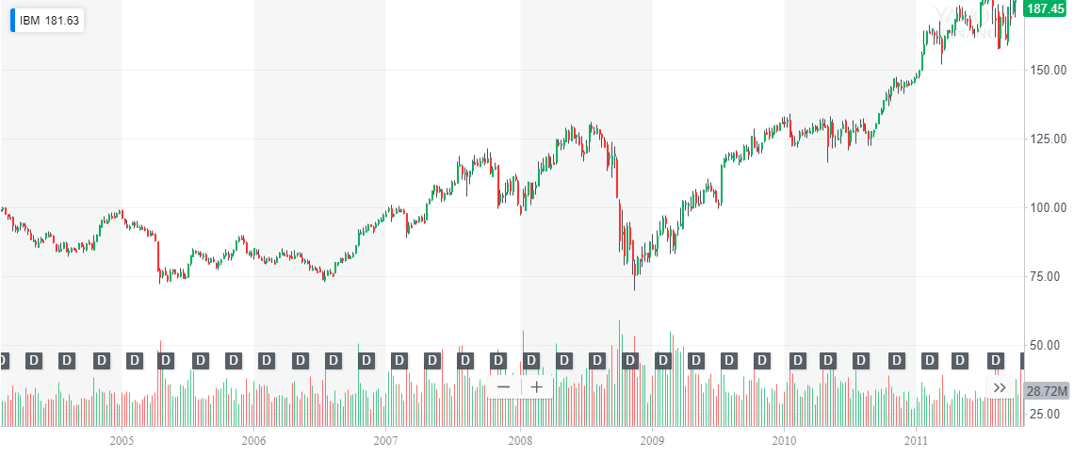¹

We can see two large downtrends here in mid-2005 and mid-2008. Notice that there are significantly taller red volume bars around the time that the biggest downward movement happened at both of these drops. Buying when you see tall red volume bars proved extremely effective in both of these scenarios, especially in the long-term.

Keep in mind that this principle holds true in active trading on a short-term basis as well. Here’s a swing-trading example with Titomic Limited:

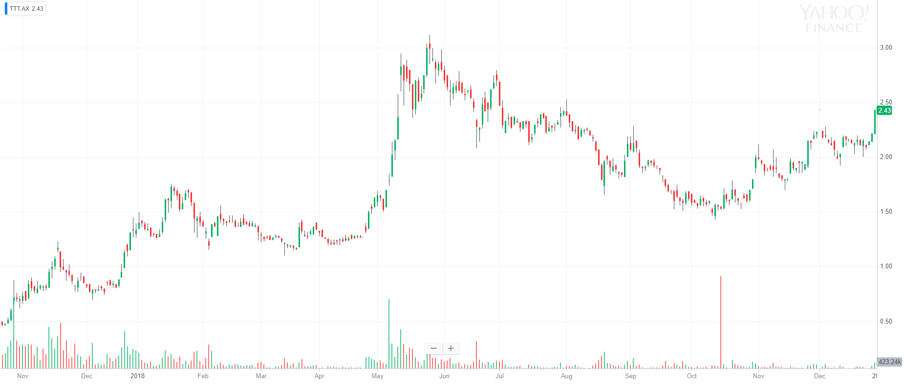²⁴

$TTT.AX bottomed after an ABCD movement almost exactly where the large red volume candle occurred, forecasting a reversal (we’ll explore ABCD setups in Chapter 28).

The next key statistic is market capitalization. $IBM’s market cap is $132,141,000,000 as of today.¹ You get this number by multiplying the $IBM price-per-share by the number of outstanding shares for International Business Machines Corporation.²⁵ Market caps are essentially what a company is worth in the stock market unless it has a class of valued shares that are not traded publicly.²⁶ Many companies issue shares like these under different classifications such as “Class B shares” in order to keep board-of-directors voting rights in the company.²⁷ For example, a company’s Class A stock could carry one vote per share, whereas the private Class B stock carries 10 votes per share.²⁷ This would allow a company to control internal affairs without worrying about public shareholder voting response. In general though, market capitalization is a fair way to estimate the value of a company.
Once you know the value of a company, you can classify them into small-cap, mid-cap, and large-cap companies. Generally, a larger market cap brings more attention to a stock which brings more volume to a stock which brings more investors to a stock which repeats this cycle.²⁸ Companies that have proven they are worth something with their large or medium market cap are great candidates for your long-term investments.
Smaller market-cap companies are what you’ll usually be actively trading since they have increased volatility often due to lower floats. We’ll discuss these terms and talk more about finding nine-to-noon trades later.

A lot of trading is based on public perception of a company. Sometimes, you may see irregular company valuation based on principles rather than how valuable the fundamental share price is. Remember to use your knowledge of news to experiment in publicly-commended positions even if you disagree with some companies and their stocks. Gains from different stocks still get taxed at the same rate, no matter their values.
In case you forgot, here’s a refresher of $IBM’s key statistics.
¹
Our next key statistic is beta. You can use beta to quickly estimate a stock’s long-term volatility and performance. Yahoo Finance uses a single regression beta.²⁹ Some find this beta calculation unreliable because its value can be manipulated by changing time periods or comparison indices (see Chapter 16).²⁹ To calculate beta, Yahoo Finance uses individual stock covariance compared to the S&P 500’s three-year return and the S&P 500’s three-year variance.³⁰ You can calculate a stock’s beta this way by using the formula:
³¹

This beta value represents the historical correlation between the stock and the S&P. Stocks with beta values greater than 1 have historically been more volatile than the S&P, whereas stocks with beta values less than 1 have been less volatile.³²
For example, a stock with a beta value of 2 has historically gone up 8 percent for the S&P's every 4 percent increase, a stock a with a beta value of .5 has historically gone down 5 percent when the S&P drops by 10 percent, and so on. Higher beta values indicate historically higher volatility and aggressiveness compared to the S&P’s movement, and lower beta values indicate a more conservative, slowly-moving stock.³²
Negative beta values indicate that a stock moves in the opposite direction of the S&P, and the same number scaling changes apply as with normal betas.³²
Stocks with low, positive betas under 1 can be strong candidates for long-term investments because they will be less risky. Medium betas, say between 1 and 2, also stand out as strong potential long-term picks for higher rewards. Ensure that your long-term portfolio balances between risky and safer stocks to take advantage of up markets and to protect yourself in down markets (we’ll talk more about diversification Chapter 35). Higher-beta stocks should be analyzed for market factors that may increase volatility.³³ Nine-to-noon stocks often have higher beta values and are very risky unless carefully and actively managed through technical analysis (coming in Part Two).

Beta alone should not determine whether or not you like a stock. None of these key statistics should. However, when used together along with technical analysis and deep corporate background research, you can use these tools to create strong, outperforming long-term portfolios. For medium-term and active trading, beta can be used to predict how much a stock will move in one day if the market only moves a certain percentage. For example, you might see daily resistances on a stock with a beta of 4 once its daily percent change reaches four times that of the S&P.³³ This principle applies mostly to swing trading and can be used to find opportune times to exit a position held for more than one day.

Our next key statistics are EPS (TTM), earnings per share for the trailing twelve months, and PE Ratio (TTM), profit to earnings ratio for the trailing twelve months. Earnings per share is calculated by dividing a company’s total earnings for the last twelve months by the number of outstanding shares.³⁶ This shows how much profit the company has made per share of stock for the past twelve months. This number is just as important as earnings, the money a company brings in from revenue after expenses.
When a stock’s EPS is negative, you know that the trailing twelve months have had overall negative earnings; the company lost money.³⁶ I’m sure you know that many companies lose money in some markets and make tons of money in others, but you should be careful when you see a company with a negative EPS. At least for long-term investing, it’s usually a good idea to invest in companies that make money. For active trading, most of the companies you’ll see have negative EPS numbers. This is fine because you do not care if the company you trade goes bankrupt the day after you buy and sell its stock.
You can divide a stock’s share price by its EPS to get the Price to Earnings Ratio.³⁴ The P/E Ratio is a terrific tool for analyzing a company’s current valuation. Average P/E ratios are around 20.³⁵ Companies with P/Es over 20 are valued more by the marketplace than their earnings alone, and companies with P/Es under 20 are sometimes called undervalued. When stocks have P/Es that significantly exceed 20, ask yourself why the market values a stock so much. Similarly, ponder as to why a company may have an extremely low P/E when you see one. Lower P/Es are generally good, and EPS depends a lot on the number of outstanding shares.

A P/E of 20 means that you pay $20 for every $1 a company makes to own their stock (since ).³⁷ If you buy a company that has a P/E of 8, it would take you eight years to make your initial cash back if absolutely nothing changed about the net income of the company. Note that companies with negative earnings have no P/E ratios.³⁷
Earnings per share is reported on companies’ quarterly and annual reports. Yahoo Finance calculates EPS and P/E Ratios by using GAAP earnings, a number that comes from the company’s reported books that uses generally accepted accounting principles.³⁸ GAAP earnings are useful for comparing one company's earnings directly to another company.³⁸ You may see non-GAAP EPS reported in a company's report as well. These calculations generally account for specific expenses, amortization, incomes, taxes, and many other business-specific numbers that they are unable to include in GAAP earnings.³⁸ The market and its analysts will generally only look at GAAP earnings, but you should also look at non-GAAP earnings when investing long-term because these numbers are more representative of a business’s true operations in income. Non-GAAP earnings can provide you with a more accurate and clear insight into a company’s profitability, but you should stick to GAAP earnings when looking at P/Es and comparing companies.³⁸
To see more about a company’s financials without directly reading these reports, click the “Financials” tab under a stock quote in Yahoo Finance to see a company's income statement, balance sheet, and cash flow.³⁹ An income statement shows a company’s revenues and expenses.³⁹ You can use this statement to determine a company’s net income. Balance sheets summarize the assets, liabilities, and equity in a company.³⁹ You can subtract a company’s’ total liabilities from a company’s total assets to calculate the “book value” of the company, the value if they sold all their assets and paid all their liabilities.⁴⁰
If the market cap is higher than the book value, then the market is willing to pay more than the basic value of a company because they think its assets provide more value. If the market cap is lower than a company's book value, then the market is not willing to pay for the full basic value of a company because they do not see value in the company. Investing in companies valued below their book value allows you to buy part of a company at a discount to their book value. You can have terrific value entries using this method, but always ask yourself why the market doesn’t want to pay full price for a company's stock. Additionally, ask yourself why the market is willing to pay extra for a stock when its market cap significantly exceeds its book price. When book price and market cap are very similar, ask yourself why the market does not pay more for a company. Always stay skeptical. Try to find companies with a fair price compared to their book value and industry context. You want the company to consistently increases assets and book price alongside stock price in the long-term by growing their business. For reference, here is a strong book value growth chart to watch for and imitate through your long-term portfolios:

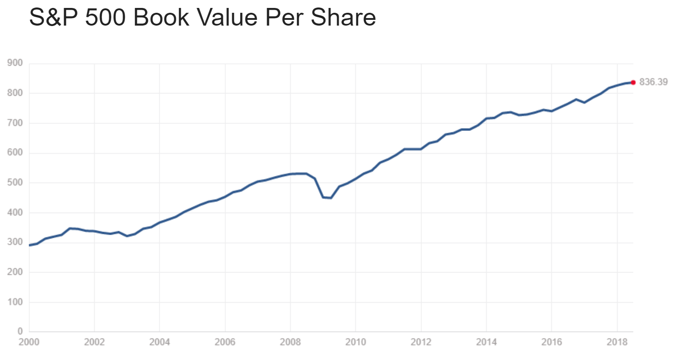⁴¹

The last financial statement Yahoo Finance summarizes for you under the “Financials” tab is a company’s cash flow.³⁹ In addition to the income statement that shows how much money a company is taking in, the cash flow statement clarifies where money moves in a company. You can analyze where cash comes in and out of corporation to understand how efficiently their professional operations and management function, among other things.⁴²

To get a quick insight into a company’s revenue and earnings, look to the bottom-right of your stock quote on Yahoo Finance to find these two useful charts.
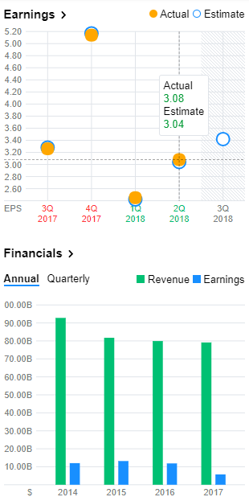¹

Stocks generally go up with satisfactory quarterly earnings beats and down after poor results. This is simply the stock’s price adjusting to the actual underlying company value or public perception of that value. Lowered revenue, customer loss, or poor management can adversely affect share price even when a stock beats analysts’ estimated EPS. Either way, expect to see large price movements when earnings season rolls around. Guessing whether or not a company beats earnings can be very difficult. If you have a solid grasp of the company’s market, then you may be able to accurately predict an earnings outcome. However, most earnings predictions are a 50-50 guesses which make large gambles on quarterly reports risky.⁴³ I’ll say that one more time to make sure you remember it: earnings reports are unpredictable.
In case you forgot, here’s a refresher of $IBM’s key statistics.
¹

Earnings date simply states the next date that the company reports quarterly earnings. Earnings reports almost always come out right after market close.⁴⁴

Next, you’ll see forward dividend and yield. Dividends are terrific for your long-term portfolio because your stocks will pay you for holding them! On top of your gains through appreciation, companies that pay dividends make you money by paying you in cash that you can then reinvest and compound back into more stock. $IBM will pay an estimated $6.28 (4.28 percent based on current per share price) total dividend in the coming year. This means that you will be paid $6.28 in your brokerage account for every share of $IBM stock per annum. $IBM distributes its dividends in quarterly payments. Some companies may elect to make larger annual or semiannual dividend payments, while others elect to pay monthly dividends. As long as you own a stock before the ex-dividend date that we see above and continue to hold it until payment day, you will be paid on the stock’s next dividend distribution.⁴⁵
Dividends, like everything else in the market, are not guaranteed. A company can choose to stop paying dividends at any time.⁴⁶ However, you can minimize your risk and establish dividend income streams by investing in large companies that have a strong track record of paying dividends. Great companies will increase their dividend payments to investors over time as they continue to make more money and their stock price increases. Sometimes, companies might maintain consistent percent dividends on their stocks by increasing the cash value of their dividends because of recent gains in the stock price.⁴⁷ This sort of behavior shows that a company cares about its shareholders and is a good investment. You can learn more about how a company treats its shareholders by looking at their dividend payout ratio. Yahoo Finance displays stocks’ dividend payout ratios under the “Statistics” tab in the bottom right.⁴⁸ Alternatively, you can calculate a stock’s dividend payout ratio yourself by using the formula:
⁴⁹
Newer or smaller companies usually have lower dividend payout ratios so that they will have more money to reinvest into the company. Inversely, large and established companies usually have higher dividend payout ratios.⁴⁹ $IBM’s dividend payout ratio is currently 97.28 percent, which means that they pay shareholders 97.28 percent of their net GAAP profits.¹
Remember that shareholders own stock which is part of the company, and executives who deserve compensation for their hard work at a company usually receive tax-preferred payments in the form of dividend income through qualified dividends. Even if you immediately reinvest your dividend income, you will be taxed on it as if it was ordinary income, paying ordinary federal income and state tax rates.⁵⁰ Qualified dividends, however, are taxed at long-term capital gains rates which are based on income brackets and much lower than ordinary income taxes.⁵¹ For you to qualify for qualified dividends according to the IRS, you must
- Be paid by an American company that qualifies for qualified dividends (some foreign exceptions) and
- Hold stock for over 60 days (90 for preferred stock) out of the 121-day period (181 for preferred stock) beginning 60 days before the ex-dividend date (90 for preferred stock)⁵² ⁵³
Preferred stock is stock that guarantees you a fixed dividend paid before common stock. This kind of stock often carries no company voting rights.⁵⁶
Whether or not a dividend is qualified determines the taxes you’ll pay on it. In 2018, refer to the following tax chart which looks at your Adjusted Gross Income (AGI) to determine your qualified dividend tax rate (2019):
Qualified Dividend Tax Rate | Single | Married Filing Jointly or Qualifying Widow(er) | Head of Household | Married Filing Separately
0% | $0-$39,475 | $0-$78,950 | $0-$52,850 | $0-$39,475
15% | $39,476- $510,300 | $78,951- $612,350 | $52,851- $306,175 | $39,476- $306,175
20% | $510,301 or more | $612,351 or more | $306,176 or more | $306,176 or more
⁵³ ⁵⁴ ⁵⁵ ⁵⁶
However, nonqualified dividends are included in your AGI and taxed at your marginal income tax rate. On top of this tax, high-income investors must pay a 3.8 percent net investment income tax for any interest, income, capital gains, and other investment income that exceeds the following MAGI thresholds (we looked at MAGI in Chapter 7) (2017):
Tax Filing Status | MAGI Threshold
Single | $200,000
Married filing jointly or qualifying widow(er) | $250,000
Head of household | $200,000
Married filing separately | $125,000
⁵³ ⁵⁷ ⁵⁸
You generally don’t need to remember these tables or worry about how your dividends are classified. Form 1099-DIV and 1099-INT from your broker will clearly lay out your income information for you to simply insert into tax returns and provided calculations.

You can check the dividend payment history, dividend payment amount increases, and dividend payment schedule for any common stock by opening its expanded chart in Yahoo Finance and hovering over the “D” icons at the bottom of the chart above the volume bars.⁴⁷ Keep in mind that these will not show up for stocks that don’t pay dividends. Stocks that don’t pay dividends will show an N/A for dividend yield and have no ex-dividend date.⁵⁹ If a stock paid timely, increasing dividends every quarter for the past decade, then it will likely continue to pay timely, increasing dividends every quarter.
Stocks that pay suspiciously high dividends should be investigated for signs of financial hardship; very high dividends can be used to draw in unsuspecting investors.⁶⁰

High-yielding dividend portfolios are great for down markets because you’ll get paid even if your stocks lose value. Plus, you can take money out of your portfolio without selling off any positions! Keep preferred shares in the back of your head. Preferred shares have dividends paid out before common shares, often trading slight historical returns for higher dividend payments.

Our last key statistic is the one target estimate. This number is the average predicted price from all public analysts on Yahoo Finance for the next 365 days.⁶¹ ⁶² ⁶³ You can assume that this number is based on speculation and poor predictions, but you should still pay some attention to it. Although nobody really knows where a stock can potentially be in a year, it’s always good to see public analysts predicting that a stock’s price will increase if you like said stock. With that said, don’t worry too much about this statistic unless it is radically lower than or higher than the current price. If you see a target estimate that astounds you, ask yourself why analysts predict that price. Keep in mind that larger stocks have significantly more analysts than smaller stocks, so the average price estimate on large stocks combines many more prices than estimates for smaller stocks.

All of these key statistics act as terrific indicators of a company’s overall health and future potential. However, these statistics should not be singled out and used alone to determine whether or not you want to invest in a stock. Use these statistics considerately for long-term positions and implement them into your larger stock analysis skill set.

Chapter 16
Long-Term Low-Management Investing

Now that we understand the basics of individual stocks, let’s look at index funds. Index funds are large collections of stocks and that can be used to track the health of the overall market. The three largest US index funds are the S&P 500®, Dow Jones Industrial Average®, and NASDAQ® Composite. These funds have been used for decades to look at the overall performance of the stock market.¹
When you look at index funds, see if they are weighted or unweighted. All of the aforementioned indices are weighted, which means that some stocks carry a larger percentage of the index’s overall balance than others.² In an unweighted index fund, all stocks represent the same percentage of the overall index.³ Differently-weighted stocks allow index funds to more accurately represent the market by giving more value to higher market-cap stocks. Market-cap weighting is the most popular type of fund weighting because it emphasizes the value of larger, more valuable, and generally more established companies.³
Sometimes, the unweighted variant of weighted funds may outperform the weighted fund in the long run. For example, the S&P 500 turned $10,000 from May 1, 2003 to the time of writing (2018) into $31,857.16.⁴ However, an equally-weighted S&P 500 ETF fund turned that same investment into $42,685.74.⁵ Keep in mind, these metrics completely ignore dividends during the same time period which averaged a 2 percent re-investable annual gain.⁴
While equally-weighted funds may expose your portfolio to more upside, remember that you inherently incur greater risk by giving your smallest, most volatile stocks the same weight as your large, stable ones.
The S&P 500 Index (^GSPC) is where we get our 9 percent number from before we even account for reinvested dividends. The S&P contains 500 or so stocks that may be slightly altered annually by S&P Global Inc. and its subsidiaries.⁶ Historically and currently, the S&P covers about 80 percent of the stock market by market capitalization.⁶ The S&P contains some of the largest companies in the market that represent their market sectors, creating a particularly diverse fund.³ To cover so much of the market, the index exclusively includes companies with very large market caps.⁶ This also allows the index to track liquidity and risk in the market’s largest companies.
The Dow Jones Industrial Average (^DJI) or Dow 30 is currently a basket of 30 large, sturdy stocks that cover all industries except transportation and utilities.⁷ Ownership of the ^DJI has moved around a lot historically, and the index is currently supervised by a joint effort between S&P Global, the CME Group, and News Corp under the name S&P Dow Jones Indices.⁸ This index was started early in the twentieth century by Charles Dow, and it originally had only 12 stocks, a number that grew to 20 in 1916 and 30 in 1928.⁸ Since then, the stocks in the Dow have changed through recessions, bankruptcies, acquisitions, and component drops thanks to its management firms. The Dow is a price-weighted index, meaning more expensive per-share stocks account for larger percentages of the total index.⁷ The Dow adjusts for splits and reverse splits to account for voluntary changes in companies’ share prices (we’ll look more at splits in Chapter 23).⁹
The NASDAQ Composite (^IXIC) is a unique index because its price is based on the entire NASDAQ Stock Market.¹⁰ The NASDAQ is a market-cap weighted collection of every common stock in the NASDAQ exchange, currently the second-largest exchange in the world behind the New York Stock Exchange (NYSE).¹¹ The NASDAQ came around in the 70s to bring electronic listing services to companies, and most large technology firms and innovative companies are listed on the NASDAQ.¹² The NASDAQ Composite contains thousands of common stocks, limited partnerships, real estate investment trusts, and foreign stock holdings.¹⁰ This number increases every time a new company goes public and gets listed on the exchange.¹² The NASDAQ 100 (^NDX) is another index that comes from the NASDAQ. This market-cap weighted index contains 100 or so components from the largest non-financial companies on the NASDAQ.¹³ Both the NASDAQ and NASDAQ 100 are known for the large technology companies that make up a significant chunk of each index. However, the NASDAQ 100 has historically outperformed the NASDAQ Composite significantly, as shown below:
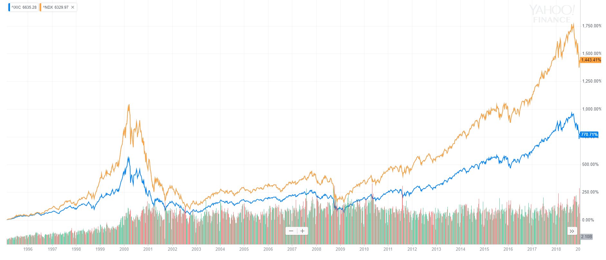¹⁴
From highest to lowest final return, we see the NASDAQ 100 and the NASDAQ Composite.

The NYSE also has an NYSE Composite (^NYA), but this index has underperformed the S&P 500 in the past, as shown below. As with the NASDAQ Composite, the NYSE Composite is a collection of the thousands of NYSE listed securities less its closed-end funds, ETFs, limited partnerships, and derivatives (we’ll look at these later).¹⁵
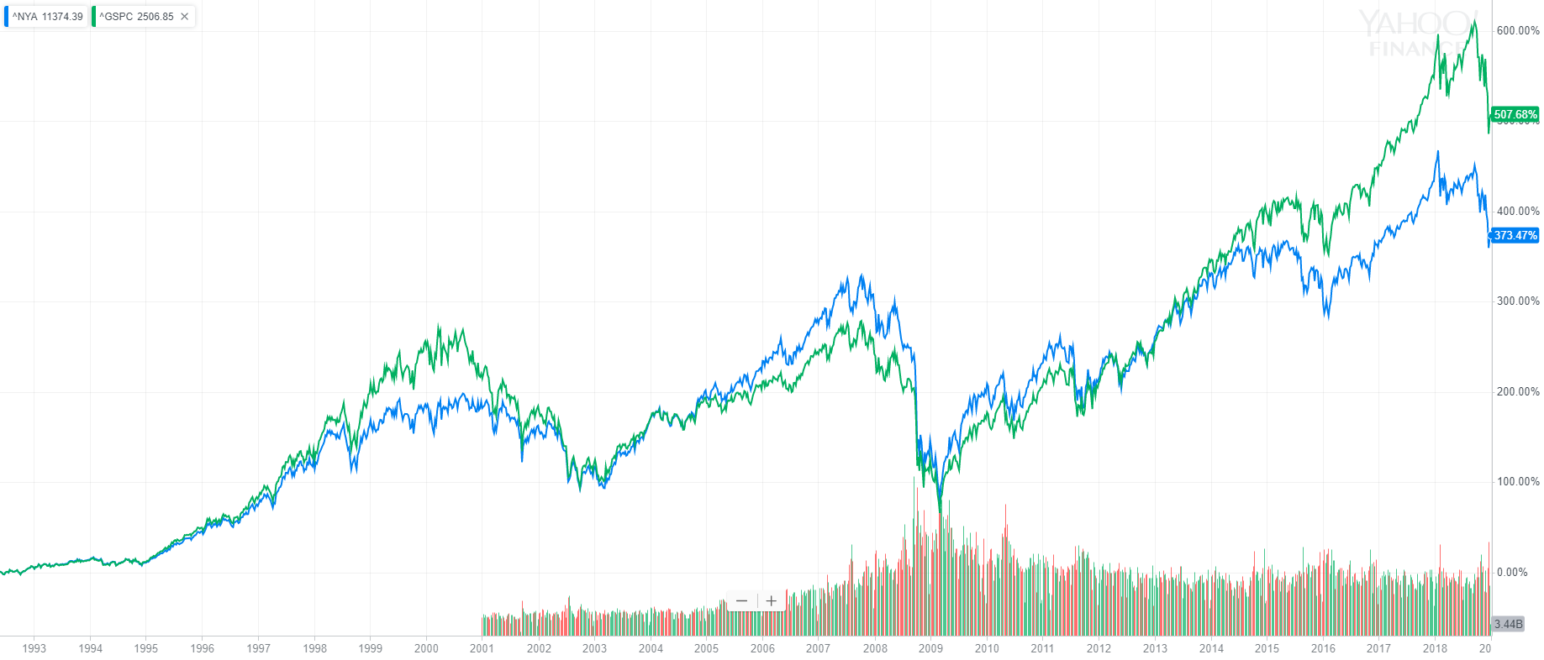¹⁶
From highest to lowest final return, we see the S&P 500 and the NYSE Composite.

Lastly, we get to the Russell 3000® (^RUA), Russell 2000® (^RUT), and Russell 1000® (^RUI) Indices.¹⁷ These three FTSE-Russell-managed funds come from the foreign London Stock Exchange Group.¹⁸ The ^RUA is a market-cap-weighted collection of 3,000 very large American companies that diversifying investors cherish since the index covers about 98 percent of the stock market.¹⁹
The ^RUT is a market-cap weighted collection of the lowest 2,000 market-cap stocks in the Russell 3000. This fund is used to collectively measure the performance of small and mid-cap stocks.²⁰ The Russell 2000 represents about 8 to 9 percent of the Russell 3000.²¹
The ^RUI is our last market-cap weighted fund that makes up the remaining highest 1,000 market-cap components in the Russell 3000. In contrast to the Dow Jones Industrial Average which tracks 30 large corporations, the ^RUI contains a wider, diverse variety of large companies.²² The large-cap companies in Russell 1000 represent about 91 to 92 percent of the Russell 3000 or 90 percent of the overall stock market.²²
Despite their differences, all three Russell® indices perform relatively similarly as they track market conditions, as shown below:
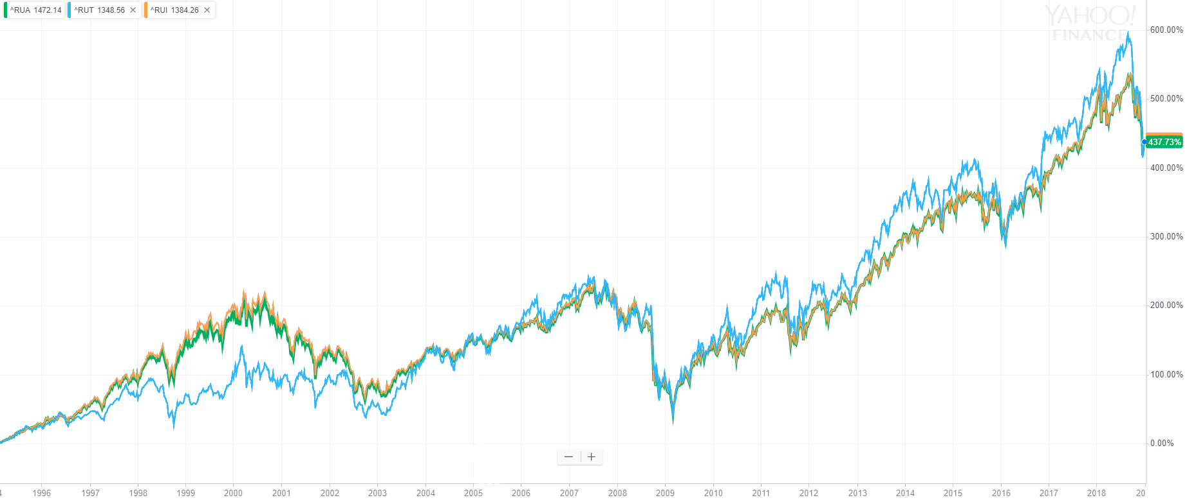²³
From highest to lowest return at the mid-2018 peak just before the final downtrend, we see the Russell 2000, Russell 1000, and Russell 3000 Indices.

The only index to seriously deviate from the Russell 3000 above is the Russell 2000.

Here is a chart that looks at the historical performance of the S&P 500, Dow Jones Industrial Average, NASDAQ Composite, and Russell 3000 from 1985 to 2018.
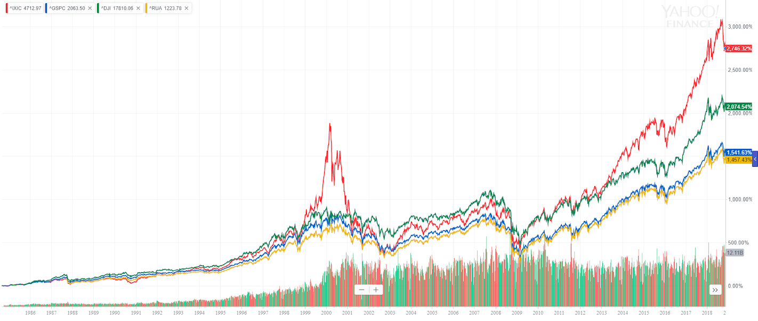⁴
From highest to lowest final return, we see the NASDAQ Composite, Dow Jones Industrial Average, Russell 3000, and S&P 500.

Notice that all of these indices recover from their downturns and pull out to make you money in the long term. Even if you encounter a short-term pullback, you can expect your money to recover and grow its value in the long run. Remember not to make overly emotional buying or selling decisions in large economic uptrends or downtrends. It’s always darkest before the dawn.

With the S&P slumping as our lowest performer, we can see that there are certainly ways to beat the “average” S&P market return while still investing only in large, diversified, less-risky indices. I put average in quotes because you should never limit your investing mentality. Never tell yourself a limit to how much you can make. You can make as much money as you want in the market as long as you put in enough time to learn the technicals, practice trading, and research constantly.

Remember that you will constantly put money into the market as a long-term investor saving for retirement, so you should care less about short-term quick price swings. Your average fill price will average out as you add more shares to your portfolio at different times. However, you should still watch out for immediate market shifts that represent an overall downturn in the economy. For example, we can see the 2001 dot-com bubble particularly well in the NASDAQ alongside the 2008 subprime mortgage housing market crisis and Madoff investment scandal in all these major index funds.²⁴

Index funds track the holistic performance of our economy. In a way, they are our economy. Indices are the most diversified and least time-consuming way to invest in the stock market because they are just large groups of hardworking companies. Index funds are foundational baselines of many retirement plans because they are generally known as the least-risky way to invest in the stock market. Crashes in the overall market do happen and should be eventually expected from all investors. At some point, large institutions or shareholder will liquidate their holdings in a stock. Remember that stock prices are largely dictated by public perception, buying pressure, and selling demands in the short term. Stick with your own solid long-term picks that you know will continue making money when other shareholders cash out their positions. It’s almost impossible to time overall market pullbacks because they only happen when widespread public perception of the market changes. To keep your returns high, worry about long-term stock performance and adapt to market trends when they arise, carefully watching out for any glaring market issues. If your research shows that a stock is poised to temporarily drop, never be afraid to act on your knowledge and take gains.

The S&P 500 in particular with its conservative 7 percent post-inflation average long-term capital gains is a true summary of American business. This low-risk index also led to the creation of the “4 percent rule” among financial planners. The principle behind the 4 percent rule is that you can withdraw 4 percent of your stock portfolio in retirement and still have an average long-term return of 3 percent in up and down-markets.²⁵ If you can cover your annual expenses with 4 percent of your investments’ combined value, then many financial planners will tell you that you can retire. You can use this principle to estimate how much you need to retire based on your current consumption habits.

Chapter 17
ETFs and Mutual Funds

As you may have picked up already, diversification is key in long-term portfolios (we’ll look more at diversification in Chapter 35). Exchange Traded Funds (ETFs) and mutual funds are perfect for diversification because they are large combinations of paper assets.
ETFs and mutual funds are almost exclusively created by large organizations that want to help you retire. These two fund types are going to be your best friends as a long-term, hands-off, research-light investor. Now, let’s start with ETFs.

As the name implies, ETFs are traded on exchanges during the market day by buyers and sellers. This means that you can buy ETFs through your brokerage that have tickers, bids, asks, and quotes just like stocks.¹ Many brokerages have special agreements with ETF-creating firms that allow you to purchase shares in an ETF without paying stock-trading commissions.²
All ETFs have management companies with investment goals.³ Some ETFs carry only stocks balanced around large index funds. Others cover market-specific sectors with a wide variety of companies.¹ From the NASDAQ to wood, you can find an ETF for almost any market sector or index managed actively or passively by an investment firm.⁴ ⁵ Since ETFs are managed by their investing firms, you never have to worry about rebalancing your portfolio when a new stock gets added to the S&P 500 Index or an amazing new company emerges in a niche industry.⁶ Rather, your fund company will update their holdings as they see fit and let you know after the fact.
Many investors successfully grow their retirements with index-fund ETFs alongside sector-specific ETFs in fields that they know a lot about. Alternatively, you may elect to purchase the best-performing ETFs you can find. Whenever you invest into something for the long-term that you know little about, be extra-careful not to make overly-emotional decisions in large market swings. Conversely, many investors feel fine holding their personal, researched long-term picks through downturns because they see the value in a company or sector’s long-term business or value propositions (perhaps based on technical analysis). It’s always fine to invest based on facts and figures alone, just remember to stick by your principles as a trader. To really step up up your long-term investing game, research the best performing assets you can find.

ETFs are great tools to use for diversified long-term investing because they drastically reduce the amount of time you’ll spend researching stocks alongside the commissions you’ll pay to buy them. For example, you’ll spend much less time buying the Invesco QQQ NASDAQ 100 ETF compared to researching the NASDAQ 100 stocks, purchasing 100 stocks, and modifying your portfolio (quarterly in Invesco’s case) when the NASDAQ 100 changes slightly.⁷ Additionally, you only have to buy one ETF which may be available from your broker as a commission-free trade rather than paying commissions on 100 unique stock purchases. This simplifies and lowers the cost of investing straight from your every paycheck.

When an ETF management company opens a fund with the SEC, they outline their fund balancing plan for approval.⁸ Once an ETF receives SEC approval, the management company acquires bulk assets (or cash, rarely) from large institutional investors that are held in a custodial bank. In this transaction, the large institution purchases ETF shares at the weighting specified in the SEC proposal (or publically disclosed holdings and weightings for actively-managed ETFs, released at the end of every market day).⁹ Institutional investors exchange shares in a like-kind exchange, giving up underlying securities and receiving the same value in new “creation unit” ETF shares.⁹ This exchange occurs at NAV (coming soon) only in extremely large blocks of ETF shares.¹⁰ These bulk transactions lower everyday operational costs of ETFs by stopping small individual shareholders from directly redeeming their shares for securities intraday. If an institution (or anyone able to get enough shares to reach an ETF’s block size) collects thousands of ETF shares, then they can give them back to the ETF firm in exchange for the fund’s underlying assets (or cash, rarely).¹⁰ The fund gives the redeeming institution the lowest cost basis shares from its holding to lower the firm’s tax liability.¹¹ Institutional and individual tax liabilities are only dependent on ETF share price appreciation and dividend distributions.³
Four new terms you should learn when looking at ETFs of any kind are Net Assets, Net Asset Value (NAV), Yield, and Net Expense Ratio.
An ETF’s net assets are the cash fair market value (FMV) of all its stocks, bonds payable, realized gains, and cash less its liabilities, realized losses, and expense ratio fees (we’ll talk more about fees soon).¹² An ETF’s net assets significantly increase when institutions give ETF firms new assets in exchange for new ETF shares and decrease when they redeem shares.¹¹ Net assets also gradually fluctuate as markets move up and down, changing underlying asset FMV.¹² Funds with higher net assets are generally more established and reputable. You should carefully investigate ETFs with low net assets, especially funds with short performance histories. Remember to look at a fund’s overall long-term goals and see if it makes sense to buy the ETF instead of directly purchasing its underlying assets or creating your own portfolio.
For actively-managed ETFs, management firms must publicly publish holdings and weightings of their ETFs at the end of every market day.⁸ The net value from this report is used in place of an automatically-calculated NAV in infrequently rebalanced ETFs.⁸
To find the Net Asset Value of a fund, simply divide its net assets by the number of shares outstanding.¹³ Generally, ETFs trade close to their NAV because that value represents the weighting-adjusted price of the underlying assets (represented per ETF share).¹³ Just like how a stock is part of a larger company, your ETF share represents a holding in a larger fund.
When an ETF trades above or below its NAV, you can sell or buy, respectively, the fund with greater certainty that the price will move towards the NAV. Many ETF firms and institutional traders maintain extremely tight margins by using computers to automatically buy/sell an ETF when it goes below/above a certain percentage value of the fund’s NAV.¹⁴ These computer-automated arbitrage mechanisms are especially useful for ETFs because an institution can purchase bulk shares under NAV and exchange them for a profit with the ETF firm or buy bulk ETF shares at NAV to sell when the market pays much more than an ETF’s NAV.¹⁴
Slight deviations from an ETF’s NAV provide enough profit incentive for most large management firms and institutions to practice this management technique.¹⁴ This constant supply-and-demand pull between buyers, sellers, high-frequency traders, and institutions keeps ETF prices backed by their underlying assets and near their true FMV. As an investor, this practice helps your portfolio stay accurately-valued and extremely liquid when you want to buy or sell ETF shares. With that said, many popular ETFs consistently trade slightly above their NAV because they are traded just like stocks, so high demand increasing the price askers sell at.¹⁵
Actively-trading index funds, market trackers, mutual funds, and ETFs alike are all difficult to time since the overall market in any sector is generally unpredictable. Additionally, these funds offer few opportunities for high percent-change price swings compared to individual stocks. For these reasons, you’ll essentially never trade ETFs nine-to-noon. However, these same reasons make ETFs a strong tool for long-term investing. Additionally, institutions with less emphasis on percent gains, perhaps firms with much more money to leverage, make money as a “market-maker” or fund arbitrageurs to keep your funds performing as they should.

An ETF’s yield is a form of investment income much like a stock’s dividends. When stocks or other assets in an ETF pay dividends or interest income, the ETF pays out the cash to you based on the number of ETF shares you own.¹⁶ Check your specific funds to see how often they pay yield distributions. If most of the assets in a fund payout quarterly dividends, then you can expect to receive quarterly yields that will add up to the total yearly yield percentage as long as you own an ETF.¹⁶ Though the ETF may own the underlying stocks for years before you buy the fund, the same qualified dividend and non-qualified dividend rules discussed earlier apply to your ETF as if it was its own common stock.¹⁶
ETFs with higher yields are great for your portfolio, but remember that you will pay taxes on dividend income but not on unrealized gains (this does not matter in most tax-abated retirement plans). Look for good long-term growth opportunities with ETF appreciation and yield payments. Yield payments are great for reinvesting into new assets just like dividends.

Finally, we get to the cost of owning ETFs: net expense ratios (adjusted from gross expense ratios minus abatements). ETF firms charge investors annual net expense ratios over the course of a year, spreading out the fee into every day’s net assets and NAV.¹⁷ These expense ratios are given as percentages and are subtracted from an ETF’s annual gain or loss.¹⁷ For example, if an ETF charges an expense ratio of .25 percent and appreciates in a straight line by 10 percent in a year, then a $100 investment will turn into $109.75. However, this .25 percent expense ratio is not directly paid to the ETF fund. Rather, the fund firm gradually lowers the ETF’s net assets and NAV every day by .25 ÷ 365 = 0.0006849315 percent. An ETF or mutual fund can sell assets in order to generate the cash necessary to pay expenses if there is not enough dividend income or leftover cash to cover expenses.¹⁸ You’ll always pay the net expense ratio every year no matter how a fund performs.¹⁷
Net expense ratios are generally lower for long-term passively-managed funds compared to actively-managed ETFs.¹⁹ Look at a fund’s historical performance to see it investing in an actively-traded fund could yield you higher long-term returns compared to index funds or sector trackers. You should try to minimize ETF expense ratios whenever possible unless a higher-cost fund yields higher returns because of its superior management. If you want to avoid fees altogether and take control over your investments, stick with your own diversified portfolio.

Before ETFs came around, mutual funds were one of the easiest ways to invest in America. Mutual fund companies create funds based around large market sectors and major indices.⁸ Money market funds are a type of mutual fund that primarily invests in guaranteed low-return investments.⁸
Mutual funds pool money from many investors, creating a greater overall portfolio shared with you based on your cash stake in the fund. By pooling your money with other investors, mutual funds give you the same diversification benefits, time-saving management, and low trading fees that ETFs offer.²⁰ However, mutual funds operate much differently than ETFs.
The two main types of mutual funds are open and closed-end funds.⁸ In an open-end mutual fund, you send your money to pool firms that issue you redeemable shares. These shares are purchased in cash and valued at the fund’s NAV at the close of the most recent trading day.²¹ If you decide to sell your mutual fund shares, the management company must buy them back from you at the last trading day’s closing NAV.²¹ Because you cannot trade an open-end fund intraday, these funds are almost exclusively geared towards long-term growth.²⁰ In fact, many funds require you to submit purchase orders before a trading day’s closing price has been determined, forcing you to estimate your entry point based on the overall market’s daily movement before you actually know the fund’s daily closing NAV.²²
You buy open-end mutual funds with cash and receive cash when you sell your fund stake just like ETFs.²² Investors can buy and sell mutual fund shares at any time, so the management company must always keep cash on hand to buy back fund shares.²³ Additionally, funds may have to sell positions to pay for share redemptions. When individuals exit a fund, share selling can result in capital gains or losses that become your tax liability.²³ In fact, almost any fund management creates tax liabilities for you even if you never sell your fund shares.²⁴ Realized capital gains for the entire fund are passed on to you to pay taxes on at least once a year.²⁴ For example, a fund could collectively purchase Wynn Resorts Ltd. stock at $60 in 2016. Then, you decide to purchase the fund in 2018 when $WYNN costs $180. A few months later, your fund manager decides to sell $WYNN stock at $195. The fund’s net gain and tax liability is based on the 2016 entry point at $60, not your individual entry point into the fund. The mutual fund is now responsible for paying long-term capital gains tax, and managers must pass all tax liabilities onto fund participants at least once a year.²⁴ So, you will be responsible for the fund’s long-term capital gains on $WYNN even though you missed out on most of the growth (tax responsibility is split up depending on how many fund shares you have).²⁴ Remember that fund yields, dividend income, or bond interest is generally taxed as income to you.²⁴ Watch out for open-end funds with large unrealized gains when you enter them, as stock selling could cost you capital gains taxes before you start making money.
One way managers lower annual shareholder tax liability is by selling off losing positions to offset gains. Some individuals also use this strategy to lower their tax burdens.²⁵ Say you have $10,000 in long-term capital gains on your $WYNN trade. Then, you may sell off some losing long-term positions that will have a taxable loss of $10,000. Suddenly, you owe no long-term capital gains taxes because your taxable net long-term gains are zero dollars.²⁵ You can even carry over losses from one year to the next, deducting some losses from your individual net income or dividend payments up to $3,000 per year ($1,500 is married filing separately) (2018 rates).²⁶ You can exclusively sell off long-term losses to offset long-term gains or liquidate short-term losses to offset short-term gains.²⁵ Mutual fund managers can settle unrealized losses in this same manner to lessen the entire fund’s overall tax liability.
While losing money to save money may sound counter-productive, remember that you would have the same unrealized loss in your account anyway. Although it’s generally best to leave long-term picks alone when the year ends, you can sell stocks for a loss to limit taxable gains and then use that money to purchase other stocks in the same industry sector. You can even buy the same stock after a month passes. Just remember the IRS wash-sale rule which will disallow long or short-term capital gain liability deductions from losses when you sell for a loss and buy the same stock or a “substantially identical” security back within 30 days of the sale.²⁷
Open-end mutual funds act more like pooled investment groups than ETFs. You invest cash with others and share all tax liabilities and interests with the mutual fund. You exit the fund by asking for your per-share NAV back in cash after all the fund’s assets settle after a trading day.²¹ Mutual funds generally carry significantly higher net expense ratios than ETFs because of the more involved management required to keep passed-on tax liabilities down, selling investors paid in cash, portfolios balanced appropriately, and other expenses paid off.²⁸ You can expect even higher expense ratios with smaller-worth or more-actively managed funds.²⁸ Net expense ratios are deducted passively from mutual funds’ net assets to cover operational costs just like ETFs.¹⁸ In addition to annual expense ratios, some funds charge front-end and back-end “loads” (aka. fees).²⁸ These funds charge you percentages of your investment whenever you buy into (front-end) or sell out of a fund (back-end), hurting your overall returns.²⁸ If a fund outperforms the market significantly, then these fees may be negligible in the long-term. However, we already know about the power of compound interest, and even small fees can have significant effects on your portfolio down the line, as shown below. Always search for high-performance funds with low net expense ratios and loads. For mutual funds in particular, watch out for net expense ratios that gradually rise depending on how long you own a fund.²⁸ If a fund charges high load fees or perhaps annual 12b-1 fees, make sure you get a higher return for the managerial investment you make.²⁸
(8 percent annual return) | 0.29 percent expense ratio | 1.22 percent expense ratio | 0 percent expense ratio (your portfolio)
Initial investment | $20,000 | $20,000 | $20,000
After 5 years | $28,994 | $27,764 | $29,387
After 10 years | $42,033 | $38,542 | $43,179
After 15 years | $60,936 | $53,503 | $63,443
After 20 years | $88,339 | $74,273 | $93,219
After 40 years | $390,185 | $275,821 | $434,490
²⁹ ³⁰

Most mutual funds are open-end funds that issue shares to the public after every trading day at NAV.³¹ With that said, some “closed-end” investment funds only issue shares to the public once.²¹ These shares are then traded in between investors like ETF shares and are not repurchased by fund issuers, which means that they can be traded intraday.²¹ However, these funds generally have little to no arbitrage mechanisms in place, so market prices can drastically differ from NAV.³²
Closed-end mutual funds function similarly to open-end funds. Dividends and interest are paid out as ordinary-income distributions to shareholders, net expense ratios are taken from net assets, and net realized capital gains are passed on to shareholders at least once a year.³²
Watch out for leveraged mutual funds and ETFs that increase shareholder risk and potential returns by using debt to finance positions.³³ Some closed-end leveraged mutual funds charge their expense ratios against total assets including invested debt, raising their effective expense rate.³⁴

One last rare investment vehicle you may see are unit investment trusts. These funds make a one-time public offering for a fixed number of securities which are forcefully sold on a specified termination date.⁸ The management company never alters the positions in the fund after this sale, simply leaving the assets to grow unmanaged and generally with very low expense ratios until the sale date when it liquidates all positions and redistributes profits and losses to shareholders who can trade the fund until expiration on the secondary market.³⁵ It’s basically a ready-made static long-term portfolio that you can buy with only one convenient order.

By purchasing ETFs or mutual funds, you can significantly lower your long-term risk and volatility by diversifying across a very broad range of stocks and industries. Monthly contributions to these funds require minimal management commitments or research on your part. Large institutions operate diligently daily to ensure you have access to top-rated funds on liquid exchanges, making it easier than ever to purchase a slice of the American economy.

Chapter 18
Commodities and Currencies

Commodities and currencies are generally tougher markets to profits from compared to stocks and corporate bonds. Some traders make consistent profits by using technical analysis to actively manage commodity and (non-crypto) currency portfolios, but these traders generally see less volatility and realize lower percent gains than nine-to-noon traders (see Part Two). Some active foreign exchange currency traders make up for low volatilities by using leveraged debt to increase their position stakes, but we already talked about why you should avoid trading on margin earlier. With that said, you can make strong medium-term gains if you think a certain commodity industry will significantly change in the near-term. For example, a horrendous hurricane in Florida may increase FCOJ-A futures prices (we’ll talk about what this means soon). Perhaps you notice gas prices getting especially low and see potential upside in crude oil. Alternatively, you can use currency markets to profit from your overall knowledge of worldwide political issues and country-specific news as currencies quickly change value compared to one another..

In the long-term, expect worldwide news and trends to dictate commodity and currency prices.¹ Because of this, it is tough to predict overall future growth in commodities and currencies, and these positions are generally excluded from long-term portfolios.² There are profits to be made in commodity and traditional currency markets, but they are usually measly compared to the stock market.³ Rather, these exchanges are used as necessary and proper tools for global commerce. Let’s start by looking at commodities.

Commodities are goods that are interchangeably similar to other like-quality goods no matter who produces them. Commodity prices change as the worldwide market determines how much they are worth based on supply, demand, and speculation.⁴
In frequently-traded exchanges, commodities have tickers followed by a rating for a predetermined amount of the underlying commodity.⁵ For example, FCOJ-A stands for A-rated Frozen Concentrated Orange Juice solids and currently trades at $1.60 a pound.⁶ Other common commodities include:
- Corn
- Oats
- Rough Rice
- Soybeans
- Rapeseed
- Wheat
- Milk
- Cocoa
- Coffee
- Cotton
- Sugar
- Adzuki Beans
- Lean Hogs
- Live Cattle
- Feeder Cattle
- Crude Oil
- Ethanol
- Natural Gas
- Heating Oil
- Gulf Coast Gasoline
- RBOB Gasoline
- Propane
- Copper
- Lead
- Zinc
- Tin
- Aluminum
- Nickel
- Cobalt
- Molybdenum
- Recycled Steel
- Gold
- Platinum
- Palladium
- Silver
- Palm Oil
- Rubber
- Wool
- Amber
- Coal
- Lumber
- Olive Oil
- Palm Oil
- Peanut Oil
- Potatoes
- Rye
- Commodity Tea
- Ambergris
- Bristles
- Butter
- Cashmere
- Feathers
- Goats
- Hide
- Horses
- Ivory
- Lard
- Musk
- Civet Oil
- Pork Bellies
- Sheep
- Silk
- Sponges
- Tallow
- Whalebone
- Compressed Hydrogen
- Thorium
- Uranium
- Purified Terephthalic Acid (used in clothing and plastic bottles)
⁴ ⁷ ⁸

Remember that some commodities like corn are more frequently traded than others, creating better active investment markets and more exchange listings. More liquidity and volume keeps commodities on worldwide exchanges and ensures tight spreads for you.⁴
Since commodity markets generally operate with less public volume than equities, intraday price movements may seem abrupt at times.⁹ However, even comparatively quick movements are usually relatively small compared to nine-to-noon stocks (we’ll talk about these in Chapter 36). Unless there is a huge environmental report or war threat, commodity prices generally have smaller and less-predictable movements day-to-day.¹⁰ For these reasons, many investors stick to commodities for risk-diversification in down markets.² For example, many flock to “safe” precious metals when overall index funds start to drop significantly. However, you can also speculate in the medium to long-term in commodities if you have a background or education in a certain market. Since prices are driven by global supply and demand, you can identify macro-level trends that could significantly change a commodity’s immediate value. To gain a better insight into commodity volatility and long-term performance history, we’ll soon look at 30-plus-year commodity price charts. Generally, investors find that almost all long-term commodity positions are outperformed by the stable, long-term returns divvied out by index funds.
The market price you see when you look up any commodity is the price the good most recently traded for in the live market. Every day, these “spot prices” move when farmers sell their harvests to buying manufacturers, distributors, etc.¹¹ You can find spot prices for most frequently-traded commodities on Yahoo Finance under the “Markets” tab.¹² However, these quotes rarely show you long-term performance. For this, search for specific commodities through online quote searches or through direct commodity exchanges like the Chicago Mercantile Exchange®, Chicago Board of Trade®, Carbon Trade Exchange, European Energy Exchange®, New York Mercantile Exchange®, Intercontinental Exchange®, London Metal Exchange®, Brasil Bolsa Balcão SA, Multi Commodity Exchange of India, Zhengzhou Commodities Exchange, Shanghai Futures Exchange, and Tokyo Commodity Exchange.¹³ ¹⁴ Your orders flow through these exchanges when you buy or sell a commodity or futures contract (coming soon).¹⁵

FCOJ-A’s current spot price is around $1.60 per pound with one contract representing 15,000 pounds of A-rated Frozen Concentrated Orange Juice solids.⁶ If orange juice was a stock, you could purchase it at this price and hold it like any paper asset. The only problem is that you get actual orange juice solids when you buy FCOJ-A rather than paper or electronic stock certificates (we’ll look more at stock fulfillment in Chapter 37).
If you are a factory, you can purchase orange juice from the market immediately at this price per pound. The exchange you submit your order to will verify the quality and delivery of your commodity from the seller you are nearly-immediately matched with.⁵ When a seller posts an order on a commodity exchange, they or the exchange guarantee the physical delivery of commodity orders.¹⁶ In some cases where fulfillment is extremely costly, distributors may store orders in warehouses or organize private delivery off an exchange.¹⁷ ¹⁸
If you buy one lot (15,000 pounds) of FCOJ-A, you will be responsible for refrigerating and storing the solids on your own property once they are delivered. As a speculative investor, actual physical delivery and commodity storage is unideal for you (what can you do with a truck full of juice?). Even for other commodities such as precious metals, actual physical possession puts you at risk for theft and other extraneous circumstances.

Futures contracts are the easiest way to trade commodities without physically owning the underlying commodity. Instead of buying gold or another commodity directly, you can buy a futures contract to lock in a current price for one hundred troy ounces (standard single lot size) of gold in a future time frame.¹⁹ If the price of gold rises anytime in this predetermined timespan from your future contract price, then you can sell your contract for a profit because your contract purchases gold below its market price. As long as you sell your futures contracts before their predetermined expiration dates, you’ll never have to physically take delivery of the underlying commodity.²⁰ To short a commodity, simply sell a futures contract first, wait for price movement, and buy it back later.²¹

Let’s say you grow Arabica coffee on your farm. You know that your harvest will be ready in five months and should yield around 40,000 pounds of coffee beans. After looking up the historical price of coffee, you grow fearful that prices will drop from the current spot price of $1 per pound to $0.70 per pound (ICE Futures price, Coffee C®, Arabica coffee).²³ To protect your crop value, you go to a few different exchanges and find that you can get a 37,500-pound futures contract from the New York Mercantile Exchange.²² The value of a 37,500-pound contract at the current spot price of $1 per pound is $37,500. However, you do not want to spend $37,500 on your contract, so you go through a broker which gives you leverage and lets you trade on margin. Because you have a great credit history with this broker, they let you enter a “sell-to-order” or short coffee position at the NYMEX after you deposit only $4,000 in a margin account. You open this position through your broker by selling a one-lot coffee contract for 37,500 pounds on the NYMEX that expires in five months. The buyer on the other end of this contract is either a ready-to-buy supplier, a speculator thinking the price will go up, a market-maker, or the actual exchange buying to create liquidity.²⁴
As the price of coffee changes, daily adjustments are made to the $37,500 leveraged value of your account at the closing price of every market day.²⁵ Remember that your actual position is funded with leveraged debt, and the cash deposit is only a small fraction of your $37,500 contract. As the price of coffee goes down, your short contract appreciates because you have the ability to sell coffee at a higher future price than the current spot price. Your $4,000 deposit grows to $13,375 (234.375 percent gain, +$9,375) while your actual contract value increases from $37,500 to $46,875 when coffee hits $0.75 after three months (25 percent gain, +$9,375). Notice that your cash deposit grows more than the actual 25 percent gain because this was a leveraged position. When trading on margin or with leveraged options (see Chapter 21), your gain or loss is the price movement of your leveraged position added to or subtracted from your initial margin deposit. Since you made $9,375 from this leveraged position so far, you have an unrealized (unsold and still in the market) gain of . Not bad! Leveraged positions present huge upside, but they also create huge downside.
Exclusively in the commodities future contract market, your account is actually credited $9,375 from the commodity exchange even though you have not sold your contract that still has two months until expiration.²⁰ The buyer on the other end of this contract was debited $9,375 from the exchange in real time since they now have to pay a higher-than-market price for the coffee you sell them.²⁵ In a traditional stock trade, you do not receive money in your account until you “cover” your position in a short trade or sell your position in a long trade (we will talk more about order types in Chapter 19). In essence, you do not gain or lose any money until you close out part or all of your position in whatever stock, ETF, etc. that you buy or short. These unrealized gains in the equity market are not taxed at the end of the year according to capital gains tax rates as they are in futures contracts because you have not actually received money from the sale of your asset.²⁶ However, commodities futures differ significantly from equity-market positions because any gains or losses are credited or debited to your account at the end of each trading day.²⁵ You can still sell your contract at any time before the last trading day as specified in your futures contract, but you will see actual cash flow in and out of your account every day rather than only seeing your position value change on paper.
Regulated futures contracts are considered Section 1256 contracts taxed using a 60/40 gain or loss split.²⁷ Other Section 1256 contracts include:
- Foreign currency contracts,
- Nonequity options,
- Dealer equity options, and
- Dealer securities futures contracts.⁷⁴
Don’t worry about those last two, as you are not a dealer.

With this special classification, long-term capital gains rates are applied to 60 percent of a contract’s year-end losses or gains, and short-term gains rates are applied to 40 percent.²⁷ You report your year-end futures and all other Section 1256 contract positions through IRS Form 6781.²⁸ This form looks at the market value of your positions and applies the 60/40 tax split to gains and losses.²⁹ Note that the wash-sale rules discussed earlier do not apply to Section 1256 contracts because they are marked-to-market.²⁷ Other nonconvertible Section 1256 contracts include foreign currency contracts, non-equity options, dealer equity options, and dealer security futures contracts.³⁰ You’ll simply copy your gains and losses from your broker-issued Form 1099-B to pay your split taxes on these contracts.³⁰
After calculating your tax liability on unrealized Section 1256 contract gains or losses, you report your tax liability on Form 1040 supplement Schedule D.³⁰ The Schedule D is also where you state your capital gains and losses as reported by your brokerage through 1099-B statements. Just follow the steps and calculations from Form 6781 and Schedule D, and you’ll be sending in your tax return in no time.³⁰ Experience makes these forms go by quicker, as you learn which parts you can skip and simply leave blank since they do not apply to your return.³¹
Before we go back to our coffee example, let’s recap one quick tax law. As you know, if you hold stock through the end of the year, you will not have to pay taxes on your unrealized gains or losses.²⁶ However, this tax benefit extends to qualified nonprofits when you donate equities with unrealized gains to charity without you or the charity paying any capital gains taxes. You can donate and account for the full value of stock donations with unrealized gains without you or the recipient paying the IRS any capital gains taxes.³²

If you are purely a speculative trader like most, then you may decide to cash out your short coffee position now, realizing your significant gain. To do this, you have your broker submit a “buy-to-open” or long futures contract order for 37,500 pounds of coffee.²⁰
Futures contracts use the same order types as stocks. We will talk about stock order types in Chapter 19. The biggest difference between trading futures contracts and stocks is that futures contracts:
- Have a tick size, (minimum amount that a contract can move in value)
- Are marked to market at the end of the day,
- Expire by certain dates,
- Have required order sizes,
- Deal much more with margin, and
- Can generally be traded 24 hours a day.³³
Short and long futures contract trades simply change the owner of the contract or terminate the contract in exchange for gains and losses if both parties agree to this option, a less likely outcome since these two-sided contracts are zero-sum trades that always have a loser.³⁴ Nonetheless, exchanges back up contracts in the market to ensure you get liquidity through automated order-matching systems.³⁴

Let’s say you decide to hold your contract after this initial downtrend. When the price of coffee goes up, your short contract depreciates. Your actual contract value decreases $9,375 from $37,500 to $28,125 (25 percent loss) while your $4,000 deposit shrinks to -$5,375 (234.375 percent loss) when coffee hits $1.25 during your last two holding months. Notice that this 234.375 percent loss mirrors your earlier 234.375 percent gain when coffee went down 25 percent. Since you theoretically sold a contract betting the price would go down, but the price ended higher, you lost . Your account has a negative balance because you made this trade on margin and lost more than your initial margin deposit (aka. you made a bet with someone else’s money and lost it).
Now we start to see the dangers of trading on margin: you can lose more than you bet! If you can’t pay back your debt to the lending broker through cash or asset liquidation, your debt will accrue interest like a loan taken out to invest. By avoiding margin trading in any asset class with money you don’t have, you ensure your financial security and protect long-term growth prospects with intelligent investments.
In commodities markets specifically, you can back up your margin position with expected crop yields as a producer. However, this practice will still expose you to disastrous risk if your harvest unexpectedly decreases, leaving you little collateral to cover potential margin losses. In all capital markets, only risk what you are willing to lose. Always prepare for the worst so that you can work for the best, sticking to your overall trading strategy and waiting out for long-term gains or taking quick short-term ones. Never be afraid to cut a loss, but always make sure you understand why a position went the wrong way for you, and ask yourself if you were right to follow your strategy and just got unlucky. Everyone loses no matter their strategy. Stick to your principles and learn more about the markets through experience.

In our coffee-farming “hedging” example, we hedged against the risk that coffee prices would decrease and lower our harvest return by opening a short futures contract. Even though we lost $9,375 when coffee’s spot price went from $1.00 to $1.25 over the course of our five-month contract, we still got to sell our 37,500 pounds of Arabian coffee at $1 per pound. Additionally, we can sell the remaining 2,500 pounds at the current $0.25 higher current spot price in the open market for $3,125. At the beginning of this five-month period, we analyzed market trends and grew fearful that coffee would drop to $0.70 a pound. Had our prediction come true, we would be able to sell our beans for much more than the current market price at the end of our harvest. Although we missed out on some potential gains in this example, we also guaranteed a market for our coffee that locked in our expected harvest revenue, helping us normalize and protect our farming income in a volatile commodity market.³⁵ Once our contract term ends and we harvest our coffee, we fulfill our contract by delivering our beans to the contract buyer. This buyer may have changed hands in the exchanging market up until the last trading day specified in our contract. Additionally, the buyer may ask us to settle a contract in cash to realize a gain or loss before the last trading day.²⁰ If we settle profits or losses with cash, we can then simply sell out beans in the open market at spot price. The exchange we sell on is responsible for reviewing and verifying the quality and quantity of our beans or any other commodities.³⁵

Commodity futures are extremely useful for farmers and factories who want to lock in a market price for materials to minimize price-volatility risk. You can trade commodities as an investor to diversify your portfolios, make plays on trends you see in commodity market price actions, and profit from volatility and active technical analysis (we’ll talk more about diversification in Chapter 35). To trade commodities, use the following order format for futures contracts:

Month Codes:
 | Jan | Feb | Mar | Apr | May | Jun | Jul | Aug | Sep | Oct | Nov | Dec | Cash/Spot
Code | F | G | H | J | K | M | N | Q | U | V | X | Z | A0

As you may notice, these letters correlate to the QWERTY keyboard layout, increasing in order as months pass by. After the initial five months, the month codes follow horizontal lines across the keyboard to streamline trading.³⁷ Additionally, the month-code letters are not easily confused with numbers, look-alike letters, or like-sounding letters.³⁶ Using these codes shortens the time taken to find a contract, enter an order, and execute a trade.

Examples:
Silver December 2019 Contract - SIZ9
Where
- SI represents Silver,
- Z represents the expiration/delivery month December, and
- 9 represents the expiration/delivery year 2019
Two-Year Treasury September 2018 Contract - TUU8³⁷
Where
- TU represents Two-Year Treasury Notes,
- U represents the expiration/delivery month September, and
- 8 represents the expiration/delivery year 2018

Many other secondary-market futures contracts exist for a wide range of underlying assets or derivatives.³⁸ However, many of these, like treasury-note contracts, serve as a more complicated and tax-involved means to profit from movements in the underlying asset. Try to stick with direct assets exclusively if available to simplify your overall portfolio, taxes, accounting, trade orders, and more. You may even realize tax advantages to traded underlying assets as opposed to derivate futures contracts since you can qualify for full long-term capital gains and ignore mark-to-market taxes on unrealized gains. Alternatively, futures contracts can help lower your active-trading tax liability if you constantly trade equity indices or perhaps foreign-exchange futures rather than the underlying indices or currencies by applying the earlier-discussed 60-40 tax split to your profits.

Major commodity markets generally make poor long-term investments. To understand this viewpoint, let’s look at the historical performance of silver, gold, the S&P 500, the Dow Jones, and the Wilshire Large-Cap Index. The Wilshire is a total return index which includes dividends. The index tracks the 750 largest market-cap companies in the Wilshire 5000 Total Market Index and assumes that you reinvest dividends.⁴⁰
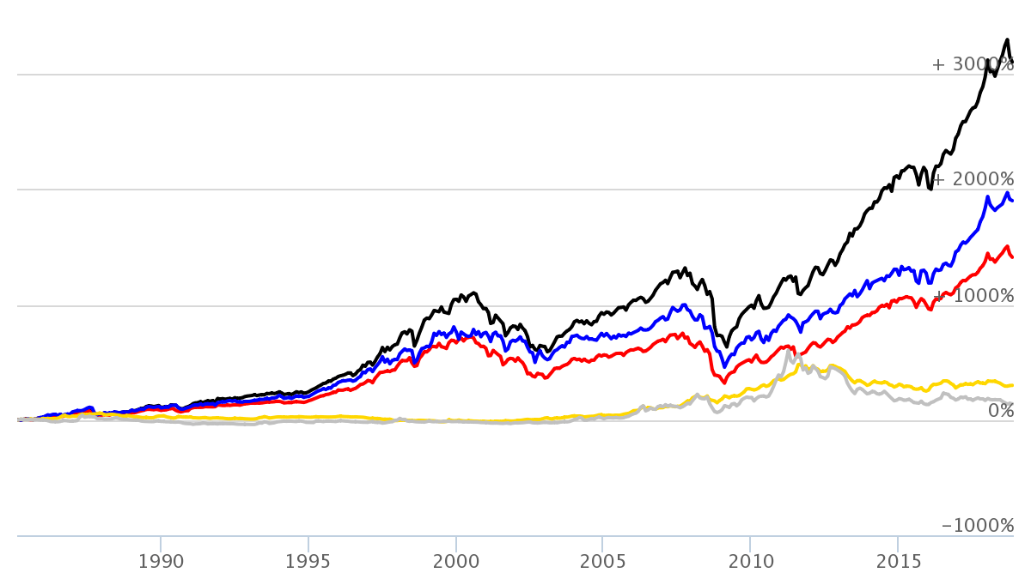⁴¹
From highest to lowest final percent return, we see the Wilshire Large-Cap, Dow Jones Industrial Average, S&P 500, Gold, and Silver.

This chart analyzes asset performance since 1985. Notice that in the 2008 subprime mortgage crash, metal prices rallied.⁴¹ In market downturns, investors tend to purchase safer assets like gold or bonds, whereas they buy riskier speculative investments in upturns.⁴² ⁴³ Buying gold futures contracts during the ‘08 crash would have yielded a great shorter-term gain, but this was also a terrific time to invest in stocks for the long-term. According to this data, gold increased around 91 percent at its peak from the time the stock market bottomed, while the ^DJI increased around 85 percent in the same time period.⁴¹ However, gold peaked and reversed in 2011 whereas the ^DJI keep increasing, now yielding around a 271 percent gain from the “buy-gold bottoms.”⁴¹ Note that silver increased 223 percent from the market bottom to its peaks, too.⁴¹ Silver has historically been much more volatile than gold.⁴⁴ In the short-term, you can most definitely outperform the market through futures contracts, but you should try to time them as informed, researched trades rather than long-term investments.

Many ETFs track commodity prices alongside other baskets of less traditional investments in well-diversified portfolios containing many underlying assets from across a niche market spectrum (we will talk more about diversification in Chapter 35).³⁹ You can use these tools to invest in commodities without going through contract hassles.

Here are more historical commodity performance examples comparing farmable, extractable, and precious commodities to the S&P 500, the most conservative of the three major US indices.
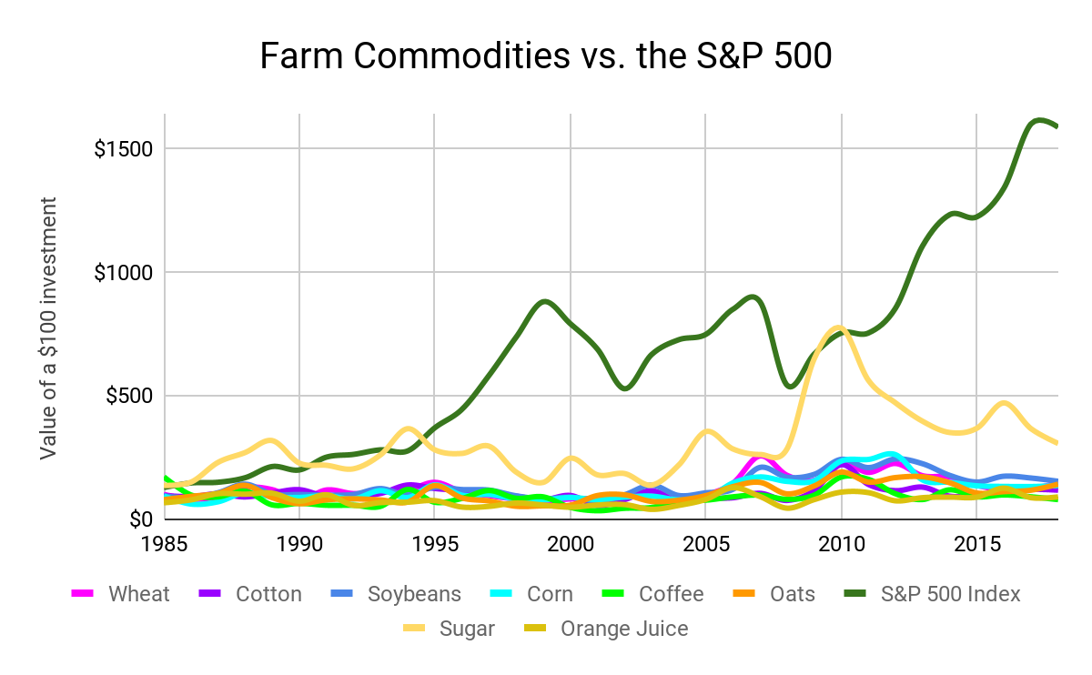
From highest to lowest final return, we see the S&P 500 ($1,584.49), Sugar ($304.75), Soybeans ($151.58), Wheat ($143.44), Oats ($139.82), Corn ($134.34), Cotton ($115.64), Orange Juice ($88.53), and Coffee ($77.52).
⁴⁵ ⁴⁶ ⁴⁷ ⁴⁸ ⁴⁹ ⁵⁰ ⁵¹ ⁵² ⁵³ ⁵⁴
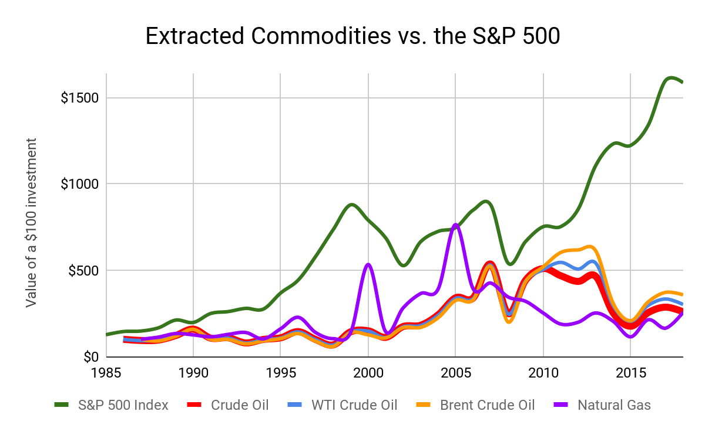
From highest to lowest final return, we see the S&P 500 ($1,584.49), Brent Crude Oil ($357.33), WTI Crude Oil ($301.32), Crude Oil ($258.78), and Natural Gas ($256.55).
⁴⁵ ⁵⁵ ⁵⁶ ⁵⁷ ⁵⁸ ⁵⁹
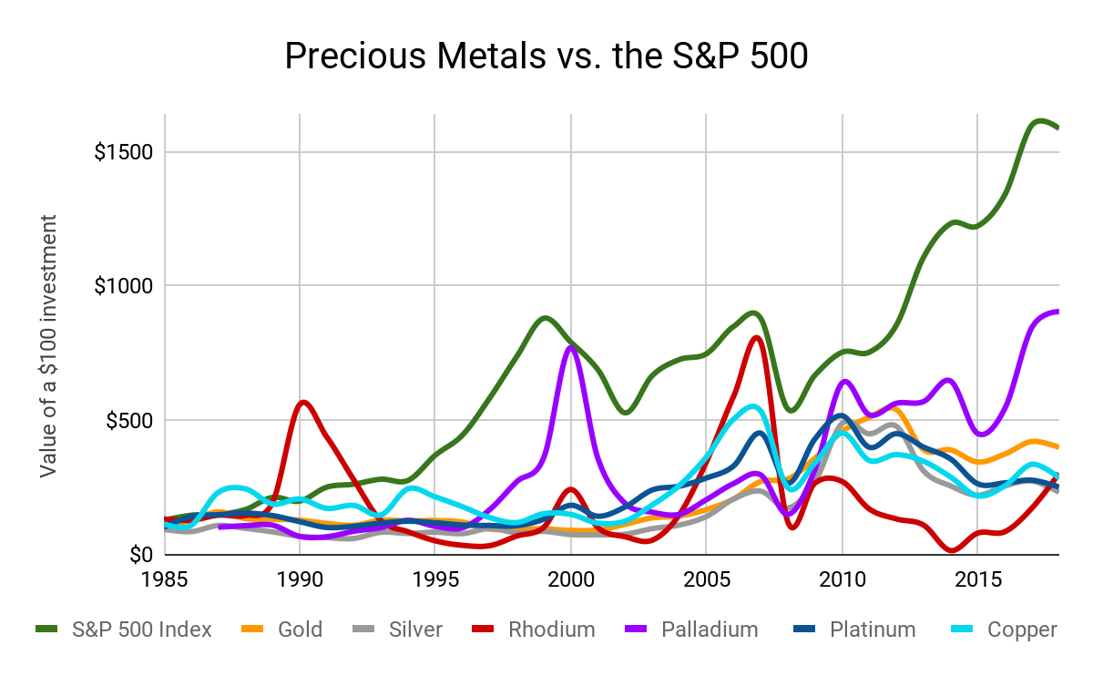
From highest to lowest final return, we see the S&P 500 ($1,584.49), Palladium ($249.93), Gold ($397.49), Rhodium ($300.73), Copper ($283.79), Platinum ($249.93), and Silver ($230.52).
⁴⁵ ⁶⁰ ⁶¹ ⁶² ⁶³ ⁶⁴ ⁶⁵

For a frame of reference in the above graphs, please note that $100 in 1985 has the same purchasing power as $239.70 today (2018).⁶⁶

You can significantly outperform the market with riskier commodity investments in the short-term, but all of these volatile commodities, many failing to even beat inflation, underperform the American powerhouse economy in the long-term. As markets keep growing and consumers keep spending, stocks continue to expand and create wealth for shareholders through dividends and capital gains. Equities are the true key to asset growth.
With commodities, remember that these investments reflect a price change due to supply and demand. A bar of gold will always be a simple bar of gold, whereas an index fund is made up of corporations built and run by people working every day to increase shareholder value. With this said, keep commodities in your trading repertoire. If you spend time searching for setups, you can most definitely find them. These positions, especially in a down market, are an excellent way to diversify your overall portfolio alongside traditional swing trades if you only want to put a medium amount of time into managing your assets (we’ll further explore diversification in Chapter 35).

Transitioning from commodities to currencies, we enter a 24-hour market that moves trillions of dollars every single day.⁶⁷ Currency, foreign exchange, or forex markets simply reflect changing political and social values in a country’s currency (ignoring cryptocurrencies). These exchanges are necessary to facilitate international travel and commerce, and they create highly-traded speculative markets that trade against innate currency inflation and deflation.

Because of their volatility, foreign currencies rarely act as reliable long-term investments. Rather, these outlooks alongside commodities are seen as safe havens for your cash in bad markets. Many take advantage of down markets and increased worldwide political tensions by swing trading foreign currencies.⁶⁸ By timing these markets, you can make great swing trades with minimal research, playing off instincts and worldwide news.⁶⁸
The daily percentage price movements in forex currencies are generally much lower than those of nine-to-noon stocks.³ You can use technical analysis to find winning positions in forex stocks just as you can with most stocks. However, percent returns in forex and some particularly volatile stocks generally pale in comparison to nine-to-noon gains. I compare currencies to actively-managed stocks because they are much more volatile investments than diversified stock portfolios, as shown below, and they therefore require more active monitoring.

To get an idea of the sideways currency exchange markets, let’s look at seven major currency trading pairs and the US Dollar Index, a measure of US Dollar value relative to a basket of foreign currencies, from 1990 to today:
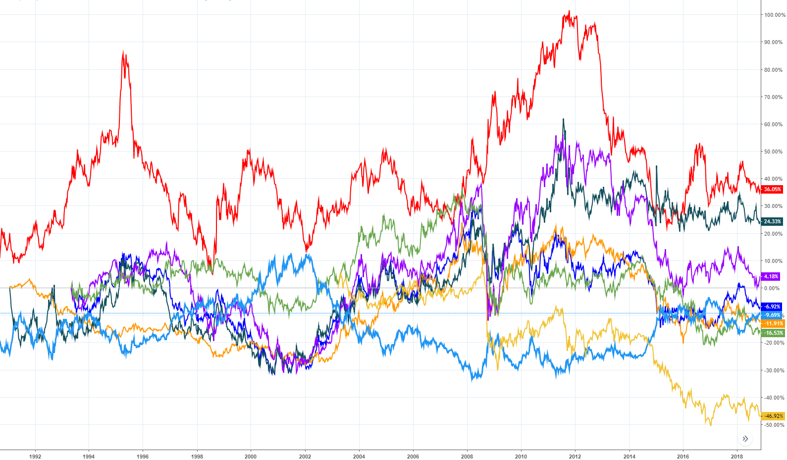⁶⁹
From highest to lowest final percent change, we see the Japanese Yen/US Dollar, Swiss Franc/US Dollar, Australian Dollar/US Dollar, Euro/US Dollar, US Dollar Index, Canadian Dollar/US Dollar, British Pound/US Dollar, and Mexican Peso/US Dollar.

In general, these markets move sideways particularly slowly compared to equity markets, especially due to economic-release slowdowns, holidays, seasonal factors, and overall currency indecision.⁷⁰ We see large movements in some currencies, but these are relatively small trades based on macroeconomic factors.⁶⁹ Though there is no clear-cut “better” investment vehicle for active trading, you’ll see significantly stronger, predictably timely setup in nine-to-noon stocks than forex.⁷¹ Nine-to-noon stocks may move hundreds of percentage points in a day, whereas foreign currencies may move a few percentage points in comparison.⁷² ⁷³ Keep forex in your mind as a swing-trading option like commodities, but focus on equities for asset accumulation.

For reference, here is the previous currency price data from 1990 compared to the S&P 500:
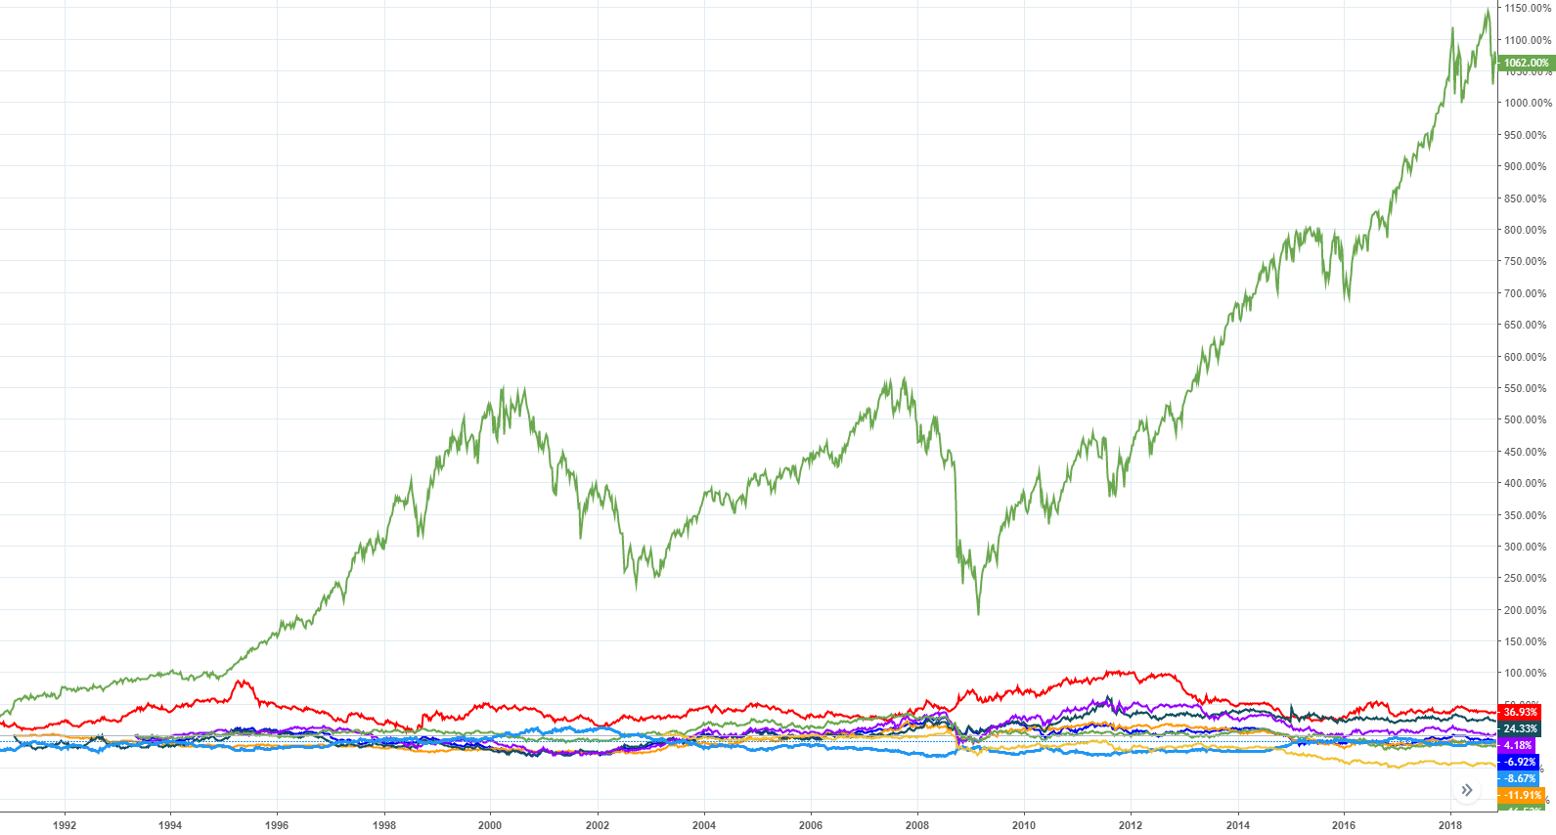⁶⁹

Chapter 19
Order Types

When you buy a stock, you send your broker an order. You should pick your order type carefully depending on how quickly and at what price you want your order fulfilled at. Additionally, you can use some orders types as trading utilities to strengthen your risk-management and technical-analysis skills.

Market Order
What you select:
Ticker
Buy/sell/short/cover
Number of shares
When the order executes:
Immediately at the market price (physical electronic signal travel times may slow your order down by a few microseconds).⁶
How the order executes:
You buy from the cheapest seller on the ask or
You sell to the cheapest buyer on the bid.
In practice, market orders work like less-predictable limit orders that execute more reliably in fast price changes, although you may buy or sell into a wider bid-ask spread.
¹
Limit Order
What you select:
Ticker
Buy/sell/short/cover
Number of shares
Price
When the order executes:
Send to market immediately. Filled as soon as someone buys or sells at your designated price or better.
How the order executes:
Once you submit your order with a specific price, it appears in the market’s bid or ask, market depth, level 2, etc. (as discussed earlier). You get “filled” once someone buys or sells to your open order which can be above or below the current market price. With most brokerages, your order will automatically be filled at cheaper prices than your limit-buy order (or sold at prices higher than your limit-sell order) if better prices are available in the market’s order book.
²
Market-If-Touched Order (Form of a Stop Order)
What you select:
Ticker
Buy/sell/short/cover
Number of shares
Trigger price
When the order executes:
When the last traded price hits your designated price level.
How the order executes:
In a buy order, you pick a level above the current price. When the stock hits this level, you market buy the specified number of shares. Similarly, you pick a level below the current price in a sell order. When the stock hits this level, you market buy the specified number of shares.
³
Stop Order
What you select:
Ticker
Buy/sell/short/cover
Number of shares
Trigger price
When the order executes:
When the last trading price hits your specified price level.
How the order executes:
These orders close out your current positions when a stock moves to a predetermined price. Once the last-traded price of a stock hits the price level that you specify, you sell or buy the given number of shares in an automated market order (to close a losing position and limit your losses).
⁴
Stop-Limit Order
What you select:
Ticker
Buy/sell/short/cover
Number of shares
Trigger price
Order price
When the order executes:
When the last trading price hits your specified price level.
How the order executes:
Your broker issues a limit order into the market only once the last sale price reaches your stop price. You can set your limit-buy or sell price to be higher or lower than your trigger price (which makes the order active when the market hits it) just in case the price moves quickly past your designated order price and you still want to get out of a losing trade. Your order will be filled at the best price your broker can find in the market relative to your execution price.¹³ You might see fast price movements, especially in nine-to-noon stocks, if you set your stop-loss at a support or resistance level (as we’ll explore in Chapter 24). Therefore, automatic stop-losses with price flexibility ensure that you get out of a failing trade before potential losses compound.
⁵
Trailing-Stop-Loss Order
What you select:
Ticker
Buy/sell/short/cover
Number of shares
Trailing amount
When the order executes:
When the last trading price hits your specified trailing price level.
How the order executes:
You set an initial stop-loss alongside a trailing amount. In a long trade, the stop-loss level increases according to the trailing amount. For example, you buy at $10 and set a stop at $9 with a $1 trailing stop. If prices increase to $13, then your stop-loss increases to $12. However, the stop-loss in a long-trade will never decrease after a new high is hit. Reverse this information for a short trade.
⁷
Conditional Orders
What you select:
Ticker
Buy/sell/short/cover
Number of shares
Conditions (the number of conditions and extent of such conditions depends on your broker)
When the order executes:
Once all of your conditions are met. These orders are a great way to ensure your swing trades execute exactly where you want even though you might not be able to actively monitor your positions.
How the order executes:
First, decide whether you want to buy or sell at market or at a specific price. Then, establish you conditions. Should your order only execute if the price falls to X support level? Perhaps you want to automatically sell half of your position at Y resistance level (we’ll explore supports and resistances in Chapter 24). Maybe you want prices to reach a certain level an hour after opening volatility fades. Perhaps you have a particularly large position and want to take profits off the table after prices increase 10 percent. Look at the conditional options your broker gives you and see if they fit with your trading style, allowing you to establish a setup and let your broker fill it when prices are just right.
⁸ ⁹ ¹⁰

Stop-losses set a maximum amount you can lose in a trade, acting as a terrific way to mitigate risk. You set a trigger price for either a market stop-loss or a stop-limit order. Once a stock trades at this price level, your order automatically enters the market. This speed is especially helpful when you want to quickly enter or exit a position.
In a stop-sell order, you can place your trigger price below the current price to limit your losses in case a long trade goes south. Similarly, you can place stop buy orders above the current market price to limit your losses in a short position.¹¹ You should set your stop price based either on your risk tolerance (aka. how much you are willing to lose on any given position in the short-term) or technical analysis. With trades based on technical analysis, try to set your stop-loss at a price that proves your trading setup or indicators invalid (we talk more about technical analysis in Part Two).¹² Your limit-sell stop-loss order should effectively close trades that are prime to lose you more cash, but they should also allow enough wiggle room for your position to continue longer-term movement despite brief pullbacks or run-ups.
Market stop-loss orders ensure that you liquidate a position in case the price action quickly moves past your stop level (i.e. critical supports and resistances in nine-to-noon trading).¹⁴ For long-term investing in more stable stocks, stop-limit orders generally work well enough for protecting profits or limiting losses and guarantee your closing price. In relatively non volatile stocks, try to wait a second or two in nine-to-noon trades or a few days in long-term investments to see if a stock will correct itself away from an extreme. We’ll talk more about price levels, supports, resistances, momentum indicators, and price bands that will help you with this technical analysis in Part Two.

In most scenarios, limit orders are the best way to enter and exit a position. Limit orders are the most consistent and reliable order type because you designate exactly where your trade executes. With this guarantee, you can always know how much you will pay for a position or make from its sale. Especially in illiquid markets with large bid-ask spreads, limit orders at the top of the bid or bottom of the ask can save you significant percentage points in your trades.
Shave percentage points off the cost basis of your trades and increase your long-term profitability by consistently buying with limit orders near the bid for a small discount or selling with limit orders near the ask for slight premium over market prices.

With that said, market orders can be extremely useful in nine-to-noon trading. When prices move quickly in fast-paced trades, you may not have enough time to enter a specific price before a stock shoots past it. In these scenarios, the increased execution speed provided by market orders can help you enter or exit extremely volatile positions. For instance, let’s say you find a very promising stock. This was a $4 stock yesterday, but the underlying company released stellar news last night and are about to open at $5.20. At 9:20, you look at key historical support and resistance levels and determine that this stock is a prone high-flier for the day since it just broke through its toughest historical support (we will talk more about supports and resistances in Chapter 24). The opening bell rings. The stock starts to skyrocket. Prices just keep ticking higher and higher within the first ten seconds of trading. Since prices don’t slow down long enough for you to calculate the number of shares you should buy and type in a price for those shares, a market order with an approximate number of shares can ensure you get skin in the stock before it soars too high. Still, use these orders sparingly as they can be unpredictable and set your orders back up to a few percentage points with some particularly poor fills.

For long-term investing, market-if-touched orders can be a great way to automatically purchase a stock if it significantly and quickly drops, whereas market-if-touched sell orders to lock in gains if a stock significantly and quickly rises. These orders are great to set at a price you think you would never get filled at unless a market panic quickly moved a price in one direction temporarily. For example, there was an extremely large, unnaturally-rapid, single-day selloff in the Invesco QQQ Trust on August 24, 2015, as shown below. With a market-if-touched order, you could instantly lock in a position as the market irrationally dropped without ever needing to constantly monitor the price level. As you might notice, this buying opportunity is further emphasized by this day’s extremely large red volume candle.

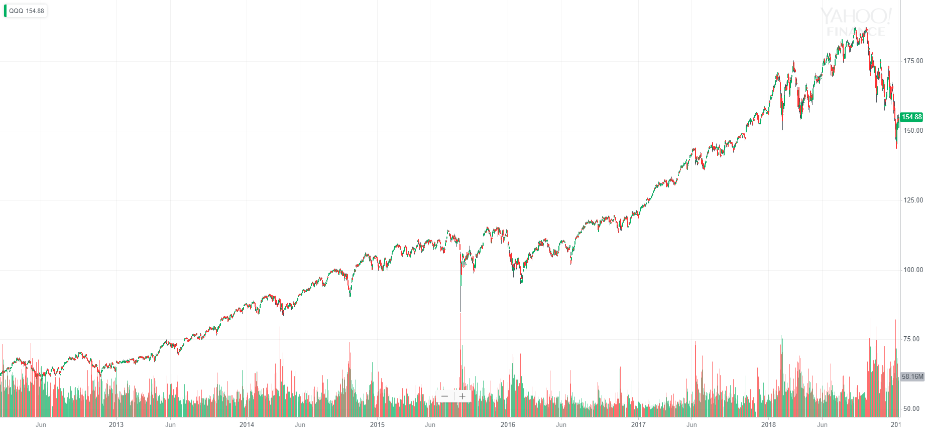¹⁵

You might not be watching $QQQ on this one day when the fund dropped 20 percent, so your automated order ensures you take part in the drop opportunity.¹⁵ Still, remember to check up on your long-term open orders periodically so that you don’t forget about an order wherein market sentiment on the underlying asset changed and it no longer makes sense to buy or sell where the market-if-touched order is set.

Chapter 20
Active Trader Status

If you trade nine-to-noon, then you can qualify for special tax treatment in futures, equities, and other asset markets that allows you to deduct many of your trading expenses that would otherwise go taxed.

The following specialty tax treatment does not apply to you if the IRS classifies you as an investor. You’re an investor if:
- Buy and sell securities,
- Expect dividend income or interest,
- Expect capital appreciation,
- Hold securities for personal investment (not for a business), and
- Hold most investments for a substantial period of time.¹

As an investor, you pay for your access to investment asset growth through the American stock market when you sell securities. Your capital gains and losses are reported on Form 1040, Schedule D alongside supplemental securities sales Form 8949.¹ Your taxable capital losses year simply subtracts from your taxable gains as you calculate your capital gains tax in any given year.
As an investor, you can deduct up to $3,000 of losses that exceed gains from your income ($1,500 if married filing separately, 2018).² If you still have excess losses after considering the wash sale rule discussed earlier, then you can carry your loss deduction indefinitely into future tax years.³ Brokerage commissions are included in your capital gains and losses as part of your price basis, and investment income isn’t subject to self-employment tax.¹

It’s very difficult to qualify as a trader unless you trade nine-to-noon.⁵ If you classify as an investor but still want to wiggle out of some capital gains taxes, don’t worry. We’ll get to entity formation in just a moment. With that said, let’s move onto active trader tax status.

You can qualify for this special treatment if you buy and sell securities for your own account and:
- Seek to profit from daily market volatility (not dividends, interest, or capital appreciation),
- Have substantial trading activity, and
- Carry on the activity with continuity and regularity.¹
If you can’t clearly decide if you qualify for this status, also consider:
- Typical holding periods for securities (shorter is better, but always give your trades time to work),
- The frequency of your trades (higher is better for diversification and maximum opportunities, but try to start with quality setups),
- The dollar amount of your trades (higher is better, but always stay within your risk tolerance),
- The extent to which you pursue the activity to produce income for a livelihood, and
- The amount of time you devote to the activity.¹

If you meet these qualifications, congratulations! You can now record your active gains and losses as a business. This preferred tax status stands independent of the markets you trade, so you can be an active trader in the stock market but only an investor in the futures market.¹ Keep detailed records with your broker separating your investor positions from your trader positions to minimize your taxes. You can easily isolate your nine-to-noon trading with a separate brokerage account from your long-term investments.¹

As an active trader, you get to report and deduct your necessary and ordinary business expenses alongside your trading income on Form 1040 supplement Schedule C, Profit or Loss From Business (Sole Proprietorship).¹ On top of that, you still do not have to pay self-employment taxes on your income. As an active trader, you can use your Schedule C to deduct the cost of:
- Trading software,
- Investment advice,
- Interest paid (e.g. margin interest which you will faithfully avoid),
- Bank fees,
- Equipment (e.g. computers, monitors, desks, bookshelves, etc. that you use more than 50 percent of the time for trading),
- Research tools,
- Educational content (e.g. books, seminars, etc.),
- Internet access,
- Market data fees,
- Startup costs (like this book!),
- Home-office costs (maximum 2018 home office deduction is $1,500 per year with the largest-deductible 300-square-foot home office⁸), and
- Any other trading-related business expense including transport costs, standard driving cost deductions, business meals, lodging, etc.⁶ ⁷

As a standard investor, you can’t deduct any of these expenses from your trading income outside of electing to itemize deductions. As we talked about earlier, you can deduct certain investment expenses on the Schedule A that exceed 2 percent of your adjusted gross income (Phasing out in 2018! See Chapter 8). With active trader status, you can directly deduct expenses and loses from your trading-business Schedule-C income.¹
Because all of your active-trader losses become ordinary loses from your business, you also need not worry about maximum yearly deductible losses. With that said, commissions are still considered part of your cost basis, but profits and losses are exempt from self-employment tax (social security tax and Medicare taxes).¹ ⁹

Alongside the benefit of deducting business expenses with Active Trader Status, you can file a section 475(f) election, the mark-to-market election.¹ This election applies to your mark-to-market status to both your personal investments and business active-trading income. With a mark-to-market election under section 475(f), you consider all of your positions closed on paper at the end of the year, and all of your capital gains and losses turn into ordinary income.¹⁰ You then pay taxes on all of your realized and unrealized gains that year in your return.
Mark-to-market accounting prevents you from deferring taxes and prolonging tax-free asset growth. With a section 475(f) election, you’ll have to pay out of your pocket for long-term unrealized gains. After you pay taxes on your open active-trader positions based on the last business-day closing price of held positions, the new tax basis for the underlying investments if the year-end fair market value.¹ You can only make the market-to-market election once, and it is almost impossible to unelect.¹

You might make a mark-to-market election as an active-trader-status individual if you want to:
- Bypass the wash-sale rule which will disallow long or short-term capital gain liability deductions from losses when you sell for a loss and buy the same stock or a “substantially identical” security back within 30 days of the sale or
- Deduct an unlimited amount of losses per year.¹
If you deduct a significant business loss, you can even carry your net operating loss back two years and forward twenty.¹⁰ This loss can also lower any other taxable income since the Schedule C return is part of your individual return.¹⁰

With that said, you will almost exclusively attain active trader status only when you trade nine-to-noon.¹⁸ Mark-to-market accounting might make more sense for you if you constantly trade the same stocks over and over. However, nine-to-noon stocks constantly change, and you rarely need to worry about the wash-sale rule because you’re always trading different premarket gainers (we’ll explore how to find these stocks in Chapter 36). Additionally, you trade actively to make money. If you consistently lose at the end of the year while actively pursuing your education, trading practice, and self-discipline, then you might not want to actively trade. Using the technical analysis techniques we’ll explore in Part Two, you’ll learn to be consistently profitable when actively trading, so you won’t need to worry about deducting over $3,000 per year in losses. If you fear a large market crash one year, weigh the cost of permanently paying taxes on unrealized active gains against the benefit of deducting an entire yearly loss rather than only $3,000 (2018 limit). We’ll look at using business entities soon to get around active-trader qualification stipulations.

As an investor, you report gains and losses on your Schedule D and Form 8949. As a trader, you report gains and losses on Form 4797 if and only if you make a mark-to-market election, securing your sales as ordinary gains and losses. (Not investment sales. A mark-to-market election protects your clearly separated long-term investments from active-tax status).¹
Individually, you have to claim mark-to-market accounting by the due date of your personal tax return (tax day) one year before the change takes effect by attaching a statement either to your income tax return or request for an extension of time to file your return.¹ This prevents individuals from claiming mark-to-market status immediately after a large loss. However, you can elect mark-to-market accounting immediately when you start a business.¹⁹
If you elect mark-to-market accounting, your business trading becomes ordinary income taxed on your return, after deductions, as income. However, this makes little difference thanks to the similarities between short-term-capital-gains taxes and income taxes, as shown below.
Short-Term Capital Gains Tax Rate (2018)
 | Single | Married Filing Jointly | Head of Household | Married Filing Separately
Rate | and income above...
10% | $0 | $0 | $0 | $0
12% | $9,525 | $19,050 | $13,600 | $9,525
22% | $38,700 | $77,400 | $51,800 | $38,700
24% | $82,500 | $165,000 | $82,500 | $82,500
32% | $157,500 | $315,000 | $157,500 | $157,500
35% | $200,000 | $400,000 | $200,000 | $200,000
37% | $500,000 | $600,000 | $500,000 | $600,000
¹¹
Income Tax Rate (2018)
 | Single | Married Filing Jointly | Head of Household | Married Filing Separately
Rate | and income above...
10% | $0 | $0 | $0 | $0
12% | $9,525 | $19,050 | $13,600 | $9,525
22% | $38,700 | $77,400 | $51,800 | $38,700
24% | $82,500 | $165,000 | $82,500 | $82,500
32% | $157,500 | $315,000 | $157,500 | $157,500
35% | $200,000 | $400,000 | $200,000 | $200,000
37% | $500,000 | $600,000 | $500,000 | $300,000
¹²
(notice that they are the exact same, so you end up paying the same tax rate, but you can deduct all ordinary and necessary business expenses)
If you elect to use mark-to-market accounting as an individual or business, you must also file Form 3115 with your timely notice. Your timely notice must state:
- That you are making an election under section 475(f),
- The first tax year for which the election is effective, and
- The trade or business for which you're making the election (make sure you explicitly separate investments from trades. You’ll essentially only get approval if you consistently trade nine-to-noon).¹
However, do not file Form 3115 at the same time you make a mark-to-market election. Rather, file Form 3115 to change your method of accounting for securities when you file your first year’s tax return using mark-to-market accounting, as specified in your previous notice.
Like we said earlier, you can try to stop using mark-to-market accounting for securities by filing an automatic request for revocation under Revenue Procedure 2017-30, Section 23.02 by the original due date of your return, but these requests are usually denied.¹
One last special tax trick you can pull as an active trader is claiming a Section 179 deduction and writing off up to $1,000,000 a year for equipment used in trading activities (rather than amortizing or depreciating the equipment along a curve like the Modified Accelerated Cost Recovery System) (though you cannot force your trading business into a loss) (2018).¹⁴
Active trader status creates an individual sole-proprietorship under which you trade (though you don’t pay self-employment taxes). If your trading gets especially serious, you might want to protect your assets and further reduce your tax bill by creating an actual trading business entity that you “work at.” This way, the assets your manage aren’t actually yours if someone sues you.
By creating a Limited Liability Company or Corporation, you can avoid the hassle of qualifying as an active trader.¹⁵ You can always deduct business expenses as a separate entity. Additionally, you can dissolve your entity at any time, perhaps to stop using mark-to-market accounting for your trades.¹⁵ If you want to use mark-to-market, you can start using the accounting when you form your business rather than waiting a year since it's just another form of business accounting.¹⁰
LLCs have flexible tax structures, so you can treat the entity as a sole-proprietorship, partnership, S corporation, or C corporation. Corporations simply stand as the two latter options. LLCs formed under the former three classifications can qualify for the 20 percent Qualified Business Income Deduction if you meet the income limitations under Provision 11011 Section 199A of the Tax Cuts and Jobs Act.¹⁷ This directly lowers the amount of taxable income you report since you operate a specified trade or business in investment management and trading.¹⁷
However, as an S corporation or C corporation, you will have to pay yourself reasonable pay from the business which is subject to payroll taxes. However, you can take a K-1 distribution of profits from an S corporation that counts as income exclusively, bypassing social security and Medicare taxes. With a C corporation, you can take dividends from your company.
Remember that you can also hire your family as “employees” of your corporation. With this strategy, you can use your increase flexibility in accounting to fund your children’s colleges with tax-free profits, cover deductible medical expenses, and distribute money to your family with pre-tax dollars through many other accounting tricks like ERISA pension funds and newfound 401(a) Plans.¹⁵
One final tax strategy involves combining LLCs and corporations. While maintaining limited liability and separate assets, you can charge a C-Corporation royalty to the underlying LLC as a business expense.¹⁶ The combination structure is used in very limited circumstances to utilize the advantages of each type of business.¹⁶
Consider opening a business entity for your significant active trading. Consider whether a 20 percent qualified business income deduction makes more sense than the added accounting and business-expense flexibility of a corporation or LLC taxed as a corporation. S-corporation distributions in particular help you take cash out of your trading after deducting any business expense you can conjure up.

Chapter 21
Options

Options give you the right but not the obligation to buy or sell an underlying security. You pay an “option premium” for the right to trade an asset at a previously agreed upon price by a specified date.¹ You can use options to hedge against risk when you own an underlying position or trade calls and puts independently for potential profits. Calls and puts simply stand as buy or sell options traded similarly to futures contracts.
Call options give you the right to purchase an underlying asset by a specified date at the strike price. When you buy calls or puts, your initial investment is nonrefundable. An option premium will cost more if the strike price is closer to the spot price.³ You will also pay more for options with later expiration dates since the underlying asset has more time to reach the strike price. Lastly, the cost to buy an option may increase as the volatility of the underlying asset increases.³
Put options give you the right to sell an underlying asset by a specified date at the strike price. Calls (buy) and puts (sell) are executed only when you tell your broker to execute a trade. There is often an exchange fee to exercise an option, but the only other cost in options trading is the premium price.⁴ You can control an underlying asset to a limited extent without actually owning it.
When you execute a call option, you want to buy the asset once prices rise above the spot price so you can sell them for higher prices in the open market. When you execute a put option, you want to sell the asset at the spot price when you can buy the asset at a lower market value.²
When purchasing a stock option, you pay a premium to control the right to buy or sell an underlying stock during the contract period. By default, stock options encompass 100 shares of any given company.¹ Some other option types include ETF options, index options, and options on futures.¹⁴ By paying an option premium, the most you risk on your bet about the underlying stock is the premium price. In a call, your options contract expires worthless if the price never reaches above the spot price. In a put, your contract expires worthless if the price never drops below the spot price.¹ Options are leveraged instruments that offer amplified gains.¹⁷ You risk absolutely everything you bet when you buy an options contract.

We’ll look at trading options alone soon, but first, let’s explore how you can use them to protect unrealized gains and draw cash flow out of existing investments.
A covered call strategy assumes you own a stock for a long-term investment. If you are confident about the underlying company, but you don’t think the stock will rise much in the short term, you can sell a call option to the marketplace at a strike price around 10 or 15 percent above the current stock price (whatever price seems reasonable and unlikely to occur to you).⁵ Since someone will pay you a premium to buy the call option you sell, you can generate cash from your long-term positions as long as you correctly predict price movements.
The best-case scenario in a covered call is that your stock stays flat. Here, your underlying position loses no value, and you get to keep the premium from the unexercised option. If the stock price falls, the premium paid for the call option acts as a hedge that pays you for some of the losses in your underlying stock. In both of these scenarios, you make extra cash flow by taking on the risk to sell a call option to the marketplace. By using technical analysis (which we’ll explore in Part Two), you can minimize this risk.
In a worst-case covered-call scenario, the stock price increases above the strike price. The option buyer exercises call option when they see fit before the expiration date to make a profit while you miss out on gains above the strike price (option exercise time frame depends on option types; we’ll look at different types soon). So, you still profit from the stock run-up and options premium, but you have to sell your shares under market value to the option buyer who purchased the right to purchase the shares at the strike price.⁵

You can also use a protective put to protect your long holdings against downturns.⁶ If you think prices will increase, you can protect against an unlucky short-term downtrend through a put option while still owning the stock. So, you’ll still be able to reap rewards if your stock appreciates or pays dividends, but you’ll also have a guaranteed selling price at the option strike price if the market turns down. You’ll pay an option premium no matter how the stock moves, presumably out of existing profits. If the stock goes up as you intend, then your option will go unexecuted and you’ll only lose the premium paid from your newfound profits.⁶

This limits your maximum loss to the strike price you are guaranteed to sell at in the given time frame since you can execute your option if prices tumble.
Remember the two types of options as you trade covered calls, protective puts, and standalone options: American and European. American options can be executed at any time before the expiration date, whereas European options cannot be executed until the expiration date.² American options give you the most trading flexibility, and your broker will usually execute your options for you on expiration date if the contract is in the money.² Most options are traded before expiration to obtain optimal profits.¹⁶
Here are two charts to show your potential upside and downside with a covered call and protective put, assuming either option has underlying long holdings:
Sell call at A: 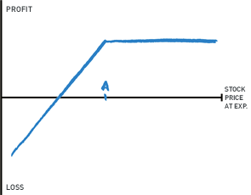²²
This covered call forces you to sell your shares for a profit if prices increase, but you also get cash from the marketplace for incurring this risk.
Buy put at A: 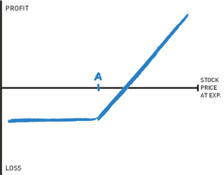²³
This protective put limits your downside, but you need not worry about actually exiting your position if prices do decrease. Rather, you can execute your option when market timing optimizes your profits while you decide whether or not to continue holding the underlying stock for the long term.

Here’s an example of a live option chain for Facebook, Inc. expiring on December 28, 2018. Notice that puts and calls in the money are emphasized in blue. The puts shown are live options contracts to sell $FB while calls are simply options to buy the stock.

Top of chain: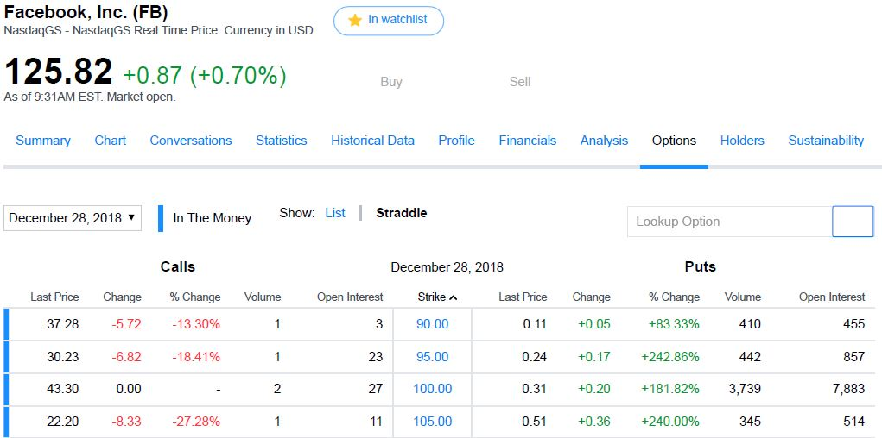²⁰

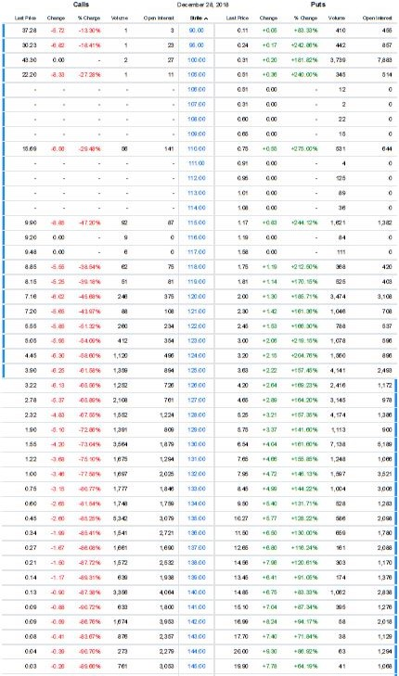²⁰
This chain shows open trades for the December 28, 2018 expiration date for $FB. The “last price” represents how much you would pay per share for the given option premium at market (or how much you can sell your contract for to take early profits). Because each contract represents 100 shares, the total options premium for one lot is where the last price represents the last premium paid to a contract seller at a given strike price and expiration date. Given the last prices from the option chain, a $130 $FB call (buy) would cost while a $120 $FB put (sell) would cost (all contracts expiring December 28, 2018). If you bought a call and $FB increased to say $140 in say a one month contract, you would profit . Inversely, if you bought the put and $FB decreased to $110 in a one month contract, you would profit given the above market prices shown in the option chain. Note that disproportionate put and call premiums may indicate market sentiment towards a stock as you pay more to bet in one “favorable” direction. However, try to go against the masses and blaze your own path, as the majority (except for overall index performance) is often wrong.
The “open interest” represents the number of open contracts at any given strike price.²¹ As you near the spot price, open interest and subsequent liquidity generally increase, but this volume still dwindles compared to actual stock trading volume. Because of this, options generally have much higher spreads than their underlying stock when you try to exit a position before expiration by purchasing a contract to cancel out your position (just as with closing futures contracts before expiration).²¹ Look for high open interest to maximize liquidity, especially as you trade options on lower-volume, volatile stocks.

With your broker and subsequent options exchange, you’ll trade options using the following code pattern, similar to futures contracts:
²¹
where

(usually the stock ticker if it fits; simply look up an asset to find its symbol if its ticker is over three letters)²¹
and monthly call codes are:
Jan | Feb | Mar | Apr | May | Jun | Jul | Aug | Sep | Oct | Nov | Dec
A | B | C | D | E | F | G | H | I | J | K | L
²¹
while monthly put codes are:
Jan | Feb | Mar | Apr | May | Jun | Jul | Aug | Sep | Oct | Nov | Dec
M | N | O | P | Q | R | S | T | U | V | W | X
(expiration occurs on the third Friday of the given month)²¹

So, our Facebook, Inc. example contract order would look like:
- FBX[price] (put) or
- FBL[price] (call)

Monthly or yearly trading is the most common options time frame for swing and long-term trades since this gives the underlying asset ample time to reach the strike price.¹⁵ There are shorter, more-active time frames, but commonplace stock trades often offer more convenience over daily or weekly options due to faster execution at exact prices (options can only be bought or sold along standardized price intervals based on the spot price of the underlying asset).¹⁵
Price codes differ from security to security based on the asset’s price interval and how your broker routes the order. Look at your brokers platform and see how they handle order entry and execution. Often, you can simply enter a strike price to trade at along a secondary-market spread.²⁶

Since naming schemes and order entry can often seem confusing, many option chains display simplified order metrics. For our Facebook, Inc. example, Yahoo Finance simply displays a $130-strike-price call option expiring on January 25, 2019 as
FB 19 01 25 C 00 130 000
(spaces added).²⁰ This naming makes it easier to analyze the current market, streamlining your research to help you make better investment decisions.

Remember that option premium prices come from two factors: time value and inherent value. The total premium cost to buy an option, also the price you can sell your options at, combines these two as shown below:
¹⁹
Inherent value comes from the difference between the strike price and spot price. If an option is out-of-the-money, its inherent value is $0, and the entire premium cost is time value. If an option is in-the-money, simply calculate its value compared to the spot price (e.g. one $122 put contract for a $120 stock is worth $200 minus premium paid). The remaining market value of the premium is the option’s time value. Time value decreases as an option nears expiration according to the following graph, as there is less time for the stock to reach the strike price.
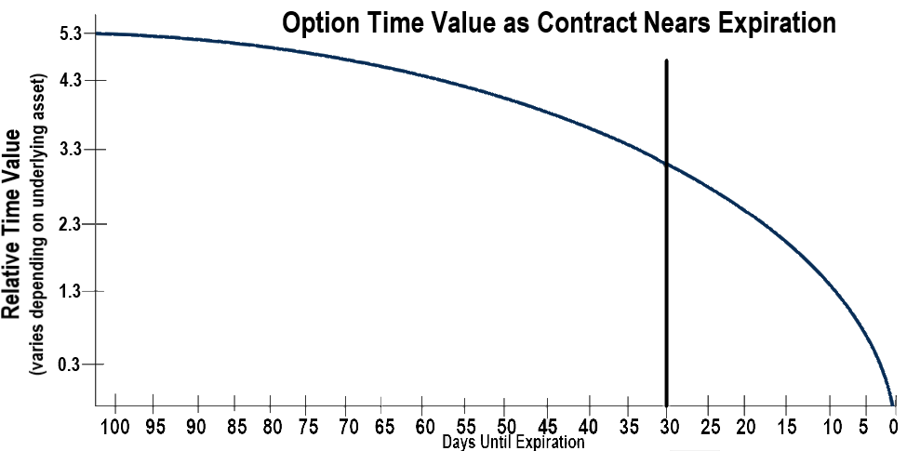¹⁸ ²⁸
So, option value decays as prices stay the same while nearing expiration. Additionally, higher implied volatility increases relative time value since a stock can deviate more towards a strike price.²⁶

Your broker usually requires you to have a margin account to trade options.⁴ A margin account will also help you trade stocks more efficiently by bypassing the clearing business days during which your transactions settle and you cannot trade with cash proceeds. Once you can trade puts and calls alone, you can use them to generate high returns since each contract controls 100 shares. Any small price movement multiplied by hundreds of shares brings high potential profits with with high risk since you lose the entire premium if your option expires out-of-the-money. The only strategy with puts and calls alone is to use technical analysis to predict where a stock price will move. With that said, let’s explore some complex option trades that lower risk or generate cash flow with costlier setups.

In a strangle, you buy a call and put option with different strike prices slightly away from the current price (out of the money).⁷ This strategy makes money when there is a large move in the underlying stock in either direction, as shown by the chart below.
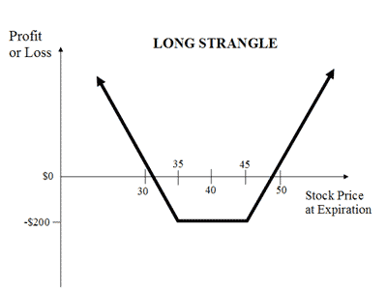⁸
In this case, you will only lose in this trade if prices trail sideways until expiration date as long as your strike prices are close to the spot price. This trade also exposes you to profit from both sides of price movement while paying only an option premium, a great strategy for volatile stocks or perhaps more established companies with highly-tensioned earnings reports.

In a straddle, you buy a put and a call at the same strike price very close to the current price (at the money).⁹ This strategy costs more to execute since options near the spot price tend to be more expensive, but it also gives you a better profit guarantee as long as the price moves in any direction enough to cover the premiums paid, as shown in the chart below.
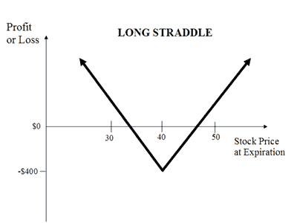¹⁰
If you’re clueless about where an asset might go, say perhaps a difficult-to-time market-tracking index fund, then strangles and straddles can help you profit off underlying volatility with defined risk (maximum loss is net premiums plus net commissions paid, which only occurs when the spot price expires at the strike price).¹⁰

In an iron condor, you buy two options and sell two more in hopes that a stock will remain stable. As long as the stock doesn’t move to the strike prices of the options you sell, you can leave your purchased options unused and keep the premiums from the options you sold.¹¹ If prices do pass an option you sell, the two you bought will limit your downside. So, for a $20 stock, you can:
- Buy a put at $10, (sets maximum loss if prices decrease)
- Sell a put at $15, (generates cash)
- Sell a call at $25, (generates cash) and
- Buy a call at $30. (sets maximum loss if prices increase)
**(all trades at same expiration date)
If a stock is especially volatile, you can sell your two options further apart from the spot price at a cheaper premium to decrease the risk that prices hit your strike price. However, try to keep the differences between your two calls and two puts the same to minimize overall risk and create the following potential profit chart:¹¹
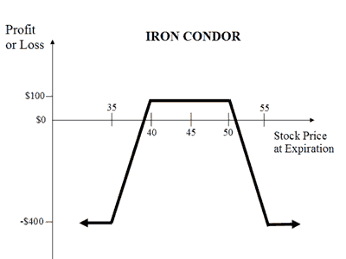¹²
To increase upside and risk, you can refrain from buying the put and call as moderately-costly insurance policies. By only selling a put at A and selling a call at B, you get the following profit chart:
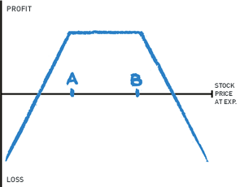²⁵
Since the iron condor requires four trades, try utilizing a low-commission broker, as we’ll explore in Chapter 37. Note that, since your profit comes from the options you sell, you’ll usually have to wait until expiration to keep the money you collect, and any variation outside of your price range before the expiration date could quickly create a loss.

In a butterfly spread, you also use four options to bet that prices will remain stable. For example, in butterfly spread for a $40 stock, you can:
- Buy an in-the-money call at $30, (builds a capital base for the setup)
- Sell two calls at $40, (generate cash) and
- Buy one call at $50. (sets maximum loss if price increases)¹³
**(all trades at same expiration date)
With this strategy, you’ll reach peak profitability when the options sold expire at the price you sold them at, a price above the in-the-money call you bought and can now sell. This profit chart is shown below. Note that the in-the-money call loses some of its value over the trading period, say one month, since the value of an option depends on how much time it has until expiration, as we talked about earlier.
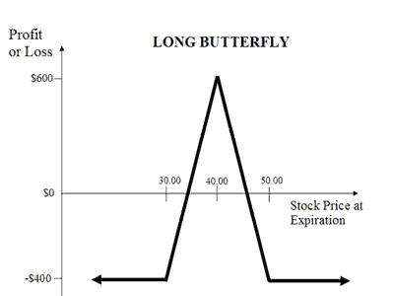¹⁴
As with the rest of these multi-leg setups, your maximum loss comes from the option premiums you pay. The low profitability area of this setup in particular makes it risky but rewarding when you are confident about future price action and balance the position well into your overall portfolio through diversification, which we’ll explore in Chapter 35.
Alternatively, you can sell a call and a put at strike price A to form the following chart without downside protection if you’re certain prices will remain flat. These strategies work best when the option chain shows low implied volatility, a measurement you can also find from Bollinger Bands (which we’ll explore in Chapter 32).
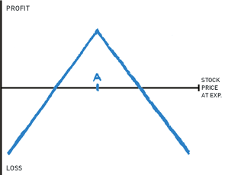²⁴

There are over fifty or so combinations of call and put option patterns used by active traders.²⁷ We’ve gone through the most unique strategies that apply in specific options-only scenarios. Many other strategies simply mimic positions that you can take with a simple stock order. While options provide leverages returns, actual stock trading will keep your gains consistent and predictable in the long run. Nonetheless, consider options as part of your overall trading strategy for swing trading and long-term investing.

Chapter 22
Bonds & Interest Rates

Before we get to technical analysis of stocks, let’s finalize bonds. Although they offer lower returns, bonds are terrific diversification tools that secure your portfolio as you approach retirement or a savings deadline, and they offer much better returns than cash equivalents. You can use bonds to:
- Grow your money with very little energy or management,
- Protect yourself from passive losses in the stock market that you may not have enough time left to let go back up after an index downturn,
- Guaranteed investment income levels rather than relying on changing stock dividends if you need spendable investment income, and
- Supplement your portfolio as you first start investing in stocks to protect against a few failed trades.

To better understand bond uses, let’s look at the return of $100 in 1927 before the Wall Street Crash of 1929 invested in the S&P 500, a virtually risk-free 10-year Treasury bond, and a mixed weighting of both. As we talked about earlier, Treasury bonds are guaranteed by the full force of the US government and buyable through TreasuryDirect.

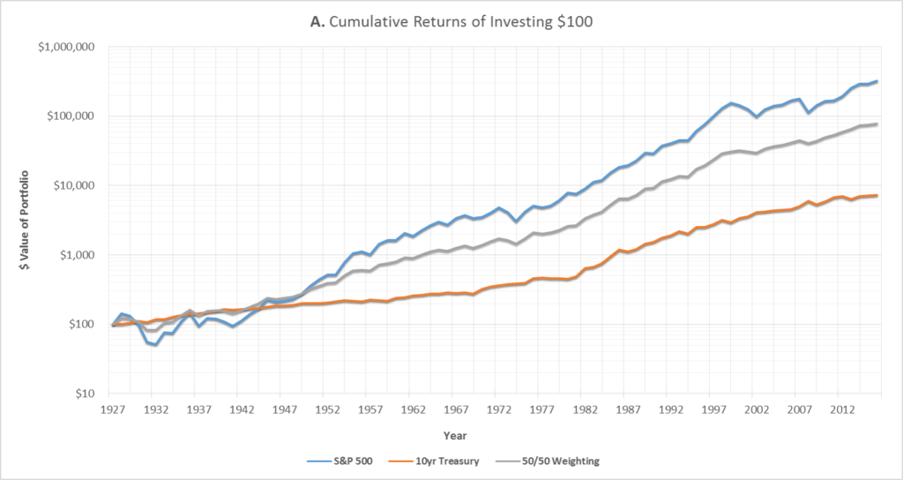¹

Notice that your money in the first decade or two dropped as the overall stock market fell. However, also remember that you can continue to purchase shares as the market falls in monthly intervals as you accumulate investable income, thereby decreasing your average order fulfillment price and increasing long-term profits. This principle is especially true for broad market indices that account for price movements of many stocks.
So, why invest in bonds? Notice that the equally weighted treasury-stock portfolio lost significantly less cash in the early market pullback. If you are planning to send your kid to college in the coming years, then this pullback could be detrimental to their college fund, whereas a portfolio with bonds retains most of the capital through the pullback. Similarly, say that you were retiring in 1930. With a market crash, you may not have 20 years to wait for the market to come back up. By weighing your portfolio in bonds, you limit your downside and protect your retirement money in its final stretch.
Now, in the long-term, the S&P 500 significantly outperformed the bond and stock portfolio. When you have the luxury of time to invest, stock with higher-yielding stock indices, and supplement your gains with active trading to outperform the market when you find the time and opportunities. S&P dividends alone often rival some bond portfolios.

Once you start investing in bonds, consider expiration dates, credit ratings, and bond yields. Remember to follow diversification principles just as with stocks so that one single loss in the bond market will not greatly affect your overall portfolio (we talk about diversification in Chapter 35).
With traditional bonds, you lock your cash up with an entity for a predetermined amount of time. Then, you get paid (usually) biannual coupons that return a percentage of the money you lent the entity. This happens over and over until you get to the expiration date specified in the bond. At last, you can receive your last interest payment depending on the time phrase, and the borrowing entity returns your full initial investment. This investment, no matter how long the bond lasted, will be in the current dollars, so it will be affected by inflation just like your regular coupon payments. You pay investment interest income tax on your coupon payments, but pay no taxes when your initial investment is finally returned.²
An alternative, lesser-used type of bond is a “zero-coupon” bond. In traditional bonds, you pay the “face value” of a bond, and you make your money off the coupon payments since you are paid back the face value at the expiration date. In a zero-coupon bond, you pay less than the face value of a bond, essentially buying it at a discount.³ As you near the expiration date of the bond, its value theoretically increases since you receive a face-value payout at the end. However, zero-coupon bonds pay no coupons. So, you can get the same bond-like return from this bond without actually receiving biannual bond payments. As for taxes, you must pay interest income taxes on the theoretical annual increase of the zero-coupon bond even though you received no cash from the borrowing company.³ The amount you pay for a zero-coupon bond can be found using:
Price = Maturity value / (1 + one-half annual yield)twice number of years until maturity ⁴
So, a $1,000 zero-coupon bond that matures in three years and yields 10 percent annually will cost:
$1,000 / (1 + .05)⁶ = $746.22 ⁴
For this bond, you would pay investment interest income on the 10 percent yearly increase in the theoretical value of the bond. We’ll talk more about why you might want to use zero-coupon bonds soon. Note that corporate interest income (not dividend) is included in your gross income, and is therefore taxed at your income tax bracket.⁵

As of writing this book, the bond-market credit-rating system is fairly centralized. The Big Three credit rating agencies, Standard & Poor’s, Moody’s, and Fitch Group, collectively control around 95 percent of the global credit-rating market. Because of this oligopoly-controlled market, credit ratings from these companies should be taken very seriously when considering a bond.
The three corporations use the following rating systems, going from best to worst corporate creditworthiness:
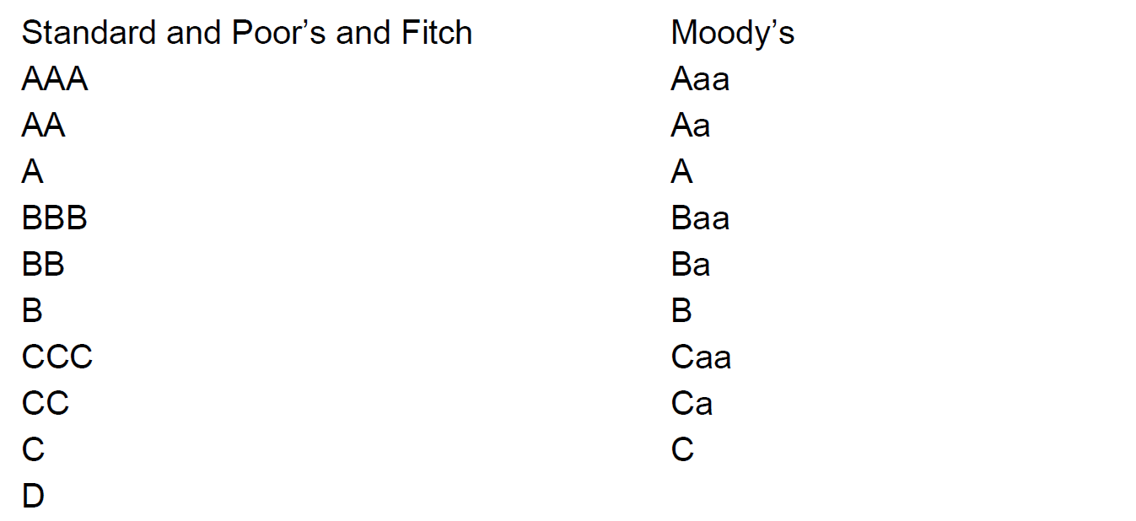⁶

Numbers and symbols are also added to further classify bond ratings. Standard and Poor's and Fitch use plus and minus signs (e.g. A+ is better than A or A-), and Moody's uses numbers where Baa1 is the best Baa rating followed by Baa2 and Baa3.⁶
You can use credit ratings as one factor when you consider how likely a lender is to default on you. Remember, bonds are simply debt instruments wherein you lend money to a company that promises to pay you back your initial capital plus interest. Corporate obligations to bondholders, generally made twice a year, are paid before any cash is distributed to shareholders. The only way you can lose money directly with a bond is for the underlying company, organization, municipality, or government to default on its debt and stop paying you (i.e. go bankrupt). Credit ratings are a professional organizations opinion on how likely a borrower is to go bankrupt on you.
Since most high-returning bonds are corporate bonds, we will focus on these for creating bond income. This isn’t to say that you should avoid municipal or government bonds. Jump at good opportunities to get a high return in either of these bond categories and you are in the market for bonds and the borrower is in good standing. However, most municipalities and government offer lower returns because they often guarantee their bonds with the full force of the underlying government. Corporate bonds, on the other hand, carry greater yet still small default risk, therefore offering higher returns in the form of bond yields.
According to the Big Three, investment-grade bonds are rated at least BBB- or Baa3. Anything lower than these credit ratings are “junk bonds” that will pay much more to borrow money from investors because they carry higher default risk.⁷ Investment-grade bonds are more qualified to borrow thanks to their ratings, but you should still perform basic corporate financial analysis before lending to a company. Ask yourself:
- Does this company have more assets than liabilities?
- Does this company bring in enough cash to pay its debts?
  - Look for companies the bring in 4 times their interest payments to be safe
  - Any income under 2.5 times interest payments can be risky
- Can the company sell assets to pay its debts in a business downturn?
- How established is this company?
Simply put, make sure the company you lend to can pay you back with interest. Try to find a good balance between highly-rated but low-yielding companies and poorly-rated by higher-yielding ones. You want to exceed average bond returns without taking on too much default risk. Feel free to invest in a “junk bond” to get a higher return if you find a company with great financial records or perhaps one you know of. Just remember to keep your positions diversified in case of default (see Chapter 35). Credit ratings and financials are both great, but you ultimately just want to get the highest possible return without too much default risk. If you’re investing in bonds near the end of a stock-market cycle (as shown through high chartable performances, abnormally positive public stock expectations, and inverted yield curves), try to buy bonds in more highly-rated companies, as a recession can bankrupt less-established companies that can no longer service their debts by selling assets, liquidating inventory, etc. (we’ll talk about inverted yield curves soon). Likewise, you may be able to get away with a few very-high-return bonds in a booming economy. Just remember that you are looking for bond returns with bonds and specifically bond funds, which we’ll explore soon alongside buying bonds at a discount in search of extraordinary individualized gains.

Corporate bond yields depend on the risk associated with the underlying company and macroeconomic factors. Since yields constantly change, your locked-in rate could be great one month and poor the next depending on the bond market.
This book was written in a low-interest-rate environment. In the many years before this book such as the 1927 to 2000s example earlier, federal Treasury bond interest rates peaked at 15 percent while inflation rates peaked between 10 and 20 percent in many years due to political and worldwide economic tensions.⁸ Values and rates for all bonds depend directly on the federal Treasury interest rates because the US government borrows so much money. Periodically check the Treasury bond rates when you invest in bonds even if you are only invested in higher-yielding corporate bonds or perhaps a corporate-bond fund, as the Treasury’s increasing or decreasing rates affect the entire bond market. Additionally, higher rates can fuel a growing stock market, emphasizing that you ought never completely leave the equities market even when you approach a savings goal or retirement (see Chapter 35). Even in market crashes, corporate bond default rates increase as companies fail. If you don’t have time to wait for the market to correct, bonds provide a cushion of promised income and priority payments in any corporate liquidation.

With that said, try not to focus too much of your portfolio in bonds, if any, before closing in on your retirement or a savings-goal deadline if possible (unless you actively manage your bond positions, which we’ll explore soon). You can outperform the bond market by keeping logical positions in the market and not marking rash selling decisions after rapid downturns when you know that the underlying companies you invest in are valuable. Additionally, bond rates tend to drastically increase in crashes, making existing bonds less appealing to new bond investors who can access higher lending rates. This “interest-rate risk” affects all bonds as the rate corporations will pay for bonds slowly changes. To mitigate this risk, let’s run through a quick example.
Let’s say you are 66 and you just retired! You know you will live a long and prosperous life, so you decide to leave most of your assets in stocks to appreciate and pay you dividends. As the market moves extremely high one year, you decide to start taking gains and rebalancing your portfolio into bonds. You do not want to take too much money out of the outperforming stock market, but you want to protect yourself in case of a downturn while also earning a modest return over inflation. Say you put 20 percent of your portfolio in bonds. As you grow older, you may spend part of your overall portfolio during retirement and move into more, safer bonds. 30 percent one year. 37 another. Maybe you get to 45 as markets rally. The percent you allocate into bonds depends on how you see the overall market. If you have made significant gains, it might make sense for you to take a little money off the table if you see limited upside in the coming years. Try to make planned, logical decisions (hopefully based on technical analysis) about when to sell some of your individual stock positions. For reference, it took around 3-5 years for the S&P to recover from the 2008 housing bubble, 7 years to recover from the dot-com bubble highs, and 2 years to recover from the stock market crash of 1987.⁹ However, much larger depressionary movements crippled the Dow for over two decades in the crash and subsequent depression of 1929.¹⁰ Analyze the general economic condition around you when approaching your deadlines to determine how much of your portfolio should be in bonds. If you are comfortable leaving, cash in the market for the next decade, then you might not even need bonds. By further using the technical analysis in Part Two, you can reveal timely opportunities to avoid and adapt to temporary market pullbacks. Everything comes down to your risk tolerance.

Besides the basic percent return guaranteed by government bonds, consider the Treasury’s “yield curve” to analyze potential future macroeconomic market movements. Here are the three yield curves you may see. Since you primarily use bonds to protect your money as you near the end of retirement savings or a savings goal rather than long-term investments, you can usually just focus on shorter-term interest rates to predict how they will affect your corporate bonds. However, as we said earlier, these yield curves reflect overall market conditions and can act as influential indicators in the stock market since they represent the percent return the government guarantees depending on how long you loan out your money.

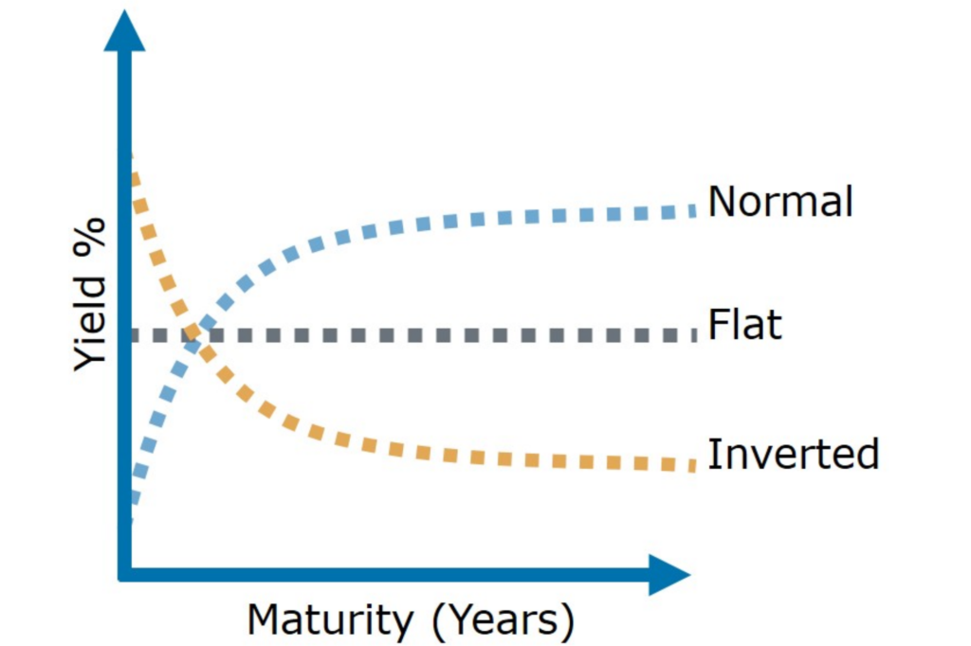¹¹

In a normal yield curve, you get paid the most for locking your money up with the Treasury for longer time periods and receive lower returns for lower time periods. This yield curve represents economic stability and shows positive future outlooks for rising interest rates. This is the normal yield curve that investments in any bond should follow. Even with higher expected future interest rates, the federal Treasury very carefully adjusts its rates to find an equilibrium between supply and demand during good economic times.
Treasury yields rarely stay at flat curves in which short-term and long-term bond rates are about the same. Rather, this yield curve acts be a precursor to a relatively swift movement to a normal yield curve or an inverted yield curve.
In an inverted yield curve, short-term interest rates exceed long-term rates, disproportionately rewarding less time-committed investments. When this happens, investors think that long-term bond outlooks are poor. These outlooks suggest that long-term bonds will continue to decline in value because interest rates will decrease, to say the least.
Inverted yield curves have preceded almost every American recession.¹² They are one of the strongest indicators of incoming economic troubles because of their consistent history of foreshadowing market recessions. Perhaps one inverted yield curve in 2 and 10-year Treasury bonds has been a false indicator in the past half-century in the mid-1960s.¹³ Here are the most recent stock-market recessions, all prefaced by inverted yield curves.
Date When the 2-Year and 10-Year US Treasury Yield Curve Inverts | Recession Start Date | Months from Inversion to Recession | S&P 500 Return from Inversion to Recession
August 18, 1978 | February 2, 1980 | 17.7 | 9.9%
September 12, 1980 | August 1, 1981 | 10.8 | 4.3%
December 13, 1988 | August 1, 1990 | 19.9 | 28.5%
May 26, 1998 | April 1, 2001 | 34.7 | 6.1%
January 31, 2006 | January 1, 2008 | 23.3 | 14.7%
 | Median: | 19.9 | 9.9%
 | Average: | 21.3 | 12.7%
¹³
So, watch out for inverted yield curves! After around 20 months from the first sight of an inverted yield curve, the stock-market has historically entered a recession. This gives you time to assess the economic situation at hand and plan your asset movement into safer investments. There are still high potential gains to realize in the months before the market peak after you recognize an inverted yield curve, as shown by the average 12.7 percent S&P 500 return from inversion to recession.
The above data looks at the 2 and 10-year Treasury bonds. These are great reference points when identifying yield curves, but you shouldn’t worry too much about looking at specific yearly Treasury bond rates. When you see an inverted yield, you’ll know it based on overall rate trends. You can check Treasury rates in Yahoo Finance under the “Markets” tab.
Note that this trend is a much less prominent indicator in foreign government-bond markets.¹⁴

As you know, bonds are simply companies taking loans directly from investors. Bond certificates are traditionally much less liquid than stocks.²² Stocks trade in both primary markets and secondary markets. In the primary market, a company sells its shares in an Initial Public Offering to directly raise cash based on current enterprise valuations. Similarly, companies sell bonds to investors in the primary market to raise credit.¹⁵
In the secondary market, investors buy shares of a company from current shareholders who sell the shares to other investors. Rather than the underlying company getting paid, the previous shareholder liquidates their position for cash.¹⁵ The secondary market for stocks is where almost all trading takes place on exchanges, internally, via dark pools, and more (as we discuss in Chapter 37). Essentially, any company that has any historical price data on Yahoo Finance has its shares traded on the secondary market between investors and corporate shareholders.
Because stocks historically create wealth much faster than bonds, demand in secondary stock markets (e.g. the NYSE, LSE, NASDAQ) generates much more trading volume for stocks. Secondary bond markets are therefore
- Less liquid (with higher spreads, as explored soon)
and
- Greatly affected by federal interest rates.²²

As you know, liquidity is key for financial transactions. When you get stuck in a trade, the market forces you to either wait for your limit order to get filled on the ask as you anxiously watch the price move back and forth or sell quickly to the bid and lose potential gains in the bid-ask spread. This liquidity is especially important for bonds because, unlike stocks which are listed on major exchanges, bonds are only currently traded secondarily over the counter¹⁶ (OTC markets also include cheap and otherwise uncredible companies which, from time to time, create great nine-to-noon trades. We’ll talk more about identifying these volatile, tradable stocks in Chapter 36).
If you want to sell a bond before its maturity date, you can sell it in the secondary market to a new investor. Market interest rates affect the bond’s value over time in the secondary market. This creates “interest-rate risk” when you look at the value of bonds sold before their expiration date.
If federal interest rates rise, then the market value of your bond decreases. If rates lower, the value of your bond decreases. Let’s look at this in the market. Say you purchase a diversified portfolio of 5-year bonds yielding an average of 4.5 percent. In the current market, treasury bonds yield around 3 percent annually. Your portfolio is doing very well in corporate bonds; the individual bonds that make up your portfolio should be marketable around their purchase price or slightly above it. As an individual bond investor, you can find the best “value” or “growth” bonds just like in stocks by buying individual bonds at a discounts and selling them at premiums, as shown below:
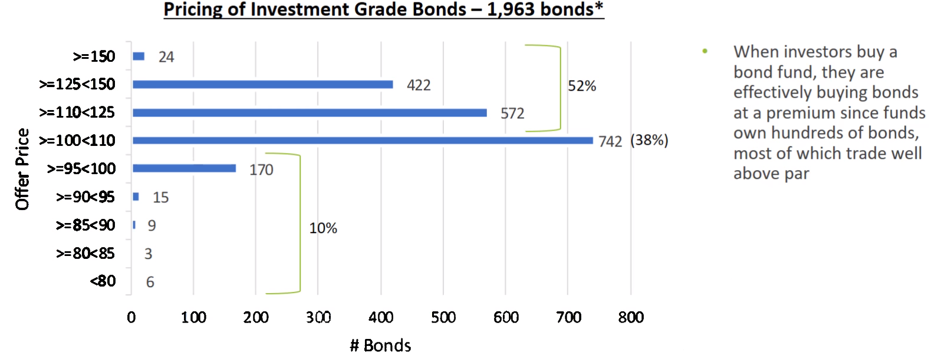²⁴
*Only including bonds with at least a 3.5 percent yield to maturity. The yield to maturity is an annual percent coupon rate which represents the total anticipated return of a bond if it is held until maturity date.²⁷

Since you can individually pick each bond you purchase, you can spend time searching for and purchasing underpriced corporate bonds in the secondary market which have increased yields due to interest-rate changes or trading discounts.²⁵ Secondary-market bond values depend on public corporate perception just like stock prices, so lower earnings and higher debt obligations with declining growth prospects can cause bonds to trade at discounts.²⁶ However, these discounts and premiums are only realized if you buy or sell a bond before maturity from or to another bondholder. If you hold the bond to maturity, you will receive its full nominal value when your principal is returned in full per the bond agreement.²³ You can take advantage of secondary-market opportunities by buying bonds from reputable companies with reasonable maturity dates (that hopefully ladder into your overall portfolio) with both high coupons and strong discounts. As you look at a bond’s bid and ask, provided by your broker feed and created by market buyers and sellers just like in equities, you can see a bond’s discount or premium represented as a number above or below 100 which simple relates the price you’ll pay relative to a bond’s face value. (we’ll look more at diversification and brokerages in Chapters 35 and 37. If you purchase individual bonds in search of consistent, high-yield returns, follow our outlined long-term diversification principles. Watch for companies that may have extremely large debt service requirements due to large leverage, creating a higher default risk).²⁶

Now, let’s say market interest rates fall to 2 percent for federal bonds in a year. Your portfolio is worth more in the market this year because borrows now expect to pay on average 1 percent or so less to borrow from investors because the market supports 2-percent Treasury bonds. Since lenders generally have access to lower-yielding bonds, you can sell your bonds before expiration date in the secondary market for a profit to immediately realize principal gain. However, remember you will also realize a bond’s full secondary-market value if you hold if to maturity. Selling your bond early simply allows you to capture gains immediately, whereas you will realize losses immediately if market rates rise. These constant ups and downs are unrealized in the nominal value of your own bond portfolio, but they cause bond funds to vary up and down. These temporary interest-rate market fluctuations cause bond funds to lose value despite a lack of underlying bond bankruptcies because mutual-fund managers are forced to sell open positions to pay for fundholder redemptions (bond ETFs also distribute or buy back creation share blocks that terminate existing bonds and acquire new ones before expiration, as discussed in Chapter 17). To understand this principle, let’s look at

Fidelity Total Bond Fund
Vanguard Total Bond Market Index Fund Investor Shares
Loomis Sayles Core Plus Bond Fund

Example about drawbacks

Short v. long-term

Compeattuve advangates

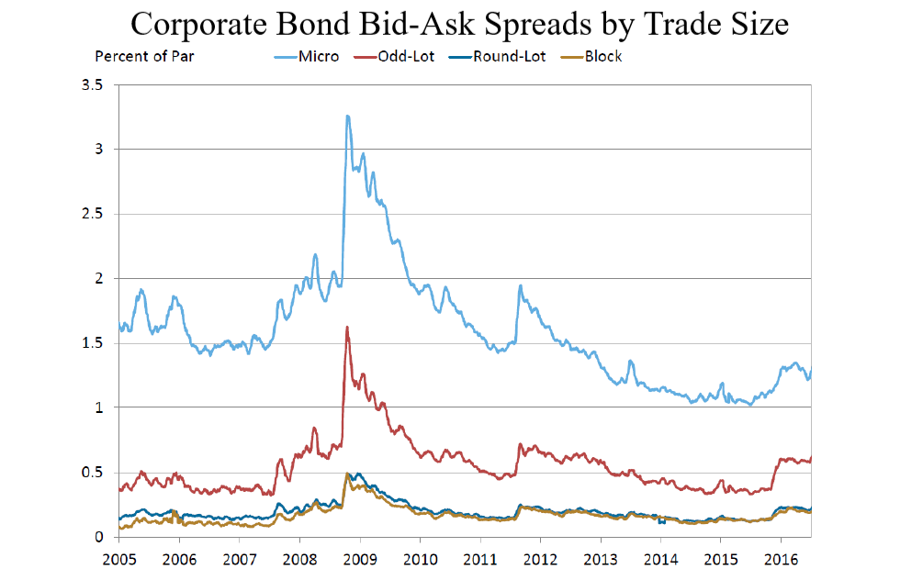

Most bond investors are nearing retirement or a large savings goal since their cash in not in the historically higher-yielding stock market. Because of this, bond investors tend to have relatively large positions, and changed in market interest rates can significantly impact the market value of your portfolio. In fact, movements in federal interest rates are recorded in basis points to track small movements in market rates. One basis point is 1/100th of 1 percent or 0.01 percent (0.0001). These small measurement increments showcase how much interest rates can affect the value of your bonds.¹⁷
To mitigate interest-rate risk, you can “ladder” your bonds to constantly give yourself investable capital. Rather than purchasing 20 bonds that expire in 7 years, you could gradually enter and exit your bond positions. In this example, you could choose to purchase 3 one-year bonds, 3 two-year bonds, 3 three-year bonds, 5 four-year bonds, 5 five-year bonds, and 1 seven-year bond. With this financial planning, you can reinvest your shorter-term bonds at market interest rates once they expire. This will protect your investments and keep them liquid without selling on secondary markets since your positions will systematically reach expiration dates over time. When you go to reinvest your cash after expiration, you can purchase bonds in the market again. If interest rates raised over your holding period, then you can take advantage of higher rates with new bonds that expire closer to your target retirement or savings goal deadline. If interest rates lowered during your holding period, then you can reinvest in the short-term knowing that your older, longer-term bonds are still paid higher interest rates.
Laddering your bonds’ expiration dates provides you with more capital liquidity and gives you upside in rising interest-rate environments. However, you may miss out on potential returns in a lowering interest-rate environment. Consider the overall trend of federal interest rates when considering how aggressive or aggressively to ladder your bonds.

Bonds are terrific investments to decrease your risk while still providing tangible returns. However, liquidating a position before its expiration date may yield a loss depending on market interest rates. When you purchase bonds, just like most stocks, ensure that the money you invest will not be needed for any immediate or emergency expense during your diversified portfolio holding period. Bonds and bond funds in particular often slightly boom when the stock market booms and slightly bust when the stock market busts in terms of average default rates.cite: We’ll look more at diversification soon, but always try to balance your stock and bond-risk exposure as interest rates change.

Bond ETFs and mutual funds are an easier way to enter the bond market with automatic diversification, lower research requirements, and minimal transaction fees.

Bond funds 989

Lastly, we get to callable bonds. If you are ready to invest in bonds, this relatively niche term will help you identify and evade hidden “call risks” in the bond market. I’ve greatly elaborated on callable bonds on my YouTube channel in a concise video that will tell you everything you need to watch out for to avoid potential losses when you face bond-issuing companies. You can find this video by searching “John Wooten: callable bonds” on YouTube.¹⁸ ¹⁹ ²⁰ ²¹ You can use zero-coupon bonds to alleviate callable-bond risk when a company refuses to remove a call clause since these bonds have a guaranteed final value.

Part Two
Technical Analysis

My experiences trading stocks, cryptocurrencies, forex, commodities, and derivatives have shown me that these strategies, indicators, setups, and more apply to almost any asset class.

Chapter 23
Charts Expanded

We looked at reading stock charts earlier; now, let’s expand on the gateway into technical analysis. Once you fluidly read and manipulate stock charts, you will be ready to explore setups and indicators.

Now that you’re familiar with dividends which show up in Yahoo Finance charts as big “D”s, let’s looks at stock splits which show up at the bottom of charts as subtle “S”s.¹
A company may split its stock when it wants to lower its per-share price for smaller investors, reward executives with more shares before new financing rounds, etc.² The principle behind these splits is existing shareholders’ positions are multiplied by X shares per existing share, and the stock price is divided by that same number X.² For instance, say a company’s stock trades at $100 and you own 10 shares of the company. A two-to-one split would reward you with 20 shares of stock, and the company’s trading price would go to $50. The number of shares you own doubles, and the price of the stock halved.³ Stock splits like these and reverse splits which we’ll explore soon affect marketplace shareholders, changing the number of shares available in the underlying company.
When a company decides to split its stock, its board of directors picks a split ratio. In a normal, forward stock split, the trading price of a company’s is divided by the split ratio, while the number of shares outstanding is multiplied by the split ratio. All existing shareholders get their position size multiplied by the split ratio while the price of each share decreases by the same factor to maintain the same overall value. For example, in a 2 to 1 forward split, a $100 stock turns into a $50 stock, and every share you own turns into 2.⁵ The overall value of the company does not change, and your position in the company is not diluted since all outstanding shares are multiplied. Existing positions are worth the same amount of cash, but stock splits, especially with more expensive stocks, allow more investors to purchase a stock since its price point is now much more accessible. Additionally, split stocks are individually worth less, but more floating shares in the marketplace increases liquidity.⁵ This increased float will make it more difficult for the stock to quickly move intraday. However, this effect can be minimal when the initial float is already low.

A reverse split in contrast, increases the price of a stock by decreasing the circulating supply of shares in a company.⁵ For example, let’s say you own 100 shares of a stock that costs $1. Suddenly, the company issues a ten-to-one reverse split, and your 100 shares turn into 10 shares while the stock price multiplies from $1 to $10.³ You should be especially skeptical when you see a company issue a reverse split. While stock splits provide increased market liquidity by giving investors more shares to buy and sell in the trading day, reverse splits decrease the number of shares in a company and artificially increase its stock price. This lowers the number of shares tradable intraday and generally hurts liquidity and spreads.²
Generally, very cheap stocks, sometimes fractions of a penny, use reverse splits to stay listed on exchanges that mandate minimum prices.⁴ Additionally, many companies must perform reverse splits to increase their price per share up to minimum quotas to stay listed on exchanges, as most major US exchanges will delist stocks that consistently fall below a minimum price.⁶ Some stocks use also reverse splits to falsely make their stock look more valuable to investors.⁷
In theory, stock splits and reverse stock splits do not change the amount of principle in your current position. However, forward stock splits generally indicate good company health in practice since they show a company tailoring their stock to retail investors.⁴ Alternatively, reverse splits do not technically change or destroy a stock’s market value, but they create poor public sentiments and decrease liquidity in practice.⁵
If you’re actively trading, you can watch out for recent splits and use them to predict where a stock will move based on its price before the split.⁸ Even for long-term investments, you can use recent splits to consider the short-term value of an enterprise.
Yahoo Finance automatically adjusts stock charts and corresponding prices to account for stock splits, saving your from calculating historical prices to analyze a company before stock splits.⁹ However, you should always notice splits as, especially in nine-to-noon trading, they can crease immediate, rapid price variations in markets looking at a newly-priced companies.

In the long-term, you can use stock charts to see how volatile a company has acted historically. This volatility can help you understand the risk of a new position rapidly moving up or down given its history of consistency. Stocks with consistent growth trends may carry lower risks than emerging stocks with much more volatility. For example, let’s look at Walmart Inc. from 1985 to today:
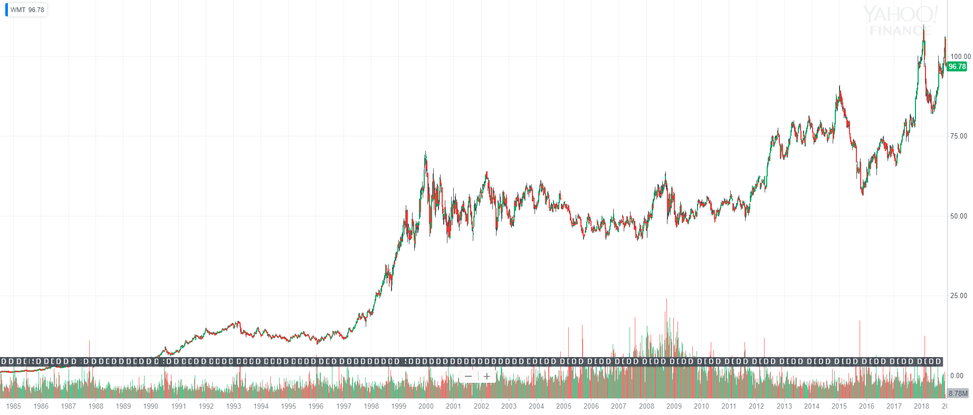¹⁰
Walmart has gone through many stock splits to keep its price point low for investors. Furthermore, we see consistent dividend payments throughout Walmart's history. In Q4 2018, Walmart’s Forward Dividend is 2.13 percent or $2.08 for each share which is currently just under $97.¹¹ Moving past this solid dividend and stock split history, we see that Walmart consistently went up in the long-term as the company grew to expand both corporate profits and shareholder distributions. However, notice that Walmart has gone through significantly extended sideways movements, slightly bearish periods, subsequently large bull runs from approximately 1993 to 2000 and 2004 to 2014, and fast price spikes and drops in the past half-decade.¹⁰

To decide if a company may be a good long-term investment, you can assess its historical volatility and general historical-trend movements. Generally, you want to see consistent growth that you expect to continue for the next 50 years because of strong fundamental business practices if you’re investing in your retirement accounts. For the extremely long-term, you essentially want to see anything but $GE.

For reference, here is General Electric Company from 1985 to today:
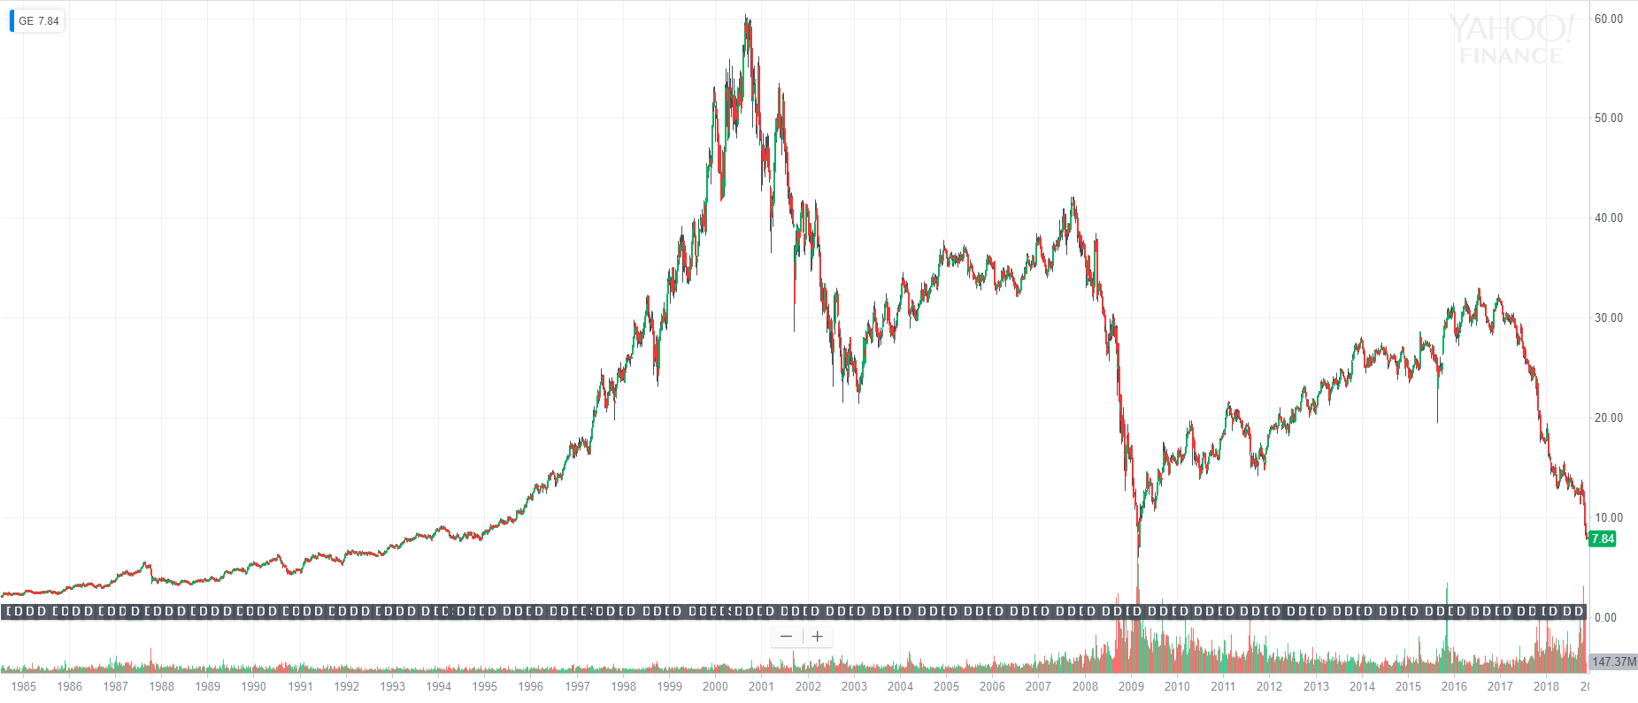¹²
From 1985 to 2001, $GE would have been a staggering investment that turned $2.50 into $50 considering capital appreciation exclusively, completely ignoring dividends which yielded almost 12 percent some years (19,000 percent gain overall, approximately a 20.6 percent annual gain compounding for 16 years).¹² ¹³ With this success, it’s no wonder the Company performed four forward splits during this time period to keep their stock affordable for the average investor.¹² Yet, more recently, $GE has seen extreme boom and bust cycles, shedding shareholder value and corporate market capitalization in rapid downturns followed by calmer bull runs. Considering this, it is important to periodically check long-term picks to assess growth and potentially take profits off the table.
With that said, General Electric is a dominant, established corporation in many profitable industries with revenues exceeding $120,000,000,000 in 2017.¹⁴ Stocks like $GE might lose some profits and stock value during market downturns, but they still stand as potential buys to later sell at new highs though swing trading. In general, try not to lose money, sell when everyone else says to buy, and buy when everyone else sells.¹⁵

Anyway, let’s get back to Walmart, Inc. Say discount grocery stores are your favorite investment industry ever, and you want to invest in Walmart for the long-run after seeing their strong historical performance. Great news for you! Stocks like $WMT are much easier to time than overall-market macroeconomic-influenced index funds.¹⁶
The first step to analyze your entry point is to zoom in. You can increase trading profits by primarily relying on short-term price action, indicators, and technical steps for nine-to-noon trading, order entries, and order exits (we’ll explore indicators, setups, and more throughout Part Two). For longer-term picks, it’s great to establish your interest in a stock based on long-term trends and company fundamentals, but you can almost always buy a stock for less or sell it for more by looking at short-term patterns. If you spend the time to analyze both these short-term movements and long-term setups, you can consistently invest at opportune entry and exit points. For nine-to-noon trading, these setups are the entire basis of profits.
Zooming into $WMT’s 5-year chart, notice that the stock is in the midst of a bull run:
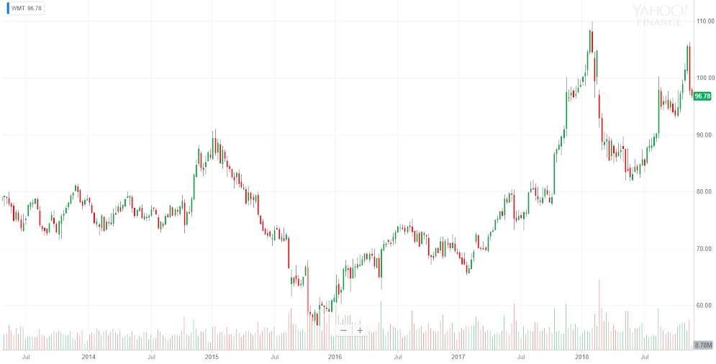¹⁰
We can also see a large red volume candle in the early 2018 pullback from $110 to the high $80s. Such volume bars, like many of the other indicators coming soon, are great indicators of price movement, however, you should rarely base an entire position on one indicator. Instead, it’s ideal to combine the many strategies coming soon with corporate fundamentals, personal insights, and market trends to find the best picks available.

Since the market is currently more volatile than normal, as show by the CBOE® Volatility Index (^VIX®), we might expect a more rapid short-term price movements in the overall market, including Walmart, Inc., a well-established thickly-traded corporation.¹⁹ The ^VIX measures the 30-day expected volatility of the S&P 500 by using options and subsequent S&P 500 options contract technical changes to produce an tradable index value.¹⁷ ¹⁸ The index has accurately measured historical S&P 500 market volatility, as shown below:
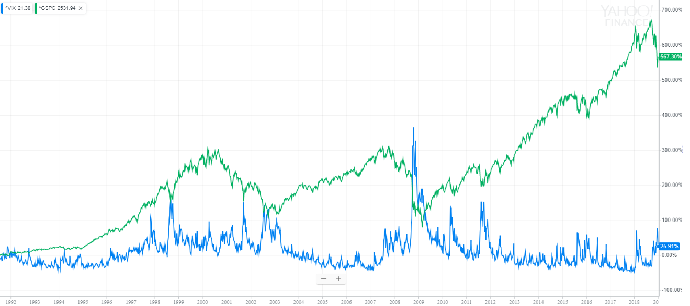¹⁹
From highest to lowest final return, we see the S&P 500 and ^VIX.

With little more to analyze in $WMT, we can change our chart’s weekly candlesticks to daily candles:
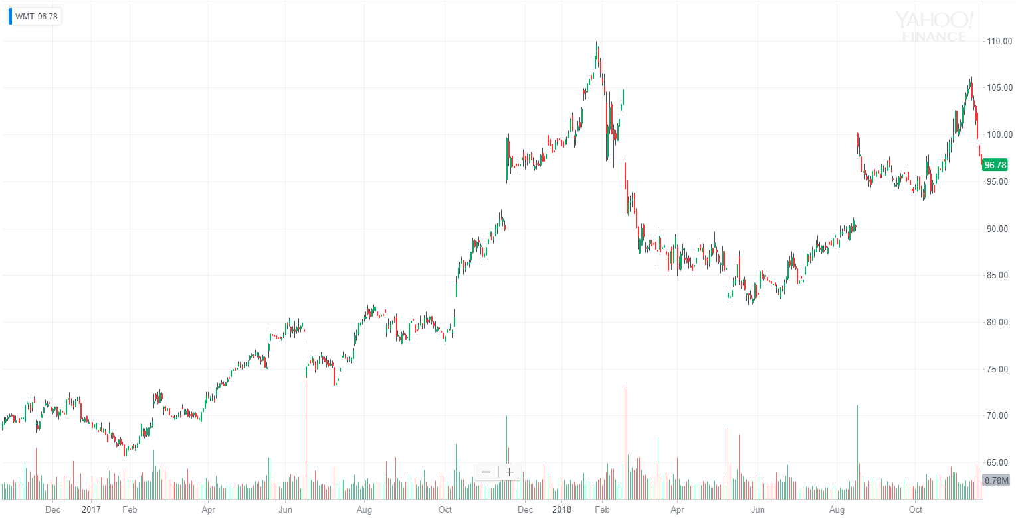¹⁰
This shorter data set demonstrates a somewhat inflated price emerging as $WMT trends upward. Without indicators or trendlines, we are “trading blind” with this chart, only able to see a somewhat inflated jump up after August and increasing selling volume in recent weeks.
We can keep zooming into this chart as much as we want to “analyze” it, but, at a certain point, too much analysis and short-term bias can blind you from macro movements. Looking too closely at a stock’s short-term movements can be counterproductive when you make a long-term trade with a larger, established, thickly-traded, publicly-followed stock. These stocks generally make meager percent-change movements compared to nine-to-noon stocks because they have higher floats that prove tough to move without large volume alongside well-established value levels. Float represents the number of outstanding shares available for immediate trading, ignoring insider shares, employee stock plans, and other long-term ownership plans.²⁰ So, even though Walmart probably won’t double the number of stores they operate overnight, you can still take advantage of such long-term growth in your retirement or overarching savings plans.

Zooming into an hourly-candle chart for $WMT, we see the following:
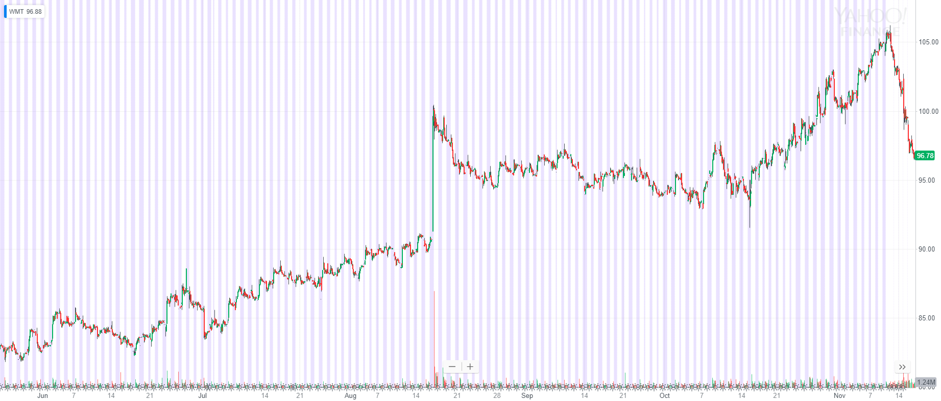¹⁰
Looking at this, little new information or candlestick setups appear to base new positions on, but there have been some good setups to analyze such as a few small head-and-shoulders setups. In fact, this entire weekly movement may unfold to be a head-and-shoulders setup soon. We’ll talk about head-and-shoulders setups and other candlestick-based setups in Chapter 29 and 30. We really need indicators to trade this chart, and, without this information, we can only see a ton of bars on top of price movements shown zoomed out earlier (we’ll explore such indicators in Chapters 31 and 32).
The pink bars that Yahoo Finance shows represent extended-hours price movements outside of 9:30 AM to 4:00 PM in New-York time.¹⁰ Yahoo Finance doesn’t have the most recent aftermarket data since it relies partially on delayed data, but your broker-provided charting service should have all possible up-to-date information.²¹ In a larger stock like $WMT, inter-day price movements are usually small unless huge news surfaces (e.g. the 8/16/2018 third-quarter earnings report causing the huge spike shown above after a 6.61 percent EPS surprise).¹⁰ ²² In nine-to-noon trading, these premarket movements are crucial to identifying potential high-fliers, as we’ll discuss later. Additionally, we’ll almost exclusively use extremely zoomed in 1-minute or 5-minute candlesticks since active trading is much more specific and analytical than holding a position for years. It is important to always look for opportunities to time a position and secure the best possible buy and sell prices.

Going back to the August 16 movement in $WMT, we see one of the stock’s largest single-day price changes in 2018. After this run-up, the stock tumbled down slowly for months, so this movement proved to be an overreaction to news. You can take advantage of this phenomenon in a wide range of trading, as many people freak out in the market and allow you to buy or sell at extreme prices which you can identify with technical analysis. Participants buy based on news rather than fundamentals and technicals, acting impulsively on emotions and extreme announcements to creates fast movements sometimes followed by equally-speedy reversals. You can overcome these tendencies and improve your trade consistency by buying undervalued stocks that you identify with technical analysis. Underlying corporate assets change very slowly, but public perception changes rapidly.
Take advantage of big downward movements in a corporation you deem valuable and dare to buy when others sell as long as you understand why others are selling and acknowledge the risk of a trade with a hard stop-loss. Big movements like these are often triggered by catalysts or institutional selloffs and buy-ins. If a company rockets much higher than you think it’s worth, then you can take advantage of technical analysis like Bollinger Bands in Chapter 32 and your own principles to short an overextended stock.
However, never base too much judgment on just one factor or indicator. Rather, look for a beautiful synthesis of the coming technical indicators along with catalysts such as market-moving news that you can easily find in news feeds available when scrolling down on any stock summary in Yahoo Finance. Most importantly, know when to admit that you’re wrong on a position and take seemingly unavoidable losses before they compound and grow. It’s also okay to miss a little upside by getting in or out moments too early as long as you participate in the overall movement you expect from a position. Technical indicators can help you buy and sell close to possible highs and lows in your given position time frame, but indicators like stochastics in Chapter 32 can also expose hesitancy and price uncertainty in stocks. Uncertain markets are certain to take you down with them.

Quarterly reports (10-Qs) and annual reports (10-Ks) are much more important when investing in Walmart or any other company for the long-term. I wouldn’t dream of touching these sacred documents with a nine-to-noon stock. Companies account for all their financials publicly in these reports, allowing Yahoo Finance to create the amazing “Financial” tab that consolidates the past four years of a company’s financial performance. You can analyze core metrics in these reports to find one of the most important long-term-growth factors: money. To find a full corporate report, look up any company’s “investor relations” webpage. Look for:
- Revenue,
- Income,
- Gross profits,
- Earnings,
- Margin
- Costs,
- Debts,
- Assets,
- Liabilities, and more.

Here is how Yahoo Finance's stock tabs currently look. These tabs are terrific portals to long-term stock analysis alongside annual and quarterly reports.
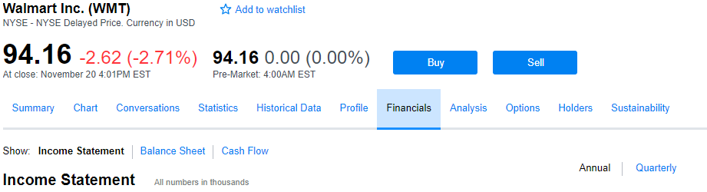²³

You usually want to see companies grow their revenues, margins, profits, and assets over time while responsibly-managing debts and other liabilities. Additionally, make sure any income influx and gross profits supports a stock’s market capitalization. To calculate the book value of a company, you can use its balance sheet given under the “financials” tab (simply subtract total liabilities from all assets and compare your result to the market capitalization or divide the number by the total shares outstanding for a per-share book value). Yahoo Finance makes book price calculation even easier for you by using its financial data to calculate a stock’s book price under the “statistics” tab.
By using the “statistics” tab, we can see the following standout statistics, among others:
- Book value
  - $WMT’s book value per share based on its most recent quarterly report is $24.62.²⁴ The Company currently trades at significant multiples of its book value, showing us that there is more to the value in Walmart Inc. than its accounting value according to the open market.
- Float
  - $WMT has around 1.43 billion tradable shares, making it tough to very rapidly move the stock price.²⁴ For nine-to-noon trading, prioritize stocks with low floats. A stock with a small float, say 4 million shares outstanding, will move significantly faster as investors compete to buy shares from limited sellers, especially after a market catalyst.²⁰ With nine-to-noon stocks, look for low floats to maximize potential returns, as the market can quickly buy up a stock’s supply, driving its prices up quickly.
- Profit margin²⁴
  - Higher is better, but not completely comparable between different companies. Some industries have innately lower and higher margins with different cash flows.
- Dividend payout ratio
  - If a stock pays a dividend, this statistic calculates the percent of all earnings paid to you and other shareholders in dividends. For newer companies, expect this number to be low since money is being reinvested to grow the business.²⁹ For well-established businesses, look for higher payout ratios that show a corporation returning its profits to shareholders. $WMT has consistently increased its dividend yield for decades, and its current payout ratio is 117.71 percent.²⁴ Without looking at the Company’s accounting methods, we can assume that Walmart Inc. must either increase earnings to supplement this dividend, use cash reserves and retained earnings to pay shareholders, or decrease their dividend.
- Percent of shares outstanding and float short
  - The percent of all outstanding shares and float currently shorted for $WMT is 1.35 and 0.66 percent, respectively.²⁴ High short interest shows that many players in the market think a stock will go down, while low short interest reflects bullish sentiments. If a stock has a high percentage of its shares shorted, you may see many short shareholders either panic and buy back their shorted shares or exit their position because of automatic stop-losses in upward swings.²⁵ “Short squeezes” are more common in nine-to-noon stocks with extremely larger percent increases which pressure short sellers to cover increasing losses early in the market, further causing prices to squeeze up (we will explore nine-to-noon stocks in Chapter 36). Other times, brokers may automatically cover shorted client shares due to individual brokerage shorting rules and time frames. The short ratio statistic (2.04 for $WMT) can also help you judge shorted shares.²⁴ This represents the number of shares sold short divided by the average daily volume, showing the number of average trading days it would take for all short-sellers to cover their positions.²⁵ Buy the rumors and sell the news for steady gains.

Beyond the accounting financials, annual reports specifically can give you great insight into a company, especially if you know little about their business. These reports, although sometimes long, generally walk you through exactly what a company does to make money alongside how they view their long-term presence in their market. They report on a company’s:
- Competition,
- Risk factors,
- Founding principles,
- Sustainability,
- Investments/acquisitions and their performance,
- Expansion plans,
- Business operations,
- Underlying business model,
- Logistical backend,
- Principle and subordinate businesses,
- Reliance on consumer credit cycles,
- Research and development plans, (i.e. improvements)
- Number of employees/employee relations,
- Executives and their compensation, and
- Physical and intellectual property specifics (to learn about a potential advantage compared to other businesses in the same market, perhaps property that raises the barrier to entry for to-be competitors).

You may not need to read an annual report about companies you already know a lot about, but these documents can significantly help you understand a new potential higher-returning To find these annual reports, simply look up “[company name] annual report.” The SEC also keeps copies of 10-Ks in the public domain.²⁶ Try to read a corporation’s most recent annual report, as it will contain insights, financials, and plans most pursuant to your investment timeframe.
To gain supreme insight into a company you invest in, consider attending or listening to a shareholder meeting. These meetings show that a company cares for its shareholders and, now that you’re a shareholder, lets you gain insight into future growth prospects.²⁷ These prospects can reaffirm your position in a corporation and present new opportunities to create shareholder value through business expansion and overhead management.

Not all trades will look terrific. Thankfully, there are thousands of listed stocks to look through in the US markets alone.²⁸ Let’s continue exploring technical analysis to learn how we can better analyze current price trends. With these skills, you’ll surely profit more consistently than trading blindly.

Chapter 24
Draw on Your Charts

Yahoo Finance gives you the invaluable ability to draw on stock charts. Using horizontal and diagonal lines, you can identify horizontal support and resistance levels.

Support and resistance are psychological levels where buyers and sellers meet in the market. Stocks tend to bounce off or break through these price levels very quickly because investors recognize the significance of support and resistance price levels.¹ Support and resistances naturally occur in stock charts and can help you decrease your trading risk by finding great buying and selling levels as previously defined by the market. Here is a basic example to summarize support and resistance levels:
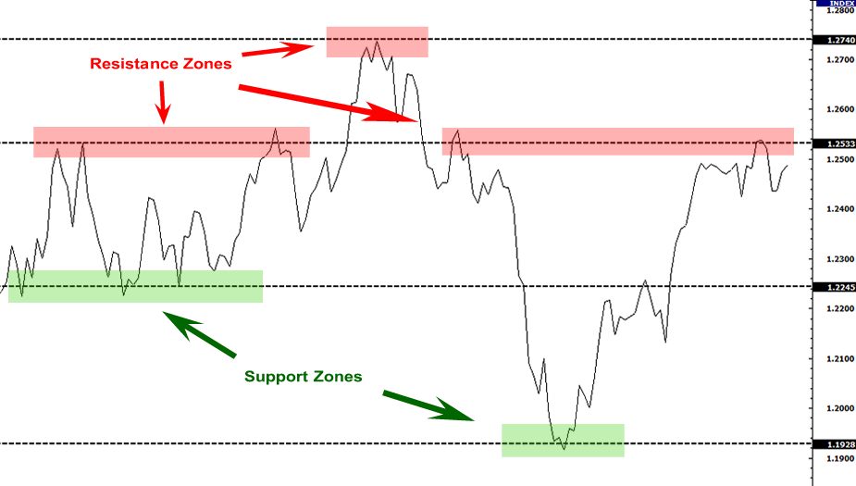⁵
The more times a stock touches a support or resistance level, the stronger its perceived validity becomes.¹ The quadruple-top resistance showcased above is extremely strong, whereas the single support level at the bottom is less established by this data. Big movements must occur for a stock to break straight through a long-term support to turn it into a resistance. Similarly, supports turn into resistances when stocks tumble down below them. In the example above, the price stumbled when first testing the historical support after its large downturn because its old support acted as an initial resistance that the market quickly broke through, quickly jumping back up to the higher resistance level. You can use support and resistance levels to predict where a stock’s price will reverse from. To strengthen the security of a trade based on support and resistance price levels, you can set a stop-loss reasonably outside of the support or resistance range. If a stock breaks through a support that you purchase and keeps falling, this can limit your losses. Alternatively, if a stock bounces off a support and rallies up to a strong resistance, you can sell at all or part of your position at the historically volatile price level. The same is true for short positions based on high prices near resistance levels.

First, let’s look at a support and resistance example in long-term trading. We’ll look at Micron Technology, Inc.’s long-term chart to find any obvious psychological price levels. We can draw on this chart by simply clicking “Draw” in Yahoo Finance’s fullscreen chart.
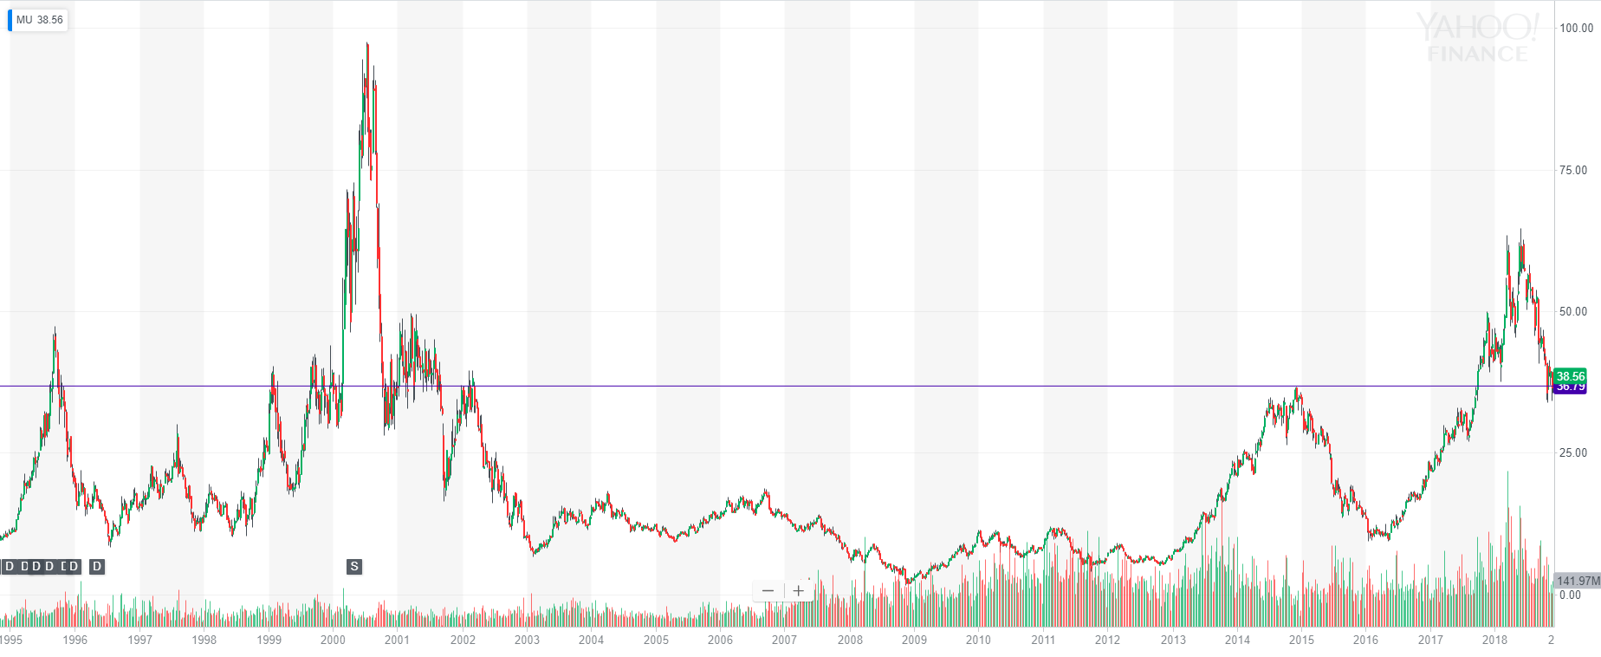²
You can identify the single historical price level marked above by looking at prices $MU consistently bounces off or has large market volatility around. We see $MU bounce off this $37 price level in 1999, trend around it scarcely in 2001, bounce off it in 2015, and quickly break through it in 2017. Since the stock tends to quickly bounce off this price level, it is a support level when the stock is trending above it and a resistance level when the stock trends below it. In either scenario, prices quickly move away from this psychological price which has existed since the 1990s and will likely exist for decades to come unless $MU moves to a significantly higher price and trading range.

You can use support and resistance lines in any stock chart that covers any duration. The key is to look for tops, bottoms, and price volatility around specific price levels. Candlesticks help you find the best support and resistance lines possible by revealing a time period’s high and low price. With this data, you can examine when a certain stock hit and bounced off a support or resistance. Here is one more swing-trading stock example with Nike, Inc.:
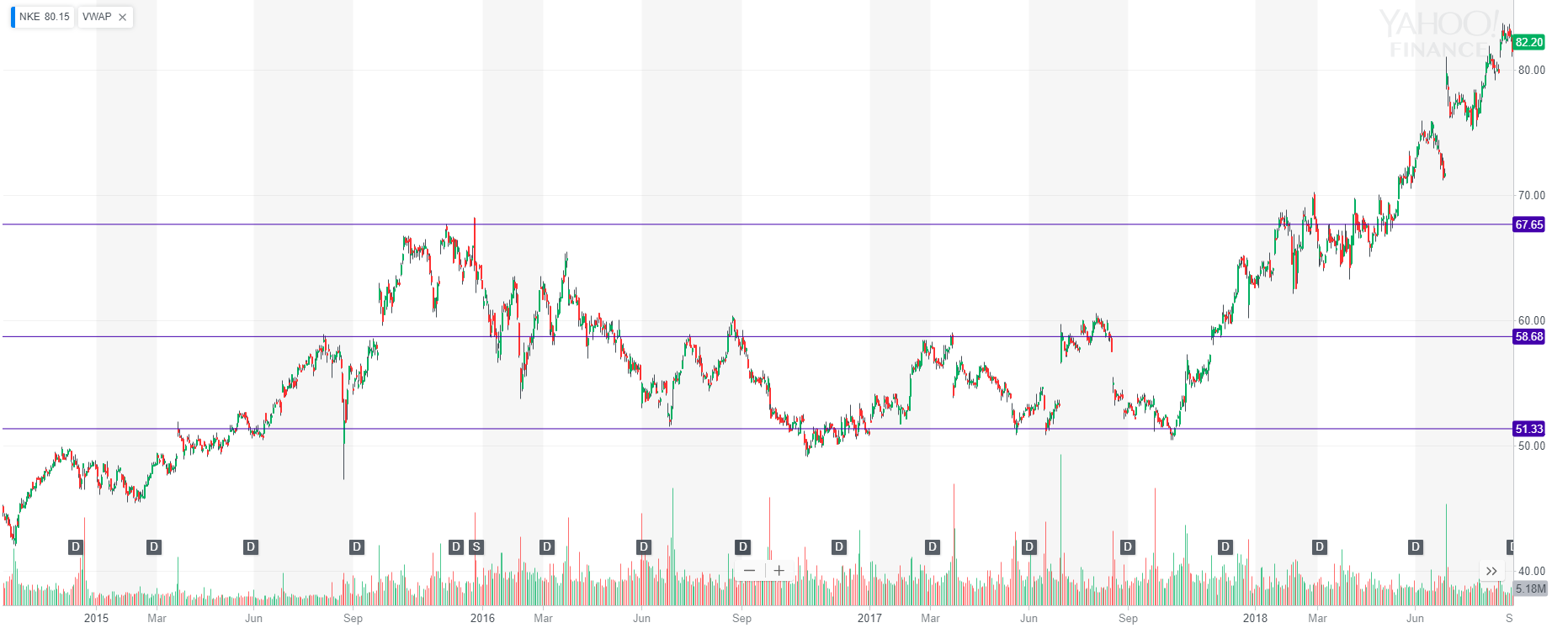⁶
We see three price levels that were constant swing points for $NKE because many buyers and sellers exchanged at these price levels. You can profit in sideways markets by buying the lower support level and waiting for prices to rise up to resistance levels. Notice that $NKE broke through both of its supports after a long consolidation at the end of this time frame. Because the stock had the momentum to create a new high, it soared as new buyers bought above the old resistance level. Try to identify support and resistance in your charting that can significantly influence price movements. Try to avoid over-analyzing a chart with too many lines, but always connect consecutive bottoms, tops, or consolidation phases that you think form obvious supports and resistances.

Horizontal supports tend to be very enduring in both long-term and nine-to-noon trades. Let's look at another example of support and resistance in a nine-to-noon setup.
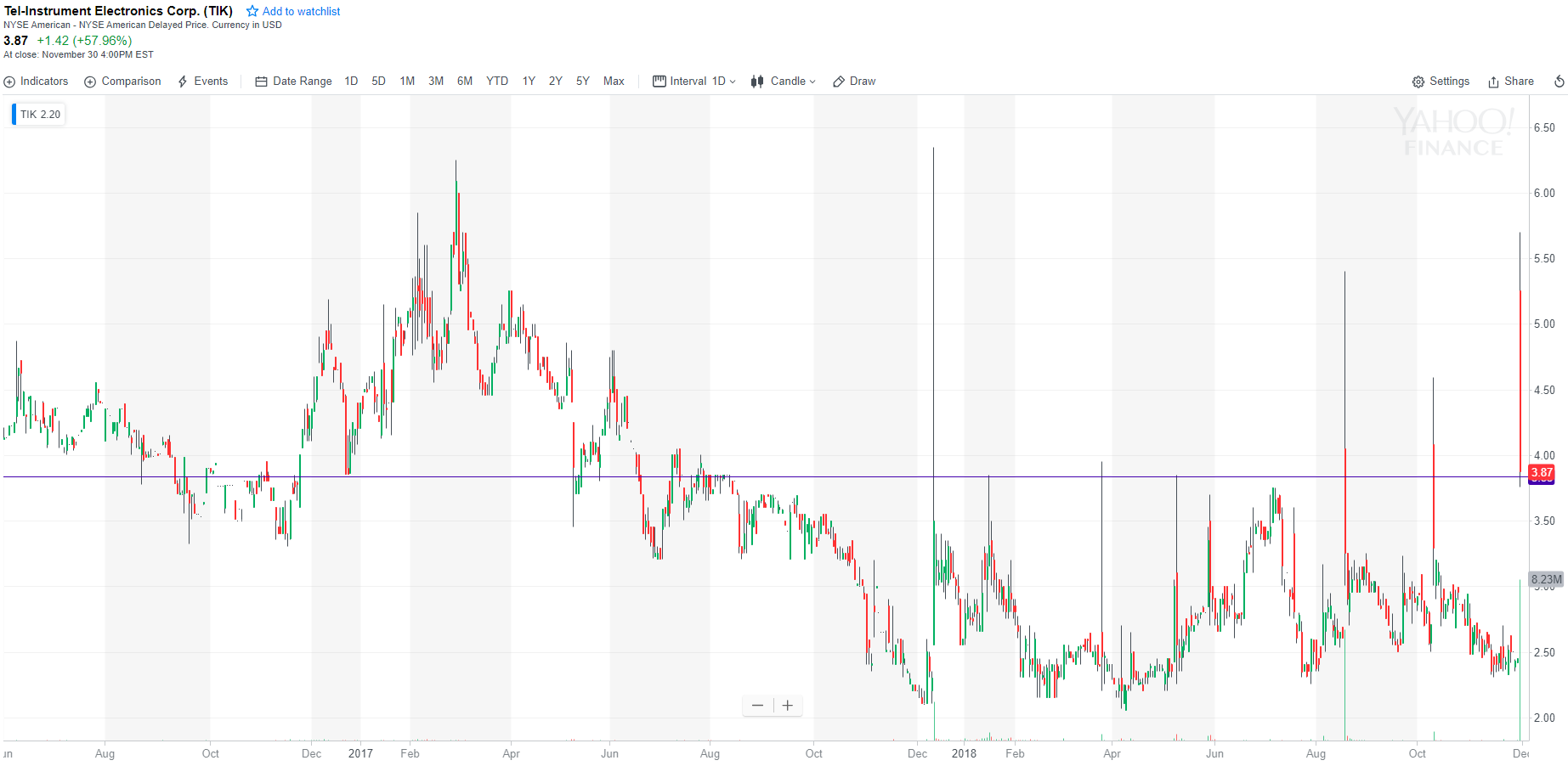³
This historical $3.85 support and resistance level was defined by slower, normal movements in $TIK’s price earlier in 2017, and you can now use this price level as a base for active trading. For three of the days above when $TIK had a massive run-up in one trading morning, the price peaked at or very near this resistance level. In recent trading days, this stock has used the $3.85 level as a support, now sitting at $5.15 during the premarket (up 110 percent in the past two days).⁴ Daily candlesticks are useful in nine-to-noon trading because you can chart our historical support and resistance levels before you enter a trade so that you know what price levels will be difficult to break through, helping you set your buy and sell targets in the morning. In the most recent trading day, you could realize a near 30 percent gain by shorting $TIK after the stock broke through the VWAP by covering at the $3.85 support level (shown below). We’ll explore VWAP and how to find a stock that goes from $2.50 to $6 in a day in Chapters 33 and 36.
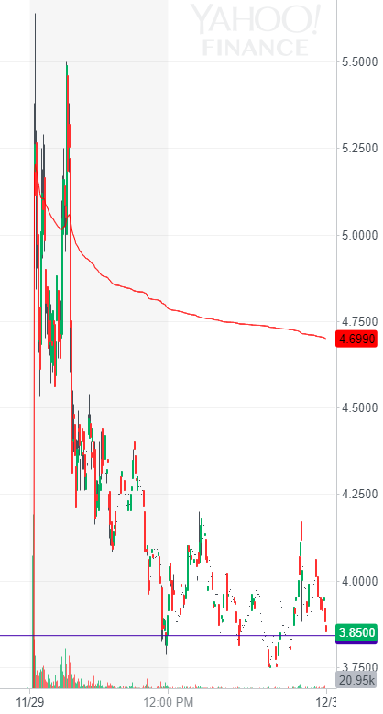³
Upper trendline is the intraday VWAP (coming in Chapter 33).

Notice that this intra-day trade bottoms out at almost the exact long-term horizontal support level we identified earlier. Because of the history of this price level in $TIK’s past shown earlier, we can use the strong, valid $3.85 psychological price level as a profit target in our volatile nine-to-noon trade after we short the VWAP crossover.⁴

Horizontal support and resistance price levels are extremely important psychological levels that dictate stock movement across all trading intervals once established. Use them!

Chapter 25
Trendlines

Now that you understand supports and resistances, let’s dive into diagonal trendlines. In an upward trend, buyers are willing to pay more for a stock while sellers stop selling for less. In a downward trend, buyers are willing to pay less for a stock while sellers start selling for less. These trends reflect immediate buying pressure and public prospects for future growth in long-term positions.
With diagonal trendlines, you can analyze price movements and time your order entries in all trading analysis periods by connecting subsequent lows, highs, and consolidation phases. Let’s look at an upward trendline example with Shopify Inc.:
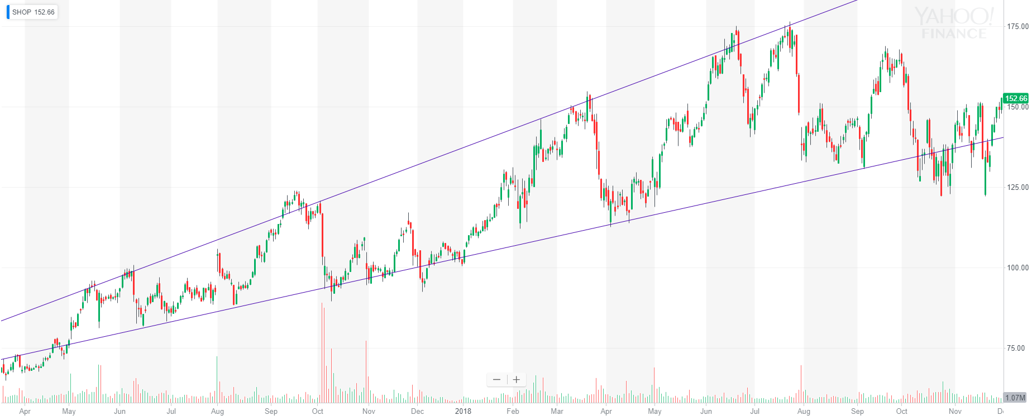¹
By connecting subsequent lows early on in this trend, we can use trendlines to predict the best times to buy. $SHOP’s price hit our quadruple-bottom trendline in October 2017 alongside large red volume candles, screaming “buy.” As time increases, the price continued to hit the trendline for a little bit. Notice that the trendline lows increase over time while the highs get higher and higher. The upper trendline in this example can predict good time to sell in the future, whereas the supporting trendline is currently being tested. If a stock falls out of a trend, adjust your trendlines accordingly.
Trendlines also appear in long-term setups just like support and resistance levels. Here is an example with ABB Ltd:
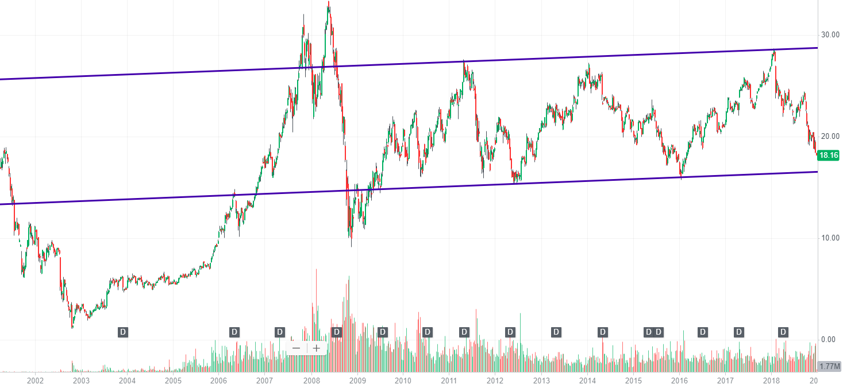²
Notice that in $ABB and many other setups, the price may temporarily fall below a supporting trendline or above a resisting trendline. Some stocks bounce more quickly off trendlines because they have more market attention and potential participants, whereas other companies like ABB Ltd are considered more stable and may fall outside of trendline ranges without necessarily breaking through them in the long-term, as shown in the 2008 crash above. Be patient with your stock picks and allow ample stop-loss room to account for temporary and slight price variations. I have personally sold at the exact bottom of a movement right before a rapid and extreme reversal due to a stop-loss.
Look for larger price movements, highs, lows, stabilization, reversals, and other previous extreme price levels to find fast-price-movement psychological levels. Learn your own risk-tolerance level over time with trading and place your stop-losses at a protective but not restrictive level. Try to use trendlines alongside support and resistance levels to create predictable price points for profit-taking and stop-loss orders. This practice will help you create consistently high profit/loss ratios and avoid trades with poor profit/loss ratios (which we’ll further explore in Chapter 35).

Trendlines, just like any technical indicator, should rarely be taken standalone when considering medium- to long-term positions. Always consider underlying corporate financials, market sector, and other indicators which we’ll explore in Chapters 31 and 32 to get the best view of a stock before you enter long-term or swing trades. Here is an example of The J. M. Smucker Company breaking through their supportive trendline:
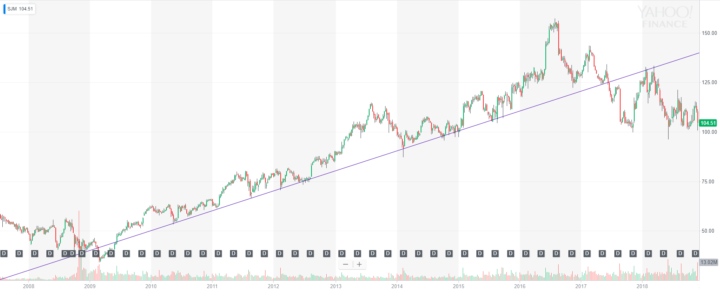³
Stocks may break out of long-term trendlines for many macroeconomic, corporate, and sector-specific reasons. Realize that these trendlines may be of use later, but they are currently invalid.
Fun fact: Smucker’s owns, among other companies, JIF.⁴

Trandlines help you identify market sentiment and often help supplement moving average supports. They can create complex wedge setups and tell you exactly where to buy a stock. Draw them!

Chapter 26
Triangles and Wedges

Now that you understand supports, resistances, and trendlines, let’s look at complex trading setups you can create with these price levels and trends.
Because supports, resistances, and trendlines create strong tension levels in stocks, they can produce explosive growth opportunities when they collide.
In a downward wedge, a downward trendline slopes into a supporting trendline as the price stables.³ The stock fights to break out of this upward resistance, and it usually should as long as the support holds until the two trendlines collide at the very latest. In a long-term setup, we see early $MU again with a near 8-year downward-wedge setup:
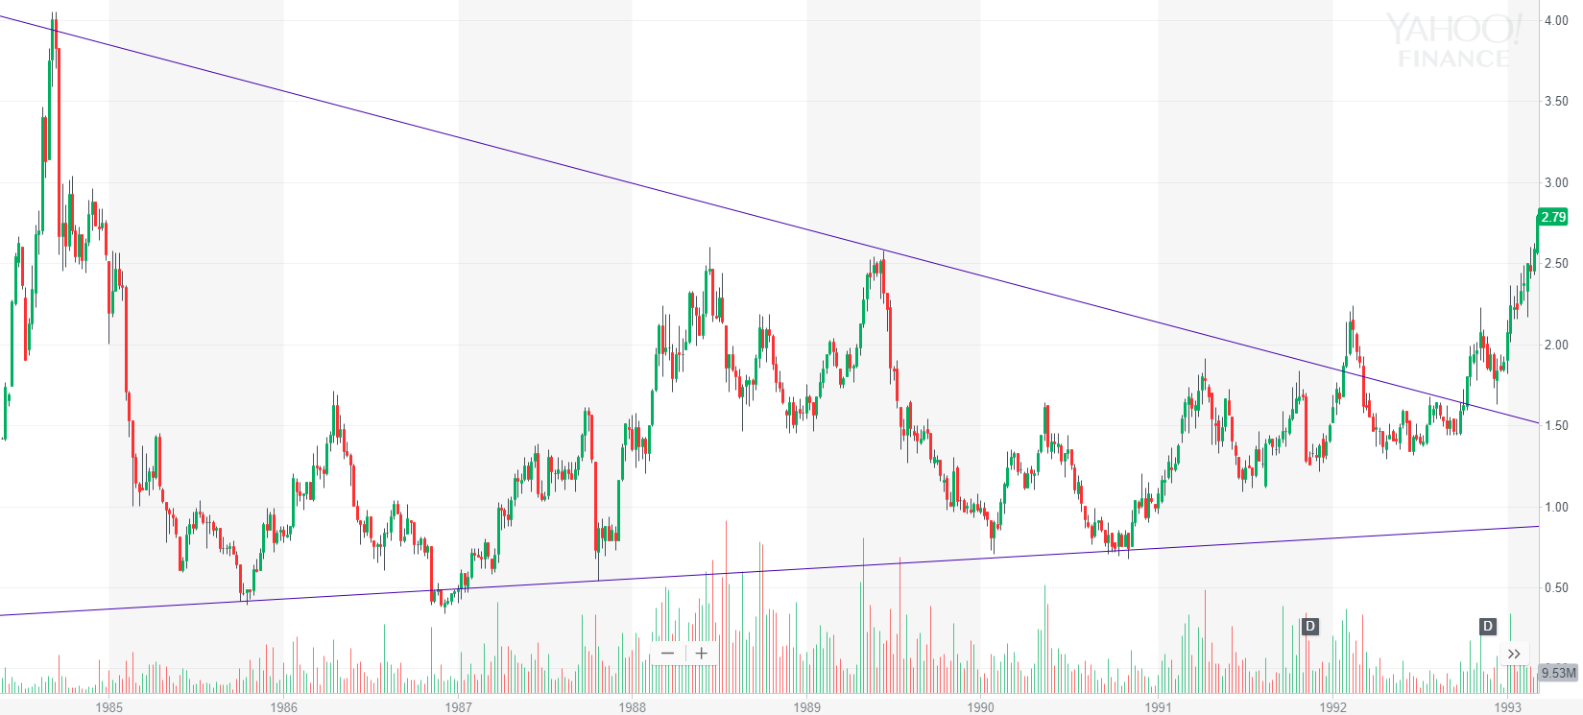¹
Long-term trendline setups can create exponential movements when the underlying company gives good news or changes public opinion to increase demand and purchasing of the stock. In this particular example, Micron Technology, Inc. went from a conservative entry point of $2 when it broke out of this wedge to over $45 in less than three years. The chart goes straight up.¹
The pressure point in the market during a downward wedge step is when a stock tests its resistance. Most players connect subsequent highs and lows instinctively to see psychological price levels, so trading volume often intensifies around these trendline boundaries. In a swing-trading setup, we see Apple Inc.:
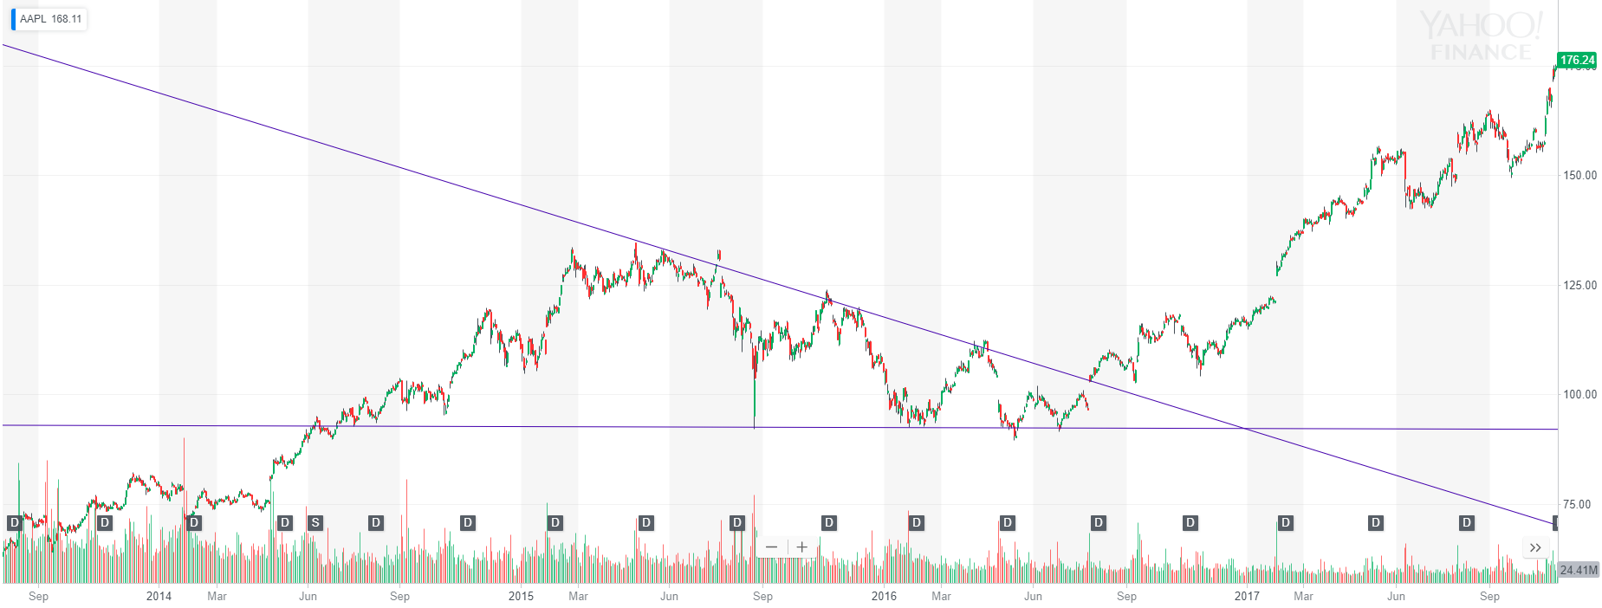²
The goal with this setup is to either buy near the collision of the two trendlines (the end of the setup) off the supporting trendline to get the best possible price or get in once the stock breaks the resistance line and stays above it for a reasonable amount of time depending on your time frame. In long-term investments, this could mean a week. In nine-to-noon trading, it could mean two seconds. Where you enter and how quickly you enter a position depends on your risk management and personal trading style development. As long as you set respectable stop-losses, you can limit your losses while your winners soar. The key to getting triangle setups right if finding the right trendlines to use for analysis. This skill simply comes with practice. Try to identify a few trendlines in current stock price movements in some of your favorite corporations’ stocks and see how you do. With time, you’ll get the hang of it. Then, you can progress to more aggressive order entry points. This mindset holds true for most technical analysis.

Opposed to bullish downward wedges, bearish upward upward wedges form when a supporting trendline runs up into a resistance. Stocks trend in the wedge until they stumble along the lower resistance and eventually fall out of the setup.⁴ Let’s look at a nine-to-noon example of upward wedges on Adial Pharmaceuticals, Inc.:
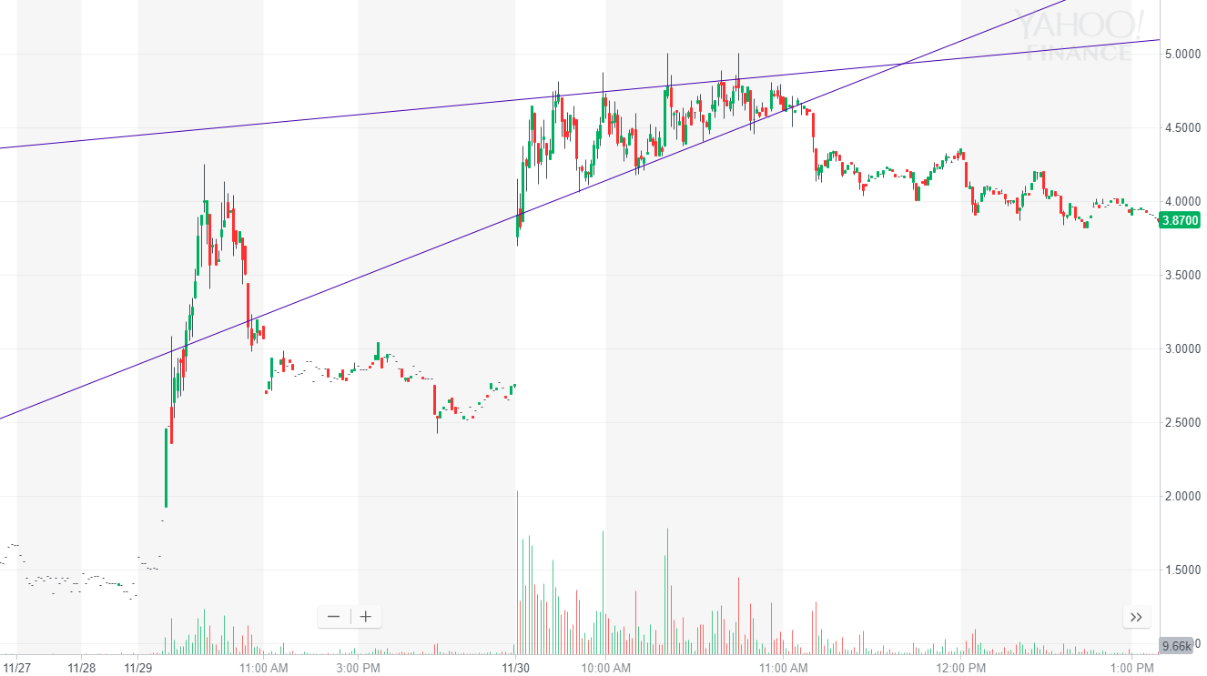⁵
Note that this chart shows two trading mornings.

In a normal trading morning, you could potentially make two or more great trades off this chart. First, you could buy off the quickly rising support around $4.20 and sell at the stable resistance around $4.80. As you get more comfortable with trading, you’ll learn to quickly identify supports and resistances and jump quickly into high-momentum upward-swimming trades. The key is to outline your parameters in a trade or identify the market sentiment early on. This particular stock had an excessive premarket gain and worked in the first ten minutes of the day to break its previous high of day. If you realized that, you may jump in slowly in the first five minutes to take advantage of the first run-up or perhaps the first pullback to beneath the VWAP (VWAP not shown. It’s right around $4.40, so you could predict the first supportive bottom based on VWAP consolidation or even just buy the VWAP and sell the third peak. We will talk more about VWAP in Chapter 33 since it is such a powerful indicator for nine-to-noon trading).⁵
As for the downward wedge short, your entry point once again depends on your risk tolerance. You could short $ADIL immediately once it started consolidating outside of its support, or you could wait for it to crash through the VWAP ($4.42) before sending in a short order.⁵ Nonetheless, the upward wedge holds true.

Let’s look at one more example with longer-term trade. Here we see an upward wedge with Lumentum Holdings Inc.:
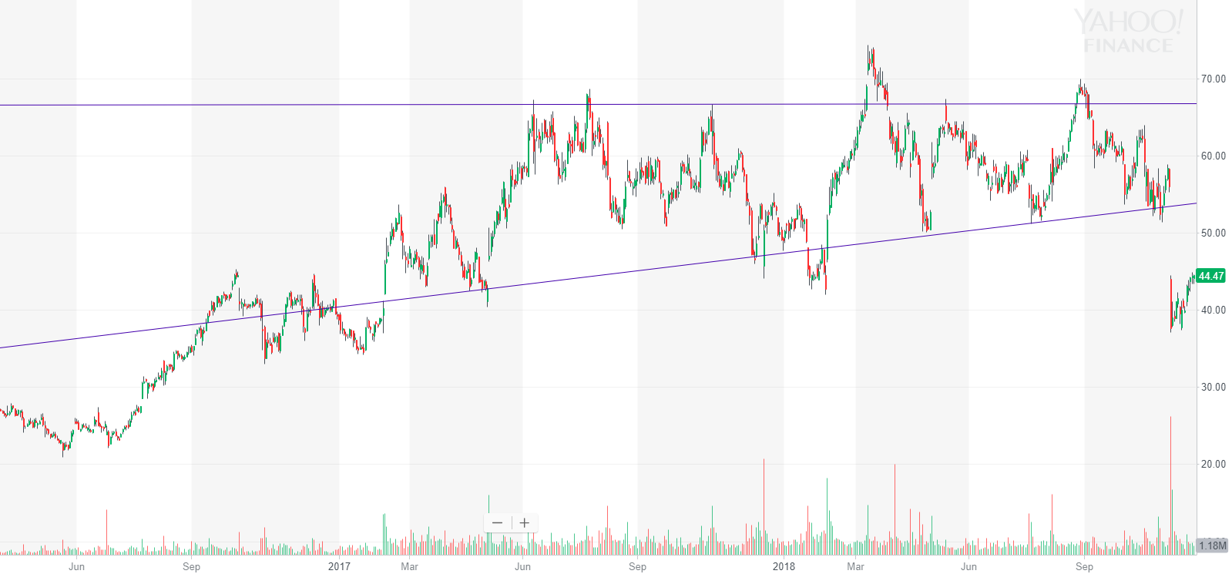⁶
The goal with an upward wedge like $LITE is to short at the upper resistance towards the end of the wedge. This minimizes your risk since you can stop out of the trade if it raises significantly enough to break the wedge pattern while simultaneously minimizing your time exposed in a trade. You can best determine entry points by looking once again at your high-to-high trendlines and comparing them with low-to-low trendlines while considering consolidation areas. Not all lines are perfect, as shown by $LITE’s slight deviations from support and resistance levels, but these lines serve as almost perfect uptrend, downtrend, and eventually selloff indication levels.⁶ With shorter-term setups, expect tighter trendlines and wedges that deviate outside of trends slightly less because active trades are much less affected by macro-market movements.

In upward and downward wedges, your price target is determined by the wedge run-up before the breakout.⁷ You can expect a wedge to reverse the same amount as its initial height as shown in the following charts:
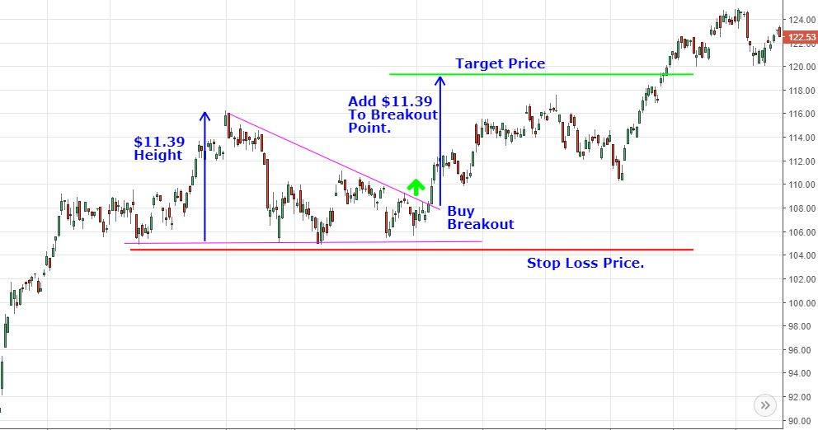⁹
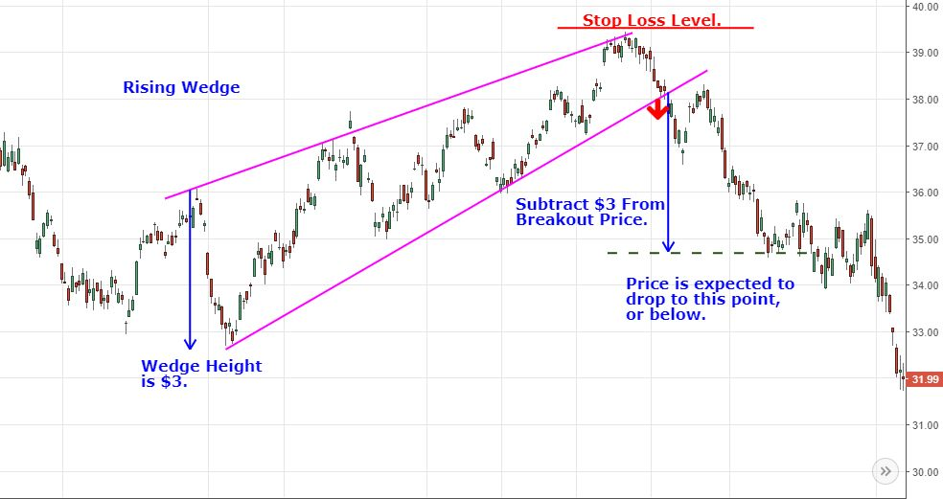⁷
You can improve your order discipline and consistency by using systematic profit targets and stop-loss levels.⁸ In combination with support and resistance levels, your wedge setups targets can help you find the best places to buy and sell while maintaining calculated risks and strong risk-reward ratios.

Lastly, we get to the symmetrical triangle wherein two trendlines converge at a single point with no definite direction. Here’s an example with Visa Inc.:
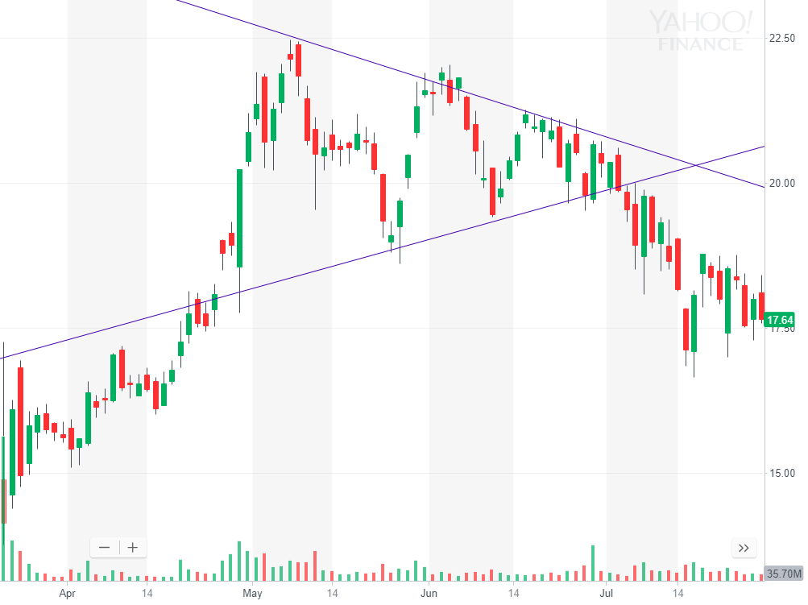¹⁰ ¹¹
The trick with symmetrical triangles that show little direction is to wait for the initial breakout. After the price first breaks out of the supportive or resistive trendline, the market will usually follow the given trend. Reversals are rare because the previous support becomes a new resistance or the previous resistance becomes a new support. However, in the case of a false breakout and reversal, the reversed movement generally reflects true market sentiment about the underlying stock and will cause a strong movement towards the corrected direction despite the initial breakout (aka. if the market changes its mind, it generally stays with its new decision).⁸
As for your expected minimum price target, use the same logic in the previous examples wherein you look at the range of the first run-up in the trend range and add or subtract this amount from the breakout point.
Here is one more example of the symmetrical triangle pattern:
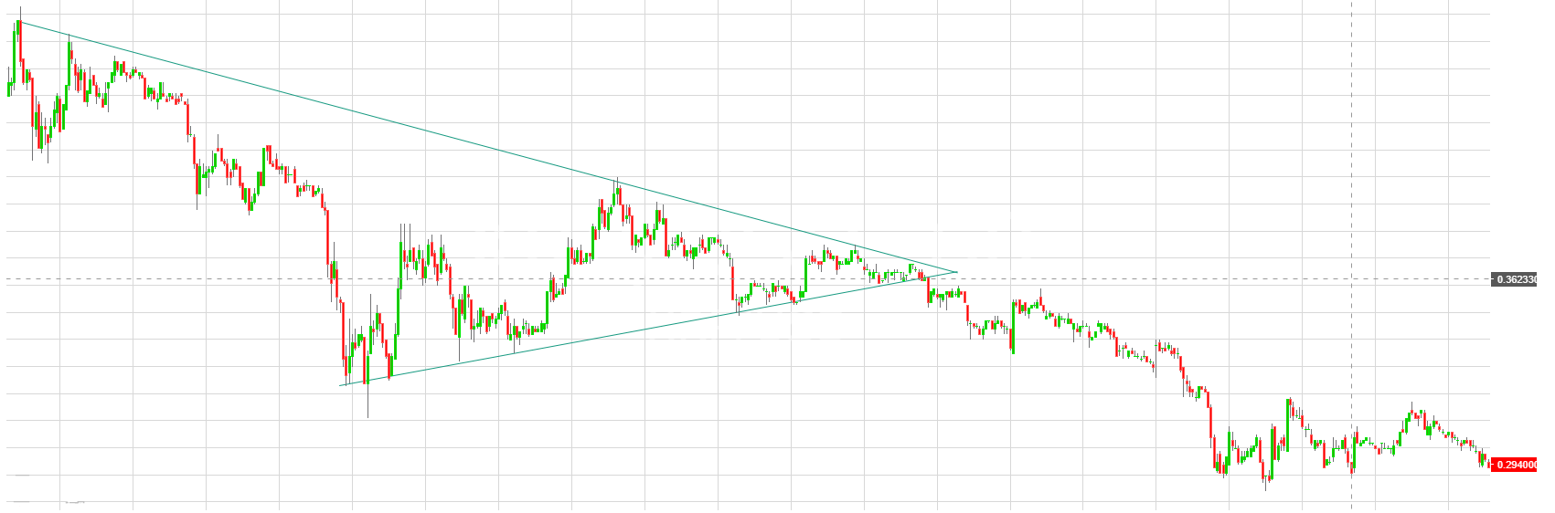¹²
Notice that the volume significantly increases at the breakout point. The goal with symmetrical triangles is to get in once you see an undeniable breakout direction towards the end of the triangle. As the market nears the convergence point of the support and resistance, it must decide which direction to move. Because this judgment move often occurs quickly, you can prepare your limit order right at the edge of a trendline or use a market order to get in a position rapidly. Use your judgement based on the time frame (shorter time frame such as 1-minute candles will generally move much faster than daily candles) and bid-ask spread to decide if a market order that risks a quality fill is necessary.

Chapter 27
Consolidation and Flags

As we’ve seen with trendlines, stocks consolidate around psychological price points. However, the market tends to move rapidly away from these price levels, creating great opportunities for you as an informed investor.
Flags use consolidation and wedges on top of previous run-ups or downtrends to predict future price continuation. Flags can act as great indicators for your current position when you are already in a trade or present a terrific buying or selling opportunity once a stock has already moved a lot. You may see flags more predominantly in large premarket gainers traded nine-to-noon (as we will discuss in Chapter 36).

Here is an example to quickly summarize flags. You can easily identify these by practicing your support and resistance-trendline drawing to get precise flags and triangles every time.
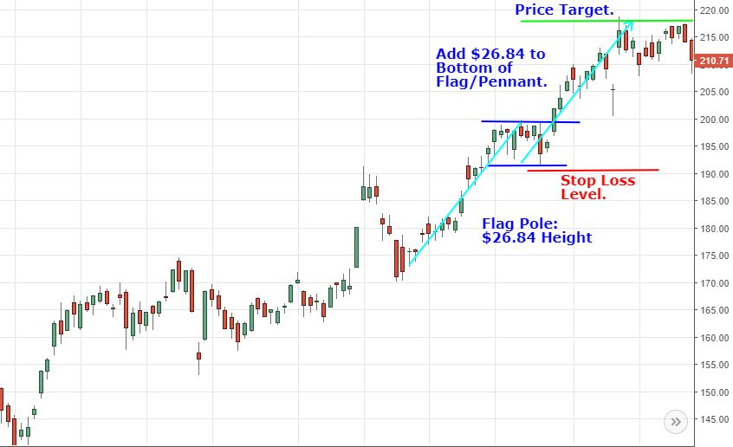¹

Notice that the run-up period for this setup starts at the previous low of the flag-pole movement. Try to enter a flag position after a strong support (or resistance if shorting) level gets established. Note that the flag itself may look more like a wedge in some trades.¹ The important thing to identify with these setups is not necessarily the support and resistance shape in the middle but rather the fact that there is consolidation in a movement that already has significant growth (or decline if shorting). The same pattern can be seen on a downward-trending flag, wedge, etc. Once you identify the support and resistance in the middle of a movement, you can find the height of the flagpole. Enter your order and calculate your profit target when you see upward price momentum breaking through the flag’s resistance (or support if shorting).
Here are two more flag examples in INTL FCStone Inc.:
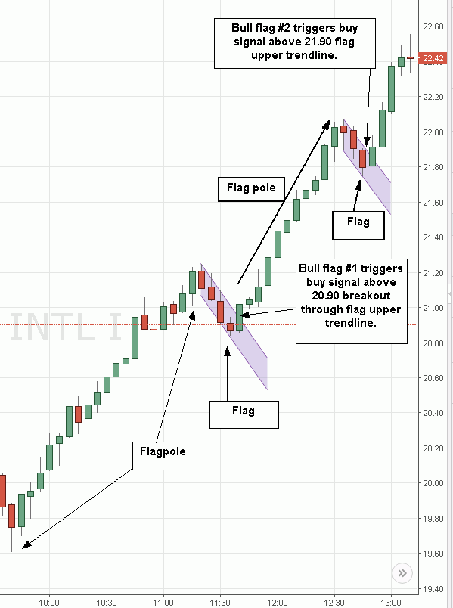²

This example is a shorter-term, active chart but not necessarily a nine-to-noon stock. You’ll see much more implicit volatility and percent changes in the stocks we’ll screen for in Chapter 36, realizing greater returns using flag patterns. This is especially true for opening-bell movements wherein orders pour in to purchase or sell a stock with significant premarket catalysts and volume.

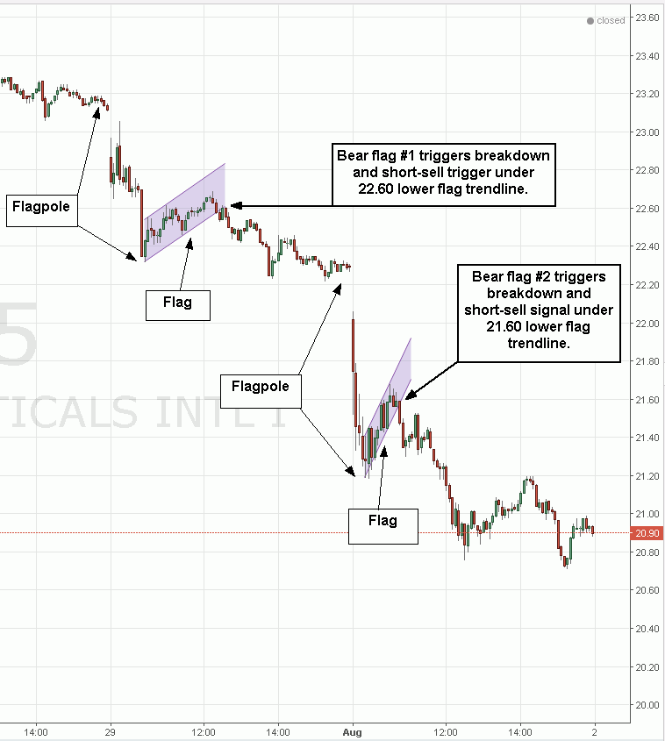²
Here, we see a swing-trading setup that requires you to hold your position post-market. Remember that post-market holding can pose significant volatility risks in nine-to-noon stocks. These positions, as shown above, can make large premarket movements in unpredictable directions, especially after a large daily run-up or downtrend.
With that said, this flag pattern held true through the post-market. Stick with strong support and resistance levels and your trades will surely turn out well with consistency.

Chapter 28
The ABCD Setup

The ABCD setup is the mother of all technical setups. This pattern provides you with:
- Low downside risks,
- Clear price entry zones,
- Easily-calculated profit targets, and
- Very high potential returns.
You’ll see this setup especially in very-early-morning nine-to-noon trading with stocks that have large premarket upward movements or simply big run-ups early in the morning from catalysts.

The basics behind the ABCD setup are shown in the rough graph below:
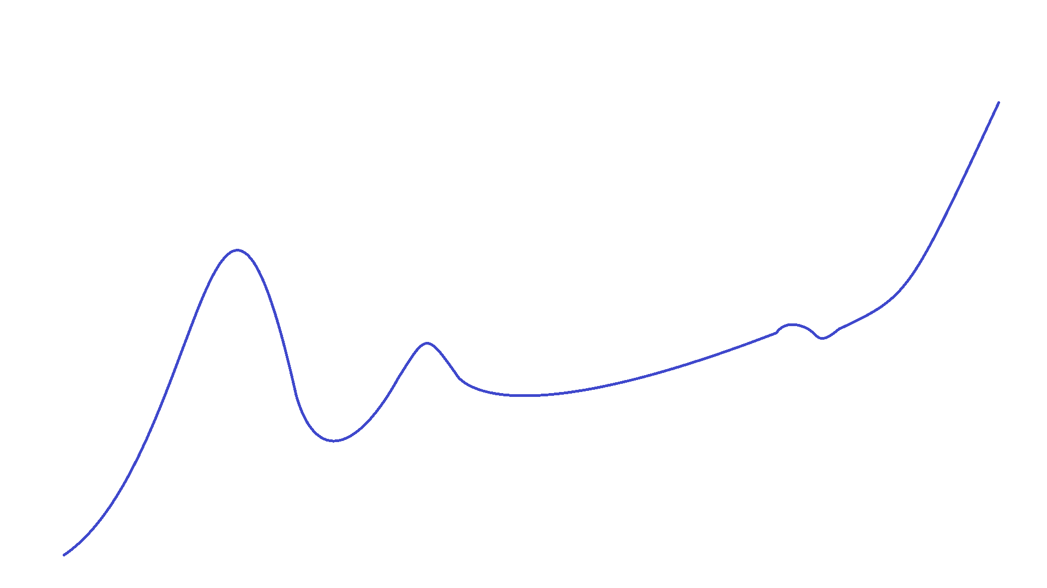¹ ²
Notice the large initial price run-up. This forms the “A” in the setup. For active trading, this large initial percent gain will get this stock on everyone’s screeners since it blazes an early-morning gain (which we’ll further explore in Chapter 36). This movement brings more attention and buyers to a stock.
Following this new high, we see a slight pullback and consolidation. This pullback should not generally exceed half of the initial run-up high in an optimal setup. However, extended setups with daily, weekly, or monthly candlestick time frames may fall below this price level before later returning to complete an extended ABCD setup. This pullback finalizes the “A” and forms the “B” in the setup once it finds market support.
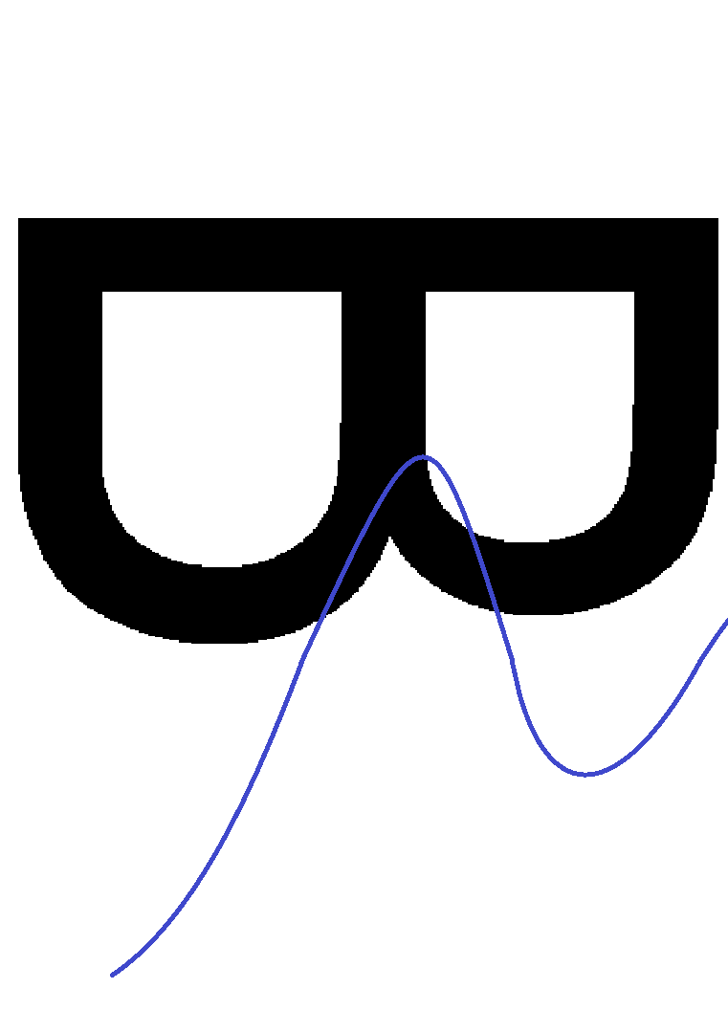¹ ²
Next, the setup starts curving up as more investors buy the stock. This slight curve forms the crucial “C” in the setup and shows that there is still interest in the stock. This interest keeps the stock afloat rather than the movement simply being a wash uptrend subsequent reversal. The “C” is shown below. If you want an aggressive order entry on the ABCD setup, try to enter your order towards the end of the “C” before the stock gets too high again but after it finds stability and guarantees a slight upward curve.
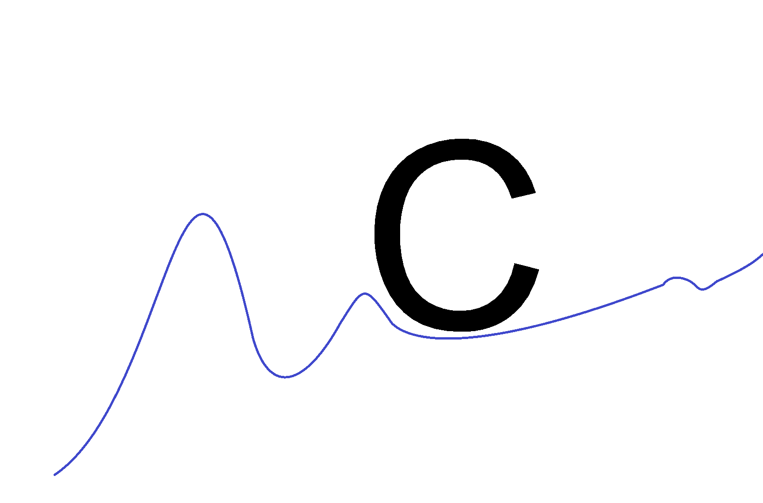¹ ²
It can be difficult to ensure initial upward price movement towards a new high before entering an order. For easier, more consistent trades, you can only enter in once the “C” ends and the stock overtakes its previous high to start an uptrend into the final “D.” This upward price movement is exactly why you trade this setup to find consistent ABCD gains.
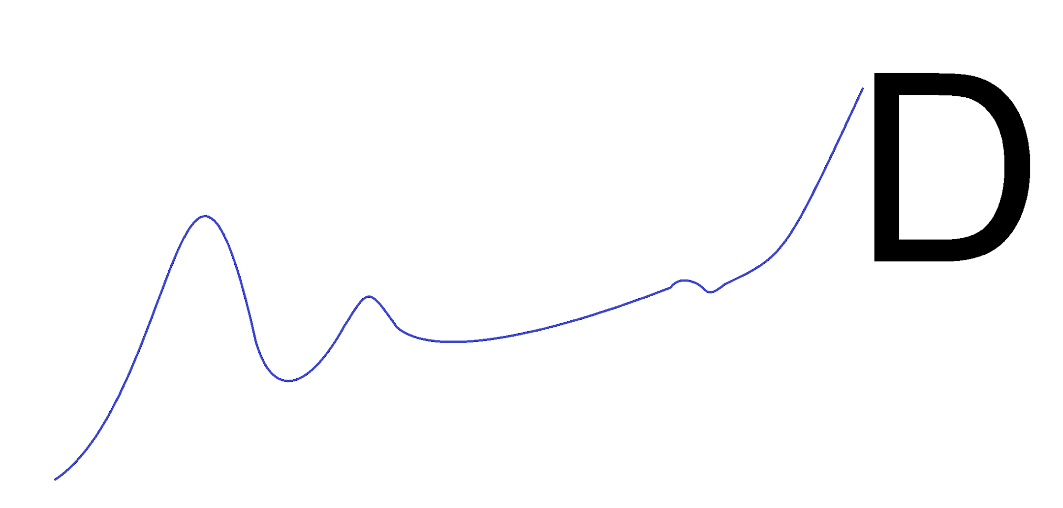¹ ²
To find your price target for the “D” movement, add the height of the “A” run-up to the previous high formed by the “A.” This minimum price target works in almost all ABCD setups to consistently close at least part of your order at the highest price possible. You’ll learn to get the best fill price for your order when it exceeds the ABCD target significantly through experience watching stocks momentum and volume patterns. Remember, more volume brings more buyers, liquidity, and shares taken out of the stock’s float.
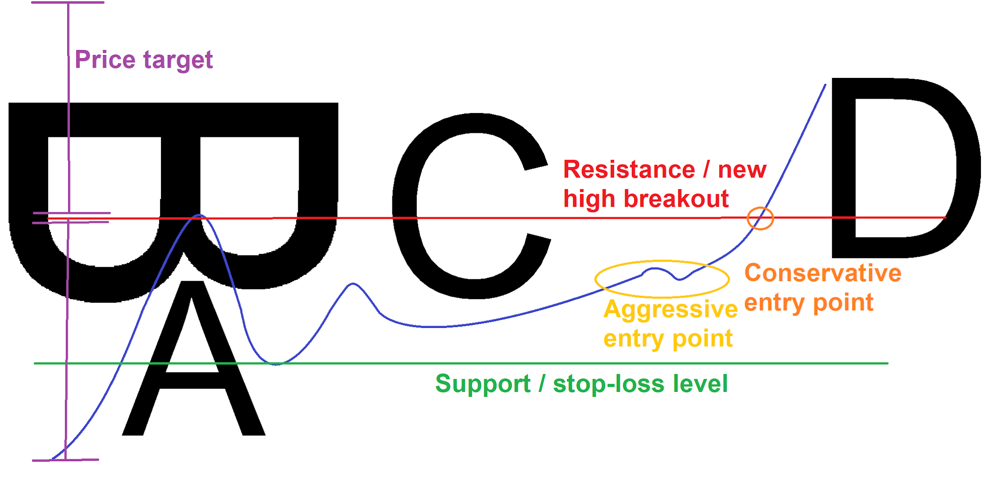¹ ²

The ABCD setup is a huge nine-to-noon setup, but its principles can also be applied to longer-term investing. Aside from long-term ABCD setups, remember the significance of a stock breaking its previous high. New highs bring new attention to a stock, attracting more buyers that push prices even higher. Watch for stocks breaking into new highs as they may temporarily be overbought or oversold. We’ll look at stochastics in Chapter 32 to better understand these levels.
The ABCD pattern also helps you understand risk management. Notice that the ABCD price target is twice as high as the downside when you enter at an aggressive entry point. By risking only half of your potential rewards, you can take more trades and earn more because you limit your losses more than your wins. Always try to find a balance wherein your risk is well rewarded with potential profits.

Here is a morning-trade ABCD setup using one-minute candles on Cronos Group Inc.:
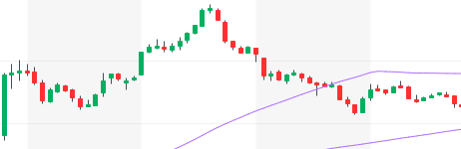³

Notice that the “B” and “C” in $CRON slightly blend together during the stock’s fifteen-minute consolidation. Worry not. You’ll do great with ABCD setups as long as you get in around the resistance and set your stop-loss in case of an unforeseen reversal. Still, give yourself enough room for the trade to work. $CRON had a slight but rapid one-minute pullback before quickly rising back up from just over $10 to just under $12.³

A slight variation of the ABCD setup is the cup-and-handle setup. With a cup and handle, you’ll see the same initial setups as an ABCD chart until the end of the “C.” Here, there is a slight downward retrace at the end of the “C” before a final move upward into the “D.” Here is an example of the cup-and-handle setup:
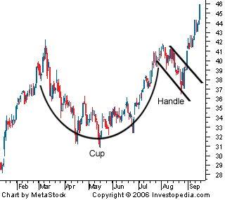⁴
Remember this setup in case a stock seems to reverse from an ABCD setup and carefully adjust your stop-loss in case prices are simply forming a handle and will eventually break the resistance and jump to new highs.

Chapter 29
The Head-and-Shoulders Setup

The head-and-shoulders setup is a very specific and predictably strong support-and-resistance setup. The pattern indicates a reversal in price action and a potential bottom in trading prices when accompanied by large red volume candles. This setup presents terrific opportunities for shorting and buying new positions while also indicating a good time to exit current positions. Here is the general pattern:
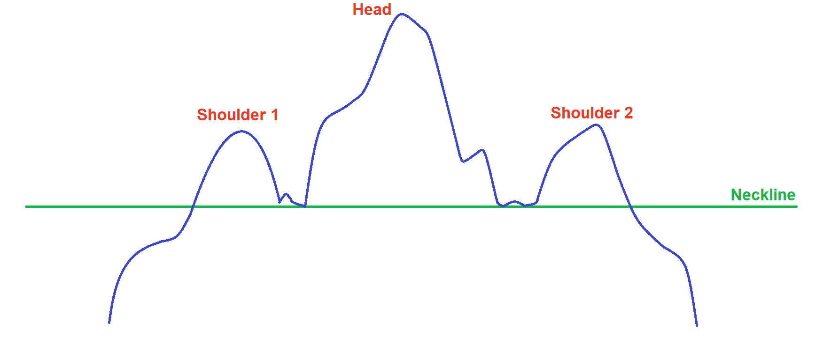¹ ²
During the initial run-up, the stock forms the first shoulder before pulling back to a resistance line. Then, the stock shoots back up to form a new high and the head in the pattern. Afterwards, prices fall down to the support line from the first shoulder and starts to trace back up. This is the first moment when the head-and-shoulders pattern starts taking shape as you can see by the underlying support alongside the first shoulder and the head. At this point, you want to see the stock bounce off the resistance created by the first shoulder as shown below:
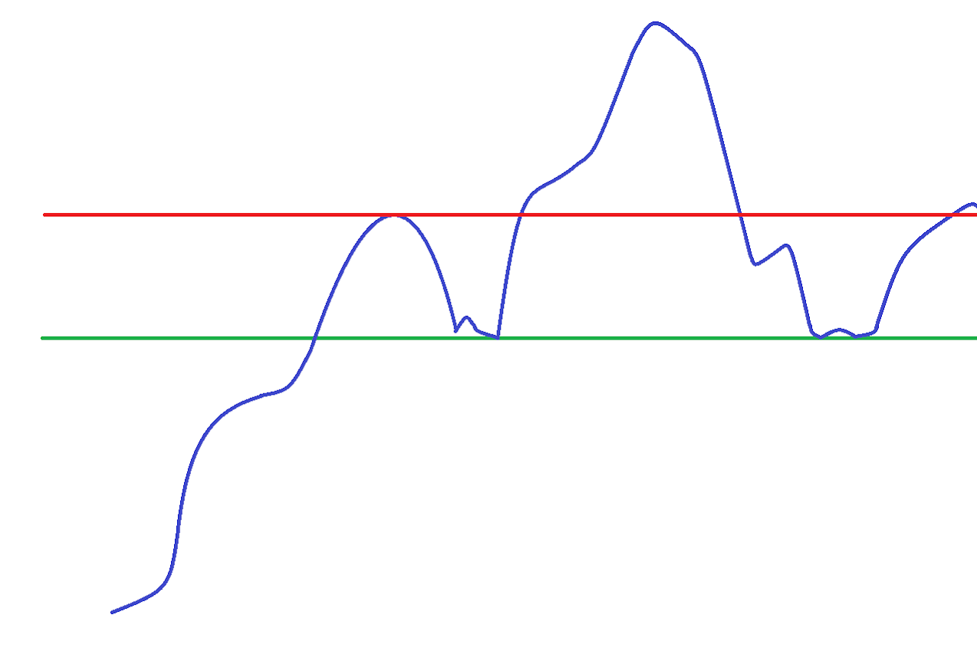¹ ²
If you were long in this position when the head-and-shoulders pattern started, then you may sell part of your position at this point. The second shoulder is often the highest price the stock will hit before it reverses off the large first-shoulder resistance level and goes downwards to break below the support.
This setup occurs throughout all time frames and usually ends where it started. At a minimum, expect the stock to move the height of the head over the neckline support level subtracted from said support level, as shown in the following diagram.¹ In a normal set up like this, you can expect the price to drop to the low before the start of the setup.
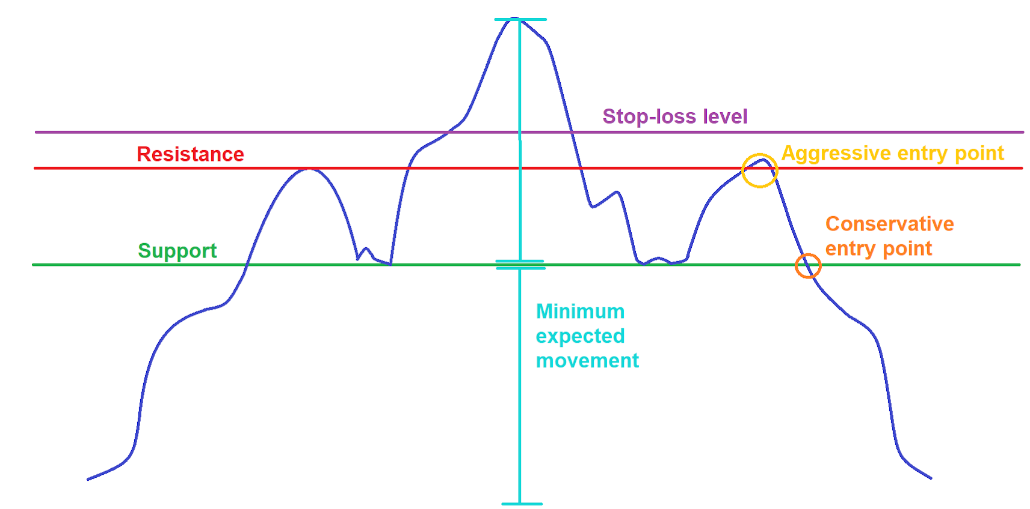¹ ²

Alternatively, the inverted-head-and-shoulders setup flips the head-and-shoulders setup to indicate upward price movement, as shown here:
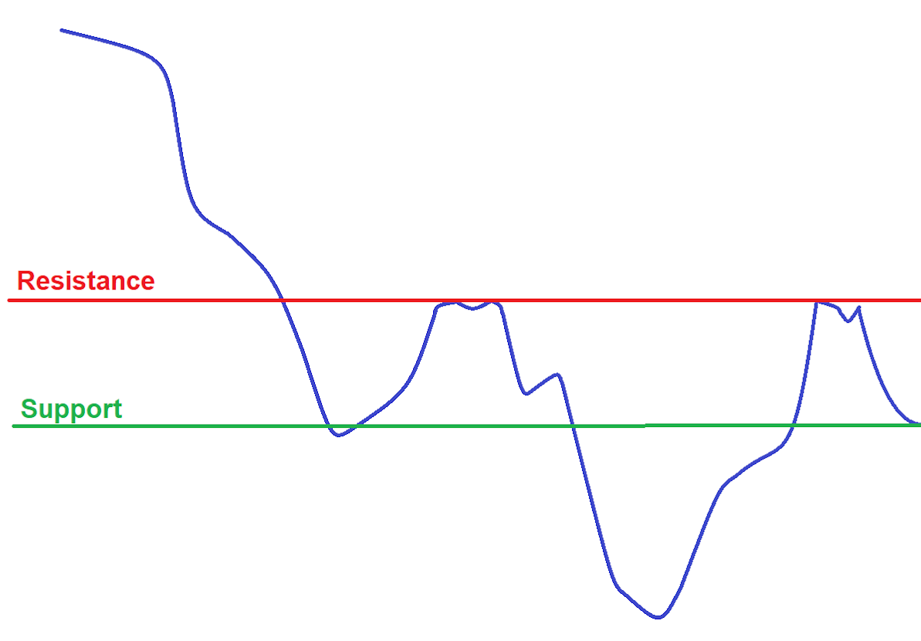¹ ²
The shoulders now create support levels while the neckline acts as resistance for an upward movement. The pattern is solidified by the first shoulder, head, and second retrace back to the initial support level. Similar to the head-and-shoulders setup, we see the following entry points and minimum profit targets in inverted-head-and-shoulders setups. We can also set a profit target where the stock initially sat before falling into the inverse setup.
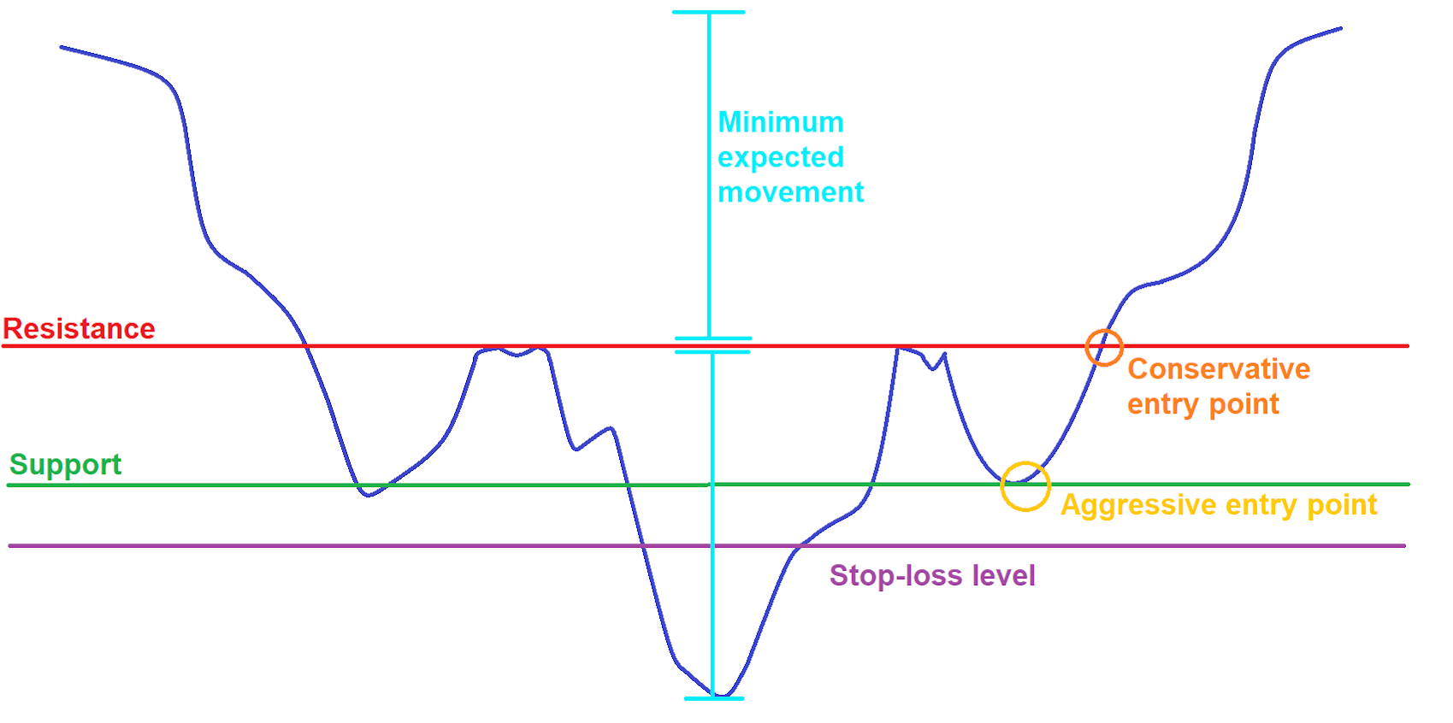¹ ²
With this strong technical setup, the underlying company you trade doesn’t matter very much. Your price analysis and disciplined support and resistance levels will yield your profits rather than an understanding of the underlying business and corporate performance.

Chapter 30
Candlestick Setups

Extreme candlesticks can serve as terrific reversal indicators when they form a “hammer.” Hammers can help you find bottoms and tops in short-term movements. You’ll see these candlesticks when a stock drops to test new lows but quickly recovers before a candle closes, leaving a large lower wick and small candle body.¹ Meanwhile, the top wick in a hammer setup is very small or completely engulfed in the candlestick, as shown below:
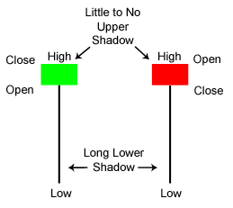¹
Hammer candles indicate strong reversal potential in markets because of rapid buying and selling at significant psychological price levels. Especially in trending movements, these candles can work off and strengthen support and resistance levels to indicate an impending reverse price movement. By mastering hammer candles and the other candlestick setups coming soon, you can identify great trading opportunities once validated by the market.²
The color of a hammer candle matters little in practice, although green attracts more buyers. You can confirm a hammer reversal once the following candle closes above the hammer candle.⁴
Below you can see the reversal power of a hammer candle after a continued downturn:
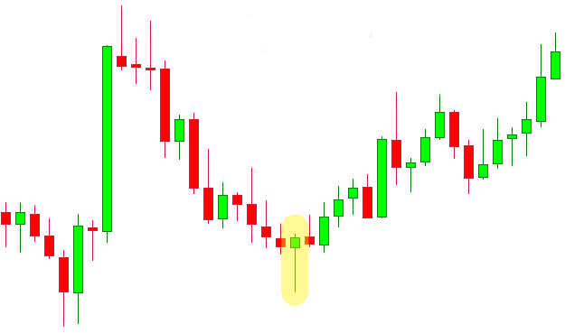³

Notice the hammer candle is quickly overtaken by the market once it reverses, proving itself quickly. The downside on a long trade here should be the bottom of the hammer candle. You can limit your risk by waiting for the next few candles to prove the hammer setup.
In the large beginning run-up, we see an upside down hammer candle swiftly reverse this stock (small body with a large top wick and small bottom wick). You can also verify the validity of these slightly less consistent “inverted hammers” by watching the following candle for an immediate shortable downtrend. Here, extreme buying pressure enters the market before prices yet the candle closes much lower, reflecting the movement of a hammer candle.

Besides looking at the following candle, you can verify hammer setups with other indicators like stochastics and VWAP, searching for oversold warnings (we will talk about these indicators and more in Chapters 32 and 33).

Lastly, watch out for miscellaneous candlestick setups. Although you may not see these particularly often, they can help confirm or deny your sentiment towards a stock’s movement. If you’re constantly having trouble finding candlestick setups like these, do not worry. Often, you can simply judge a stock with price-based indicators, volume, and overall feel based on market conditions such as level 2 and float. Watch out for these additional patterns as an element in your technical analysis strategies:
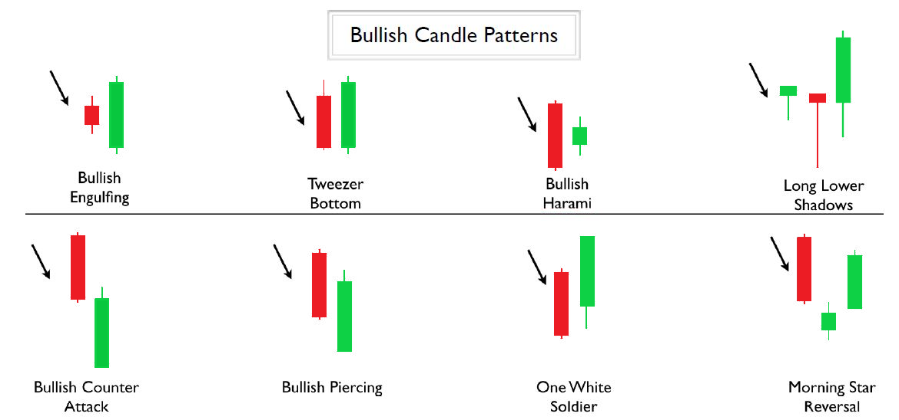⁵
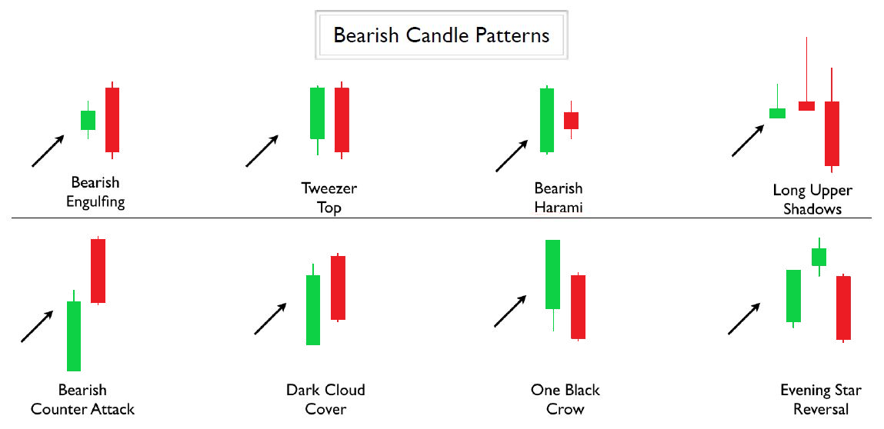⁵

Chapter 31
Moving Averages and MACD

Moving averages appear on your charts as smoothed lines averaging historical prices. These lines act as natural key historical support and resistance levels, and their strengths depending on the underlying time period measured.¹ To calculate a simple moving average, use the formula:

So, for a cheap stock’s five-day moving average, you could find the current average by calculating:
¹

Time periods measured by a moving average depend on your cheats. If you use daily candles, then the moving average is calculated with the last 5 days (in this example), whereas hourly candles calculate the five-hour moving average.¹
Moving averages are moving because they drop the last data point from a series and add a new one once available. So, to continue our example, the oldest $12 price gets dropped from the 5-period moving average and replaced by the next period’s price.¹

The three most-used averages are the 50, 100, and 200 moving averages.² Since these are popular, many other investors will look at these price levels and consider them as support and resistance levels just like you. Because these levels are mostly psychological, these averages serve as support and resistance levels throughout all time frames. With that said, longer measurement intervals produce stronger moving averages.²
Here’s a weekly-candlestick chart of Tesla, Inc. with all three major moving averages:
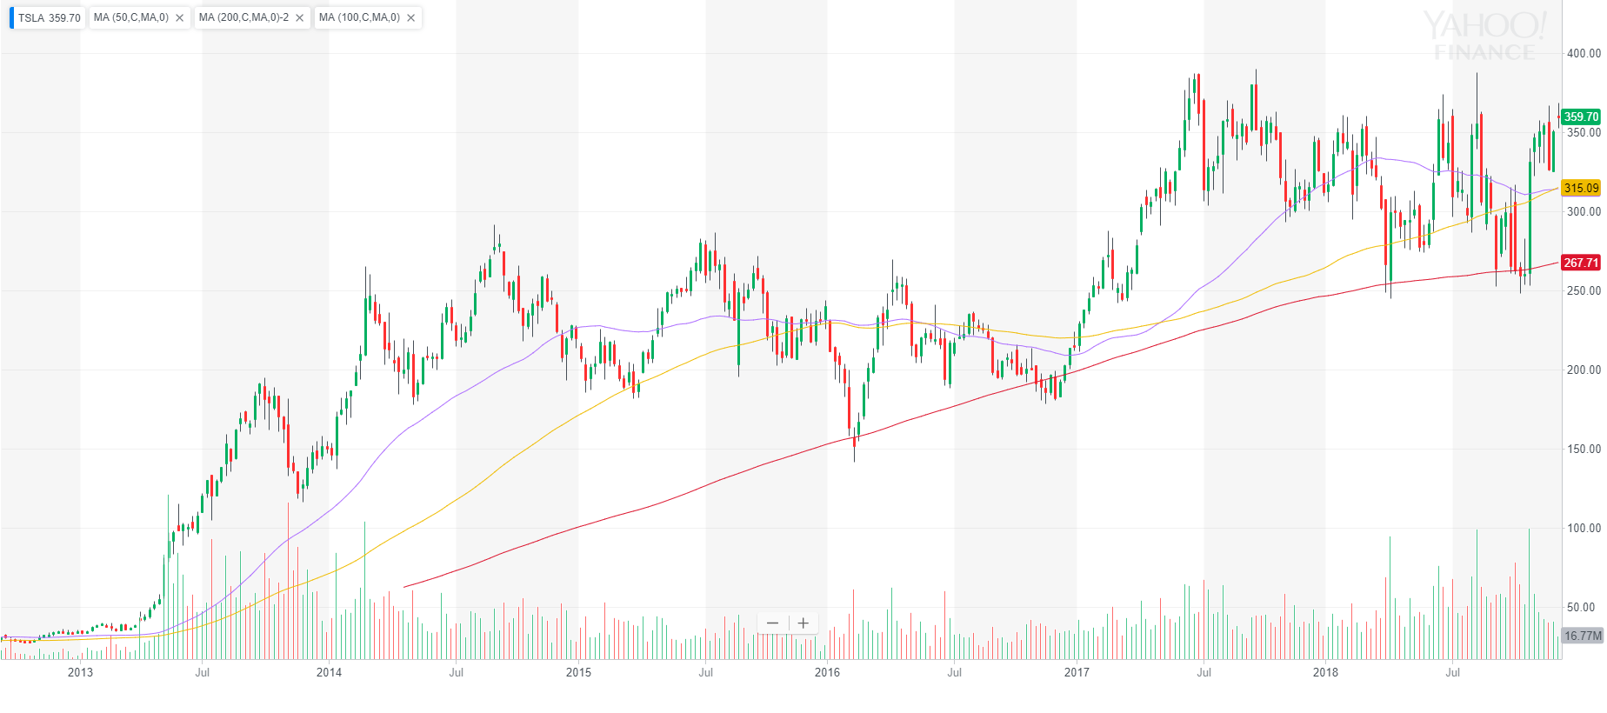³
From highest to lowest price at the beginning of 2018, we see the 50 Moving Average, 100 Moving Average, and 200 Moving Average.

The most volatile moving average (MA) is the 50 MA, the intermediate moving average is the 100 MA, and the stable lower moving average is the 200 MA. All of these averages use weekly values. We can make our moving averages less volatile with monthly candlesticks, or we use can daily or hourly candlesticks to make our graph more volatile.³ Depending on the underlying stock, different time periods may make more sense. You can find past time periods to analyze by searching for a moving averages that act as a valid support and resistance levels.

In $TSLA, we see that the weekly 200 MA in particular historically acts as a very strong support level. The stock tested this moving-average-support level four times in early 2016, late 2016, early 2018, and late 2018. However, the market brought extreme buying power to the stock at these averages, quickly reversing price movement. These averages can often be a great place to enter an order because you can expect the stock to move quickly away from the historically-strong moving-average level.² In case the stock breaks through the MA into a downtrend, you can set your stop-loss a reasonable distance below or above the moving average (if shorting).
Add 50, 100, and 200 moving averages to all your charts to analyze unseen support and resistance levels. Here is one more example with eBay Inc:.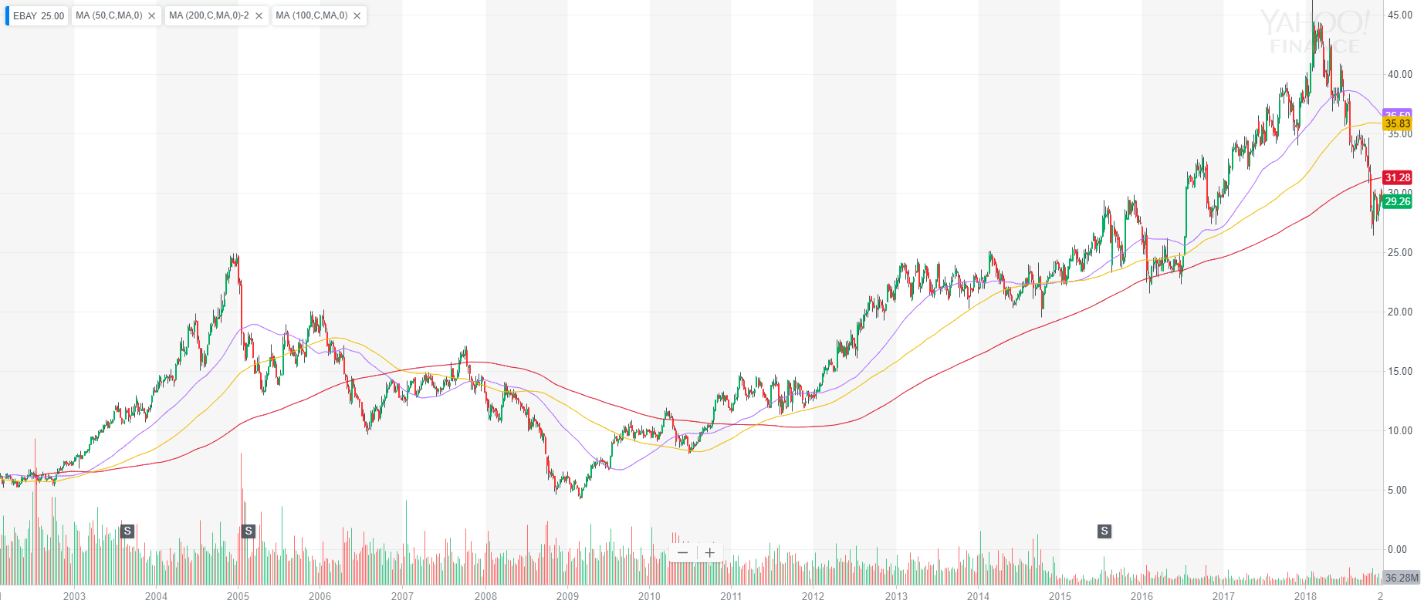⁴
From highest to lowest final price, we see the 50 Simple Moving Average, 100 Simple Moving Average, and 200 Simple Moving Average.

In recent bullish years, $EBAY consistently bounced off its 50-, 100-, and 200-week moving averages to continue upwards (highest to lowest average lines, respectively).⁴ The current price below the 200-week MA suggests bearish sentiment as the stock enters a seemingly flag-shaped pattern with newfound lows past the supposedly supportive 200 monthly moving average.
However, as we look towards $EBAY’s pre-2008-crash price action, we see a significant moving average indicator: the death cross. Death crosses occur when a short-term moving average (say the 50-period) crosses a long-term moving average (200-period).² ⁵
Death crosses indicate a significant shift in market sentiment. Crosses in longer-term moving averages such as weekly or monthly moving averages are significantly stronger than shorter-period MAs.⁵ Weekly moving average death crosses forerun almost every major market crash in the S&P 500.⁶ These long-term moving averages can predict a stock’s price reversal for years, whereas shorter daily or hourly MA death crosses can predict temporary price movement.
Alongside death crosses which suggest lower future prices, a golden cross indicates higher future prices. This cross happens when a 50-period moving average rises above the 200-period average.⁷ After $EBAY’s 2007 death cross and subsequent downtrend, the stock began a recover run-up and performed a golden cross in 2011.⁴ After this cross, the stock continued an upward rally. Often, upward trends indicated by a golden cross can last much longer than downward trends indicated by a death cross.

Simple moving averages form great setups on your charts. Some alterations of moving averages are weighted moving averages, exponential moving averages, and moving average envelopes.
Weighted moving averages give more weight to recent prices. In our five-day MA from before, we could use the following calculation:
⁸
Weightings can differ depending on how much you want to emphasize recent price trends. You can use any weighting metric you want as long as all price percentage makeups add up to 1 or 100 percent. In our example, the most recent price is five times more influential to the moving average than the first closing price in the five-day average. This is a normal price weighting since each time period closer to the current price is weighed one increment more than the last.¹¹ Similar to simple moving averages, a new time period’s price will enter this calculation as the most weighted factor while the last price in the old average is forced out of the calculation as all other prices move back one spot.⁸
Exponential moving averages (EMA) uniquely use previous exponential moving averages rather than prices to calculate new averages. To find an exponential moving average, use the formula:

where

and
¹¹

In our five-day average from before, the EMA would be:
¹¹
So, to recap, our simple moving average is $12.40, our weighted moving average is $12.47, and our exponential moving average is $12.77.
Both weighted and exponential moving averages follow stock trends slightly faster than simple moving averages. You may find these averages more helpful in short-term scenarios where you want to quickly follow the underlying momentum, support, and resistance in a movement. However, shorter-term simple moving averages also accomplish this goal, often with more consistency.⁹ Experiment with what works best for you, and understand that you’re often thinking too hard when you focus on fine details.
Here’s a long-term example with Cimarex Energy Co. using simple, weighted, and exponential 200 moving averages. To enter these in Yahoo Finance, simply add a moving average and click on “simple” to change to weighted or exponential.
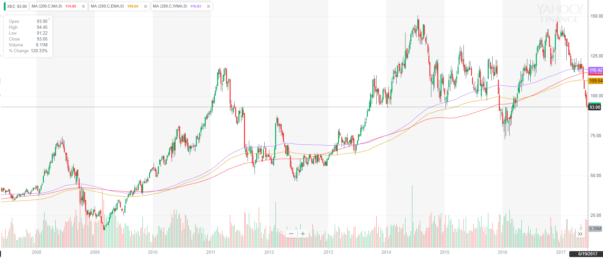¹⁰
From highest to lowest final price, we see the 200 Weighted Moving Average, 200 Simple Moving Average, and 200 Exponential Moving Average.

Here, the weighted and exponential weekly moving averages closely follow the simple moving averages. For support and resistance levels alongside price-average crosses, these averages function similar to simple moving averages. However, weighed and exponential moving averages are generally used less because of their increased complexity compared to simple moving averages. This is shown specifically in this graph of $XEC in late 2011 to 2013 when the stock initially bottomed under the weighted and exponential 200 MAs at the simple 200 MA.¹⁰ The stock later found resistance and broke away from its lows when it crossed back over the simple moving average.¹⁰
As more people use simple moving averages, the perceived significance of the calculated psychological price level increases. Nonetheless, all three of these moving averages help you identify trends. Simply use one to three simple moving averages on your charts, and they will help you identify long-term and swing trends through lagged average prices. Stick with 50, 100, and 200 simple moving averages to find the best natural support lines, resistance levels, and moving-average crossovers in stocks and more. Trend is your friend, and moving averages help you identify and profit from price-average crossovers, moving-average crossovers, and large potential moving average deviations.⁹

Yahoo Finance also allows you to add a moving average envelope to your charts. By default, Yahoo Finance bases this envelope on the 50 moving average, but you can change this to 100, 200, or anything else.⁶ Yahoo also systematically sets the moving average envelope charts with a plus or minus 5 percent range.⁶ Even though you can change the percent values for the range, this envelope proves less predictive of support and resistance levels in practice. Rather, look at basic moving averages alongside Bollinger Bands to measure how far a price deviates from averages (we’ll look at Bollinger Bands in Chapter 32). This indicator is better because it dynamically adjusts for price volatility rather than applying a static percent deviation to a moving average.²
As for nine-to-noon trading, you’ll primarily use long-term moving averages to identify potential intraday support and resistance levels. Alongside VWAP, which we’ll discuss in Chapter 33, you can also use shorter 20 or 9-period moving averages to predict intraday support and resistance levels with short-term candlesticks. These short-term moving averages work especially well when identifying support and resistance levels in one or five-minute candlesticks.¹⁸ Combine these moving averages with longer-term support and resistances from 200, 100, and 50 daily, weekly, and monthly levels to improve nine-to-noon trading consistency.

Moving on from moving averages, we discover the Moving Average Convergence Divergence (MACD) and Moving Average Deviation indicators.
The Moving Average Deviation simply tracks the standard deviation of a stock’s prices away from any given moving average.¹² The most-used and default moving average for the MA Deviation in Yahoo Finance is a 12-period average.⁶ You can use the MA Deviation like the MACD to track volatility, trends, and potential reversals. Here is Apple Inc. with both MA Divergence and MACD:
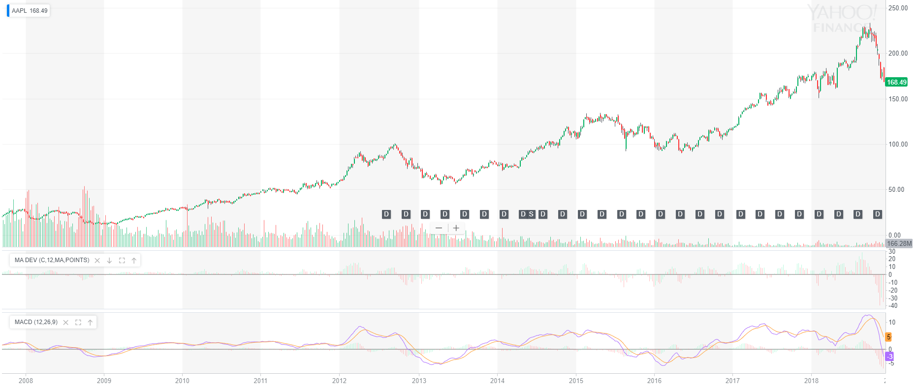¹³
$AAPL moves up as the moving average deviation simultaneously rallies before eventually crashing back down when $AAPL pulls back.¹³ You can time these movements by looking for the MA Deviation to crossover the positive-negative average midpoint to find a great buy and sell opportunities at optimum prices. As you increase your time period, these movements become more significant. Note that MA Deviation is almost the exact same as the underlying bars in the MACD indicator.

The Moving Average Convergence Divergence measures momentum oscillation through a MACD Line, Signal Line, and MACD Histogram.¹⁴
The MACD Line is simply a stock’s 12-period EMA minus its 26-period EMA.¹⁵ This tracks weighted changes in the underlying stock’s price.
The Signal Line is a 9-period Exponential Moving Average of the MACD Line.¹⁵ Expect prices to reverse direction when the MACD Line crosses the Single Line like a death gross or golden cross, especially in longer timespans.
The MACD Histogram represents the differential between the MACD Line and the Signal Line.¹⁵ Therefore, the underlying stock has high momentum when the MACD’s lines and histogram rise alongside the stock, and this momentum reverses as the MACD’s lines and histograms reverse into negative convergence and divergence.
Now that you know the technicals, let’s look at the MACD on Six Flags Entertainment Corporation:
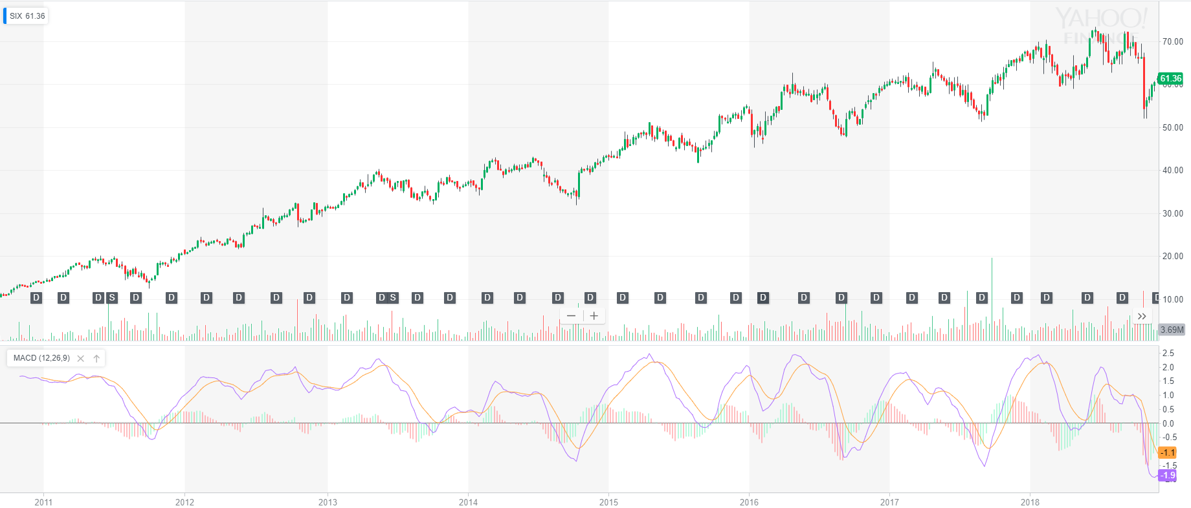¹⁷
Notice strong correlations to $SIX price and the MACD’s lines and histogram. The MACD is positive when the MACD Line is greater than the slower-moving Signal Line and negative when the rapidly-changing MACD Line is below the MACD Signal Line.¹⁶ Look for selling opportunities in extended markets and buying opportunities in lower ones. You can see that there are strong buying opportunities in $SIX when the MACD crosses below zero because there is strong market demand and momentum behind the stock. You can use MACD to find and confirm temporary pullbacks to get the best order prices possible when you enter a position. Use the MACD line to spot reversals in the MACD crossovers, peaks, troughs, and trends. Look out for green-to-red shifts, zero-average crossings, peaks, troughs, support levels, and resistance levels in the MACD histogram.

MACD lines may rarely form short-term trends alongside trading price action. You can draw trendlines on some particularly strong MACD lines to predict and trade future breakouts while you simultaneously watch the two lines for a strong cross.¹⁵

The MACD is a solid indicator that you can use on almost any medium- to long-term trading setup alongside 50, 100, and 200 moving averages. Keep these on your charts!

Chapter 32
RSI, Stochastics, and Bollinger Bands®

RSI, stochastics, and Bollinger Bands all help you identify extreme price movements in stock price. With this information, you can enter a trade near its most extreme downswing and exit towards the top with a technical background and basis behind your positions. These indicators help increase your trading consistency, especially while swing trading, by allowing you to easily play off trending or sideways environments with identifiable minimum and maximum series.

The Relative Strength Index was developed by J. Welles Wilder in 1978.² The indicator compares recent gains to recent losses, looking for oscillating differences in magnitude. Wilder recommends using a 14-period RSI, and this is by far the most popular increment used today.² To calculate the RSI, use the formula:
,
where (for a 14-period RSI)

and (for a 14-period RSI)

¹

This equation gives you a number between 0 and 100. RSI is traditionally considered overbought when above 70 and oversold when below 30.¹ In other words, the stock will probably go down soon when the RSI is extremely high, and it will probably go up soon when the RSI is extremely low. Yahoo Finance and other modern trading platforms extend RSI extremum values to 80 and 20 for more pronounced indications of overbought and oversold territory. When the RSI passes 80, consider selling. Inversely, consider buying as RSI hits 20.
RSI often lags behind tops and bottoms more so than other indicators in long-term setups. Just as with stochastics, you may see extended periods of high RSI levels before a stock comes back down. Bollinger Bands can help you find extreme peaks when a stock’s RSI indicates overbought territory.¹ With that said, oversold RSI levels often prefaces more immediate price movement. Let’s look at an example with Toll Brothers, Inc. to showcase this:

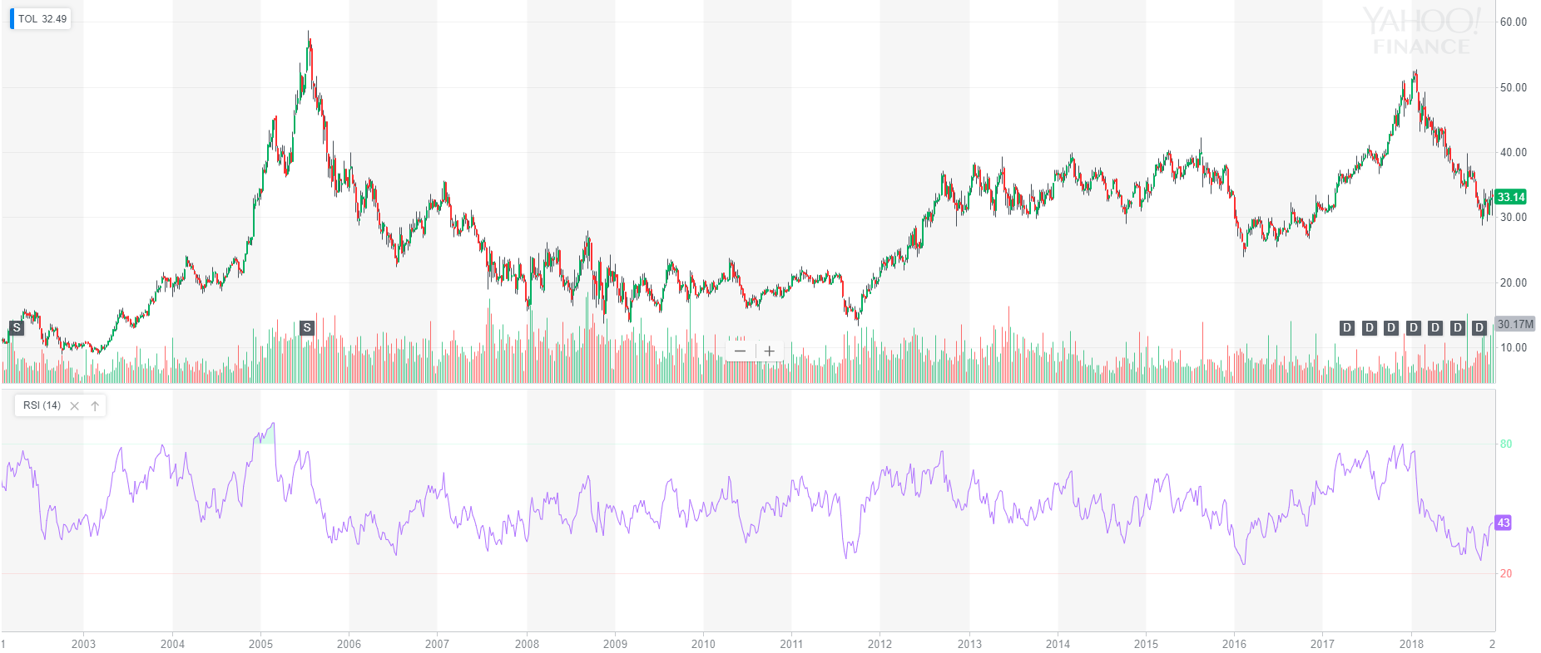⁵

Especially in the 2004-2005 $TOL run-up, we see extended RSI levels telling us to sell. However, prices kept rising after a quick drop in the RSI, showing that the stock had more momentum left. To lower your risk when making trades based on RSI, try waiting for the indicator to drop back below 80 when overbought or above 20 when oversold to confirm a movement reversal.³
In this example, the default RSI is relatively stable and presents only a few compelling buying and selling opportunities. To see more volatility in the underlying stock, we can decrease the RSI period to only 2, resulting in the following graph:⁶
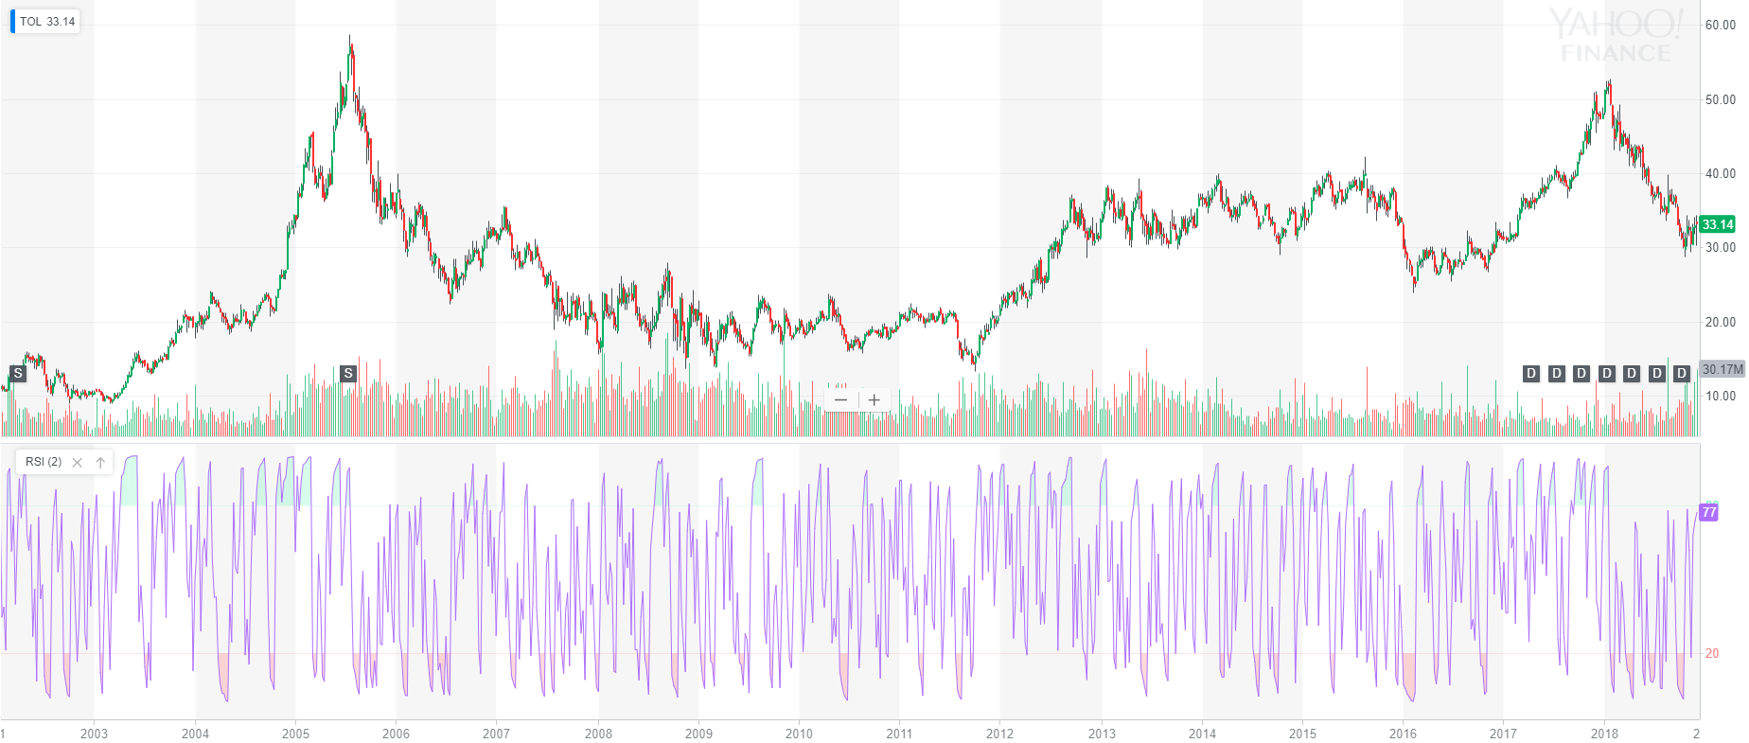⁵

Now, we see significantly more buy and sell signals since the RSI is greatly affected by smaller price movements. Combine the RSI with other indicators to confirm the best entry and exit opportunities for your trades.

RSI, stochastics, MACD, and more can all indicate reversals through divergence. Divergence occurs when oscillating indicators trend in the opposite direction of the underlying stock price as opposed to convergence when the indicator follows the trend direction to show strength.³ So, prices might diverge while MACD and RSI trend downward. This often occurs in movements when the price is already extremely high or low, and the indicator often tries to return to normalcy. Although this movement is slightly rare and often short-lived, you can use it to strengthen your analysis when you see extreme oscillation to forecast reversal patterns in your stocks.
Here’s an example of divergence with McDonald's Corporation. Notice that it takes a while for the setup to actually complete and break below the resistance as the MACD and RSI trend opposite to price movements. There can still be significant gains in a position after the RSI indicates an oversold condition if other market factors keep pushing a stock.

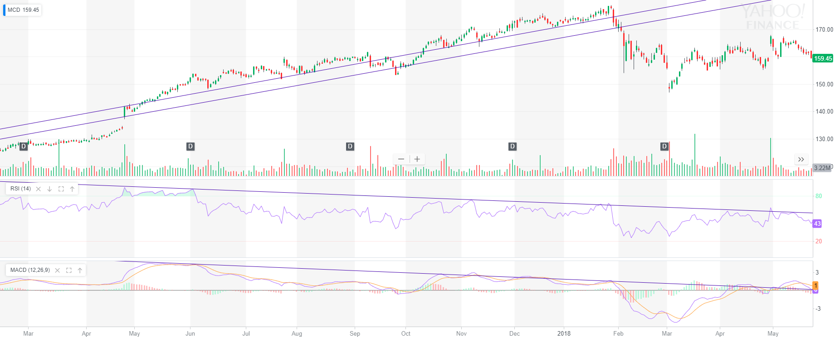⁷

As soon as the stock shows weakness towards the end of this divergence, $MCD crashes through its support and finds new lows. Even if you miss the breakout in a divergence movement like this, you can use subsequent bottoms as great buying opportunities. If you are in the position during the divergence and looking for times to sell, watch for indicators crossing their midpoints. If you don’t get in a trade at an extreme RSI value, especially watch indicator midpoint values. You will likely see quick reversals if the RSI shoots through 50 and leaves its midpoint behind.⁴

Stochastics, created by George Lane, are an extremely accurate indicator when you use it in a stock’s historically-proven effective interval range.¹¹ The indicator stands as a favorite indicator to many because of its high accuracy.⁸
Stochastics combines extremely well with other indicators and work splendidly on their own to help you find the best place to enter and exit a trade. The indicator uses two lines plotted along a 0 to 100 oscillation chart similar to the RSI with extremes at 80 and 20.
To find the quicker K stochastics line (black by default in Yahoo Finance), use

To find the slower D stochastics line (red by default in Yahoo Finance), use
⁹
The lookback period for the K line by default is 14 periods. This value keeps your stochastics accurate and prevents false signals while still showing you setups as they arise. The default lookback period for the D line’s is 3 periods. Because the D line is a simple moving average of the K line, it moves slower than the K line. You can use this speed difference to spot crossovers in the stochastics lines just as with MACD lines to indicate potential price reversals, especially at extreme values below 20 and over 80. With these critical levels, stochastics measure upward and downward momentum to help you predict price reversals.¹¹
As with all other indicators, the timespan for stochastics changes as you change the length of individual candlesticks, and longer timespans generally predict stronger results and trends. Let’s look at an example with Newell Brands Inc. using Stochastics, RSI, and 50 and 200 moving averages:
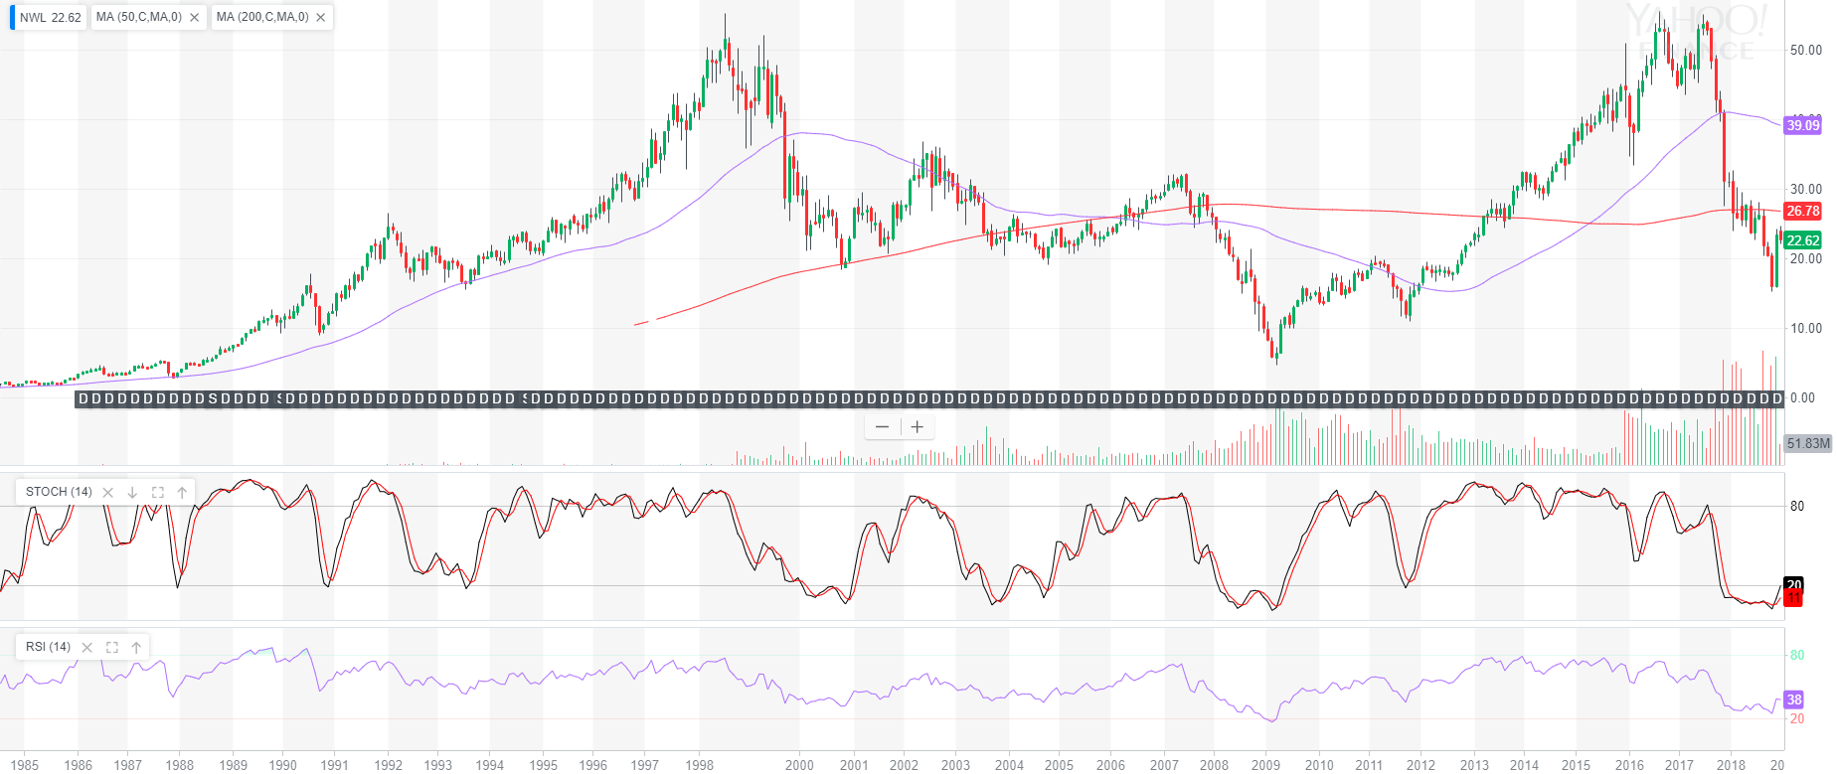¹⁰

In this monthly chart, notice two primary lower stochastic patterns. First, you can see quick downtrends followed by rapid bounces back up, presenting you with tremendous buying opportunities. In stochastics, this shows up as a quick drop and seemingly immediate bounce off the 20 level. Then, there are slower downtrends the gradually decrease stochastics. In times like 2000 and 2008, $NWL stayed under the 20 stochastics level for a while until prices started to rally back up. For a conservative entry into an order like this, wait for the underlying stock to clearly and deliberately reverse enough to bring the stochastics straight through the 20 level, rocketing back toward a midpoint pivot at the 50 stochastics level.
Alongside great buying opportunities when stochastics are low, you can also find good selling opportunities when stochastics are high. With that said, stochastics often stay high during extended rallies, signaling that you might want to wait for the stock to cool off before entering a long position. If you are already long or looking to take a short position, watch for the stochastics to crash back below the 80 level after a run-up. High stochastics often persist through big bull runs. As stochastics eventually break below the 80 level, you want to watch for an approach to the middle-50 level again to indicate impending downtrends. We see this especially with the initial 1999, 2007, and 2017 drop in $NWL. Here’s a short-term example on a larger stock to demonstrate this principle:
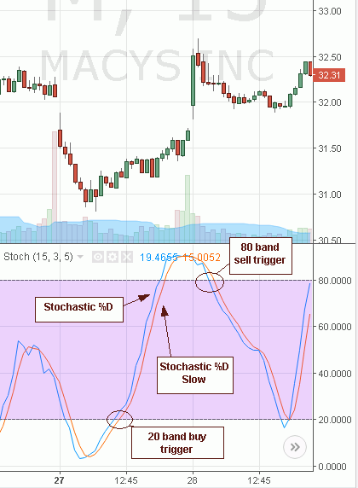¹²
Alongside the stochastics crossing the 20, 50, and later 80 level, notice how the faster K line breaks through the D line almost perfectly at the top and bottom of this movement in $M just like a MACD crossover.

Furthermore, here’s one last example with 1-800-FLOWERS.COM, Inc.:
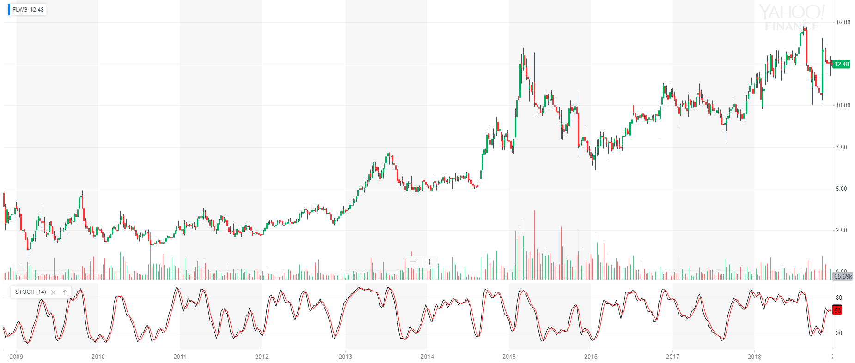¹³
Almost every single bottom in the weekly stochastics correlates to a swift reversal in the market, while the biggest downtrends come at the end of an extended high-stochastics streak. Combine stochastics with other indicators, moving averages, and more to find opportune times to enter and exit a position. Remember that stochastics can remain overbought and oversold for an extended period of time. Look at the stochastics of a stock you’re considering and see how it historically performed at high and low stochastics levels.

When looking for divergence in stochastics, you’ll likely find the most success when the indicator is near an extreme 20 or 80 value, as shown below:
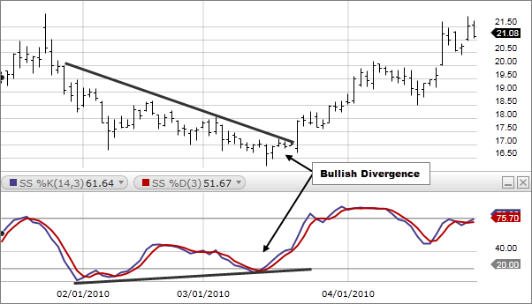¹⁴

Like with all oscillating indicators, draw lines when you see a potential indicator trend and correlate them to support and resistance trendlines in the underlying stock.

A slight variation of stochastics is stochastics RSI. Rather than being based on the actual price of the stock, stochastics RSI is based on the stochastics of a stock’s Relative Strength Index.³² You can generally use stochastics and stochastics RSI interchangeably, though stochastics alone tends to be more accurate since it tracks the actual underlying stock price. However, some platforms use stochastics RSI in place of stochastics, so just know that they work approximately the same. Stochastics RSI often moves slightly faster than stochastics, as shown below. In the end, stochastics RSI mimic stochastics to an extreme.

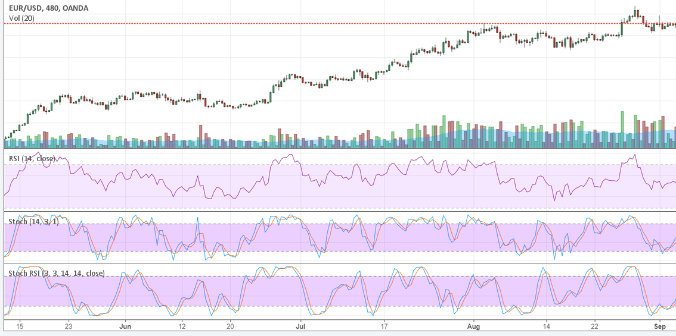¹⁵ ¹⁶
From the highest to lowest chart element, we see the standard candlestick graph, RSI, stochastics, and stochastics RSI

Stochastics RSI can stay extremely high or low for extended periods of time until a stock eventually pulls back or runs up like with traditional stochastics. Timeframe changes drastically alter stochastic perspectives. Decrease your candlestick reference length to find more immediate opportunities, or increase said data to identify swing-trade movements.

Lastly, we get to Bollinger Bands to identify and profit from extreme price movements and trend volatility. Bollinger Bands were created by John Bollinger in the early 1980s.¹⁷ You can calculate the three lines in the Bollinger Bands by using the equations:

¹⁸
The default values in Yahoo Finance are 20 for the simple moving average and 2 for the number of standard deviations. These are the Bollinger Bands values most traders use, and they have historically proven reliable.¹⁹ You can change the moving average lookback period and number of standard deviations to further restrict volatility movements in the Bollinger Bands if you see few trending signals with standard settings.

Bollinger Bands adapt to price action volatility by expanding and contracting because they are build around constantly-changing standard-deviation bands. Volatility decreases as the upper and lower bands near the central moving average when price changes slow down due to low volume or perhaps complacent investor sentiment. Periods of low volatility are frequently followed by periods of high volatility in either the upside or downside.²⁰ As the Bollinger Bands squeeze together, stretch out, and repeat, you can see constantly-changing volatility in an underlying asset, as shown below in Brent Crude Oil:
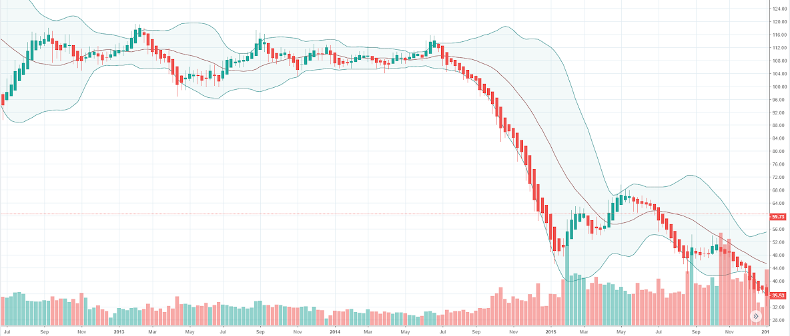²¹ ²²

After a five-month period of sideways movement and decreasing volatility, the market finally tested the upper region of Bollinger Bands, signaling an impending increase in volatility. After this test failed, Brent Crude went through on a rampant three-month selloff of increased volatility. The tight Bollinger Bands for the five months prior rapidly expanded as the market radically adjusted its price point on Brent Crude.
When you notice prolonged periods of low volatility in Bollinger Bands, be prepared to place your bets when the stock starts moving again. You can look especially for prices to continue in the direction of a previous trend.²² In the example above, Brent Crude Oil had a long downtrend prefacing this movement.²¹ If you’re unsure about where a movement might go, simply wait for the first decisive initial breakout like with a symmetrical triangle pattern.

In strong downtrend or uptrend, prices can continually run along the Bollinger Bands as buying or selling remains strong. You can predict a trend reversal once prices start falling away from extreme values, perhaps falling back towards moving averages.²⁴ Watch especially for prices bouncing off the edge of Bollinger Bands into the central moving average as a sign of slowing trends. If the price doesn’t bounce back away from this average, then the stock may finally reverse. Here’s an example with BlackBerry Limited: 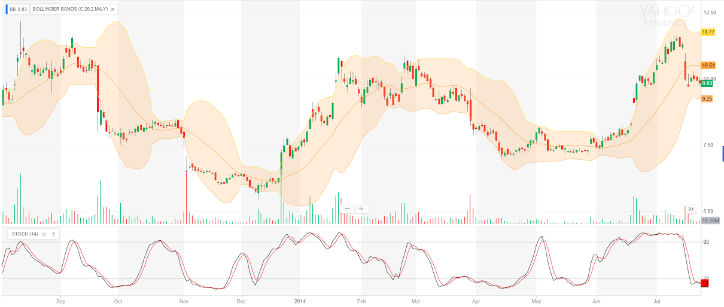²³

Notice that $BB actually breaks out of the Bollinger Bands during many movements from 2013 to 2015. This extreme move often leads to rapid a correction, although this may not be an extreme correction if there is enough momentum in the movement, as shown in $BB’s 2014 initial pop out of the Bollinger Bands. However, sustained breakouts of the Bollinger Bands later in an upward movement after an already large move may showcase the end of a movement, as shown above in early 2014 before the formation of a “W” pattern.²³

Two distinct patterns that form in the Bollinger Bands are “M” and “W” patterns. Ms and Ws play off support and resistance levels just like many other price setups, but they also respect and bounce off Bollinger Band trendlines. Below you can see an M setup in Exxon Mobil Corporation:
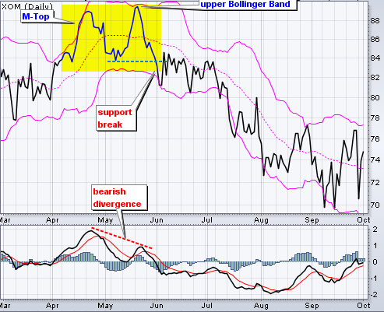²⁵ ²⁶

Notice that $XOM nears the upper Bollinger Band on its second M run-up, but it lacks the momentum to break through. As it breaks its lower M support line, the trend reverses and, rather than trading at the top of the Bollinger Bands, the stock crashes along the bottom and even drops out of the Bollinger Bands as momentum slows and the MACD bottoms. As this chart points out, there was also a bearish MACD divergence while the M formed, further strengthening the impending downtrend.²⁵

Contrary to the M pattern, you can use the W pattern to spot impending uptrends. Here is an example with Nordstrom, Inc.: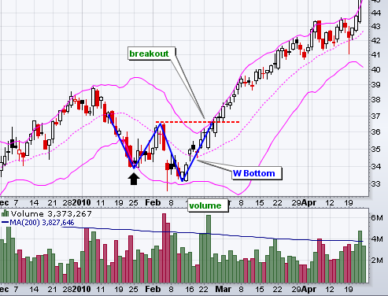²⁵ ²⁷
The goal with W and M patterns is to wait for the stock to break through its respective support or resistance. Unlike head-and-shoulders setups where you can skillfully time the second shoulder, these Bollinger Bands reversal patterns are less set in stone. As this chart along with the many other you’ve seen show, a stock can rally along the bands in a downtrend, even breaking out of theme with extreme momentum or lack thereof, before reversing price action. In this example, we see decreasingly less volume in the market after the W pattern completes in $JWN as fewer investors want to purchase the stock while it rallies near the top of the Bollinger Bands. The uncertain price action in $JWN only attracts big spikes in volume (and therefore market participants) when it touches the W resistance line, breaks through the resistance after bouncing off the Bollinger Bands, and eventually breaks out of the Bollinger Bands to newfound highs. If at all possible, try to see your positions as they break into newfound highs outside of the Bollinger Bands.

You can also use the Bollinger %b and Bollinger Bandwidth indicators to show volatility and potential divergence. By default in Yahoo Finance, these indicators use the same standard 20-period-moving-average and 2-standard-deviation calculations as Bollinger Bands.

Here’s an example showcasing Bollinger Bands, Bollinger %b, Bollinger Bandwidth, and moving averages in Carvana Co.:
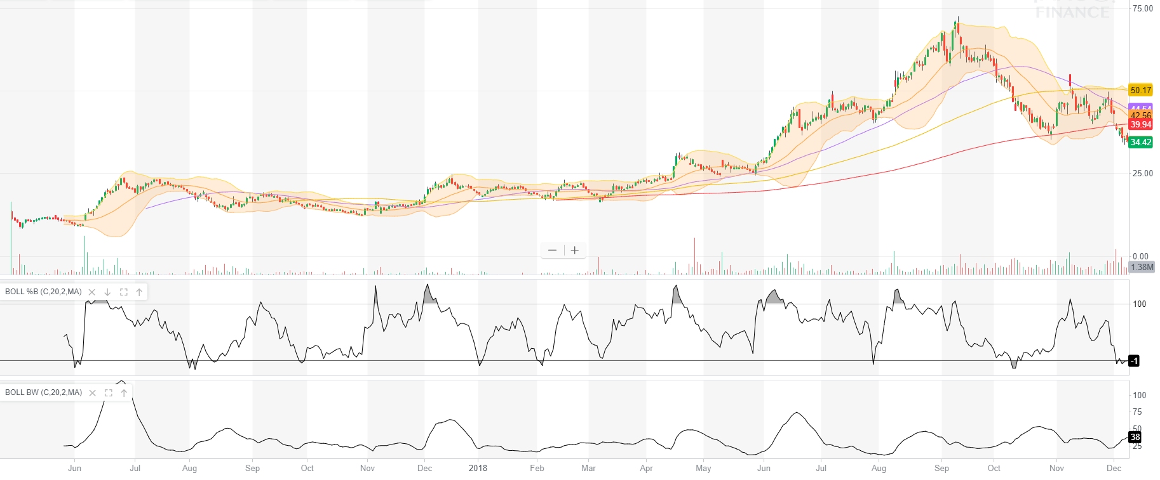²⁸

Besides simply seeing $CVNA pop out of the Bollinger Bands, the Bollinger %b graphs the stock price in relation to the Bollinger Bands by using an adaptation of the Stochastics formula.²⁹ So, you can watch for comminuted %b breakouts above 100 percent of the Bollinger Bands (aka when the stock has an extreme upward movement) to indicate strong momentum behind a stock, forecasting higher future trends. You can see this in $CVNA as it runs from just over $10 to $70 within a year, consistently breaking above the Bollinger Bands and respective Bollinger %b.²⁸ As we look into the future, we see more minimums in the Bollinger %b as prices quickly drop to a strong support around $35. Continued %b lower breakouts show a lack of momentum and could predict downwards price movement. On top of this, we see the daily 50 moving average quickly approaching the 200, forecasting a potential death cross. Lastly, you can see a head-and-shoulders setup in recent months. Both of these indicators’ immediate bearish predictions are further supported by the Bollinger Bands.
Lastly, the Bollinger Bandwidth shown at the bottom of our $CVNA chart showcases volatility by measuring the width of the Bollinger Bands.²⁹ High values and peaks here indicate large momentum and volatility, as you can see in the increasing size of the actual Bollinger Bands’ bands and subsequent moving-average standard deviation. In periods of low volatility, look out for divergence in the Bollinger %b.
The Bollinger Bandwidth indicator, with its default parameters, is four times the coefficient of variation.²⁹ You can effectively use this to find volatile periods and predict future volatility after very calm periods without looking directly at the Bollinger Bands. For reference, you calculate this coefficient using the equation:
³⁰

You can also use this calculation with an asset’s historical return and standard deviation to find a position’s risk relative to its return. For a higher standard deviation (aka taking on more risk), you should expect to receive higher returns. This will make your coefficient of variation lowest for assets that reward you best for the risk level you take.³¹ This calculation is especially useful when comparing long-term bonds or marketable funds. As an example, here are the coefficients of variation for three major indices tracked by ETFs. Lower coefficient of variation values show better risk-to-return payoffs.
- SPDR S&P 500 ETF:
- PowerShares QQQ ETF:
- iShares Russell 2000 ETF: ³¹
(15-year lookback period used, 2018)

You can find significantly higher returns with more volatile positions, but you must be conscious of potential downsides and adapt accordingly when market sentiment shifts to maximize your returns. It’s very difficult to time overall markets, but stay aware of macroeconomic factors that could influence your long-term portfolio value.

Chapter 33
VWAP and Circuit Breakers

Volume Weighted Average Price (VWAP) looks at average prices over a single trading day like a continually growing moving average while simultaneously accounting for volume.² You can use this indicator to identify support levels, breakout points, and resistances in an intraday movement. Essentially, the VWAP creates extremely strong psychological price levels for you automatically.⁴
Although the two look similar on your chart, VWAP often predicts future intraday price movements more precisely than standalone short-term 9, 20, or 50 moving averages because the VWAP accounts for the intraday volume a stock trades at as a significant factor in its average price.¹ Compared to moving averages which blindly assign the same value to each individual period, VWAP gives realistic price calculates by looking at the number of shares exchanged at any given intraday price level, dynamically adapting to market supply and demand.¹ Notwithstanding, moving averages and VWAP still work tremendously together as a means of identifying significant psychological price levels in nine-to-noon trades.
To calculate VWAP, use:
³
or, more simply, the combined total dollars traded in a single day (which is calculated by multiplying all orders’ share amounts by their respective transaction price) divided by the number of shares exchanged. So, rather than simply averaging last-trade prices, the VWAP looks at the actual perceived intraday average market value of a stock based on volume. Here’s an example on a nine-to-noon premarket gainer:
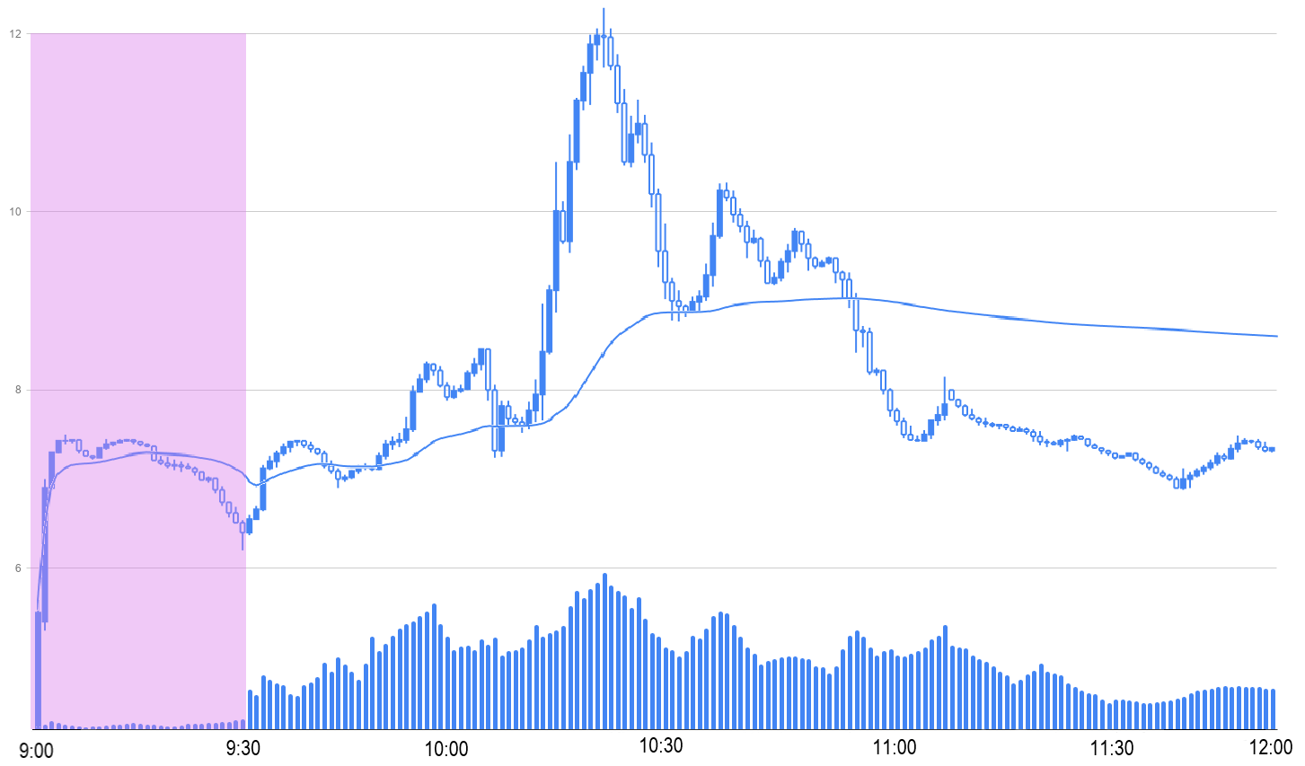⁵ ²⁸

In the early morning hours, the price skyrockets past the VWAP, but momentum soon slows as a short-term ABCD setup forms and the stock falls under the VWAP again. However, prices latter rally above the VWAP and complete the ABCD setup right before a slight interior Bollinger Band M setup that brings prices crashing through the VWAP. If the VWAP-price spread is large, then either the VWAP has to come down, or the stock has to go up. This principle holds especially true during the more volatile early-morning hours when prices tend to come back to or break through the VWAP in large moves.
After this pullback, the stock bounces off the VWAP again to pull a rapid bull run. If you missed out early on in this trade, you could still enter here as long as there is enough momentum. You can judge momentum given the number of shares exchanged daily on a stock versus its historical average number of shares traded. More traders will bring more buying and selling pressure to quickly move a stock, especially one with a low float. Since you can see increasing volume bars at the bottom of this chart, you could assume there’s strong momentum in this stock during the huge run-up, and perhaps get in during the first one-minute pullback. Entering on the first one-minute pullback can be especially risky as you start off, but you can quickly enter and exit large percent-gain trades by timing the first pullback in an inevitably upward movement. The trick is identifying strong momentum behind a movement and having the discipline to take profits or cut losses when necessary. In this particular trade, the stock tapered off after this morning run-up. Most nine-to-noon stocks slowly trend downward after a volatile morning as traders with profits and losses leave the stock for the rest of the day. Ensure you close your positions in these volatile stocks before the end of the day, as they can be completely unpredictable in aftermarket hours (we will talk about how to find these stocks in Chapter 36).
Here’s another example of a stock first trending above the VWAP but later falling beneath it:
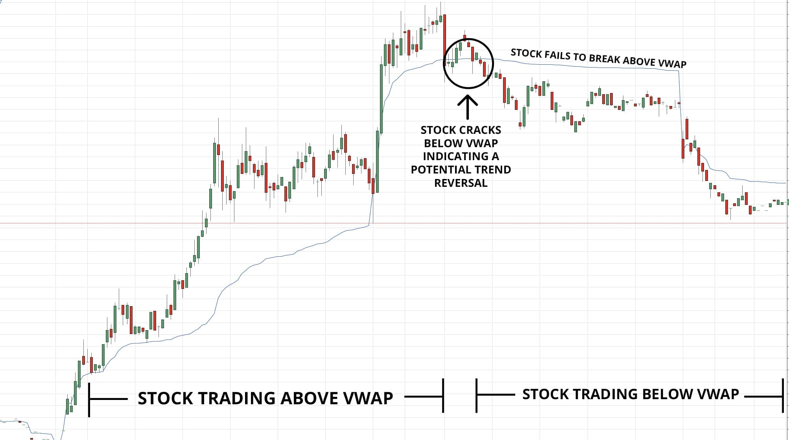⁶

Notice that the stock quickly climbs as it touches and subsequently bounces off the initial VWAP price. This VWAP also supports the stock’s initial upward movements and reinforces its later downtrend. As the stock trends, the VWAP gets closer to the actual price, providing a potential breakout or downtrend trade when the stock bounces off or breaks through the psychologically-significant VWAP.
Here is one last example using VWAP alongside upper and lower VWAP standard deviation bands.²⁵ You cannot add these standard-deviation bands with Yahoo Finance, but you can add them in most brokers’ trading platforms (we’ll talk more about brokers in Chapter 37).²⁶ ²⁷
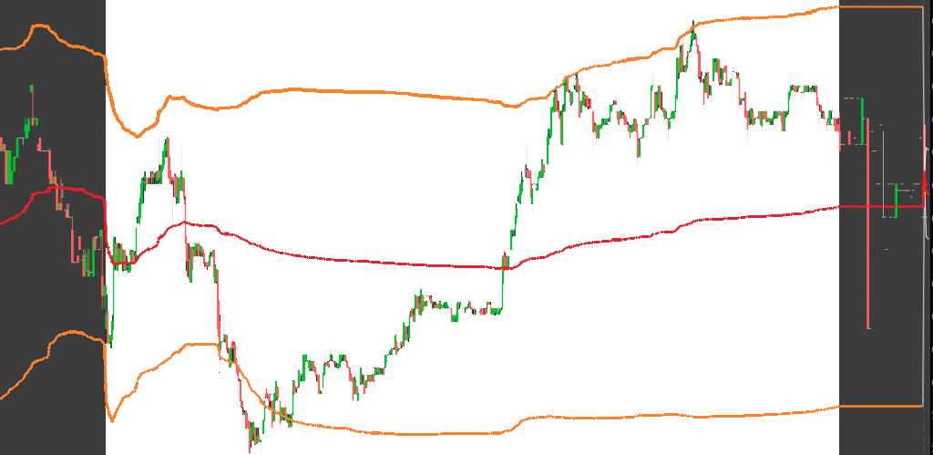²⁵ ²⁸

Notice that the VWAP (center line) acts as both a support in uptrends and a resistance in downtrends, like before. As the underlying stock breaks through this line, it quickly moves either up or down. In this example, the price runs almost perfectly towards the standard-deviation VWAP bands (upper and lower lines). You can use these as a profit target for nine-to-noon trading just like Bollinger Bands in swing and long-term trading. As you use VWAP with fast-moving stocks, focus on one and five-minute candles to accurately and automatically find support and resistance levels in your nine-to-noon trades. Just as a good limit order fill sets you up for profits, an accurate VWAP can help you set your order at the best possible price level.

Stock exchanges started enforcing circuit breakers after the dreaded Black Monday in 1987 when the Dow Jones Industrial Average dropped almost 23 percent in one day.⁷ Also known as trading curbs, limit ups, and limit downs, these automated mechanisms forcefully halt all trading temporarily in volatile markets. Circuit breakers affect the broad US stock market indices alongside nine-to-noon stocks. In times of economic panic, circuit breakers give market players a forced break to reconsider large selloffs in an attempt to decrease volatility.⁸ By understanding circuit breakers, you can learn to recognize and avoid them to protect your active and long-term investments. Without proper circuit-breaker knowledge in nine-to-noon trades, you can get stuck in illiquid and quickly-unprofitable trades.

Marketwide circuit breakers are currently based on percent changes in the S&P 500 (2018).⁷ These circuit breakers take effect when the overall index drops to a Level 1, Level 2, or Level 3 decline, as showcased below. Note that Level 1 and Level 2 circuit breakers only affect US markets if the S&P decline occurs 35 minutes before the market closes, whereas a Level 3 circuit breaker freezes all US-exchange-traded equities, options, and futures at any time.⁹
Circuit Breaker Level | S&P 500 Percent Decline | Circuit Breaker Time
Level 1 | 7 percent | 15-minute halt
Level 2 | 13 percent | 15-minute halt
Level 3 | 20 percent | All trading in US-exchange-traded equities, options, and futures halted for the rest of the day
⁷
Futures and options differ from stocks in that they trade outside of normal market hours. For almost all futures and options traded through the Chicago Mercantile Exchange, trading hours are Sunday at 6:00 pm EST to Friday at 5:00 pm EST with a one-hour break each day from 5:00 pm to 6:00 pm.¹⁰ Trading hours are slightly shifted for weather derivatives which track underlying changes in worldwide heating and cooling levels, but they still trade just under 23 hours a day, 6 days a week.¹⁰ ¹¹
Because of these differences, many commodity futures trade with daily price-movement limits. Unlike index limits which only limit losses, futures circuit breakers also limit price increases. These limits are usually the first signal of a trend change after a one or two-day maximum price movement (forecasting a reversal).¹⁵ Futures-contract limits depend on the underlying commodity traded and are often set around 10 percent per day.¹⁶
If futures circuit breakers are triggered for consecutive days, then assets can move more the second day and even more the third consecutive limit day, just as with market-wide circuit breakers (increase amounts depend on the underlying asset).¹⁵ Futures contracts that track the S&P 500 and all other global equity indices follow the S&P circuit breaker system above during market hours alongside a plus or minus 5 percent limit aftermarket.¹⁷ ¹⁸

Currencies and cryptocurrencies do not have centralized circuit breakers since they are traded on 24-hour exchanges to provide global value liquidity (ignoring Bitcoin futures which currently trade like an equity index, 2018).¹² ¹³ ¹⁴ ¹⁸

Individual stock circuit breakers halt stocks that move over certain percentage bands during any five-minute period.²³ Intended to give the market time to react to extreme volatility, these circuit breakers can cause your position in a stock to significantly drop in value when it opens back up. When the stock drops, it can reopen at any price as exchanges clear and freeze orders and investors change sentiments about their positions.¹⁹

Individual circuit breakers designate securities as Tier 1 or Tier 2 National Market System Stocks depending on whether or not they are included in major US indices.²¹ The two classifications have different circuit-breaker percentage parameters for stocks above $3, as shown in the circuit-breaker parameter chart below.²² Tier 1 Stocks include all NMS Stocks in the S&P 500, the Russell 1000, and a semi-annually list of unleveraged exchange-traded products that average at least $2,000,000 traded per day.²⁴ Tier 2 Stocks include all other securities and funds less broker-dealer or corporation-issued options called rights and warrants.²⁴ Leveraged exchange-traded-products’ percentage parameters are the same as the following table multiplied by their leverage ratio.²⁴

Previous Closing Price | Circuit-Breaker Percentage Parameter (5-minute change)
> $3.00 | Tier 1: 5 percent  Tier 2: 10 percent
$0.75 up to and including $3.00 | 20 percent
< $0.75 | Lesser of $0.15 or 75 percent
²²
Price band percentages are doubled during the first 15 and last 25 minutes of trading, and trading must persist outside of the percentage bands for 15 seconds to trigger a circuit breaker.²²

Circuit breaker initially halt trading for five minutes.²⁰ If the exchange that issued the halt still deems the security unready to trade due to significant imbalances between buy and sell orders, then they can extend the halt up to ten minutes, after which other exchanges can resume trading in over-the-counter markets thereby reopening the stock.²⁰

Here’s an example of circuit-breaker halt on Plan Green Holdings Corp. stock, a premarket gainer and nine-to-noon trade:
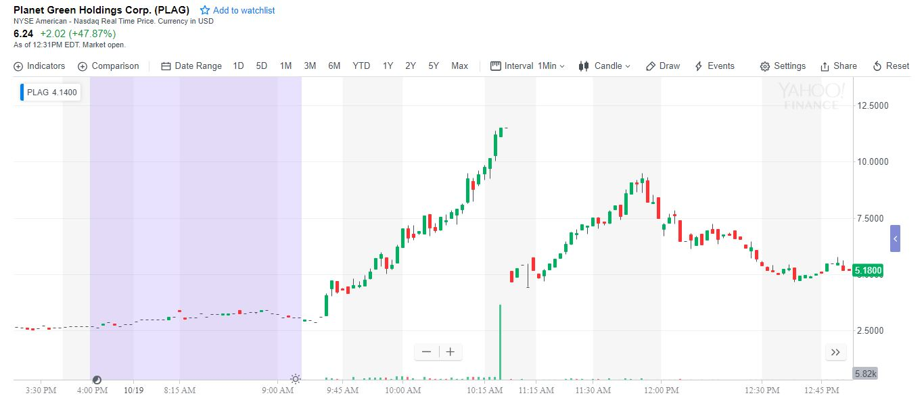²⁹

$PLAG was halted after the first fifteen minutes of trading, so it's circuit-breaker parameters were not doubled. In the five minutes before the halt, the stock moved from around $8.50 to around $11.00. $PLAG is a Tier 2 stock since it’s not an exchange-traded-product or an NMS Stock in the S&P 500 or Russell 1000. Since the stock closed at $2.67 the day before this massive movement, its maximum 5-minute percentage parameter was 20 percent. Using the approximate-price equation
8.50 + (8.50 0.2) = $10.20,
we find that the stock traded above its circuit-break level up to the daily high for fifteen seconds before a five-minute halt was enacted. Notice that volume significantly increased just before and just after the circuit breaker. On the way up, you almost always want to sell out of a position if you see a potential circuit-breaker halt forming. Circuit breakers are extremely risky because you have no control or clue where a stock will open after the halt.¹⁹ Sometimes momentum carries up into another halt, but stocks also often go through tremendous drops after halts, especially after a large run-up in a nine-to-noon stock.
Note that $PLAG did a 25/1 reverse split 14 days before this movement on November 19, 2018.²⁹ Reverse splits can be huge, unrealized catalysts in nine-to-noon stocks. Additionally, the stock broke through a recent resistance at $4.75 during this movement.²⁹

If you identify a potential circuit breaker, try to exit with your profits before trading freezes. The untold price-volatility risk of frozen trading rarely exceeds potential intraday returns. Remember that halted stocks can’t change price, but investors can still cancel unfilled orders and trade options during the halt.³¹

More rarely, stocks can halt because of more obscure news or regulatory concerns that can last much longer than traditional circuit breakers.³⁰ Among others, three standout halts are the T12, H10, and T1 halts.¹⁹ All three of these infrequent halts essentially occur only in nine-to-noon stocks.
A notably rare T12 halt occurs when the trading exchange requests additional information from the underlying company, often after a significantly volatile trading period. The SEC can initiate a T12 halt on a stock for up to 10 business days at any time they think the investing public may be at risk.³² Often, prices in T12-halted stocks seem manipulated or over-speculatively traded.
H10 halts occur when the SEC suspends trading on a stock.³⁰ These halts can last for days or weeks as the SEC investigates criminal manipulation of a given stock.¹⁹ These halts are most common in penny stocks traded on OTC pink sheets since these often-poor-quality companies do not meet standard exchange listing requirements and may not stay credible with the SEC, sometimes trade at fractions of a penny with exceedingly low liquidity and volume.³³ These halts in particular can lead to extreme price drops in penny stocks.¹⁹ You can avoid these halts and make strong profits in these extremely-cheap stocks, but you should find safer, consistent growth with nine-to-noon stocks which we’ll explore in Chapter 36.
In an uncommon T1 halt, trading is halted as a company issues news during market hours while freezing trading during the press release to allow investors to consider.³⁰ When stocks make large moves based on rumors, the underlying company might issue this forced circuit breaker to release news and remedy rash investor buy or sell panics with level-headed facts about company's fundamental growth.¹⁹ These halts can last hours and potentially reverse large run-ups based on speculation and invalid catalysts or attempt to calm investors with stability as the market sells, fearful of corporate bankruptcy.¹⁹ Either way, these halts freeze market liquidity and present a large risk in the very rare cases that they occur, but there is little you can do to stop or predict a T1 halt. Avoid the halts you can predict, and simply recognize and scale out of the ones you cannot.

Chapter 34
Combining Trendlines and Indicators

It’s tough to predict the exact top or bottom of any stock movement. Nobody is perfect in financial analysis, and many long-term prices average out over time. However, you can get optimal fill prices by using trendlines and indicators. These rarely form perfect setups on their own, but they present compelling opportunities when used together to identify trends. Some indicators work better than others depending on the stock you’re trading, whereas other assets rely more on trendlines. Try out different indicators and trendlines on stocks to find ones that work in a given situation. All of the indicators you’ve learned about work well in different analysis situations. You may get better results with an indicator or perhaps find a stronger trendline when you change the time frame of a stock chart. Most indicators look radically different as you change from hourly to weekly candlesticks. As you find the asset-management time commitment that suits you, you’ll naturally figure out which indicators and trendlines work best alongside your trading strategy. All indicators eventually return to normalcy.
Here’s a standard chart on Amazon.com, Inc. using every indicator we’ve discussed: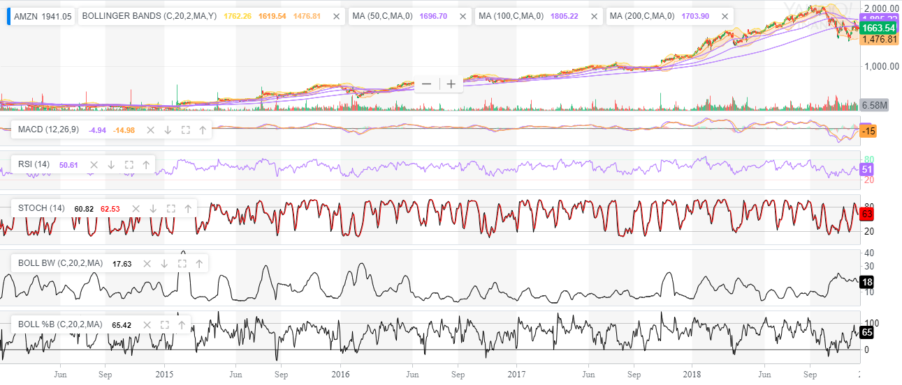¹

Try to efficiently and systematically remove indicators from your charts that you see no setup in until only a few indicators remain. Especially with shorter-term charts, you may base positions entirely on price action, trendlines, and VWAP alone. Still, indicators can help in any given situation. MACD, RSI, and stochastics in particular seem helpful in this trading situation. However, other indicators like Ichimoku Clouds may prove less useful in your analyses.
You can choose from hundreds of indicators in Yahoo Finance and your brokerage-specific trading software.³ We’ve gone through some of the most-adapted indicators that work well in a diverse range of trading situations. Try these indicators out on your stock charts and see what works well for you. If something doesn’t work for you in a certain situation, remove it to declutter your charts.
For reference, Ichimoku Clouds plot moving averages and “clouds” derived from moving averages to predict a stock’s current trend and forecast future crossovers.⁴ You can use these slightly-messy clouds to identify a current stock trend just as you compare current prices to moving averages. There are many random indicators such as this one that adds complexity to most analysis.
Master the indicators given in the book. Figure out exactly when to use each one and make a few trades based on any combination of them. Once you master these core indicators and trendlines, you can move onto more obscure indicators, but always remember to stick to your principles and trading style that you’ll establish over time.

Here’s an example of overanalyzing Six Flags Entertainment Corporation with five trendlines, a weekly 200 moving average, stochastics, and MACD.
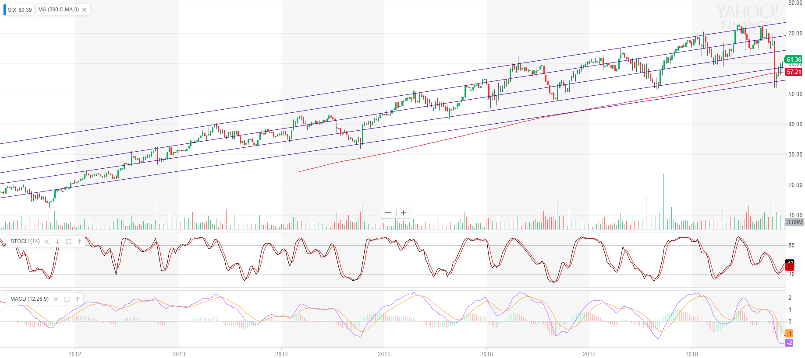³

These trendlines seem valid in this movement, but the sheer number of support and resistance levels makes $SIX difficult to analyze. By simplifying your trendlines to two or three primary trends, you can streamline your order-entry triggers stop-loss levels based on drops or rises into a stock’s strongest trendlines. The overall number of trendlines depends on the stock in question, but try to find the strongest diagonal trendlines along historical support and resistance levels. Combining simplified trendlines with strong, reliable indicators to clear up any remaining price confusion.

Alongside indicators, company fundamentals are crucial for long-term and swing-trade investments. Does the underlying company make money? Here’s an example with Advanced Micro Devices, Inc.:
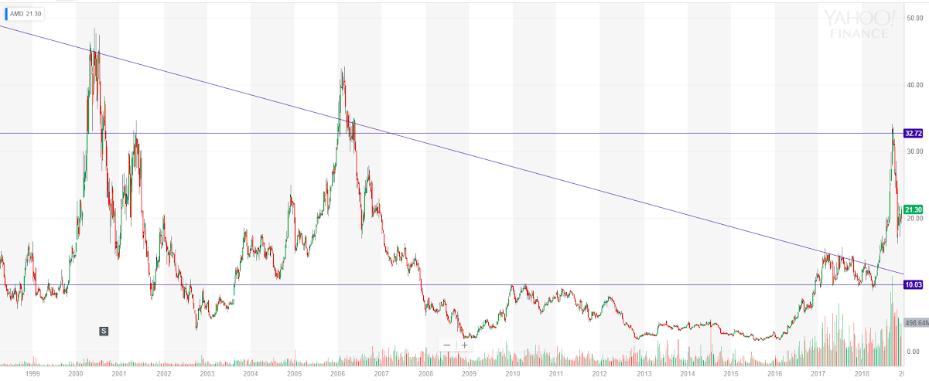²

Before the initial run-up that formed the recent wedge shown above, Advanced Micro Devices, Inc. invested significant time, energy, and resources into developing a new line of consumer-processing chips that significantly outperformed their previous product generation.⁵ Advanced Micro Devices was still unprofitable and down from its historical highs, but they showed potential innovation in their industry. After the Company launched these chips and retook a larger market share in the technology-chip sector, the stock skyrocketed from around five to fifteen dollars.⁵ ² However, this move proved to be short-lived as the stock soon crashed to a support at $10.² Yet, over the next year, $AMD proved very profitable and took a large market share from Intel Corporation.⁶ With this fundamental growth, the company broke out of its downward wedge and flew to historical highs. You can then time your exit from this trade or enter a short position based on previous resistance levels in historical large run-ups. The large previous run-ups also show immense long-term volatility in $AMD and further support a long trade in the stock for the hope of a similar run-up. By using your technical analysis skills, you can find a strong resistance just under the peak of two previous run-ups in 2000 and 2006 but at the very top of the 2001 upswing at $34.65.² You could also find a more conservative price target for the recent movement just over $31 based on historical consolidation at this price level in $AMD’s 2006 run-up and average peak in the 2001 bounceback.² With both fundamental analysis and technical analysis, you can find the best opportunities to buy, after the wedge breakout in this position, and the best places to sell, historical resistances in this position.
In-depth research about corporate fundamental and overall market shifts are key to long-term investments but matter much less for nine-to-noon trading compared to immediate news catalysts. By combined fundamental knowledge of any company with technical analysis and financial-report analysis, you can ensure the strongest long-term stock picks and best order entries on macro-factor-influenced positions.

Stay dynamic with your lookback periods and indicator usage. Put indicators on your charts and find ones that work well in different scenarios. Fluidly transition from daily to weekly to monthly candlesticks when analyzing long-term performance, especially with moving averages. With nine-to-noon trading, find historical support and resistance levels and trade with shorter 1-minute, 5-minute, and 15-min intervals. For swing trading, find a sweet middle ground with hourly or 4-hour candles. With enough indicators, trendlines, flexibility, and practice, your trading will surely improve.

Chapter 35
Diversification

Stocks are inherently volatile and you can lose your investments when you put all your eggs in one basket. By establishing, understanding, and following diversification principles, you’ll ensure long-term success in your retirement planning, savings-goal investments, and nine-to-noon trading.

Stocks may swing up or down 50 percent in a year. You can minimize your portfolio's volatility and improve overall performance by investing in a wide range of companies in a variety of industries.² You don’t want your whole portfolio reliant on three stocks in the unfortunate event two of them tank in one year.
The best path to long-term diversification is to limit your exposure to any single investment. Don’t let any single stock take up over 5 to 7 percent of your portfolio.¹ By following this rule, you ensure that single positions don’t determine the success of your overall portfolio.
You can never be 100 percent sure on any stock pick. So, your whole portfolio should determine your success rather than a few stocks.¹ With a wider range of assets, you give yourself many more chances to succeed while you slowly weed out underperforming investments. Give your losing stocks time to play out if they have a strong underlying setup, business plan, etc. before you cut them from your portfolio. Simultaneously, let your winners run until you think they have no steam left. Remember that the risk with any investment is that the entire company goes bankrupt and the stock goes to $0. Companies with long histories might be less likely to go bankrupt, but you still don’t want to let one stock take too much of your portfolio. By diversifying, you minimize the impact individual downtrends will have on your portfolio.
Funds stand out as one great exception to the 5-7 percent rule. Since ETFs and mutual funds already invest in a wide range of assets, all you have to do is consider how they balance their investments. Does the fund simply follow an index, diversifying it across the entire market? Perhaps it focuses on a specific sector. Does the fund invest in bonds or Treasury bills? Perhaps they dabble in foreign equity assets through individual investments or market-tracking indices. Nonetheless, these funds are already inherently diversified, so you may need to worry significantly less about diversification with these options.
Take the Invesco PowerShares QQQ ETF for example. This fund aims to mimic the Nasdaq-100 Index which includes 100 of the largest domestic and international non-financial companies listed on the Nasdaq stock market based on market capitalization. ³ ⁴ Since it has 100 stocks, the ETF is already fairly diversified. By balancing a few funds in other market sectors with the technology-heavy $QQQ, you can easily create a diversified portfolio suitable for reliable long-term growth. However, this fund alone may not give you ample diversification, especially in downtrends, because it focuses heavily in leisure-spending companies and holds particularly high individual weightings. For example, Invesco gives Apple, Inc. a 12.44 percent weight, Amazon.com, Inc. an 11.15 percent weight, and Microsoft Corporation a 10.01 percent weight in the fund as of September 30, 2018.⁵ Still, this leaves dozens and dozens of other companies diluting the volatility of these stocks with their own strong collective performances even though many are individually weighted under one percent of the ETF.⁵ Most ETFs and mutual funds are, by definition, well-diversified. The biggest risk you’ll see with these are market-sector dependence. You could counteract this sector-dependence with a more stable, historically-performing industry such as energy or industrial stocks depending on current market sentiment and macroeconomic trends.

On Yahoo Finance, you can hover over the “Industries” tab to get a condensed list of nine major global industries or click the tab to get Yahoo’s full list of 215 industries ranging from Auto Parts Stores to Cement (as of 2018).⁶ By spreading your investments across different, non-correlated markets, you can significantly increase your long-term diversification to mitigate short-term volatility. These new markets also open up opportunities for technical analysis to find strong potential stock picks.¹
You don’t want your entire portfolio to go down because you’re in technology or energy stocks exclusively. Let’s look at an elementary example to showcase the importance of having many market sectors captured in your overall portfolio:
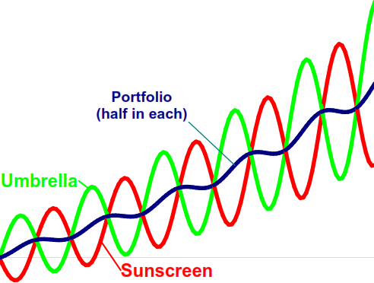⁷

If you invest entirely in a company that sells sunscreen, you’ll see strong growth during the sunny parts of the year, but poor performance when it rains. The reverse would occur if you placed all of your assets in the umbrella company. By balancing your investments between industries, you can achieve consistently reliable returns.⁸ The same methodology holds true in real-world industries, although correlation is slightly tougher to calculate. Everyone needs basic materials and utilities, but services and consumer goods might slump when markets run into trouble and spending decreases, especially luxury good companies (spending includes credit).
To see if two or more stocks or funds you’re considering strongly correlate, try comparing them in Yahoo Finance. Simply fullscreen a chart and press “Comparison.” Here’s an example with Visa Inc. ($V), Mastercard Incorporated ($MA), and American Express Company ($AXP):
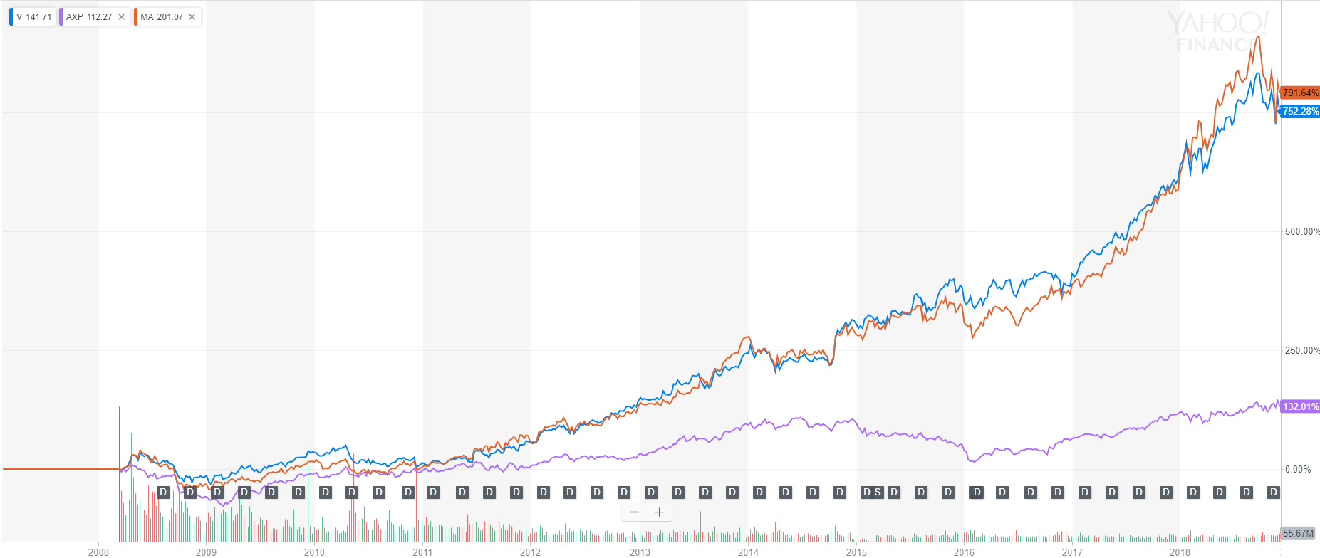¹²
From highest to lowest final return, we see Mastercard Incorporated, Visa Inc., and American Express Company.

Although $MA finishes slightly above $V, the two stocks have performed almost identically over the past decade or so while $AXP severely underperformed the duo. Therefore, we may choose to invest more of our credit-card-sector fund in $V since they currently pay a .75 percent dividend compared to $MA’s .5 percent dividend.¹⁰ Although $AXP currently pays a 1.48 percent dividend, its poor historical performance makes it a seemingly worse investment than $V and $MA in upward markets.¹¹ Notice, however, the all three credit-card companies follow the same general trends with high correlation, American Express Company just rises less historically.¹² The same principles should hold true for other companies in this market sector such as Chase Bank or Discover Financial Services. Therefore, we can diversify our overall portfolio with other market sectors and other stocks perhaps less reliant on the banking and financials sector.

The point of diversification is to protect you from rampant volatility in sector-heavy asset markets. By diversifying your portfolio, you can ensure consistent returns when all aspects of the market boom. However, remember that market sectors still perform and recover when overall indices do well. If you have smart sector-dependence, you’ll be fine with long-term picks that provide growing value, as sectors historically move together, as shown below with American-only equally-balanced and yearly-rebalanced mid- to large-cap sector indices:
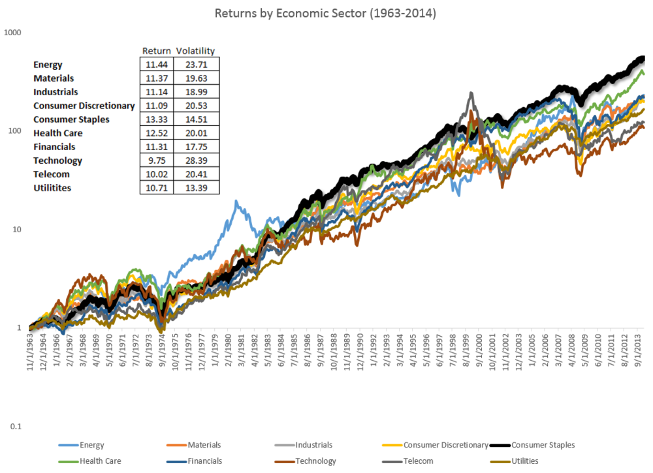¹⁸ ¹⁹
From highest to lowest final return, we see Consumer Staples, Health Care, Energy, Materials, Financials, Industrials, Consumer Discretionary, Technology, Telecom, and Utilities.

So, although one sector may boom while another one busts, the overall market increases together in the long-term. In this example, notice that consumer staples offer the highest historical sector return with the second lowest volatility. Not bad!

When you start out small, you might not be able to fully diversify due to your account size or commission costs. You might even have to avoid larger stocks until you start depositing into and growing your account unless you’re buying funds that are already diversified. It’s tough to balance a $5,000 portfolio around Amazon.com, Inc. when it costs upwards of $2,000 at its 2018 highs, but significantly easier enter the market buying computer-gaming-peripheral-company Razer Inc. for $0.15.¹³ ¹⁴ The great thing about stocks of all sectors and sizes is that you can buy as many shares as you want to achieve your desired position size as long as the price for one share fits into your portfolio. By working towards strong diversification, you’ll ensure long-term success no matter short-term market conditions.

As you near retirement and savings goals, reference the following recommended bond-allocation tables. These are simply suggestions, and you may choose to raise or lower your exposure to bonds versus equities depending on overall market conditions. If you see a strong economy brewing, perhaps wait to invest in bonds until interest rates follow. Similarly, you may invest more in bonds during a high point in the overall market.
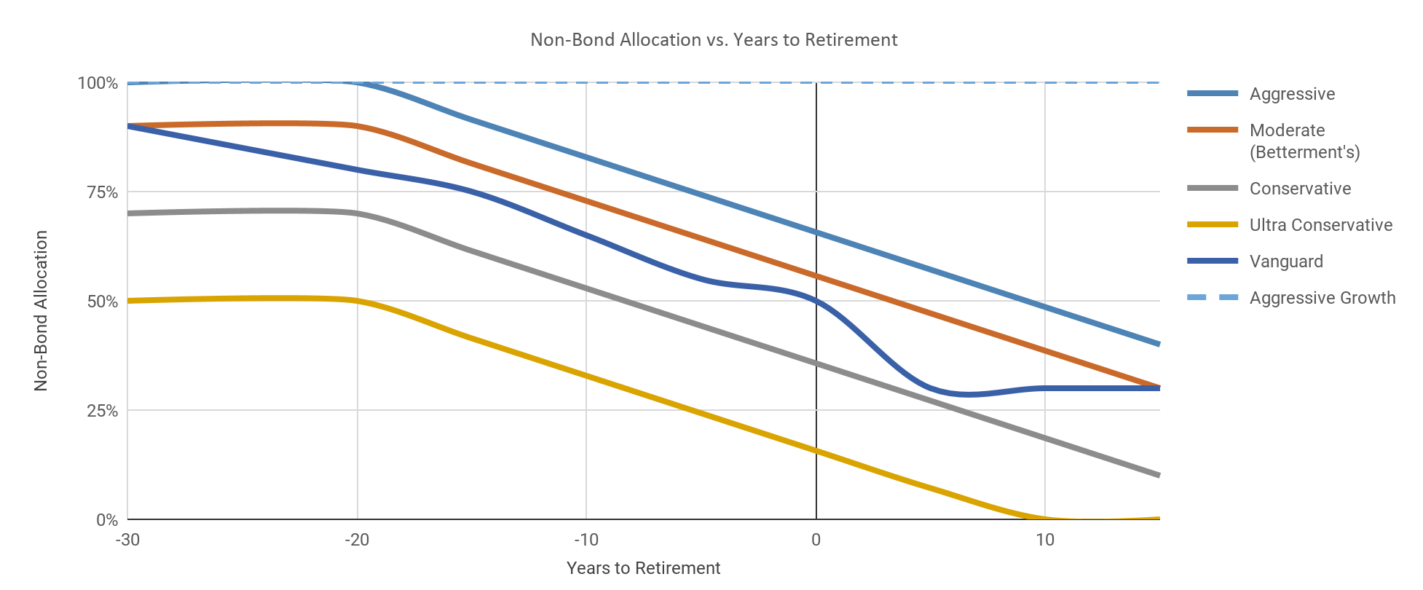²⁰
From highest to lowest final non-bond allocations, we see Aggressive Growth, Aggressive, Moderate (Betterment’s), Vanguard, Conservative, and Ultra Conservative.
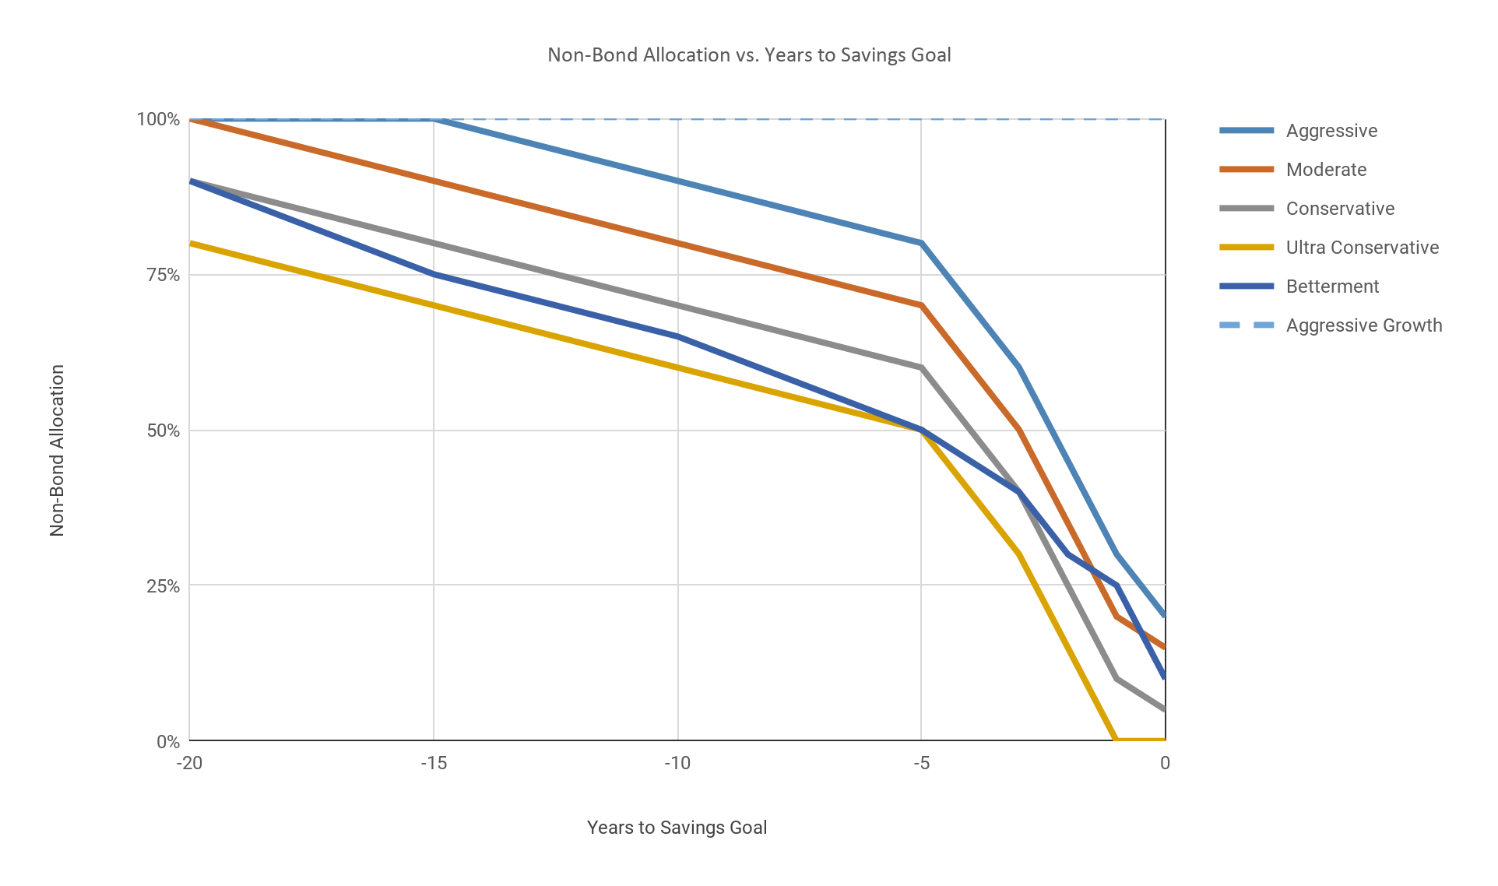²⁰
From highest to lowest final non-bond allocations, we see Aggressive Growth, Aggressive, Moderate, Betterment, Conservative, and Ultra Conservative.

Many recommend these bond trends near retirement and savings goals because of the following well-documented tendencies and inherent volatility in the stock market. The dots in the center of each volatility bar represent the average excess stock-market return over average high-grade corporate bond index returns.³⁴
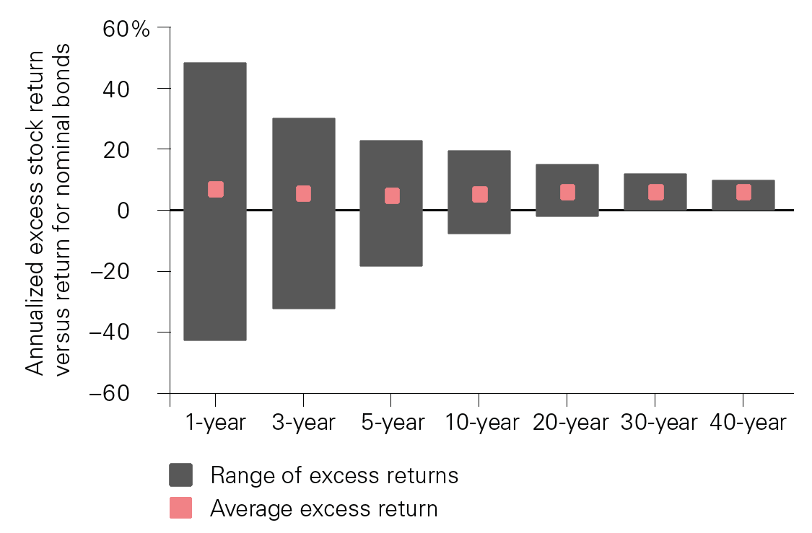²¹ ³⁴

Notice that, in the long-term, stock returns historically prove superior. This data extends from 1926 to 2014, covering all recent stock market crashes, panics, downturns, and more.²¹ ³⁴ Regardless, stocks still average out to grow your wealth through uncommon returns.

As you diversify your portfolio, always remember correlation. The more uncorrelated your stock picks, the better your portfolio diversification becomes. This principle is well-shown in fund-manager Ray Dalio’s “holy grail” chart shown below:
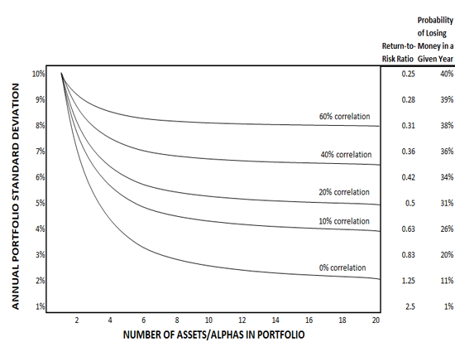²⁵ ²⁶
On the left side of this chart, we see the risk of any individual investment based on its return. The asset could go up 10 percent, down 10 percent, or more in either direction in periods extending past single-standard-deviation yearly movements. The standard deviation simply measures inherent asset volatility. As you add more assets with similar risk and returns, the trendlines show how your return to risk changes based on the correlation of your underlying positions. At a certain point, your risk reduction depends on the correlation of the underlying assets more so than the number of diversifying investments. At 7 or 8 assets, you decrease your risk of losing money in a given year from 40 percent individually to 11 percent with perfectly uncorrelated returns like in our umbrella-sunscreen example. As you focus more on correlated market sectors, you may expose yourself to more correlation risk, but you can simultaneously push for higher returns through active management. Estimate your potential profits versus stop-loss maximum risks to work towards improving your profitability through technical analysis. Alternatively, decrease long-term your risk through global diversification and alternative investments (which we’ll explore soon). With fifteen or twenty solid, uncorrelated return streams, you can minimize your total risk while maximizing steady returns, following the 5 to 7 percent rule.²⁷ You won’t lose your 10 percent return, but you will reduce your risk through other investments that you cannot predict the performance of. Your overall portfolio will grow over time, but individual growth is blended into the performance of all your other positions to minimize volatility. With five times less portfolio deviation, you can quintuple your return-to-risk ratio in any one portfolio.²⁷

You can use this mindset to minimize your investment risks through the “holy grail” while still fighting for market-beating returns through technical analysis an individual equities. Always consider how much time you have to be aggressive in the market, understanding that it’s okay to take on more risk and higher returns when you have a long time ahead to recapture losses while winners run. Nonetheless, you can avoid large portfolio losses with investments in the broad, uncorrelated markets shown below:
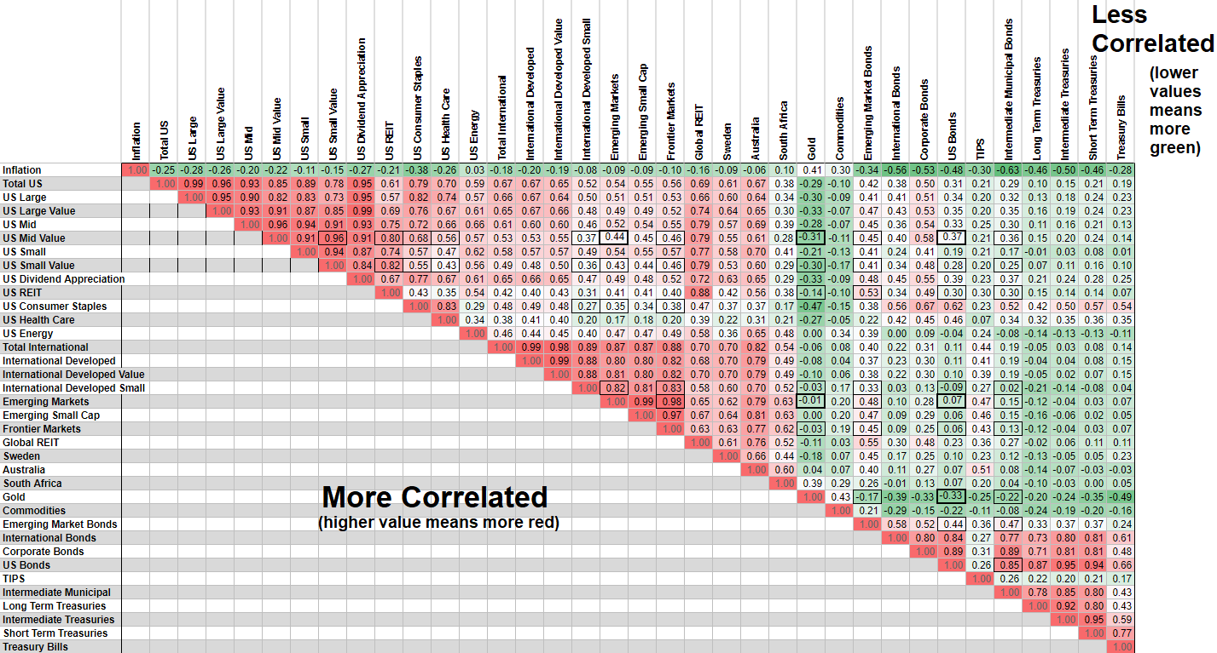²⁰

Red values indicate high correlations, whereas green values indicate a low correlation to each items’ respective counterpart. Notice that essentially all US equities are closely correlated, as these assets follow major US market indices. Notwithstanding, these assets provide extremely strong long-term gains as long as you can weather out market downturns. Remember the dollar-cost-averaging principle that sits at the base of value investing when low stock prices tumble. As you gradually purchase assets, you can average your fill prices down over time. For example, you could buy $200 of a stock every year or perhaps invest $150 into a certain fund every month. If the price of the asset decreases, you can gradually purchase more with the same amount of cash, as you expect the price to increase in the long-term. If the price increases, you can add to your position knowing that you are adding to your long-term growth potential on top of current gains.²⁸ This methodology is splendid for long-term low-management investors who want to ensure consistent, fair prices. You can further improve your price-fill quality by employing technical analysis to find great buying and selling opportunities in the market.
REITs are Real Estate Investment Trusts. You can use these to take advantage of real-estate returns without the active management needed to collect rent every month. These trusts often yield high dividends and present compelling long-term opportunities in good housing markets.
There are unheard of value opportunities in long-term American equity-asset markets that take advantage of the prolific and regenerative US Economy. The US stock market makes up over half of the entire world’s publicly traded stock market.²² With that said, some investors turn to foreign equity markets for risk management because most global economies are not immediately correlated, as shown above.

Some investors turn to emerging foreign markets in search of extremely high returns as new economic boom.¹⁵ The following scatterplot reports average GDP growth and stock returns over the long run from 1900 to 2009 in global market indices. Although you may outperform the market through specific stock picks, most global indices underperform the American markets, even when they have rapid, emerging economic growth. Remember that most of a stock’s price depends on its underlying public perception. Just because a stock is expensive doesn't mean it has a large market capitalization or vice versa. Look for corporate value, not just cheap or expensive stock price. In our example with Singapore-company Razer Inc. earlier, $RAZFF shares cost a nickel and dime, but the underlying company is worth $1,333,000,000 (2018).¹⁴ Rather, pay attention to historical price trends to predict where future market performance might move. Keep in mind the following international data is from the most recent bottom in the US stock market.
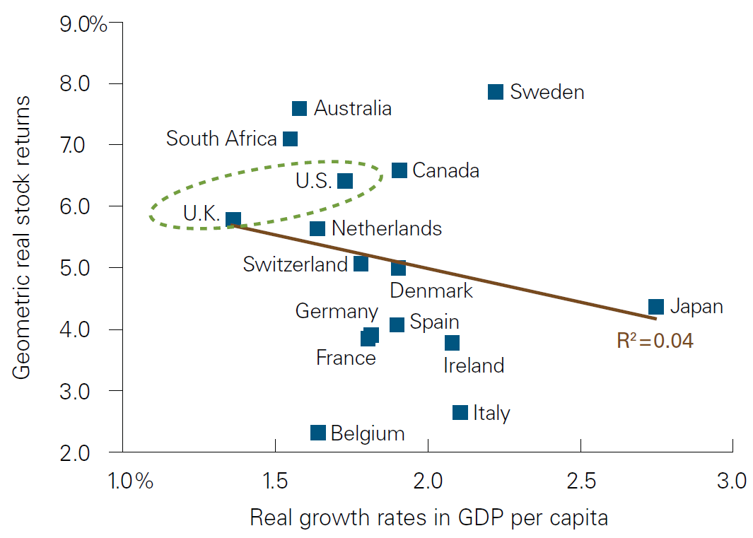¹⁵ ¹⁶ ¹⁷
So, “emerging” markets might not be the highest growth candidates for you, but international diversification is still very popular. Four of the countries above seemingly outperformed America, after all. Although it costs more time and money to spread your eggs into many baskets, you can benefit from long-term diversification in international markets through ETFs tracking foreign index funds alongside individual stocks and bonds. Additionally, you can time emerging market stocks to take advantage of superb growth as part of your international portfolio no matter how long you invest in foreign markets. Just remember important socio-political factors can affect global equity performance and bond payments. As long as you don’t try to time market indices, there are strong international profits to compliment your domestic holdings in bull and bear markets.
Here is an updated 1900-to-2016 comparison of global market returns post-inflation. Remember that inflation in these markets includes foreign currency valuation changes unless the underlying stock is traded through American markets or perhaps a derivative or subclass of shares is traded Over-the-Counter or on the Pink Sheets. You may see some of these cheap stocks in nine-to-noon. For long-term investors, it’s fine to invest in reputable companies listed on these less-than-par exchanges as long as you know the value and performance history of the stock you invest in. With that said, these stocks historically repel investors because of low listing requirements and often low trading volume. Look for good liquidity before taking a trade for any timespan in these markets.
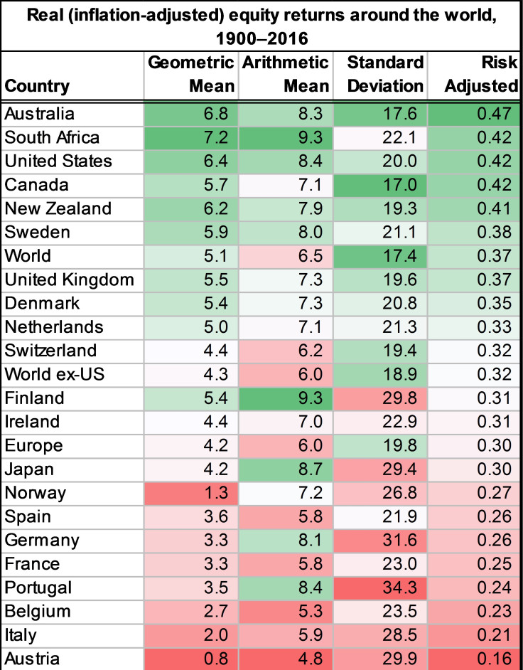²²
You can make strong returns in foreign markets as long as you focus on long-term thinking and ideologies. Analyze global indices and invest in areas you see high-return potential with minimal risk. If you ignore short-term market movements and invest in strong foreign companies, you’re sure to find high-yielding investment opportunities.

But please, for all that’s good, don’t buy the ^FTSE®. The Footsie or Financial Times Stock Exchange 100 Index is an index of the largest 100 market-cap companies on the London Stock Exchange.²³ Here is the FTSE’s performance (lower final performance) relative to the S&P 500 (higher final performance).
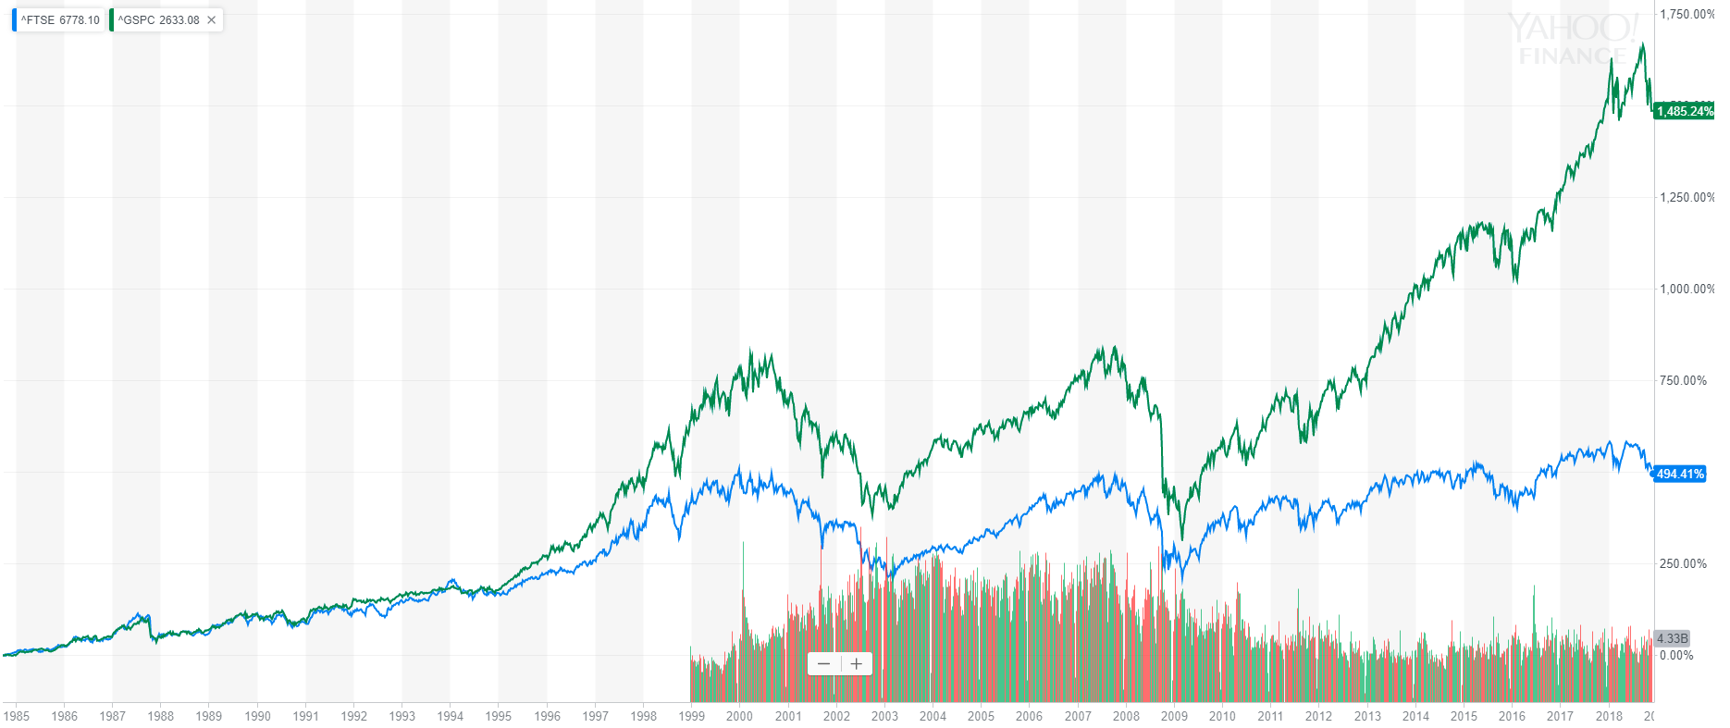²⁴

Index-to-index, the Europeans markets historically underperformed American markets.

Here’s a Fidelity infographic showcasing four differently-diversified portfolios. The calculated performance is based on domestic indices, foreign indices, bond indices, and Treasury-bill interest rates from 1926 to 2015, assuming reinvested dividends and coupon payments.
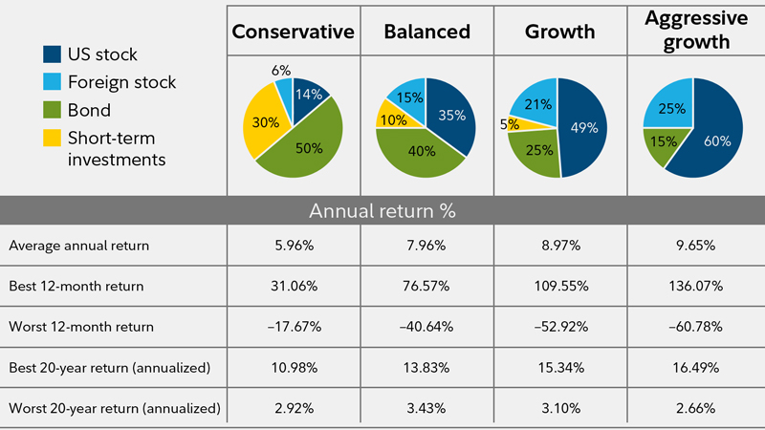²⁹ ³⁵
Though you may need especially less diversification in your early investing years, these portfolio balances represent general market diversification sentiment. Fidelity in particular often emphasizes bond fund holdings. For color reference, the growth portfolio has a 5 percent stake in short-term investments, 21 percent in foreign stock, 25 percent in bonds, and 49 percent in US stock. Consider whether or not a portfolio balanced away from stocks works best for you, especially considering your age. With a longer time horizon, you can weather out market crashes and take advantage of historically-higher equity-asset growth.

Furthermore, we can see that diversified portfolios provide safe havens in economic downturns in exchange for their lower long-term returns. Try to find a balance between safety and growth, perhaps a dynamically changing balance depending on macroeconomic conditions. Just remember that it’s much easier to time individual stocks than market indices.
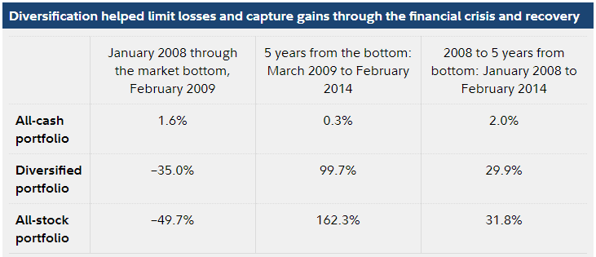³⁰

Before we move on to diversification in nine-to-noon trading, please write 5 to 7 percent down in the blank space below (I mean it).

___________________________________________

Use this percent allocation for long-term diversified portfolios to prevent any one company or factor from influencing your portfolio too much. As your investing experience grows, you may decide to change these numbers as you see fit to build your opportune diversified portfolio. It’s okay to take higher risks in companies you believe in when you understand the potential downside in even the most certain stocks; this knowledge simply comes with experience. However, remember that any position can go south no matter how great it looks if public perception drastically changes.

Diversified portfolios are the basis for building retirements, college plans, and long-term savings-goal funds. Continue writing down other principles you learn through trading, as these will help you develop your overall trading strategy and improve your market returns. If 5 or 20 out of 100 companies perform poorly in the long-term, you can still prove extremely profitable through diversification. Just don’t put everything you have in your Enron employee stock purchase plan. In the short-term, expect temporary losses as it is always difficult to time the exact top or bottom on any movement.

As you enter nine-to-noon trading, diversification lines fade because you actively adapt to market risk and set precise stop-losses to limit your risk while you work towards market-beating returns. Your position size, given enough liquidity, is essentially what determines your trading income once you master nine-to-noon trading.

Consistent, high average profits are key to nine-to-noon success. As long as you can make more than you lose, you’ll prove successful with repetitive trades. One extreme trading setup can exceed your weekly profit goals. They key is taking reasonable positions with excellent setups rather than taking as many trades as possible. You don’t need to be perfect, but you should understand your trading and work towards better future consistency, profit/loss ratios, and trade success percentages.³¹
Let’s look at the “profit trifecta:”
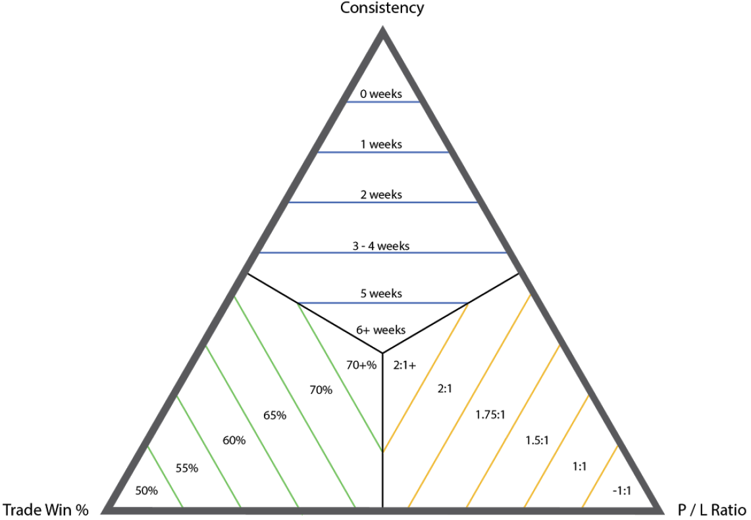³¹

As you practice trading, you can work to improve your skills and move towards the center of the profit trifecta to find consistent profit, high success rates, and a strong profit/loss ratio.³²

You never have to be perfect with trading, but you can work towards consistent, disciplined trades to grow closer to the center of the trifecta. It might make sense for you to have a temporarily lower win percentage if you take many trades because of your underlying trading strategy. That’s fine as long as you consistently take high-quality setups with good risk-reward ratios and diversification principles. Your trading will significantly improve with patience.

For nine-to-noon trading, your main goal is to pay as little “market tuition” as possible while learning to become a consistent, profitable trader. There are loose diversification standards because you will learn over time how much to put into a position depending on how confident you feel about a stock based on your technical analysis and the underlying trade momentum.
Set aside a certain amount of money aside for active trading. Then, calculate how much you want your average order size to be worth. Generally, try to start off risking lower proportions of your nine-to-noon fund, and work your way up to your own reasonably-sized positions over time as you discover how to manage risk with strong market returns.
Here’s an example of what happens to a $2,000 trading account when you double your money four times, but the market fools you into one bad trade and you lose half of your portfolio:
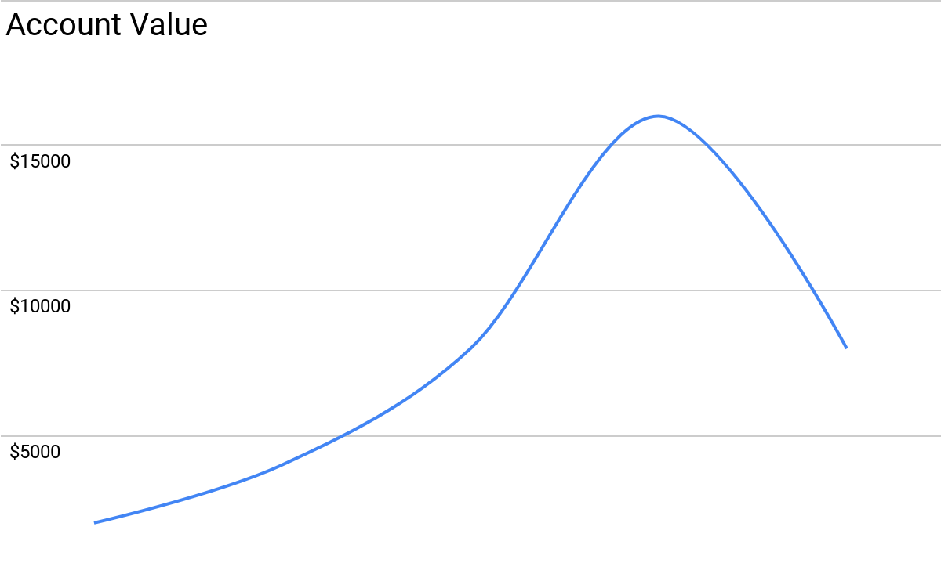
By risking all of your cash, you present significant growth opportunities, but you also expose yourself to rapid downtrends. As you start trading, learn your principles with smaller trades and work your way up you to consistent profitability. Perhaps risking one-quarter of your day trading fund in the example above will help you find consistent growth and leave you less stressed when you inevitably lose a trade. Nonetheless, risk what you're willing to lose and always close out your nine-to-noon positions by the end of the day, as aftermarket movement in such stocks can be irrevocably unpredictable. Sticking to stop-losses also helps limit your losses and psychological burden because you pass off the responsibility of existing potentially bad trades to an automated market-hours computer system.
Once you find consistent profits with strong risk-to-reward rations, you can start to expose yourself to higher upsides and losses with larger cash positions. The technical skills you build while learning allow you to measure your performance through percent gains that reveal your potential profits and losses. You trade for the upside, but you have to be prepared for the downside and analyze exactly how much you risk on average.
To streamline your order entries, consider using a handheld calculator to quickly divide your intended value per trade by the share price of the stock you’re trading. Use this rapid calculation method to ensures consistent order size for all trades, allowing you to consciously grow your position sizes since you account for your trades’ dollar value every time you press buy. Especially for nine-to-noon trading, this handheld-calculator order-entry method lets you enter and exit positions quickly before a stock runs away from you.
Note that many active-trading platforms offer “order review” windows after you press buy. For nine-to-noon trading, I highly recommend disabling this review screen as it slows your trading down, often stopping you from getting the best possible fills in volatile situations.

Start with one position at a time when trading. You can start to trade more stocks as your skills improve, especially if you have multiple monitors. Still, look for quality rather than quantity. It’s better to start slow and make one great trade rather than making three poor trades before 10 o’clock. With one position, you can think about what went wrong in your position intraday and better your future trading with your self-reflection. Your active profits and losses are not your entire portfolio, but rather a certain percent of your active-trading fund that integrates with your overall long-term portfolio

Nine-to-noon trading requires clear thinking and disciplined stop-losses. You need to be emotionally unattached from your stock positions so you can holistically consider their performance both in and out of a trade without letting emotions cloud your vision.
Don’t try to catch a falling knife when you first start out. Accept any early-morning losses and move on. If I lose money on any stock, I ignore it for the rest of the day. Conversely, I’ll stick with winners while simultaneously looking for new nine-to-noon opportunities. Set hard limits on how much you can lose in a day. Follow these limits. Give yourself time and find the patience to find the perfect setup rather than trading and trading with no defined strategy for consistent profits.
Minimize your market tuition in losses and keep studying patterns and psychological rules to better your trading.³³ Anger and greed can drive your trading into a stress-filled, unprofitable state. Never get mad at the market or yourself. Try to clear your mind before you start screening in the morning (see Chapter 1 and 36). I meditate in the morning and at night after reading my long-term goals to clear my emotions and prepare myself to tackle the market. Additionally, electric music helps me stay razor sharp while trading. Figure out what works for you and stick with it.

Chapter 36
Stock Screeners

Stock screeners are the most vital key to finding nine-to-noon stocks. They are also very useful for long-term picks when you looking for certain types of companies to trade. Use screeners to identify where the money is and where the money will be.

As you first look for long-term investments, try to find companies you already know about. This will streamline and simplify your investment research. After you identify, approve, or reject potential assets, you can use stock screeners to find companies with compelling fundamental buy signals.
Stock screeners simply take any certain set of parameters into account and spit out the resulting stocks. You can filter by price changes, key statistics, accounting statistics, earnings, net margin, book value, and more with Yahoo Finance under the “Screeners” tab.¹ With these options, you can configure custom screeners to look for undervalued stocks, growing stocks, active stocks, industry-specific stocks, foreign holdings, and any other circumstance you can think of by combining the many filters Yahoo Finance offers. You can quickly find many potential investments by combining your filters into a concise stock screener. Try them out!
Other great websites for long-term stock screeners are Finviz, Chartmill, and StockFetcher. Finviz works similarly to Yahoo Finance, but you can look at additional filters such as percent of shares short, dividend payout ratio, and technical factors.² Chartmill lets you look at specific underlying corporate fundamental analysis through their analyzer alongside more technical factors like support and resistance levels, flag setups, and moving averages.³ Lastly, StockFetcher lets you directly analyze values in technical indicators like the Relative Strength Index, Stochastics, and MACD to identify potential swing trades.⁴
All of the aforementioned screening websites provide tremendous starter screeners to help you find potential movers. With this narrowed-down search, you can quickly build a diversified portfolio or possibly make a few picks to compliment your long-term indices. If you put in the time to research here, you can find previously unheard of stocks that may outperform your overall portfolio.

For nine-to-noon trading, you’ll almost exclusively look at price, percent gain, and volume. With these three factors, you can quickly identify nine-to-noon stocks before the market opens and fluidly use screeners to find new positions as the morning develops.
Before the market opens, you want to see a high premarket gap to create significant opening volatility. These breakouts serve as catalysts as more market players enter nine-to-noon stocks and turn them into morning high-fliers. These are the stocks where money quickly flows in and out of the order book as trading intensifies following large gains. Fundamentals are completely thrown out the window here as you focus solely on technical analysis. Screen for stocks:
- Priced between $0.20 and $20,
- With a daily gain of at least 10 percent, and
- With high volume (relative to when you look at the screener).⁵
Note that, if you use Yahoo Finance’s screener, you’ll have to constantly update the page and re-filter by highest percent gain to find newfound gaining morning stocks.

Be especially careful with cheap stocks under $2 and only look for very quality soups with enough volume to support a day trade, as these stocks tend to have the least volatility and highest spreads unless the market pays particular attention to it one day because of surreal gains and potential trades.
This price range is a general average of stocks that trade well through technical analysis since they correlate to lower floats and faster price movements thanks to increased volatility and momentum.⁵ These stocks are also much more easily move due to catalysts and premarket trading activity in general.⁵ High-priced stocks outside of this daily movement range may present good trades, but they often simply stay flat after an initial run-up throughout the day since they are more difficult to move because of often-higher floats.
As for percent gains, 10 percent may sound high, but this movement is easily attained by tons of nine-to-noon stocks every trading day. High initial run-ups are crucial for trading because they put investors’ spotlights on a stock that can be further traded using technical analysis for gains. High initial percent gains, especially before the market even opens, also shows that the underlying stock can move quickly, a great quality as you try to get in and out of technical trades in a matter of minutes. (In a boring day with few movers you may lower this figure to 5 percent in hopes of finding an early-morning setup. There will be slow days in the market, but you have to trade constantly to capture the largest gains when a stock suddenly goes from $2 to $6.)
When you run your stock screener, sort the results by largest daily percent gains. These stocks are the most likely to move because they have the highest initial momentum. Additionally, high percentage gains can correlate to low floats since the limited supply of sellers quickly gets purchased. Low floats help you make consistent profits as you time price movements using technical analysis as long as there is enough volume to support active trading. It’s difficult to quantify a “perfect” volume level because markets quickly increase in daily volume as nine-to-noon stocks take off. Look for volume that’s high compared to the other stocks in your screener. The higher the volume, the better. Note that average volume in nine-to-noon stocks rarely helps you predict the volume influx after a large premarket gain. Here’s an example on a recent mover, MICT, Inc.:
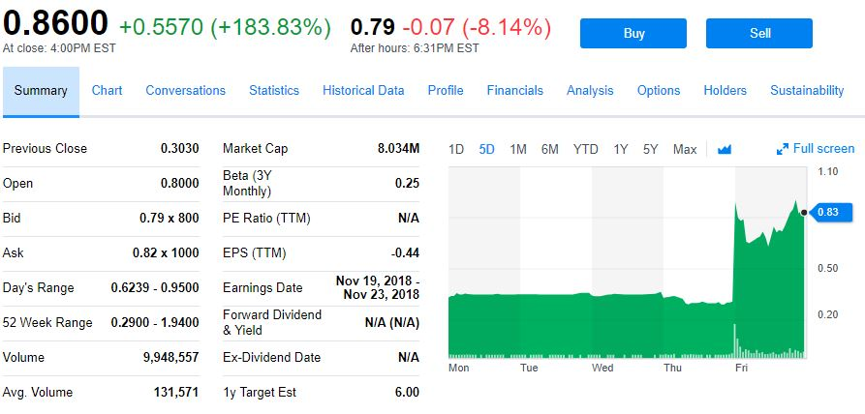⁶
Clearly, the average 130,000 or so shares exchanged dwindles compared to the almost 10,000,000 traded on this single day, especially considering that $MICT’s float is around 6,550,00 shares.⁷

The best way to scan for nine-to-noon stocks is with live data through a broker-provided screener. With live data, you’ll see gaining stocks as soon as possible, ready to load up a chart and analyze a potential trade. Yahoo Finance tries its best to get accurate data quickly, but the site sometimes slightly lags behind the market. Additionally, Yahoo Finance does not record and display live premarket data in screeners.² See if your broker’s stock screeners record premarket changes. Premarket gainers between $0.20 and $20 are nine-to-noon stocks.

For simplicity’s sake, you can use the Stock Market Watch’s premarket movers list. As of writing this book, this list is the first thing when you look up “premarket gainers.”⁹ This free, online scanner shows you the top gaining and losing stocks, as shown below. It’s the perfect screener for finding premarket gainers at nine.
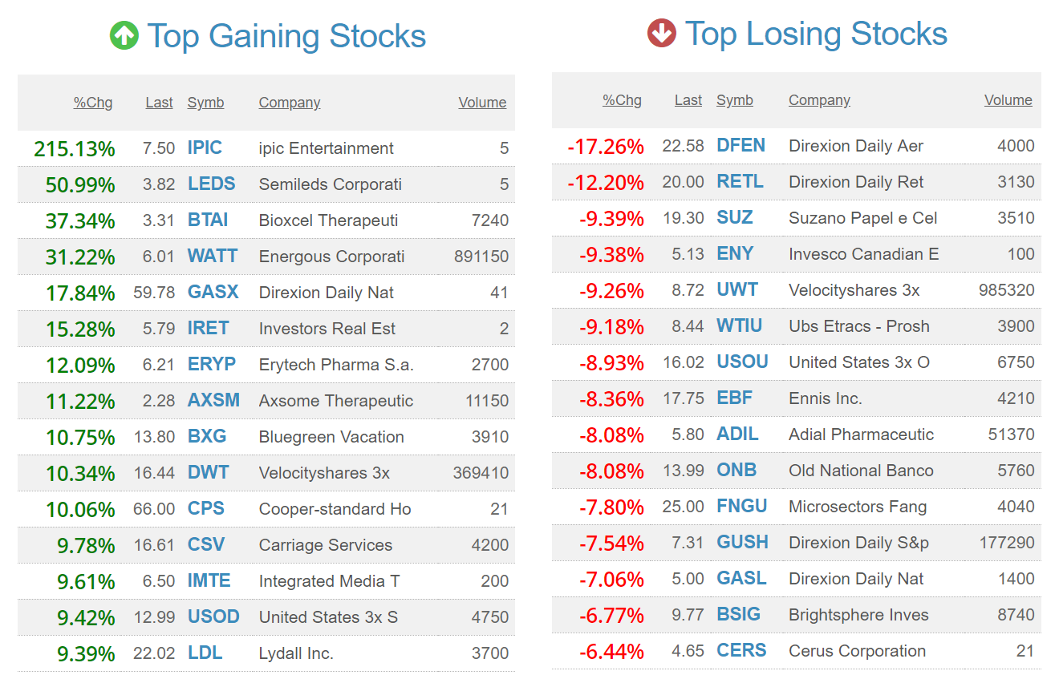⁸
Although you might be tempted to buy top losing stocks, perhaps thinking that they’ll bounce back up during the trading day, these losing stocks generally maintain flat prices throughout the day just like expensive stocks. Poor performance tends to repel investors, whereas strong performance attracts them and fosters larger gains based on technical analysis.
As you look over the premarket gainers, only pay attention to the ones with significant volume. In our photo above, we would focus on $WATT specifically since it is the only individual stock with high volume (3x indicated a leveraged fund for $DWT). Once the market opens, try to find good trades on these stocks, perhaps buying as they break the VWAP and selling as they shoot over the top of the Bollinger Bands. Then, transition into your live screens provided by either your broker or Yahoo Finance to find newfound daily gainers and potential trades. Similar to before, look for high-volume gainers only, say above 250,000 shares intraday. In case you are curious, here is how $WATT played out after this initial run-up:
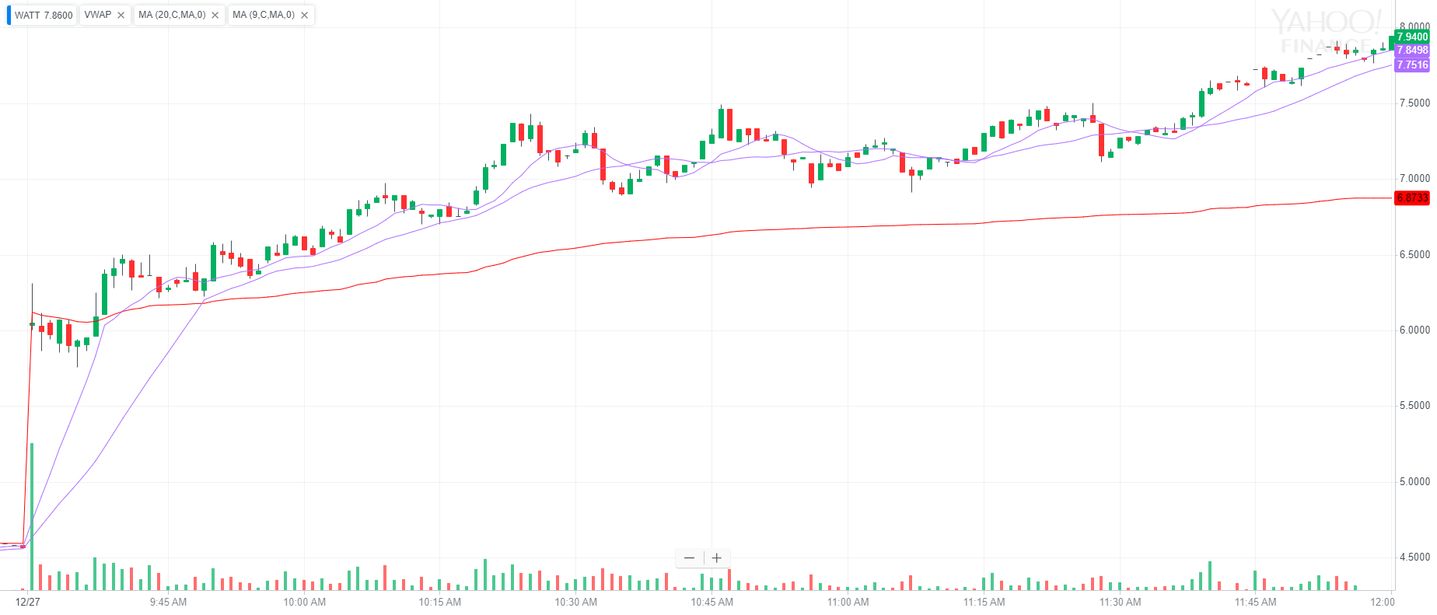¹⁰
In a trade like this, try to buy when you see the stock clearly break through the VWAP (lowest final line under the 9 and 20-period moving averages). From the early-morning breakthrough around $6.06 after a large premarket gain, the stock continued to rise up to $7.94 at noon, as shown above (31 percent gain before a colossal rise to over $9, as shown below). Take profits as you see fit and try not to be too greedy. Bulls and bears make bank, but pigs go broke.¹¹
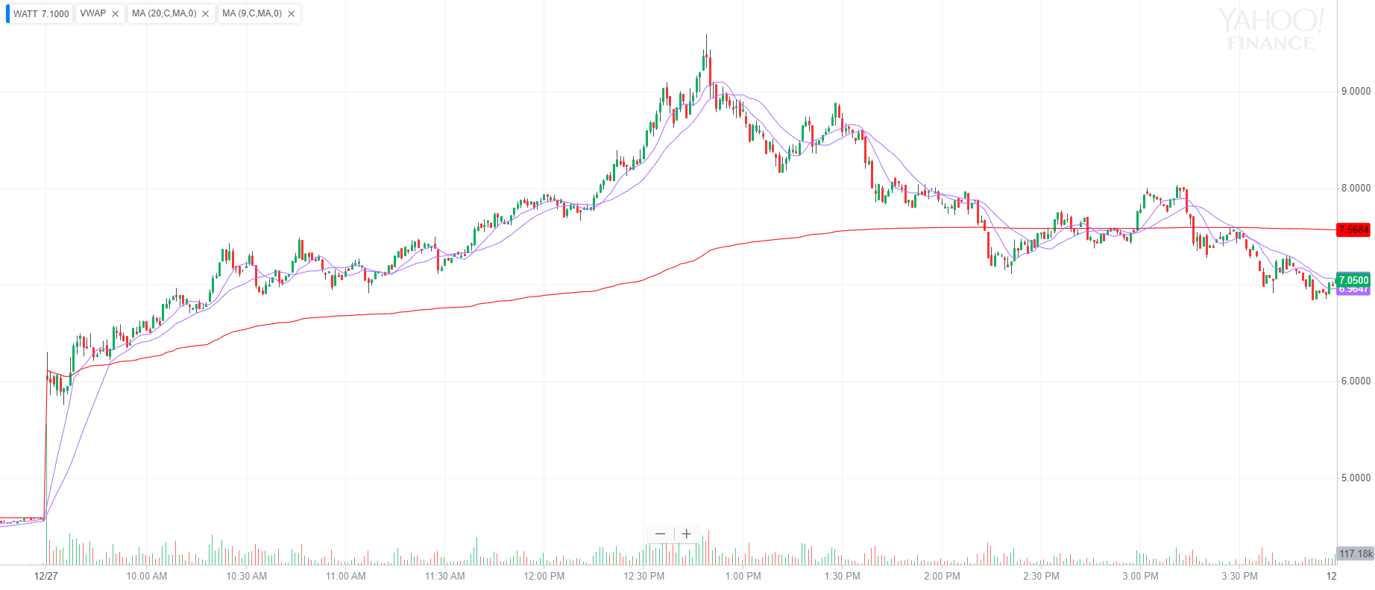¹⁰

Not all premarket gainers will form perfect setups. Many prime nine-to-noon stocks prove tough to trade. Simply move on and search for better setups in the morning until you find stocks that work for you. As you initially start trading, try focusing on one position at a time. If your comfort level increases and you feel a need to grow, start working with multiple stocks at a time when you see extremely strong setups in different companies at the same time. Volatility explodes right after the opening bell, and stocks can shoot up or crash down quickly. Learn to find reversals and time your orders alongside moving averages and VWAP. As time goes by, your trading will drastically improve with experience. Keep your positions calculated and try to know exactly how much you want each position to be worth. As you improve, you can increase your average trade size, perhaps scaling in or scaling out as prices move.

Screeners give you options and open nine-to-noon stocks for active trading. They also help you find technical swing trades and may compliment your underlying fundamental long-term investments. Stick with what you believe in for the long-term as long as you can outperform the market since short-term losses may dwindle compared to potential long-term gains. Otherwise, turn to indices and outperforming funds. Long-term screeners and robotic-investors based on technicals and statistics rarely outperform human portfolio managers. If you’re interested in expanding your portfolio with actively-managed outperforming stock picks, explore WootenStockPicks.com TK

Chapter 37
Brokers

This book was written in an age of centralized brokers, clearinghouses, rebates, regulation, and more. I see many issues with current centralized asset markets and plan to spend a large part of my coming life decentralizing asset management to truly open the floodgates holding back global asset growth opportunities that can build you real savings and retirements.
With that said, I wrote this book to abolish the educational barrier to entry into finance for all. I want this work to stand the test of time, so please understand that some of the information presented later in this chapter especially may change in the coming decades as blockchain technologies grow in global development and utilization. However, the principles we will go through here hold true and should stand at the core of your broker-dealer analysis. These institutions are your gateway into financial markets and asset growth, and they are in constant competition in a centralized asset market. Find the best option for your situation and always watch out for more competitive options.

Ready to get into the markets? Investment brokers are your access point to financial markets. These brokerages, regulated by the SEC, connect asset buyers and sellers based on marketplace orders submitted by investors.¹ To understand how brokers hold your assets, let’s explore how stock ownership works in an Internet age.
The oldest known stock certificate come from the Dutch East Indies Company from Holland in 1606.³ Stocks started on paper, and you used to physically exchange them with your broker. Today, you no longer have to sign a piece of paper to trade stocks, but you can still specifically request a company to send you a paper stock certificate.⁴ You can sell your old-time paper stock certificates by signing a transfer form for the stock and notarizing it for a transfer agent or stockbroker to liquidate.³
Companies keep track of current bondholders and shareholders using transfer agents and registrars.⁶ Companies use these records to record changes in stock ownership, shareholders to pay dividends to, and bondholders to pay interest. For your purposes, the registrar keeps track of all outstanding shares as well as the number of shares owned by each shareholder so there is an official record of your stock or bond ownership (we’ll look more at how you are identified on these ledgers soon).⁶ Bond registrars also record interest rates due so that your debtor borrower knows exactly how much to pay you each year.⁶ Just as a stock registrar updates when someone sells shares to another investor, a bond registrar updates when someone sells their bond in the secondary market.⁷
These ledges can be maintained by the underlying company or outsourced to a third-party trust or bank.⁸ The constantly-updated lists contains basic information like each shareholder’s name, their address (used for mailings annual reports, dividend checks, tax documents, and other documents), how much stock you own, stock transfers, direct deposit dividend addresses (if applicable), and other miscellaneous information like physical certificate history and stock class.⁵ Remember that preferred stock often gets paid dividends first and may receive more voting rights than common stock.¹⁶
Since stock transfers are all electronic by default today, your name can be in any company’s transfer-agent book depending on how you purchase stock. With direct registration, you buy stock directly from the underlying company, and all mailings and dividends are sent to your address.⁹ This form of registration is commonplace for direct stock purchase plans and employee stock purchase plans wherein you can purchase directly diversified shares of a company.¹⁰
To avoid brokerage fees which we’ll further explore soon, you can use direct-purchase plans from individual companies.¹⁰ Fees vary depending on the corporation, but you will almost always save cash thanks to the extra time commitment to buy directly from a company.¹² You can also purchase fractional company shares through direct stock purchase plans as you start off if an expensive stock would unbalance your portfolio.¹³ Most direct-purchase-plan companies also allow you to automatically reinvest your dividends in dividend reinvestment plans that promote long-term holding, capital appreciation, dividend compounding, and overall growth.
However, direct stock ownership, when available, comes with decreased liquidity and control over your investments. Rather than instantly buying or selling your shares on the market at any price you choose, you must notify the underlying company that you want to buy or sell your shares.¹¹ Then, the company will purchase or sell shares for the plan along established intervals (like once a week) and at an average market price (often VWAP or a high-low average from the previous trading day).¹¹ ¹⁴
If you’re willing to put the time and energy into opening plans with a diversified group companies, you can use direct stock purchase programs for long-term investing to decrease transaction fees, receive direct corporate recognition, and reinvest dividends with fractional shares. You can also order psychical stock certificates through these programs if you want nice, expensive wall art and don’t mind a tedious and fee-filled selling process on top of physical certificate security against damage or theft.¹⁶ Most shareholders stick with online inventory to streamline their investments. The process for selling physical shares varies greatly depending on the underlying company or brokerage you buy them from, but it is almost always slower and more expensive than electronic fulfillment.

It’s much easier to simply hold all your stocks in a brokerage account or two where you can simply purchase stock through your account and leave dividends to be reinvested while you can quickly and efficiently liquidate any position at your desired price. For nine-to-noon trading, brokerage accounts are an absolute necessity. For long-term investors, these accounts streamline your portfolio in a central location and give you access to companies without cheaper direct stock purchase plans or dividend reinvestment plans. You’ll always want a brokerage account to use their research tools, stock screeners, trading software, and access to investment options such as options, currencies, futures, and of course stocks.

When you electronically send a market order to your broker, they instantaneously determine the best way to route your order based on available market prices. First, your broker looks at prices on exchange order books.¹⁷ Then, the broker compares quotes prices to those of third-party market makers, secondary-pool participants, and internalized trades.¹⁷
Internalization occurs when your broker fills your order from an inventory of stocks owned by the brokerage or from another buyer or seller of the same stock at the brokerage.¹⁸ Your broker will only internalize a trade when they can get a price at or better than the market quote.¹⁹ Additionally, your broker has a duty to seek the best execution path readily available for your market order.¹⁹ They will scan the entire marketplace in a matter of microseconds to help determine the best order route according to their algorithms.²³
Most brokers initially try routing orders internally or through market makers in secondary pools to avoid marginal exchange fees while still filling you at market rates.¹⁷ A market maker is simply a firm that buys and sells stock along the bid-ask spread to create a market for you.²¹ Many market makers pay your broker rebates for routing your order to them through “payments for order flow” (we’ll discuss this more soon).²⁰ Still, brokers must report the quality of executions on a stock-by-stock basis and ensure investors get the best execution.¹⁸
Point being, your broker has a lot of options to route your order to besides actual exchanges. They should automatically find the best option for you and give you a quality fill. As you compare firms, look at customer reviews and statistics about how often customer orders get price improvements. Consider which broker will give you the best fill possible. Any small amount of slippage can quickly add up over time, especially as you start sending in larger orders.
Remember that order fill quality and payment for order flow (PFOF) generally only changes how your broker directs market orders, if they direct them away from exchanges at all. To disclose their order-routing rebates, SEC Rule 606 forces brokers to publicly report how certain routing and execution metrics in a standard 606 quarterly report.³² This reveals exactly which exchanges the broker routes orders to and outlines their rebate compensation from liquidity-providing market markers.
Specifically for limit orders, your broker will most likely route your order through an Electronics Communication Network (ECN) that automatically matches buy and sell orders at specific prices.²⁰ These electronic order books cut out market makers and let buyers and sellers exchange directly. They work best with high market participation rates providing seamless liquidity.³³ Your level 2 feed is made up of open ECN orders, market makers that buy and sell when nobody else will, and wholesalers who execute orders for online brokers and retail brokers.³⁴ Remember that open but unfilled trades can be canceled at any time and may serve as bait to slightly more a market up or down by spoofing other investors with selling or buying pressure. Recent US crackdowns on high-frequency traders have lowered spoofing risk in more stable securities.³⁵

According to a 2016 study by the Organisation for Economic Cooperation and Development, 58 percent of trading occurs publically on exchange order books.²² In the other 42 percent of trades, your order may be routed to an OTC market maker, a dark-pool market maker, a hidden exchange market, an internalization algorithm, a PFOF-sponsored market maker, or an electronic communications network.²² By increasing marketplace liquidity, market makers help you no matter where your order actually executes by constantly buying and selling stocks to make a market for your trade. The market maker buys the bid and sells the ask in hopes of making a small profit while making a liquid market, as you should when possible by entering trades through limit orders.²¹
Dark pools were created to facilitate bulk trading outside of public exchanges to minimize a market reaction to large trades before they complete.²⁵ Large investors can sell bulk lots of a stock, say a 1,000,000-share block, at a static price out of the market order books and overview rather than individually selling many smaller lots.²⁶ Because buying and selling pressure moves stock prices, a large buy or sell order in the public market could prove difficult as the market reacts to such large orders. So, dark pools allow order fulfillment initially unrecorded to the market with lower fees.²⁶ These transactions are not immediately published on traditional public stock exchanges, and pre-trade data (i.e. your order showing up in the level 2 quote box) is completely unpublished.²⁷ After a trade occurs in the dark, it can take up to one day for it to appear in the public order book.²⁴ Unless you are trading millions of shares, you broker will handle your trade execution automatically, and dark-pool fulfillment will only be automatically used to receive comparable fill prices from exchange order books to lower transaction costs.

Huge buy and sell orders from institutional trades can significantly affect public perception of a stock’s price, hence the creation of dark pools to trade out of public sight. You can profit from dark-pool transactions by watching for extremely large orders from hedge funds, mutual funds, etc.²⁴
Many brokers such as Interactive Brokers, LightSpeed, and TradeStation route orders through dark pools to buyers and sellers to efficiently fulfill your trade at the best possible prices.²⁸ However, actually viewing transactions that go through dark pools proves more difficult since they are designed with opaque markets in mind. FINRA has recently made large strides to increase marketplace transparency in dark pools by committing to publish trading information from alternative trading systems (dark pools and other off-exchange market makers) regarding all Tier 1 NMS Stocks on a two-week delayed basis.³⁰ All other stocks and OTC trades are subject to standard traded reporting requirements and are released two weeks following the Tier 1 release.³⁰ However, it’s tough to make informed swing trades based on two-week-old data.
Currently, Charles Schwab and Lightspeed are the only two brokers out of the many we will discuss soon that let you directly monitor large dark-pool trades via their desktop trading platforms.²⁴ Charles Schwab uses their proprietary StreetSmart® Edge software to deliver this market depth through the “Block Trade Indicator.”²⁹ Lightspeed also displays the Block Trade Indicator through their Lightspeed Trader desktop software.²⁴ ⁴² Simply open an account with one of the brokerages to access their software platform and data.
As you configure your block trade indicator, set the window to show orders with a minimum block size of say 500,000 shares.²⁴ This will show you orders from all exchanges exceeding 500,000 shares. You can further specify your search by only displaying orders from dark-pool exchanges (common dark-ticker ADFN) while removing other mainstream exchanges (NYSE Arca, Bats®, etc.).²⁴ If you want to spend more time analyzing dark-pool orders for large buyers or sellers, you can add an additional indicator showing block trades over 50,000 shares.²⁴ Remember that these indicators show all market trades by default, not just those for one stock. The indicator also display the time the trade was released to the public and at what price it executed at.²⁴ Large discrepancies between huge dark-pool order prices and current market prices show that a trade happened far before it was actually reported on exchange books and transfer registrars. Note that the data does not tell you whether or not the institutional trader bought or sold the underlying security.
By analyzing dark-pool trade history and placing orders mimicking institutional traders with massive accounts, you can find decent profits in swing-trade setups.²⁴ If you don’t want to commit to nine-to-noon trading, then you may consider this trading style. Nonetheless, the methodology acts as a solid complement to your technical analysis and can undoubtedly help you make a few strong swing trades each year.
The strategy with dark-pool trading involved three simple steps:
- Identify an abnormally large (say 1,000,000+ shares on a $40 stock, higher is better) trade
- Wait for the last hour or so of trading for the day the order executed (or appears to have executed)
- Determine if the stock will close above or below the massive dark-pool order price point
  - If above: buy
  - If below: short
²⁴
This strategy assumes that people with lots of money (presumably fund managers or perhaps corporate executives) know insider information or otherwise non-public secrets.²⁶ ³¹
Here’s an example with Energy Select Sector SPDR ETF. Notice that this fund is far out of the normal nine-to-noon price range of $0.20 to $20.
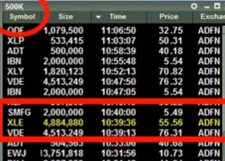²⁴
After this large trade early in the morning, $XLE continues to tread down until around noon. As shown below, the stock closed at $55.83. Since the stock closed above the dark-pool order, the steps outlined above predict a future run-up. We predict that the large order was a buy order, and this buying pressure was well-informed and will squeeze the market up.²⁴ The stop-loss on a dark-pool trade should be slightly above (short position) or below (long position) the massive order since that price is an established psychological level by some large trader. Here’s how $XLE turned out after two weeks of trading:
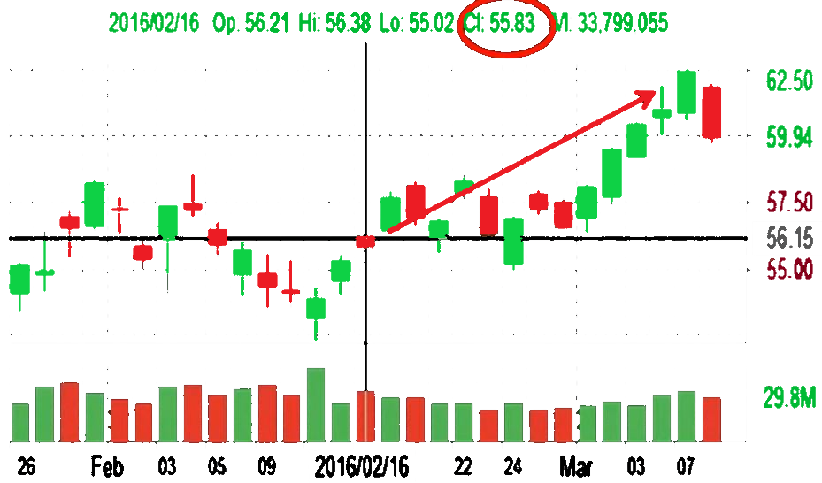²⁴

If dark-pool trading fits into your time-tested written trading style, you can access the aforementioned institutions’ platforms and trading data while still trading with another brokerage by simplifying opening a small or empty account. We will look more at minimum account standing and more with specific brokerages soon.

Every stock trade no matter its execution destination must be reported to a stock exchange to update the transfer agent and registrar so that the underlying transfer agents can update shareholder information. In the case of an off-exchange transaction, most reporting is sent to the stock’s home registration and Initial-Public-Offering exchange.¹⁷ In traditional exchanges, this usually occurs within 90 seconds of a transaction.²⁴
However, book registration with transfer agents and registrars slightly differs when you purchase stock through your broker. Rather than your name, address, etc. in a company's registrar, the stock, mostly for simplicity’s sake, is held in your broker’s “street name.”² Similar to direct registration, you do not receive a physical stock certificate when you buy stock through your broker who subsequently uses street-name registration to identify itself as the security manager on your behalf.² Your broker then simply keeps its own record of who owns what stock while the underlying companies send all mail (physical and digital) such as dividend payments and annual reports to your broker who subsequently distributes dividends and mailed information to you.

As we talked about in the chapter about commodities, centralized clearinghouses act as a middleman for futures and commodities. These clearinghouses collect cash, maintenance margin, and underlying assets between anonymous buyers and sellers and oversee the delivery of a contract at expiration date.³⁶ Your broker connects you to these contract clearinghouses alongside options markets at central exchanges.³⁶ ³⁸ Lastly, your broker connects you to global, decentralized over-the-counter currency exchanges.³⁷

As you analyze potential brokers to deal with, consider their order fill quality. As we’ve seen, brokers have many different options for routing orders. By getting the best fills possible, you’ll minimize any unseen losses when you enter and exit a position. With that said, it’s particularly difficult to measure how well or poorly your broker fulfills your orders since there is no common metric to identify order quality. All your broker can do is look for potential price improvements and either fill you or leave your order open if you submit a limit order. Nonetheless, consider what online reviews say about your broker. Especially once you start making larger orders, a couple of cents off the bid-ask spread can add up over time just like any other fee.
On top of fill quality, consider order speed. The faster your orders get to the market, the better chance you have of getting filled at the price you see on your screen.

For nine-to-noon trading, especially consider what desktop trading platform a broker includes. Since you’ll stare at this all morning, it’s important that the software works well for you and gives you all pertinent trading information. A poorly organized, sluggish, or otherwise unintuitive trading software can significantly hurt your trading efficiency and returns. Your broker should also give you live data feeds from all major exchanges. Check to see if you have to pay a special live data fee for access to some markets (e.g. pink sheets) or perhaps a software usage fee. These platform and data fees can be large recurring monthly charges at some brokers, while they are included in commissions for others.

If you’re only swing trading or making long-term investments, then an active desktop trading platform matters less since you can simply use Yahoo Finance alongside your brokerage. To link your brokerage to Yahoo Finance, simply open any portfolio and press “Link Broker.”³⁹ From here, you can link any of the following brokerages (2018):
- Fidelity
- E*Trade
- Coinbase
- Robinhood
- Just2Trade
- Ally Invest
- Interactive Brokers
- TradeStation
- Tradier Brokerage
- DriveWealth
- Scottrade
- TD Ameritrade
- Charles Schwab
- Vanguard
- Capital One (acquired by E*Trade)³⁹
This linking process is completely free from Yahoo Finance; you simply pay your broker’s commissions and fees.⁴⁰ You can search for brokers with lower fees if you use this service since you can worry less about your trading platform and news feed as a less-active investor. With that said, you can still use high-quality desktop software to streamline your analysis. We’ll look at platforms soon.

Lastly, consider trading fees when you compare brokers. Aside from tracing software for active trading, commissions are arguably the most important brokerage factor. How much your broker charges you to trade directly affects how much cash you make for long-term and short-term trading.
Most “full-service” brokers that offer you investment advice, education, etc. charge commissions on a per-trade basis. However, you don’t need much help constructing a portfolio since you read this book and you’re going to practice trading for a little bit while you get used to the markets. So, you can avoid full-service brokers and opt for more budget-friendly brokers that connect you to all trading markets with minimal costs yet strong account management and customer support.
Many “discount” brokers offer both per-trade and per-share fee structures. So, rather than paying X much per trade, you can pay X much per share traded (often with a minimum cost). For active traders, this cost structure almost always results in less commissions and higher profitability. For long-term investing and swing-trading, consider you average order sizes. It might make much more sense to use a per-trade commission structure if you make particularly large trades often or trade extremely cheap stocks. Do the math to find out what takes less money out of your pocket once you start trading and understand approximately how many shares your average position size is based on your average position cash value. Note that per-share fee structures especially help for active trading when you want to slowly scale in or out of a position. For example, you could buy a stock at $7, watch a giant run-up to $9, and sell half your position. Since you only sold half of your shares, you can hold the rest if the price keeps climbing or sell the rest if momentum teeters off.
You can use a ratio for this example, buying and selling different amounts of stock as you slowly phase in or out of a position. How much you do this depends greatly on your personal trading strategy and risk-management mentality. Do you want to lock in maximum profits all at once or wait to see what the market will do while you take some profits off the table? Perhaps you want to sell half of your position once it doubles to get your initial investment back. Your trading experience will help you develop this mindset. A profit-taking-stop or market-if-touched order can automatically help you take profits, but it can also cut off future growth. Try to stay decisive, disciplined, and researched for maximum profitability.
Either way, you often pay much less for your single or multi-part trades on a cost-per-share basis because, for example, you pay the full commission to buy 100 shares, pay around half to sell 50, and then pay the last half to sell the rest. Compared to an X-dollar trade plus an X-dollar trade plus an X-dollar trade, this per-share structure can bring your commissions down to a fraction of comparable fees.

Here’s a comprehensive table to compare a long list of major US brokerages ranked from highest to lowest commissions. This list looks only at equity-trade costs. Assume that options contracts and other asset classes follow similar pricing trends for each broker. Each broker is assumed to trade stocks, options, mutual funds, ETFs, foreign currency exchanges, futures contracts, and bonds. Many of the brokers below offer fee-free ETFs. The nature of these offers alongside the quality of the underlying funds changes frequently, ⁴⁷

Though it’s hard to judge order execution, a recent, well-developed study found that Fidelity, Interactive Brokers, Charles Schwab, Tradestation, and Merrill Edge were ranked the top five brokerages by order execution quality (best to worst).³²

US Brokers (2018)
Name | Trading Platform | Per-Trade Fee | Per- Share Fee | Minimum Balance | Notes
T. Rowe Price | Online and mobile platforms | $19.95 base rate. $9.95 if you make over 30 trades per year or over $250,000 account | N | $2,500 ($1,000 for IRAs) | 2,800 commission-free mutual funds. $35 commission for other mutual funds. $30 annual fee (waivable with enough activity or account value)
USAA | Limited website and mobile platforms | $8.95  Additional $0.01 per share fee for stocks under $1 | N | $3,000 | Commission-free ETFs and mutual funds.
Vanguard | Online platform | $7 for first 25 trades; $20 thereafter | N | $0 | $20 annual fee until account grows over $10,000
Merrill Edge | Online platform and Merrill Edge Market Pro platforms | $6.95 | N | $0 | 30 $0 trades per month for Platinum tier clients and  100 $0 trades per month for Platinum Honors tier clients at Bank of America
TD Ameritrade | Web, mobile, and thinkorswim platforms | $6.95 | N | $0 | Commission-free ETFs. 24-hour trading from Sunday at 8 PM EST to Friday at 8 PM EST. Advertised high order-fulfillment quality and fast execution times
E*TRADE | Power E*TRADE, E*TRADE Desktop, and mobile platforms | $6.95 ($4.95 with 30 or more trades per quarter) | N | $500 | Minimum $1,000 account value for real-time platform quotes. $99 platform fee for older E*TRADE Pro Platform
Wells Fargo WellsTrade® | Online and mobile platforms | $5.95 ($2.95 when trading linked with your Portfolio by Wells Fargo®) | N | $25 | Greater of $34.95 or 3.5 percent of trade value commision for stocks under $1.00 per share
Charles Schwab | Web, mobile, and StreetSmart Edge® platforms | $4.95 | N | $0 | Commission-free ETFs
Ally Invest | Ally Invest LIVE desktop platform and mobile platforms | $4.95 (lowerable to $3.95 with 30+ quarterly trades or $100,000 daily balance) | N | $0 | Additional $0.01 per-share charge up to 5 percent of trade value for stocks under $2.00 per share. Additionally fees for other assets
Fidelity | Active Trader Pro®, stock screener, website, and mobile platform | $4.95 | N | $0 | Commission-free ETFs and zero expense ratio index mutual funds with no investment minimums. No IRA fees. No data fees. Planning, advice, news, research, and education
Trade Station | Desktop, mobile, online, and dedicated scanner platforms | $5 (must place at least 5 trades per year or maintain a minimum account balance of $2,000 to avoid a $50 annual charge under this plan) (additional $0.004 charge per share for directly routed orders) | $0.01 (min. $1) and $0.006 after the first 500 shares per trade | $500 | Bond and mutual fund fees start at $14.95 per trade plus $5 per bond. For per-share pricing structure exclusively, there is a $99.95 monthly maintenance fee and a $99.95 monthly platform fee unless you trade 5000 shares, trade 50 contracts, or maintain a $100k balance. Full data quotes cost about $50 per month depending on your plan. $50 Treasury trading fee
SogoTrade | SogoTrader Desktop,  SogoElite, options, online, and mobile platforms | $4.88 base rate. $2.88 if you execute at least 50 trades per month. | N | $0 but cannot trade stocks under $1 without $100 | Prepay your commissions for $3.88 or $2.88 per trade depending on the number of trades. For stocks under $1, add the greater of $0.0003 per share (10 percent of principal max.) or 0.25 percent of principal.
eOption | eOption Trader Desktop, website, options, and mobile platforms | $3 | N | $500 | Offers auto trading with $5 commissions. $15 annual IRA fee
Tastyworks | Tastyworks Desktop, mobile, and browser platforms | $5 for opening order and $0 for closing order | N  Add minimal clearing fees to all trades | $0 | Especially low options commissions with similar $0 closing trade plus clearing fees.
Place Trade Financial | Place Trader Workstation, website, and mobile platforms | N  Add minimal routing and regulatory fees to all trades | $0.01 (min. $1.50) (max. 1 percent of trade value) | $0 | Same inactivity fee structure as Interactive Brokers ($3 for under 25) (fee waived for first three months at both brokerages). $10 live monthly data fee (waived if over $30 in trades)
Lightspeed | Lightspeed Trader, Sterling Trader, Livevol® X, RealTick Pro, online, and mobile. Lightspeed Trader Desktop platform costs $130 per month minus generated commissions | $4.50  Additional $0.003 per share fee for all pre and post-market orders | $0.0045  default  (min. $1)  $0.0065 if you use Livevol X  (min. $1.50) | $25,000 ($10,000 if you only use Web Trader platform) ($35 annual fee for IRAs) | All routing fees/rebates and regulatory fees are charged separately. You pay 0.3 percent times the total trade value for shares priced less than $1.00. Minimum market-data monthly fees around $10 for desktop platforms. Flat $230 to $260 monthly fee for Sterling Trader
Cobra Trading | Cobra TraderPro, DAS Trader Pro, Sterling Trader Pro, and mobile platforms | N  Add higher-than-average platform- dependent routing and regulatory fees to all trades | $0.004 (min. $1) | $30,000  $15 quarterly inactivity fee (must make one trade) | Basic data fees start at $25. Monthly platform fees start at $100 (waivable for traders with over 200,000 or more shares per month). $35 annual IRA fee
CenterPoint Securities | Centerpoint Trader, Sterling Trader® Pro, and DAS Trader Pro platforms | $5.95 plus minimal routing and regulatory fees | $0.004 (min. $0.95) | $30,000 | High platform and data fees, but some fees can be waived
Interactive Brokers | Flagship Desktop TWS, mobile, online, and messenger platforms | N | $0.0035 (min. $0.35) (max. 1 percent of trade value) | $0 for cash account or $2,000 for margin (min. fees per month apply unless account value is at least $100k) ($2,000 required for live data) | Minimum $10 in commissions per month or cover the difference ($20 if average account value under $2,000)(lower minimum for different account types or ages under 25). Commission-free ETFs. Extensive list of free research and news platforms.⁶¹ Free educational content and passive robo-advisors.⁶⁶
Just2Trade | Just2Trade Desktop, Sterling Trader Pro, Etna Trading Platform, website, and mobile platforms | $2.50 ($12.50 mutual funds) ($75.00 foreign stock fee)  For all orders, add routing and regulatory fees | $0.0025 (min. $0.50) | Fees increase under $2,500. Cannot trade with under $2,000. Must have $25,000 for per- share pricing | Minimal per-share monthly commissions are $333 (the difference is paid like with Interactive Brokers). Additional $0.003 per share fee for pre and post-market trading. Special trading rates available for registered active traders
Choice Trade | Quotestream Trader Pro, Direct ProTrader, ChoiceTrade Elite Trader, website, and mobile platforms | $0 with a $5 monthly fee or $5 per trade. Trades on stocks under $1 are $5 | N  OTC trades are $7 plus routing fees | $100 | Pre and post-market trades add $0.005 per share. Desktop platform fees range from $15 to $135 a month
Folio | Website platform and basic screener platforms | $0 for first 2,000 market orders that execute around 11 AM and 2 PM EST if you subscribe. $4 in “trading windows” otherwise | N  Any order trades outside of trading windows is $3 if sub- scribed or $10 if not | $0 | Subscribe for $29 or $290 per year if you pay in bulk. If not subscribed, you must make over three trades per quarter to avoid an inactivity fee. Limited selection of premade but customizable diversified portfolios. Automatic rebalancing. Fractional shares
Betterment | Website and mobile platforms | You don’t make direct trades, but rather Betterment offers advising and places you in low-cost investment portfolios | N  No trading or transfer fees on top of annual fee | $0 for digital advising  $100k for premium advising | 0.25 percent annual fee charged quarterly for digital advising. 0.4 percent for premium. Automatic rebalancing. Easily adjust your portfolio diversification to meet savings and retirement goals
Ustocktrade | Web and mobile minimalist platforms | $1 plus $1 monthly fee | N | $0 | 10,000 share and $10,000 order buy value limits. Stocks and ETFs only. Has level 2 quotes
Stockpile | Web and mobile minimalist platforms. Also offers stock gift cards for additional fees | $0.99  Market orders that execute at the end of the day only | N | $0 | Fractional shares available. Limited selection of only around 1000 stocks, foreign companies through American holdings, and ETFs. No level 2
Acorns | Mobile platform | $0  $1 monthly fee. $2 if you want an IRA. $3 if you want a checking account. | N | $0 | You can only deposit your money to be automatically invested into one of Acorn’s five prebuilt and unchangeable portfolios.
M1 Finance | Online and mobile platforms | $0 plus minimal routing and regulatory fees  You can specifically request an order and it will execute like a normal free rebalance | N  You don’t usually directly trade  Trades execute at market around 10:00 AM EST | $0  Uses fractional shares | You create custom-weighted portfolios, and M1 Finance automatically balances and rebalances your deposits to fit the percent allocations of the underlying securities in your portfolio
Firstrade | Firstrade Navigator, Options Wizard, website, and mobile platforms | $0  (plus minimal routing and regulatory fees for all order types)  (including options trading, +$14.95 execution) | $0  (fee includes mutual funds and options) | $0  $0 pre and post- market trading | Commission-free ETFs. No IRA fees. No check or electronic transfer fees. No data fees. Offers ESAs. 0.1 second execution time guarantee
Robinhood | Online and mobile minimalist platforms | $0  (including options trading and execution) | $0 | $0 | Only broker out of all brokers listed to not offer dividend reinvestment (2018). No level 2. Extended-hours trading with live prices. Only broker listed that does not allow you to short stocks (2018).⁴¹ Allows you to directly trade cryptocurrencies⁴³
44 45 46 48 49 50 51 52 53 54 55 56 57 58 59 60 62 63 64 65 67 68 69 70 71 72 73 74 75 76 77 78 79 80 81 82 83 84 85 86 87 88 89 90 91 92 93 94 95 96 97 98 99 100 101 102 103 104 105 106 107 108 109 110 111 112 113 114 116 117
*If multiple tiers of commission plans are available, the most basic (lowest volume) tier was used. If you have significant trading volume, explore tiered per-share rates from the lowest-cost per-share brokers to find the best deal for you.
Other conditions apply. See current broker website for details or promotions. Many large firms constantly offer free trades for signing up, so you could get away with using a bigger broker during a “trial period” and then moving to another, more affordable one after the promotion ends. This also gives you many chances to try out different charting software while you make free trades.

I highly recommend TD Ameritrade's thinkorswim platform for charting. You can open an account and leave it sparsely funded to get access to the platform and live data feeds. If you are a long-term investor or swing trader, then you can use this platform for analysis alongside Yahoo Finance while executing your trades and holding your positions in a much cheaper broker like Robinhood or perhaps M1 Finance if you want to spend less time managing your investments.
However, if you trade nine-to-noon, you’ll want a broker with both a strong platform and a strong commission structure. Remember that you can create separate accounts and isolate your active trading and long-term investing. With a dedicated active broker, you can enter and exit positions faster as you directly see them set up. Interactive Brokers and Lightspeed work especially well with their desktop platform and low fees. Explore the many platforms above ranging from DAS Trader to the unmentioned Ninja Trader. You can link external software with your broker, but it’s much easier to use the provided desktop software to ensure extremely fast order execution and live quotes, especially when many trades end in fifteen minutes or less. Visual appeal with these platforms is crucial, as you will stare at them every morning. Find a platform that flows well with your trading to increase your productivity while also operating with low fees. Not to mention, high-quality trading platforms help you quickly scan through more and more potential setups.

If you’re only investing for the long-term, consider how much time you want to commit to your financial future. Some of the brokers above help you manage your money for a small fee. Others simply give you access to globally-leading index-fund-tracking ETFs for very low prices, notably Fidelity with zero-commission and zero-expense ratio funds. Otherwise, you can stick to the free Yahoo Finance analysis tools and screeners we’ve explored to maximize your potential returns with individual trades.
If you want to start trading actively but are still stuck under the PDT rule, then you could get away with cheaper charting software since you only have to make a few really good trades per week, and most live-data feeds will let you do this with a fairly-fast order entry box. However, try to practice investing, especially as you first begin, like you have an account ten times larger than your current portfolio. With this mentality, 10 percent gains will, as they should, seem phenomenal with long-term investments, and you’ll prepare yourself to manage your future money when you do grow your account. By taking your trading especially seriously, you’ll learn to master level 2 quotes and live data through your broker’s initially-complex desktop platform, a platform that will serve as your gateway for future profits.
Many of the brokers above offer after-hours trading. Like we said earlier, try to stick to market-hours trading to maximize volume and minimize spreads. However, this feature can prove handy if you want to make a quick trade based on news such as an earnings report. You can never be certain where a stock will open the next day after the market closes. For this reason, try not to buy stocks at market open with limit orders generated the night before, as you may significantly overpay for a stock that quickly tumbles the next day. Generally, early-morning trading in all stock set securities up for a red or green (down or up) trading days as most stocks collectively follow major market indices each day.
Lastly, some of the brokers above advertise their “tax-efficiency” or easy year-end accounting. Losses do cancel out gains with respect to their trading time frames. However, I implore you to worry less about taxes and more about making as much money as you possibly can. At the end of the year, you can offset gains by selling losing stocks, but you can also cut off future growth by closing out temporarily-down positions that may outperform in the long run.
I give this warning from experience. In the earlier technical example with $AMD, I bought the stock as a fundamental play since I saw the company growing. As I shared the position with investment friends, one friend took a position at $13 as $AMD bounced around in a downward wedge. At the end of that same year, this friend chose to sell their position at a loss at $11 to offset short-term gains, partially because they knew little about the underlying business fundamentals. Was the tax benefit worth the loss? Just a few short months later, the stock popped out of a downward wedge to a long-term resistance over $33 where I sold half my shares.¹¹⁵ Makes trades normally and your broker will send you the necessary 1099s to pay the right amount of taxes. Nonetheless, still remember tax laws. I sold my shares on the exact day I bought them the year before, forcing the sale into the short-term capital gains tax bracket. I could have eradicated my capital gains taxes by waiting just one more day to exit the stock. Learn from your mistakes to strengthen your trading.

Chapter 38
The Mentality

That’s all there is to Nine to Noon. It’s a fairly calculated but flexible workday. Some traders cut their active trading after a few quick wins, hoping to keep their early profits for the day. Others intentionally finish active trading quickly in order to pay more attention to their long term portfolios; long-term grown is always extremely important.
No matter how any certain day plays out or how you balance your time, most people can be truly successful in the long-term by trading nine-to-noon. This shortened workday gives you just enough time to use your technical analysis skills to make quick, unemotional, and larger trades in the early morning while still leaving enough time at the end to manage and amend long-term portfolios.
The nine-to-noon grind is completely self-enforced. You have to love the trading you do to keep up with it every market day. Consistent profits come to traders because they commit to trading repetitively so they can master the game. When you find a way to love trading, you open yourself up to success in trading as long as you put in the work.

If the nine-to-noon workday doesn’t work for you, fear not. Long-term investing, no matter who makes your portfolios, can help everyone. Grow your wealth in the stock market through the compounding strategies and diversified funds mentioned in this book. If you find the time, try to outperform the market with some stock picks. You don’t have to work nine-to-noon to analyze and trade five medium- to long-term stocks a week. By doing your own research, checking news periodically, and acting independently from the herd, you put yourself at a large financial advantage over your those who ignore their investment future.

If the first few trades comes easily, don’t get ahead of yourself. When you start trading your own stocks, it’s normal to lose money as you rapidly form and improve your own investing strategies. By taking small positions, you can minimize your losses, learn underlying trading strategies, strengthen your trading psychology, and better your overall trading principles. You’ll learn from your mistakes, mistakes that teach you the cold, hard rules of the market. With this development, you’ll grow into your brokerage and truly start accumulating assets.
Let me give you a quick example. One of the first stocks I bought was NVIDIA Corporation. $NVDA was worth a ludicrous 25 percent of my overall portfolio at the time, and I saw a downward wedge forming:
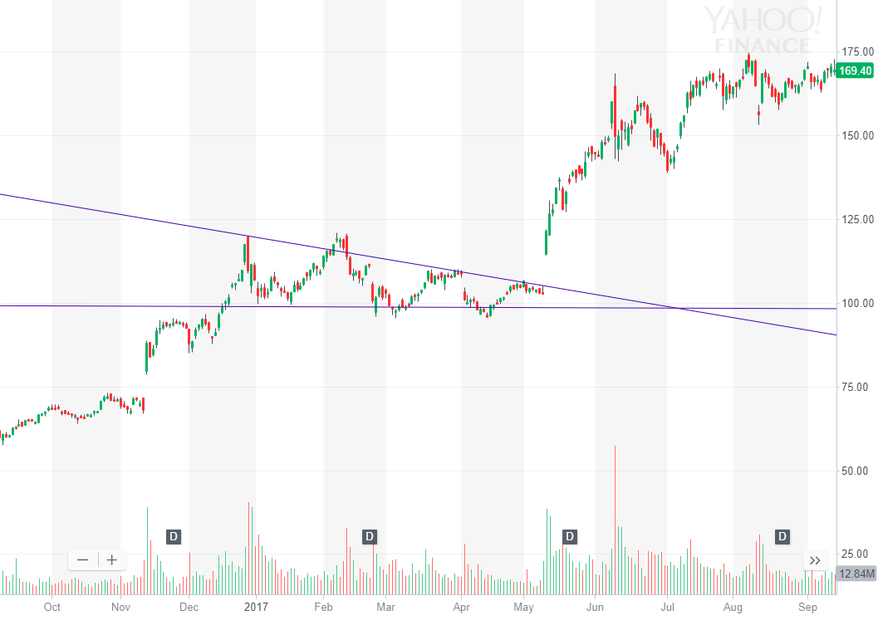¹

I knew little about technical analysis when I entered the position around $101 during March’s lows. However, as the stock progressed through its downward wedge, I began learning about trendlines. I identified the wedge pattern above when $NVDA hit the high $90s nearing earning date. However, I incorrectly thought that the downward wedge meant $NVDA would go down rather than up. So, I made the executive decision to sell my shares for a 2 percent profit on the day before $NVDA reported earnings and broke out of the wedge resistance, gaining 20 percent almost instantly after they reported earnings at 4:20 or so. The stock continued to rally for the next year and a half, reaching 2018 highs of just under $300.¹ I learned from that mistake! Now you don’t have to make it.

With technical skills, you can outperform the market to grow your account faster than average market returns. With that said, there’s nothing wrong with leaving your money in a simple fund or two. Passive investing is a tremendous way to grow your wealth through assets. Start early rather than worrying about how much you start with to maximize the time your money has to grow in the market. Prove to society that you should be wealthy by accumulating assets. You can live frugally for a half-decade and put investments into the market that will grow as you age to better your future life exponentially.
Think about the future and plan ahead. The stock market is an astounding place to accumulate assets and receive solid, long-term historical returns.
You can do anything you want to leverage your money to make you more money. Find the ETF you love, the stock that’s busting, the bond that’s explosive. It’s not easy to commit to financial success, but you can start your financial future by growing real savings and retirements through asset accumulation.

Throughout this book, we’ve seen the past performance of indices, technical setups, market sector performance, trends in alternative markets, and much more. Take this knowledge and apply it to the future. Now is the time to start accumulating assets and wealth. All the calculations we’ve made about potential returns, college plans, personal savings, and more are simply forecasts. It’s up to you to take the information from this book and act on it. Your fiscal fate depends on your current decisions.
Think of what you want to achieve in your financial future. Embody your thoughts in goals. You can achieve anything you can write down and believe. Now, I invite you to use the immense power of capital markets and equity investing to forge your own financial future.

J. Wooten

January 29, 2019
Six months ago, I sat down in my room after closing a finalizing position with my first major company, MonerAds. After six months of constant labor, the project finally came to fruition. MonerAds creates revenue for online publishers through blockchain technologies and user computing contributions. Based on the Monero network, the Company aims to change the face of online marketing by providing a real, profitable alternative to advertising. Only time will tell if much comes out of this project which has proudly brought work to many of my peers. As I fell into my bed, I asked myself, “What next?” I recalled the past three years of High School, internally manifesting my interests and passions, wondering for a brief moment about my future. That’s the day I started writing this book. Fifteen days before the start of senior year, I set my writing deadline: Christmas Eve.
I started learning about our economy on my own a few months before I left my year-long job at Subway in the latter part of my sophomore year. Inspired by my research, I started trading stocks after school. Once summer came along, I started actively trading every weekday.
In my first few weeks of trading with my saved Subway money, my profits quickly taught me the earning power of the stock market; I made much more trading stocks than I ever thought possible.
I continued trading throughout the summer partially for the money but also because I loved every market morning and the nine-to-noon workday. However, my fun started approaching an end as the school year started, and I realized that I could not trade the opening bell in second period. Thus, I started looking for other ways to keep growing.
I started investigating cryptocurrencies and “mining” with computers while on a family trip. I planned and built my first computer the Christmas prior. This technical background helped me understand some of the baseline processes behind cryptocurrencies.
I researched hundreds of cryptocurrencies of all prices and market sectors. The more I watched smaller, volatile currencies, the more I saw the same patterns I traded in the stock market. Once school started, I used my technical skills from the stock market to swing trade cryptocurrencies on constantly volatile 24-hour exchanges.
Cryptocurrencies fueled my passion for trading in financial markets and showed me a new path for wealth management. This strengthened my drive to bring the power of financial markets to more Americans.
By the time second semester of junior year started, I had a plethora of gains and losses in the crypto trading space and built a lucrative crypto mining rig over the four months prior. With all of this behind me, I decided to start looking towards the future. I started thinking about how I could bring financial markets to everyone.
Realizing that it takes millions to start an international brokerage, I started MonerAds. Soon after, I planned a curriculum and spent six weeks teaching stock classes at school while intermittently building custom computers for local clients. I have refined and vastly improved upon the ideas developed with students in these classes in this book.
This book was inspired by one student from these classes who I saw happily invest into the American economy. Seeing Jake prosper showed me that anyone can get a solid grasp on their financial future by practicing the everyday techniques of Wall-Street traders. I combined my passion for inspiring others to accumulate wealth through asset accumulation with my immense love of nine-to-noon trading to create this book. Yet, I also hope it stands as something that can change many people’s lives by showing them time-tested ways to build their wealth through equities, bonds, and eventually cryptocurrencies no matter their current wealth, age, or time commitment to personal finance. I’ve presented many different options that all yield strong returns throughout this book, and I hope more than anything that this book inspires masses of people to change the way they save and invest (or start to!).
Recent studies reveal that around half of Americans do not own stocks.¹ That's give-or-take 50 percent of people in the most powerful economic machine in the world completely lacking equity-asset income. On top of that, around 2 billion worldwide citizens have no bank accounts.² How can these people even consider opening a brokerage account when they have no bank savings?
American stock ownership should easily be 90 percent or more. Assets are the absolute key to building wealth, and this is the very reason the top 10 percent control so much America’s wealth. These are the capitalist-investors who use their money to earn more money and build retirements and savings through asset-allocation returns. You, too, deserve this opportunity. Currently, I see two main reasons more Americans don’t own stocks: a lack of information and a high barrier of entry into financial markets.
Throughout this book, I worked as hard as possible to teach you everything you could need to start investing or actively trading in the stock market. No doubt you can achieve your financial goals with this information alongside personal development of your principles and financial literacy through experience in the market. Now, it’s your turn. Find an account that works for you. If you are a teenage worker, then go to your bank today to open a free Roth IRA. Figure out how you can invest to maximize your lifetime returns. If you are a hard worker at the job all day, perhaps start a retirement 401(k) plan alongside a traditional IRA or a normal investing account. Investment accounts open the floodgates of economic opportunity to the American financial market. You can average out your fill prices across any given year by making consistent monthly investments which also add strong discipline to your budget. Perhaps take out investment funds before you start your monthly spending and budgeting. It’s tough to put seemingly everything away for decades-away goals, never missing your monthly investment payments or retirement fund deposits. Living below your means can ease this process. The gains presented in this book in long-term and nine-to-noon trading require you to work hard for the hopes of building a better tomorrow.
Hone in on your skills now so that you can make 10 percent on $10,000. With these skills and enough hard work and compounding, you’ll grow to new points where you make 10 percent on $1,000,000 thanks to your technical skills. By no means is it easy to automatically save and invest part of every paycheck you get, but this lifelong disciplined asset accumulation will pay off in the end. Money now is worth significantly more later in assets. By committing to your savings goals and retirement today, you can overcome the challenges of investing to truly see what that your idle or otherwise spent cash can do as it forges your financial future. Good luck and happy trading.
If it’s not too much an inconvenience for you, please help spread this book to more Americans through either word-of-mouth or through an ever-supportive Amazon review.

Acknowledgements

The Internet opens information to the world. Without this amazing technology and those who contribute to it, there is no chance this book would exist. Special considerations go out to the writers and publishers at Investopedia, The Balance, FIRNA, the SEC, the IRS, statistic sites like Macrotrends, Bloomberg, the amazing compound interest calculator at MoneyChimp, and many other broker-dealer and local government sites that influenced my growth in the stock market and this book. These educational sites improve the world of personal finance and investing by teaching the principles of asset accumulation and growth in capital markets.
Investopedia and The Balance are Dotdash brands.
Dotdash is an InterActiveCorp brand.
Investopedia is owned and operated by AIC Publishing, LLC.¹
The Balance is owned and operated by About, Inc. and its affiliates.²
I greatly thank the developers and publishers at Yahoo Finance, ChartIQ, and TradingView for contributing to all asset investors by publishing market information, news, and stock analyses that influence sprouting individuals around the world and sit at the backbone of this book.
Yahoo Finance is an Oath brand.³
Oath is owned and operated under Verizon Communications Inc.⁴
Oath was rebranded to Verizon Media Group on January 8, 2019.⁵
Many thanks go to Google for unifying all of these sites and more through its search engine. Without this ability to connect individuals with information, I doubt I would have bought my first stock so long ago. Additionally, this manuscript was written in the ever-useful Google Docs.
Thank you Ross Cameron and the Investors Underground team for the immeasurably influential investing content, educational videos, and market success overviews I found as an inspiration to start exploring capital markets many years ago.
Thank you Dan Lok and the Sharks on CNBC’s Shark Tank for pushing me over the edge to start writing this book by showing me that anyone can accomplish anything they put their mind to. Combined with Think and Grow Rich, these motivational influencers helped me understand the absolute need to write this book.
Thank you Mom, Dad, Christopher, Pam, Sam, Chris, Grandma Lambert, Grandma Wooten, Grandpa Lambert, Grandpa Wooten, Aunt Patty, Mama Lucy, Uncle Jim, Aunt Sandy, Terez, David, Aunt Liz, Uncle TC, Austin, Uncle Kit, Aunt Lynn, and Harrison for your continued support and most helpful additions to this book.
Thank you Mrs. Joyce, Mr. Patterson, Mrs. Schroth, Mrs. Sealock, Mrs. Zamaira, and many other teachers who put up with my stock and cryptocurrency trading during class alongside business calls.
Thank you Mr. Awbrey, Mr. Brown, Mr. Carr, Mr. Chang, Mr. Cox, Mrs. Lord, Mr. Russell, Mr. Seneca, Mrs. Smith, Mr. Venable, Mr. Zamaira, and many other teachers who were crucial influencers in my education.
Thank you Mrs. Bravener, Mrs. Casillas, Mr. Colby, Mr. Funchess, Mrs. Norris, Mr. Smith, Mr. Steele, and many more administrators who enabled my education.

Without all of you, this book would not be possible.
“ Invest ” 

Disclaimer

The information in this book is provided as-is at an as available basis. Some information may not be relevant to or compliant with your local laws, regulations, or other legal requirements. It is your responsibility to determine whether, how, and to what extent your use of the information will be technically and legally possible in the areas of the world where you intend to use them. Please verify any information before using it for any personal, financial, accounting, legal, or business purpose.⁴ This book does not provide individual or customized legal, tax, accounting, or investment services since each individual's situation is unique.⁵ Trading involves a significant and substantial risk of loss and may not be suitable for everyone. You should only trade with money you can afford to lose. There is no guarantee that you will profit from your trading activity and it is possible that you may lose all of, or if trading on margin more than, your investment. Some of the results shown may be based on simulated or historical performance. Simulated or historical performance results have certain inherent limitations. These results do not represent actual trading and may have under or over-compensated for any possible impact of certain market factors such as lack of liquidity. Simulated or historical outlooks are systematically designed with the benefit of hindsight. No representation is being made that any account will or is likely to achieve profits or losses similar to those shown. Any past performance or claims are not necessarily indicative of future performance. This brief statement cannot disclose all the risks and other significant aspects of trading. You should carefully study trading and consider whether such activity is suitable for you in light of your circumstances and financial resources before you trade. Any trading in securities, futures, forex, or other investment vehicles involves a risk of substantial losses. Nine-to-noon trading involves particularly high risks and potential losses. Cautiously approach and closely manage your active investments while periodically checking long-term investments for substantial movements.¹ The opinions and analyses expressed in this book are subject to change at any time, as are statements of financial market trends, which are based on current market conditions. John Wooten is not responsible for any capital losses, tax penalties, brokerage charges, bank fees, court-arbitration costs, attorney fees, IRS liabilities, or other investment losses or damages. Any third party information contained in this book is from sources believed to be reliable. Any suggestions contained are general, and do not take into account an individual’s or entity’s specific circumstances or applicable governing law, which may vary from jurisdiction to jurisdiction and be subject to change.² Tax law is subject to continual change, at times on a retroactive basis and may result in incremental taxes, interest or penalties. Advice is based on the facts provided and on current tax law interpretation.³

Works Cited

All citations are grouped together at the end of this work because I do not want to distract you from the important information in each chapter. This book contains difficult-to-grasp financial concepts that are key to unlocking your financial future. I try to put these concepts into easy-to-understand, applicable words and situations. Some of these citations are more technical in nature. For a deeper understanding of the underlying concepts explained, explore the following qualified and helpful sources. However, please do not spend too much time researching. The best way to learn about the stock market is to invest.
There are many programs online that let you start off with fake portfolios and invest in stocks with simulated money. I think these programs are hurtful in the long-term because a significant amount of trading is based on emotions triggered when you gain or lose money. Making and losing real money is key to mastering your emotions and disciplining yourself to follow your principles and fundamental analyses. Moreover, these simulations often instantly fill your positions, creating unrealistic representations of real financial markets. With instant fills, you neither learn about the importance of volume and liquidity nor understand the struggle of being stuck in a real position. You should understand these real capital liquidity issues with smaller positions before you start taking large trades so that you can always identify ample volume and capital liquidity.
With that said, these “fake-money” trading programs can be a great way to start learning about the market hands-on. No matter how actively you want to trade, you can practice technical analysis and start developing your own trading style and portfolio balances. Once you are confident in yourself, move on to real money. The hardest position you will take is your first one. Even if you only buy one share of a $25 stock, the emotional responses from your trade will teach you about the psychological control necessary for either nine-to-noon trading or somewhat volatile long-term investing.
The sooner you start investing, the sooner you can tackle the emotions that come alongside equity-asset management and start building real savings and retirements for yourself. Individual stocks open the doors to higher returns in the market. To an extreme, actively trading nine-to-noon using the techniques outlined in this book can yield you staggering and consistent returns once you identify, practice, and solidify your trading strategy.
Always be cautious and extremely hesitant to change your principles once you develop an executable market strategy you find success. The worst trap you can fall into is constantly changing your principles and strategy for analyzing potential equity positions. Watch stocks move with the technical indicators and tools presented in this book. Once you are comfortable investing in individual stocks and funds abroad, see how your technical analysis skills develop as you discover newfound, consistent market patterns and trends.

This book would not be possible without the joint efforts of all of the following writers, publishers, data collectors, chart creators, and more.

Preface

Chapter 1: The Day

Chapter 2: Starting to Get There

Chapter 3: Why should I trade stocks?
¹ “How Do I Know My Credit Union Is Federally Insured?” National Credit Union Administration, United States Congress, www.ncua.gov/files/press-releases-news/NCUAHowYourAcctInsured.pdf.
² Bell, Claes. “Survey: CD Early Withdrawal Penalties Are Steep.” Bankrate, Bankrate, LLC, 7 Dec. 2015, www.bankrate.com/banking/cds/survey-cd-early-withdrawal-can-come-at-a-high-price.
³ “ How Are CD Interest Rates Determined?” Discover Bank - Banking Topics Blog, Discover Financial Services, Inc., www.discover.com/online-banking/banking-topics/how-are-cd-interest-rates-determined/
⁴ Mazzucco, Denise. “Historical CD Interest Rates - 1984-2016.” Bankrate, Bankrate, LLC, 19 Apr. 2016, www.bankrate.com/banking/cds/historical-cd-interest-rates-1984-2016.
⁵ “High Yield Online CD Savings Accounts.” Capital One, Capital One, N.A., Capital One Bank (USA), N.A, Capital One Investing, LLC, Capital One Advisors, LLC, Capital One Agency, LLC, and Capital One Financial Corporation, www.capitalone.com/bank/cds/online-cds.
⁶ Amadeo, Kimberly. “US Inflation Rate by Year from 1929 to 2020.” How Bad Is Inflation? Past, Present, Future, The Balance, 19 Dec. 2018, www.thebalance.com/u-s-inflation-rate-history-by-year-and-forecast-3306093.
⁷ Volcker, Paul Adolph Jr. “What’s Wrong With the 2 Percent Inflation Target.” Bloomberg Opinion, Bloomberg L.P., 24 Oct. 2018, 9:00 AM EDT, www.bloomberg.com/opinion/articles/2018-10-24/what-s-wrong-with-the-2-percent-inflation-target.
⁸ Moon, Chris. “Average Savings Account Interest Rates for 2018: Compared Across Banks.” ValuePenguin, ValuePenguin Inc., www.valuepenguin.com/average-savings-account-interest-rates.
⁹ “Corporate Bond Yield Curve Papers and Data.” U.S. Department of the Treasury, United States Government, 10 Oct. 2018, 11:13 AM, www.treasury.gov/resource-center/economic-policy/corp-bond-yield/Pages/Corp-Yield-Bond-Curve-Papers.aspx.
¹⁰ “How Do Bonds Work?” BBC News, The British Broadcasting Corporation, 4 May 2010, www.bbc.com/news/10093437.
¹¹ “Convertible Bond.” Investing Answers, InvestingAnswers, Inc., investinganswers.com/financial-dictionary/bonds/convertible-bond-1106.
¹² “Treasury Bonds.” TreasuryDirect, United States Department of the Treasury, 27 Sept. 2013, www.treasurydirect.gov/indiv/products/prod_tbonds_glance.htm.
¹³ Lioudis, Nick K. “Treasury Bond vs Treasury Note vs Treasury Bill.” Investopedia Questions and Answers, Investopedia, LLC, 21 Mar. 2018, www.investopedia.com/ask/answers/033115/what-are-differences-between-treasury-bond-and-treasury-note-and-treasury-bill-tbill.asp.
¹⁴ “CDFI Bond Guarantee Program.” Community Development Financial Institutions Fund, United States Department of the Treasury, www.cdfifund.gov/programs-training/Programs/cdfi-bond/Pages/default.aspx.
¹⁵ Riddix, Mark. “Treasury Bonds vs Corporate Bonds.” Moolanomy Personal Finance, Sukorn Group Inc., www.moolanomy.com/4215/investing-in-bonds-a-look-at-treasury-and-corporate-bonds-mriddix2.
¹⁶ “How Government Bonds Are Taxed.” Vanguard Investor Education, The Vanguard Group, Inc., investor.vanguard.com/investing/taxes/government-bonds.
¹⁷ Morah, Chizoba. “Why Are Most Bonds Traded on the Secondary Market ‘over the Counter’?” Investopedia Questions and Answers, Investopedia, LLC, 2 Apr. 2018, www.investopedia.com/ask/answers/09/bond-over-the-counter.asp.
¹⁸ Khan, Salman. “Treasury Bond Prices and Yields.” Khan Academy, www.khanacademy.org/economics-finance-domain/core-finance/stock-and-bonds/bonds-tutorial/v/treasury-bond-prices-and-yields.
¹⁹ “Treasury Notes.” TreasuryDirect, United States Department of the Treasury, 6 Mar. 2015, www.treasurydirect.gov/instit/marketables/tnotes/tnotes.htm.
²⁰ “Treasury Bill (T-Bill) Index: Frequently Asked Questions.” Mortgage-X Mortgage Information Service, Mortgage-X.com, mortgage-x.com/general/indexes/t-bill_index_faq.asp.
²¹ “Treasury Inflation-Protected Securities (TIPS).” TreasuryDirect, United States Department of the Treasury, 27 Sept. 2013, www.treasurydirect.gov/indiv/products/prod_tips_glance.htm.
²² Chen, James. “Treasury Inflation Protected Securities - TIPS.” Investopedia Terms, Investopedia, LLC, 1 Feb. 2018, www.investopedia.com/terms/t/tips.asp.
²³ “TIPS/CPI Data.” TreasuryDirect, United States Department of the Treasury, 20 July 2018, www.treasurydirect.gov/instit/annceresult/tipscpi/tipscpi.htm.
²⁴ “Consumer Price Index for All Urban Consumers (CPI-U).” CPI-U.info, Rossomeo, LLC, www.cpi-u.info/What-Is-CPI-U.aspx.
²⁵ “TIPS: Tax Considerations.” TreasuryDirect, United States Department of the Treasury, 13 Feb. 2018, www.treasurydirect.gov/indiv/research/indepth/tips/res_tips_tax.htm.
²⁶ Tucker, Matt, CFA. “Comparing Treasury Inflation-Protected Securities and Treasuries.” Yahoo! News, Yahoo! Finance, 19 May 2015, finance.yahoo.com/news/comparing-treasury-inflation-protected-securities-180308902.html.
²⁷ “Comparison of TIPS and Series I Savings Bonds.” TreasuryDirect, United States Department of the Treasury, 11 Oct. 2012, www.treasurydirect.gov/indiv/products/prod_tipsvsibonds.htm.
²⁸ “Table 1. Consumer Price Index for All Urban Consumers (CPI-U): U. S. City Average, by Expenditure Category.” Bureau of Labor Statistics, United States Department of Labor, 12 Dec. 2018, www.bls.gov/news.release/cpi.t01.htm.
²⁹ Chen, James. “Series I Bond.” Investopedia Terms, Investopedia, LLC, 8 Feb. 2018, www.investopedia.com/terms/s/seriesibond.asp.
³⁰ “Series I Savings Bonds FAQs.” TreasuryDirect, United States Department of the Treasury, 13 Dec. 2018, www.treasurydirect.gov/indiv/research/indepth/ibonds/res_ibonds_ifaq.htm#lose.
³¹ Lioudis, Nick K. “Knowing the Difference Between EE and I Bonds.” Investopedia Questions and Answers, Investopedia, LLC, 23 Mar. 2018, www.investopedia.com/ask/answers/111414/what-difference-between-ee-and-i-bonds.asp.
³² “I Bonds vs TIPS.” Bogleheads Investing Advice and Info, Bogleheads.org, 28 Oct. 2016, 2:02 AM, www.bogleheads.org/wiki/I_Bonds_vs_TIPS.
³³ “Series I Savings Bonds Rates & Terms: Calculating Interest Rates.” TreasuryDirect, United States Department of the Treasury, 1 Nov. 2018, www.treasurydirect.gov/indiv/research/indepth/ibonds/res_ibonds_iratesandterms.htm#past.
³⁴ “May 2005 and Later (EE Bond Rates and Terms).” TreasuryDirect, United States Department of the Treasury, 1 Nov. 2018, www.treasurydirect.gov/indiv/research/indepth/ebonds/res_e_bonds_eeratesandterms_eebondsissued052005andafer.htm.
³⁵ “Annual Rate of Return Calculator.” Andrews FCU Calculator, Andrews Federal Credit Union, www.andrewsfcu.org/calculators/AnnualReturn.html.
³⁶ “Series EE Savings Bonds.” TreasuryDirect, United States Department of the Treasury, 10 Dec. 2018, www.treasurydirect.gov/indiv/products/prod_eebonds_glance.htm.
³⁷ Berger, Rob. “8 Fun Facts About EE Bonds (Including How To Avoid Paying Taxes On The Interest).” Forbes Magazine, Forbes Media LLC, 3 Apr. 2017, 9:01 AM, www.forbes.com/sites/robertberger/2017/04/03/8-fun-facts-about-ee-bonds-including-how-to-avoid-paying-taxes-on-the-interest.
³⁸ Chen, James. “Money Market Account.” Investopedia Terms, Investopedia, LLC, 29 Aug. 2018, www.investopedia.com/terms/m/moneymarketaccount.asp.
³⁹ “Are Money Market Accounts FDIC Insured?” Ally, Ally Financial Inc., 1 Sept. 2015, www.ally.com/do-it-right/banking/are-money-market-accounts-fdic-insured.
⁴⁰ “What Are Money Market Investments?” AXA, AXA Equitable Financial Services, LLC, AXA Equitable Life Insurance Company, MONY Life Insurance Company of America, AXA Advisors, LLC, AXA Distributors, LLC, AXA S.A., and AXA Equitable Financial Services, LLC, us.axa.com/goals/saving-and-investing/basics/what-are-money-markets.html.
⁴¹ “Money Market Account & Rates.” Capital One, Capital One, N.A., Capital One Bank (USA), N.A, Capital One Investing, LLC, Capital One Advisors, LLC, Capital One Agency, LLC, and Capital One Financial Corporation, www.capitalone.com/bank/savings-accounts/online-money-market-account.
⁴² “Can I Close a Money Market Without a Penalty?” The Motley Fool, The Motley Fool, LLC, www.fool.com/knowledge-center/can-i-close-a-money-market-without-a-penalty-for-w.aspx.
⁴³ “Why Hold Money Market Mutual Funds?” AnnuityAdvantage, Kenneth Nuss, 1 Feb. 2018, www.annuityadvantage.com/newsletters/why-hold-money-market-mutual-funds.
⁴⁴ Kenton, Will. “Secondary Market.” Investopedia Terms, Investopedia, LLC, 24 June 2018, www.investopedia.com/terms/s/secondarymarket.asp.
⁴⁵ “S&P 500.” S&P Dow Jones Indices, S&P Dow Jones Indices LLC, us.spindices.com/indices/equity/sp-500.
⁴⁶ Santoli, Michael. “The S&P 500 Has Already Met Its Average Return for a Full Year, but Don't Expect It to Stay Here.” CNBC, CNBC LLC, a Division of NBCUniversal, 19 June 2017, 9:19 AM ET, www.cnbc.com/2017/06/18/the-sp-500-has-already-met-its-average-return-for-a-full-year.html.
⁴⁷ “^GSPC.” Summary for S&P 500, Yahoo! Finance, finance.yahoo.com/quote/^GSPC.
⁴⁸ Hamm, Trent. “Average Stock Market Return: Where Does 7% Come From?” The Simple Dollar, TheSimpleDollar.com, 27 Mar. 2016, www.thesimpledollar.com/where-does-7-come-from-when-it-comes-to-long-term-stock-returns.
⁴⁹ “Benefits By Year Of Birth.” SSA.gov, United States Social Security Administration, www.ssa.gov/planners/retire/agereduction.html.

Chapter 4: Fundamentals
¹ “Basic Investment (Growth and Contributions).” Moneychimp, Moneychimp.com, www.moneychimp.com/articles/finworks/fmbasinv.htm. I frequently use Moneychimp’s online website and highly recommend their compound interest calculator available at www.moneychimp.com/calculator/compound_interest_calculator.htm.
² “Compound Interest Calculator.” Moneychimp, Moneychimp.com, www.moneychimp.com/calculator/compound_interest_calculator.htm.

Chapter 5: Following the Rules to Wealth
¹ Kenton, Will. “Securities Exchange Act Of 1934.” Investopedia Terms, Investopedia, LLC, 28 July 2018, www.investopedia.com/terms/s/seact1934.asp.
² “Avoiding Cash Account Trading Violations.” Fidelity Learning Center, FMR LLC, www.fidelity.com/learning-center/trading-investing/trading/avoiding-cash-trading-violations.
³ Staff, Investopedia. “What Do T+1, T+2 and T+3 Mean?” Investopedia Questions and Answers, Investopedia, LLC, 22 Dec. 2017, www.investopedia.com/ask/answers/what-do-t1-t2-and-t3-mean.
⁴ Chandler, Pete. “T+2 Is Here.” FINRA.org, Financial Industry Regulatory Authority, Inc., 7 Sept. 2017, www.finra.org/investors/highlights/t-plus-two-is-here.
⁵ Payne, Joanna. “Stock Settlement: Why You Need to Understand the T 2 Timeline.” Charles Schwab, The Charles Schwab Corporation, www.schwab.com/active-trader/insights/content/stock-settlement-why-you-need-to-understand-the-timeline.
⁶ “Understanding the Pattern Day Trader Rule.” Speedtrader, Mint Global Markets, Inc., speedtrader.com/understanding-the-pattern-day-trader-rule.
⁷ “Day-Trading Margin Requirements: Know the Rules.” FINRA.org, Financial Industry Regulatory Authority, Inc., www.finra.org/investors/day-trading-margin-requirements-know-rules.

Chapter 6: Retirement Funds & Taxes
¹ “What Is an IRA?” Fidelity Learning Center, FMR LLC, www.fidelity.com/building-savings/learn-about-iras/what-is-an-ira.
² “Retirement Topics - IRA Contribution Limits.” Internal Revenue Service, United States Department of the Treasury, 2 Nov. 2018, www.irs.gov/retirement-plans/plan-participant-employee/retirement-topics-ira-contribution-limits.
³ “IRA Deduction Limits.” Internal Revenue Service, United States Department of the Treasury, 2 Nov. 2018, www.irs.gov/retirement-plans/ira-deduction-limits.
⁴ “Traditional IRAs.” South State Bank, South State Corporation, www.southstatebank.com/wealth-management/products-services/investment-advice/iras/traditional-iras.
⁵ “Publication 590A: Contributions to Individual Retirement Arrangements (IRAs).” Internal Revenue Service, United States Department of the Treasury, www.irs.gov/pub/irs-pdf/p590a.pdf
⁶ “Roth IRAs.” South State Bank, South State Corporation, www.southstatebank.com/wealth-management/products-services/investment-advice/iras/2587-2.
⁷ “Roth IRAs.” Internal Revenue Service, United States Department of the Treasury, 2 Nov. 2018, www.irs.gov/retirement-plans/roth-iras.
⁸ “Top Ten Differences Between a Roth IRA and a Designated Roth Account.” Internal Revenue Service, United States Department of the Treasury, 5 Nov. 2018, www.irs.gov/retirement-plans/top-ten-differences-between-a-roth-ira-and-a-designated-roth-account.
⁹ “Retirement Topics - Catch-Up Contributions.” Internal Revenue Service, United States Department of the Treasury, 5 Nov. 2018, www.irs.gov/retirement-plans/plan-participant-employee/retirement-topics-catch-up-contributions.
¹⁰ “401(k) Plans.” Internal Revenue Service, United States Department of the Treasury, 27 July 2018, www.irs.gov/retirement-plans/401k-plans.
¹¹ “Retirement Topics - 401(k) and Profit-Sharing Plan Contribution Limits.” Internal Revenue Service, United States Department of the Treasury, 2 Nov. 2018, www.irs.gov/retirement-plans/plan-participant-employee/retirement-topics-401k-and-profit-sharing-plan-contribution-limits.
¹² “Low Cost 401(k) Investments.” Employee Fiduciary, Employee Fiduciary, LLC, www.employeefiduciary.com/401k-investments.
¹³ “What Is a 401(k)?” The Wall Street Journal, Dow Jones & Company and News Corporation, guides.wsj.com/personal-finance/retirement/what-is-a-401k.
¹⁴ Klaas, Kira. “10 Of the Most Common Employee 401(k) Questions, Answered.” Gusto, ZenPayroll, Inc., gusto.com/framework/hr/10-of-the-most-common-employee-401k-questions.
¹⁵ “Publication 560: Retirement Plans for Small Business.” Internal Revenue Service, United States Department of the Treasury, www.irs.gov/pub/irs-pdf/p560.pdf.
¹⁶ “IRC 457(b) Deferred Compensation Plans.” Internal Revenue Service, United States Department of the Treasury, 6 Nov. 2018, www.irs.gov/retirement-plans/irc-457b-deferred-compensation-plans.
¹⁷ “Publication 4484: Retirement Plan Feature Comparison Chart.” Internal Revenue Service, United States Department of the Treasury, www.irs.gov/pub/irs-pdf/p4484.pdf.
¹⁸ Planning, Fed Retirement. “How to Become a TSP Millionaire!” YouTube, YouTube, LLC, 30 Mar. 2017, www.youtube.com/watch?v=_bw6jDixe_Y.
¹⁹ “Designated Roth Accounts.” Internal Revenue Service, United States Department of the Treasury, 3 July 2018, www.irs.gov/retirement-plans/designated-roth-accounts.
²⁰ Treece, Dock David. “403(b) Vs 401(k): Rules, Limits, Costs & Which Is Best 2018.” Fit Small Business, FitSmallBusiness.com, 9 May 2018, fitsmallbusiness.com/403b-vs-401k.
²¹ “IRC 403(b) Tax-Sheltered Annuity Plans – Establish a 403(b) Plan.” Internal Revenue Service, United States Department of the Treasury, 27 Mar. 2018, www.irs.gov/retirement-plans/irc-403b-tax-sheltered-annuity-plans-establish-a-403b-plan.
²² “Choosing a Retirement Plan: 403(b) Tax-Sheltered Annuity Plan.” Internal Revenue Service, United States Department of the Treasury, 30 July 2018, www.irs.gov/retirement-plans/choosing-a-retirement-plan-403b-tax-sheltered-annuity-plan.
²³ “SEP IRA: Simplified Employee Pension Plan.” Fidelity Learning Center, FMR LLC, www.fidelity.com/retirement-ira/small-business/sep-ira.
²⁴ O'Shea, Arielle. “What Is a SEP IRA?” NerdWallet, NerdWallet, Inc., 2 May 2017, www.nerdwallet.com/blog/investing/what-is-a-sep-ira.
²⁵ “Choosing a Retirement Plan: SIMPLE IRA Plan.” Internal Revenue Service, United States Department of the Treasury, 8 Nov. 2018, www.irs.gov/retirement-plans/choosing-a-retirement-plan-simple-ira-plan.
²⁶ “Who Can Participate in a SIMPLE IRA Plan?” Internal Revenue Service, United States Department of the Treasury, 3 July 2018, www.irs.gov/retirement-plans/plan-participant-employee/who-can-participate-in-a-simple-ira-plan.
²⁷ “Operating a SIMPLE IRA Plan.” Internal Revenue Service, United States Department of the Treasury, 6 Nov. 2018, www.irs.gov/retirement-plans/operating-a-simple-ira-plan.
²⁸ “Distributions.” South State Bank, South State Corporation, www.southstatebank.com/wealth-management/products-services/investment-advice/iras/distributions.
²⁹ “Purpose and History.” Thrift Savings Plan, Federal Retirement Thrift Investment Board, www.tsp.gov/PlanParticipation/AboutTheTSP/index.html. See subsequent financial statements.
³⁰ “SIMPLE-IRA (Savings Incentive Match Plan for Employees).” Hilliard Lyons, J.J.B. Hilliard, W.L. Lyons, LLC, onprem.hilliard.com/marketing/Brochures/934_SIMPLE_IRA_POD.pdf.
³¹ “Simple IRA (Savings Incentive Match Plan for Employees).” Davis Funds, Davis Distributors, LLC, davisfunds.com/document/read/simple_ira_savings_incentive_match_plan_for_employees.
³² “Tax Penalties on Early Withdrawals from Retirement Plans.” Efile.com, eFile LLC, TaxWork LLC, and Disqus, Inc., www.efile.com/tax-penalty-early-retirement-withdrawals-distributions.
³³ “Is There a Penalty for Early Withdrawals from a 457 Plan?” CNNMoney, Cable News Network, a Warner Media, LLC Company, money.cnn.com/retirement/guide/401k_457plans.moneymag/index4.htm.
³⁴ “SIMPLE IRA: A Guide for Business Owners.” Amazon Web Services, Oppenheimerfunds, Inc., www.oppenheimerfunds.com/advisors/da/SIMPLE_IRA_Employer_Guide.pdf.
³⁵ Steiner, Sheyna. “What Is the Roth IRA 5 Year Rule?” Bankrate, Bankrate, LLC, 13 Mar. 2016, www.bankrate.com/investing/ira/roth-ira-5-year-rule-the-tax-free-earnings-clock-starts-ticking-at-different-times.
³⁶ “Retirement Topics - Exceptions to Tax on Early Distributions.” Internal Revenue Service, United States Department of the Treasury, 13 Dec. 2018, www.irs.gov/retirement-plans/plan-participant-employee/retirement-topics-tax-on-early-distributions.
³⁷ “Salary Reduction Simplified Employee Pension Plan (SARSEP).” Internal Revenue Service, United States Department of the Treasury, 27 July 2018, www.irs.gov/retirement-plans/plan-sponsor/salary-reduction-simplified-employee-pension-plan-sarsep.
³⁸ Kagen, Julia. “Uniform Transfers To Minors Act - UTMA.” Investopedia Terms, Investopedia, LLC, 14 Apr. 2018, www.investopedia.com/terms/u/utma.asp.
³⁹ Kagen, Julia. “Uniform Gifts to Minors Act - UGMA.” Investopedia Terms, Investopedia, LLC, 12 Jan. 2018, www.investopedia.com/terms/u/ugma.asp.
⁴⁰ Tsai, Wallis Wilkinson. “What Are the Benefits and Drawbacks of an UGMA / UTMA?” AboveBoard, AboveBoard Financial Inc., AboveBoard Insurance Services, LLC, and AboveBoard Wealth Management, LLC, www.aboveboardfinancial.com/blog/what-are-the-benefits-and-drawbacks-of-ugma-utma-accounts.
⁴¹ Clark, Ken. “Beginner's Guide to UGMA and UTMA Custodial Accounts.” Is a Custodial Account for Your Kid's College Fund Ideal?, The Balance, 19 Nov. 2018, www.thebalance.com/beginners-guide-to-ugma-and-utma-custodial-accounts-4060475.
⁴² Dulin, Jon (Don). “529 Plans versus UTMA Accounts.” My Dollar Plan, MyDollarPlan.com, 28 June 2016, www.mydollarplan.com/529-plans-versus-utma-accounts.
⁴³ “UGMA & UTMA Custodial Accounts.” Financial Aid Advice, FinAid.org, www.finaid.org/savings/ugma.phtml.
⁴⁴ Williams, Sean. “A 95-Year History of Maximum Capital Gains Tax Rates in 1 Chart.” The Motley Fool, The Motley Fool, LLC, 11 Feb. 2017, 8:21 AM, www.fool.com/retirement/2017/02/11/a-95-year-history-of-maximum-capital-gains-tax-rat.aspx.
⁴⁵ Bradford, W. Murray, CFA. “History of Federal Income Tax Rates: 1913 – 2019.” Bradford Tax Institute, bradfordtaxinstitute.com/Free_Resources/Federal-Income-Tax-Rates.aspx.
⁴⁶ Schnotz, Wilhelm. “Do You Pay Capital Gains on a Traditional IRA?” Zacks, Zacks Investment Research, 10 May 2018, finance.zacks.com/pay-capital-gains-traditional-ira-4110.html.
⁴⁷ “Guide to Short-Term vs Long-Term Capital Gains Taxes (Brokerage Accounts, Etc.).” TurboTax, Intuit, Inc., turbotax.intuit.com/tax-tips/investments-and-taxes/guide-to-short-term-vs-long-term-capital-gains-taxes-brokerage-accounts-etc/L7KCu9etn.
⁴⁸ “Roth IRA Taxes Rules for Contributions & Withdrawals.” RothIRA.com, Retirement Online LLC, www.rothira.com/roth-ira-taxes-and-tax-issues.
⁴⁹ Caplinger, Dan. “Betting On the Bear in Your IRA.” The Motley Fool, The Motley Fool, LLC, 10 July 2008, 12:00 AM, www.fool.com/retirement/iras/2008/07/10/betting-on-the-bear-in-your-ira.aspx.
⁵⁰ Bernstein, William J. “If You Can: How Millennials Can Get Rich Slowly.” ETF.com, Cboe Global Markets, Inc., Mar. 2014, www.etf.com/docs/IfYouCan.pdf.

Chapter 7: College
¹ Kennon, Joshua. “If You Spend Your Child's UTMA Money, You're Probably Breaking the Law.” Touch That College Fund and You Could Go to Jail or End Up Financially Destroyed, The Balance, 17 Oct. 2016, www.thebalance.com/spending-childs-utma-money-illegal-358134.
² Bank, Eric. “When Can a Parent Cash Out a UTMA or a UGMA?” Pocket Sense, Leaf Group Ltd., 4 Dec. 2018, pocketsense.com/can-parent-cash-out-utma-ugma-9971.html.
³ “UGMA/UTMA Accounts.” OppenheimerFunds, OppenheimerFunds Distributor, Inc., www.oppenheimerfunds.com/investors/article/ugma-utma-accounts.
⁴ Buttell, Amy E. “Shifting Ugma Money to a 529: the Pros and Cons.” Savingforcollege, Saving for College, LLC, 18 June 2010, www.savingforcollege.com/articles/20100618-shifting-UGMA-money-to-529-the-pros-and-cons.
⁵ “UGMA & UTMA Custodial Accounts.” Financial Aid Advice, FinAid.org, www.finaid.org/savings/ugma.phtml.
⁶ Team, The Fastweb. “Should Parents Transfer College Savings from an UTMA Account to a 529 Plan?” Fastweb, Fastweb.com, 28 Aug. 2017, www.fastweb.com/financial-aid/articles/should-parents-transfer-college-savings-from-an-utma-account-to-a-529-plan.
⁷ “What Is the FAFSA?” Federal Student Aid, U.S. Department of Education, 30 Sept. 2018, studentaid.ed.gov/sa/help/fafsa.
⁸ “Student Aid Secrets: Reporting Student vs. Parent Assets on the FAFSA.” Edvisors, Edvisors Network, Inc., www.edvisors.com/fafsa/secrets/student-vs-parent-assets.
⁹ Kantrowitz, Mark. “How Do Retirement Funds Affect Student Aid Eligibility?” Fastweb, Fastweb.com, 6 Oct. 2009, www.fastweb.com/financial-aid/articles/how-do-retirement-funds-affect-student-aid-eligibility.
¹⁰ Onink, Troy. “2017 Guide To College Financial Aid, The FAFSA And CSS Profile.” Forbes Magazine, Forbes Media LLC, 8 Jan. 2017, 8:00 AM, www.forbes.com/sites/troyonink/2017/01/08/2017-guide-to-college-financial-aid-the-fafsa-and-css-profile.
¹¹ “The EFC Formula, 2017–2018.” Federal Student Aid, U.S. Department of Education, studentaid.ed.gov/sa/sites/default/files/2017-18-efc-formula.pdf.
¹² Baldwin, William. “Paying for College: How the Financial Aid Formulas Work.” Forbes Magazine, Forbes Media LLC, 18 Mar. 2013, 12:04 PM, www.forbes.com/sites/baldwin/2013/02/28/college-aid-formulas-fafsa-profile-and-consensus/#4366496b1671.
¹³ Morrow, Edwin P. “Asset Protection Planning .” Financial Planning Association, KeyBank, NA, 15 Aug. 2012, chapters.onefpa.org/cinci/wp-content/uploads/sites/3/2014/05/CreditorProtectionforIRAsAnnuitiesInsuranceAug152012WEPC1.pdf.
¹⁴ Richard et al. “Is the Distribution of an UTMA a Taxable Event?” JustAnswer Tax, JustAnswer LLC, www.justanswer.com/tax/7urfk-distribution-utma-taxable-event-will-produce.html.
¹⁵ “Publication 970: Tax Benefits for Education.” Internal Revenue Service, United States Department of the Treasury, www.irs.gov/pub/irs-pdf/p970.pdf.
¹⁶ Feldman, Amy. “Don't Let That 529 College Plan Hurt Your Financial Aid.” Reuters, Thomson Reuters Corporation, 29 Apr. 2013, 12:01 PM, www.reuters.com/article/us-column-feldman-529/dont-let-that-529-college-plan-hurt-your-financial-aid-idUSBRE93S0LZ20130429.
¹⁷ “Student Aid Secrets: Reporting Student vs. Parent Assets on the FAFSA.” Edvisors, Edvisors Network, Inc., www.edvisors.com/fafsa/secrets/student-vs-parent-assets.
¹⁸ Buttell, Amy. “529 Plans: Not for Kids Only.” Savingforcollege, Saving for College, LLC, 30 Jan. 2018, www.savingforcollege.com/article/529-plans-not-for-kids-only.
¹⁹ Sullivan, Vince. “Should Your Clients Use Their Home State's 529 Plan?” Savingforcollege, Saving for College, LLC, 4 Apr. 2018, www.savingforcollege.com/article/should-your-clients-use-their-home-state-s-529-plan.
²⁰ Flynn, Kathryn. “7 Reasons To Have A Separate 529 Plan For Each Child.” Forbes Magazine, Forbes Media LLC, 4 Sept. 2018, 6:25 PM, www.forbes.com/sites/katiepf/2018/09/04/7-reasons-to-have-a-separate-529-plan-for-each-child/#1b6b8c5d7c81.
²¹ “Save in The Vanguard 529 Plan & Get More.” Vanguard, The Vanguard Group, Inc., investor.vanguard.com/529-plan/vanguard-529-plan.
²² “Common 529 Plan Questions.” Vanguard, The Vanguard Group, Inc., investor.vanguard.com/529-plan/common-questions.
²³ Bill, Big and Joe. “Two Kids, Two 529 Plans?” Savingforcollege, Saving for College, LLC, 13 Oct. 2005 (Updated 7 Mar. 2018), www.savingforcollege.com/questions-answers/article/two-kids-two-529-plans.
²⁴ Gobel, Reyna. “Beware of 5 Myths About Changing a 529 Plan Beneficiary.” U.S. News & World Report, U.S. News & World Report L.P., 9 July 2014, 11:44 AM, www.usnews.com/education/best-colleges/paying-for-college/articles/2014/07/09/beware-of-5-myths-about-changing-a-529-plan-beneficiary.
²⁵ “529 Plans: Questions and Answers.” Internal Revenue Service, United States Department of the Treasury, 20 Feb. 2018, www.irs.gov/newsroom/529-plans-questions-and-answers.
²⁶ Schwab-Pomerantz, Carrie. “529 Accounts: What Happens When Your Child Doesn't Go to College?” Charles Schwab, The Charles Schwab Corporation, 30 Aug. 2017, www.schwab.com/resource-center/insights/content/529-account-what-happens.
²⁷ Appleby, Denise. “529 Plans: Eligibility.” Investopedia University, Investopedia, LLC, www.investopedia.com/university/retirementplans/529plan/529plan2.asp.
²⁸ “Avoid These 529 Withdrawal Traps.” Savingforcollege, Saving for College, LLC, www.savingforcollege.com/article/avoid-these-529-withdrawal-traps.
²⁹ “How to Transfer 529 Plan Funds to a Sibling without Paying Taxes.” Savingforcollege, Saving for College, LLC, 10 July 2018, www.savingforcollege.com/article/how-to-transfer-529-plan-funds-to-a-sibling.
³⁰ “5 Things to Consider before Doing a 529 Plan Rollover.” Savingforcollege, Saving for College, LLC, 27 Aug. 2018, www.savingforcollege.com/article/5-things-to-consider-before-doing-a-529-plan-rollover.
³¹ “How to Spend from a 529 Savings Plan.” Fidelity Viewpoints, FMR LLC, 3 Dec. 2018, www.fidelity.com/viewpoints/personal-finance/college-529-spending.
³² “An Introduction to 529 Plans.” SEC Investor Publications, U.S. Securities and Exchange Commission, 29 May 2018, www.sec.gov/reportspubs/investor-publications/investorpubsintro529htm.html.
³³ “The Tax Advantages of 529 College Savings Plans.” Edvisors, Edvisors Network, Inc., www.edvisors.com/education-tax-benefits/college-savings/529-college-savings-plans.
³⁴ Lankford, Kimberly. “Paying for Off-Campus Housing with a 529 Plan.” Kiplinger, Kiplinger Washington Editors Inc., 13 June 2017, www.kiplinger.com/article/college/T002-C001-S001-paying-for-off-campus-housing-with-a-529-plan.html.
³⁵ Kagen, Julia. “529 Plan.” Investopedia Terms, Investopedia, LLC, 8 Jan. 2018, www.investopedia.com/terms/1/529plan.asp.
³⁶ Kagen, Julia. “529 Prepaid Tuition Plan.” Investopedia Terms, Investopedia, LLC, 26 June 2018, www.investopedia.com/terms/1/529-prepaid-tuition-plan.asp.
³⁷ “Plan Details: Tomorrow's Tuition at Today's Prices.” Private College 529 Plan, Tuition Plan Consortium, LLC and OFI Private Investments Inc., a Subsidiary of OppenheimerFunds, Inc., www.privatecollege529.com/OFI529/theme/pc529/learn-more/plan-details.jsp.
³⁸ Hegar, Glenn. “Saving For College In Texas.” Texas Tuition Promise Fund, Texas Prepaid Higher Education Tuition Board, Northern Lights Distributors, LLC, and NorthStar Financial Services Group, LLC, www.texastuitionpromisefund.com/content/explore-my-options/saving-for-college-in-texas. See "Transfer Value" popup.
³⁹ “FAQs: Tax Considerations.” Private College 529 Plan, Tuition Plan Consortium, LLC and OFI Private Investments Inc., a Subsidiary of OppenheimerFunds, Inc., www.privatecollege529.com/OFI529/theme/pc529/learn-more/faqs/tax-considerations.jsp.
⁴⁰ “FAQs: Plan Basics.” Private College 529 Plan, Tuition Plan Consortium, LLC and OFI Private Investments Inc., a Subsidiary of OppenheimerFunds, Inc., www.privatecollege529.com/OFI529/theme/pc529/learn-more/faqs/plan-basics.jsp.
⁴¹ “Prepaid Tuition Plans Tax Advantages.” Edvisors, Edvisors Network, Inc., www.edvisors.com/education-tax-benefits/college-savings/prepaid-tuition-plans.
⁴² “529 Prepaid Tuition Plans.” FINRA.org, Financial Industry Regulatory Authority, Inc., www.finra.org/investors/529-prepaid-tuition-plans.
⁴³ Hamill, Sean D. “Prepaid College Savings Plans Might Not Cover All Costs.” The New York Times, The New York Times Company, 4 Oct. 2009, www.nytimes.com/2009/10/05/education/05college.html.
⁴⁴ Tanner, Jane. “The High - Risk Prepaid Tuition Plan.” Florida Trend, Trend Magazines Inc., 1 Sept. 1997, www.floridatrend.com/article/13868/the-high--risk-prepaid-tuition-plan.
⁴⁵ Storjohann, Mary Beth. “Should I Invest in a 529 Plan for My Child?” Haven Life, Massachusetts Mutual Life Insurance Company, 14 May 2018, havenlife.com/blog/should-i-invest-in-a-529-plan.
⁴⁶ “Section 529 Plans.” Financial Aid Advice, FinAid.org, www.finaid.org/savings/529plans.phtml.
⁴⁷ “Consumer Price Index, 1913-.” Federal Reserve Bank of Minneapolis (Ninth District), United States Federal Reserve System, www.minneapolisfed.org/community/financial-and-economic-education/cpi-calculator-information/consumer-price-index-and-inflation-rates-1913.
⁴⁸ “Average Tuition and Fees and Room and Board (Enrollment-Weighted) in Current Dollars and in 2018 Dollars, 1971-72 to 2018-19.” Trends in Higher Education, The College Board, trends.collegeboard.org/sites/default/files/2018-trends-college-pricing-souce-data_0.xlsx.
⁴⁹ “S&P 500 Historical Annual Returns” Macrotrends, Macrotrends LLC, www.macrotrends.net/2526/sp-500-historical-annual-returns.
⁵⁰ “NASDAQ Composite - 45 Year Historical Chart” Macrotrends, Macrotrends LLC, www.macrotrends.net/1320/nasdaq-historical-chart.
⁵¹ Stockton, Kimberly; Donaldson, Scott, CFA®, CFP®; Ahluwalia, Harshdeep, M.Sc.; Tufano, Matthew; and Walker, David, CFA.® “When age meets risk tolerance: Best practices for 529 investing” Vanguard Research, The Vanguard Group, Inc., Sept. 2018, personal.vanguard.com/pdf/ISG529A.pdf.
⁵² “Investment Portfolio Management” Public Examination Manual, The Federal Housing Finance Agency, www.fhfa.gov/SupervisionRegulation/Documents/Investment_Portfolio_Management_Module_Final_Version_1_0-508.pdf.
⁵³ “Education Savings Account (ESA)” Wells Fargo Investing, Wells Fargo & Company, www.wellsfargo.com/investing/education/education-savings-account.
⁵⁴ Edspira. “Coverdell Education Savings Account (ESA).” YouTube, YouTube, LLC, 5 Sept. 2016, www.youtube.com/watch?v=wq-KTWZZ8vM.
⁵⁵ Shows, BizTV. “The Coverdell ESA.” YouTube, YouTube, LLC, 13 July 2013, www.youtube.com/watch?v=45YeJg1Gr6s.
⁵⁶ LLC, Arbogast Advisers. “5 Minute Finance ESA vs 529.” YouTube, YouTube, LLC, 23 Feb. 2016, www.youtube.com/watch?v=2KuFAmRA1HQ.
⁵⁷ Edspira. “Section 529 Plans vs. Coverdell Education Savings Accounts.” YouTube, YouTube, LLC, 30 Oct. 2016, www.youtube.com/watch?v=d3LKmQdEb4o&t=17s.
⁵⁸ “IRS Tax Tip 2003-38: Coverdell Education Savings Accounts Can Make Education Costs Less Taxing” Internal Revenue Service, United States Department of the Treasury, www.irs.gov/pub/irs-news/at-03-38.pdf.
⁵⁹ “Chapter 7: Coverdell Education Savings Account (ESA).” Internal Revenue Service, United States Department of the Treasury, taxmap.irs.gov/taxmap/pubs/p970-022.htm.
⁶⁰ Kagen, Julia. “Coverdell Education Savings Account (ESA).” Investopedia Terms, Investopedia, LLC, 4 Jan. 2018, www.investopedia.com/terms/c/coverdellesa.asp.
⁶¹ “Where can I find my Prior Year AGI (Adjusted Gross Income)?” TaxSlayer, TaxSlayer LLC, www.taxslayer.com/support/655/Where-can-I-find-my-prior-year-AGI.
⁶² Lake, Rebecca. “Modified Adjusted Gross Income (MAGI)” RothIRA.com, Investopedia, LLC, www.rothira.com/modified-adjusted-gross-income-magi.
⁶³ “What Is the Difference Between AGI and MAGI on Your Taxes?” TurboTax, Intuit Inc., 2018, turbotax.intuit.com/tax-tips/irs-tax-return/what-is-the-difference-between-agi-and-magi-on-your-taxes/L7kHckNS3.
⁶⁴ Fisher, David. “How to Calculate Your Modified Adjusted Gross Income.” The IRS uses your MAGI to determine whether you can contribute to an IRA, The Balance, 1 Nov. 2018, www.thebalance.com/how-to-calculate-your-modified-adjusted-gross-income-4047216.
⁶⁵ “Coverdell ESA Contribution.” New Direction IRA, New Direction IRA Inc., newdirectionira.com/ira-info/contributions/coverdell-esa.
⁶⁶ “Coverdell Education Savings Accounts.” Finra.org, Financial Industry Regulatory Authority, Inc., apps.finra.org/investor_information/smart/529/307000.asp. Article posted before 2010 Congressional renewal with same conditions.
⁶⁷ Hagan, Martin. “Section 529 Plans: Saving for Higher Education.” Martin Hagan’s Trust and Estate Resource Center, Meyer Unkovic & Scott LLP, haganlaw.net/?page_id=103.
⁶⁸ “Account Ownership: In Whose Name to Save?” Financial Aid Advice, FinAid.org, www.finaid.org/savings/accountownership.phtml.
⁶⁹ “Topic Number 310 - Coverdell Education Savings Accounts.” Internal Revenue Service, United States Department of the Treasury, 1 Mar. 2018, www.irs.gov/taxtopics/tc310.
⁷⁰ “Intro to ESAs (Coverdell Education Savings Accounts).” Savingforcollege, Saving for College, LLC, www.savingforcollege.com/intro_to_esas/?esa_faq_category_id=2.
⁷¹ “Traditional IRA Contribution.” New Direction IRA, New Direction IRA, Inc., newdirectionira.com/ira-info/contributions/traditional-ira.
⁷² “Custodial Account Agreement For Coverdell Education Savings Accounts.” Nationwide Funds, U.S. Bancorp Fund Services, LLC, Jan. 2013, nationwidefinancial.com/media/pdf/CESA-DISC.pdf.
⁷³ “Frequently Asked Questions About Coverdell Education Savings Accounts.” ICI Global, The Investment Company Institute, Mar. 2015, www.ici.org/pubs/faqs/faqs_coverdell.
⁷⁴ Rose, Jeff. “What’s the Differences between Coverdell Education Savings Accounts vs. 529 College Savings Plans?” Good Financial Cents, Alliance Wealth Management, LLC, 15 May 2018, www.goodfinancialcents.com/difference-between-esa-education-savings-accounts-vs-529-college-savings-plans.
⁷⁵ “Publication 559: Survivors, Executors, and Administrators.” Internal Revenue Service, United States Department of the Treasury, www.irs.gov/pub/irs-pdf/p559.pdf.
⁷⁶ “Instructions for Form 709: United States Gift (and Generation-Skipping Transfer) Tax Return (2018 Draft).” Internal Revenue Service, United States Department of the Treasury, 10 Dec. 2018, www.irs.gov/pub/irs-dft/i709--dft.pdf.
⁷⁷ “Gift Taxes.” Financial Aid Advice, FinAid.org, www.finaid.org/savings/gifttaxes.phtml.
“Using 529 plans to invest for college and transfer wealth.” Merrill Edge, Bank of America Corporation, www.merrilledge.com/article/using-529-plans-invest-for-college.
⁷⁹ Abendroth, Thomas W. “FAQs on the Use of the Gift Tax Medical and Tuition Expense Exclusion.” Schiff Hardin, Schiff Hardin LLP, 2 Jan. 2018, www.schiffhardin.com/insights/publications/2018/faqs-on-the-use-of-the-gift-tax-medical-and-tuition-expense-exclusion.
⁸⁰ Kagen, Julia. “Generation-Skipping Transfer Tax - GSTT.” Investopedia Terms, Investopedia, LLC, 11 June 2018, www.investopedia.com/terms/g/generation-skipping-transfer-tax.asp.
⁸¹ Garber, Julie. “The Exemption From Generation-Skipping Transfer Taxes.” How the tax works and how to avoid it, The Balance, www.thebalance.com/exemption-from-generation-skipping-transfer-taxes-3505526.
⁸² “Instructions for Form 706” Internal Revenue Service, United States Department of the Treasury, Nov. 2018, www.irs.gov/pub/irs-pdf/i706.pdf.
⁸³ Scarboro, Morgan. “Does Your State Have an Estate or Inheritance Tax?” State Estate & Inheritance Tax Rates & Exemptions in 2018, Tax Foundation, 5 Apr. 2018, taxfoundation.org/state-estate-tax-inheritance-tax-2018.
⁸⁴ “Inheritance Tax vs. Estate Tax” USTaxCenter, IRS.com, www.irs.com/articles/inheritance-tax-vs-estate-tax.

Chapter 8: Do Your Taxes
¹ “Form 1040 Instructions (2018 Draft).” Internal Revenue Service, United States Department of the Treasury, 26 Sept. 2018, www.irs.gov/pub/irs-dft/i1040gi--dft.pdf.
² “Form 1040 Instructions.” Internal Revenue Service, United States Department of the Treasury, www.irs.gov/pub/irs-pdf/i1040gi.pdf
³ “What is Form 1040” Tax Information Center, HRB Digital LLC, www.hrblock.com/tax-center/irs/forms/form-1040.
⁴ “About Form 1040, U.S. Individual Income Tax Return.” Internal Revenue Service, United States Department of the Treasury, www.irs.gov/forms-pubs/about-form-1040.
⁵ “What IS an IRS 1040 Form?” TurboTax, Intuit Inc., turbotax.intuit.com/tax-tips/irs-tax-return/what-is-an-irs-1040-form/L4aOys6cI.
⁶ “Form W-2: Wage and Tax Statement.” Internal Revenue Service, United States Department of the Treasury, 29 Nov. 2018, www.irs.gov/pub/irs-pdf/fw2.pdf.
⁷ “About Form W-2, Wage and Tax Statement.” Internal Revenue Service, United States Department of the Treasury, www.irs.gov/forms-pubs/about-form-w-2.
⁸ Kokemuller, Neil. “What Is a W2 Form?” Sapling, Lead Group Ltd., 28 Oct. 2011, www.sapling.com/5405367/form.
⁹ “About Form W-2 G, Certain Gambling Winnings.” Internal Revenue Service, United States Department of the Treasury, 21 Nov. 2018, www.irs.gov/forms-pubs/about-form-w-2-g.
¹⁰ “About Form W-3, Transmittal of Wage and Tax Statements.” Internal Revenue Service, United States Department of the Treasury, 21 Nov. 2018, www.irs.gov/forms-pubs/about-form-w-3.
¹¹ Wang, Jim. “What Are the Different 1099 Tax Forms?” TurboTax Blog, Intuit Inc., 16 Nov. 2011, blog.turbotax.intuit.com/income-and-investments/what-are-the-different-1099-forms-7900.
¹² “Publication 15: (Circular E), Employer's Tax Guide.” Internal Revenue Service, United States Department of the Treasury, www.irs.gov/pub/irs-pdf/p15.pdf.
¹³ “Instructions for Form 1099-MISC.” Internal Revenue Service, United States Department of the Treasury, www.irs.gov/pub/irs-pdf/i1099msc.pdf.
¹⁴ Botkin, Kira. “What is a 1099 IRS Tax Form – 1099-INT, 1099-R, SSA-1099 Variants.” Money Crashers, SparkCharge Media, LLC., www.moneycrashers.com/what-is-a-1099-form-taxes.
¹⁵ “Forms and Instructions.” Internal Revenue Service, United States Department of the Treasury, apps.irs.gov/app/picklist/list/formsInstructions.html?value=1099&criteria=formNumber.
¹⁶ “1099 Form INformation-Types, Filing Requirements, Due Dates.” efile.com, eFile LLC, TaxWork LLC, and Disqus, Inc., www.efile.com/what-is-form-1099-misc-income-tax-return-requirements.
¹⁷ Kagen, Julia. “Form 1098.” Investopedia Terms, Investopedia, LLC, 9 Aug. 2017, www.investopedia.com/terms/f/form_1098.asp.
¹⁸ “Description of 2018 1098.” PDFfiller, PDFfiller, Inc., 1098-form.pdffiller.com.
¹⁹ Botkin, Kira. “What Is a 1098 IRS Tax Form – 1098-C, 1098-E, 1098-T?” Money Crashers, SparkCharge Media, LLC., www.moneycrashers.com/what-is-a-1098-form-taxes.
²⁰ “General Instructions for Certain Information Returns.” Internal Revenue Service, United States Department of the Treasury, www.irs.gov/pub/irs-pdf/i1099gi.pdf.
²¹ “About Form 1098, Mortgage Interest Statement.” Internal Revenue Service, United States Department of the Treasury, 3 Dec. 2018, www.irs.gov/forms-pubs/about-form-1098.
²² “Instructions for Form 1098-Q.” Internal Revenue Service, United States Department of the Treasury, www.irs.gov/pub/irs-pdf/i1098q.pdf.
²³ Salam, Debera, CPP® and Hausser, Kenneth, CPP®. “Federal and State Form W-4 Compliance.” EY: Building a better working world, Ernst & Young LLP, 2016, www.ey.com/publication/vwluassets/ey-w-4-federal-and-state-compliance-tips-2016-3-30-2016/%24file/ey-w-4-federal-and-state-compliance-tips-2016-3-30-2016.pdf.
²⁴ “Form W-4 (2019).” Internal Revenue Service, United States Department of the Treasury, www.irs.gov/pub/irs-pdf/fw4.pdf.
²⁵ “Publication 505: Tax Withholding and Estimated Tax.” Internal Revenue Service, United States Department of the Treasury, www.irs.gov/pub/irs-pdf/p505.pdf.
²⁶ Savage, Laurie. “IRS Releases Draft of New Form W-4 for 2019.” Paychex Worx, Paychex, Inc., 20 Sept. 2018, www.paychex.com/articles/compliance/irs-releases-draft-form-w4-2019.
²⁷ “What Is a W-4 Form?” TurboTax, Intuit, Inc., turbotax.intuit.com/tax-tips/irs-tax-forms/what-is-a-w-4-form/L2NapDzX2.
²⁸ “Use IRS Free File to File Taxes for Free.” Internal Revenue Service, United States Department of the Treasury, 16 Oct. 2018, www.irs.gov/newsroom/use-irs-free-file-to-file-taxes-for-free.
²⁹ “Free File: Do Your Federal Taxes for Free.” Internal Revenue Service, United States Department of the Treasury, 21 Dec. 2018, www.irs.gov/filing/free-file-do-your-federal-taxes-for-free.
³⁰ “Publication 5307: Tax Reform Basics for Individuals and Families.” Internal Revenue Service, United States Department of the Treasury, www.irs.gov/pub/irs-pdf/p5307.pdf.
³¹ Greenbergy, Scott. “Who Itemizes Deductions?” Taxpayers with Higher Incomes Are More Likely to Itemize Deductions, Tax Foundation, 22 Feb. 2018, taxfoundation.org/who-itemizes-deductions.
³² Ellis, Ryan. “Nine In Ten Will Claim The Standard Deduction Under Tax Reform According To New White House Study.” Forbes Magazine, Forbes Media LLC, 22 Nov. 2017, 2:56 PM, www.forbes.com/sites/forbes-finds/2018/12/28/5-best-tvs-under-1000-of-2018/#6c0cd5323890.
³³ Gilstrap, Amber. “Itemized Deductions: A Beginner’s Guide.” Money Under 30, Webpals Systems S.C Ltd., 12 Sept. 2018, www.moneyunder30.com/itemized-deductions
³⁴ “2018 Instructions for Schedule A (Form 1040).” Internal Revenue Service, United States Department of the Treasury, www.irs.gov/pub/irs-pdf/i1040sca.pdf.
³⁵ “Schedule A (Form 1040).” Internal Revenue Service, United States Department of the Treasury, www.irs.gov/pub/irs-pdf/f1040sa.pdf.
³⁶ Bischoff, Bill. “The little-noticed tax change that could affect your return” MarketWatch, MarketWatch, Inc., 9 Sept. 2018, 9:52 AM ET, www.marketwatch.com/story/the-little-noticed-tax-change-that-could-affect-your-return-2018-03-19.
³⁷ Kagen, Julia. “Itemized Deduction” Investopedia Terms, Investopedia, LLC, 24 Oct. 2018, www.investopedia.com/terms/i/itemizeddeduction.asp.
³⁸ “Policy Basics: The Earned Income Tax Credit.” CBPP.org Research, Center on Budget and Policy Priorities, 19 Apr. 2018, www.cbpp.org/research/federal-tax/policy-basics-the-earned-income-tax-credit.
³⁹ “What is the earned income tax credit (EITC)?” Tax Policy Center, Urban Institute, and Brookings Institution, www.taxpolicycenter.org/briefing-book/what-earned-income-tax-credit-eitc.
⁴⁰ “Earned Income Tax Credit (EITC).” Internal Revenue Service, United States Department of the Treasury, 5 Nov. 2018, www.irs.gov/credits-deductions/individuals/earned-income-tax-credit.
⁴¹ “What are the qualifications for the Earned Income Credit (EIC or EITC)?” TurboTax, Intuit Inc., July 2018, ttlc.intuit.com/questions/1899157-what-are-the-qualifications-for-the-earned-income-credit-eic-or-eitc.
⁴² “How Do I Claim EITC?” Internal Revenue Service, United States Department of the Treasury, 24 July 2018, www.irs.gov/credits-deductions/individuals/earned-income-tax-credit/claiming-earned-income-tax-credit-eitc.
⁴³ “Do I Qualify for EITC?” Internal Revenue Service, United States Department of the Treasury, 20 Oct. 2018, www.irs.gov/credits-deductions/individuals/earned-income-tax-credit/do-i-qualify-for-earned-income-tax-credit-eitc.
⁴⁴ “Claiming EITC Without a Qualifying Child.” Internal Revenue Service, United States Department of the Treasury, 24 July 2018, www.irs.gov/credits-deductions/individuals/earned-income-tax-credit/claiming-eitc-without-a-qualifying-child.
⁴⁵ “Special EITC Rules.” Internal Revenue Service, United States Department of the Treasury, 24 July 2018, www.irs.gov/credits-deductions/individuals/earned-income-tax-credit/special-eitc-rules.
⁴⁶ “Disability and Earned Income Tax Credit.” Internal Revenue Service, United States Department of the Treasury, 24 July 2018, www.irs.gov/credits-deductions/individuals/earned-income-tax-credit/disability-and-earned-income-tax-credit.
⁴⁷ Miller, G.E. “Earned Income Tax Credit Basics (2018 & 2019).” 20 Something Finance, 20somethingfinance.com, 25 Nov. 2018,
⁴⁸ “Rules for Claiming a Dependent on Your Tax Return.” TurboTax, Intuit Inc., turbotax.intuit.com/tax-tips/family/rules-for-claiming-a-dependent-on-your-tax-return/L8LODbx94.
⁴⁹ “Module 4—Dependents.” Internal Revenue Service, United States Department of the Treasury, 13 December 2017, 1:06:55 PM, www.irs.gov/pub/irs-utl/mod_4_-_tax_tutorial.pdf.
⁵⁰ “Dependents.” Internal Revenue Service, United States Department of the Treasury, apps.irs.gov/app/vita/content/globalmedia/4491_dependency_exemptions.pdf.
⁵¹ “Who is considered a qualifying dependent?” ExpressTaxRefund, RT Software Inc, www.expresstaxrefund.com/faq/005/dependency/?list=005.
⁵² “Earned Income Definition & Example.” InvestingAnswers, InvestingAnswers, Inc., investinganswers.com/financial-dictionary/tax-center/earned-income-2982.
⁵³ “EITC, Earned Income Tax Credit, Questions and Answers.” Internal Revenue Service, United States Department of the Treasury, 24 July 2018, www.irs.gov/credits-deductions/individuals/earned-income-tax-credit/eitc-earned-income-tax-credit-questions-and-answers.
⁵⁴ “Retirement Savings Contributions Credit (Saver’s Credit).” Internal Revenue Service, United States Department of the Treasury, 13 December 2018, www.irs.gov/retirement-plans/plan-participant-employee/retirement-savings-contributions-savers-credit.
⁵⁵ Kagen, Julia. “Saver's Tax Credit” Investopedia Terms, Investopedia, LLC, 13 June 2018, www.investopedia.com/terms/s/saverstaxcredit.asp.
⁵⁶ O’Shea, Arielle. “How the Saver’s Credit Works.” Nerdwallet, Nerdwallet, Inc., 4 Oct. 2018, www.nerdwallet.com/blog/taxes/can-you-take-the-savers-credit.
⁵⁷ “Form 8880: Credit for Qualifying Retirement Savings.” Internal Revenue Service, United States Department of the Treasury, www.irs.gov/pub/irs-pdf/f8880.pdf.
⁵⁸ “Publication 970: Tax Benefits for Education.” Internal Revenue Service, United States Department of the Treasury, www.irs.gov/pub/irs-pdf/p970.pdf. Tuition and Fees Deduction was extended via the Bipartisan Budget Act of 2018.
⁵⁹ “Form 8917: Tuition and Fees Deduction.” Internal Revenue Service, United States Department of the Treasury, www.irs.gov/pub/irs-pdf/f8917.pdf.
⁶⁰ “Tuition and Fees Deduction at a Glance.” Internal Revenue Service, United States Department of the Treasury, 12 Mar. 2018, www.irs.gov/credits-deductions/individuals/tuition-and-fees-deduction-at-a-glance.
⁶¹ “Topic Number 457 - Tuition and Fees Deduction.” Internal Revenue Service, United States Department of the Treasury, 13 Feb. 2018, www.irs.gov/taxtopics/tc457.
⁶² Frankel, Matthew, CFP.® “Your 2018 Guide to College Tuition Tax Breaks.” The Motley Fool, The Motley Fool, LLC, 17 Mar. 2018, 6:53 AM, www.fool.com/investing/2018/03/17/your-2018-guide-to-college-tuition-tax-breaks.aspx.
⁶³ “American Opportunity Tax Credit.” Internal Revenue Service, United States Department of the Treasury, 24 July 2018, www.irs.gov/credits-deductions/individuals/aotc.
⁶⁴ “American Opportunity Tax Credit: Questions and Answers.” Internal Revenue Service, United States Department of the Treasury, 10 May 2018, www.irs.gov/newsroom/american-opportunity-tax-credit-questions-and-answers.
⁶⁵ “Take Advantage of Two Education Tax Credits.” TurboTax, Intuit Inc., turbotax.intuit.com/tax-tips/college-and-education/take-advantage-of-two-education-tax-credits/L7Vi7FQxd.
⁶⁶ Backman, Maurie. “Can I Claim the Lifetime Learning Credit?” The Motley Fool, The Motley Fool, LLC, 15 Feb. 2018, 10:18 AM, www.fool.com/retirement/2017/02/15/can-i-claim-the-lifetime-learning-credit.aspx.
⁶⁷ “Lifetime Learning Credit.” Internal Revenue Service, United States Department of the Treasury, 15 Nov. 2018, www.irs.gov/credits-deductions/individuals/llc.
⁶⁸ Perez, William. “Learn about the Lifetime Learning Tax Credit.” This federal tax credit is worth up to $2,000 per year, The Balance, 27 Dec. 2018, www.thebalance.com/lifetime-learning-tax-credit-3192933.
⁶⁹ “Form 8863: Education Credits (American Opportunity and Lifetime Learning Credits).” Internal Revenue Service, United States Department of the Treasury, www.irs.gov/pub/irs-pdf/f8863.pdf.
⁷⁰ “Cost of Attendance.” Harvard College: Griffin Financial Aid Office, Harvard University, college.harvard.edu/financial-aid/how-aid-works/cost-attendance.
⁷¹ Kantrowitz, Mark. “Don't let a 529 plan penalty stop you from saving for college.” Savingforcollege, Saving for College, LLC, 25 May 2018, www.savingforcollege.com/article/college-savings-penalties.
⁷² “Compound Interest Calculator.” Moneychimp, Moneychimp.com, www.moneychimp.com/calculator/compound_interest_calculator.htm.
⁷³ “Average Estimated Undergraduate Budgets, 2018-19.” Trends in Higher Education, The College Board, trends.collegeboard.org/college-pricing/figures-tables/average-estimated-undergraduate-budgets-2018-19.
⁷⁴ “CPI Inflation Calculator.” Bureau of Labor Statistics, United States Department of Labor, data.bls.gov/cgi-bin/cpicalc.pl.
⁷⁵ “Consumer Price Index for All Urban Consumers (CPI-U).” CPI-U.info, Rossomeo, LLC, www.cpi-u.info/What-Is-CPI-U.aspx.
⁷⁶ “The Investigation into the Rising Cost of Textbooks.” Scholarly Publishing Office, University of Michigan Library, January 2010, www.lib.umich.edu/files/SPOTextbookBackground.pdf.
⁷⁷ Grasgreen, Allie. “Options Don't Stem Textbook Woes.” Inside Higher Ed, Quad Partners, 28 Jan. 2014, www.insidehighered.com/news/2014/01/28/textbook-prices-still-crippling-students-report-says.
⁷⁸ “Higher education bubble in the United States.” Wikipedia, the Wikimedia Foundation, Inc., 20 Dec. 2018, 14:02 UTC, en.wikipedia.org/wiki/Higher_education_bubble_in_the_United_States.
⁷⁹ “The Education Bubble Keeps Growing. What Can We Do to Prevent a Burst?” HuffPost News, Oath Inc., 26 Aug. 2017, www.huffingtonpost.com/quora/the-education-bubble-keep_b_11696998.html.
⁸⁰ Simkovic, Michael. “Risk Based Student Loans -- Powerpoint Presentation.” SSRN, Elsevier Inc., 15 Apr. 2013, papers.ssrn.com/sol3/papers.cfm?abstract_id=2121096. Also see full paper.

Chapter 9: A Quick Note on Debt
¹ Maverick, J.B. “What is the average annual return for the S&P 500?” Investopedia Questions and Answers, Investopedia, LLC, 18 Dec. 2018, www.investopedia.com/ask/answers/042415/what-average-annual-return-sp-500.asp.
² Amadeo, Kimberly. “How Interest Rates Are Determined.” Who Decides?, The Balance, 1 Dec. 2018, www.thebalance.com/how-are-interest-rates-determined-3306110.
³ “Interest Rates on Student Loans.” Debt.org, ClayRun LLC, www.debt.org/students/financial-aid-process/interest-rates.
⁴ “Historical Credit Card Interest Rates, Nominal and Inflation-Adjusted.” Nerdwallet, Nerdwallet, Inc., 11 Apr. 2017, www.nerdwallet.com/blog/credit-card-data/historical-credit-card-interest-rates.
⁵ Dilworth, Kelly. “Credit card interest rates chart.” CreditCards.com, CreditCards.com, LLC, 19 Dec. 2018, www.creditcards.com/credit-card-news/historic-credit-card-interest-rate-chart.php.
⁶ “30 Year Fixed Mortgage Rate - Historical Chart.” Macrotrends, Macrotrends LLC, Dec. 2018, www.macrotrends.net/2604/30-year-fixed-mortgage-rate-chart.
⁷ “Historical Mortgage Rates: Averages and Trends from the 1970s to 2017.” ValuePenguin, ValuePenguin Inc., www.valuepenguin.com/mortgages/historical-mortgage-rates.
⁸ Kiernan, John S. “Q3 2018 Auto Financing Report.” Wallet Hub, Evolution Finance, Inc., 29 Aug. 2018, wallethub.com/edu/auto-financing-report/10131.
⁹ “Interest rates on auto loans in the United States from November 2016 to November 2018.” Statista, Ströer Content Group GmbH, www.statista.com/statistics/290673/auto-loan-rates-usa.
¹⁰ “Average Auto Loan Interest Rates: 2019 Facts & Figures.” ValuePenguin, ValuePenguin Inc., www.valuepenguin.com/auto-loans/average-auto-loan-interest-rates.
¹¹ “Average Personal Loan Interest Rates for 2019.” ValuePenguin, ValuePenguin Inc., www.valuepenguin.com/personal-loans/average-personal-loan-interest-rates.
¹² “Personal Loans: Estimated offers for $5,000.” Nerdwallet, Nerdwallet Inc., www.nerdwallet.com/personal-loans.
¹³ Ashton, Valerie. “See Interest Rates Over the Last 100 Years.” Find out how history affects today's rates and what it means for you, GoBankingRates, www.gobankingrates.com/banking/interest-rates/see-interest-rates-last-100-years.
¹⁴ “Compound Interest Calculator.” Moneychimp, Moneychimp.com, www.moneychimp.com/calculator/compound_interest_calculator.htm.
¹⁵ Stephan, Graham. “I'm over $1 MILLION in Debt (Lessons of Leverage in Business and Real Estate).” YouTube, YouTube, LLC, 7 Mar. 2018, www.youtube.com/watch?v=l3jlFZ4XMUo.
¹⁶ “Brokerage Firms Margin Rates” TopRatedFirms, TopRatedFirms.com, topratedfirms.com/brokers/fees/margin-rates-major-brokerages.aspx.

Chapter 10: Discovering the Stock Market
¹ “How linked brokerage accounts work with Yahoo Finance.” Yahoo! Help, Yahoo! Finance and TradeIt, Inc., help.yahoo.com/kb/finance-app-for-ios/sln28346.html#cont2.
² “NKE.” Summary for Nike, Inc., Yahoo! Finance, finance.yahoo.com/quote/NKE.
³ Chen, James. “Stock Symbol (Ticker).” Investopedia Terms, Investopedia, LLC, 2 Oct. 2018, www.investopedia.com/terms/s/stocksymbol.asp.
⁴ “CPB.” Summary for Campbell Soup Company, Yahoo! Finance, finance.yahoo.com/quote/CPB.
⁵ O’Daniel, Peter. “The Last Traded Price is Not the market Price.” Futures Blog, Daniels Trading, 27 Feb. 2014, www.danielstrading.com/2014/02/27/the-last-traded-price-is-not-the-market-price.
⁶ Nagy, Chris and Rotblut, Charles, CFA. “How Your Buy and Sell Orders Get Filled.” AAII, American Association of Individual Investors, www.aaii.com/journal/article/how-your-buy-and-sell-orders-get-filled.touch.
⁷ “Market Calendar & Trading Hours.” NASDAQ.com, NASDAQ, Inc., business.nasdaq.com/discover/events/trading-hours/index.html.
⁸ Investor, Fidelity Active. “Extended-hours trading.” Fidelity Viewpoints, FMR LLC, 21 Nov. 2017, www.fidelity.com/viewpoints/active-investor/extended-hours-trading.
⁹ Kenton, Will. “Opening Bell.” Investopedia Terms, Investopedia, LLC 15 Mar. 2018, www.investopedia.com/terms/o/openingbell.asp.
¹⁰ Wolff, Ken. “What the Premarket Can Tell You.” TheStreet, TheStreet, Inc., 17 July 2000, 1:33 PM EDT, www.thestreet.com/story/1003266/1/what-the-premarket-can-tell-you.html.
¹¹ “Public Companies.” Investor.gov, U.S. Securities and Exchange Commission, www.investor.gov/introduction-investing/basics/how-market-works/public-companies.
¹² “GE Annual Report 2017.” GE Investor Relations, General Electric Company, 23 Feb. 2018, www.ge.com/investor-relations/sites/default/files/GE_AR17.pdf.
¹³ “Beginners' Guide to Financial Statement.” SEC Investor Publications, U.S. Securities and Exchange Commission, 5 Feb. 2007, www.sec.gov/reportspubs/investor-publications/investorpubsbegfinstmtguidehtm.html.

Chapter 11: Reading Stock Charts
¹ “HD Interactive Chart.” Home Depot, Inc. (The) Stock, Yahoo! Finance, finance.yahoo.com/quote/HD/chart.
² “Reading Colors in Stock Charts – Green and Red Explained.” StockMarketEye, TransparenTech LLC, 11 Sept. 2014, www.stockmarketeye.com/blog/reading-colors-in-stock-charts-green-and-red-explained.
³ Reinkensmeyer, Blain. “Volume and its Meaning.” StockTrader.com, Reink Media Group LLC, 16 June 2011, www.stocktrader.com/2006/03/21/volume-and-its-meaning.
⁴ “^GSPC Interactive Stock Chart.” S&P 500 Stock, Yahoo! Finance, finance.yahoo.com/chart/^GSPC.
⁵ Engineer, The Investing. “The 'Past Performance' Contradiction.” Seeking Alpha, Seeking Alpha Ltd., 26 Oct. 2012, 3:22 PM ET, seekingalpha.com/article/955361-the-past-performance-contradiction.
⁶ “Introduction to Candlesticks.” StockCharts, Interactive Data Corporation, Pinnacle Data Corporation, and StockCharts.com, Inc, stockcharts.com/school/doku.php?id=chart_school:chart_analysis:introduction_to_candlesticks.

Chapter 12: Bulls, Bears, and Shares
¹ “^GSPC Interactive Stock Chart.” S&P 500 Stock, Yahoo! Finance, finance.yahoo.com/chart/^GSPC.
² Town, Phil. “What’s the Difference Between a Bull & Bear Market?” Rule #1 Finance Blog, Rule #1 Investing, LLC., www.ruleoneinvesting.com/blog/stock-market-basics/whats-the-difference-between-a-bull-and-bear-market.
³ Moore, Simon. “Busting The Myth Of Market Timing.” Forbes Magazine, Forbes Media LLC, 7 Mar. 2016, 5:02 PM, www.forbes.com/sites/simonmoore/2016/03/07/the-myth-of-market-timing.
⁴ Wooten, John. “Stock Lecture Tuesdays 5: Fundamentals for Spreading Money out to Minimize Risk (Diversification).” YouTube, YouTube, LLC, 23 May 2018, www.youtube.com/watch?v=GkzlqxYmRIA.
⁵ “ALK.” Summary for Alaska Air Group, Inc., Yahoo! Finance, finance.yahoo.com/quote/ALK. Scroll down for news.
⁶ “Events & Presentations.” NVIDIA, NVIDIA Corporation, investor.nvidia.com/events-and-presentations/events-and-presentations/default.aspx.
⁷ Chen, James. “Annual General Meeting - AGM.” Investopedia Terms, Investopedia, LLC, 28 Mar. 2018, www.investopedia.com/terms/a/agm.asp.

Chapter 13: News and Principles
¹ “What Causes Stock Prices to Change?” Desjardins, Desjardins Securities Inc., www.disnat.com/en/learning/trading-basics/stock-basics/what-causes-stock-prices-to-change.
² “ALK.” Summary for Alaska Air Group, Inc., Yahoo! Finance, finance.yahoo.com/quote/ALK. Scroll down for news.
³ McParlane, Phil. “How to ‘trade the news:’ a comprehensive overview (2018).” Scoop Markets, A Medium Corporation and the Obvious Corporation, medium.com/scoop-markets/how-to-trade-the-news-the-ultimate-guide-2018-5b8c3b371249.
⁴ Trading, Warrior. “Learn How to Day Trade Gappers and Gaps.” YouTube, YouTube, LLC, 12 Jan. 2014, www.youtube.com/watch?v=VNsh-8cS2Tg.
⁵ Blodget, Henry. “People Who Predict Stock-Market Crashes In Bull Markets Always Look Like Idiots ... Until The Market Crashes.” Business Insider, Insider Inc., 7 Oct. 2014, 9:21 AM, www.businessinsider.com/people-who-predict-stock-market-crashes-2014-10.
⁶ “The Big Short (2015).” IMDb, IMDb.com Inc., an Amazon company, 23 Dec. 2015, www.imdb.com/title/tt1596363.
⁷ “Yahoo Finance: Real-Time Stocks & Investing News.” Google Play, Alphabet Inc., play.google.com/store/apps/details?id=com.yahoo.mobile.client.android.finance.
⁸ Wooten, John. “A Normal Morning for a Day Trader.” YouTube, YouTube, LLC, 10 July 2018, www.youtube.com/watch?v=V6t9oRUrjPs.

Chapter 14: Selling Short
¹ Wooten, John. “Technical Analysis Wednesdays 1: Charts–the Gateway to Technical Analysis (Introduction to Charts).” YouTube, YouTube, LLC, 26 Apr. 2018, www.youtube.com/watch?v=4-6qVWy-evQ&t=2s.
² Caplinger, Dan. “How to Short a Stock.” The Motley Fool, The Motley Fool, LLC, 19 June 2016, 2:40 PM, www.fool.com/investing/2016/06/19/how-to-short-a-stock.aspx.
³ “How do I sell a stock short?” Interactive Brokers, Interactive Brokers LLC, ibkr.info/node/232.
⁴ Langager, Chad. “Why do you need a margin account to short sell stocks?” Investopedia Questions and Answers, Investopedia, LLC, 20 Dec. 2018, www.investopedia.com/ask/answers/05/marginaccountshortsell.asp.
⁵ Langager, Chad. “When short selling a stock, how long does a short seller have before covering?” Investopedia Questions and Answers, Investopedia, LLC, 23 Feb. 2018, www.investopedia.com/ask/answers/05/shortsaleclosed.asp.

Chapter 15: Breaking Down Key Statistics
¹ “IBM.” Summary for International Business Machines, Yahoo! Finance, finance.yahoo.com/quote/IBM.
² Wooten, John. “Stock Lecture Tuesdays 2: From P/Es to Betas–Basic Stock Statistics (Key Statistics Breakdown).” YouTube, YouTube, LLC, 2 May 2018, www.youtube.com/watch?v=tt0dTV0Ro-8.
³ “A Simple Day Trading Strategy For Beginners: Gap and Go!” Warrior Trading, Warrior Trading, Inc, www.warriortrading.com/gap-go.
⁴ Hansen, Toni and Bourquin, Tim. “Watching Top Gainers and Losers to Find Profitable Trades.” MoneyShow, MoneyShow.com LLC, 12 Nov. 2009, 2:00 PM EST, www.moneyshow.com/articles/fxbiwkly08-18212.
⁵ Curtis, Glenn. “The Basics Of The Bid-Ask Spread.” Yahoo! News, Yahoo! Finance, 19 Aug. 2013, finance.yahoo.com/news/basics-bid-ask-spread-160000412.html.
⁶ Chen, James. “Level 2.” Investopedia Terms, Investopedia, LLC, 26 July 2018, www.investopedia.com/terms/l/level2.asp.
⁷ Kenton, Will. “Order Book.” Investopedia Terms, Investopedia, LLC, 1 Apr. 2018, www.investopedia.com/terms/o/order-book.asp.
⁸ DataDash. “Trading Tip #7: How To Use The Order Book.” YouTube, YouTube, LLC, 26 Sept. 2017, www.youtube.com/watch?v=-TnHY0VVPlM.
⁹ Lesicar, Walter. “Order Book Basics.” trading ot win, Publii, 7 Feb. 2018, 11:09:10, ttwatrader.netlify.com/order-book-basics.
¹⁰ “National Best Bid and Offer (NBBO).” Investing Answers, InvestingAnswers, Inc., investinganswers.com/financial-dictionary/stock-market/national-best-bid-and-offer-nbbo-5838.
¹¹ “Exchanges and data providers on Yahoo Finance.” Yahoo! Help, Yahoo! Finance, help.yahoo.com/kb/finance-for-web/SLN2310.html.
¹² “Level 2 Quotes: An In-Depth Guide for Stock Market Traders.” Timothy Sykes Blog, Millionaire Media LLC, 19 Dec. 2018, www.timothysykes.com/blog/level-2-quotes-definition-introduction.
¹³ News, Nugget's. “Buy/Sell Walls and Order Books - What You Need To Know.” YouTube, YouTube, LLC, 11 Oct. 2017, www.youtube.com/watch?v=LSkEWrCT-eo.
¹⁴ Kenton, Will. “Bid-Ask Spread.” Investopedia Terms, Investopedia, LLC, 25 Apr. 2018, www.investopedia.com/terms/b/bid-askspread.asp.
¹⁵ Divine, John. “Penny Stocks: 5 Ways to Spot a Pump-and-Dump Scam.” U.S. News & World Report, U.S. News & World Report L.P., 8 Mar. 2018, money.usnews.com/investing/stock-market-news/articles/2018-03-08/penny-stocks-5-ways-to-spot-a-pump-and-dump-scam.
¹⁶ “SEC and FINRA Warn Investors About Penny Stock Scams Hyping Dormant Shell Companies.” SEC Press Release, U.S. Securities and Exchange Commission, 30 Oct. 2014, www.sec.gov/news/press-release/2014-243.
¹⁷ Gallant, Chris. “Why are the bid and ask quotes usually so far away from each other in after-hours trading?” Investopedia Questions and Answers, Investopedia, LLC, 30 Mar. 2018, www.investopedia.com/ask/answers/06/afterhoursbidandask.asp.
¹⁸ “Side.” GainFutures.com, GAIN Capital Holdings Inc., gainfutures.com/userguide/trader/Trading/DOM/Side.htm.
¹⁹ Bogdan, Siniša; Bareša, Suzana; and Ivanovic, Saša. “Measuring Liquidity on Stock Market: Impact on Liquidity Ratio.” Tourism and Hospitality Management, University of Zagreb, hrcak.srce.hr/file/138302.
²⁰ Saito-Chung, David. “Making Money In Stocks: How To Find The Correct Buy Point.” Investor’s Corner, Investor's Business Daily, Inc., 7 Nov. 2018, www.investors.com/how-to-invest/investors-corner/chart-reading-basics-how-a-buy-point-marks-a-time-of-opportunity.
²¹ Gondo, Nancy. “How Much Daily Volume Should You Look For In A Great Stock?” Investor’s Corner, Investor's Business Daily, Inc., 16 Oct. 2018, www.investors.com/how-to-invest/investors-corner/how-much-volume-should-a-stock-have.
²² Wooten, John. “Technical Analysis Wednesdays 1: Charts–the Gateway to Technical Analysis (Introduction to Charts).” YouTube, YouTube, LLC, 26 Apr. 2018, www.youtube.com/watch?v=4-6qVWy-evQ&t=2s.
²³ “Volume Spikes and Dips.” Incredible Charts, Incredible Charts Pty Ltd. www.incrediblecharts.com/technical/volume_spikes.php.
²⁴ “TTT.AX.” Titomic Limited Interactive Stock Chart, Yahoo! Finance, finance.yahoo.com/chart/TTT.AX.
²⁵ Chen, James. “Market Capitalization.” Investopedia Terms, Investopedia, LLC, 10 Dec. 2018, www.investopedia.com/terms/m/marketcapitalization.asp.
²⁶ “Market cap calculation for stocks with dual share structure.” GuruFocus, GuruFocus.com, LLC, 11 June 2011, www.gurufocus.com/news/136968/market-cap-calculation-for-stocks-with-dual-share-structure.
²⁷ Chen, James. “Class Of Shares.” Investopedia Terms, Investopedia, LLC, www.investopedia.com/terms/c/class.asp.
²⁸ “Market capitalization: large-cap, mid-cap, and small-cap stocks.” Financial Engines, Edelman Financial Engines, LLC, financialengines.com/education-center/small-large-mid-caps-market-capitalization.
²⁹ Nakhoul, Walid. “How does Yahoo Finance calculate beta values?” Quora, Quora, Inc., 25 May 2018, www.quora.com/How-does-Yahoo-Finance-calculate-beta-values.
³⁰ “Why is my beta different from yahoo finance?” Stack Overflow, Stack Exchange Inc, Feb. 2015, stackoverflow.com/questions/28351139/why-is-my-beta-different-from-yahoo-finance.
³¹ “How does Yahoo finance calculate Beta?” Stack Exchange, Stack Exchange Inc, December 2014, quant.stackexchange.com/questions/15797/how-does-yahoo-finance-calculate-beta.
³² “Investing Education: Beta.” Yahoo! News, Yahoo! Finance, 28 Aug. 2014, finance.yahoo.com/news/investing-education--beta-190529416.html.
³³ McNulty, Daniel. “Bettering your portfolio with alpha and beta.” Investopedia Articles, Investopedia, LLC, 30 Apr, 2018, www.investopedia.com/articles/07/alphabeta.asp.
³⁴ Ro, Sam. “You're probably using P/E ratios incorrectly.” Yahoo! News, Yahoo! Yahoo! Finance, 18 July 2018, finance.yahoo.com/news/pe-valuation-vs-cpi-000000837.html.
³⁵ Shiller, Robert. “S&P 500 PE Ratio.” multpl, Irrational Exuberance, 31 Dec. 2018, www.multpl.com.
³⁶ “Investing Education: Earnings Per Share (TTM).” Yahoo! News, Yahoo! Finance, 1 Oct. 2014, finance.yahoo.com/news/investing-education--earnings-per-share--ttm-142540641.html.
³⁷ “Price Earnings Ratio.” Corporate Finance Institute, CFI Education Inc., corporatefinanceinstitute.com/resources/knowledge/valuation/price-earnings-ratio.
³⁸ Kenton, Will. “Generally Accepted Accounting Principles - GAAP.” Investopedia Terms, Investopedia, LLC, 2 Nov. 2018, www.investopedia.com/terms/g/gaap.asp.
³⁹ “SWK Financials.” Stanley Black & Decker, Inc. Stock, Yahoo! Finance, finance.yahoo.com/quote/SWK/financials.
⁴⁰ Bragg, Steven, CFA®. “Book value.” AccountingTools, AccountingTools, Inc., 3 Nov. 2017, www.accountingtools.com/articles/what-is-book-value.html.
⁴¹ Shiller, Robert. “S&P 500 Book Value Per Share.” multpl, Irrational Exuberance, June 2018, www.multpl.com/s-p-500-book-value
⁴² “Understanding the Cash Flow Statement.” ABC-Amega, ABC-Amega, Inc., May 2010, www.abc-amega.com/articles/credit-management/understanding-the-cash-flow-statement.
⁴³ Troy. “Don’t Trade Earnings Reports.” Bull Markets, Fundamental Capital, 8 Mar. 2018, bullmarkets.co/dont-trade-earnings-reports.
⁴⁴ “Earnings Calendar.” Showing Earnings for: AAPL, Yahoo! Finance, finance.yahoo.com/calendar/earnings?symbol=AAPL.
⁴⁵ “How are dividends released?” Australian Securities Exchange, ASX Limited, www.asx.com.au/prices/dividends.htm.
⁴⁶ Langager, Chad. “Why Would a Company Drastically Cut Its Dividend?” Investopedia Questions and Answers, Investopedia, LLC, 6 Apr. 2018, www.investopedia.com/ask/answers/06/dividendpaymentcut.asp.
⁴⁷ “NVDA Interactive Stock Chart.” NVIDIA Corporation Stock, Yahoo! Finance, finance.yahoo.com/chart/NVDA.
⁴⁸ “RACE Statistics.” Ferrari N.V. Stock, Yahoo! Finance, 31 Dec. 2018, finance.yahoo.com/quote/RACE/key-statistics?p=RACE.
⁴⁹ “Dividend Payout Ratio” Corporate Finance Institute, CFI Education Inc., corporatefinanceinstitute.com/resources/knowledge/finance/dividend-payout-ratio-formula.
⁵⁰ “Topic Number 404 - Dividends.” Internal Revenue Service, United States Department of the Treasury, 13 Mar. 2018, www.irs.gov/taxtopics/tc404.
⁵¹ “Qualified dividends.” Fidelity Tax Information, FMR LLC, www.fidelity.com/tax-information/tax-topics/qualified-dividends.
⁵² “What Is the Difference Between Qualified Dividends and Ordinary Dividends?” The Motley Fool, The Motley Fool, LLC, www.fool.com/knowledge-center/qualified-dividends-vs-ordinary-dividends.aspx.
⁵³ “Publication 550: Investment Income and Expenses (Including Capital
Gains and Losses).” Internal Revenue Service, United States Department of the Treasury, www.irs.gov/pub/irs-pdf/p550.pdf.
⁵⁴ El-Sibaie, Amir. “2019 Tax Brackets.” Tax Brackets and Rates, Tax Foundation, taxfoundation.org/2018-tax-brackets.
⁵⁵ O’Bannon, Isaac M. “IRS Income Tax Rates and Brackets for 2017.” CPA Practice Advisor, Endeavor Business Media, LLC, www.cpapracticeadvisor.com/news/12281147/irs-income-tax-rates-and-brackets-for-2017.
⁵⁶ Edspira. “Preferred Stock (Characteristics and Features).” YouTube, YouTube, LLC, 3 Sept. 2014, www.youtube.com/watch?v=xwwwpie6NX8.
⁵⁷ Frankel, Matthew, CFP. “Your 2018 Guide to Dividend Taxes.” The Motley Fool, The Motley Fool, LLC, 18 June 2018, 7:11 AM, www.fool.com/investing/2018/06/18/your-2018-guide-to-dividend-taxes.aspx.
⁵⁸ “Form 8960: Net Investment income Tax—Individuals, Estates, and Trusts.” Internal Revenue Service, United States Department of the Treasury, www.irs.gov/pub/irs-pdf/f8960.pdf.
⁵⁹ “TOPS.” Summary for TOP Ships Inc., Yahoo! Finance, finance.yahoo.com/quote/TOPS.
⁶⁰ “Highest Yield Dividend Stocks.” NASDAQ.com, Nasdaq, Inc., www.nasdaq.com/dividend-stocks.
⁶¹ Heinzl, John. “What every investor should know about analysts' price targets.” Investor Education, The Globe and Mail Inc, 3 May 2018, www.theglobeandmail.com/globe-investor/investor-education/what-every-investor-should-know-about-analysts-price-targets/article627565.
⁶² Dier-Scalise, Chris. “How To Use Analyst Price Targets To Inform Your Trades.” Yahoo! News, Yahoo! Finance, 30 Aug. 2017, finance.yahoo.com/news/analyst-price-targets-inform-trades-152400265.html.
⁶³ “TGT Analysis and Estimates” Target Corporation Stock, Yahoo! Finance, 1 Jan. 2019, finance.yahoo.com/quote/TGT/analysis?p=TGT.

Chapter 16: Long-Term Low-Management Investing
® Dow Jones Industrial Average is a registered trademark of Dow Jones Trademark Holdings LLC.
® S&P 500 is a registered trademark of Standard & Poor’s Corporation.
® S&P is a registered trademark of Standard & Poor’s Financial Services LLC,
® Nasdaq is a registered trademark of Nasdaq Stock Market, Inc.
¹ Reiss, Dawn. “What You Should Know About 3 Major U.S. Indexes.” U.S. News & World Report, U.S. News & World Report L.P., 31 May 2017, money.usnews.com/investing/articles/2017-05-31/what-you-should-know-about-3-major-us-indexes.
² Robinson, Paul. “Difference between Dow, Nasdaq, and S&P 500: Major Facts & Opportunities.” DailyFX, IG Markets Limited and IG Index Limited, www.dailyfx.com/sp-500/differences-between-dow-nasdaq-and-sp-500.html.
³ “Equal Weighted Index Funds: The Pros and Cons and Which to Pick.” Lyn Alden, WordPress.org, www.lynalden.com/equal-weighted-index-funds.
⁴ “^GSPC Interactive Stock Chart.” S&P 500 Stock, Yahoo! Finance, finance.yahoo.com/chart/^GSPC.
⁵ “RSP Interactive Stock Chart.” Invesco S&P 500 Equal Weight ETF Stock, Yahoo! Finance, finance.yahoo.com/chart/RSP.
⁶ “S&P 500.®” S&P Dow Jones Indices, S&P Global Inc., us.spindices.com/indices/equity/sp-500.
⁷ “Dow Jones Industrial Average®.” S&P Dow Jones Indices, S&P Global Inc., us.spindices.com/indices/equity/dow-jones-industrial-average.
⁸ “Dow Jones Industrial Average First Published.” This Month in Business History, The Library of Congress, April 2017, www.loc.gov/rr/business/businesshistory/May/djia.html.
⁹ Segal, Troy. “DJIA 101: How Does the Dow Jones Work?” Investopedia Investing Strategy, Investopedia, LLC, 6 Apr. 2018, www.investopedia.com/investing/what-moves-the-djia.
¹⁰ “NASDAQ Composite Index: Composite Eligibility Requirements.” NASDAQ.com, Nasdaq, Inc., www.nasdaq.com/markets/composite-eligibility-criteria.aspx
¹¹ Carlozo, Lou. “Nasdaq vs. NYSE: Why Companies Choose One Over the Other.” U.S. News & World Report, U.S. News & World Report L.P., 5 Aug. 2016, money.usnews.com/investing/articles/2016-08-05/nasdaq-vs-nyse-why-companies-choose-one-over-the-other.
¹² Kennon, Joshua. “What is the NASDAQ? - An Overview.” From humble origins to 3,300 companies under its umbrella., The Balance, 1 June 2018, www.thebalance.com/what-is-the-nasdaq-356343.
¹³ “Nasdaq 100.” NASDAQ.com, Nasdaq, Inc., www.nasdaq.com/markets/indices/nasdaq-100.aspx.
¹⁴ “^IXIC Interactive Stock Chart.” NASDAQ Composite Stock, Yahoo! Finance, finance.yahoo.com/chart/^IXIC. Add ^NDX comparison.
¹⁵ “New York Stock Exchange Composite Index” Bloomberg, Bloomberg LP, 31 Dec. 2018, 7:14 PM, www.bloomberg.com/quote/NYA:IND.
¹⁶ “^NYA Interactive Stock Chart.” NYSE COMPOSITE (DJ) Stock, Yahoo! Finance, finance.yahoo.com/chart/^NYA. Add ^GSPC comparison.
® Russell, Russell 3000, Russell 2000, and Russell 1000 are trademarks of the London Stock Exchange Group companies.
¹⁷ “Russell US Indexes.” FTSE Russell, FTSE International Limited, www.ftserussell.com/index-series/index-spotlights/us-equity-indexes.
¹⁸ “Russell 3000® Index” Data and fact sheets, FTSE International Limited, 30 Nov. 2018, www.ftse.com/Analytics/FactSheets/Home/DownloadSingleIssue?issueName=US3000USD&IsManual=True. PDF download; see 17.
¹⁹ Chen, James. “Russell 3000 Index.” Investopedia Terms, Investopedia, LLC, 13 Nov. 2017, www.investopedia.com/terms/r/russell_3000.asp.
²⁰ Richards, Brian. “What Is the Russell 2000? And Why Is It Important?” The Motley Fool, The Motley Fool, LLC, 18 June 2018, 12:00 AM, www.fool.com/investing/general/2012/06/18/what-is-the-russell-2000-and-why-is-it-important.aspx.
²¹ Kenton, Will. “Russell 2000 Index.” Investopedia Terms, Investopedia, LLC, 31 Mar. 2018, www.investopedia.com/terms/r/russell2000.asp.
²² Chen, James. “Russell 1000 Index.” Investopedia Terms, Investopedia, LLC, 20 Nov. 2017, www.investopedia.com/terms/r/russell_1000index.asp.
²³ “^RUA Interactive Stock Chart.” Russell 3000 Stock, Yahoo! Finance, finance.yahoo.com/chart/^RUA. Add ^RUT and ^RUI comparisons.
²⁴ Valetkevitch, Caroline. “Timeline: Key dates and milestones in the S&P 500's history.” Reuters, Thomson Reuters Corporation, www.reuters.com/article/us-usa-stocks-sp-timeline/timeline-key-dates-and-milestones-in-the-sp-500s-history-idUSBRE92R11Z20130328.
²⁵ Moss, Wes. “The 4% Rule: Why it still makes sense for retirement.” Clark, Clark Howard Inc., 18 May 2018, 8:33 AM, clark.com/personal-finance-credit/budgeting-saving/4-percent-rule-retirement.

Chapter 17: ETFs and Mutual Funds
¹ “What are ETFs?” Fidelity Learning Center, FMR LLC, www.fidelity.com/learning-center/investment-products/etf/what-are-etfs.
² Thune, Kent. “Should You Buy Commission-Free ETFs?” Investing Strategies, The Balance, 17 Dec. 2018, www.thebalance.com/should-you-buy-commission-free-etfs-4164353.
³ “Exchange-Traded Funds.” FINRA.org, Financial Industry Regulatory Authority, Inc., www.finra.org/investors/exchange-traded-funds.
⁴ Olson, Sheila. “Top 4 ETFs to Track the Nasdaq as of October 2018.” Investopedia Articles, Investopedia, LLC, 12 Oct. 2018, www.investopedia.com/articles/etfs/top-etfs-nasdaq.
⁵ “WOOD” iShares Global Timber & Forestry ETF, Morningstar, Inc., www.morningstar.com/etfs/xnas/wood/quote.html.
⁶ “How are securities weighted in traditional ETFs versus alternative ETFs?” Vanguard, The Vanguard Group, Inc., advisors.vanguard.com/VGApp/iip/site/advisor/etfcenter/article/ETF_ETFVersusAltETF.
⁷ “QQQ - Invesco QQQ” Exchange-Traded Funds, Invesco Capital Management LLC, Invesco Distributors, Inc., and Invesco Ltd., 31 Dec. 2018, www.invesco.com/portal/site/us/financial-professional/etfs/product-detail?productId=QQQ.
⁸ “Mutual Funds and Exchange-Traded Funds (ETFs) – A Guide for Investors.” SEC Investor Publications, U.S. Securities and Exchange Commission, www.sec.gov/reportspubs/investor-publications/investorpubsinwsmfhtm.html#ETFs.
⁹ Staff, ETF.com. “So You Want To Launch An ETF.” ETF.com, Cboe Global Markets, Inc., 1 July 2006, www.etf.com/publications/journalofindexes/joi-articles/2305.html.
¹⁰ Riedl, Dominique. “Creation / Redemption - The secret sauce of ETFs.” justETF, justETF GmbH, 14 Nov. 2017, www.justetf.com/uk/news/etf/creation-redemption-the-secret-sauce-of-etfs.html.
¹¹ Kersbergen, Ruben. “ETF Creation And Redemption Models.” ETF.com, Cboe Global Markets, Inc., 17 Aug. 2012, www.etf.com/publications/journalofindexes/joi-articles/8470-etf-creation-and-redemption-models.
¹² Reed, Eric. “ETFs vs. Mutual Funds: Which Should You Choose?” TheStreet, TheStreet, Inc., 24 Oct. 2018, 12:46 PM EDT, www.thestreet.com/investing/etfs/etfs-vs-mutual-funds-14755276.
¹³ Chen, James. “Net Asset Value - NAV.” Investopedia Terms, Investopedia, LLC, www.investopedia.com/terms/n/nav.asp.
¹⁴ Pan, Kevin and Zeng, Yao. “ETF arbitrage under liquidity mismatch.” Working Paper Series, European Systemic Risk Board, December 2017, www.esrb.europa.eu/pub/pdf/wp/esrb.wp59.en.pdf?c32ad640616557344d67f09d62590646. ISBN-13 9789295210462. See the role of APs.
¹⁵ “Understanding Premiums And Discounts.” ETF.com, Cboe Global Markets, Inc., www.etf.com/etf-education-center/21026-understanding-premiums-and-discounts.html.
¹⁶ Beers, Brian. “Does an ETF pay out the full dividend that comes with the stocks held in that ETF?” Investopedia Questions and Answers, Investopedia, LLC, 23 Mar. 2018, www.investopedia.com/ask/answers/052815/does-etf-pay-out-full-dividend-comes-stocks-held-etf.asp.
¹⁷ “Expense Ratio.” Morningstar investing Glossary, Morningstar, Inc., www.morningstar.com/InvGlossary/expense_ratio.aspx.
¹⁸ “How Am I Charged for Total Expense Ratio?” The Motley Fool, The Motley Fool, LLC, www.fool.com/knowledge-center/how-am-i-charged-for-total-expense-ratio.aspx.
¹⁹ “Compare ETFs.” ETFdb.com, Mitre Media Corp., etfdb.com/compare. See “ETFs by Cost.”
²⁰ “What are mutual funds?” Fidelity Learning Center, FMR LLC, www.fidelity.com/learning-center/investment-products/mutual-funds/what-are-mutual-funds.
²¹ Edspira. “Open-End vs Closed-End Mutual Funds.” YouTube, YouTube, LLC, 28 Apr. 2015, www.youtube.com/watch?v=msXDmc5Yyas.
²² Duff, Victoria. “How to Cash Out a Mutual Fund Early.” the nest, XO Group Inc.budgeting.thenest.com/cash-out-mutual-fund-early-27577.html.
²³ Chen, James. “Mutual Fund Cash Level.” Investopedia Terms, Investopedia, LLC, 16 Jan 2018, www.investopedia.com/terms/m/mutual_fund_cash_level.asp.
²⁴ “Mutual Funds and Taxes.” Fidelity Tax Information, FMR LLC, www.fidelity.com/tax-information/tax-topics/mutual-funds.
²⁵ Johnston, Kevin. “How to Offset Tax Gains by Selling Bad Stocks.” Zacks, Zacks Investment Research, finance.zacks.com/offset-tax-gains-selling-bad-stocks-2320.html.
²⁶ “Capital Gains and Losses – 10 Helpful Facts to Know.” Internal Revenue Service, United States Department of the Treasury, 17 July 2018, www.irs.gov/newsroom/capital-gains-and-losses-10-helpful-facts-to-know-0.
²⁷ “Wash Sales.” SEC Fast Answers, U.S. Securities and Exchange Commission, 17 Nov. 2016, www.sec.gov/answers/wash.htm.
²⁸ Finance, Wiley Global. “ETFs vs. mutual funds: cost comparison.” Fidelity Learning Center, FMR LLC, www.fidelity.com/learning-center/investment-products/etf/etfs-cost-comparison.
²⁹ Moore, Alison. “Are a Fund's Expenses Deducted Daily From Assets?” TheStreet, TheStreet, Inc., 30 Mar. 1999, 12:02 PM EST,
³⁰ “Compound Interest Calculator.” Moneychimp, Moneychimp.com, www.moneychimp.com/calculator/compound_interest_calculator.htm.
³¹ Chen, James. “Open-End Fund.” Investopedia Terms, Investopedia, LLC, 26 Feb. 2018, www.investopedia.com/terms/o/open-endfund.asp.
³² “A Guide to Closed-End Funds.” ICI Global, Investment Company Institute, www.ici.org/cef/background/bro_g2_ce.
³³ “Leveraged Fund Law and Legal Definition.” US Legal, US Legal, Inc., definitions.uslegal.com/l/leveraged-fund.
³⁴ “Leverage.” Fidelity Learning Center, FMR LLC, www.fidelity.com/learning-center/investment-products/closed-end-funds/leverage.
³⁵ Conley, Paul. “Unit Investment Trusts.” Funds and ETFs. The Balance. www.thebalance.com/should-i-invest-in-unit-investment-trusts-416971.

Chapter 18: Commodities and Currencies
¹ Barrington, Richard. “What Determines The Strength Of A Currency?” Forbes Magazine, Forbes Media LLC, 1 Dec. 2011, 2:45 PM, www.forbes.com/sites/moneybuilder/2011/12/01/what-determines-the-strength-of-a-currency.
² Baldwin, William. “Best ETFs: Commodities And Currencies.” Forbes Magazine, Forbes Media LLC, 20 June 2018, 9:30 AM, www.forbes.com/sites/baldwin/2018/06/20/best-etfs-currencies-and-commodities.
³ Folger, Jean. “Should you trade forex or stocks?” Investopedia Articles, Investopedia, LLC, 6 Apr. 2018, www.investopedia.com/articles/forex/11/forex-or-stocks.asp.
⁴ Lioudis, Nick K. “Commodities trading: An overview.” Investopedia Investing, Investopedia, LLC, 28 Feb. 2018, www.investopedia.com/investing/commodities-trading-overview.
⁵ “Cotton No. 2® Rules.” ICE Futures Rulebook, Intercontinental Exchange, Inc., www.theice.com/publicdocs/rulebooks/futures_us/10_Cotton.pdf.
⁶ “FCOJ-A Futures” ICE Markets, Intercontinental Exchange, Inc., www.theice.com/products/30/FCOJ-A-Futures.
⁷ Kowalski, Chuck. “The Commodities You Can Trade on U.S. Exchanges.” The Commodities You Can Trade on U.S. Exchanges, The Balance, 5 May 2017, www.thebalance.com/what-commodities-can-you-trade-809384.
⁸ “List of traded commodities.” IPFS, InterPlanetary File System Protocol, ipfs.io/ipfs/QmXoypizjW3WknFiJnKLwHCnL72vedxjQkDDP1mXWo6uco/wiki/List_of_traded_commodities.html.
⁹ Kowalski, Chuck. “The Most Actively Traded Commodities.” Macro Topics, The Balance, 22 August 2018, www.thebalance.com/the-most-actively-traded-commodities-809314.
¹⁰ Jacks, David S.; O'Rourke, Kevin H.; and Williamson, Jeffrey G. “Commodity Price Volatility and World Market Integration Since 1700.” NBER Working Paper Series, National Bureau of Economic Research, Feb. 2017, www.nber.org/papers/w14748.pdf.
¹¹ Chen, James. “Spot Price.” Investopedia Terms, Investopedia, LLC, 11 July 2018, www.investopedia.com/terms/s/spotprice.asp.
¹² “Markets.” Commodities Futures, Yahoo! Finance, finance.yahoo.com/commodities.
¹³ “The Major U.S. and Worldwide Commodity Exchanges.” dummies.com, John Wiley & Sons, Inc., www.dummies.com/personal-finance/investing/the-major-u-s-and-worldwide-commodity-exchanges.
¹⁴ “Commodities Exchanges Around the World.” index mundi, IndexMundi.com, www.indexmundi.com/commodities/glossary/commodities-exchanges-around-the-world.
® London Metal Exchange is a registered Trademark of London Metal Exchange Limited.
® NYMEX and Commodity Exchange are registered Trademarks of the New York Mercantile Exchange, Inc.
® IntercontinentalExchange is a registered trademark of IntercontinentalExchange, Inc.
® European Energy Exchange is a registered trademark of EEX AG.
® Chicago Board of Trade is a registered Trademark of the Board of Trade of the City of Chicago, Inc.
® Chicago Mercantile Exchange is a registered Trademarks of the Chicago Mercantile Exchange Inc.
¹⁵ “Latest Commodity Prices.” NASDAQ.com, Nasdaq, Inc., www.nasdaq.com/markets/commodities.aspx.
¹⁶ “Glossary.” CME Glossary of Commodity Terms, Roy E. Abbott Futures, Inc., www.abbottfutures.com/resources/glossary. Search “physical” and “delivery.”
¹⁷ Stefanov, Ilia and Blanco, Tuire. “Supply Chain Strategy as Part of Customer Satisfaction.” Degree Programme in International Business Thesis, Lahti University of Applied Science, 2006, www.theseus.fi/bitstream/handle/10024/11132/2007-04-27-16.pdf?sequence=1.
¹⁸ Hecht, Andrew. “Taking Delivery of Commodities via the Futures Market.” Commodity Basics, The Balance, 23 Sept. 2018, www.thebalance.com/taking-delivery-of-commodities-via-the-futures-market-4118366.
¹⁹ “Exchange For Physical on Gold Futures.” CME Group, CME Group Inc., www.cmegroup.com/trading/metals/precious/gold-futures-and-options/exchange-for-physical-gold-futures.html.
²⁰ Chen, James. “Commodity Futures Contract.” Investopedia Terms, Investopedia, LLC, 10 Jan. 2018, www.investopedia.com/terms/c/commodityfuturescontract.asp.
²¹ Kowalski, Chuck. “The Short Side Of Commodities - How To Sell Commodities.” Futures and Options, The Balance, 29 Apr. 2018, www.thebalance.com/the-short-side-of-commodities-how-to-sell-commodities-809393.
²² “Coffee Futures Trading Basics.” The Options Guide, TheOptionsGuide.com, www.theoptionsguide.com/coffee-futures.aspx.
²³ “Coffee C® Futures.” ICE Futures U.S., Intercontinental Exchange, Inc., www.theice.com/products/15/Coffee-C-Futures/specs.
®See Works Cited registered trademark citations.
²⁴ Allen, Russ. “Who is on the other side of your option trade?” Lessons from the Pros, Online Trading Academy, 5 Aug. 2014, www.tradingacademy.com/lessons/article/who-is-on-the-other-side-of-your-option-trade.
²⁵ “Definition of ‘Futures Contract’” The Economic Times, Bennett, Coleman & Co. Ltd., economictimes.indiatimes.com/definition/futures-contract.
²⁶ Kiyosaki, Kim. “Have You Considered Paper Assets?” Rich Dad, the Rich Dad Company, 10 Apr. 2014, www.richdad.com/Resources/Rich-Dad-Financial-Education-Blog/April-2014/have-you-considered-paper-assets.aspx.
²⁷ Atias, Michael. “The Advantages of Trading Futures.” Lessons from the Pros, Online Trading Academy, 14 Feb. 2012, www.tradingacademy.com/lessons/article/the-advantages-of-trading-futures.
²⁸ “About Form 6781, Gains and Losses From Section 1256 Contracts and Straddles.” Internal Revenue Service, United States Department of the Treasury, 12 Dec. 2018, www.irs.gov/forms-pubs/about-form-6781.
²⁹ “Form 6781, Gains and Losses From Section 1256 Contracts and Straddles.” Internal Revenue Service, United States Department of the Treasury, www.irs.gov/pub/irs-pdf/f6781.pdf.
³⁰ Cody, Colin M., CPA, CMA. “Futures and Commodities Trading.” Trader Status, TraderStatus.com, LLC, www.traderstatus.com/futures.htm.
³¹ “Mitt Romney’s 2011 Tax Return.” Tax History Project, Tax Analysts, www.taxhistory.org/thp/presreturns.nsf/Returns/9F81699BC7D6DE238525798F0051C35F/$file/M_Romney_2011.pdf.
³² Lankford, Kimberly. “5 Things You Should Know About Giving Stock to Charity: Donating stock instead of cash may help you get a bigger tax break.” Kiplinger, The Kiplinger Washington Editors, Inc., 1 Dec. 2015, www.kiplinger.com/article/taxes/T054-C001-S001-giving-stock-to-charity.html.
³³ Kumar, V. Phani. “24-hour stock trading never took off; here’s why.” MarketWatch, MarketWatch, Inc., 30 Nov. 2011, 4:19 PM ET, www.marketwatch.com/story/24-hour-stock-trading-never-took-off-heres-why-2011-11-30.
³⁴ “How Futures Work and How to Get Started Trading.” Nerdwallet, Nerdwallet, Inc., 15 Dec. 2017, www.nerdwallet.com/blog/investing/started-futures-trading.
³⁵ Heifner, Richard G.; Wright, Bruce H.; and Plato, Gerald E. “Using Cash, Futures, and Options Contracts in the Farm Business.” Economic Research Service, United States Department of Agriculture, naldc.nal.usda.gov/download/CAT93973963/PDF.
³⁶ Dunnette, Robbie. “In futures contracts, each month is represented by a letter code. This is done alphabetically, but why does it start in F for January and why are some letters skipped?” Quora, Quora, Inc., 13 Mar. 2015, www.quora.com/In-futures-contracts-each-month-is-represented-by-a-letter-code-This-is-done-alphabetically-but-why-does-it-start-in-F-for-January-and-why-are-some-letters-skipped.
³⁷ Suh, Chan-Ho et al. “Why do futures traders write months in a strange way?” Stack Exchange, Stack Exchange Inc, money.stackexchange.com/questions/49323/why-do-futures-traders-write-months-in-a-strange-way.
³⁸ Tiwari, Sanjay, Dr. “Introduction to Derivative Securities.” Financial Derivatives, Guru Jambheshwar University of Science & Technology, Hisar - Haryana, www.ddegjust.ac.in/studymaterial/mba/fm-407.pdf
³⁹ “Top 125 Commodity ETFs.” ETFdb.com, Mitre Media Corp., etfdb.com/etfs/asset-class/commodity.
⁴⁰ “Wilshire 5000 Family : Wilshire 5000 Total Market Index.” Wilshire, Wilshire Associates, Inc., wilshire.com/indexes/wilshire-5000-family/wilshire-5000-total-market-index.
⁴¹ “Stocks vs. Gold and Silver.” Longtermtrends, Silvan Frank, www.longtermtrends.net/stocks-vs-gold-comparison.
⁴² Bams, Dennis; Honarvar, Iman; and Lehnert, Thorsten. “Risk Aversion, Sentiment and the Cross Section of Stock Returns.” Content Media, Complutense University of Madrid, June 2017, www.ucm.es/data/cont/media/www/pag-37515/Lehnert_Nov17.pdf.
⁴³ “Why Investing in Gold Coins Make Sense during a Market Crash.” Focus on the User, focusontheuser.org, www.focusontheuser.org/buy-gold/why-does-investing-in-gold-coins-make-sense-during-a-market-crash.
⁴⁴ Clark, Jeff. “Gold vs. Silver: The 5 Differences That Matter Most to Investors.” GoldSilver, GoldSilver, LLC, 2 Feb. 2018, goldsilver.com/blog/gold-vs-silver-the-5-differences-that-matter-most-to-investors.
⁴⁵ “S&P 500 Historical Annual Returns” Macrotrends, Macrotrends LLC, 31 Dec. 2018, www.macrotrends.net/2526/sp-500-historical-annual-returns.
⁴⁶ “Wheat Prices - 40 Year Historical Chart.” Macrotrends, Macrotrends LLC, 31 Dec. 2018, www.macrotrends.net/2534/wheat-prices-historical-chart-data.
⁴⁷ “Sugar Prices - 37 Year Historical Chart.” Macrotrends, Macrotrends LLC, 31 Dec. 2018, www.macrotrends.net/2537/sugar-prices-historical-chart-data.
⁴⁸ “Soybean Prices - 45 Year Historical Chart.” Macrotrends, Macrotrends LLC, 31 Dec. 2018, www.macrotrends.net/2531/soybean-prices-historical-chart-data.
⁴⁹ “Oats Prices - 45 Year Historical Chart.” Macrotrends, Macrotrends LLC, 31 Dec. 2018, www.macrotrends.net/2536/oats-prices-historical-chart-data.
⁵⁰ “Corn Prices - 45 Year Historical Chart.” Macrotrends, Macrotrends LLC, www.macrotrends.net/2532/corn-prices-historical-chart-data.
⁵¹ “Cotton Prices - 45 Year Historical Chart” Macrotrends, Macrotrends LLC, 31 Dec. 2018, www.macrotrends.net/2533/cotton-prices-historical-chart-data.
⁵² “Coffee Prices - 45 Year Historical Chart.” Macrotrends, Macrotrends LLC, 31 Dec. 2018, www.macrotrends.net/2535/coffee-prices-historical-chart-data.
⁵³ “Free Historical Futures Price Data.” Turtle Trader, Trend Following, www.turtletrader.com/hpd. Select Orange Juice.
⁵⁴ “Orange Juice Futures - Mar 19.” Investing.com, Fusion Media Limited, 2 Jan. 2019, www.investing.com/commodities/orange-juice-historical-data.
⁵⁵ “Europe Brent Spot Price FOB.” Independent Statistics & Analysis, U.S. Energy Information Administration, 28 Dec. 2018, www.eia.gov/dnav/pet/hist/rbrteD.htm.
⁵⁶ “Crude Oil Prices: West Texas Intermediate (WTI) - Cushing, Oklahoma.” FRED Economic Research, Federal Reserve Bank of St. Louis, 28 Dec. 2018, fred.stlouisfed.org/series/DCOILWTICO.
⁵⁷ “Crude Oil Prices - 70 Year Historical Chart.” Macrotrends, Macrotrends LLC, 31 Dec. 2018, www.macrotrends.net/1369/crude-oil-price-history-chart.
⁵⁸ “Natural Gas Prices - Historical Chart.” Macrotrends, Macrotrends LLC, 31 Dec. 2018, www.macrotrends.net/2478/natural-gas-prices-historical-chart.
⁵⁹ “Henry Hub Natural Gas Futures End of Day Settlement Price.” index mundi, IndexMundi.com, Nov. 2018, www.indexmundi.com/commodities/?commodity=natural-gas&months=360
⁶⁰ “Palladium Prices - Interactive Historical Chart.” Macrotrends, Macrotrends LLC, 31 Dec. 2018, www.macrotrends.net/2542/palladium-prices-historical-chart-data.
⁶¹ “Gold Prices - 100 Year Historical Chart.” Macrotrends, Macrotrends LLC, 31 Dec. 2018, www.macrotrends.net/1333/historical-gold-prices-100-year-chart.
⁶² “Rhodium Monthly Averages.” Historical London Fix, Kitco Metals Inc., Jan. 2019, www.kitco.com/scripts/hist_charts/yearly_graphs.plx.
⁶³ “Copper Prices - 45 Year Historical Chart.” Macrotrends, Macrotrends LLC, 31 Dec. 2018, www.macrotrends.net/1476/copper-prices-historical-chart-data.
⁶⁴ “Platinum Prices - Interactive Historical Chart.” Macrotrends, Macrotrends LLC, 31 Dec. 2018, www.macrotrends.net/2540/platinum-prices-historical-chart-data.
⁶⁵ “Silver Prices - 100 Year Historical Chart.” Macrotrends, Macrotrends LLC, 31 Dec. 2018, www.macrotrends.net/1470/historical-silver-prices-100-year-chart.
⁶⁶ “CPI Inflation Calculator.” Bureau of Labor Statistics, United States Department of Labor, data.bls.gov/cgi-bin/cpicalc.pl.
⁶⁷ “Forex Market Overview.” NASDAQ.com, Nasdaq, Inc., www.nasdaq.com/forex/education/foreign-exchange-market-overview.aspx.
⁶⁸ Gopalakrishnan, Jayanthi. “All the World’s a Trade: Market Perspective Through Global Events.” The Ticker Tape, TD Ameritrade, Inc., 1 Oct. 2017, tickertape.tdameritrade.com/trading/swing-trading-commodities-analyzing-global-events-16150.
⁶⁹ “U.S. Dollar Currency Index.” TradingView, TradingView Inc., www.tradingview.com/symbols/TVC-DXY. Add other currencies as comparisons.
⁷⁰ Woolley, James. “Why Is The Forex Market So Slow Today?” The Forex Chronicles, WordPress.org, www.theforexchronicles.com/why-is-the-forex-market-so-slow-today.
⁷¹ “Forex vs. Stocks: Should You Trade Forex or Stocks?” Admiral Markets, Admiral Markets UK Ltd, Admiral Markets AS, Admiral Markets Cyprus Ltd, and Admiral Markets Pty Ltd, admiralmarkets.com/education/articles/forex-basics/forex-vs-stocks-should-you-trade-forex-or-stocks.
⁷² “U.S. Dollar / Japanse Yen.” TradingView, TradingView Inc., www.tradingview.com/symbols/USDJPY.
⁷³ “Prana Biotechnology Ltd - American Depositary Shares” TradingView, TradingView Inc., www.tradingview.com/symbols/NASDAQ-PRAN.
⁷⁴ “26 U.S. Code § 1256 - Section 1256 contracts marked to market.” Legal Information Institute, Cornell University, www.law.cornell.edu/uscode/text/26/1256.

Chapter 19: Order Types
¹ “Market Order.” Investing Answers, InvestingAnswers, Inc., investinganswers.com/financial-dictionary/investing/market-order-1214.
² Plaehn, Tim. “What Does a Limit Order Mean?” Zacks, Zacks Investment Research, finance.zacks.com/limit-order-mean-7944.html.
³ “Market if Touched Orders.” Interactive Brokers, Interactive Brokers LLC, www.interactivebrokers.com/en/index.php?f=600.
⁴ “stop order.” Business Dictionary, WebFinance Inc., www.businessdictionary.com/definition/stop-order.html.
⁵ Chen, James. “Stop-Limit Order.” Investopedia Terms, Investopedia, LLC, 28 June 2018, www.investopedia.com/terms/s/stop-limitorder.asp.
⁶ Aït-Sahalia, Yacine and Saglam, Mehmet. “High Frequency Traders: Taking Advantage of Speed.” Tinbergen Institute, Princeton University and the University of Cincinnati, 15 May 2014, www.tinbergen.nl/wp-content/uploads/2014/05/High-Frequency-Traders.-Taking-Advantage-of-Speed.pdf.
⁷ “Trailing Stop Orders.” Interactive Brokers, Interactive Brokers LLC, www.interactivebrokers.com/en/index.php?f=605.
⁸ Etzel, Ranee. “Conditional Orders: Why Use Them?” Charles Schwab, The Charles Schwab Corporation, www.schwab.com/active-trader/insights/content/conditional-orders-why-use-them.
⁹ “Conditional Orders.” Interactive Brokers, Interactive Brokers LLC, www.interactivebrokers.com/en/index.php?f=584.
¹⁰ “Advanced trading types: Conditional orders.” Fidelity Learning Center, FMR LLC, www.fidelity.com/learning-center/trading-investing/trading/conditional-order-types.
¹¹ “Reducing Trading Risk with Stop Losses.” Alvexo Academy, VPR Safe Financial Group Limited, academy.alvexo.com/academy-advanced/advanced-articles/reducing-trading-risk-stop-losses.
¹² Teo, Rayner. “How to Set Stop Loss to Protect Your Profits and Ride Big Trends.” TradingwithRayner, TradingwithRayner.com, 21 Dec. 2015, www.tradingwithrayner.com/set-stoploss.
¹³ “Limit Orders.” SEC Fast Answers, U.S. Securities and Exchange Commission, 10 Mar. 2011, www.sec.gov/fast-answers/answerslimithtm.html.
¹⁴ Milton, Adam. “Stop Loss Orders - Market or Limit?” The Pros and Cons of Limit and Market Stop Loss Orders, The Balance, 14 Sept. 2018, www.thebalance.com/stop-loss-orders-market-or-limit-1031053.
¹⁵ “QQQ Interactive Stock Chart.” Invesco QQQ Trust Stock, Yahoo! Finance, finance.yahoo.com/chart/QQQ.

Chapter 20: Active Trader Status
¹ “Topic No. 429 Traders in Securities (Information for Form 1040 Filers).” Internal Revenue Service, United States Department of the Treasury, 1 Mar. 2018, www.irs.gov/taxtopics/tc429.
² “26 U.S. Code § 1211 - Limitation on Capital Losses.” Legal Information Institute, Cornell University, www.law.cornell.edu/uscode/text/26/1211.
³ Caplinger, Dan. “Capital Loss Carryovers Can Cut Your Tax Bill for Years.” The Motley Fool, The Motley Fool, LLC, 2 Oct. 2012, 12:00 AM, www.fool.com/taxes/2012/10/02/capital-loss-carryovers-can-cut-your-tax-bill-for-.aspx.
⁴ “Trader Taxation.” Asset Protection & Tax Advisors, Anderson Law Group, PLLC dba Anderson Business Advisors, andersonadvisors.com/trader_taxation.
⁵ “Trader Tax Status: How To Qualify.” GreenTraderTax, Green & Company, Inc., greentradertax.com/trader-tax-center/trader-tax-status/how-to-qualify.
⁶ Angela. “Trader Tax Status Benefits for Day Traders.” Traders Accounting, 28 Nov. 2017, www.tradersaccounting.com/2017/11/28/trader-tax-status-benefits-for-active-traders.
⁷ Zepeda, Amanda. “Five Tips To Reduce Taxes For Day Traders.” Finovera, Finovera, Inc., 5 July 2013, www.finovera.com/2013/07/05/five-tips-to-reduce-taxes-for-day-traders.
⁸ “How Home Office Deduction Will Change in 2018.” GT Reilly & Company, Moore Stephens International Limited, 23 Jan. 2018, www.gtreilly.com/blog/article/how-home-office-deduction-will-change-in-2018.
⁹ “Self-Employment Tax (Social Security and Medicare Taxes).” Internal Revenue Service, United States Department of the Treasury, www.irs.gov/businesses/small-businesses-self-employed/self-employment-tax-social-security-and-medicare-taxes.
¹⁰ Harmon, Michael R., J.D., CPA and Kulsrud, William N., Ph.D., CPA “Sec. 475 Mark-to-Market Election.” The Tax Adviser, Association of International Certified Professional Accountants, 1 Feb. 2010, www.thetaxadviser.com/issues/2010/feb/sec475mark-to-marketelection.html.
¹¹ Frankel, Matthew, CFP.® “Your Guide to Capital Gains Taxes in 2018.” The Motley Fool, The Motley Fool, LLC, 22 Dec. 2017, 7:33 AM, www.fool.com/taxes/2017/12/22/your-guide-to-capital-gains-taxes-in-2018.aspx.
¹² Orem, Tina. “2018 Federal Income Tax Brackets and New Tax Rates.” NerdWallet, NerdWallet, Inc., 2 Nov. 2018, www.nerdwallet.com/blog/taxes/federal-income-tax-brackets.
¹³ “Comprehensive Guide: Section 475(f) Mark-To-Market Accounting and IRS Form 4797.” tradelog: Tax Software for Active Traders, Cogenta Computing Inc., www.tradelogsoftware.com/resources/mark-to-market-form-4797.
¹⁴ “Section 179 Tax Deduction for 2018.” Section179.org, Section 179 Organization, www.section179.org/section_179_deduction.
¹⁵ Hall, Mary. “Benefits Abound for Active Traders Who Incorporate.” Investopedia Articles, Investopedia, LLC, 23 Feb. 2018, www.investopedia.com/articles/trading/09/incorporate-active-trading.asp.
¹⁶ “Set Up & Manage Your Day Trading Business and Taxes - Trading as a Business.” Traders Accounting, www.tradersaccounting.com/trader-business-llc.
¹⁷ “Tax Cuts and Jobs Act, Provision 11011 Section 199A - Qualified Business Income Deduction FAQs.” Internal Revenue Service, United States Department of the Treasury, www.irs.gov/newsroom/tax-cuts-and-jobs-act-provision-11011-section-199a-qualified-business-income-deduction-faqs.
¹⁸ Green, Robert A., CPA. “Holsinger case: IRS denies trader tax status and MTM.” GreenTraderTax, Green & Company, Inc., 3 Sept. 2008, greentradertax.com/holsinger-case-irs-denies-trader-tax-status-and-mtm.
¹⁹ “26 U.S. Code § 475 - Mark to market accounting method for dealers in securities.” Legal Information Institute, Cornell University, www.law.cornell.edu/uscode/text/26/475.
²⁰
²¹
²²
²³
²⁴
²⁵
²⁶
²⁷
²⁸
²⁹
³⁰

Chapter 21: Options
¹ Chen, James. “Option.” Investopedia Terms, Investopedia, LLC, 4 Aug. 2018, www.investopedia.com/terms/o/option.asp.
² “Option.” Investing Answers, InvestingAnswers, Inc., investinganswers.com/financial-dictionary/optionsderivatives/option-2049.
³ Downey, Lucas. “Options Basics: Call and Put Options.” Investopedia University, Investopedia, LLC, www.investopedia.com/university/options/option.asp.
⁴ “Commissions & Fees.” Tastyworks, Tastyworks, Inc., tastyworks.com/commissions-and-fees.html.
⁵ Chen, James. “Covered Call.” Investopedia Terms, Investopedia, LLC, 2 June 2018, www.investopedia.com/terms/c/coveredcall.asp.
⁶ Chen, James. “Protective Put.” Investopedia Terms, Investopedia, LLC, 23 July 2018, www.investopedia.com/terms/p/protective-put.asp.
⁷ Chen, James. “Strangle.” Investopedia Terms, Investopedia, LLC, 24 June 2018, www.investopedia.com/terms/s/strangle.asp.
⁸ “Option Strangle (Long Strangle).” The Options Guide, TheOptionsGuide.com, www.theoptionsguide.com/long-strangle.aspx.
⁹ Chen, James. “Straddle.” Investopedia Terms, Investopedia, LLC, 31 May 2018, www.investopedia.com/terms/s/straddle.asp.
¹⁰ “Option Straddle (Long Straddle).” The Options Guide, TheOptionsGuide.com, www.theoptionsguide.com/long-straddle.aspx.
¹¹ Wolfinger, Mark. “The Iron Condor.” Investopedia Articles, Investopedia, LLC, 5 Aug. 2018, www.investopedia.com/articles/trading/08/flock-to-iron-condors.asp.
¹² “Iron Condors.” The Options Guide, TheOptionsGuide.com, www.theoptionsguide.com/iron-condor.aspx.
¹³ Chen, James. “Butterfly Spread.” Investopedia Terms, Investopedia, LLC, 9 Aug. 2018, www.investopedia.com/terms/b/butterflyspread.asp.
¹⁴ “Butterfly Spread.” The Options Guide, TheOptionsGuide.com, www.theoptionsguide.com/butterfly-spread.aspx.
¹⁵ Royal, James, PhD and Yochim, Dayana. “How to Trade Options.” NerdWallet, NerdWallet, Inc., 5 June 2018, www.nerdwallet.com/blog/investing/how-to-trade-options.
¹⁶ Gillies, Jim. “Options: The Basics.” The Motley Fool, The Motley Fool, LLC, www.fool.com/investing/options/options-the-basics.aspx.
¹⁷ “Options: A Foolish Introduction.” The Motley Fool, The Motley Fool, LLC, www.fool.com/investing/options/options-a-foolish-introduction.aspx.
¹⁸ Downey, Lucas. “Options Basics: How To Read An Options Table.” Investopedia Articles, Investopedia, LLC, www.investopedia.com/university/options/option4.asp.
¹⁹ Chen, James. “Time Value.” Investopedia Terms, Investopedia, LLC, 9 Feb. 2009, www.investopedia.com/terms/t/timevalue.asp.
²⁰ “FB Option Chain.” Facebook, Inc. Stock, Yahoo! Finance, 24 Dec. 2018, finance.yahoo.com/quote/FB/options?p=FB&date=1545955200&straddle=true.
²¹ Gillies, Jim. “Options: The Basics II.” The Motley Fool, The Motley Fool, LLC, www.fool.com/investing/options/options-part-2.aspx.
²² “Covered Call.” The Options Playbook, Ally Invest Securities, LLC and Ally Financial Inc., www.optionsplaybook.com/option-strategies/covered-call.
²³ “Protective Put.” The Options Playbook, Ally Invest Securities, LLC and Ally Financial Inc., www.optionsplaybook.com/option-strategies/protective-put.
²⁴ “Short Straddle.” The Options Playbook, Ally Invest Securities, LLC and Ally Financial Inc., www.optionsplaybook.com/option-strategies/short-straddle.
²⁵ “Short Strangle.” The Options Playbook, Ally Invest Securities, LLC and Ally Financial Inc., www.optionsplaybook.com/option-strategies/short-strangle.
²⁶ projectoption. “Vertical Spread Trading: Implied Volatility & Profitability.” YouTube, YouTube, LLC, 26 July 2017, www.youtube.com/watch?v=h0IaTQvoV7g.
²⁷ “A - Z List of Trading Strategies.” Options Compared to Other Financial Instruments, Optionstrading.org, www.optionstrading.org/strategies/a-z-list.
²⁸ Edited with Microsoft Paint 3D

Chapter 22: Bonds & Interest Rates
¹ McRitchie, James. “CSR Investments May Someday Drive CalPERS.” Corporate Governance, WordPress.org, 22 Oct. 2018, www.corpgov.net/2018/10/csr-investments-may-someday-drive-calpers.
² “What Is a Bond? A Way to Get Income & Stability.” Vanguard Advisor's Alpha®, Valley Forge, Pa.: The Vanguard Group, 2016, investor.vanguard.com/investing/investment/what-is-a-bond.
³ “Zero Coupon Bonds.” Fast Answers, U.S. Securities and Exchange Commission, 29 Mar. 2010, www.sec.gov/fast-answers/answerszerohtm.html.
⁴ “Zero-Coupon Bond.” Bonds, Investing Answers, InvestingAnswers, Inc., investinganswers.com/financial-dictionary/bonds/zero-coupon-bond-859.
⁵ O'Hara, Neil. “Investment Tax Basics For All Investors.” Investing Articles, Investopedia, LLC, 30 Sept. 2018, 10:05 PM EDT, www.investopedia.com/articles/investing/072313/investment-tax-basics-all-investors.asp.
⁶ Kenny, Thomas. “Bond Credit Ratings.” Corporate & High Yield Bond Investing, The Balance, 29 Oct. 2018, www.thebalance.com/what-are-bond-credit-ratings-417074.
⁷ “Bond Ratings.” Fixed Income and Bonds, Fidelity Learning Center, www.fidelity.com/learning-center/investment-products/fixed-income-bonds/bond-ratings.
⁸ Short, Doug. Putting Treasury Yields In Perspective. Seeking Alpha, 31 Oct. 2011, 8:14 AM ET, seekingalpha.com/article/303613-putting-treasury-yields-in-perspective.
⁹ Sun, Celine, PhD and Rachleff, Andy. “Stock Market Corrections: Not As Scary As You Think.” Wealthfront Blogs, Wealthfront, 11 May 2018, blog.wealthfront.com/stock-market-corrections-not-as-scary-as-you-think.
¹⁰ DeGrace, Thomas. “Stock Market Crash of 1929 Causes, Effects and Timeline.” Stock Picks System Investment Services, Stock Systems Inc., 19 Mar. 2011, www.stockpickssystem.com/1929-stock-market-crash.
¹¹ Creger, Mark. “The Shape of the U.S. Treasury Yield Curve.” Texas CLASS, Public Trust Advisors, LLC, 23 Apr. 2018, www.texasclass.com/shape-u-s-treasury-yield-curve.
¹² Mauldin, John. “Almost All Recessions Began 6 To 24 Months After The Yield Curve Inverted.” Forbes Magazine, Forbes Media LLC, 1 May 2018, www.forbes.com/sites/johnmauldin/2018/05/01/almost-all-recessions-began-6-to-24-months-after-the-yield-curve-inverted.
¹³ Light, Larry. “An Inverted Yield Curve Portends A Recession, But Guess What? Stocks Keep Climbing.” Forbes Magazine, Forbes Media LLC, 11 July 2018, www.forbes.com/sites/lawrencelight/2018/07/11/an-inverted-yield-curve-portends-a-recession-but-guess-what-stocks-keep-climbing.
¹⁴ Oh, Sunny. “An Inverted Yield Curve Is a Recession Indicator, but Only in the U.S.” Market Extra, MarketWatch, Inc., 7 May 2018, 4:07 PM ET, www.marketwatch.com/story/an-inverted-yield-curve-is-a-recession-indicator-but-only-in-the-us-2018-05-07.
¹⁵ Kramer, Leslie. “What's the Difference between Primary and Secondary Capital Markets?” Investopedia Questions and Answers, Investopedia, LLC, 3 Jan. 2018, 3:38 PM EST, www.investopedia.com/ask/answers/012615/whats-difference-between-primary-and-secondary-capital-markets.asp.
¹⁶ Morah, Chizoba. “Why Are Most Bonds Traded on the Secondary Market ‘over the Counter’?” Questions and Answers, Investopedia, LLC, 2 Apr. 2018, 4:32 PM EDT, www.investopedia.com/ask/answers/09/bond-over-the-counter.asp.
¹⁷ “Basis Point (BPS).” Investopedia Terms, Investopedia, LLC, www.investopedia.com/terms/b/basispoint.asp.
¹⁸ Wooten, John. “Bond Investors Beware - Callable Bonds.” YouTube, YouTube, LLC, 2 Dec. 2018, www.youtube.com/watch?v=pNFBuffqv8k.
¹⁹ Conley, Paul. “Understanding Callable Bonds.” The Risks and Rewards of Bonds that Can be Redeemed Early, The Balance, 28 Nov. 2018, www.thebalance.com/understanding-callable-bonds-417110.
²⁰ Chen, James. “Callable Bond.” Investopedia Terms, Investopedia, LLC, 1 Dec. 2017, www.investopedia.com/terms/c/callablebond.asp.
²¹ “What Is a Callable Bond? - TheStreet Definition.” TheStreet, TheStreet, Inc., www.thestreet.com/topic/46181/callable-bond.html.

²² Bennyhoff, Donald G., CFA®; Donaldson, Scott J., CFA®, CFP®; and Tolani, Ravi G. “A topic of current interest: Bonds or bond funds?” Vanguard Research, The Vanguard Group, Inc., Dec. 2012, personal.vanguard.com/pdf/s354.pdf.
²³ XTB. “Are You Aware of the Risks of Investing in Fixed Income ETFs?” YouTube, YouTube, LLC, 13 Feb. 2017, www.youtube.com/watch?v=N1iGwvNpLPo.
²⁴ BondSavvy. “How Bond Fund Investing Reduces Investment Returns.” YouTube, YouTube, LLC, 15 Jan. 2018, www.youtube.com/watch?v=HAyEDjKR4SU.
²⁵ BondSavvy. “Corporate Bond Investing Basics.” YouTube, YouTube, LLC, 13 July 2017, www.youtube.com/watch?v=yMYS8t2QazU.
²⁶ BondSavvy. “How To Invest in Corporate Bonds.” YouTube, YouTube, LLC, 16 Nov. 2017, www.youtube.com/watch?v=75Ib7MbOYL8.
²⁷ Chen, James. “Yield to Maturity (YTM).” Investopedia Terms, Investopedia, LLC, 15 Nov. 2018, www.investopedia.com/terms/y/yieldtomaturity.asp.
²⁸ Ness, Rick Van. “Bond Basics 5: Bonds? Or A Bond Fund?” YouTube, YouTube, LLC, 12 Mar. 2014, www.youtube.com/watch?v=F_boP9bu5Bw.
²⁹ Adrian, Tobias; Fleming, Michael; Shachar, Or; and Vogt, Erik. “Market Liquidity after the Financial Crisis.” Federal Reserve Bank of New York Staff Reports, U.S. Federal Reserve System, June 2017, www.newyorkfed.org/medialibrary/media/research/staff_reports/sr796.pdf.
³⁰
³¹
³²
³³
³⁴
³⁵
³⁶
³⁷
³⁸
³⁹

Chapter 23: Charts Expanded
¹ “BIDU Interactive Stock Chart.” Baidu, Inc. Stock, Yahoo! Finance, finance.yahoo.com/chart/BIDU.
² Dilger, Daniel Eran. “Why Apple, Inc decided to split its stock 7-1.” Apple Insider, Quiller Media, Inc., 29 Apr. 2014, 11:13 AM ET, appleinsider.com/articles/14/04/29/why-apple-inc-decided-to-split-its-stock-7-1-.
³ Wooten, John. “Technical Analysis Wednesdays 1: Charts–the Gateway to Technical Analysis (Introduction to Charts).” YouTube, YouTube, LLC, 26 Apr. 2018, www.youtube.com/watch?v=4-6qVWy-evQ.
⁴ Wooten, John et al. “Does a split or a reverse split change the value of your investment?” Quora, Quora, Inc., 24 June 2017, www.quora.com/Does-a-split-or-a-reverse-split-change-the-value-of-your-investment.
⁵ Staff, Investopedia. “Understanding Stock Splits.” Investopedia Articles, Investopedia, LLC, 30 Oct. 2017, www.investopedia.com/articles/01/072501.asp.
⁶ Haring, Bob. “The Minimum Stock Price for the NYSE.” Zacks, Zacks Investment Research, finance.zacks.com/minimum-stock-price-nyse-5116.html.
⁷ Merritt, Cam. “Is a Reverse Stock Split Good or Bad?” Zacks, Zacks Investment Research, 19 May 2018, finance.zacks.com/reverse-stock-split-good-bad-2298.html.
⁸ Duggan, Wayne. “What Stock Splits And Reverse Stock Splits Mean For Traders.” Lightspeed, Lime Brokerage LLC, 3 Nov. 2017, www.lightspeed.com/active-trading-blog/stock-splits-reverse-stock-splits-mean-traders.
⁹ “How does Yahoo finance adjust stock data for splits and dividends?” Stack Exchange, Stack Exchange Inc, money.stackexchange.com/questions/44142/how-does-yahoo-finance-adjust-stock-data-for-splits-and-dividends.
¹⁰ “WMT Interactive Stock Chart.” Walmart Inc. Stock, Yahoo! Finance, finance.yahoo.com/chart/WMT.
¹¹ “WMT.” Summary for Walmart Inc., Yahoo! Finance, 29 Dec. 2018, finance.yahoo.com/quote/WMT.
¹² “GE Interactive Stock Chart.” General Electric Company Stock, Yahoo! Finance, finance.yahoo.com/chart/GE.
¹³ “Percentage Gain Calculator.” ConvertALot, Colin Allchin, www.convertalot.com/percentage_gain_calculator.html.
¹⁴ “2017 Annual Report.” Investor Relations, General Electric Company, 23 Feb. 2018, www.ge.com/investor-relations/sites/default/files/GE_AR17.pdf.
¹⁵ “Warren Buffett.” Wikiquote, The Wikimedia Foundation, Inc., 17 Dec. 2018, 12:04 UTC, en.wikiquote.org/wiki/Warren_Buffett.
¹⁶ Rosenberg, Eric. “When Timing the Market Can Actually Work” Understanding Stocks, The Balance, 29 Oct. 2018, www.thebalance.com/how-timing-the-market-works-4147362.
¹⁷ Chen, James. “VIX - CBOE Volatility Index” Investopedia Terms, Investopedia, LLC, 24 Oct. 2018, www.investopedia.com/terms/v/vix.asp.
® CBOE and VIX are registered service marks of Chicago Board Options Exchange, Incorporated.
¹⁸ “CBOE VIX White Paper” Chicago Board Options Exchange, Cboe Exchange, Inc., www.cboe.com/micro/vix/vixwhite.pdf.
¹⁹ “^VIX Interactive Stock Chart.” CBOE Volatility Index Stock, Yahoo! Finance, finance.yahoo.com/chart/%5EVIX.
²⁰ “What Does Float Mean (in Stocks)? - TheStreet Definition.” TheStreet, TheStreet, Inc., www.thestreet.com/topic/46442/float.html.
²¹ “Exchanges and data providers on Yahoo Finance.” Yahoo! Help, Yahoo! Finance, help.yahoo.com/kb/finance-for-web/SLN2310.html.
²² “WMT Earnings Date” NASDAQ.com, Nasdaq, Inc., www.nasdaq.com/earnings/report/wmt.
²³ “WMT Income Statement.” Walmart Inc. Stock, Yahoo! Finance, 5 Jan. 2019, finance.yahoo.com/quote/WMT/financials.
²⁴ “WMT Key Statistics.” Walmart Inc. Stock, Yahoo! Finance, 5 Jan. 2019, finance.yahoo.com/quote/WMT/key-statistics.
²⁵ Staff, Investopedia. “Short interest: What it tells us.” Investopedia Articles, Investopedia, LLC, 5 Aug. 2018, www.investopedia.com/articles/01/082201.asp.
²⁶ “Visa Inc. Form 10-K.” SEC Archives, U.S. Securities and Exchange Commission, 15 Nov. 2012, www.sec.gov/Archives/edgar/data/1403161/000138410812000011/v09301210-k.htm.
²⁷ Chen, James. “Annual General Meeting - AGM.” Investopedia Terms, Investopedia, LLC, 28 Mar. 2018, www.investopedia.com/terms/a/agm.asp.
²⁸ Azrak, Elias et al. “How many publicly traded companies are in the world?” Quora, Quora, Inc., www.quora.com/How-many-publicly-traded-companies-are-in-the-world.
²⁹ Kenton, Will. “Dividend Payout Ratio.” Investopedia Terms, Investopedia, LLC, 22 May 2018, www.investopedia.com/terms/d/dividendpayoutratio.asp.

Chapter 24: Draw on Your Charts
¹ Wooten, John. “Technical Analysis Wednesdays 2: Building Baselines for Trend Line Analysis (Support and Resistance).” YouTube, YouTube, LLC, 3 May 2018, www.youtube.com/watch?v=OorZcltoaHE.
² “MU Interactive Stock Chart.” Micron Technology, Inc. Stock, Yahoo! Finance, finance.yahoo.com/chart/MU.
³ “TIK Interactive Stock Chart.” Tel-Instrument Electronics Corp. Stock, Yahoo! Finance, finance.yahoo.com/chart/TIK.
⁴ “TIK Extended Hours.” TIK Premarket Quote and Chart, Stock Market Watch, thestockmarketwatch.com/stock/premarketQuote.aspx?stock=TIK.
⁵ “Forex Support and Resistance.” Learn Support and Resistance Levels, BabyPips.com, www.babypips.com/learn/forex/support-and-resistance.
⁶ “NKE Interactive Stock Chart.” NIKE, Inc. Stock, Yahoo! Finance, finance.yahoo.com/chart/NKE.

Chapter 25: Trendlines
¹ “SHOP Interactive Stock Chart.” Shopify Inc. Stock, Yahoo! Finance, finance.yahoo.com/chart/SHOP.
² “ABB Interactive Stock Chart.” ABB Ltd Stock, Yahoo! Finance, finance.yahoo.com/chart/ABB.
³ “SJM Interactive Stock Chart.” The J. M. Smucker Company Stock, Yahoo! Finance, finance.yahoo.com/chart/SJM.
⁴ “Smucker Brands.” Smucker's, The J.M. Smucker Company, www.jmsmucker.com/jm-smucker-brands.

Chapter 26: Triangles and Wedges
¹ “MU Interactive Stock Chart.” Micron Technology, Inc. Stock, Yahoo! Finance, finance.yahoo.com/chart/MU.
² “AAPL Interactive Stock Chart.” Apple Inc. Stock, Yahoo! Finance, finance.yahoo.com/chart/AAPL.
³ “Falling Wedge (Reversal).” StockCharts, Interactive Data Corporation, Pinnacle Data Corporation, and StockCharts.com, Inc., stockcharts.com/school/doku.php?id=chart_school:chart_analysis:chart_patterns:falling_wedge_reversal.
⁴ “Rising Wedge (Reversal).” StockCharts.com, Interactive Data Corporation, Pinnacle Data Corporation, and StockCharts.com, Inc., stockcharts.com/school/doku.php?id=chart_school:chart_analysis:chart_patterns:rising_wedge_reversal.
⁵ “ADIL Interactive Stock Chart.” Adial Pharmaceuticals, Inc. Stock, Yahoo! Finance, finance.yahoo.com/chart/ADIL.
⁶ “LITE Interactive Stock Chart.” Lumentum Holdings Inc. Stock, Yahoo! Finance, finance.yahoo.com/chart/LITE.
⁷ Staff, Investopedia. “Analyzing Chart Patterns: The Wedge.” Investopedia Chart University, Investopedia, LLC, www.investopedia.com/university/charts/charts7.asp.
⁸ Wooten, John. “Technical Analysis Wednesdays 3: ABCDs to Upward Wedges (Intro. to Complex Patterns and Setups).” YouTube, YouTube, LLC, 11 May 2018, www.youtube.com/watch?v=5QQI6aBgkhY.
⁹ Staff, Investopedia. “Analyzing Chart Patterns: Triangles.” Investopedia Chart University, Investopedia, LLC, www.investopedia.com/university/charts/charts5.asp.
¹⁰ “V Interactive Stock Chart.” Visa Inc. Stock, Yahoo! Finance, finance.yahoo.com/chart/V.
¹¹ Reinkensmeyer, Blain. “Symmetrical Triangle Example, Visa (V).” StockTrader.com, Reink Media Group, 27 June 2011, www.stocktrader.com/2008/09/03/symmetrical-triangle-example-2-visa-v.
¹² “XRP/USD Price Quote [Bittrex].” Professional Bitcoin & Cryptocurrency Trading Platform, Coinigy Inc., www.coinigy.com/main/markets/BTRX/XRP/USD.

Chapter 27: Consolidation and Flags
¹ Staff, Investopedia. “Analyzing Chart Patterns: Flags And Pennants.” Investopedia Chart University, Investopedia, LLC, www.investopedia.com/university/charts/charts6.asp.
² “How to Trade Flag Patterns.” SpeedTrader, Stock USA Execution Services, Inc. and Mint Global Markets, Inc., speedtrader.com/how-to-trade-flag-patterns.

Chapter 28: The ABCD Setup
¹ InvestorsLive. “ABCD Chart - The Pattern That Made Me Over $100,000 in Profits.” Investors Underground, InvestorsLive, LLC, 23 Feb. 2015, www.investorsunderground.com/the-chart-pattern-that-made-me-over-100000-in-trading-profits. Reference image
² Made in Microsoft Paint.
³ “CRON Interactive Stock Chart.” Cronos Group Inc. Stock, Yahoo! Finance, finance.yahoo.com/chart/CRON.
⁴ “Cup and Handle.” Investopedia Terms, Investopedia, www.investopedia.com/terms/c/cupandhandle.asp.

Chapter 29: The Head-and-Shoulders Setup
¹ Mitchell, Cory. “How to Trade the Head and Shoulders Pattern.” Investopedia Technical, Investopedia, 5 Aug. 2018, 9:19 AM EDT, www.investopedia.com/articles/technical/121201.asp.
² Made in Microsoft Paint.

Chapter 30: Candlestick Setups
¹ Pines, Lawrence. Hammer Candlestick Chart Pattern. Commodity.com LLC, commodity.com/technical-analysis/hammer.
² TradeWithTrend. “Hammer Candlestick Patterns - Technical Analysis.” YouTube, YouTube, LLC, 25 Apr. 2018, www.youtube.com/watch?v=7Xzt4qiIE1M.
³ “Candlestick Chart Patterns - 5 Popular Patterns You Need to Know.” SpeedTrader, Mint Global Markets, Inc., speedtrader.com/5-popular-candlestick-patterns-explained.
⁴ Boat, Forex. “Live Trading Example 16 - Forex Channel & Hammer Candlestick.” YouTube, YouTube, LLC, 12 Apr. 2017, www.youtube.com/watch?v=3iAauJePbBk.
⁵ “Additional Tools: Candlesticks With Bollinger Bands.” Bollinger Bands Essentials, TradeSmart University LLC, www.tradesmartu.com/external/files/bollinger-bands/bollinger-bands-essentials-3.pdf.

Chapter 31: Moving Averages and MACD
¹ “Moving Average - MA.” Investopedia Terms, Investopedia, LLC, www.investopedia.com/terms/m/movingaverage.asp.
² Wooten, John. “Technical Analysis Wednesdays 4: Moving Averages to RSI–Why They Matter (Technical Indicators).” YouTube, YouTube, LLC, 21 May 2018, www.youtube.com/watch?v=nuHkILqvkDw.
³ “TSLA Interactive Stock Chart.” Tesla, Inc. Stock, Yahoo! Finance, finance.yahoo.com/chart/TSLA.
⁴ “EBAY Interactive Stock Chart.” eBay Inc. Stock, Yahoo! Finance, finance.yahoo.com/chart/EBAY.
⁵ Staff, Investopedia. “Death Cross.” Investopedia Terms, Investopedia, LLC, 23 July 2018, www.investopedia.com/terms/d/deathcross.asp
⁶ “^GSPC Interactive Stock Chart.” S&P 500 Stock, Yahoo! Finance, finance.yahoo.com/chart/^GSPC.
⁷ Nath, Trevor. “Golden Cross: What Is It, And Should Investors Watch It?” NASDAQ.com, Nasdaq, Inc., 13 May 2016, 10:56:46 AM EDT, www.nasdaq.com/article/golden-cross-what-is-it-and-should-investors-watch-it-cm620734.
⁸ O'Loughlin, Eugene. “How To... Calculate a Weighted Moving Average in Excel 2010.” YouTube, YouTube, LLC, 5 Mar. 2012, www.youtube.com/watch?v=-ZsrkI0OsEw.
⁹ “Moving Averages - Simple and Exponential.” StockCharts.com, Interactive Data Corporation, Pinnacle Data Corporation, and StockCharts.com, Inc., stockcharts.com/school/doku.php?id=chart_school:technical_indicators:moving_averages.
¹⁰ “XEC Interactive Stock Chart.” Cimarex Energy Co. Stock, Yahoo! Finance, finance.yahoo.com/chart/XEC.
¹¹ “Technical Tools for Traders: Moving Averages, Measure Market Fluctuations.” Learn Trading Tools and Strategies, OANDA Corporation, www.oanda.com/forex-trading/learn/trading-tools-strategies/moving-averages.
¹² “Moving Average Deviation.” Stock Doctor Help, Lincoln Indicators Pty Ltd, help.stockdoctor.com.au/hc/en-us/articles/360000099836-Moving-Average-Deviation.
¹³ “AAPL Interactive Stock Chart.” Apple Inc. Stock, Yahoo! Finance, finance.yahoo.com/chart/AAPL.
¹⁴ “What Is MACD? - Moving Average Convergence/Divergence .” Fidelity Learning Center, FMR LLC, www.fidelity.com/learning-center/trading-investing/technical-analysis/technical-indicator-guide/macd.
¹⁵ “Moving Average Convergence Divergence (MACD).” Investors Underground: Technical Indicators, InvestorsLive, LLC, www.investorsunderground.com/technical-indicators/macd-moving-average-convergence-divergence.
¹⁶ Maverick, J.B. “What Is the Moving Average Convergence Divergence (MACD) Formula, and How Is It Calculated?” Investopedia Questions and Answers, Investopedia, LLC, 23 Aug. 2018, www.investopedia.com/ask/answers/122414/what-moving-average-convergence-divergence-macd-formula-and-how-it-calculated.asp.
¹⁷ “SIX Interactive Stock Chart.” Six Flags Entertainment Corporation Stock, Yahoo! Finance, finance.yahoo.com/chart/SIX.
¹⁸ Trading, Warrior. “Behind the Trades The Metrics of Profitable Trader Ep. 8.” YouTube, YouTube, LLC, 16 June 2017, www.youtube.com/watch?v=2NViTsWfQAo.

Chapter 32: RSI, Stochastics, and Bollinger Bands
®Bollinger Bands is a registered trademark of their developer John Bollinger. Learn more at www.BollingerBands.com
¹ “Relative Strength Index (RSI).” StockCharts.com ChartSchool - Technical Indicators and Overlays, Interactive Data Corporation, Pinnacle Data Corporation, and StockCharts.com, Inc., stockcharts.com/school/doku.php?id=chart_school:technical_indicators:relative_strength_index_rsi.
² “Relative Strength Index (RSI).” CNS Classes, Thomson Financial, cns.bu.edu/~gsc/CN710/fincast/Technical _indicators/Relative Strength Index (RSI).htm.
³ Insights, Schwab Trading. “Relative Strength Index (RSI).” Schwab Research & Analyze, Charles Schwab & Co., Inc., www.schwab.com/active-trader/insights/content/relative-strength-index-rsi.
⁴ “Introduction to Technical Indicators and Oscillators.” StockCharts.com ChartSchool - Technical Indicators and Overlays, Interactive Data Corporation, Pinnacle Data Corporation, and StockCharts.com, Inc., 13 Nov. 2017, stockcharts.com/school/doku.php?id=chart_school:technical_indicators:introduction_to_technical_indicators_and_oscillators#momentum_oscillators.
⁵ “TOL Interactive Stock Chart.” Toll Brothers, Inc. Stock, Yahoo! Finance, finance.yahoo.com/chart/TOL.
⁶ UKspreadbetting. “6 Ways to Use the RSI (Relative Strength Index).” YouTube, YouTube, LLC, 12 Apr. 2018, www.youtube.com/watch?v=wbz5dvY64MQ.
⁷ “MCD Interactive Stock Chart.” McDonald's Corporation Stock, Yahoo! Finance, finance.yahoo.com/chart/MCD.
⁸ Staff, Investopedia. “Stochastics: An Accurate Buy and Sell Indicator.” Investopedia Technical, Investopedia, LLC, 5 Dec. 2018, www.investopedia.com/articles/technical/073001.asp.
⁹ “Stochastic Oscillator.” StockCharts.com ChartSchool - Technical Indicators and Overlays, Interactive Data Corporation, Pinnacle Data Corporation, and StockCharts.com, Inc., stockcharts.com/school/doku.php?id=chart_school:technical_indicators:stochastic_oscillator_fast_slow_and_full.
¹⁰ “NWL Interactive Stock Chart.” Newell Brands Inc. Stock, Yahoo! Finance, finance.yahoo.com/chart/NWL.
¹¹ Rolf. “Learn How To Use The Stochastic Indicator Step By Step.” Tradeciety Trading Academy, Quantum Trade Solutions GmbH, www.tradeciety.com/how-to-use-the-stochastic-indicator.
¹² “Stochastic Oscillators Pros and Cons Explained.” Investors Underground, InvestorsLive, LLC, www.investorsunderground.com/technical-indicators/stochastic-oscillator.
¹³ “FLWS Interactive Stock Chart.” 1-800-FLOWERS.COM, Inc. Stock, Yahoo! Finance, finance.yahoo.com/chart/FLWS.
¹⁴ “Slow Stochastic.” Fidelity Learning Center, FMR LLC, www.fidelity.com/learning-center/trading-investing/technical-analysis/technical-indicator-guide/slow-stochastic.
¹⁵ “EUR/USD Chart - Euro Dollar Rate.” TradingView, TradingView Inc., www.tradingview.com/symbols/EURUSD.
¹⁶ Jon, Morgan. “Is StochRSI Indicator More Accurate than Stochastic?” Quora, Quora, Inc., www.quora.com/Is-StochRSI-indicator-more-accurate-than-Stochastic.
¹⁷ “Bollinger Bands (BB).” Technical Analysis and Trading Ideas, TradingView Inc., www.tradingview.com/ideas/bollingerbands.
¹⁸ “Definition of ‘Bollinger Bands.’” The Economic Times, Bennett, Coleman & Co. Ltd., economictimes.indiatimes.com/definition/bollinger-bands.
¹⁹ Mitchell, Cory. “Ultimate Guide to Bollinger Bands.” TraderHQ.com, Mitre Media, 4 June 2014, traderhq.com/ultimate-guide-to-bollinger-bands.
²⁰ News, Active Trader. “The Bollinger Band Indicator Suggests Caution for Stocks over the Short Term.” A Trading Signal, FMR LLC and Fidelity Brokerage Services LLC, 14 Mar. 2017, www.fidelity.com/viewpoints/active-investor/understanding-bollinger-bands.
²¹ “UKOIL Charts and Quotes.” TradingView, TradingView Inc., www.tradingview.com/symbols/UKOIL.
²² Teo, Rayner. “The Bollinger Bands Trading Strategy Guide.” TradingwithRayner, TradingwithRayner.com, 15 Mar. 2018, www.tradingwithrayner.com/bollinger-bands-trading-strategy.
²³ “BB Interactive Stock Chart.” BlackBerry Limited Stock, Yahoo! Finance, finance.yahoo.com/chart/BB.
²⁴ “What Are Bollinger Bands?” Corporate Finance Institute Trading and Investing, CFI Education Inc., corporatefinanceinstitute.com/resources/knowledge/trading-investing/bollinger-bands.
²⁵ “Bollinger Bands.” StockCharts.com ChartSchool - Technical Indicators and Overlays, Interactive Data Corporation, Pinnacle Data Corporation, and StockCharts.com, Inc., stockcharts.com/school/doku.php?id=chart_school:technical_indicators:bollinger_bands.
²⁶ “XOM - Exxon Mobil Corp.” StockCharts.com, Interactive Data Corporation, Pinnacle Data Corporation, and StockCharts.com, Inc., stockcharts.com/h-sc/ui?s=xom.
²⁷ “JWN - Nordstrom, Inc.” StockCharts.com, Interactive Data Corporation, Pinnacle Data Corporation, and StockCharts.com, Inc., stockcharts.com/h-sc/ui?s=jwn.
²⁸ “CVNA Interactive Stock Chart.” Carvana Co. Stock, Yahoo! Finance, finance.yahoo.com/chart/CVNA.
²⁹ “Bollinger Bands Explained. Rules to Use Bollinger Bands Successfully.” John Bollinger's Official Bollinger Band Website, Bollinger Capital Management, Inc., www.bollingerbands.com/bollinger-band-rules.
³⁰ Wall, Donovan. “Coefficient of Variation [DW].” TradingView, TradingView Inc., 5 Jan. 2018, www.tradingview.com/script/ZEFjwcKV-Coefficient-of-Variation-DW.
³¹ Staff, Investopedia. “Coefficient of Variation (CV).” Investopedia Terms, Investopedia, LLC, 22 May 2018, www.investopedia.com/terms/c/coefficientofvariation.asp.
³² “StochRSI” StockCharts.com, Interactive Data Corporation, Pinnacle Data Corporation, and StockCharts.com, Inc., stockcharts.com/school/doku.php?id=chart_school:technical_indicators:stochrsi.

Chapter 33: VWAP and Circuit Breakers
¹ Trading, Warrior. “VWAP Explained for Day Trading Stocks.” YouTube, YouTube, LLC, 20 Dec. 2013, www.youtube.com/watch?v=U0uftXzvUZU.
² “Technical Glossary: VWAP.” Money Control, e-Eighteen.com Ltd., www.moneycontrol.com/glossary/technicals/vwap_2203.html.
³ Staff, Investopedia. “Volume Weighted Average Price (VWAP).” Investopedia Terms, Investopedia, LLC, 23 June 2018, www.investopedia.com/terms/v/vwap.asp.
⁴ Wooten, John. “Technical Analysis Wednesdays 4: Moving Averages to RSI–Why They Matter (Technical Indicators).” YouTube, YouTube, LLC, 21 May 2018, www.youtube.com/watch?v=nuHkILqvkDw.
⁵ Made in Google Sheets
⁶ “Volume Weighted Average Price (VWAP).” Investors Underground, InvestorsLive, LLC, www.investorsunderground.com/technical-indicators/vwap-volume-weighted-average-price.
⁷ White, Joanna. “What is a ‘Trading Curb’ or ‘Rule 80?’” Capital Discussions, Capital Discussions, LLC, 5 Mar. 2017, capitaldiscussions.com/what-is-a-trading-curb-or-rule-80/103570.
⁸ Pisani, Bob. “20 Years Ago Friday, This Unprecedented Trading Curb Kicked In.” CNBC, CNBC LLC, a Division of NBCUniversal, 27 Oct. 2017, 7:23 AM ET, www.cnbc.com/2017/10/27/20-years-ago-friday-this-unprecedented-trading-curb-kicked-in.html.
⁹ Staff, Investopedia. “Trading Curb.” Investopedia Terms, Investopedia, LLC, 23 July 2018, www.investopedia.com/terms/t/tradingcurb.asp.
¹⁰ “Trading Hours: Futures & Options.” CME Group, CME Group Inc., www.cmegroup.com/trading-hours.html.
¹¹ “Weather Products Homepage.” CME Group, CME Group Inc., www.cmegroup.com/trading/weather.
¹² Khalique, Farah. “Circuit Breakers: Does FX Need a Kill Switch?” Euromoney, Euromoney Institutional Investor PLC, 20 Mar. 2015, www.euromoney.com/article/b12kll6j168vl1/circuit-breakers-does-fx-need-a-kill-switch.
¹³ npl 77. “Should Cryptocurrency Exchanges Have Circuit Breakers In Place To Stop Crashes.” Cryptocurrency - Steemit, Steemit, Inc., 2017, steemit.com/cryptocurrency/@npl77/should-cryptocurrency-exchanges-have-circuit-breakers-in-place-to-stop-crashes.
¹⁴ Patterson, Michael. “Bitcoin Futures Trigger Circuit Breakers After 25% Gain.” Bloomberg Businessweek, Bloomberg L.P., 11 Dec. 2017, 3:17 AM EST, www.bloomberg.com/news/articles/2017-12-11/bitcoin-futures-trigger-circuit-breakers-after-25-gain-chart-jb1xd8nt.
¹⁵ Senters, Hubert and MoneyShow. “Understanding Limit Up and Limit Down in the Futures Market.” YouTube, YouTube, LLC, 5 Oct. 2011, www.youtube.com/watch?v=-pPxn-K7ODg.
¹⁶ Staff, Investopedia. “Price Limits.” Investopedia Exam Guide, Investopedia, LLC, www.investopedia.com/exam-guide/series-3/studyguide/chapter4/price-limits.asp.
¹⁷ “S&P 500 Price Limits: Frequently Asked Questions.” CME Group, CME Group Inc., www.cmegroup.com/trading/equity-index/faq-sp-500-price-limits.html.
¹⁸ “Price Limit Guide.” CME Group, CME Group Inc., www.cmegroup.com/trading/equity-index/price-limit-guide.html.
¹⁹ Cameron, Ross. “Circuit Breaker Halts: Day Trading Terminology.” Warrior Trading, Warrior Trading, Inc, 21 Mar. 2016, www.warriortrading.com/circuit-breaker-halts.
²⁰ “Investor Bulletin: New Stock-by-Stock Circuit Breakers.” SEC.gov, U.S. Securities and Exchange Commission, 1 Aug. 2011, www.sec.gov/oiea/investor-alerts-bulletins/investor-alerts-circuitbreakershtm.html. Percentage rules use old standards before Nasdaq's 2012-pilot and 2013-rollout National-Market-System Limit-Up-Limit-Down Plan.
²¹ “Calculation of Price Bands.” Limit Up-Limit Down - Index, Cboe BZX Exchange, Inc., Cboe BYX Exchange, Inc., Cboe EDGA Exchange, Inc., Cboe EDGX Exchange, Inc., Chicago Stock Exchange, Inc., Financial Industry Regulatory Authority, Inc.,Investors Exchange LLC, Nasdaq BX, Inc., Nasdaq Phlx, LLC, The Nasdaq Stock Market LLC, New York Stock Exchange LLC, NYSE American LLC, NYSE Arca, Inc., and NYSE National, Inc., www.luldplan.com.
²² Staff, Investopedia. “Circuit Breaker.” Investopedia Terms, Investopedia, LLC, 1 Apr. 2018, www.investopedia.com/terms/c/circuitbreaker.asp.
²³ “Circuit Breaker - Overview, Definition, and Breakdown of Levels.” Corporate Finance Institute, CFI Education Inc., corporatefinanceinstitute.com/resources/knowledge/trading-investing/circuit-breaker.
²⁴ “LULD Plan through Amendment 17.” Limit Up-Limit Down - Plans, Cboe BZX Exchange, Inc., Cboe BYX Exchange, Inc., Cboe EDGA Exchange, Inc., Cboe EDGX Exchange, Inc., Chicago Stock Exchange, Inc., Financial Industry Regulatory Authority, Inc.,Investors Exchange LLC, Nasdaq BX, Inc., Nasdaq Phlx, LLC, The Nasdaq Stock Market LLC, New York Stock Exchange LLC, NYSE American LLC, NYSE Arca, Inc., and NYSE National, Inc., www.luldplan.com/plans.html.
²⁵ Madaz. “Everything You NEED To Know About VWAP!” Madaz Money, Madaz Money LLC, 30 Sept. 2018, madazmoney.com/post/everything-you-need-to-know-about-vwap.
²⁶ “ASTC Interactive Stock Chart.” Astrotech Corporation Stock, Yahoo! Finance, finance.yahoo.com/chart/ASTC.
²⁷ Gutierrez, Ricky. “What is VWAP & How to Use it | Best Entry Indicator 2017.” YouTube, YouTube, LLC, 31 Aug. 2017, www.youtube.com/watch?v=p4OuRb9GquI.
²⁸ Edited with Microsoft Paint and Paint 3D.
²⁹ “PLAG Interactive Stock Chart.” Planet Green Holdings Corp. Stock, Yahoo! Finance, finance.yahoo.com/chart/PLAG.
³⁰ “Trading Halt Codes.” Nasdaq Trader, Nasdaq, Inc., www.nasdaqtrader.com/Trader.aspx?id=tradehaltcodes.
³¹ Balboa, Elizabeth. “Trading Halt 101: Basics You Need To Know.” Benzinga Education, Benzinga, 16 July 2017, 1:13 PM, www.benzinga.com/general/education/17/07/9748301/trading-halts-101-the-basics-you-need-to-know.
³² Derrick, Jayson. “T-12 Nasdaq Halt (DRYS): When Stocks Get Called To The Principal's Office.” Benzinga News, Benzinga, 17 Nov. 2016, 8:41 AM, www.benzinga.com/news/16/11/8712449/the-t-12-nasdaq-halt-when-stocks-get-called-to-the-principals-office.
³³ Chen, James. “Pink Sheets.” Investopedia Terms, Investopedia, LLC, 22 Jan. 2018, www.investopedia.com/terms/p/pinksheets.asp.

Chapter 34: Combining Trendlines and Indicators
¹ “AMZN Interactive Stock Chart.” Amazon.com, Inc. Stock, Yahoo! Finance, finance.yahoo.com/chart/AMZN.
² “AMD Interactive Stock Chart.” Advanced Micro Devices, Inc. Stock, Yahoo! Finance, finance.yahoo.com/chart/AMD.
³ “SIX Interactive Stock Chart.” Six Flags Entertainment Corporation Stock, Yahoo! Finance, finance.yahoo.com/chart/SIX.
⁴ Staff, Investopedia. “Ichimoku Cloud.” Investopedia Terms, Investopedia, LLC, 13 Aug. 2018, www.investopedia.com/terms/i/ichimoku-cloud.asp.
⁵ Su, Lisa, Dr and AMD Employees. “AMD 2016 Annual Report and Form 10-K.” AMD Investor Relations, Advanced Micro Devices, Inc., 21 Feb. 2017, ir.amd.com/static-files/b3724c50-8010-4ed9-b3cb-b34eadc83969.
⁶ Su, Lisa, Dr and AMD Employees. “AMD 2017 Annual Report and Form 10-K.” AMD Investor Relations, Advanced Micro Devices, Inc., 27 Feb. 2018, ir.amd.com/static-files/8bb65d11-8cd8-4402-8951-fa16383bcf5e.

Chapter 35: Diversification
¹ Wooten, John. “Stock Lecture Tuesdays 5: Fundamentals for Spreading Money out to Minimize Risk (Diversification).” YouTube, YouTube, LLC, 23 May 2018, www.youtube.com/watch?v=GkzlqxYmRIA.
² Little, Ken. “Know the Two Forms of Stock Diversification.” Understanding Stock Diversification, The Balance, 19 Apr. 2018, www.thebalance.com/understanding-stock-diversification-3141333.
³ “QQQ - Invesco QQQ.” Exchange-Traded Fund Product Details, Invesco Ltd. and Its Subsidiaries Invesco Capital Management LLC and Invesco Distributors, Inc., www.invesco.com/portal/site/us/financial-professional/etfs/product-detail?productId=QQQ.
⁴ “Nasdaq 100.” NASDAQ.com, Nasdaq, Inc., www.nasdaq.com/markets/indices/nasdaq-100.aspx.
⁵ “Invesco QQQ Trust Fact Sheet.” Invesco, Invesco Distributors, Inc., 30 Sept. 2018, www.invesco.com/static/us/financial-professional/contentdetail?contentId=3a48e01e98630410VgnVCM10000046f1bf0aRCRD.
⁶ “All Industries.” Industry Center, Yahoo! Finance, finance.yahoo.com/industries.
⁷ Anke, Lee. “Correlation – ‘The Basis of Risk Management.’” Prudent Investors Network, Ceros Financial Services, Inc., 1 May 2010, www.prudentnetwork.com/prudent-perspective/correlation-and-risk-management.
⁸ Staff, Investopedia. “Diversification.” Investopedia Financial Concepts, Investopedia, LLC, www.investopedia.com/university/concepts/concepts2.asp.
⁹ “V.” Summary for Visa Inc., Yahoo! Finance, 8 Dec. 2018, finance.yahoo.com/quote/V.
¹⁰ “MA.” Summary for Mastercard Incorporated, Yahoo! Finance, 8 Dec. 2018, finance.yahoo.com/quote/MA.
¹¹ “AXP.” Summary for American Express Company, Yahoo! Finance, 8 Dec. 2018, finance.yahoo.com/quote/AXP.
¹² “V Interactive Stock Chart.” Visa Inc. Stock, Yahoo! Finance, finance.yahoo.com/chart/V.
¹³ “AMZN.” Summary for Amazon.com, Inc., Yahoo! Finance, 8 Dec. 2018, finance.yahoo.com/quote/AMZN.
¹⁴ “RAZFF.” Summary for Razer Inc., Yahoo! Finance, 8 Dec. 2018, finance.yahoo.com/quote/RAZFF.
¹⁵ Davis, Joseph H, PhD; Aliaga-Díaz, Roger, PhD; Cole, C William; and Shanahan, Julieann, CFA®. “Investing in Emerging Markets: Evaluating the Allure of Rapid Economic Growth.” Vanguard Research, The Vanguard Group, Inc., Apr. 2010, www.vanguard.com/pdf/icriem.pdf.
¹⁶ Vanguard Investment Strategy Group calculations based on data from Dimson, Marsh, and Staunton (2003); International Monetary Fund; MSCI; Thomson Financial Datastream; and the World Bank.
¹⁷ Results first documented and later updated to 2009 in the 2002 book Triumph of the Optimists: 101 Years of Global Investment Returns by Elroy Dimson, Paul Marsh,
and Mike Staunton of the London Business School.
¹⁸ “The Best Performing Sector (Consumer Staples, Part 1).” The Investors Field Guide, investorfieldguide.com/2014618the-best-performing-sector-consumer-staples-part-1.
¹⁹ Each custom sector index (and industry group index) is constructed as follows: first, every stock with an inflation adjusted market cap floor of $200,000,000 or higher is included. Stocks must be domiciled in the U.S., so no ADRs. Stocks are then equally weighted in the index and the index is rebalanced using the same criteria once per year in December.
²⁰ “Investment Historical Returns Data.” engineered_portfolios_rev16g, WordPress.org, 16 July 2017, engineeredportfolio.com/investment-historical-returns-data.
²¹ Donaldson, Scott J, CFA®, CFP®; Kinniry, Francis M, Jr, CFA®; Maciulis, Vytautas, CFA®; Patterson, Andrew J, CFA®; DiJoseph, Michael A, CFA®. “Vanguard's Approach to Target-Date Funds.” Vanguard Research, The Vanguard Group, Inc., May 2015, personal.vanguard.com/pdf/icrtdf.pdf.
²² “Which Country Has the Best Stock Market?” Engineered Portfolio, WordPress.org, 30 July 2017, engineeredportfolio.com/2017/07/30/which-country-has-the-best-stock-market/comment-page-1.
²³ “FTSE 100 Index.” Wikipedia, the Wikimedia Foundation, Inc., 2 Dec. 2018, en.wikipedia.org/wiki/FTSE_100_Index.
²⁴ “^FTSE Interactive Stock Chart.” FTSE 100 Stock, Yahoo! Finance, finance.yahoo.com/chart/^FTSE.
® FTSE is a registered trademark of the London Stock Exchange Group companies.
²⁵ Yuh, Ang Chung, CFA®. “How Diversification Can Save Your Portfolio.” Fundsupermart.com, FSMOne, 8 May 2018, secure.fundsupermart.com/fsm/article/view/14083/how-diversification-can-save-your-portfolio.
²⁶ Dalio, Ray. Principles: Life and Work. Simon and Schuster, 2017. amzn.to/2Uukan5. ISBN-13 9781501124020. This alpha-overlay graph was not invented by Dalio’s firm, but Dalio and his associates researched, developed, and published this graph in their book. Please support the official release.
²⁷ Dalio, Ray. “Ray Dalio Breaks down His ‘Holy Grail.’” Investopedia Originals, Investopedia, LLC, 26 Nov. 2018, www.investopedia.com/video/play/ray-dalio-his-portfolio-holy-grail.
²⁸ Staff, Investopedia. “Dollar-Cost Averaging (DCA).” Investopedia Terms, Investopedia, LLC, 1 Nov. 2018, www.investopedia.com/terms/d/dollarcostaveraging.asp.
²⁹ “Why Diversification Matters.” Fidelity Learning Center, FMR LLC, www.fidelity.com/learning-center/investment-products/mutual-funds/diversification.
³⁰ Viewpoints, Fidelity. “The Guide to Diversification: Build a Solid Investment Strategy to Help Realize Your Goals.” How Mutual Funds, ETFs, and Stocks Trade - Fidelity, FMR LLC, 1 Aug. 2018, www.fidelity.com/viewpoints/investing-ideas/guide-to-diversification.
³¹ “Pre-Webinar Profit Trifecta.” Warrior Trading, Warrior Trading, Inc, www.warriortrading.com/pre-webinar-profit-trifecta.
³² “Warrior Trading Profit Trifecta.” Warrior Trading, Warrior Trading, Inc, www.warriortrading.com/profit-trifecta.
³³ “Have You Ever Met a Successful Day Trader?” r/Investing, Reddit, Inc., www.reddit.com/r/investing/comments/480qjf/have_you_ever_met_a_successful_day_trader.
³⁴ U.S. stock market returns are represented by the Standard & Poor’s 90 from
1926 through March 3, 1957; the Standard & Poor’s 500 Index from March 4, 1957,
through 1974; the Wilshire 5000 Index from 1975 through April 22, 2005; the MSCI US
Broad Market Index from April 23, 2005, through June 2, 2013; and the CRSP US Total
Market Index thereafter. U.S. bond market returns are represented by the Standard &
Poor’s High Grade Corporate Index from 1926 to 1968, the Citigroup High Grade Index
from 1969 to 1972, the Lehman Brothers U.S. Long Credit AA Index from 1973 to 1975,
the Barclays Capital U.S. Aggregate Bond Index from 1976 to 2009, and the Spliced
Barclays U.S. Aggregate Float Adjusted Bond Index thereafter. Vanguard calculations based on data from Standard & Poor’s, Wilshire, MSCI, CRSP, Citigroup, and Barclays.
³⁵ Domestic stocks represented by S&P 500 1926 – 1986, Dow Jones U.S. Total Market 1987– most recent year end; foreign stock represented by S&P 500 1926 – 1969, MSCI EAFE 1970 – 2000, MSCI ACWI Ex USA 2001 – most recent year end; bonds represented by U.S. intermediate-term bonds 1926 – 1975, Barclays U.S. Aggregate Bond 1976 – most recent year end; short term represented by 30-day U.S. Treasury bills 1926 – most recent year end.

Chapter 36: Stock Screeners
¹ “Stock Screener.” New Untitled Screener, Yahoo! Finance, finance.yahoo.com/screener/new.
² “Free Stock Screener.” Financial Visualization, FINVIZ.com, finviz.com/screener.ashx.
³ “Most Popular Stock Screener Configurations.” The Technical Analysis Stock Screener, Chartmills.com, www.chartmill.com/findscreens.php.
⁴ “Indicators and Measures.” StockFetcher, Vestyl Software, L.L.C., stockfetcher.com/forums/Indicators.
⁵ Wooten, John. “Technical Analysis Wednesdays 5: Stock Screeners, Trading Software, and More! (Brokerages).” YouTube, YouTube, LLC, 27 May 2018, www.youtube.com/watch?v=Yv9da1m1kLk.
⁶ “MICT.” Summary for MICT, Inc., Yahoo! Finance, 21 Dec. 2018, finance.yahoo.com/quote/MICT.
⁷ “MICT.” MICT, Inc. Stock Quote, FINVIZ.com, 21 Dec. 2018, finviz.com/quote.ashx?t=mict.
⁸ “Today's Pre Market Movers.” Stock Market Watch, Stock Market News, thestockmarketwatch.com/markets/pre-market/today.aspx.
⁹ “Premarket Gainers - Google Search.” Google, Alphabet, Inc., www.google.com/search?q=premarket gainers.
¹⁰ “WATT Interactive Stock Chart.” Energous Corporation Stock, Yahoo! Finance, finance.yahoo.com/chart/WATT.
¹¹ “Bulls Make Money, Bears Make Money, Pigs Get Slaughtered.” The Motley Fool, The Motley Fool, LLC, www.fool.com/knowledge-center/bulls-make-money-bears-make-money-pigs-get-slaught.aspx.

Chapter 37: Brokers
¹ Kenton, Will. “Broker.” Investopedia Terms, Investopedia, LLC, 13 June 2018, www.investopedia.com/terms/b/broker.asp.
² Staff, FINRA. “It's Your Stock, Just Not in Your Name: Explaining ‘Street Names.’” FINRA, Financial Industry Regulatory Authority, Inc., 21 Dec. 2015, www.finra.org/investors/its-your-stock-just-not-your-name-explaining-street-names.
³ Lee, Matt. “Paper Stock Certificates Are Gone With the Winds of Change.” Investopedia Questions and Answers, Investopedia, LLC, 14 Dec. 2018, www.investopedia.com/ask/answers/06/stockcertificate.asp.
⁴ “Stock Transfer Agent.” The Home Depot, Home Depot Product Authority, LLC and The Home Depot U.S.A., Inc., ir.homedepot.com/shareholder-services/stock-transfer-agent.
⁵ “Stock Transfer Agent and Registrar.” Medtronic, Medtronic Plc, phx.corporate-ir.net/phoenix.zhtml?c=76126&p=irol-stockTransfer.
⁶ Chen, James. “Registrar.” Investopedia Terms, Investopedia, LLC, 25 Mar. 2018, www.investopedia.com/terms/r/registrar.asp.
⁷ “Registered Bonds Required; Bond Registrar and Bond Register Sample Clauses.” Law Insider, Yah Rah Rah, LLC, www.lawinsider.com/clause/registered-bonds-required-bond-registrar-and-bond-register.
⁸ “Transfer Agents.” SEC Fast Answers, U.S. Securities and Exchange Commission, 2 Mar. 2012, www.sec.gov/fast-answers/answerstransferagenthtm.html.
⁹ “Holding Your Securities: Get the Facts.” SEC Investor Publications, U.S. Securities and Exchange Commission, 4 Mar. 2003, www.sec.gov/reportspubs/investor-publications/investorpubsholdsechtm.html.
¹⁰ “Shareholder Services.” The Home Depot, Home Depot Product Authority, LLC and The Home Depot U.S.A., Inc., ir.homedepot.com/shareholder-services/shareholder-services.
¹¹ “Shareholder FAQ: Dividend Reinvestment Program.” Duke Energy, Duke Energy Corporation, www.duke-energy.com/our-company/investors/individual-investors/shareholder-faq.
¹² Schroeder, John. “Disadvantages of Direct Stock Purchase Plans.” Cash Money Life, 13 July 2018, cashmoneylife.com/disadvantages-of-direct-stock-purchase-plans.
¹³ Schroeder, John. “Advantages of Direct Stock Purchase Plans.” Cash Money Life, 13 July 2018, cashmoneylife.com/advantages-of-direct-stock-purchase-plans.
¹⁴ “Direct Investment Plans: Buying Stock Directly from the Company.” SEC Fast Answers, U.S. Securities and Exchange Commission, 1 Mar. 2002, www.sec.gov/fast-answers/answersdriphtm.html.
¹⁵ Schroeder, John. “What Is a DRIP? Pros and Cons of Dividend Reinvestment Plans.” Cash Money Life, 14 Sept. 2016, cashmoneylife.com/dividend-reinvestment-plans-drip.
¹⁶ Chen, James. “Transfer Agent.” Investopedia Terms, Investopedia, LLC, 6 Mar. 2018, www.investopedia.com/terms/t/transferagent.asp.
¹⁷ Udacity. “How Orders Get to the Exchange.” YouTube, YouTube, LLC, 6 June 2016, www.youtube.com/watch?v=lEBiyNojTqY&t=186s.
¹⁸ Staff, Investopedia. “Understanding Order Execution.” Investopedia Trading Strategy, Investopedia, LLC, 5 Aug. 2018, www.investopedia.com/articles/01/022801.asp.
¹⁹ “Trade Execution:” SEC Investor Publications, U.S. Securities and Exchange Commission, 16 Jan. 2013, www.sec.gov/reportspubs/investor-publications/investorpubstradexechtm.html.
²⁰ “Executing an Order.” Investor.gov, U.S. Securities and Exchange Commission, www.investor.gov/introduction-investing/basics/how-market-works/executing-order.
²¹ Kenton, Will. “Market Maker.” Investopedia Terms, Investopedia, LLC, 9 Feb. 2018, www.investopedia.com/terms/m/marketmaker.asp.
²² OECD (2016), “Changing business models of stock exchanges and stock market fragmentation,” in OECD Business and Finance Outlook 2016, OECD Publishing, Paris. See Figure 4.5 on page 11 (Outlook page 127), www.oecd.org/daf/ca/BFO-2016-Ch4-Stock-Exchanges.pdf.
²³ Nagy, Chris and Rotblut, Charles, CFA. “How Your Buy and Sell Orders Get Filled.” AAII Journal, American Association of Individual Investors, www.aaii.com/journal/article/how-your-buy-and-sell-orders-get-filled.touch.
²⁴ Lightspeed Trader. “How to Profit off the Dark Pool.” YouTube, YouTube, LLC, 3 Oct. 2016, www.youtube.com/watch?v=NzNDjWDZETw&t=141s. Webinar hosted by Rob Liftson from Lime Brokerage LLC and presented by Stefanie Kammerman, a leading dark-pool trader and advocate of transparent financial markets. Learn more about Stefanie on her website at www.thestockwhisperer.com/About. You can learn more about global algorithmic capital markets and dark pool trading via Walter Mattli’s book on the subject at amzn.to/2SRr19e (ISBN-13 9780198829461).
® Bats is a registered trademark of Cboe or its affiliates.
²⁵ MoneyWeek. “Why You Should Worry about Dark Pools - MoneyWeek Investment Tutorials.” YouTube, YouTube, LLC, 19 Apr. 2013, www.youtube.com/watch?v=NxD8q28BYZE.
²⁶ Picardo, Elvis. “An Introduction to Dark Pools.” Investopedia Articles, Investopedia, LLC, 5 Dec. 2018, www.investopedia.com/articles/markets/050614/introduction-dark-pools.asp.
²⁷ Kiernan, Kaitlyn. “Can You Swim in a Dark Pool?” FINRA.org, Financial Industry Regulatory Authority, Inc., 27 Jan. 2016, www.finra.org/investors/can-you-swim-dark-pool.
²⁸ William. “Does Any US Retail Broker Offer Access to Dark Pools?” Quora, Quora, Inc., 21 May 2017, www.quora.com/Does-any-US-retail-broker-offer-access-to-dark-pools.
²⁹ “Block Trade Indicator.” Charles Schwab, Charles Schwab & Co., Inc., content.schwab.com/web/trading/public/sse/23_Block_Trade_Indicator.html.
®Streetsmart Edge is a registered trademark of Charles Schwab & Co., Inc.
³⁰ “FINRA Makes Dark Pool Data Available Free to the Investing Public.” FINRA.org, Financial Industry Regulatory Authority, Inc., 2 June 2014, www.finra.org/newsroom/2014/finra-makes-dark-pool-data-available-free-investing-public.
³¹ “​Marriott Family Members Sell Shares in Million-Dollar Transactions.” American City Business Journals: Washington Business Journal, Advance Publications, Inc., 12 Nov. 2017 11:50 AM EDT, www.bizjournals.com/washington/news/2017/09/11/marriott-family-members-sell-shares-in-millions.html.
³² Reinkensmeyer, Blain. “Order Execution Retail Investors Guide.” StockBrokers.com, Reink Media Group LLC, 19 Feb. 2018, www.stockbrokers.com/guides/order-execution.
³³ “Order Routing And How It Affects Your Trading.” SpeedTrader, Mint Global Markets, Inc., speedtrader.com/order-routing-and-how-it-affects-your-trading.
³⁴ Kuepper, Justin. “Introduction to Level II Quotes.” Investopedia Articles, Investopedia, LLC, 5 Dec. 2018, www.investopedia.com/articles/trading/06/level2quotes.asp.
³⁵ Leising, Matthew; Rojanasakul, Mira; and Pearce, Adam. “How to Catch a Spoofer.” Bloomberg, Bloomberg L.P., 4 Sept. 2015, www.bloomberg.com/graphics/2015-spoofing.
³⁶ Chen, James. “Clearinghouse.” Investopedia Terms, Investopedia, LLC, 3 June 2018, www.investopedia.com/terms/c/clearinghouse.asp.
³⁷ “Guide to the Currency Exchange Market.” Travelex Worldwide Money, Travelex Currency Services Inc., www.travelex.com/currency/currency-exchange-market.
³⁸ Harris, Larry. Trading and Exchanges: Market Microstructures for Practitioners. Oxford University Press, 2003, pp. 26–27. books.google.com/books?id=Rd9hDRR1Yx4C&printsec=frontcover&source=gbs_ge_summary_r
³⁹ “My Portfolios.” Yahoo! Finance, Oath, a Verizon Company, finance.yahoo.com/portfolio/p_3/view/v1.
⁴⁰ “How Linked Brokerage Accounts Work with Yahoo Finance.” Yahoo! Help, Oath, a Verizon Company, help.yahoo.com/kb/SLN28346.html.
⁴¹ “Brokerage Firms Offering Shorting Stocks. Short Selling Trading Commissions.” Brokerage Reviews, ACM MEDIA LLC, www.brokerage-review.com/discount-broker/brokers-offering-short-selling-stocks.aspx.
⁴² Platform verified on phone call with Lightspeed sales representative Robert Morris.
⁴³ “Buy Bitcoin & Other Cryptocurrencies.” Robinhood Crypto, Robinhood Markets Inc., Robinhood Financial LLC, Robinhood Crypto, LLC, crypto.robinhood.com.
⁴⁴ “Pricing and Brokerage Fees.” CenterPoint Securities, Precision Securities LLC, centerpointsecurities.com/stock-broker-dealer/pricing-brokerage-fees.
®Sterling Trader is a registered trademark of Precision Securities LLC.
⁴⁵ “FAQs: Opening.” TD Ameritrade, TD Ameritrade, Inc., www.tdameritrade.com/account-types/faqs-opening.page.
⁴⁶ “Online Trading Pricing.” TD Ameritrade, TD Ameritrade, Inc., www.tdameritrade.com/pricing.page.
⁴⁷ Pen, Ting. “Best Online Brokerages for Commission-Free ETFs.” ValuePenguin, ValuePenguin Inc., www.valuepenguin.com/best-online-brokerages-commission-free-etfs.
⁴⁸ “WellsTrade Online and Mobile Brokerage.” Wells Fargo, Wells Fargo & Company, Wells Fargo Advisors, and Wells Fargo Securities LLC, Wells Fargo Clearing Services, LLC, www.wellsfargo.com/investing/wellstrade-online-brokerage.
®WellsTrade is a registered trademark of Wells Fargo & Company.
®Portfolio by Wells Fargo is a registered trademark of Wells Fargo & Company.
⁴⁹ “WellsTrade Brokerage Commissions and Fees.” Wells Fargo, Wells Fargo & Company, Wells Fargo Advisors, and Wells Fargo Securities LLC, Wells Fargo Clearing Services, LLC, www.wellsfargo.com/investing/wellstrade-online-brokerage/pricing.
⁵⁰ Account minimum verified on phone call with Wells Fargo sales representative Coy Little.
⁵¹ “Self-Directed Trading.” Ally Invest, Ally Financial Inc., www.ally.com/invest/self-directed-trading.
⁵² Schwab.com. “Costs of Investing.” Schwab Brokerage, The Charles Schwab Corporation, www.schwab.com/costs-of-investing.
⁵³ “Vanguard Brokerage Services® Commission & Fee Schedules.” Vanguard, The Vanguard Group, Inc., investor.vanguard.com/investing/transaction-fees-commissions/stocks.
⁵⁴ “Investing with Merrill Edge.” Merrill Edge, Bank of America Corporation, www.merrilledge.com/pricing.
⁵⁵ “Pricing and Rates.” E*TRADE, E*TRADE Financial Corporation, us.etrade.com/what-we-offer/pricing-and-rates.
⁵⁶ Platform costs verified on phone call with E*TRADE sales representative Richard Aguilar.
⁵⁷ “Commissions.” Interactive Brokers, Interactive Brokers LLC, www.interactivebrokers.com/en/index.php?f=1590&p=stocks2.
⁵⁸ “IBKR Trading Platforms.” Interactive Brokers, Interactive Brokers LLC, www.interactivebrokers.com/en/index.php?f=13868.
⁵⁹ Account minimums verified on phone call with Interactive Brokers sales representative Benny .
⁶⁰ “New Simplified Low-Cost Commission Pricing.” TradeStation, TradeStation Group, Inc., www.tradestation.com/pricing.
⁶¹ “Research, News, and Market Data.” Interactive Brokers, Interactive Brokers LLC, www.interactivebrokers.com/en/index.php?f=14193.
⁶² “Award-Winning Trading Tools and Technology.” TradeStation, TradeStation Group, Inc., www.tradestation.com/technology.
⁶³ “Market Data Pricing.” TradeStation, TradeStation Group, Inc., www.tradestation.com/pricing/market-data-pricing.
⁶⁴ “Technology.” Tastyworks, Tastyworks, Inc., tastyworks.com/technology.html.
⁶⁵ “Pricing.” Tastyworks, Tastyworks, Inc., tastyworks.com/pricing.html.
⁶⁶ Carey, Theresa W. “Interactive Brokers Eliminates $10,000 Account Minimum.” Investopedia News, Investopedia, LLC, 23 Aug. 2018, www.investopedia.com/news/interactive-brokers-eliminates-10000-account-minimum.
⁶⁷ “Prepaid Commission Packages for Trading Stocks Online.” SogoTrade, SogoTrade, Inc., www.sogotrade.com/pre-paid-trading.aspx.
⁶⁸ “Frequently Asked Questions.” SogoTrade, SogoTrade, Inc., www.sogotrade.com/faq.aspx.
⁶⁹ “Trading Platforms.” SogoTrade, SogoTrade, Inc., www.sogotrade.com/trading-tools.aspx.
⁷⁰ “Commision.” Lightspeed, Lime Brokerage LLC, www.lightspeed.com/pricing/commission.
⁷¹ “Routing Fees.” Lightspeed, Lime Brokerage LLC, www.lightspeed.com/pricing/routing-fees.
⁷² “Trading Account Requirements.” Lightspeed, Lime Brokerage LLC, www.lightspeed.com/brokerage-services/trading-accounts/trading-platform-requirements.
⁷³ “Platform Comparison.” Lightspeed, Lime Brokerage LLC, www.lightspeed.com/platform-comparison.
⁷⁴ “Livevol X.” Lightspeed, Lime Brokerage LLC, www.lightspeed.com/trading-platforms/livevol-x/#livevolx-pricing.
® LiveVol is a registered trademark of Cboe Exchange, Inc.
⁷⁵ “Your Favorite Stocks By The Dollar.” Stockpile, Stockpile, Inc., www.stockpile.com.
⁷⁶ Chen, James. “American Depositary Receipt - ADR.” Investopedia Terms, Investopedia, LLC, 22 July 2018, www.investopedia.com/terms/a/adr.asp.
⁷⁷ “Dividends.” FAQ – Robinhood Help Center, Robinhood Financial LLC and Robinhood Securities, LLC, support.robinhood.com/hc/en-us/articles/360001227206-Dividends.
⁷⁸ Support, Stockpile. “How Do I Buy Stock for Myself?” Stockpile Help Center, Stockpile, Inc., help.stockpile.com/trading-and-dividends/buy-and-sell-orders/how-do-i-buy-stock-for-myself.
⁷⁹ “Trading Interface.” Ustocktrade, Ustocktrade LLC and Ustocktrade Securities, Inc., www.ustocktrade.com/trading-interface.
⁸⁰ Support, Ustocktrade “Order Types.” Ustocktrade, Ustocktrade LLC and Ustocktrade Securities, Inc., support.ustocktrade.com/hc/en-us/articles/360010066334-Order-Types?mobile_site=false.
⁸¹ “For the Noobs: Switch from Robinhood to Ustocktrade.” Reddit r/Wallstreetbets, Reddit, Inc., www.reddit.com/r/wallstreetbets/comments/46ii5o/for_the_noobs_switch_from_robinhood_to_ustocktrade.
⁸² Mustped. “Rates & Fees.” EOption, Regal Securities, Inc., www.eoption.com/rates/#TradingActivityFeesModal.
⁸³ “North American Stock Commissions.” Place Trade, Place Trade Financial, Inc., www.us.placetrade.com/index.php/low-cost-trading-investing/deep-discount-commissions-fees/north-america-canada-mexico-united-states-us.
⁸⁴ “Trading Technology.” Place Trade, Place Trade Financial, Inc., www.us.placetrade.com/index.php/online-trading.
⁸⁵ “Minimum Requirements - Monthly Activity.” Place Trade, Place Trade Financial, Inc., www.us.placetrade.com/index.php/component/content/article/21-help-me/654-fees-activity-minimum-requirements-inactivity-fees.
⁸⁶ “Brokerage Trading Commission Rates.” USAA, USAA Investment Management Company and USAA Financial Advisors Inc., www.usaa.com/inet/wc/investments-commissions-fees-margin-rates?tab=commissions.
⁸⁷ Voigt, Kevin. “USAA Brokerage Review 2018.” NerdWallet, NerdWallet, Inc., www.nerdwallet.com/blog/investing/usaa-brokerage-review.
⁸⁸ “We're Raising the Bar on Value.” Fidelity, FMR LLC, www.fidelity.com/mutual-funds/investing-ideas/index-funds.
®Active Trader Pro is a registered trademark of FMR LLC.
⁸⁹ “Trades Are Just $4.95.” Fidelity, FMR LLC, www.fidelity.com/why-fidelity/trading.
⁹⁰ “Commissions, Margin Rates, and Fees.” Fidelity, FMR LLC, www.fidelity.com/trading/commissions-margin-rates.
⁹¹ Firstrade Securities Inc. “True Value Investing Only at Firstrade.” Firstrade, Firstrade Securities, Inc., www.firstrade.com/content/en-us/pricing.
⁹² Lack of Fidelity live data fees confirmed on phone conversation with Fidelity sales representative David Monte.
⁹³ “Extended Hours Trading.” Firstrade, Firstrade Securities, Inc., www.firstrade.com/content/en-us/trading/afterhours.
⁹⁴ “Extended-Hours Trading.” FAQ – Robinhood Help Center, Robinhood Financial LLC and Robinhood Securities, LLC, support.robinhood.com/hc/en-us/articles/360001226766-Extended-Hours-Trading.
⁹⁵ Finance, M1. “M1 Finance: Making Your First Deposit.” YouTube, YouTube, LLC, 14 May 2018, www.youtube.com/watch?v=Vk18714a_y8.
⁹⁶ “How Do Buy/Sell Orders Work?” M1 Finance | Support, M1 Finance LLC, support.m1finance.com/hc/en-us/articles/360001066047.
⁹⁷ LLC, M1 Finance. “Miscellaneous Fees Disclosure.” Taking Stock | M1 Finance Blog, M1 Finance LLC, www.m1finance.com/legal/disclosures/misc-fees.
⁹⁸ “Commissions and Fees.” Cobra Trading, Cobra Trading, Inc., www.cobratrading.com/low-cost-online-trading-platform.
⁹⁹ “Our Trading Platforms.” Cobra Trading, Cobra Trading, Inc., www.cobratrading.com/platforms.
¹⁰⁰ Ryan. “Cobra Trading Broker Review - Direct Access Broker for Day Traders.” Top Trade Reviews, 24 Apr. 2018, toptradereviews.com/cobra-trading-review.
¹⁰¹ “Brokerage Services | Commission Fee Schedule.” T. Rowe Price Investment Management, T. Rowe Price Investment Services, Inc, www.troweprice.com/personal-investing/products-and-services/brokerage/commissions-and-fees.html.
¹⁰² Yochim, Dayana. “T. Rowe Price Review 2018.” NerdWallet, NerdWallet, Inc., 19 Jan. 2018, www.nerdwallet.com/blog/investing/t-rowe-price-review.
¹⁰³ Steenwyk, Jason Van. “Folio Review 2018.” Investopedia Broker Reviews, Investopedia, LLC, www.investopedia.com/broker/folio-investing-review.
¹⁰⁴ “Pricing.” Folio, Folio Financial, Inc. and Folio Investments, Inc., www.folioinvesting.com/folioinvesting/pricing.
¹⁰⁵ “Window Trade Times & Frequency.” Folio, Folio Financial, Inc. and Folio Investments, Inc., www.folioinvesting.com/content/retailcontent/window_trade_info.shtml.
¹⁰⁶ Boyte-White, Claire. “Betterment Review 2018.” Investopedia Broker Reviews, Investopedia, LLC, 20 June 2018, www.investopedia.com/broker/betterment-review.
¹⁰⁷ “Our Pricing.” Betterment, Betterment LLC and Betterment Holdings Inc., www.betterment.com/pricing.
¹⁰⁸ “Trading Platforms.” ChoiceTrade, LetsGoTrade Inc, www.choicetrade.com/stock-trading-software.php.
¹⁰⁹ “Pricing.” ChoiceTrade, LetsGoTrade Inc, www.choicetrade.com/ctpricing.php.
¹¹⁰ Boyte-White, Claire. “ChoiceTrade Review 2018.” Investopedia Broker Reviews, Investopedia, LLC, 1 Jan. 2018, www.investopedia.com/broker/choicetrade-review/#education.
¹¹¹ “Pricing.” Just2Trade, Just2Trade Inc, just2trade.com/pricing.
¹¹² “Stock Trading Platforms.” Just2Trade, Just2Trade Inc, just2trade.com/stock.
¹¹³ TV, Investing Apps. “Acorns Portfolio Types Explained: Which Portfolio Is Right For You?” YouTube, YouTube, LLC, 3 Feb. 2018, www.youtube.com/watch?v=k4Z7Ap7EkhY.
¹¹⁴ “Pricing.” Acorns, Acorns Advisers LLC, www.acorns.com/pricing.
¹¹⁵ “AMD Interactive Stock Chart.” Advanced Micro Devices, Inc. Stock, Yahoo! Finance, finance.yahoo.com/chart/AMD.
¹¹⁶ “Powerful trading platforms and tools. Always innovating for you.” TD Ameritrade, TD Ameritrade, Inc., 15 Jan. 2019, 4:20 PM ET, https://www.tdameritrade.com/tools-and-platforms.page.
¹¹⁷ “Order Execution Quality.” TD Ameritrade, TD Ameritrade, Inc. and S3 Matching Technologies, July-Sept. 2018, www.tdameritrade.com/tools-and-platforms/order-execution.page.

Chapter 38: The Mentality
¹ “NVDA Interactive Stock Chart.” NVIDIA Corporation Stock, Yahoo! Finance, finance.yahoo.com/chart/NVDA.

J. Wooten
¹ Long, Heather. “Dow 22,000? Most Americans don't benefit from record stock market gains.” Chicago Tribune, Tribune Publishing Company, 3 Aug. 2017, 7:32 AM, www.chicagotribune.com/business/ct-americans-dow-22000-investing-20170803-story.html.
² “2 Billion: Number of Adults Worldwide Without Access to Formal Financial Services.” The World Bank, The World Bank Group, 10 Mar. 2016, www.worldbank.org/en/news/video/2016/03/10/2-billion-number-of-adults-worldwide-without-access-to-formal-financial-services.

Acknowledgements
¹ “Privacy Policy.” Investopedia Corporate, Investopedia, LLC, 25 May 2018, www.investopedia.com/corp/privacypolicy.aspx.
² “Terms of Use.” Make Money Personal, The Balance, 2 May 2017, www.thebalance.com/legal#terms.
³ Benzinga, Spencer Israel. “Now Under The Oath Brand, Yahoo Finance's Strategy Can Be Boiled Down To One Word: Utility.” Yahoo! News, Yahoo! Finance, 19 May 2018, finance.yahoo.com/news/now-under-oath-brand-yahoo-210122926.html.
⁴ “Oath Terms of Service.” Oath Policies, Verizon Communications Inc., policies.oath.com/us/en/oath/terms/otos/index.html.
⁵ Spangler, Todd. “Verizon Is Officially Killing the 'Oath' Name.” Variety, Variety Media, LLC, a Subsidiary of Penske Business Media, LLC, 18 Dec. 2018, variety.com/2018/digital/news/verizon-oath-renamed-verizon-media-group-1203092933.

Disclaimer
¹ “Terms of Use and Privacy Policy.” Barchart, Barchart.com, Inc., 6 Sept. 2018, www.barchart.com/terms.
² “Disclaimer.” Andersen Tax, Anderson Tax LLC, andersentax.com/disclaimer.
³ “Disclaimer Concerning Tax Advice.” KPMG, LLC, KPMG International Cooperative, home.kpmg.com/ca/en/home/misc/disclaimer-tax.html.
⁴ “Terms of Use.” Investopedia Corporate, Investopedia, LLC, www.investopedia.com/corp/termsofuse.aspx.
⁵ “About Us.” Get to Know Us, The Balance, www.thebalance.com/about-us.

Works Cited
® CFP is a registered trademark of Financial Planner Board of Standards Inc. (Certified Financial Planner).
® CFA is a registered trademark of CFA Institute (Chartered Financial Analysts).
® CPP is a registered trademark of ASIS International (Certified Protection Professional).
® Vanguard Advisor's Alpha is a registered trademark of The Vanguard Group, Inc.
® Cotton No. 2 is a registered trademark of ICE Futures U.S., Inc.
® Coffee C is a registered trademark of ICE Futures U.S., Inc.
® Dow Jones Industrial Average is a registered trademark of Dow Jones Trademark Holdings LLC.
® S&P 500 is a registered trademark of Standard & Poor’s Corporation.
® CME Group is a registered trademark of CME Group Inc.
® ICE Futures and ICE Futures U.S. is a registered trademark of IntercontinentalExchange, Inc.
® Barchart.com is a registered trademark of Market Research, Inc.
® Microsoft and Excel are registered trademarks of Microsoft Corporation.
® Bloomberg is a registered trademark of Bloomberg L.P.
® Thomson Reuters is a registered Trademark of Thomson Reuters Canada Limited.
®
®
tk
This book would not be possible without the innovative business practices of On-Demand Publishing, LLC doing business as CreateSpace which was later acquired by Amazon.com, Inc. and now adopted into Kindle Direct Publishing. I greatly thank the print-on-demand engineers, software developers, logistic professionals, and Amazon-fulfillment specialists necessary to make this book a reality.

Thank you again for leaving a review of Nine to Noon on Amazon.com

Back Cover

Read this book and you’ll be trading stocks, guaranteed. You will learn about many different strategies that professional Wall-Street managers use every day to grow your own savings and retirement. You will uncover how to actively and passively manage your money in investments that can grow your wealth over time and secure your financial future. See the Preface on page four for more information.


John F. Wooten, IV is a high-school senior fed up with high educational barriers to entry into finance. John’s been trading in the stock market for two years now and absolutely hates seeing Americans who don’t take advantage of the massive economic powerhouse we call a nation. Over summer breaks, nine-to-noon trading engulfs John’s life with passion and vigor, and trading only escalates after school-year cross-country practice. No matter how much time you plan to commit to personal finance and investing, this book will turn your financial goals into an achievable, plannable reality.

