**What is JQSQL?**

JQSQL is .net library which is designed for MS SQL Server 2005 and higher versions to provide flexible and simple query options over JSON data. If you store JSON in your MS SQL Server database, it is most likely to have the need of querying this JSON in MS SQL Server just like the way you query relational data with T-SQL and xml data with SQLXML. This is where JQSQL takes its crucial place. With JQSQL, you can enjoy querying your JSON data, which is stored in MS SQL Server, in simple and elegant ways with high performance compared with traditional string parsing methods.

Main features of JQSQL:

* Query JSON data and retrieve value(s) or portion of JSON data
* Sum values in JSON data
* Take average of values in JSON data
* Retrieve count of items in JSON data
* Find maximum/minimum of values in JSON data
* Transform JSON data to table

**Main components**

Expression is the core element of JQSQL. It is the main input to JQSQL to find the exact elements in given JSON data. Because it has different variations, it is very important to supply right syntax as expression highly depending on the structure of JSON data. However, JQSQL keeps the expressions simple and logical to work with any JSON data structure.

Here is typical JSON data structure from sample database. In all examples below, this data structure is used.

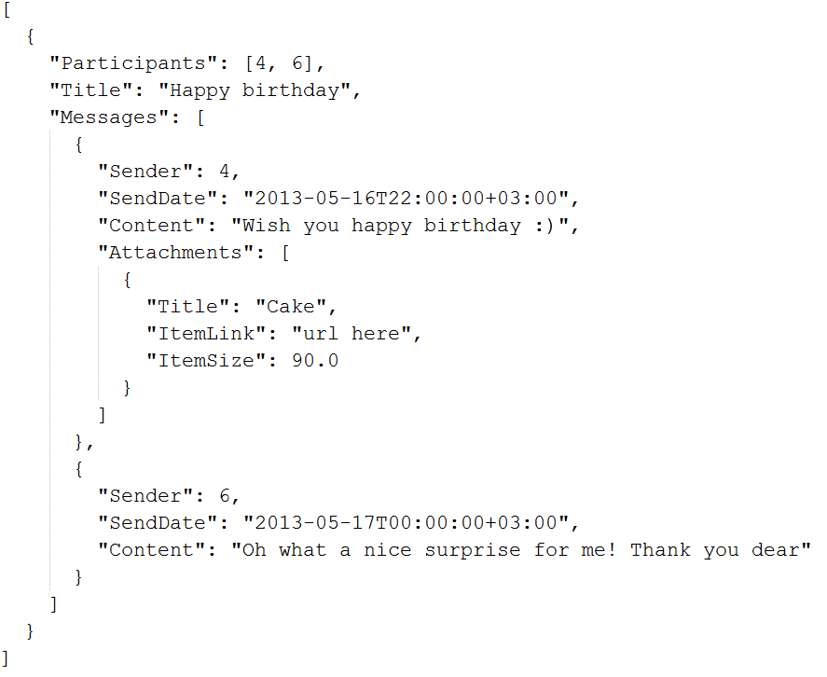

**GetValue**

Syntax:

jqsql.getvalue(@jsonData nvarchar(max), @expression nvarchar(500)

It returns the findings by given expression. The result types might differ, being a value, an object or a list. That’s why it is so dynamic and highly depends on the data structure and given expression.

In the following example, because our data is a JSON array, value function returns the list of titles in conversations.

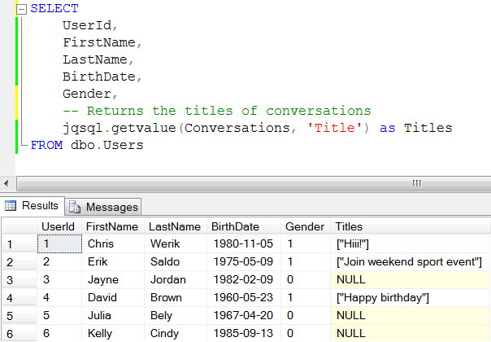

In the following example, value function returns the list of send dates of first message in each conversation, which means also the start date of each conversation.

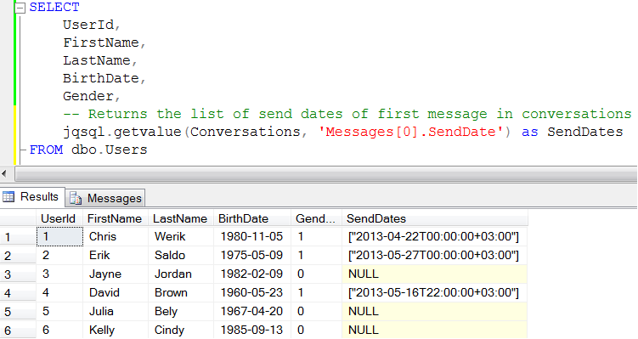

**GetCount**

Syntax:

jqsql.getcount(@jsonData nvarchar(max), @expression nvarchar(500)

It returns the count of the findings by given expression.

In the following example, it finds the total number of attachments in messages in conversations.

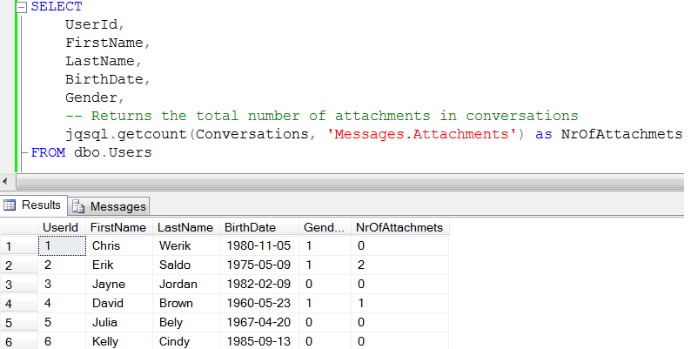

**GetAvg**

Syntax:

jqsql.getavg(@jsonData nvarchar(max), @expression nvarchar(500)

It returns the average of the findings by given expression. It supports only numerical values.

**GetSum**

Syntax:

jqsql.getsum(@jsonData nvarchar(max), @expression nvarchar(500)

It returns the sum of the findings by given expression. It supports only numerical values.

In the following example, it calculates the total sizes of available attachments in messages in conversations

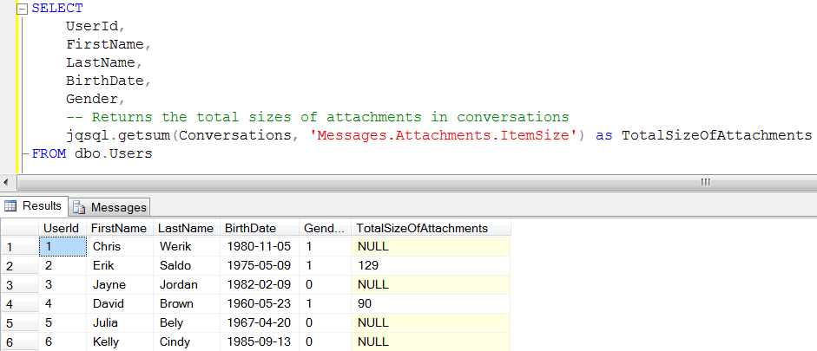

**GetMax**

Syntax:

jqsql.getmax(@jsonData nvarchar(max), @expression nvarchar(500)

It returns the max of the findings by given expression. Currently, it supports numerical and date values.

In the following example, it returns the most recent send date in messages, which means also the last message send date in conversations.

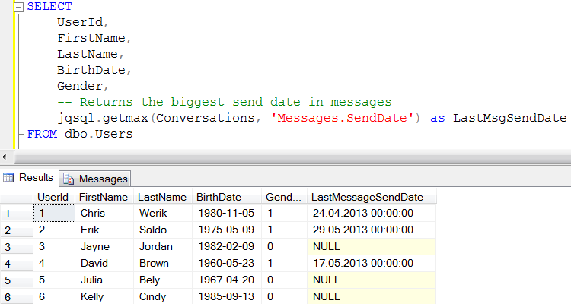

**GetMin**

Syntax:

jqsql.getmin(@jsonData nvarchar(max), @expression nvarchar(500)

It returns the min of the findings by given expression. Currently, it supports numerical and date values.

**ToTable**

Syntax:

EXEC jqsql.totable @jsonData nvarchar(max), @expression nvarchar(500)

It returns findings in tabular format as it is relational data.

In the following example, it finds the first messages in conversations of the user with id, 1. Then, it outputs the results as table, so you can use T-SQL on this data set.

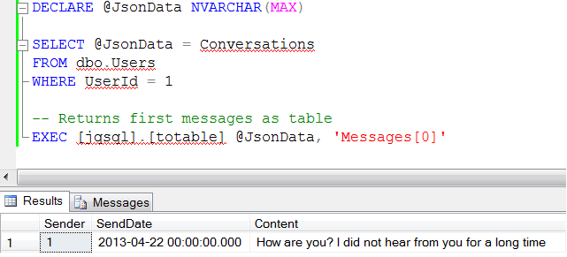

Similarly, in the following example, it finds the attachments in messages. Then, it outputs the results as table.

