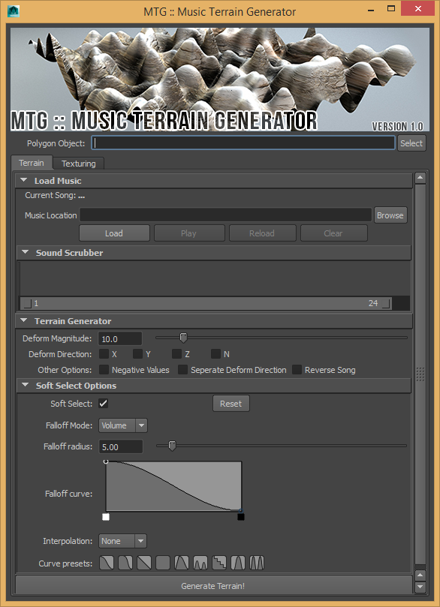

Contents
About 3
How to setup 3
How to use it 3
Terrain 3
Texturing 4

About
The scripting project I chose to tackle was to create a Music Terrain Generator (or MTG for short). The code uses Wave music sound files to displace and deform any polygonal object in the Maya scene dependent on the song amplitude in the song. The program also creates height materials from a selection of textures that have been stored with the program (but can be added to by the user.)

How to setup
To setup the files, simply copy the files from the ‘scripts’ folder into a Maya scripts folder (all my testing was done in ‘User\Documents\maya\2014-x64’) and then open the Script Editor window. When you have done this, click the ‘Source Script…’ button shown below and find the ‘mtg.py’ in the directory you placed the Python files.
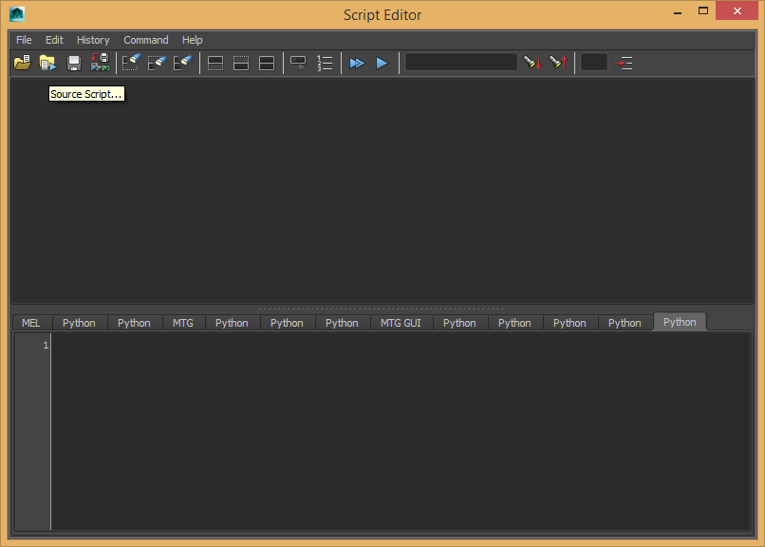

How to use it

Terrain
To use the program you must first select a polygonal object in the Maya scene. This can be anything, that has a mesh, but the most traditional choice is a poly plane. Once you have done this, in the ‘Polygon Object’ field at the top of the window, press the ‘Select’ button to the right of the field. If this doesn’t work, make sure the object you have selected is a polygon object.
The next step is to load the song into the programming. Find the browse button to the right of the ‘Music Location’ text field and find the wave file you want to use in the hard drive. Then, press the load button to load the song into the program. I have uploaded some music files into the folder ‘03_ASSETS’
The last necessary step to run the code is to select a deform direction. Click the check box next to the ‘Deform Direction’ label and set a direction: either/or X,Y,Z and N (for Normal).
You can then press the ‘Generate Terrain!’ Button. If you want, you can play around with the other settings such as ‘Deform Magnitude’ and the ‘Soft Select’ settings that are identical to the Maya interface.
The only options that might not seem obvious are ‘Negative Values’ which means the terrain will be both translated negatively and positively if it is checked and ‘Separate Deform Direction’ which takes the values for the ‘Deform Direction’ and instead of combining the move commands, separated them into individual commands.

Texturing
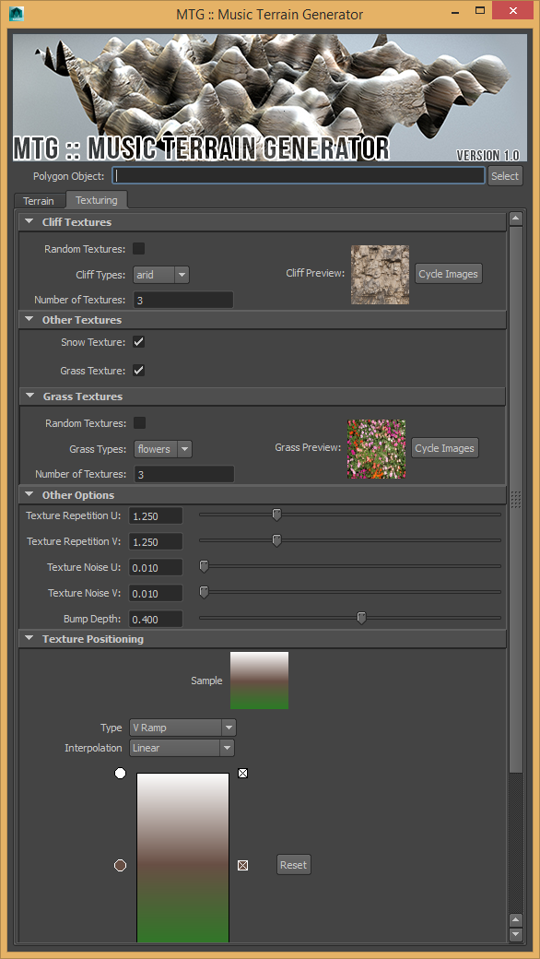
On the Texturing Tab, you can choose the options for the textures to be applied to the object. ‘Random Textures’ under the Cliff and Grass Textures frames means that all of the images in the texture directory will be used (i.e. all cliff textures in the cliff folder). Otherwise, ‘Cliff Type’ will be the type of cliff or grass texture used. ‘Number of Textures’ is the number of random textures from that directory. If you set more files then are in the folder, repeats texture files will be used.
The image preview are the images from the relevant file directory and the button ‘Cycle Images’ shows all the files available in that directory.
The ‘Snow’ and ‘Grass’ texture check box will add or remove the use of snow and grass textures from the final texture result. The other options are fairly self-explanatory.
The ramp Texture Positioning is a little difficult to explain:
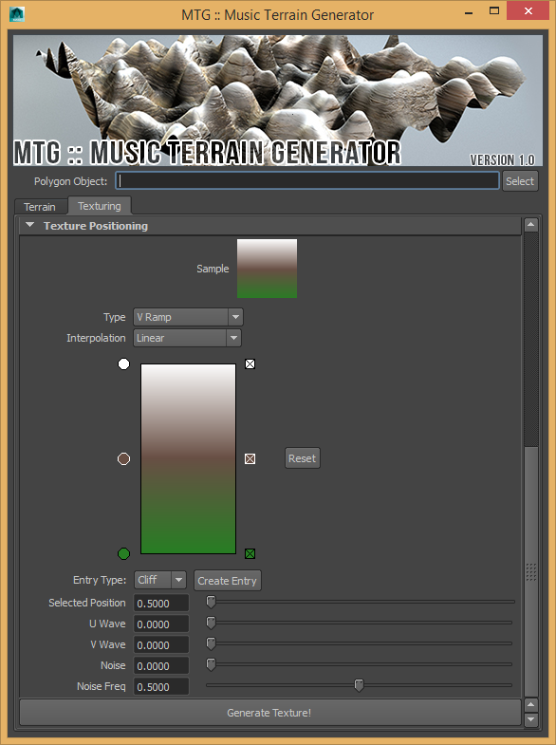
The ramp represents the final height map of the textures that will be created. This is what will decide where the textures will go. The different colours decide what connection it will have from the different type of texture: white for snow, brown for cliff, green for grass. Since I haven’t implemented blending of two different texture inputs, all the colours that will be created by clicking on the ramp will be transferred into the appropriate Cliff, Snow or Grass colour entry.
Once you have adjusted this and then the ramp rendering settings, you click ‘Generate Texture’ to create the texture on the terrain. For the best result, render the scene using Mental Ray and Smooth Shading on.

