COMP 4981

Assignment 1

Testing

Jacob Fonseca
A01413680
Feb 3rd, 2026

Tests 3
Test 1 3
Test 2 4
Test 3 4
Test 4 4
Test 5 4
Test 6 5
Test 7 5
Test 8 5
Test 9 6
Test 10 6
Test 11 7
Test 12 7

Test | Expected | Actual | Screenshot
No arguments | fail | fail | Test 1
No port value | fail | fail | Test 2
Wrong flag | fail | fail | Test 3
Non integer port | fail | fail | Test 4
Negative port | fail | fail | Test 5
Out of range port | fail | fail | Test 6
Successful start | pass | pass | Test 7
Standard GET | pass | pass | Test 8
HEAD Request | pass | pass | Test 9
Missing File | fail | fail | Test 10
Unsupported Method | fail | fail | Test 11
Root directory GET | pass | pass | Test 12

Tests

Test 1
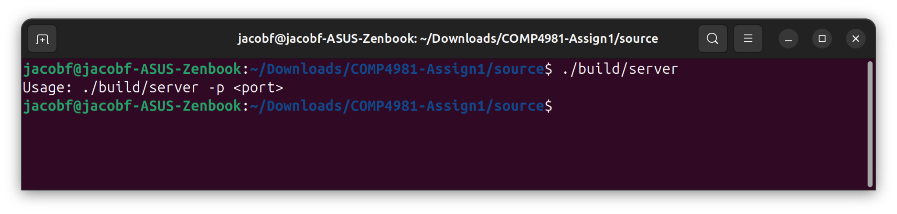

Test 2
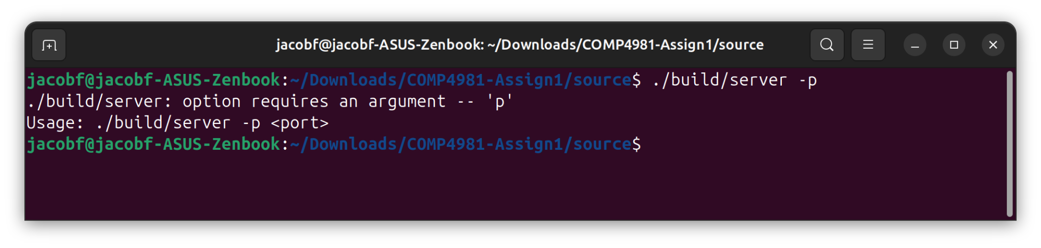

Test 3
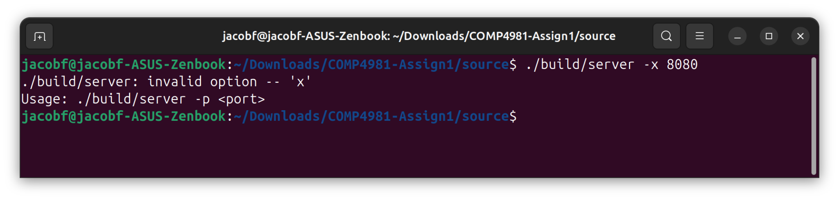

Test 4
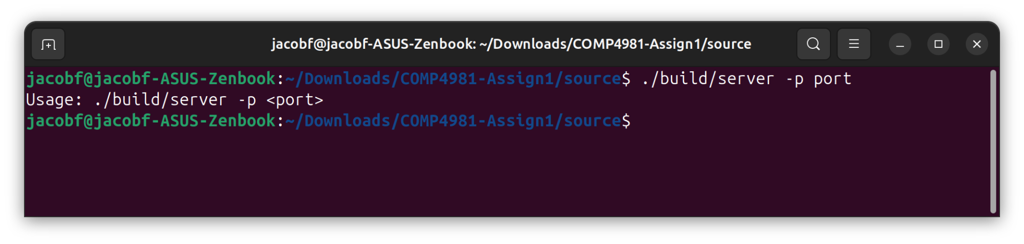

Test 5
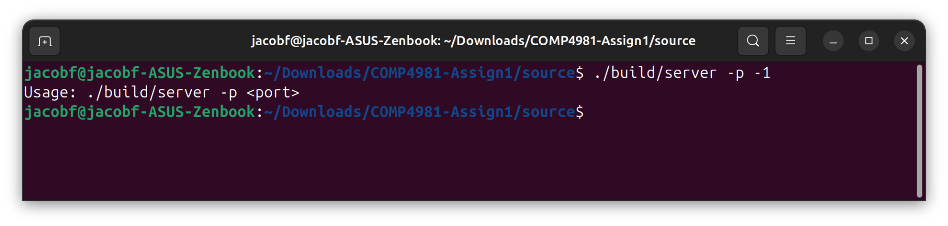

Test 6
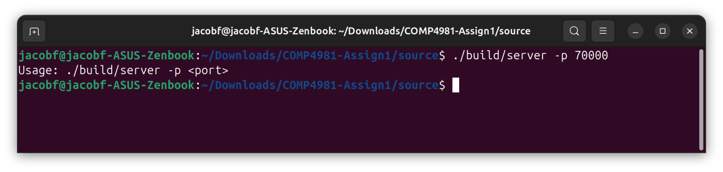

Test 7
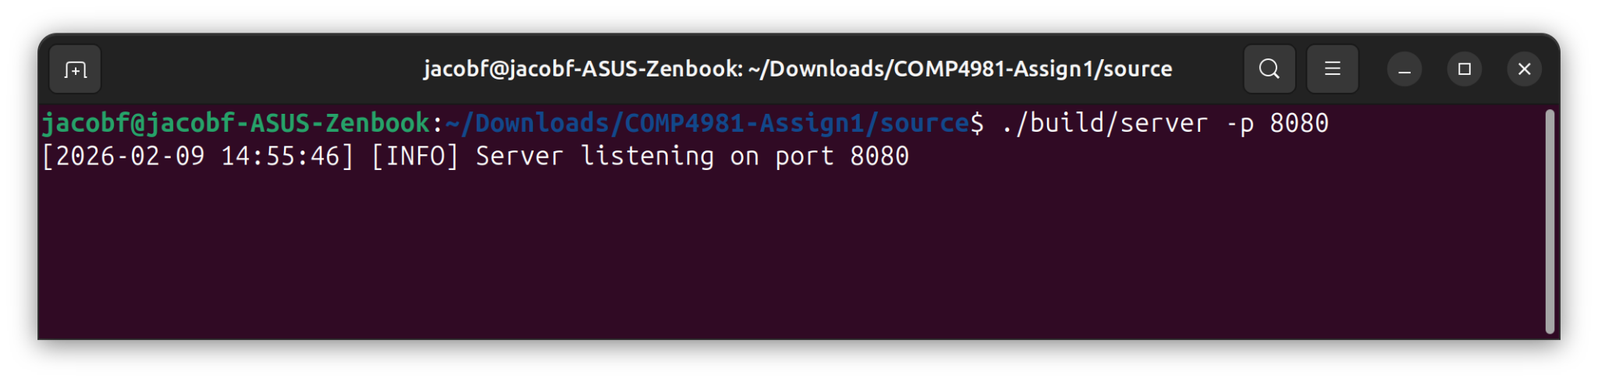

Test 8
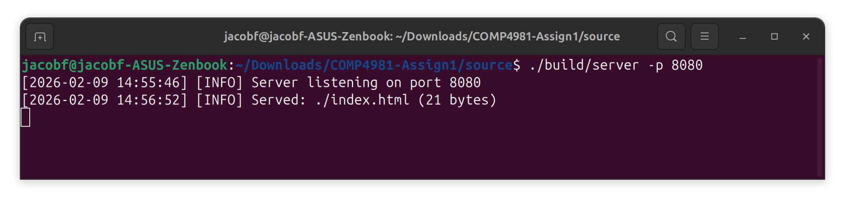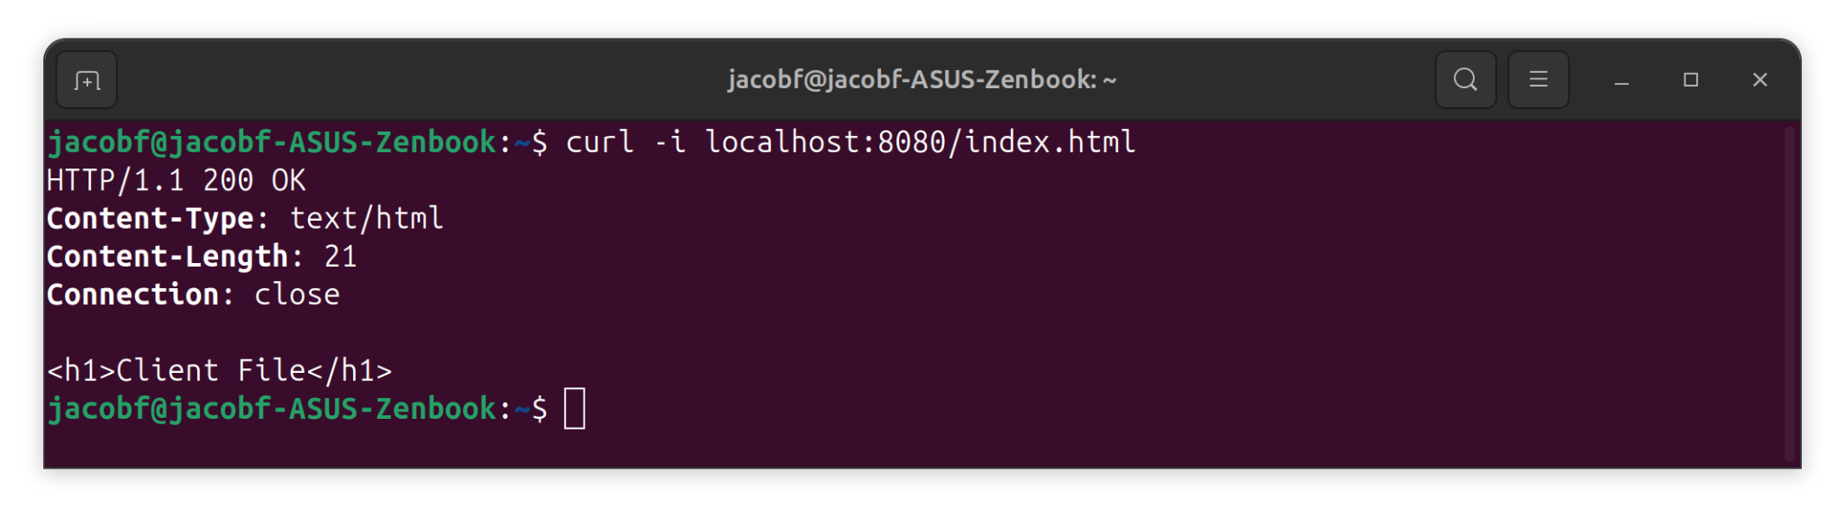

Test 9
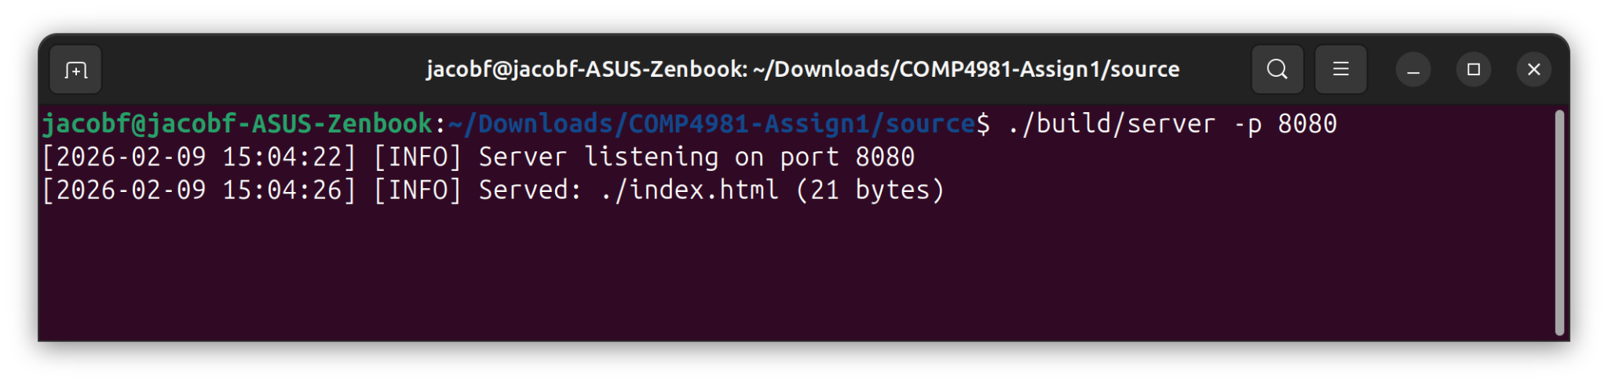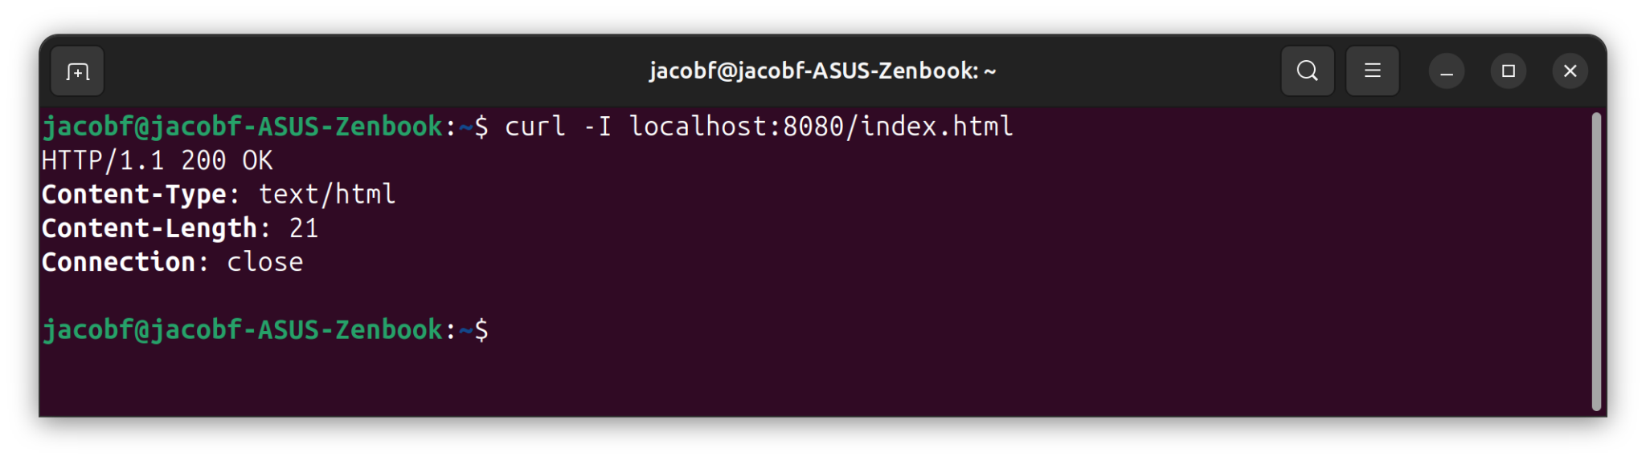

Test 10
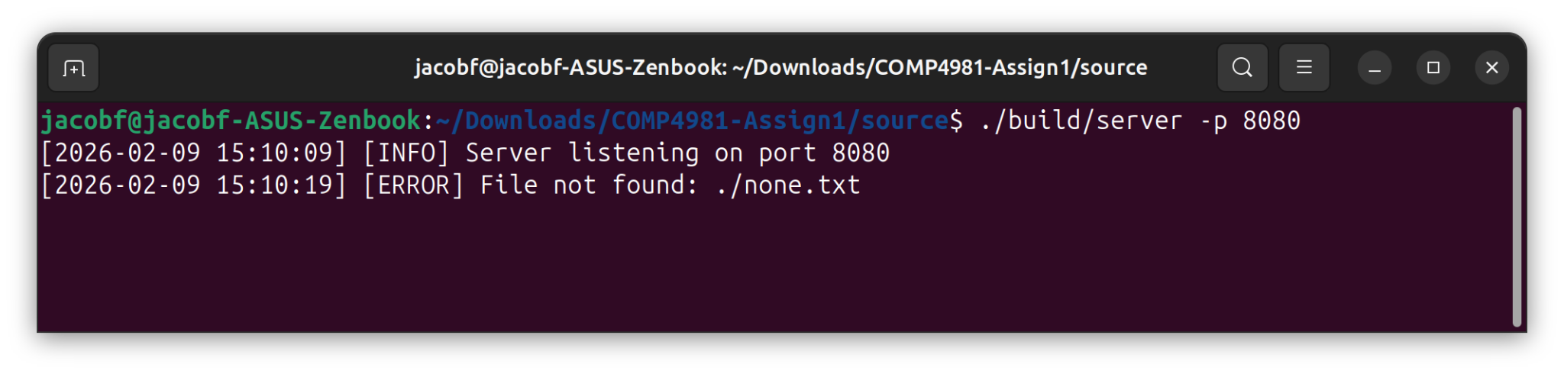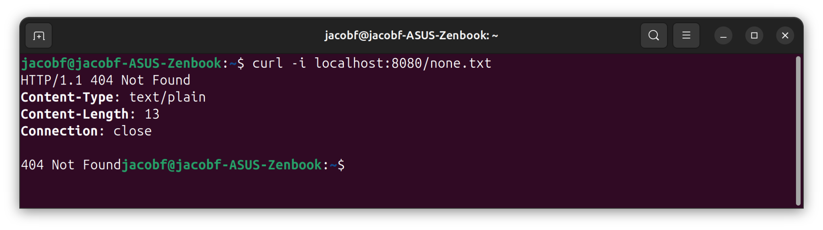

Test 11
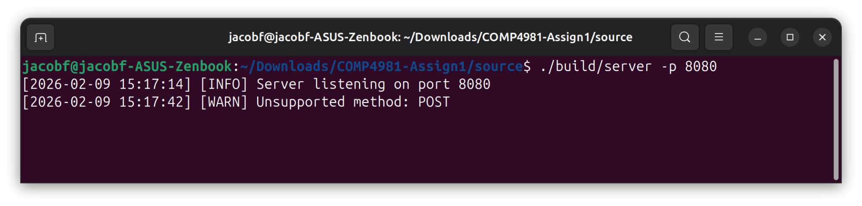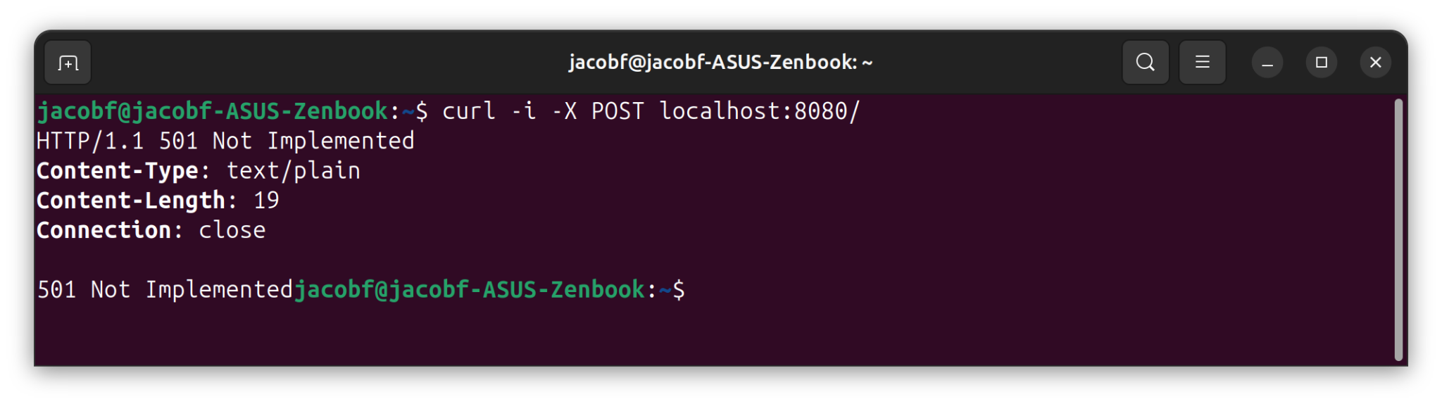

Test 12
