COMP 4981

Assignment 1
Design

Jacob Fonseca
A01413680
Jan 18th, 2026

What it does

Goal
Launch a multi-threaded or I/O multiplexed HTTP server that listens for incoming TCP connections, parses HTTP GET and HEAD requests, and serves the requested files or appropriate error codes to concurrent clients.

Success condition (observable outcome)
The server stays running and responsive. When a client sends a valid GET request, the server returns the file contents and an OK status; for missing files or invalid methods, it returns the correct HTTP error code.

Invariant (one checkable rule)
The server listens on the specified port and accepts new connections without blocking existing active clients..

How I will test it

Valid GET Request
The server is running, and a client requests an existing file using the GET method.

Steps:
- Start the server on a known port.
- Use curl or a browser to send a GET /index.html request.
- Observe standard output and the client response.

Expected result:
- The client receives the full content of index.html with HTTP status 200 OK. The server logs the request and remains active.

What it proves:
- The system correctly accepts connections, parses valid GET requests, and performs file I/O using POSIX APIs.

Missing File (404)
The client requests a file that does not exist in the server's directory.

Steps:
- Start the server.
- Send a request for a non-existent file (e.g., GET /ghost.txt).
- Observe client response.
Expected result:
- The client receives an HTTP 404 Not Found response. The server does not crash and continues listening.

What it proves:
- The system handles file system errors gracefully and sends appropriate HTTP status codes.

Concurrent Connections
Multiple clients attempt to connect and request files simultaneously.

Steps:
- Start the server.
- Launch a script that spawns multiple concurrent curl requests (e.g. 10 parallel requests) to the server.
- Observe server logs and client outputs.
Expected result:
- All clients receive their responses successfully without timeouts or connection refusals. The server handles the load using poll or threads.

What it proves:
- The concurrency mechanism (I/O multiplexing/poll) functions correctly, preventing blocking on a single client.

Unsupported Method
A client sends a request using a method other than GET or HEAD (e.g., POST).

Steps:
- Start the server.
- Send a POST request using curl -X POST ...
- Observe client response.
Expected result:
- The client receives an HTTP 501 Not Implemented (or similar) error.

What it proves:
- The request parser correctly identifies and rejects unsupported HTTP methods.

FSM

State meanings
State | Meaning
START | The program has begun, no sockets are created yet.
INIT | Parsing arguments and setting up the server socket (bind/listen).
EVENT_LOOP | Waiting for events (new connections or data) via poll.
ACCEPT_CLIENT | Accepting a new incoming TCP connection.
HANDLE_IO | Reading request data, parsing HTTP, and sending responses.
USAGE | Invalid command-line arguments were detected.
CLEANUP | Closing sockets and freeing resources before exit.
EXIT | The program has terminated

Transition table
State | Call (function) | Fail state | Success state
START | parse_arguments | USAGE | INIT
INIT | handle_arguments | USAGE | EVENT_LOOP
EVENT_LOOP | usage | CLEANUP | ACCEPT_CLIENT  HANDLE_IO
ACCEPT_CLIENT | display_messages |  | DISPLAY_MESSAGES
HANDLE_IO | usage | EVENT_LOOP | EVENT_LOOP
USAGE | cleanup | EVENT_LOOP | EVENT_LOOP
CLEANUP | cleanup |  | EXIT

FSM diagram

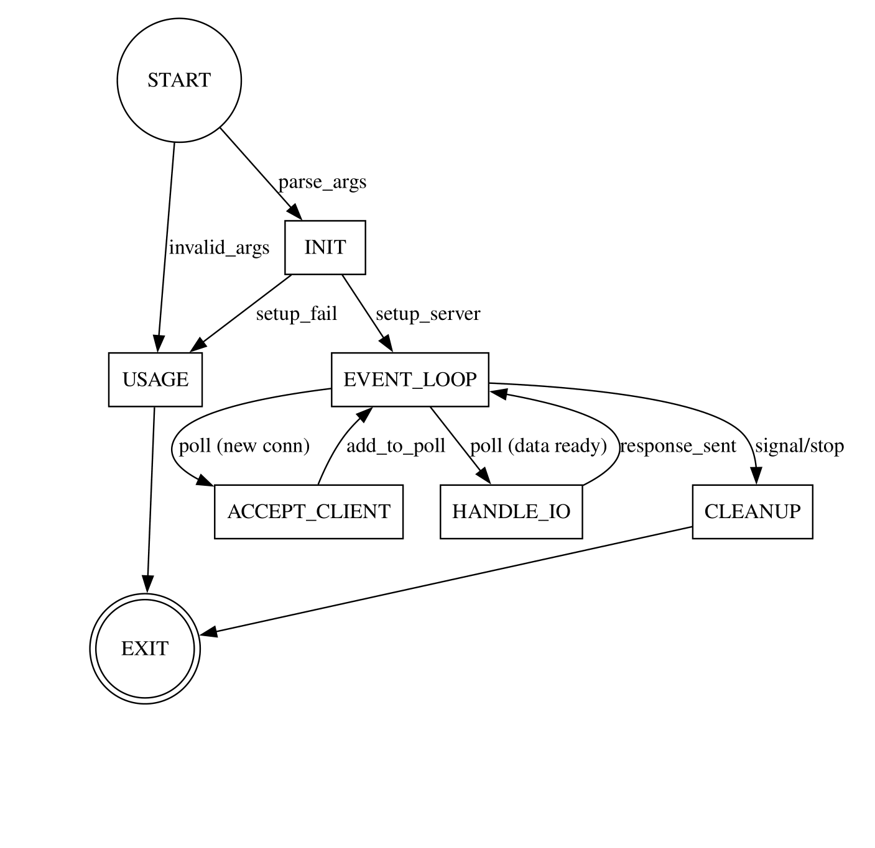

Functions
Name | Inputs | Outputs | Responsibility
setup_server | Port number | Server socket FD | Create, bind, and listen on a TCP socket using POSIX APIs.
poll_events | List of FDs | Active FD count | Monitor multiple file descriptors for incoming data using poll.
accept_connection | Server socket | Client socket FD | Accept a new incoming client connection.
handle_request | Client socket | HTTP response | Read buffer, parse GET/HEAD, and prepare the response.
send_response | Socket, Status, Content | - | Write the HTTP header and file content to the client socket.
cleanup | Socket list | Exit status | Close all open sockets and free memory on shutdown.

