COMP 4981

Assignment 2
Design

Jacob Fonseca
A01413680
Feb 11th, 2026

What it does

Goal
Implement a client-server remote shell application where a server listens for TCP connections, accepts commands from a client, executes them on the remote machine using execv/execve, and returns the standard output and standard error to the client.

Success condition (observable outcome)
The client successfully connects to the server, sends a command (e.g., ls -la), and displays the exact output returned by the server. If "exit" is sent, the connection terminates gracefully.

Invariant (one checkable rule)
The server must always support at least two simultaneous client connections, using child processes to isolate client sessions so that one client crashing or hanging does not affect the main server listener.

How I will test it

Basic Command Execution
The client sends a standard shell command to the server.

Steps:
- Start the server on a specific port.
- Start the client and connect to that IP/Port.
- Enter the command ls -la.
- Observe the client terminal.

Expected result:
- The client displays the directory listing of the server's working directory. The server remains active.

What it proves:
- The basic TCP connection, command parsing, execv execution, and response forwarding are working.

Output Redirection
The client sends a command involving file redirection (>).

Steps:
- Connect client to server.
- Enter command echo "Hello World" > test_output.txt.
- Check the server's directory for test_output.txt.

Expected result:
- The file test_output.txt is created on the server containing "Hello World". The client receives no error message.

What it proves:
- The server correctly identifies redirection symbols (>) and uses dup2 to redirect standard output before execution.

Concurrent Clients
Two clients attempt to use the server simultaneously.

Steps:
- Start the server.
- Open Terminal A and connect Client 1.
- Open Terminal B and connect Client 2.
- Send sleep 5 from Client 1, and immediately send ls from Client 2.
Expected result:
- Client 2 receives the ls output immediately, even while Client 1 is still waiting for sleep to finish.

What it proves:
- The server successfully creates a pool of child processes to handle multiple clients concurrently.

Graceful Exit
The user terminates the session.
Steps:
- Connect client to server.
- Enter command exit.
- Observe client and server behavior.
Expected result:
- The client application terminates. The server logs the disconnection but continues listening for new clients.

What it proves:
- The application detects the exit command and closes the TCP socket properly.

FSM

State meanings
State | Meaning
START | Program entry point; argument validation.
INIT | Server creation: socket, bind, listen.
LISTENING | Main server loop waiting for incoming TCP connections.
FORK_CHILD | A connection is accepted; process forks to handle client.
WAIT_CMD | Child process waiting to read command from client.
PROCESS_CMD | Parsing command, handling redirection (<, >), and execv.
SEND_RESP | Transmitting stdout/stderr buffer back to client.
USAGE | Invalid arguments provided; help text displayed.
CLEANUP | Closing sockets and reclaiming resources.
EXIT | Program termination.

Transition table
State | Call/Event | Fail State | Success State
START | parse_args | USAGE | INIT
INIT | setup_server (socket/bind) | CLEANUP | LISTENING
LISTENING | accept (new connection) | LISTENING | FORK_CHILD
FORK_CHILD | fork (parent process) | LISTENING | LISTENING
FORK_CHILD | fork (child process) | CLEANUP | WAIT_CMD
WAIT_CMD | read (client data) | CLEANUP (if EOF/Err) | PROCESS_CMD
PROCESS_CMD | parse & execv | SEND_RESP (error msg) | SEND_RESP
PROCESS_CMD | "exit" command | -- | CLEANUP
SEND_RESP | write (to socket) | CLEANUP | WAIT_CMD
USAGE | -- | -- | EXIT
CLEANUP | close | -- | EXIT

FSM diagram
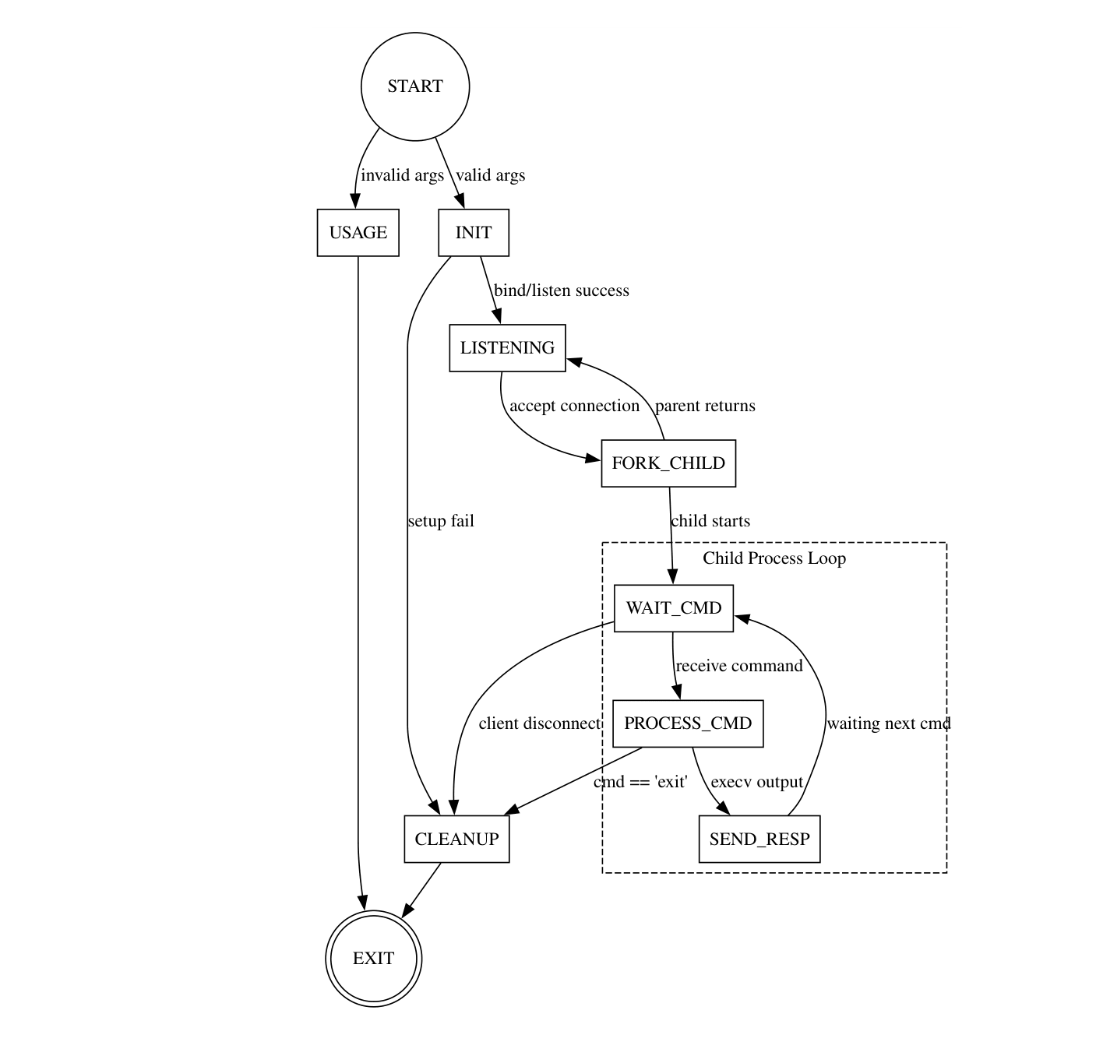

Functions
Name | Inputs | Outputs | Responsibility
setup_server | Port number | Server Socket FD | Create socket, bind to port, and start listening for connections.
accept_client | Server Socket FD | Client Socket FD | Accept incoming TCP connection and return new file descriptor.
process_client | Client Socket FD | Void | The main loop for the child process: reads commands, executes them, and sends results.
parse_command | Raw string buffer | Argument Array (argv) | Tokenize input string (using strtok) and detect redirection symbols (<, >, 2>).
execute_command | Argument Array | Output/Error Stream | Handles dup2 for redirection and calls execv to run the command.
cleanup | Socket FD | Exit Status | Ensures sockets are closed and resources freed before process termination.

