COMP 4981

Assignment 2

Testing

Jacob Fonseca
A01413680
Mar 7th, 2026

Tests 4
Test 1 4
Test 2 4
Test 3 5
Test 4 5
Test 5 6
Test 6 6
Test 7 7
Test 8 7
Test 9 8
Test 10 9
Test 11 9
Test 12 11
Test 13 12
Test 14 13
Test 15 14

Test | Expected | Actual | Screenshot
Server - no arguments | Fail | Fail | Test 1
Server - too many arguments | Fail | Fail | Test 2
Server - invalid port | Fail | Pass | Test 3
Client - no arguments | Fail | Fail | Test 4
Client - no port | Fail | Fail | Test 5
Client - too many arguments | Fail | Fail | Test 6
Client - invalid IP | Fail | Fail | Test 7
Server offline | Fail | Fail | Test 8
pwd | Pass | Pass | Test 9
ls -la | Pass | Pass | Test 10
\n | Pass | Pass | Test 11
Output redirection (>) | Pass |  | Test 12
Error redirection (2>) | Pass |  | Test 13
Graceful disconnect | Pass |  | Test 14
Concurrent Clients | Pass |  | Test 15

Tests

Test 1
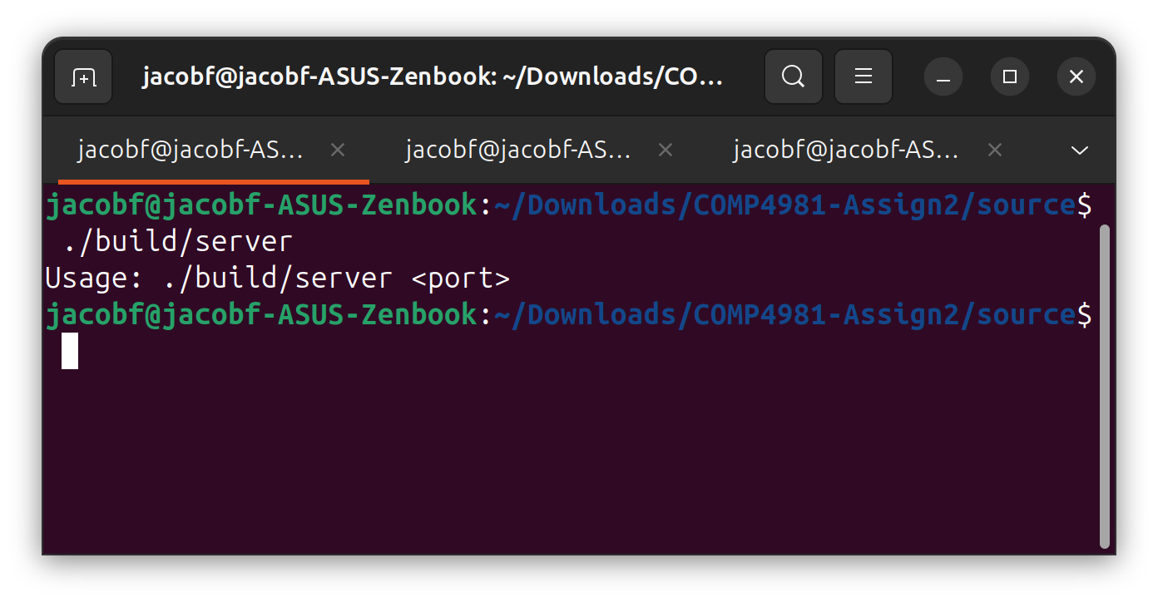

Test 2
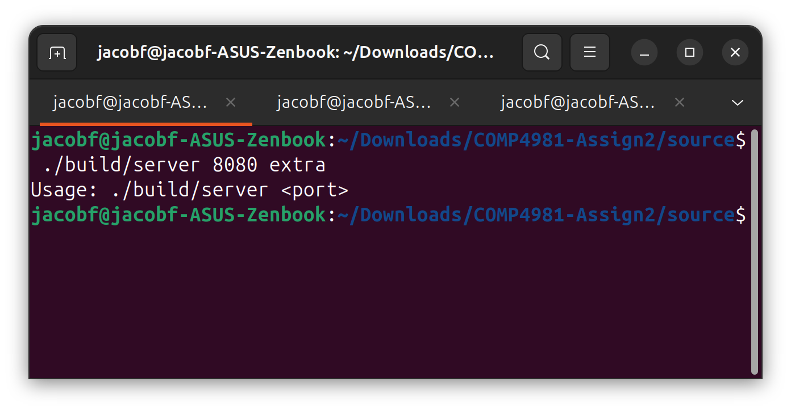

Test 3
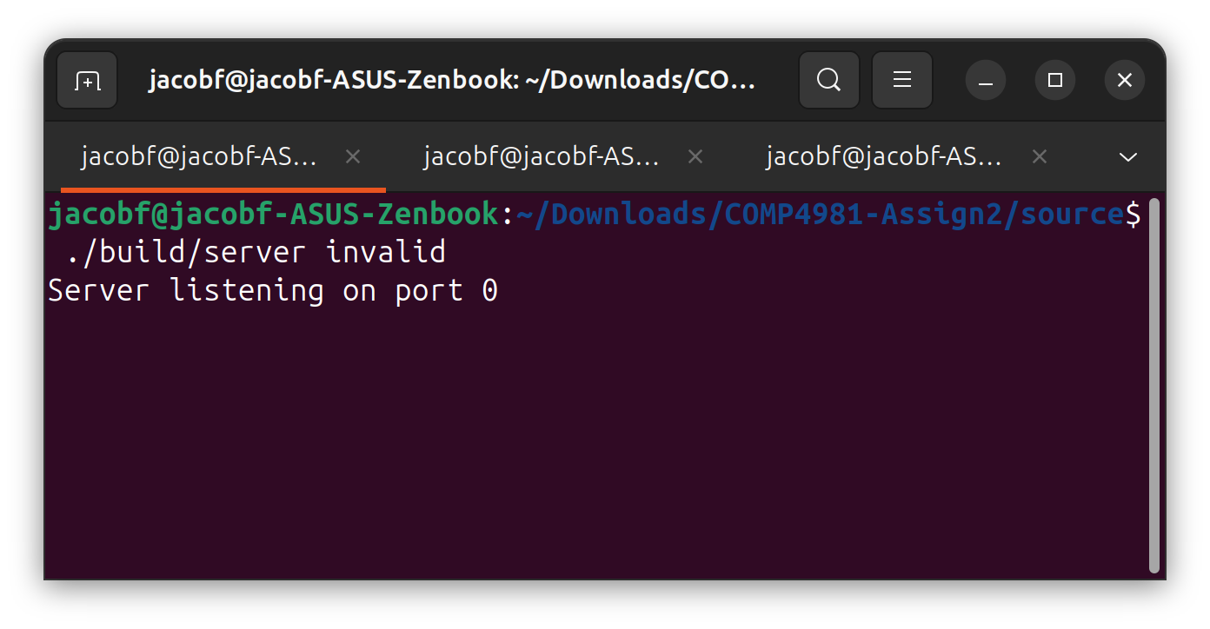

Test 4
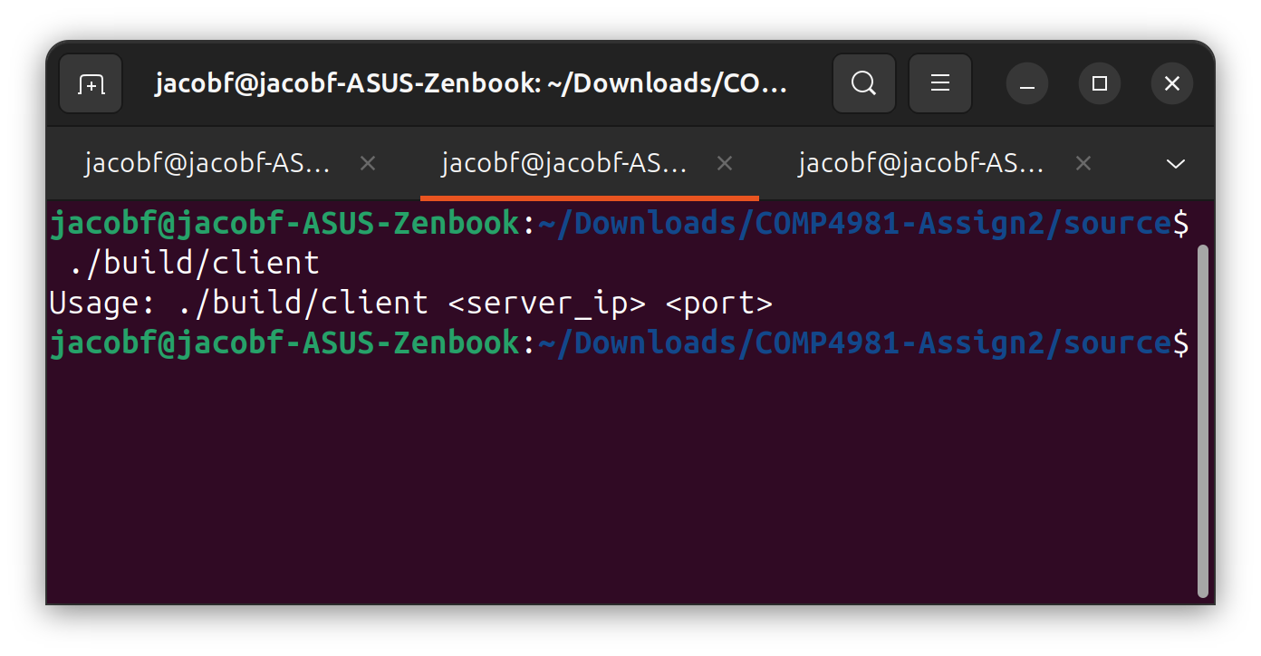

Test 5
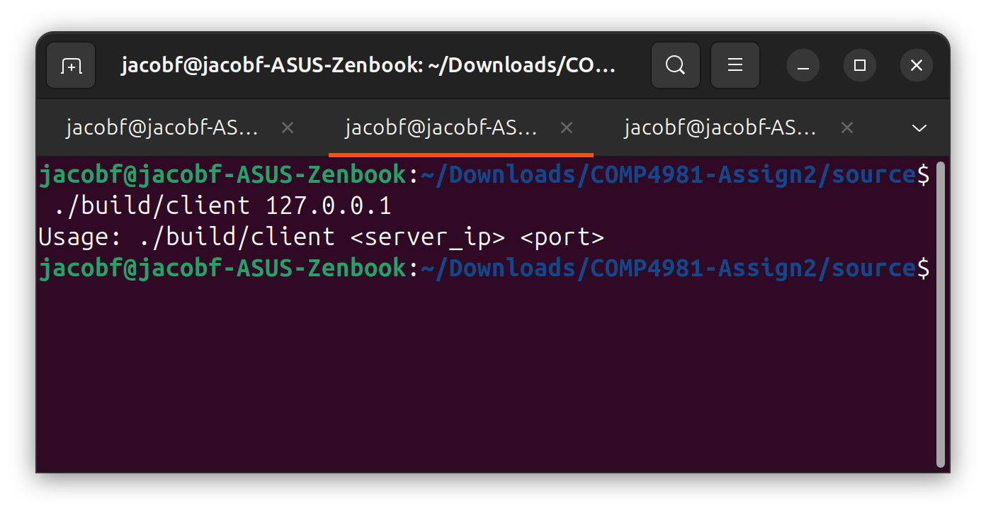

Test 6
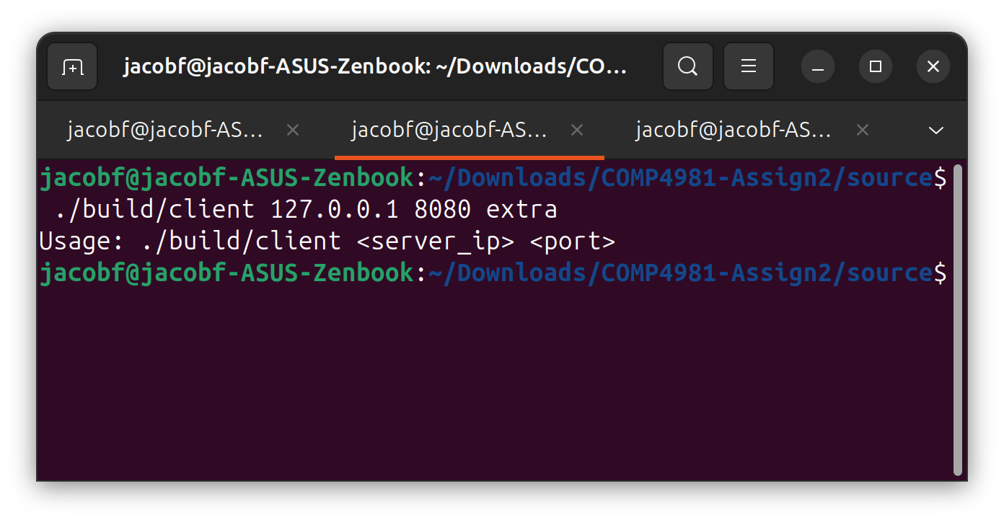

Test 7
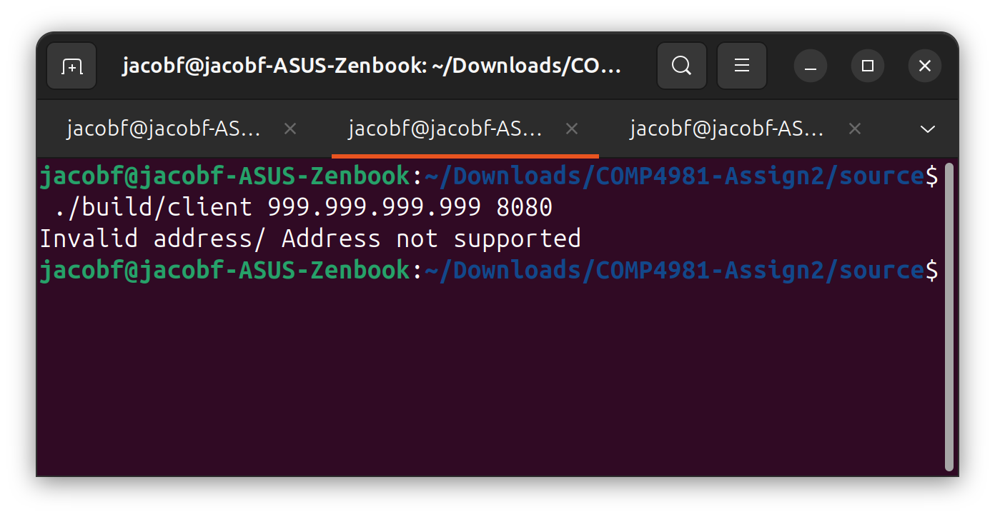

Test 8
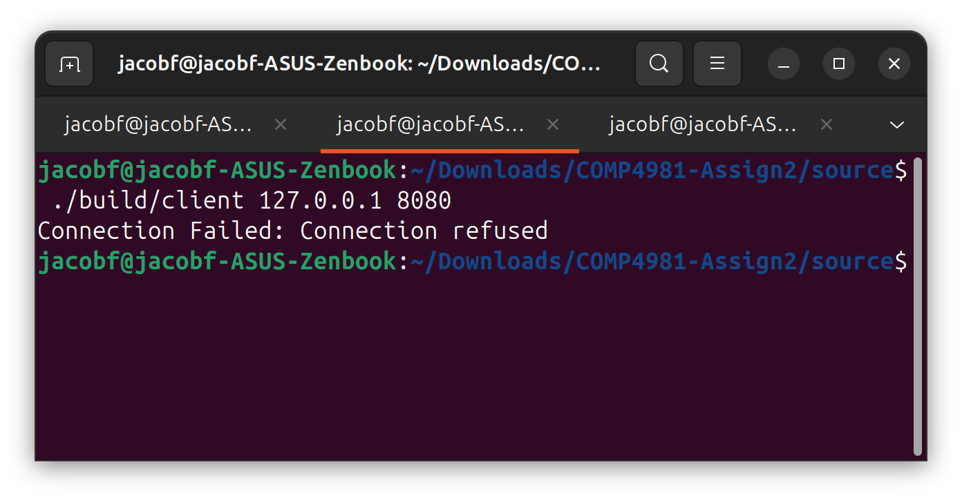

Test 9
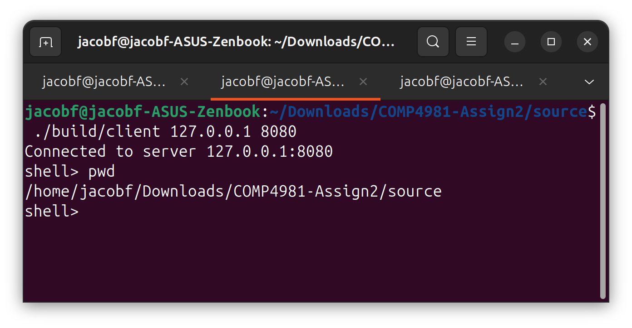

Test 10
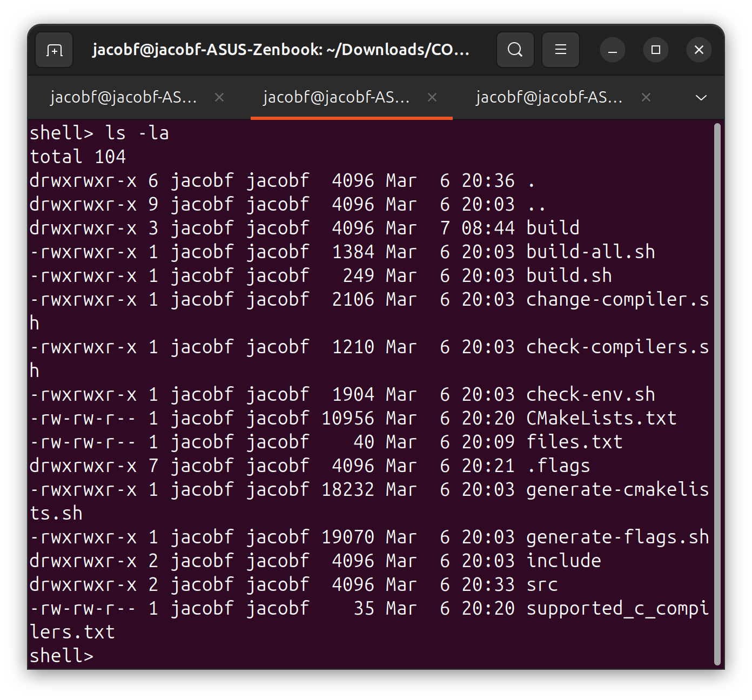

Test 11
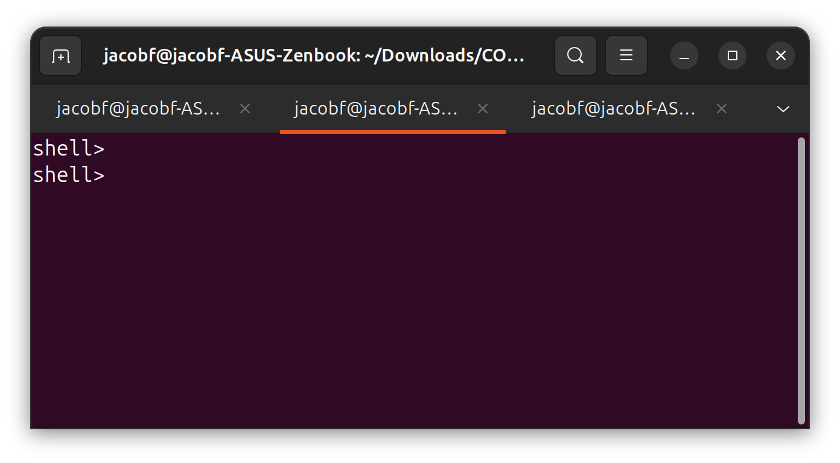

Test 12
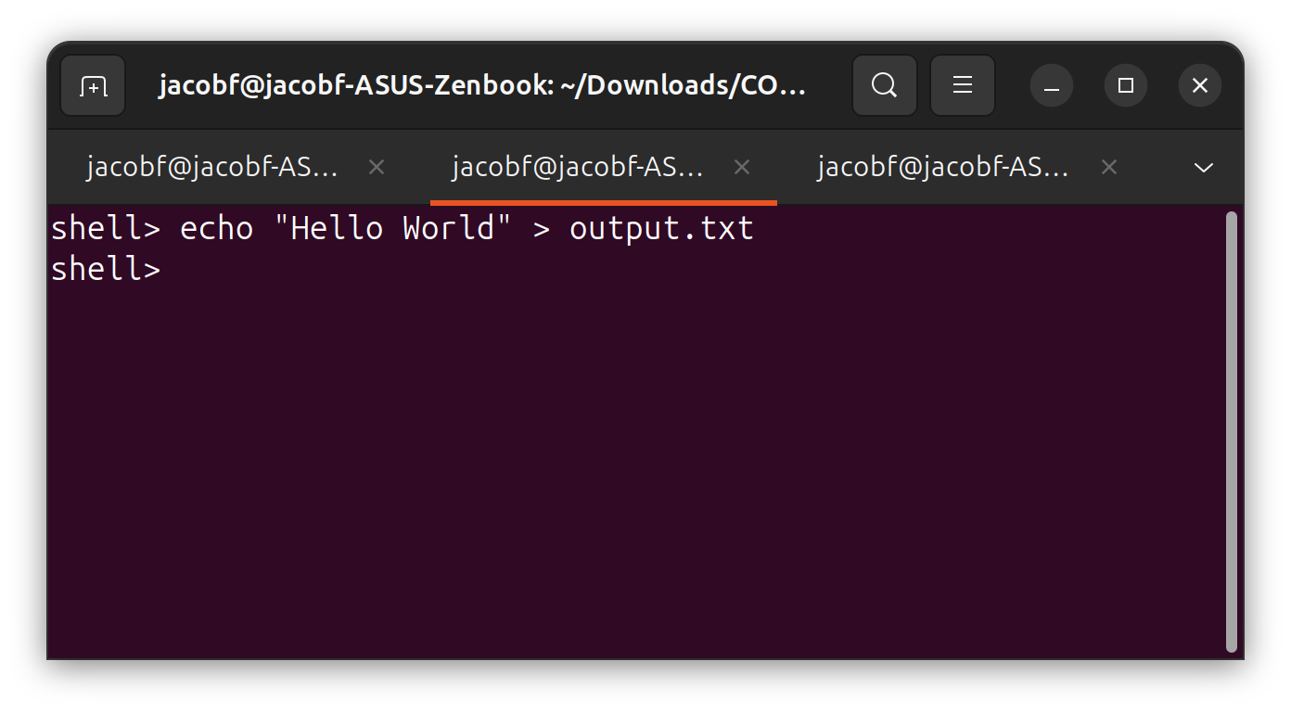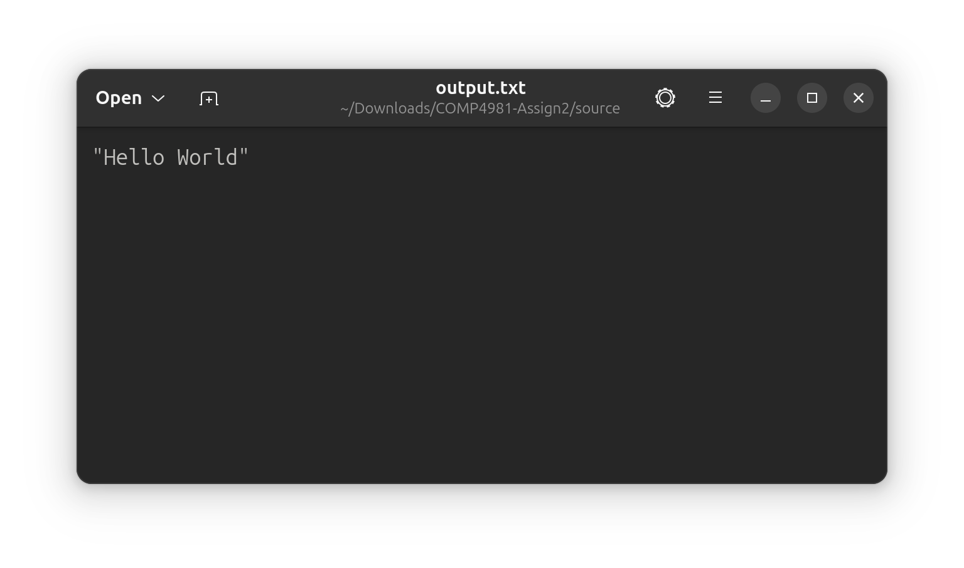

Test 13
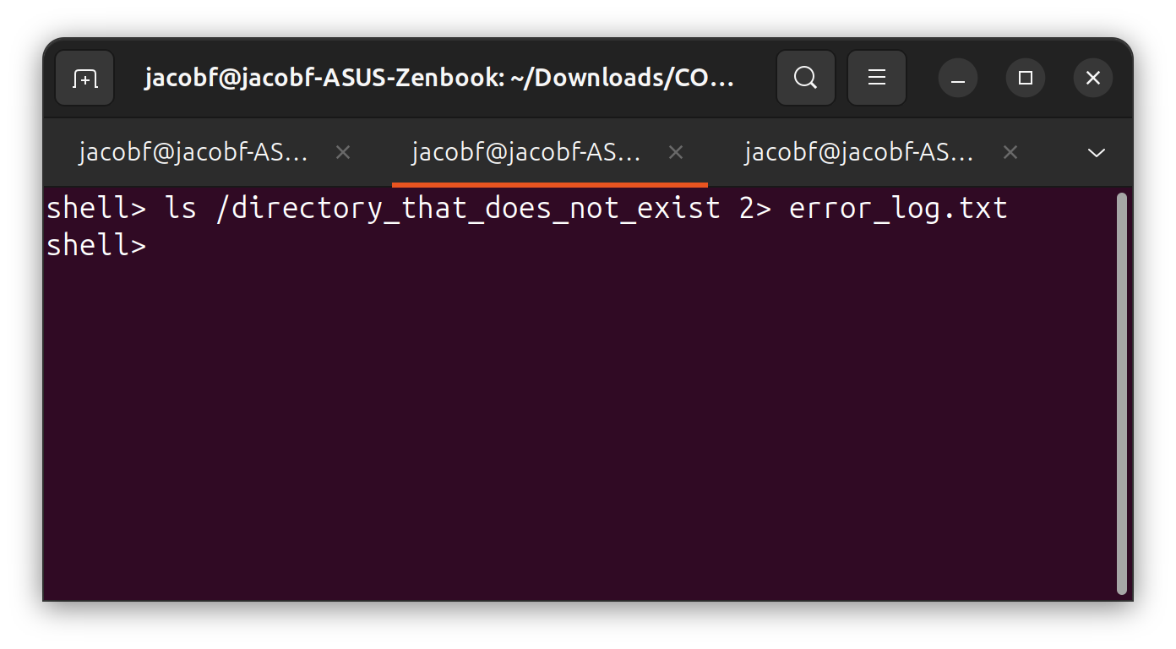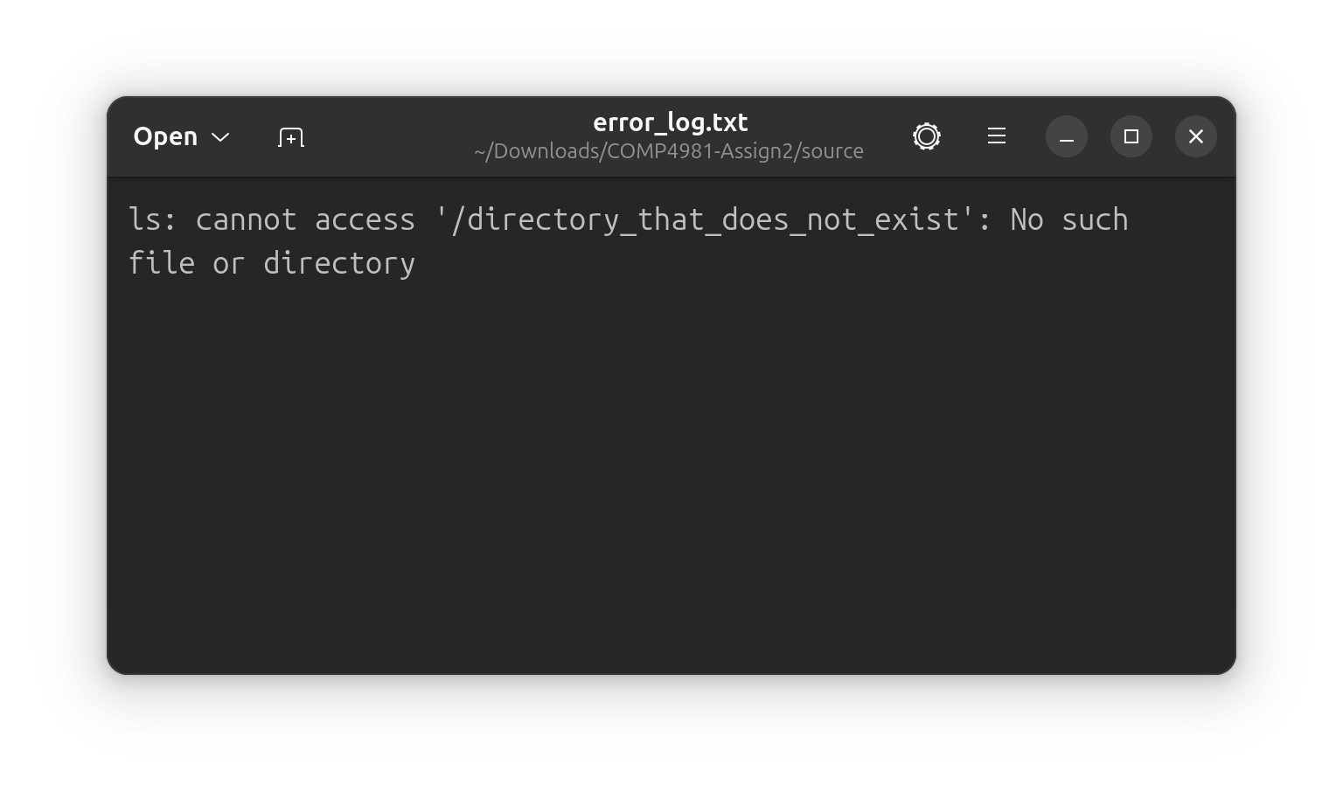

Test 14
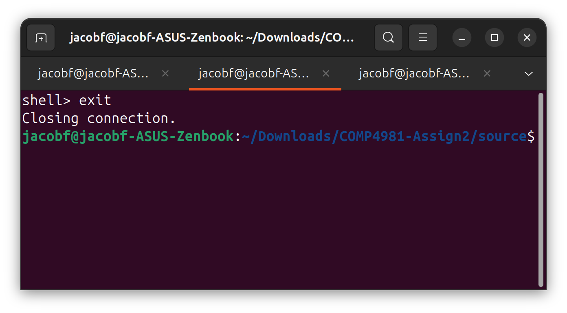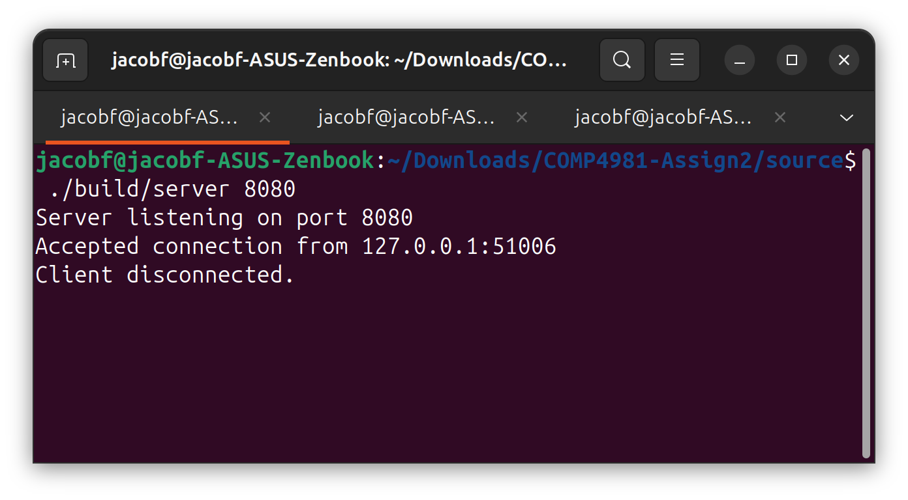

Test 15
