COMP 4981

Assignment 3
Design

Jacob Fonseca
A01413680
Mar 24th, 2026

What it does

Goal
Launch a pre-forked, multi-process HTTP 1.0 server that utilizes a dynamic shared library for request handling and an ndbm database for persistent storage of POST data. The server must monitor worker health and support on-the-fly logic updates.

Success condition (observable outcome)
The server maintains a configurable pool of worker processes. When a POST request is received, data is successfully stored in an ndbm database. If a worker process crashes, the parent process automatically restarts it. Updates to the request-handling shared library are applied without a server restart.

Invariant (one checkable rule)
The parent process always maintains the specified number of active worker processes, regardless of individual worker crashes or library reloads.

How I will test it

Persistent POST Storage
The client sends data to the server using the HTTP POST method, and the server stores it in the ndbm database.

Steps:
- Start the server on a specified port.
- Use curl -X POST -d "key=value" http://IPv4:port to send data.
- Run the separate query program provided with the assignment to view the database contents.

Expected result:
- The client receives a successful HTTP status code (e.g., 200 OK). The query program displays the "key=value" pair exactly as sent.

What it proves:
- The system correctly parses POST requests and integrates with the ndbm database for persistent data storage.

Dynamic Library Update
The request handling logic is updated by replacing the shared library file without restarting the main server process.

Steps:
- Start the server with the initial version of the shared library (.so).
- Modify the source code of the shared library (e.g., change a response string) and recompile it.
- Replace the existing .so file while the server is still running.
- Send a new GET or POST request to the server.

Expected result:
- The worker process detects the modification time change and reloads the library using dlopen(). The client receives a response reflecting the updated logic.

What it proves:
- The server successfully monitors and hot-swaps request-handling logic at runtime.

Worker Process Recovery (Crash Resistance)
The parent process monitors the pre-forked worker pool and ensures that crashed workers are replaced.

Steps:
- Start the server with a configured number of worker processes.
- Identify the Process ID (PID) of one of the worker processes.
- Forcefully terminate that worker (e.g. using kill -9).
- Observe the server logs and the process list.
Expected result:
- The parent process detects the child exit and immediately forks a new worker to maintain the pool. The server continues to handle client connections without interruption.

What it proves:
- The pre-forking model is robust and the parent process correctly implements crash recovery.

Concurrent Connections
Multiple clients attempt to connect simultaneously to verify the efficiency and stability of the pre-forked worker pool.

Steps:
- Start the server with a configured number of pre-forked workers.
- Launch a script or benchmarking tool to send a high volume of simultaneous requests (e.g., 50 parallel connections).
- Observe server logs to verify that different workers are picking up the requests.
Expected result:
- All clients receive their responses successfully without timeouts or refused connections. The workers process the load in parallel as intended by the pre-forked model.

What it proves:
- The pre-forking implementation correctly handles concurrent client connections using POSIX socket APIs.

FSM

State meanings
State | Meaning
START | Program entry; parsing arguments and configuration.
INIT | Creating the master listening socket and initial dlopen of the shared library.
PRE_FORK | Parent process spawning the initial pool of worker processes.
MONITOR | Parent process blocking on wait() to detect worker exits/crashes.
WORKER_LOOP | Child process waiting to accept() a new connection.
CHECK_LIB | Worker checking file modification time to see if .so needs reloading.
HANDLE_REQ | Execution of logic inside the shared library to process GET/HEAD/POST.
CLEANUP | Closing the database, sockets, and terminating remaining workers.

Transition table
State | Call (function) | Fail state | Success state
START | parse_args | USAGE | INIT
INIT | setup_listener | CLEANUP | PRE_FORK
PRE_FORK | fork_worker | CLEANUP | MONITOR
MONITOR | wait (child exit) | CLEANUP | PRE_FORK
WORKER_LOOP | accept | WORKER_LOOP | CHECK_LIB
CHECK_LIB | stat/dlopen | HANDLE_REQ | HANDLE_REQ
HANDLE_REQ | lib_handler | WORKER_LOOP | WORKER_LOOP

FSM diagram

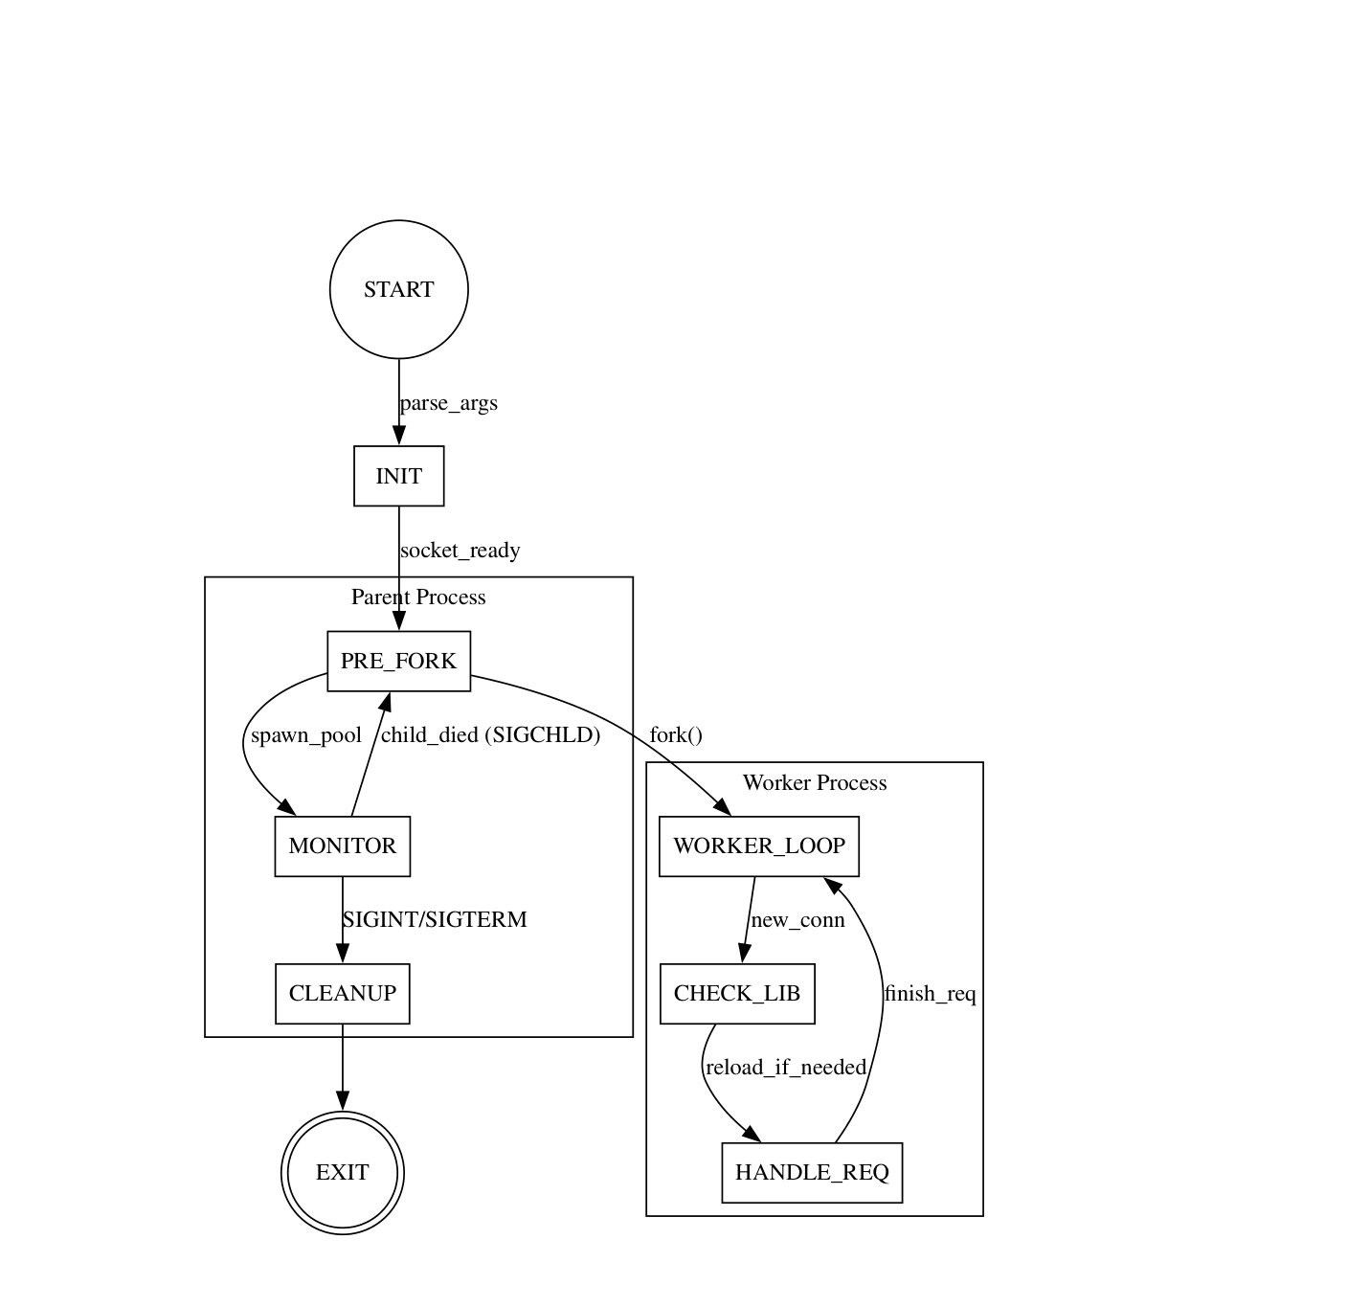

Functions
Name | Inputs | Outputs | Responsibility
setup_listener | Port | Socket FD | Initialize the TCP socket with SO_REUSEADDR.
monitor_workers | Worker count | - | Parent loop using wait() to maintain the worker pool.
load_handler_lib | Lib path | Function pointer | Dynamically load logic using dlopen() and dlsym().
check_for_update | File path | Boolean | Use stat() to compare modification times for the .so.
db_store_data | POST data | Status | Interface with ndbm (dbm_open, dbm_store) to persist data.
process_request | Client FD | HTTP Code | The core logic (moved to shared library) to parse and respond.

