Lensa

Build a visualization dashboard that must have the following elements and attributes.

1 - Create individual pages for each plot

Temperature

Humidity

Cumulus

Windspeed

2 - Create navigation between the pages.

These pages will contain the visualizations and their corresponding explanations.

3 - Create a landing page

4 - Create a comparisons page where we can see a comparison of all of the plots

5 - Create another page where we can view the data used to build them.

Website Requirements For reference, see the "Screenshots" section below.

The website must consist of 7 pages total, including:

1) A navigation menu at the top of every page that:

1.1) Has the name of the site on the left of the nav which allows users to return to the landing page from any page.

1.2) Contains a dropdown on the right of the navbar named "Plots" which provides links to each individual visualization page.

1.3) Provides two more links on the right:

1.3.1)"Comparisons" which links to the comparisons page.

1.3.2)"Data" which links to the data page.

1.3.3 Is responsive (using media queries).

1.4) The nav must have similar behavior as the screenshots "Navigation Menu" section (notice the background color change).

1.5) Be sure to use a CSS media query for the navigation menu.

2) A landing page containing:

2.1) An explanation of the project.

2.2) Links to each visualizations page.

2.3) Four visualization pages, each with:

2.1.1) A descriptive title and heading tag.

2.1.2) The plot/visualization itself for the selected comparison.

2.1.3) A paragraph describing the plot and its significance.

3) A "Comparisons" page that:

3.1) Contains all of the visualizations on the same page so we can easily visually compare them.

3.2) Uses a bootstrap grid for the visualizations.

3.2.1) The grid must be two visualizations across on screens medium and larger,

3.2.2) The grid must be 1 across on extra-small and small screens.

4) A "Data" page that:

4.1) Displays a responsive table containing the data used in the visualizations.

4.2) The table must be a bootstrap table component.

4.3) The data must come from exporting the .csv file as HTML, or converting it to HTML.

4.4) You may use a csv-to-html table conversion tool, e.g. ConvertCSV.

5) The website must be deployed to GitHub pages.

6) When finished, submit to BootcampSpot the links to

6.1) the deployed app and

6.2) the GitHub repository.

**Considerations**

* 1. You may use the weather data or choose another dataset. Alternatively, you may use the included cities dataset and pull the images from the assets folder.
  2. **You must use bootstrap.** This includes using the **bootstrap navbar** component for the header on every page, **the bootstrap table component for the data page**, **and the** **bootstrap grid for responsiveness** **on the comparison page.**
  3. You must deploy your website to GitHub pages, with the website working on a live, publicly accessible URL as a result.
  4. Be sure to use a CSS media query for the navigation menu.
  5. Be sure your website works at all window widths/sizes.
  6. Feel free to take some liberty in the visual aspects, but keep the core functionality the same

**Screenshots**

**This section contains screenshots of each page that must be built, at varying screen widths. These are a guide; you can meet the requirements without having the pages look exactly like the below images.**

**Navigation menu Large screen:**

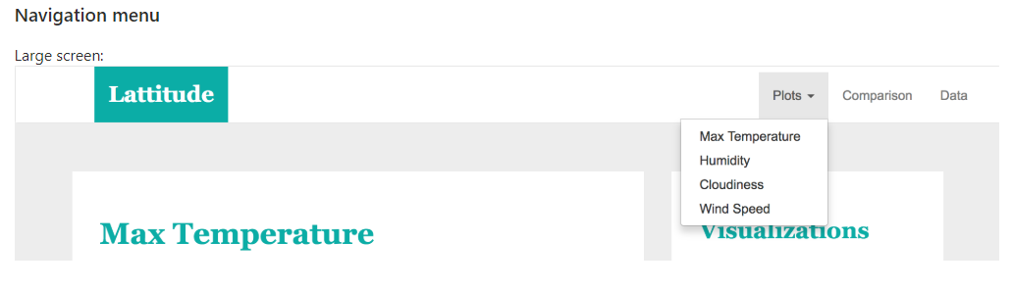

**Navigation Menu Small screen:**

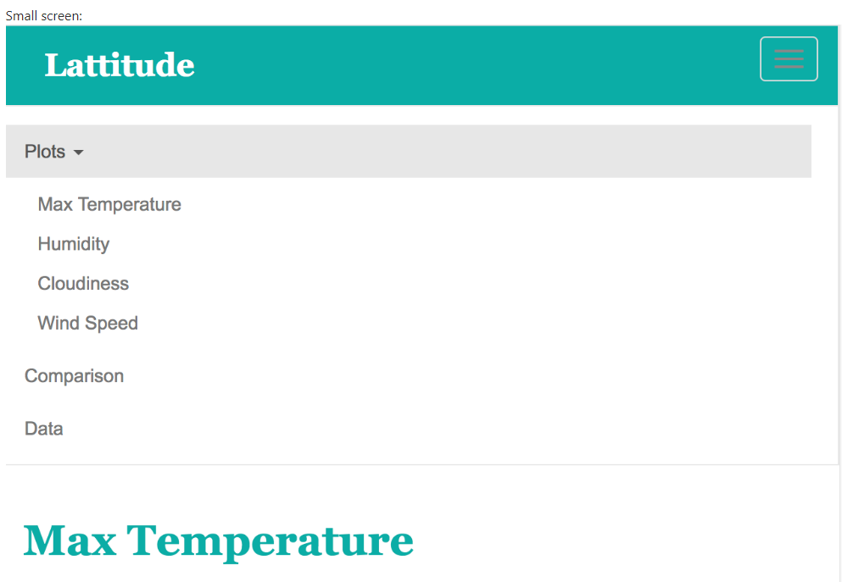

**Landing page Large screen:**

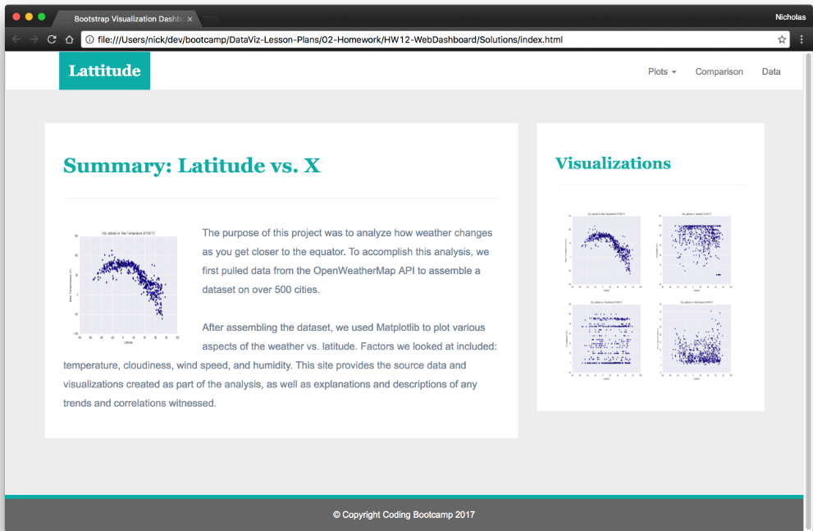

**Landing Page Small screen:**

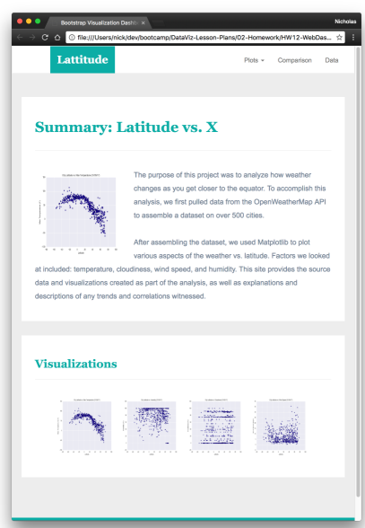

**Comparisons page Large screen:**

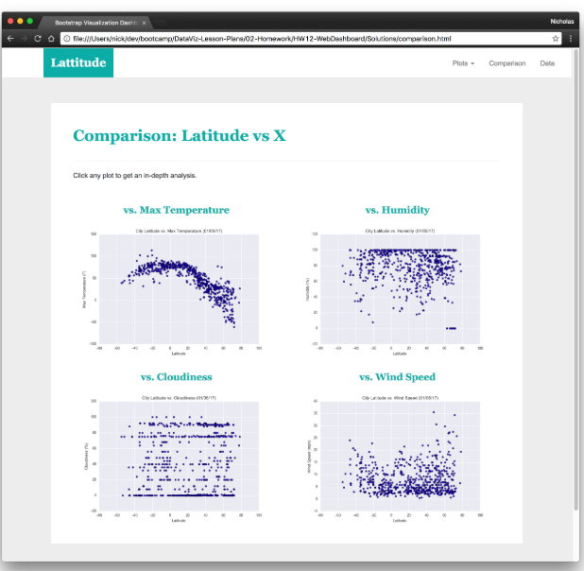

**Comparisons Small screen:**

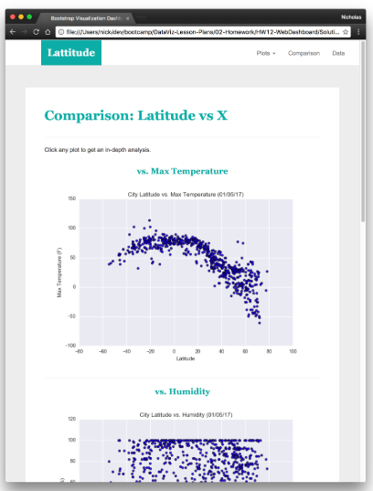

**Data page Large screen:**

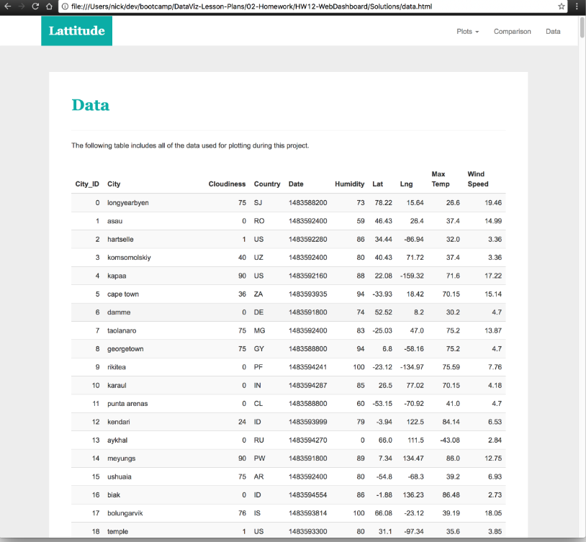

**Data Page Small screen:**

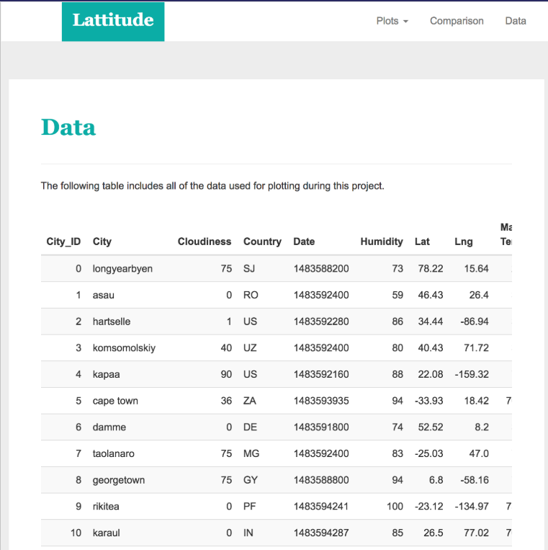

**Visualization pages: build four of these, one for each visualization. Here's an example of one:**

**Large screen:**

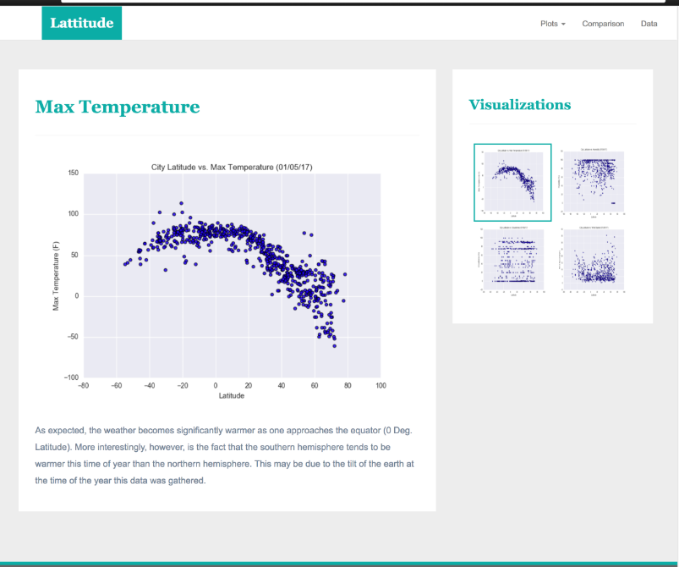

**Small screen:**

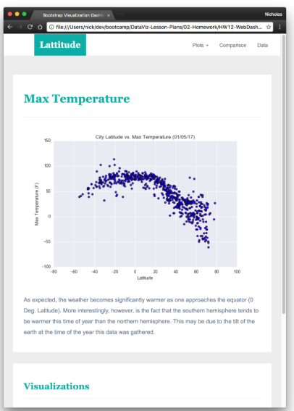

[**https://www.w3schools.com/bootstrap/bootstrap_theme_me.asp**](https://www.w3schools.com/bootstrap/bootstrap_theme_me.asp)

[**https://www.w3schools.com/css/css_navbar.asp**](https://www.w3schools.com/css/css_navbar.asp)

[**https://www.w3schools.com/bootstrap/trybs_theme_me_complete.htm**](https://www.w3schools.com/bootstrap/trybs_theme_me_complete.htm)

[**https://www.w3schools.com/howto/howto_css_dropdown_navbar.asp**](https://www.w3schools.com/howto/howto_css_dropdown_navbar.asp)

[**https://www.w3schools.com/howto/tryit.asp?filename=tryhow_css_dropdown_navbar**](https://www.w3schools.com/howto/tryit.asp?filename=tryhow_css_dropdown_navbar)

[**https://www.wikihow.com/Create-a-Dropdown-Menu-in-HTML-and-CSS**](https://www.wikihow.com/Create-a-Dropdown-Menu-in-HTML-and-CSS)

[**https://getbootstrap.com/docs/4.1/components/navbar/**](https://getbootstrap.com/docs/4.1/components/navbar/)