PYBER SUMMARY

Jeff Olson

Data Analytics Matplot Results

Trend 1) Average Rural fares were higher than Suburban or Urban average fares (figure 1). Presumably due to longer travel distances.

**Figure 1: Average fare rates increase in rural areas**

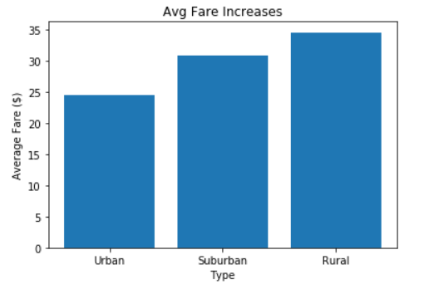

Trend 2) Data shows that driver density is much higher in urban cities than rural cities. Bubble Chart (figure 2) shows not only does the average fare increase for rural areas but also the driver density decreases for rural cities but increases for urban cities. Driver density in rural areas was shown to be 8%, but in urban areas it increased to 87% of the total driver population.

**Figure 2: Driver density increase in urban areas.**

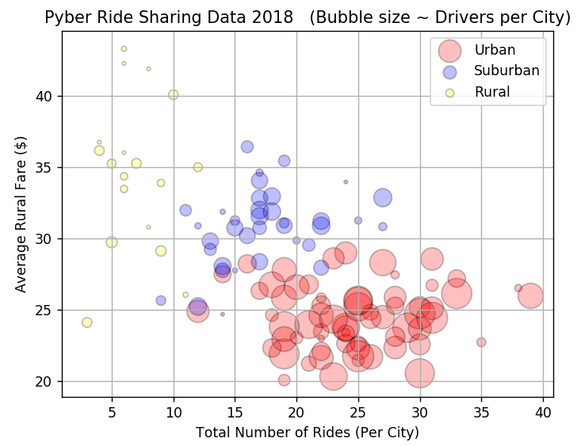

Trend 3) The large majority of Total Fares were collected in the Urban areas due to population density.

