Observable Data Trends for Heroes of Pymoli

There are significantly more male players than female players:

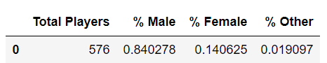

The total purchase value for males is more than 5 times the total purchase values for females.

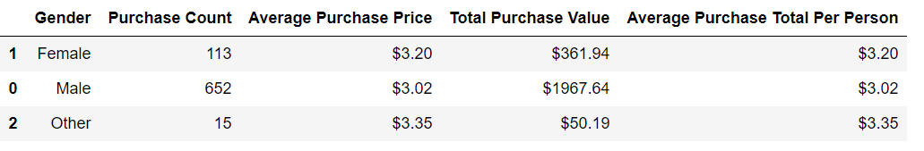

The most common age group for the participants of the game are in the age range of 20 – 24 with a total count of 365.

