My omputer configuration:
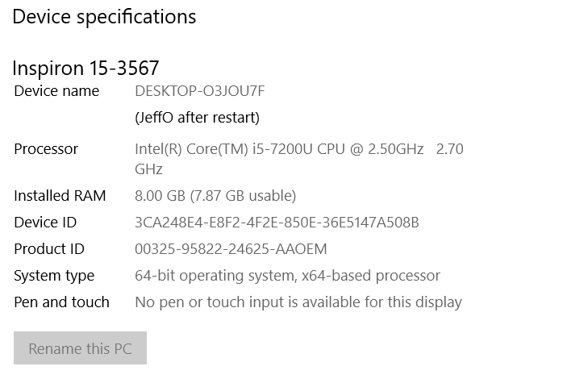
submit pre-work at bootcampspot-V2.com using a google drive upload link to share with instructor
LAPTOP-O3JOU7F

