1. Downloaded files from <https://github.com/rosskush/GWPATH_flopy>
   1. Git clone <https://github.com/rosskush/GWPATH_flopy>
   2. To h:/
2. Opened ArcMap and pulled the files in
   1. Following files loaded blank:
      1. fig_12_head.tif
      2. fig_16_sourcesy.tif
      3. fig_19_head.tif
3. Created folder to save digitized files to
   1. S:\PSC\CHPRC.C003.HANOFF\Rel.060\MODPATH_testing
4. Created empty polyline file
   1. Saved the coordinate system from “starting_location.shp” point as a favorite projection; it’s apparently not one that’s saved in Arc already, so it’s custom
5. 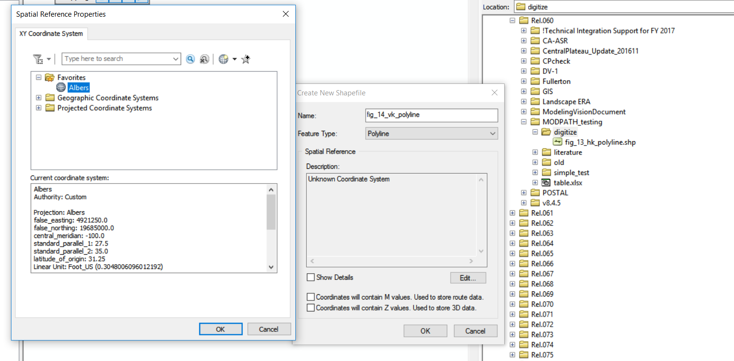
6. I’ve been told by Greg I have to do the capture zone analysis first, because the other two are out of scope
7. Okay, so I digitized figures 20 and 21, btu 19 just showed up like, all white, so I had to digitize it in qgis following these instructions: https://geo.nls.uk/urbhist/guides_vectorlayerqgis.html
8. 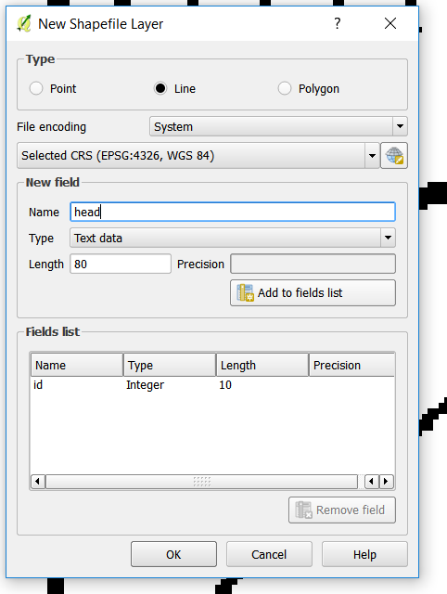
9. Had to redownload gwpath_rasters, just assumed there was no change
10. Added the lines, saved the file. Saved the project as digitize.qgs

New task! Assign K values to grid_hk.shp

1. Ross showed me how to set up my drive with github, and I re-downloaded the data from his version
2. I opened grid.shp in digitize.mxd, and manually assigned hk values in a column titled “Hk” which I’m annoyed I capitalized but here we are.
3. I checked these values using the “categories” symbology setting

Put everything back up on github