**Supermarket Inventory w/ Departments**

Tables w/ columns – At least 25 rows per table in applicable department table(25 products per department)

Lucid Diagram (if needed)

|  |
| --- |
| **TotalSold**  Dairy – totalSoldDairy  Meat – totalSoldMeat  Non-Foods – totalSoldProduce  Frozen – totalSoldGrocery |
| **TotalStock**  totalStockDairy (sum records in “**Dairy**”)  totalStockMeat (sum records in “**Meat**”)  totalStockNon-Foods (sum records in “**Non-Foods**”)  totalStockFrozen (sum records in “**Frozen**”) |
| **Dairy**  productName  productUPC  productCompany  totalInStock  retailPrice  wholesalePrice  vendorCode |
| **Frozen**  productName  productUPC  productCompany  totalInStock  retailPrice  wholesalePrice  vendorCode |
| **Non-Foods**  productName  productUPC  productCompany  totalInStock  retailPrice  wholesalePrice  vendorCode |
| **Grocery**  productName  productUPC  productCompany  totalInStock  retailPrice  wholesalePrice  vendorCode |
| **VendorInfo**  vendorCode  vendorName  vendorType  *vendorCode ; vendorName ; vendorType*  *1 ; Keasby ; commissary*  *2 : Bayonne ; commissary*  *3 : Daisy ; company* |

––––––––––––––––––––––––––––––––––––––––––––––––––––––––––––

**Circular:**

<https://www.shoprite.com/sm/pickup/rsid/3000/circular>

**UPC Lookup:**

<https://www.barcodelookup.com/>

**Links from Classes:**

<https://learn.microsoft.com/en-us/previous-versions/tn-archive/cc505835(v=technet.10)>

––––––––––––––––––––––––––––––––––––––––––––––––––––––––––––

**UPC REFERENCE:**

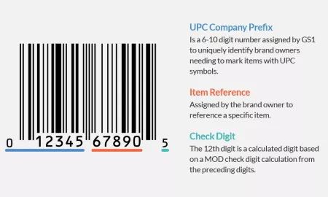

––––––––––––––––––––––––––––––––––––––––––––––––––––––––––––

**Response:**

Hi, the UPC is split up into two parts since the two parts reference different information. The first half, UPC1, refers the the first half of the code which references the brand/company that makes and assumes responsibility for the production. UPC2 refers to the second half which is product specific. For any products from the same company the first half of the UPC will be the same for all products, the second half changes based on what product is being referenced. (See this for a better understanding: <https://www.gtin.info/upc/)> For simplicity though, I don't know if the information is best stored this way since the company prefix can sometime be longer then the product identifier.

In regard to the vendor types, larger retail companies don't get all of their products directly from the manufacturer. They will often go in a order like this: Manufacturer –> warehouse –> warehouse(sometimes) –> Retail location. A "Commissary" refers to the last warehouse in which a product is at and then shipped to a retail location. This would be a "Vendor" in the sense that the product is paid for but being shipped in-house instead of coming directly from the manufacturer. Sometimes products do come from the manufacturer though so this is noted as a "company" vendor type. The vendorName attribute refers to which warehouse or company the product originates from and assigns a vendorCode to it appropriately.