**CSC311 project report**

Part A

1.

(a)

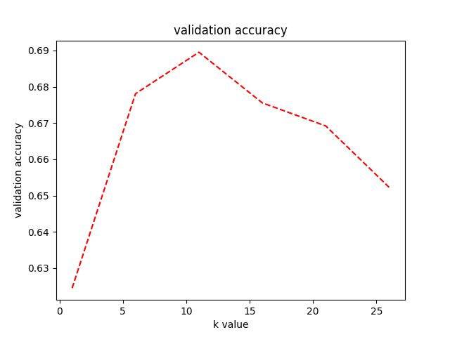

(b)

k* = 11 has the best validation accuracy of 0.6895.

(c)

The underlying assumption of this scenario is that if question A has the same correct and incorrect answers with other students as question B, A’s correctness on specific students matches that of question B.

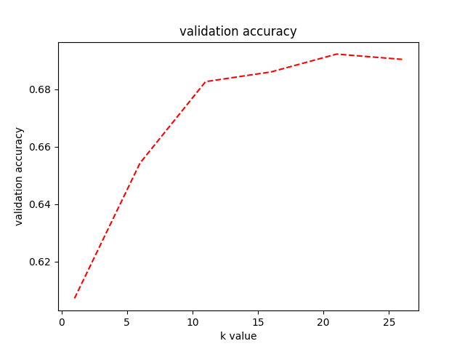

k* = 21 has the best validation accuracy of 0.6922.

(d)

Imputing by user has accuracy of 0.6842 on the testing set.

Imputing by item has accuracy of 0.6816 on the testing set.

Imputing by user has better performance.

(e)

1. The underlying assumptions of either cases are invalid.

2. There is no strong relevance between students and questions, which means there could be many noisy samples.

2.