Group 5 - TNT

**UI Prototype**

Note: Let U# be short for use case #. For example, U13 is short for use case 13.

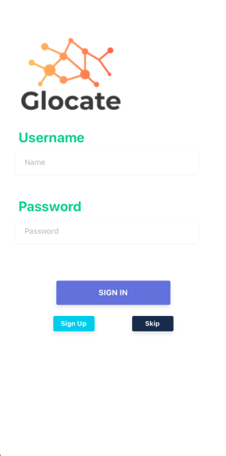

* Login interface. The interface when the user first opens the app.
* The user can choose to enter username / password to sign in (U2) or they can choose to sign up (U1).

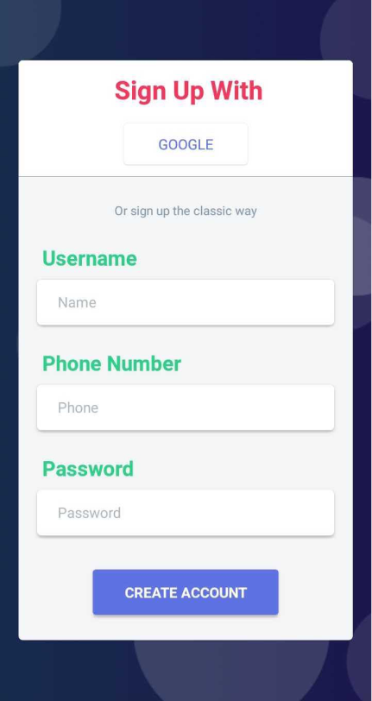

* Sign up interface (U1).
* The user can choose to sign up with Google or the classic way.

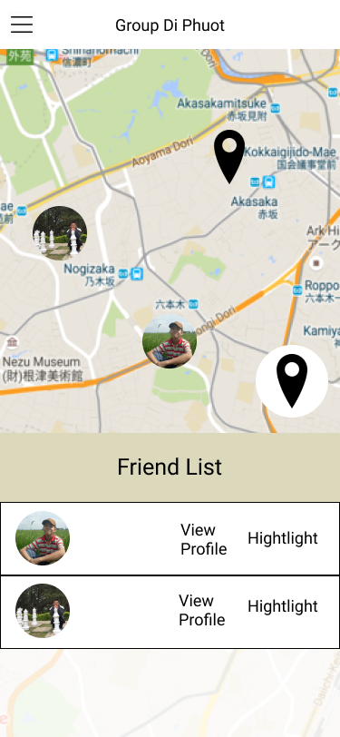

* The map interface, the main interface of the app.
* At the top left is a menu icon that a user can click to show a list of functionalities.
* At the top in the middle is the name of the current selected group of the user.
* On the map are profile pictures indicating the real-time positions of the group members of the current group (U12).
* Also shown on the map is a marker icon indicating the meeting point of the group.
* At the bottom right of the map, the marker icon surrounded by a white circle can be clicked on to place a meeting point on the map. (U15)
* On the bottom is a list of the group members of the current group. Each group member is displayed with their profile picture and the user can choose to view their profile (U18) or highlight them (U13).

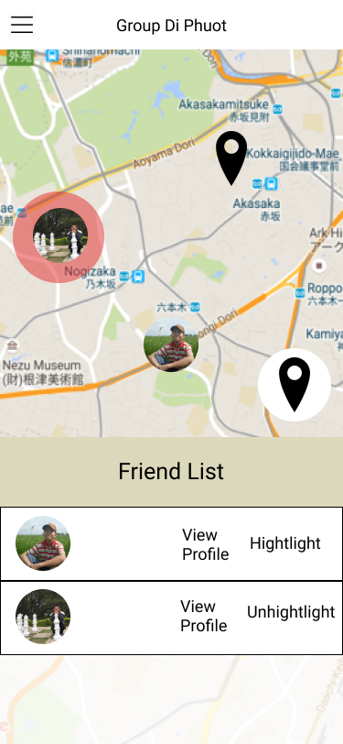

* A group member is highlighted with a red marker on the map.
* Because the group member is highlighted, there is an option to un-highlight the member below (U14).

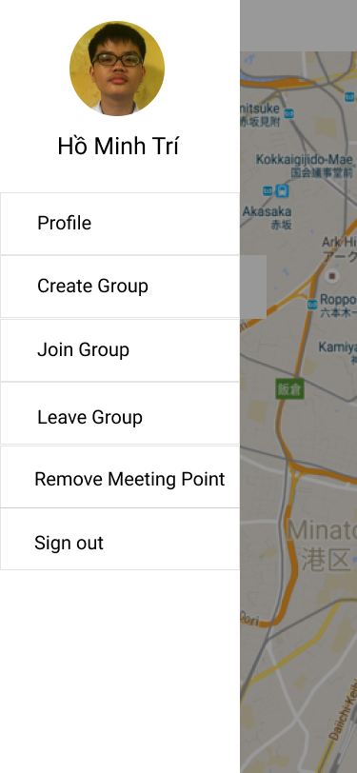

* The functionalities shown when the menu icon at the top left is clicked on.
* At the top is the profile picture and name of the user.
* The user can choose to view and edit their profile (U17), create a group (U4), join a group (U5), leave the current group (U6), remove the meeting point (U16), and sign out (U3).
* Currently, there are three group buttons (U4, U5, U6) but we plan to have only one “Group” button that leads to:

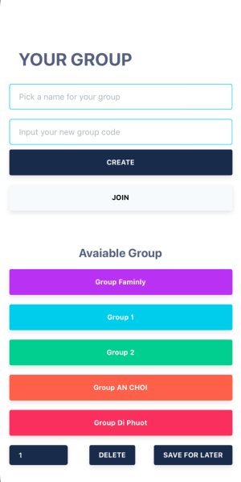

* Here the user can create and join groups.

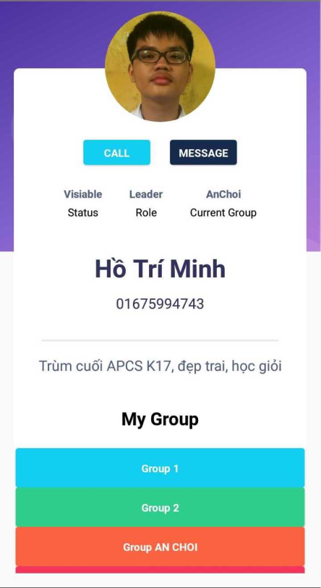

* The prototype for the profile of a user, accessed through “Profile” in the sidebar or “View profile” in the map.
* If this is the profile of the user then there will be options to modify the information.
* If this is the profile of other users then there are options such as calling or messaging the user.
* There is also a list of groups the user is a part of. Clicking on a group leads to the info about the group:

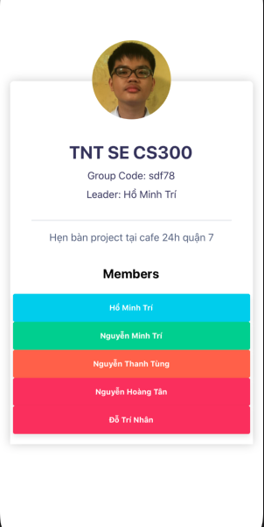

* We can see the name (U7), group code (U8, U9), and leader of the group.
* There is also a list of members of the group.

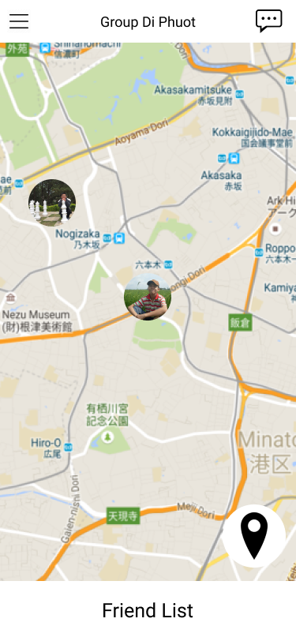

* An interface where the friend list is collapsed and there is a group message icon (U19) at the top right.
* Clicking on the icon leads to:

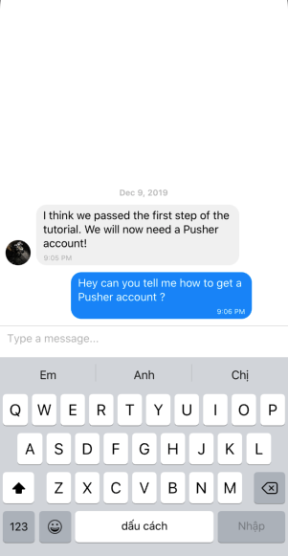

* The group message interface. The user can view messages posted by others and also post message to the thread.

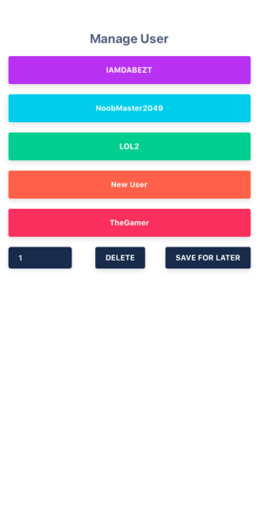

* Admin user management prototype (U21).

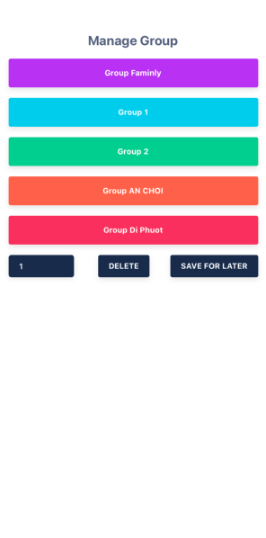

* Admin group management prototype (U22).