COMBO model for coral reef growth and mortality, with valuation

Written by C. Wobus, Stratus Consulting, July 2012. Based on original code written by B. Buddemeier, Kansas Geological Survey

All inputs required to run code are included in this .zip archive, as follows:

* Baseline temperature data are from the Reynolds historical gridded SST product, and are contained in folder “Temps_hist”. By default, a hybrid of Reynolds 1 degree and 2-degree historical SST is used (e.g., “xx_R1R2”)
* Climate model outputs are from MAGICC/SCENGEN, and are contained in folder “Scengen_EPA” for business as usual (BAU) and policy (POL) scenarios. These folders contain gridded SST data for specified future years (“GHANDAER####.out”), and also the representative CO2 concentration pathways (“CO2_concs.txt”) for these different scenarios.
* Baseline salinity and alkalinity, as well as latitudes and longitudes for individual locations, are in files “XX_locs.xls”
* All other user inputs are in file “User_inputsv5.xls”

Subroutines and dependencies for all MATLAB (*.m) files are as illustrated below:

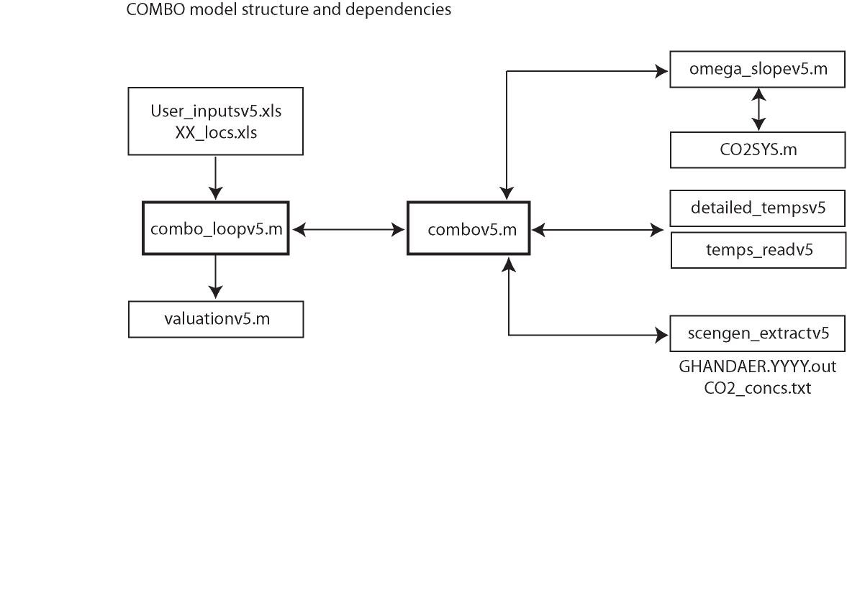

USAGE:

Navigate to proper folder within MATLAB. At MATLAB command prompt, type “combo_loopv5” and follow prompts at command line.

Combo_loopv5 is the shell code that loops through individual columns of user-input baseline temperature data, and runs the COMBO code on each individual cell. Outputs from this code are strings of projected decreases in coral cover, for each cell from which baseline temperature data were extracted. For valuation, it is recommended that the policy scenario be run first, followed by the BAU scenario. Outputs from the BAU runs will include figures as .pdf files.