a) BIODIV30 - UNIFORM30, protected suitable
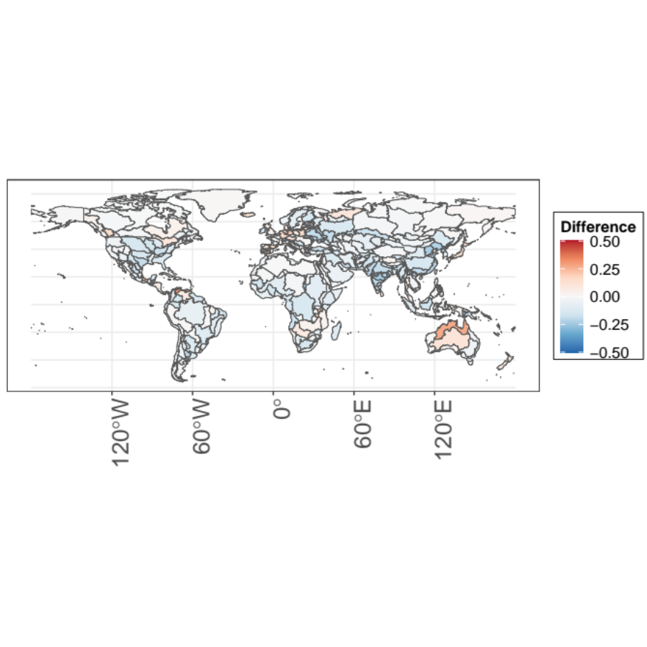
b) BIODIV30 - UNIFORM30, protected unsuitable
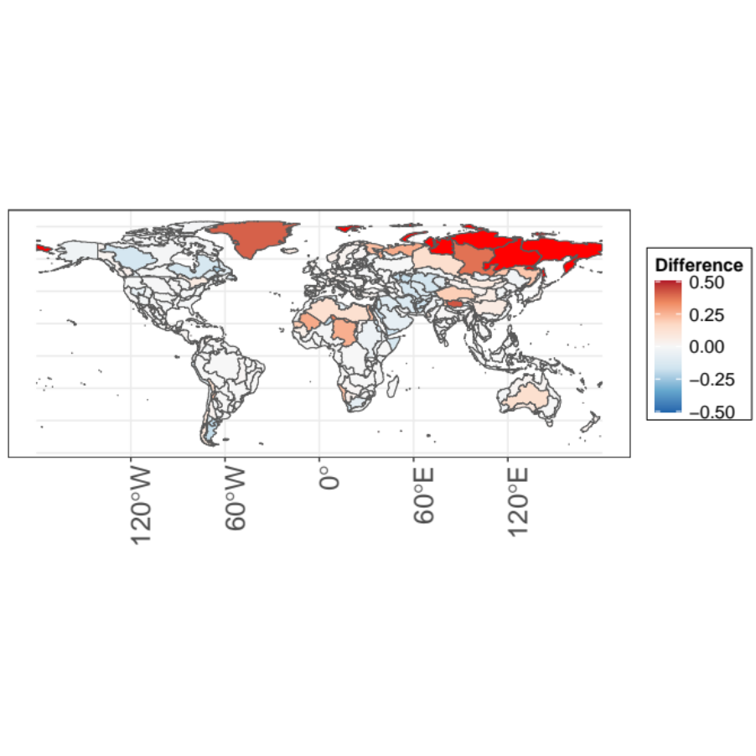
c) BIODIV - UNIFORM30, protected suitable
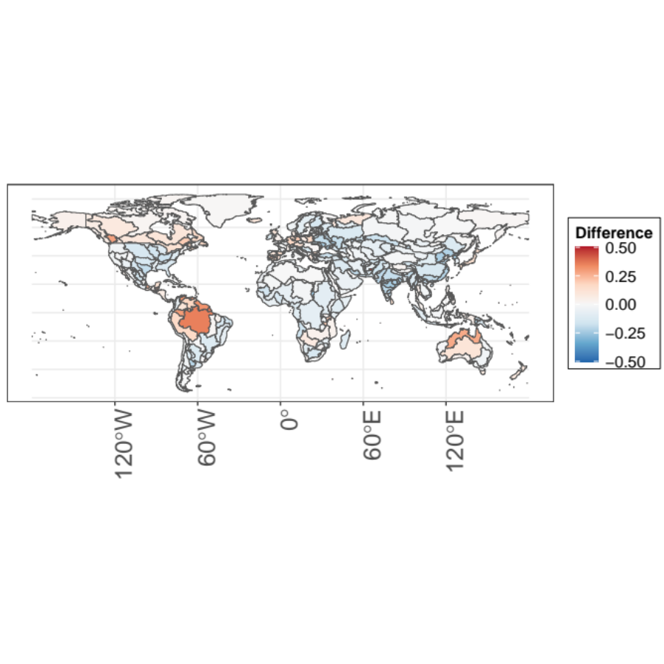
d) BIODIV - UNIFORM30, protected unsuitable
