GCAMUSAJobs: An R package for employment projections based on GCAM-USA power sector outcomes

19 September 2024

Di Sheng (0009-0006-7567-380X)

Brian O'Neill (0000-0001-7505-8897)

Stephanie Waldhoff (0000-0002-8073-0868)

Matthew Binsted (0000-0002-5177-7253)

Joint Global Change Research Institute, Pacific Northwest National Laboratory, College Park, MD, USA

# Summary

GCAMUSAJobs R package was developed to post-process power sector projections from GCAM-USA, enabling the estimation of future state-level jobs by fuel technology and job types. GCAMUSAJobs extends GCAM-USA functionality by (1) estimating the capacity levels of different activities – operational capacity, capacity addition, and retirement; and (2) calculating jobs associated with production activities, including those in operation and maintenance (O&M), construction, and decommissioning.

# Statement of need

The development of GCAMUSAJobs was driven by the need to assess the distributional labor impacts of energy system transition (Xie et al. 2023; Hanson 2023; Raimi 2021). While the transition is expected to bring overall job growth (Xie et al. 2023), fossil fuel-intensive states may experience job losses (Hanson 2023; Xie et al. 2023).

Currently, GCAM-USA does not report power sector jobs, GCAMUSAJobs addresses this gap by providing users a GCAM-USA output-based estimated jobs in the power sector, enhancing the functionality of GCAM-USA for labor impact analysis.

# Workflow

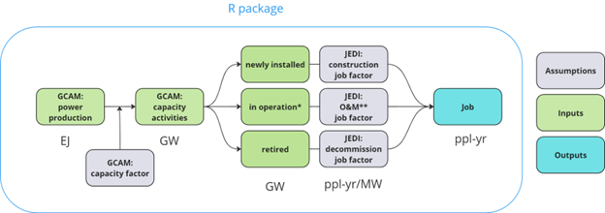

Figure. 1. Package workflow.

GCAMUSAJobs utilizes GCAM-USA power generation outputs to estimate underlying capacity levels and calculate associated jobs based on assumptions about capacity factors and employment factors (Fig. 1). The employment factor represents the average number of jobs created per unit of power production activity (e.g., jobs per gigawatt). This method is widely used in the relevant literature (Rutovitz, Dominish, and Downes 2015; Mayfield et al. 2023). GCAMUSAJobs adopts employment factor from the NREL’s Jobs & Economic Development Impacts (JEDI) model (<https://www.nrel.gov/analysis/jedi/models.html>), a commonly used resource (Xie et al. 2023; Rutovitz, Dominish, and Downes 2015; Jacobson et al. 2017).

# Key functions

GCAMUSAJobs::GCAM_EJ queries power generation data from GCAM-USA for a single scenario, calculating the implied power generation associated with installed capacity, newly added capacity, and retired capacity. The output is provided annually, disaggregated by state, and fuel technology. Building on this, GCAMUSAJobs::GCAM_GW, taking the output from GCAMUSAJobs::GCAM_EJ and calculates the average annual capacity levels by state, fuel technology for different activities, including operation, addition, and retirement. It supports both the “Total” and “Net” methods. The “Total” method allows capacity addition and pre-mature retirement of a given technology to happen in the same period, while the “Net” method offsets the addition by pre-mature retirement, providing adjusted capacity level by activities. GCAMUSAJobs::GCAM_JOB then utilizes the output from GCAMUSAJobs::GCAM_GW to estimate the average annual job estimates, broken down by fuel type and job type. Users can select between the “Total” or “Net” method, with “Total” used as the default. GCAMUSAJobs also provides a list of functions to visualize the employment factor assumptions, capacity, and job outcomes.

GCAMUSAJobs::GCAM_EJ is compatible with both the GCAM-USA output database as well as a project data file queried using the R package rgcam. Please refer to the package vignette for additional examples and visualizations.

## Implementation

For demonstration purposes, we use GCAMUSAJobs to post-process the outcome from GCAM v7.1 for a standard reference scenario, estimating the direct job associated with U.S. power generation (Fig. 2).

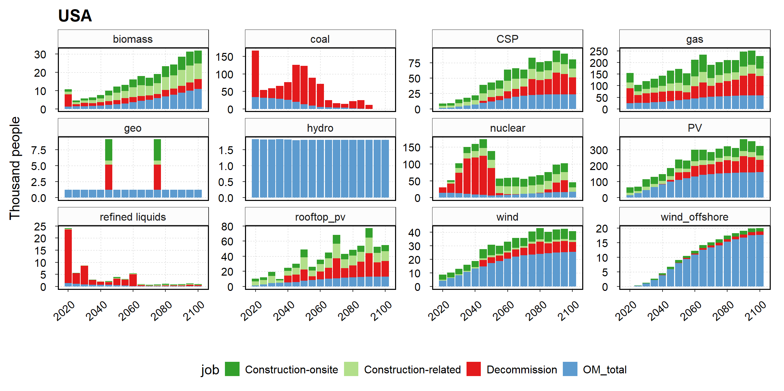

Figure. 2. Annual average power sector jobs by fuel and job types over a 5-year model period.

# Acknowledgment

This research was supported by the Laboratory Directed Research and Development (LDRD) Program at Pacific Northwest National Laboratory (PNNL). PNNL is a multi-program national laboratory operated for the U.S. Department of Energy (DOE) by Battelle Memorial Institute under Contract No. DE-AC05-76RL01830. We also appreciate the support from Narayan, Kanishka Balu, Ben Bond-Lamberty, Mengqi Zhao, and Gokul Iyer. The views and opinions expressed in this paper are those of the authors alone.

# References

Hanson, Gordon H. 2023. “Local Labor Market Impacts of the Energy Transition: Prospects and Policies.” National Bureau of Economic Research.

Jacobson, Mark Z, Mark A Delucchi, Zack AF Bauer, Savannah C Goodman, William E Chapman, Mary A Cameron, Cedric Bozonnat, et al. 2017. “100% Clean and Renewable Wind, Water, and Sunlight All-Sector Energy Roadmaps for 139 Countries of the World.” *Joule* 1 (1): 108–21.

Mayfield, Erin, Jesse Jenkins, Eric Larson, and Chris Greig. 2023. “Labor Pathways to Achieve Net-Zero Emissions in the United States by Mid-Century.” *Energy Policy* 177: 113516.

Raimi, Daniel. 2021. “Mapping County-Level Exposure and Vulnerability to the US Energy Transition.” *Resources for the Future Working Paper*, 21–36.

Rutovitz, Jay, E Dominish, and J Downes. 2015. “Calculating Global Energy Sector Jobs: 2015 Methodology.”

Xie, Judy Jingwei, Melissa Martin, Joeri Rogelj, and Iain Staffell. 2023. “Distributional Labour Challenges and Opportunities for Decarbonizing the US Power System.” *Nature Climate Change* 13 (11): 1203–12.