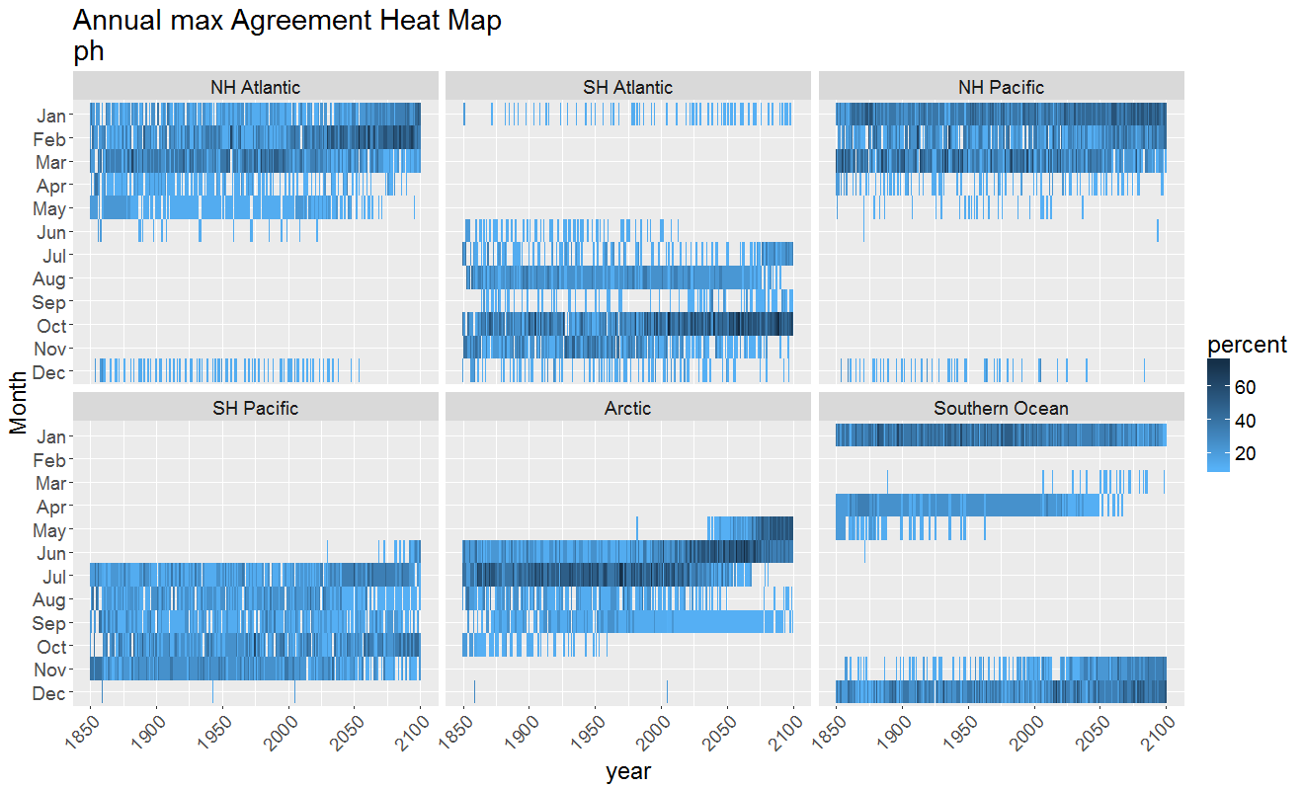

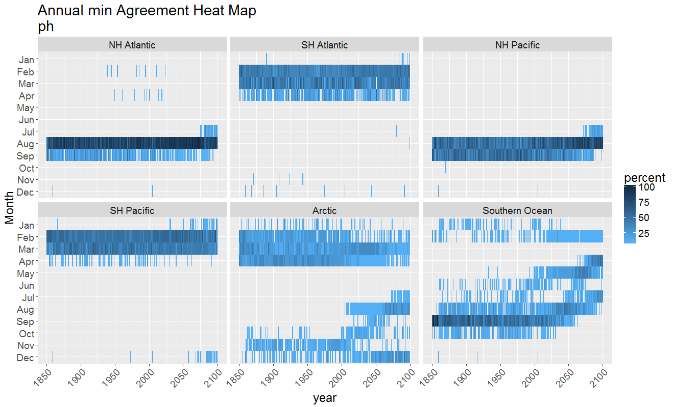 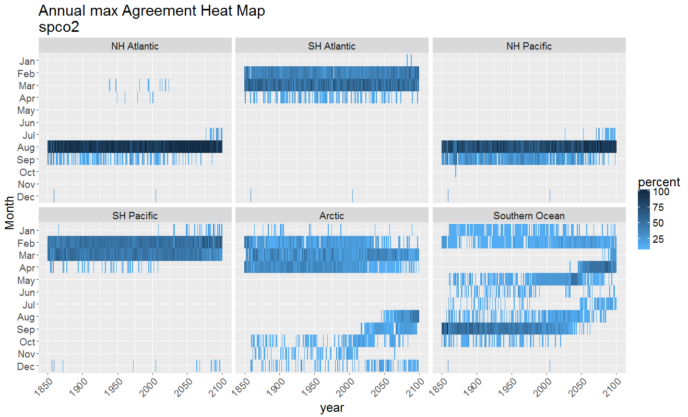

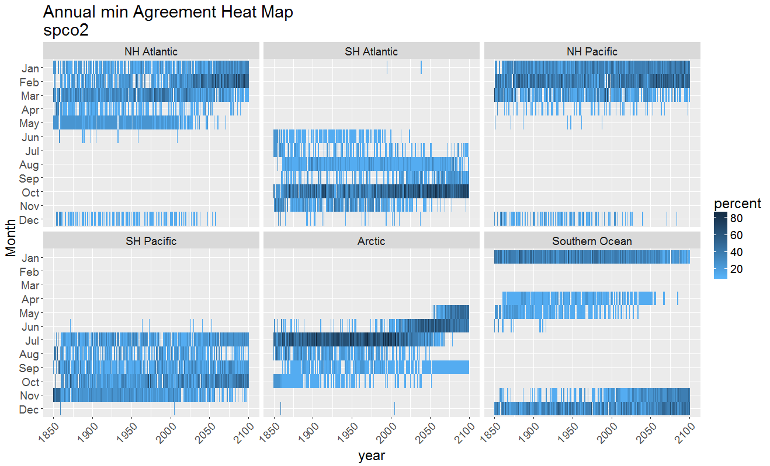

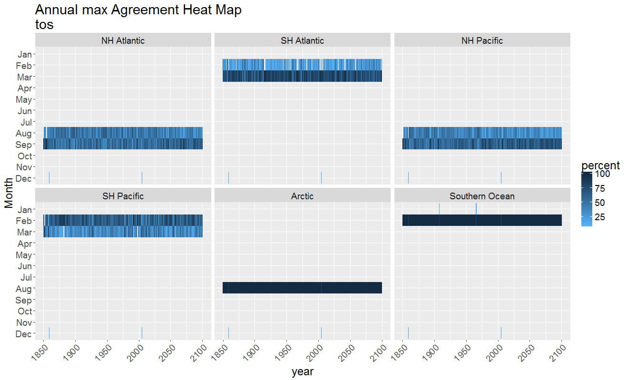

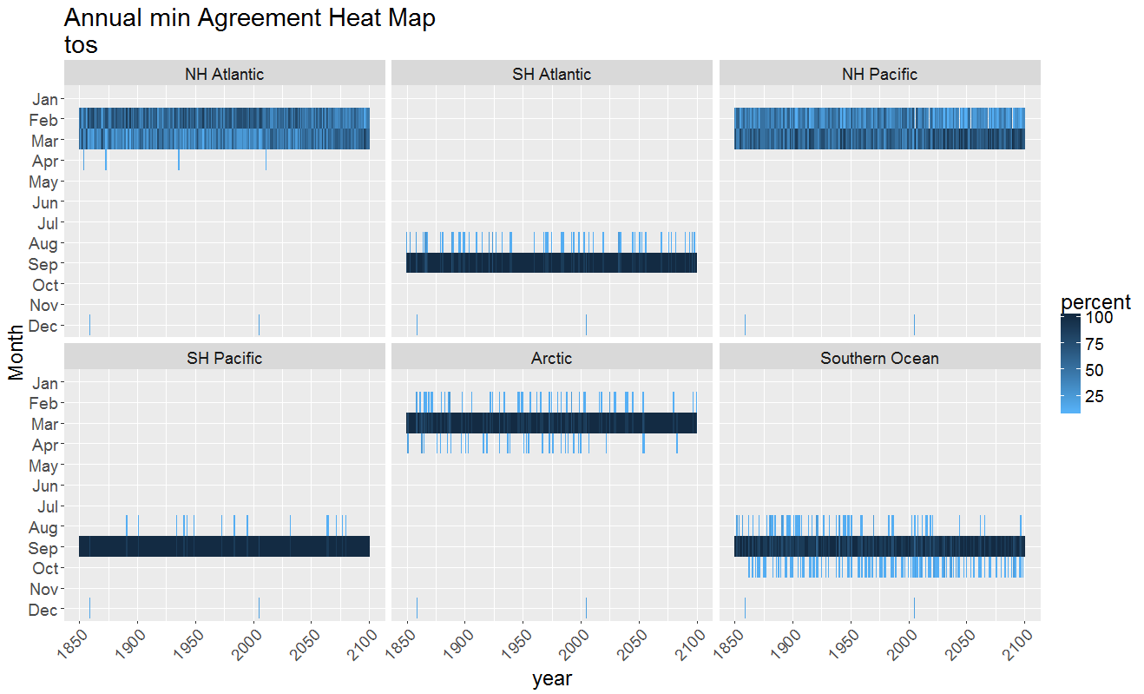 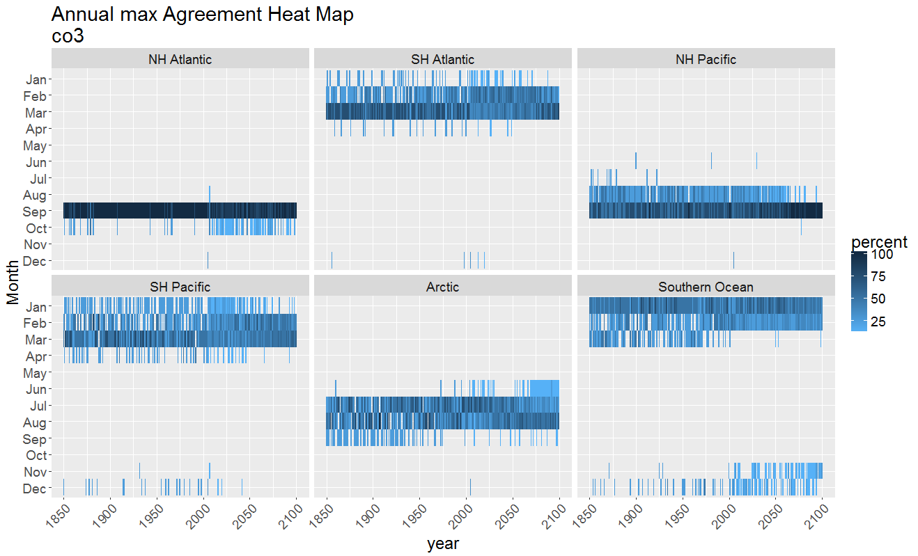

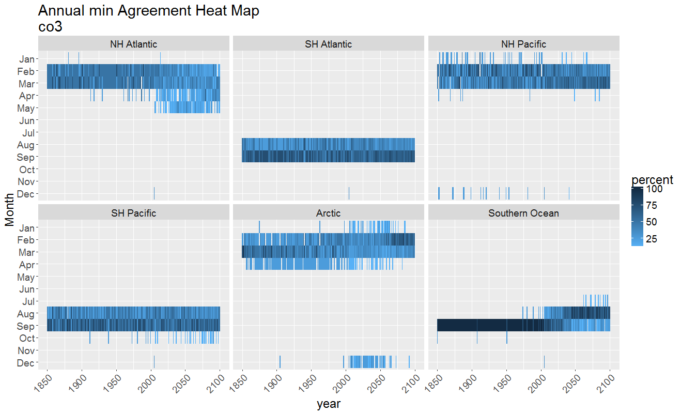

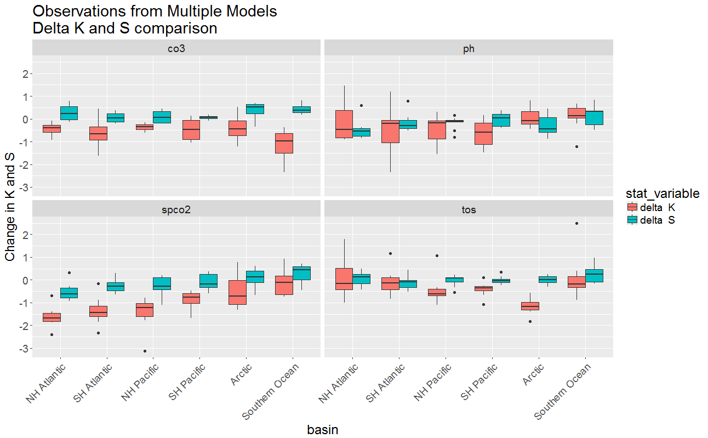

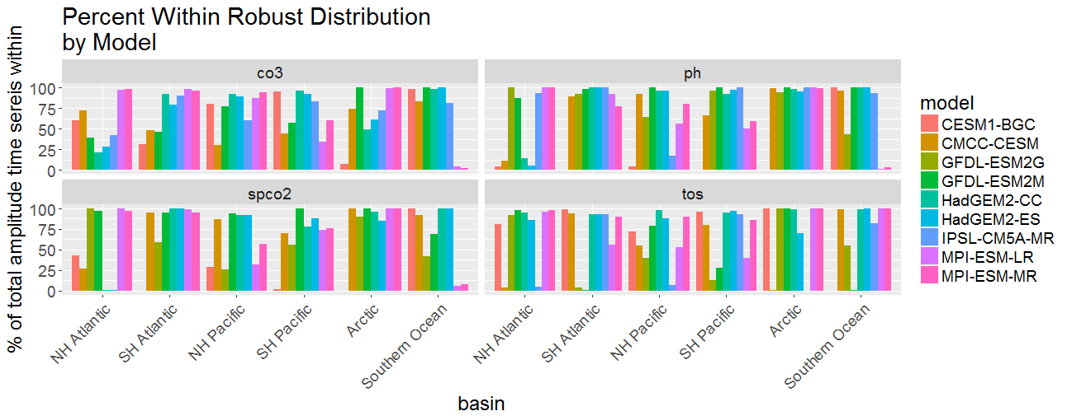

|  |  |
| --- | --- |
| Ranking for the models for the highest % within  robust distribution for each basin / variable  |model | count|  |:------------|-----:|  |CMCC-CESM | 1|  |CESM1-BGC | 3|  |GFDL-ESM2G | 3|  |IPSL-CM5A-MR | 3|  |HadGEM2-CC | 6|  |HadGEM2-ES | 7|  |MPI-ESM-LR | 7|  |MPI-ESM-MR | 8|  |GFDL-ESM2M | 9| | Model average of percent of amplitude time series within the distribution  |model | mean|  |:------------|-----:|  |CESM1-BGC | 45.95|  |GFDL-ESM2G | 64.79|  |CMCC-CESM | 67.26|  |IPSL-CM5A-MR | 67.26|  |MPI-ESM-LR | 69.84|  |GFDL-ESM2M | 77.76|  |MPI-ESM-MR | 77.77|  |HadGEM2-ES | 80.96|  |HadGEM2-CC | 83.23| |

