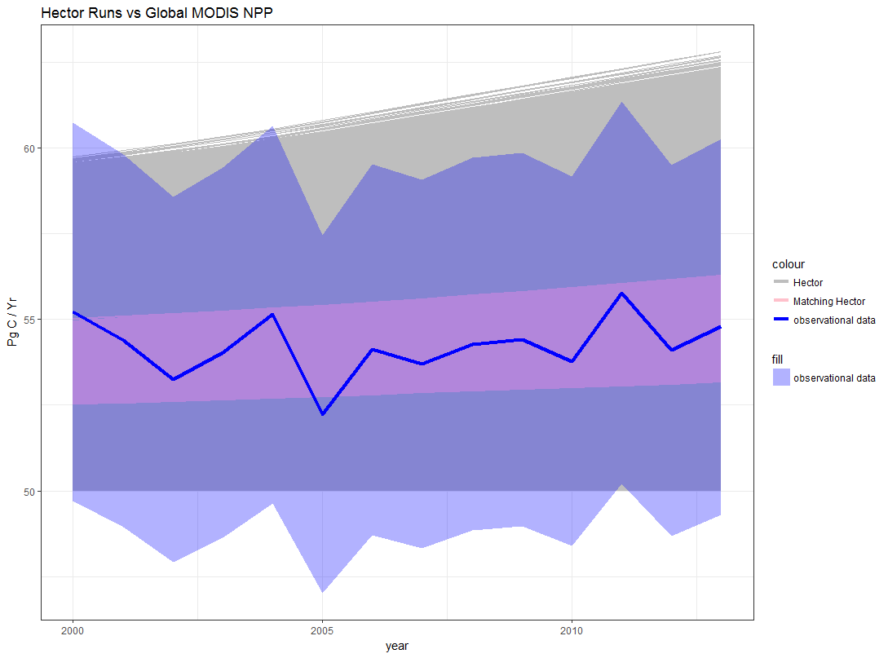

* The dark blue line is the global NPP aggergated from MODIS NPP, the ribbon is equal to +/- 10% of the global value
* The Hector runs that “match” the observations based on the Dn metric ~ 1000
* Calculating Dn
  + S2n = .10 \* NPP, I did not know how to figure out the variability/error because we aggregated I don’t think we can do the sd
  + Sigma^2 = (s \* sd) ^2, I did not use the mean rolling sd here because the time series is not that long enough to have a climate signal in it so we don’t have to wory about the balance between cliamte varibailty and the climate signal

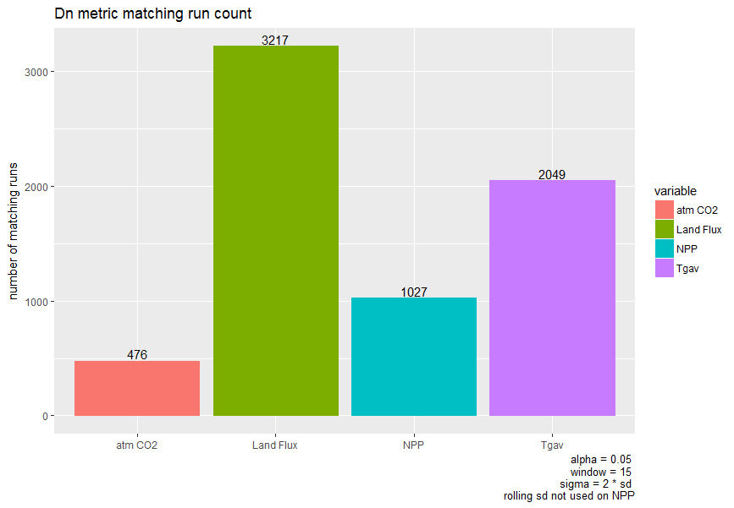

* atm CO2, Land Flux, and Tgav all use the rolling sd method with a 5 year window size
* NPP does not use the rolling sd method

C:\Users\dorh012\Documents\hector-SA-npar\diag-out\run_count_venndiagram.png

* When we combine the numbers from this plot with the previous plot
  1. Only 25% of the land flux passing runs also match at least one other observation
  2. ~67% of the matching Tgav runs also match at least one other observation
  3. ~89% of the matching NPP runs also match at least one other observation
  4. ~94% of the matching atm CO2 runs also match at least one other observation

## CMS Meeting Notes May 30

So CH liked the MODIS NPP figure / the normal bar run count, but has mixed feelings on the Venn diagram because there are so many categories that it is overwhelming. Not very clear.

## To Do List

* Write up the methods section. Can copy a lot from that one paper, very similar set up
  1. Outline
  2. Very detailed outline
  3. Check in with CH before starting the actual writing
* GCAM 5 w/ Hector 2 runs
  1. Come up with the method for selecting the parameter sets
     + We want to do the 2 from each category on the venn diagram and then look at the full 5,000 spread
  2. Fix the batch maker / xml code
  3. Run GCAM 60 times
     + Reference
     + 2.6 target finder
  4. Run GCAM 60 times
  5. Look for patterns in the results… do the basic UIUC figures may be
* Make 2100 temperature ranges figure
  1. Come up with the method for selecting the extreme values at 2100
  2. Plot the temperature paths… will need some method of indicating what group the runs fall into
* Clean up the repo documentation
  1. This is a minor priority mostly has to do with my sanity can only do if it looks like dooms day or finish other things. Hopefully just cause I finish other things.