This figure visualizes the number of runs in each filtered/matching observations category. The bars represent min and max temperatures in year 2100. The bars/filters are ranked so that the left side of the plot has the largest range in the 2100 temp and the right side has the smallest spread in max and min, ties are broken alphabetically.

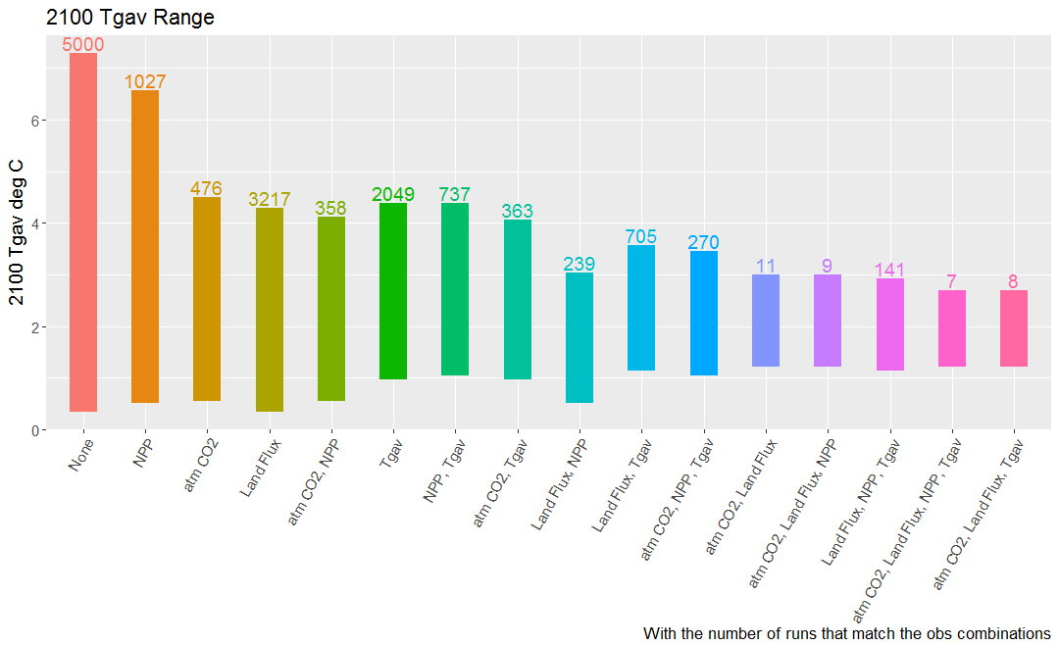

Interesting observations

* Atm CO2 may reduce the passing Hector run count but Land Flux narrows the 2100 temperature range more.
* The temperature observation filter has a hotter 2100 temperature range.
* Adding NPP on top of atm CO2, Land Flux, Tgav does not do anything other than remove a run, the 2100 temperature range is the same.