April 2023

**Title**

Navigating the Future of Global Water Use: A High-Resolution Analysis

**Subtitle**

Unveiling Diverse Scenarios and Implications for Water Resource Management in a Rapidly Changing World

[Photo image]

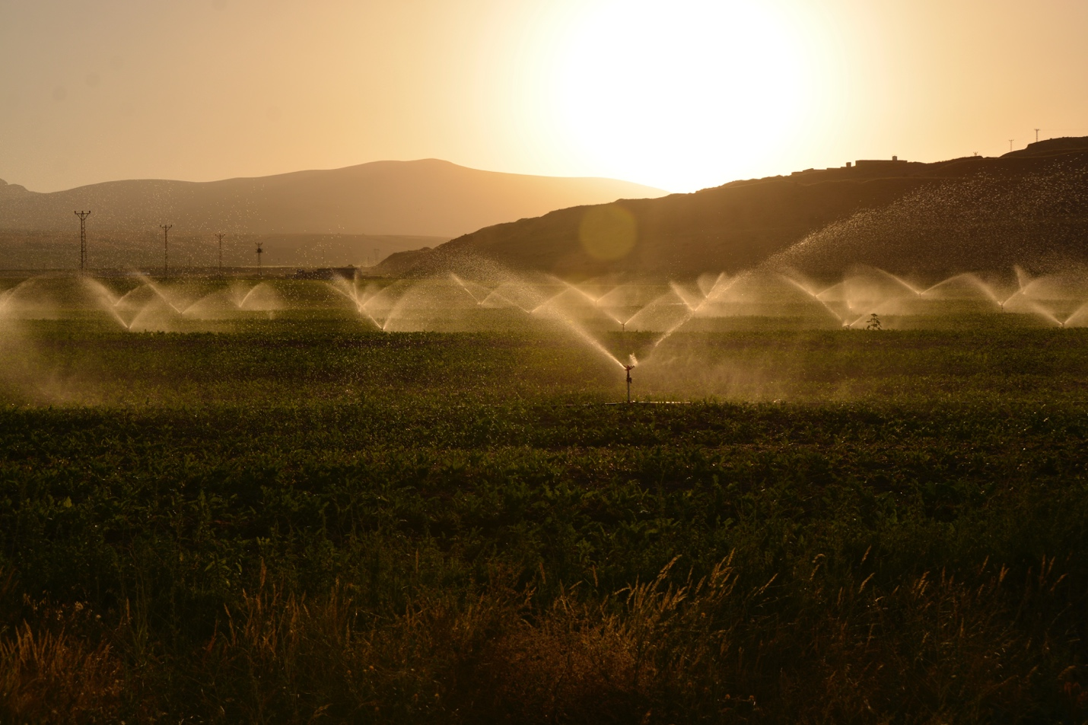

**Photo image link**

https://www.pexels.com/photo/sprinkling-of-grass-land-during-dawn-2684805/

**Image courtesy of** [source]

Photo by Süleyman Şahan on pexels.com

**Image caption**

Presenting a global 0.5° resolution dataset (2010-2100) of sectoral water withdrawal and consumption across 75 scenarios, accounting for human activities, spatio-temporal scale, and crop-specific irrigation.

**The Science**

Water usage is crucial for sustainable development and economic growth, but it is also a limited resource. To help plan for the future, researchers have created a detailed dataset of global water usage from 2010 to 2100. This dataset considers various factors, such as climate change and socioeconomic changes, and breaks down water usage by sectors like agriculture, industry, and domestic use. By providing a comprehensive view of water usage at a fine scale, this dataset can help us understand the challenges of water scarcity and inform decision-making for sustainable water management.

**Impact**

This groundbreaking research presents a high-resolution dataset mapping global water usage from 2010 to 2100, offering insights into future changes due to climate change and socioeconomic development. The first of its kind, this study provides detailed information on water usage across sectors, including 13 crop types, at a 0.5° resolution and monthly scale.   
  
Crucial for addressing water scarcity and sustainable development, this comprehensive dataset enables scientists and policymakers to understand regional water use patterns and manage resources effectively. Innovatively combining multiple models and datasets, the research explores dynamic interactions among energy, water, and land systems globally. The dataset serves as a valuable tool for scientists in agriculture, climate change, and resource management to investigate water scarcity impacts and develop sustainable solutions.

**Summary**

Researchers have developed a global monthly gridded sectoral water withdrawal and consumption dataset at 0.5° resolution for 2010-2100 across 75 diverse scenarios. This dataset is significant as it quantifies the sources of demand-side pressures on scarce water resources globally under various future socio-economic and climate scenarios. The study accounts for key factors such as water use for human activities, fine spatio-temporal scale, and detailed irrigation water use by crop types.  
  
The dataset was generated by coupling the Global Change Analysis Model (GCAM) with a land use spatial downscaling model (Demeter), a global hydrologic framework (Xanthos), and a water withdrawal downscaling model (Tethys). The dataset offers a finer spatiotemporal resolution for future projections compared to previous studies and provides more detail in the irrigation sector, including 13 different crop types. This research addresses the critical need for future projections of distributed water demand at a fine resolution, and the dataset can be downloaded from an open-source online repository.

**Point of Contact**

Marshall Wise

GCIMS Principal Investigator  
marshall.wise@pnnl.gov

**Funding**

This research was supported by the U.S. Department of Energy, Office of Science, as part of research in MultiSector Dynamics, Earth and Environmental System Modeling Program. The Pacific Northwest National Laboratory is operated for DOE by Battelle Memorial Institute under contract DE-AC05-76RL01830. The views and opinions expressed in this paper are those of the authors alone.

**Article Citation**

Khan, Z., I. Thompson, C.R. Vernon, N.T. Graham, T.B. Wild, and M. Chen. 2023. “Global monthly sectoral water use for 2010–2100 at 0.5° resolution across alternative futures.” *Sci. Data.*, 10(201. DOI: 10.1038/s41597-023-02086-2

**Related Links (Optional)**

None