In addition to prior validation of the downscaling algorithms (see their respective sources?) and confirming that Tethys has preserved the total volume of water withdrawals and consumption at each step, we compare spatial and temporal patterns from our year 2010 outputs (in which all 75 scenarios are identical) with those of other similar data sets.

The first data set is Huang et al. (2018), which used an earlier version of Tethys on historical data from 1971-2010. The underlying data have more regions and different totals, but many of the downscaling methods are identical, leading to similar results.

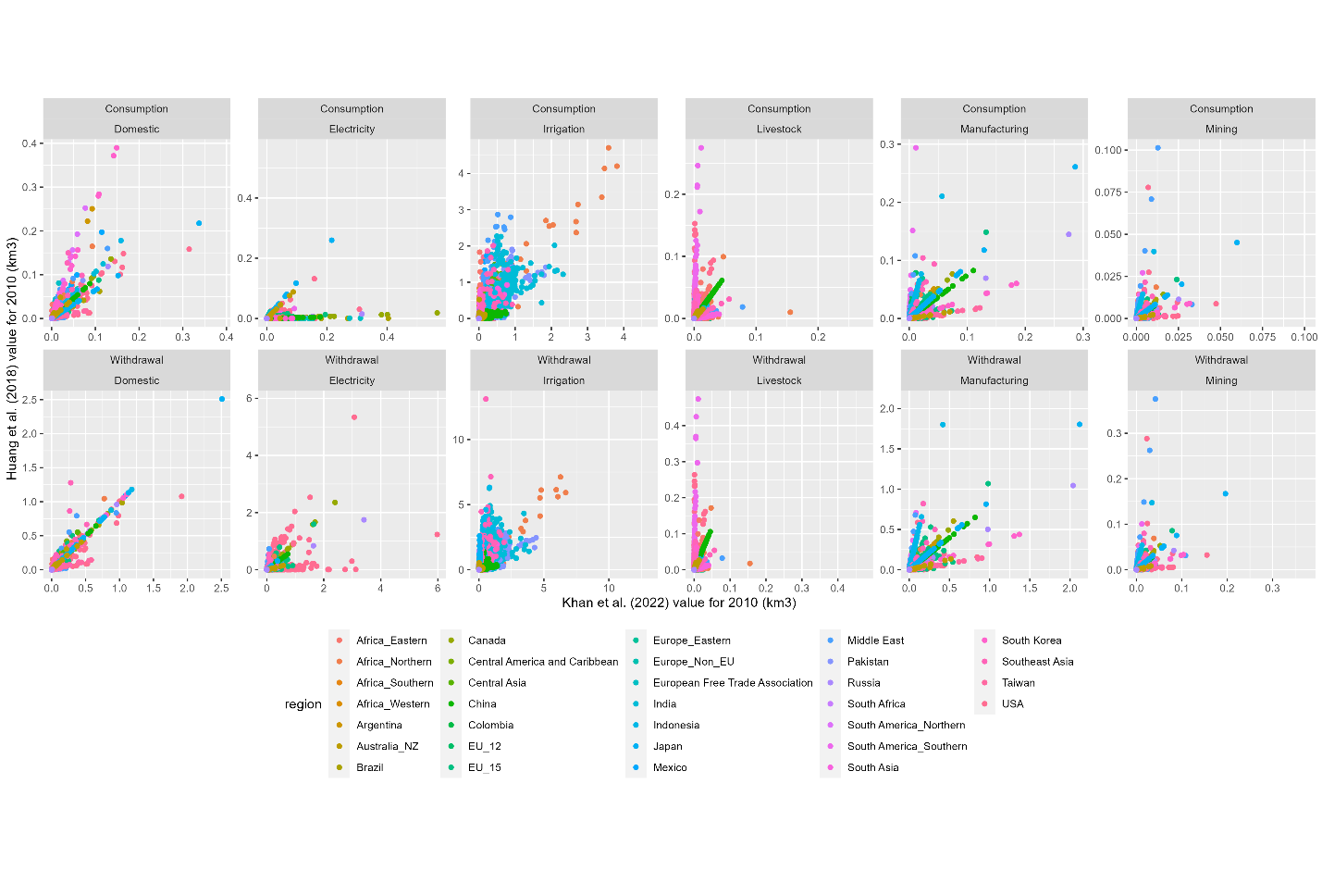

For the non-agricultural sectors (domestic, electricity, manufacturing, and mining), the same population map is used. This means that within each intersection of the different region schemes, the distribution of demand is identical, i.e., the ratio of their values to ours is constant for each grid cell in that intersection. This leads to the straight lines of the same color on the figure (calculations in appendix?). The livestock sector has similar patterns, although the ratios do not work out as cleanly, possibly due to how Tethys adjusts GCAM livestock categories to match the categories of the livestock maps. Irrigation, however, is downscaled in a completely different way. Huang et. al. use USGS and FAO AQUASTAT irrigation data, whereas the current version of Tethys uses crop landcover maps from Demeter. Nonetheless, there is some agreement.

Consumption and withdrawals generally show similar spatial patterns, with differences in assumptions regarding each region's and sector's consumption to withdrawal ratios accounting for some differences. There also may be differences in accounting. For example, our data set includes hydropower in the consumption for electricity generation category, which by itself is several times greater than Huang et al.'s entire water consumption for electricity generation value.

The second data set we compared with is from Mekonnen, M.M. and Hoekstra, A.Y. (2011). It contains monthly total blue water consumption values representing an average of years 1996-2005, which is close enough to 2010 to compare with our data set, though this probably accounts for some of the differences. The sectoral breakdown is also different, but the data are at the same spatial resolution, so we can compare monthly totals for each grid cell.

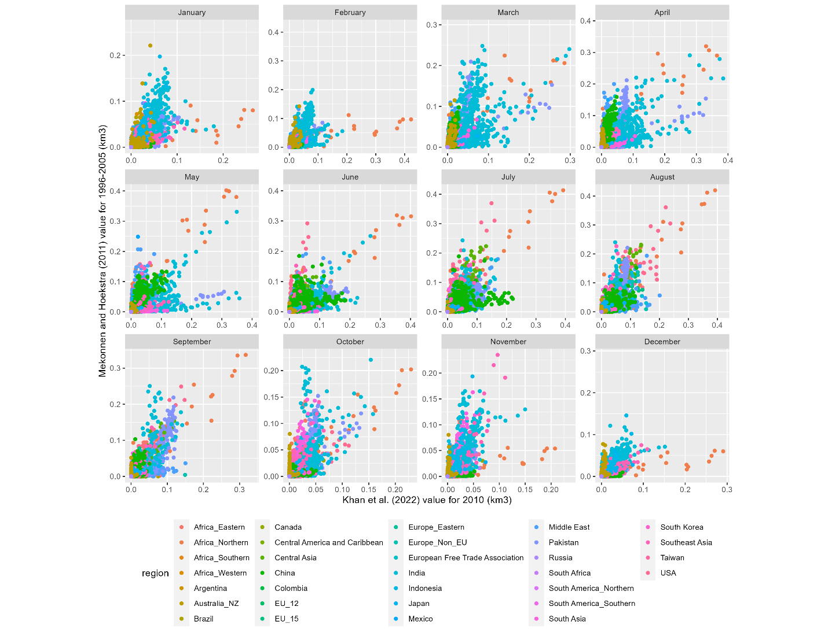

We see some agreement between the two data sets. As the largest sector, differences in irrigation downscaling are likely responsible for the variation. Consider two adjacent grid cells, where Demeter allocates significant crop land to one, but a different model says there is much more irrigation in the other. If you compare the models based only on these cell values (and not location) it would appear that they wildly disagree, even though the water demand comes from roughly the same area in both cases. We plot the water demand maps for each data set to compare visually.

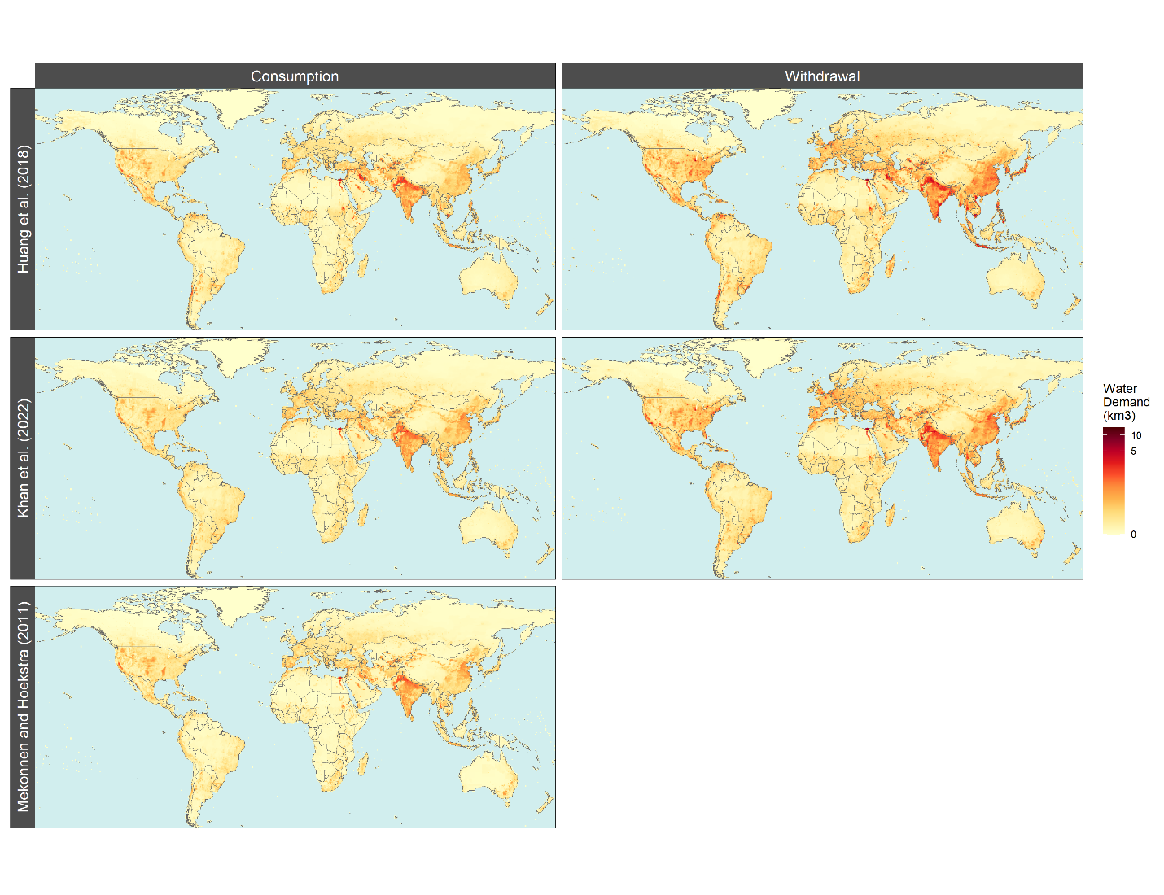

While there may be more sophisticated ways to quantify spatial agreement, one can observe many of the same sub-regional patterns in all data sets.

To get a sense for the overall sub annual distribution, we plot the monthly totals for each set.

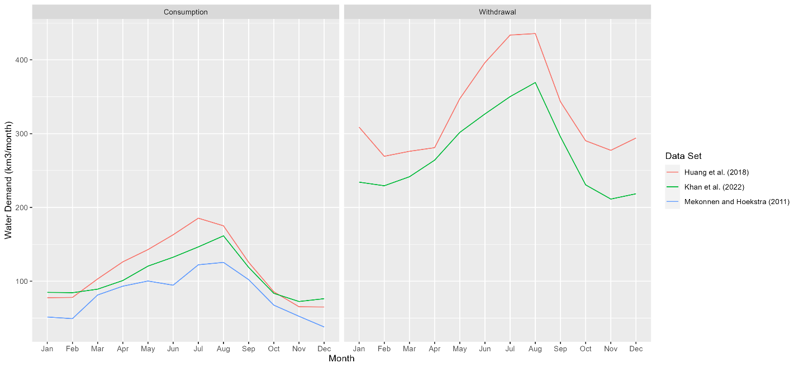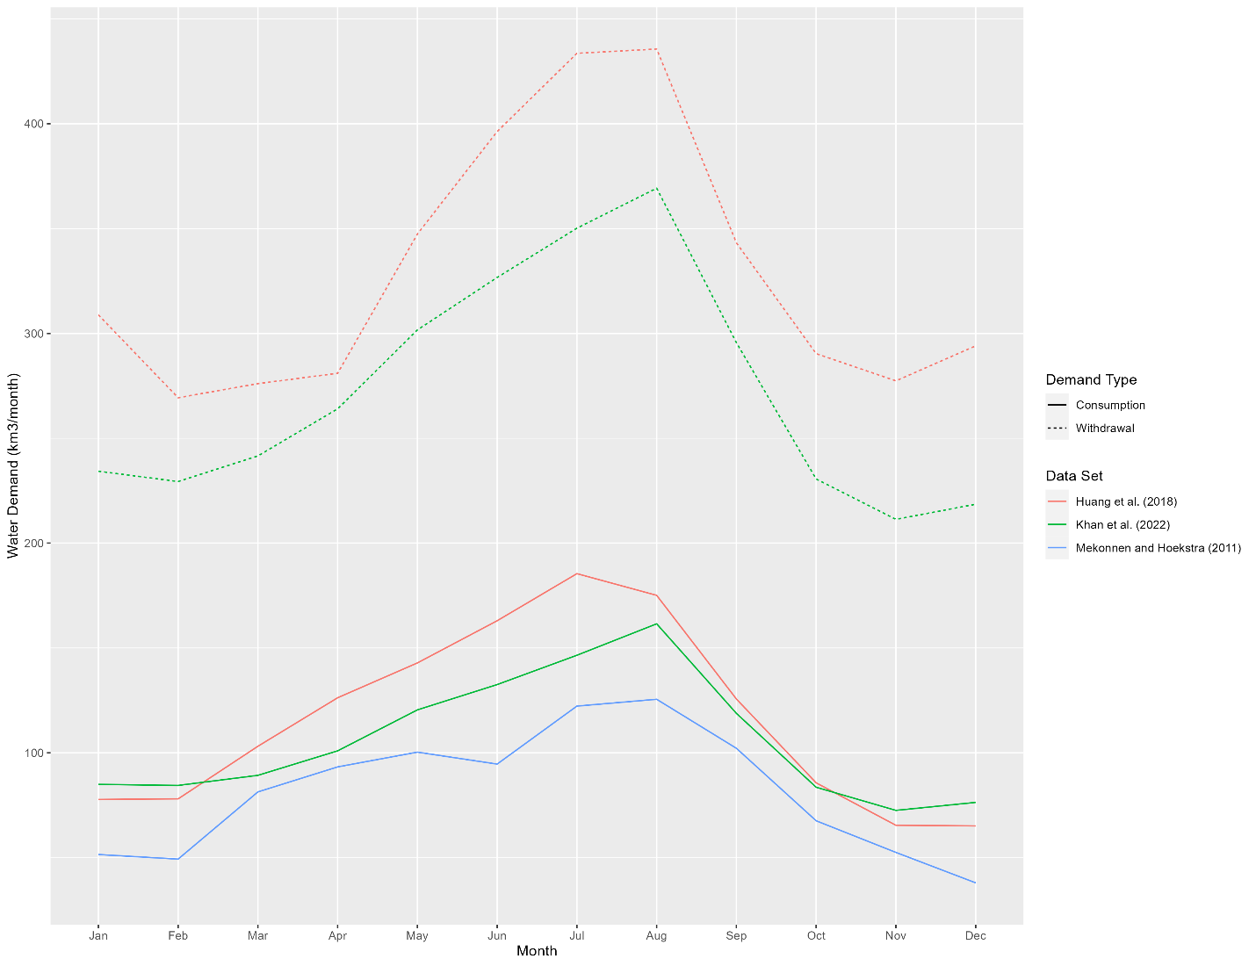

The distributions follow the same basic shape, though Mekonnen and Hoekstra show a sharp decline in June that is not present in the other data sets. Total annual water demands also vary considerably between data sets. This is somewhat expected when comparing 1996-2005 with 2010, but our totals are much lower than Huang et al.'s for the same year. Since downscaling doesn't change the total, this comes down to differences in the water demand inputs.