**Land Data System (LDS) User’s Guide**

**Version 2.0 (still beta4 at this point, until the GCAM data system is updated)**

**Overview**

The Land Data System (LDS) is designed to produce inputs to the AgLU module of GCAM data system[1], but the LDS outputs could also be used by other models/applications. The primary function of the LDS is to combine spatially explicit input data (e.g., raster images) with tabular input data (e.g., crop price table) to generate tabular output data for a suite of variables. Some of these outputs replace the data provide by the Global Trade Analysis Project (GTAP), and other data replace and augment the original GCAM GIS processing. The LDS output data are aggregated by Geographic Land Unit (GLU)[2] within each country. The GLU coverage is an input to the LDS (as a thematic raster image and an associated csv file that maps the thematic integers to names), and the GLU boundaries can be determined arbitrarily. Previous versions of GCAM (and LDS) used bioclimatic Agro-Ecological Zones (AEZs) and corresponding data that were provided by GTAP, as the GLUs. The LDS now enables any set of boundaries to be used as GLUs (including AEZs), allowing for more flexible generation of land use region boundaries (which are the GLUs intersected with the GCAM geopolitical regions). The current default set of GLUs is the same set of 235 global watersheds as used by the GCAM water module.

**LDS Framework**

This section focuses on the meta-structure of the LDS framework with the aim of providing a background for using the system. Complementarily, the basic processing flow is depicted in Figures 1 and 2. The LDS framework consists primarily of C code and is contained within the …/lds2 directory, with the exception of three input data sets that need to be downloaded from the internet by the user. The downloaded input data sets can be stored anywhere because their location is set in the LDS input file (…/lds2/lds_input.txt). The user will also need to download and install the C NetCDF library to read on of these downloaded data sets. The rest of the input data are in …/lds2/indata (this directory is set in the LDS input data file), including the two files that specify the GLUs (which are also set in the LDS input file). The LDS outputs go into a directory within …/lds2/outputs that is specified in the LDS input file. A runtime log file (lds_log.txt) is also written to the …/lds2/outputs directory, the name of which is also set in the LDS input file.

Five R scripts are also included in the framework. The …/lds2/indata/convert_wfgrids2binary.r script converts the water footprint files (downloaded by the user) from ARC binary grids to simple binary raster images for input to the LDS (because the linked GDAL library in the C code would not recognize the original files). The four R scripts in …/lds2/outputs generate various diagnostic outputs, and need some of the LDS diagnostic output files in order to run. The LDS outputs used by the GCAM data system are copied by the LDS into the more accessible …/aglu-data/LDS and …/aglu-data/mappings directories (the names of these files and their destination directories are also set in the LDS input file).

The LDS is a command line tool that takes the name of the LDS input file as the sole argument. The LDS can be run within Xcode on a Mac, or compiled anywhere (hopefully) using the …/lds2/makefile (which is for Linux and has been tested on the Mac terminal). The easier way to use the LDS is by opening the …/lds2/lds2.xcodeproj file in Xcode, then compiling and running it directly within Xcode, mainly because most of the conditions for running it are already established (location of the NetCDF library may have to be changed in the build settings, and also in lds.h). The current default setting for the location of the executable is …/lds2/build/Products/Debug. The makefile, however, puts the executable in …/lds2/bin, and the objects in …/lds2/obj, but it is easier to call lds2 from …/lds2 because of the input file default path entries. The user must first create these two directories and also change the location of the NetCDF library in both the makefile and in lds.h. Regardless of how the code is run, the user must also correctly specify the input and output directories (and any other input data files that they may want to substitute) in the LDS file before running the code.

The LDS production outputs are independent of the GCAM regions. However, there are diagnostic outputs that do aggregate data to the GCAM land use regions based on either 14 or 32 GCAM regions. These aggregated diagnostic outputs are used by some of the diagnostic R scripts. The user specifies which GCAM region set to use in the LDS input file, by pointing to two files copied directly from …/gcam-data-system/_common/mappings.

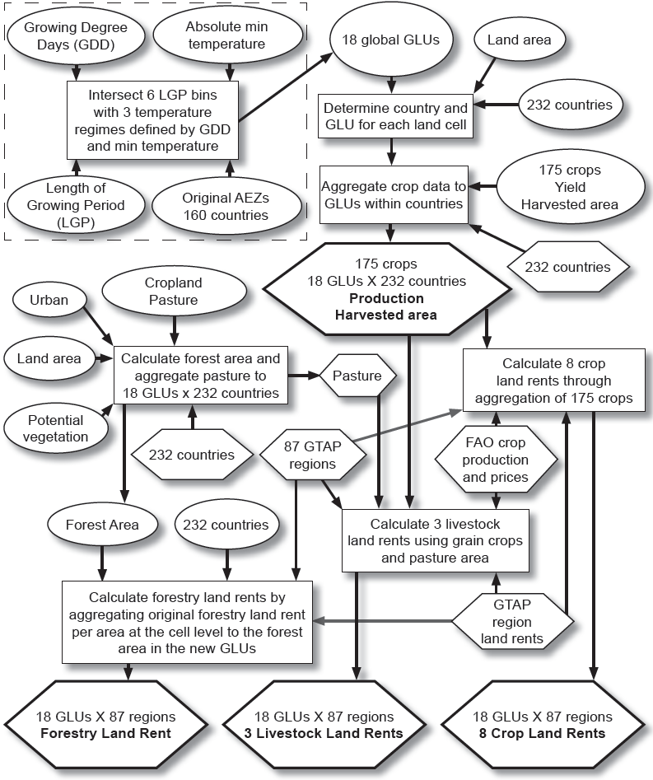

Figure 1. LDS processing flow for the economic land data outputs that replace GTAP data. The AEZ generation in the box is just an example of the GLU input data; the default GLU set contains the 235 water basins. There are actually 235 countries in the input data, but two are not used, and two are merged into one for output. The ovals contain raster data, the hexagons contain tabular data, and the outputs are in bold.

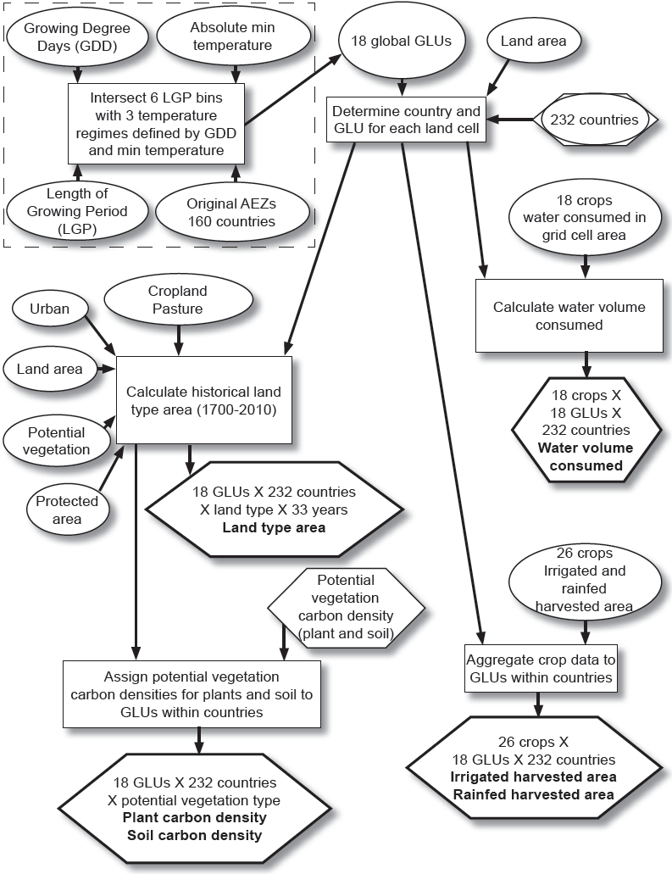

Figure 2. LDS processing flow for the other geographic data outputs. The AEZ generation in the box is just an example of the GLU input data; the default GLU set contains the 235 water basins. There are actually 235 countries in the input data, but two are not used, and two are merged into one for output. The ovals contain raster data, the hexagons contain tabular data, and the outputs are in bold.

Required downloads/installs

C NetCDF library

The user must have the C NetCDF library installed (available at http://www.unidata.ucar.edu/software/netcdf/). The header and library search paths for compiling LDS must include the location of the installed C NetCDF library. The linking flags must also be set (-L<header_location> -lnetcdf) for successful compilation of the LDS.

SAGE 175 crop harvested area and yield data, circa 2000

These data are now available at http://www.earthstat.org/data-download/, labeled as “Harvested Area and Yield for 175 Crops.” Put all of the zipped NetCDF files (one for each crop) in a single directory, then set this directory in the LDS input file. The LDS will automatically unzip the files and leave the both the zipped and unzipped files in the directory. Alternatively, the user can download the ascii grid files and rewrite the read function accordingly so that the NetCDF library is not necessary. The corresponding journal article is cited on the download page. Units are the fraction of land area within each grid cell.

MIRCA2000 crop irrigated and rainfed harvested area data, circa 2000

These data are available at https://www.uni-frankfurt.de/45218031/data_download. The specific data are labeled “Annual harvested area grids for 26 irrigated and rainfed crops.” Login as a guest, and put all of the 5 arcmin individual crop files (ANNUAL_AREA_HARVESTED_IRC_CROP#_HA.ASC.gz and NNUAL_AREA_HARVESTED_RFC_CROP#_HA.ASC.gz) into a single directory, unzip them, then set this directory in the LDS input file. The corresponding journal article is also available. Units are hectares.

Water footprint data, circa 2000

These data are available at http://waterfootprint.org/en/resources/water-footprint-statistics/, labeled as “Product water footprint statistics: Water footprints of crops and derived crop products.” Select the Rastermap download link, unzip the file, and then run …/lds2/indata/convert_wfgrids2binary.r (with the proper paths, of course) to convert the files to simple binary raster files. This R script writes the new files into the same, newly unzipped directory, so the user can set this directory in the LDS input file (the current default is the name already given to this directory). The corresponding journal article is also available. Units are average annual mm over the entire grid cell area (1996-2005).

**Outputs**

The LDS takes a given set of GLU boundaries and generates **ten production output files** for use by the GCAM data system. It also generates many diagnostic files (if specified in the LDS input file) that will not be described here. Eight of the production output files contain data and two of them contain mapping values between countries or land types. The LDS production data files contain several “type” columns and a single “value” column, with no zero-value records. The first two columns of each file contain the country iso3 code and the GLU integer, in that order. The rightmost type column varies the fastest, and the value column is last. The values are rounded to the integer to represent an appropriate level of precision based on the input data. The data files contain six header lines, and the mapping files contain five header lines, the last of which contains the column labels.

The LDS generates the following three files and copies them to the LDS destination directory (…/aglu-data/LDS; these files replace the GTAP data previously stored in …/aglu-data/level0):

**LDS_ag_HA_ha.csv** = harvested area, country X GLU X 175 crop (hectares)

**LDS_ag_Prod_t.csv** = production, country X GLU X 175 crop (metric tonnes)

**LDS_value_milUSD.csv** = land rent value, country X GLU X 12 use sector (million USD)

Note that these data are based on the 1997-2003 annual average.

These names and the destination directory are set in the LDS input file.

The LDS also generates these files (some of which were previously stored in either the deprecated …/aglu-data/GIS directory or …/aglu-data/level0, may have been previously produced from the old “GIS” code), and copies them to the LDS destination directory (…/aglu-data/LDS):

**MIRCA_irrHA_ha.csv** = irrigated harvested area, country X GLU X 26 crop (hectares)

**MIRCA_rfdHA_ha.csv** = rainfed harvested area, country X GLU X 26 crop (hectares)

**Land_type_area_ha.csv** = land type area, country X GLU X land type X year (hectares)

**Pot_veg_carbon_Mg_per_ha.csv** = soil and veg C density for potential vegetation land types, country X GLU X land type X soil/veg C (Megagrams per hectare). The presence of a given land type within a GLU X country depends on the HYDE_YEAR set in lds.h. HYDE_YEAR is also used for determining area for land rent outputs, and the default is 2000

**Water_footprint_m3.csv** = average annual water volume consumed (1996-2005), country X GLU X 18 crop X water type (m3), blue = surface and groundwater irrigation, green = rain, gray = needed to dilute pollutant runoff, total = the sum, but is slightly different than summing the individual type outputs due to rounding

These names and the destination directory are set in the LDS input file.

These two mapping files are generated and copied to the mappings destination directory (…/aglu-data/mappings):

**LDS_ctry_GLU.csv** = maps the VMAP0 raster integer country codes to iso3 code and FAO country name for each GLU within each country. This is based on the …/gcam-data-system/_common/mappings/iso_GCAM_regID_##reg.csv file specified in the LDS input file. The mapping works because the GCAM file lists the FAO country names, which can be matched to the LDS input FAO/VMAP0 country list.

**LDS_land_types.csv** = mapping of land type code to description for area and carbon outputs

These names and the destination directory are set in the LDS input file.

**Inputs**

This section focuses on the inputs listed in the LDS input file. Of the many inputs to the LDS, those listed in the LDS input file are the most important as they include the primary source data in addition to the GLU definition that determines how to aggregate the source data. The extent and resolution of the default raster input data determine the working resolution of the LDS, which is defined in the LDS header file (…/lds2/lds.h; global extent, 5 arcmin resolution). When substituting input data the user must ensure that the new data are read in and resampled to the working grid. An alternative grid can also be defined in the LDS header file. Each input has its own read function that can be rewritten to accommodate input data set substitution.

LDS input file (…/lds2/lds_input.txt)

The LDS input file specifies the input and output paths, the file names of the primary input and output files, and whether additional diagnostic files are output. The flag to recalibrate the production, harvested area, and land rent outputs to a different period of FAO data is included in the input file, but is not used because the recalibration code is not working correctly. The input file code variables are filled based on the order of the uncommented lines in the input file, rather than by keyword (# is the comment character), and there are 49 input values read from the input file. Thus, the following input descriptions follow the order in the input file.

Flags

* recalibrate: 0 = no, 1 = yes; hardcoded to zero because it is not working properly
* diagnostics: 0 = no, 1 = output diagnostics files

File paths (must include final “/”)

* inpath: path to directory containing all input files except for the SAGE 175 crops, MIRCA2000, and water footprint data (…/lds2/indata)
* outpath: path to directory where all output files will be written (this directory must already exist) (…/lds2/outputs/<user_specified>)
* sagepath: path to directory containing the SAGE 175 crop netCDF files (<user_specified>)
* mircapath: path to directory containing the MIRCA2000 ascii grid files (<user_specified>)
* wfpath: path to directory containing the water footprint simple binary raster files (<user_specified>)
* ldsdestpath: path to directory where the eight LDS output data files will be copied to (…/aglu-data/LDS; this directory must already exist)
* mapdestpath: path to directory where the two LDS output mapping files will be copied to (…/aglu-data/mappings; this directory must already exist)

Raster input data (filename without path)

* **HYDE grid cell area**: area of whole grid cell in km2, based on a spherical earth (WGS84 mean radius), with valid data only in cells with valid HYDE land area data
* Default data are based on the HYDE GCP2012 best data set (url), with data cells added to include several arctic islands that have been added to the HYDE land area data set (hyde_cell_plus.bil)
* Alternatively, the user can select the original HYDE GCP2012 grid cell area data, which is the same as the HYDE3.1 data (cell_area_hyde.bil)
* **SAGE land fraction**: land area fraction of grid cell, with valid data only in cells with valid SAGE potential vegetation or crop data (sage_land_frac.bil)
* These fractions assume a spherical earth (WGS84 mean radius), so the corresponding grid cell area is calculated for the entire grid
* SAGE land area is then calculated by multiplying the land fraction data with these calculated grid cell data
* The SAGE land area data are used in conjunction with other data sets that utilize the SAGE data, such as the SAGE crop data, the MIRCA2000 data, and the water footprint data
* **HYDE land area**: available land area within grid cell in km2, with valid data only in cells that are not completely ocean. As such, these data constitute the effective land mask for HYDE data. The HYDE land area data are the bases for land type area calculations and are considered as the working grid land area data
* Default data are based on the HYDE GCP2012 best data set (ftp://ftp.pbl.nl/../hyde/tmp/gcp2012_best/), with data cells added to include several arctic islands that have been added based on the SAGE land fraction data set (hyde_area_plus.bil). The original data do not include major glacier area in the available land area, so zero area land cells that are classified as “Polar Desert/Rock/Ice” and have non-zero land area in the SAGE potential vegetation and land fraction data sets are set to the SAGE land area. Additionally, all Greenland cells have been set so that the land area equals the entire grid cell area, in order to capture the ice area (only 141828 km2 of additional area is added by this method over the method of just adding entire grid cell area for the zero area land cells, so capturing the partial ice cells is worth potential overestimation of coastal ice-free land)
* Alternatively, the user can select the original HYDE GCP2012 land area data, which is the same as the HYDE3.1 data (land_area_hyde.bil)
* **GLU thematic map**: integer codes representing the coverage of the output GLUs, with valid data only in cells determined to be part of a GLU. The GLUs can be arbitrarily defined by the user, and are enumerated starting at 1
* Default data are the 235 water basins used by the GCAM water module (Global235_CLM_0125_dissolve.gri). There is a corresponding csv file that maps the integer values to basin names
* Alternatively, the user can select the original 18 AEZs (AEZ_orig_lds.gri), which have also been tested. There is a corresponding csv file that maps the integer values to AEZ names
* Also, the user can select the ECHAM 2100 projected 18 AEZs (AEZ_echam_2100_lds.gri), which have not been evaluated in this version, but were used in a previous version of LDS. There is a corresponding csv file that maps the integer values to AEZ names
* **Original AEZ thematic map**: integer codes representing the coverage of the original AEZs, with valid data only in cells determined to be part of an AEZ
* These data are the 18 original AEZs previously used by GCAM (AEZ_orig.gri). These data are needed to remap the forest land rent to the new GLUs. There is a corresponding csv file that maps the integer values to AEZ names
* **SAGE potential vegetation**: integer codes representing the potential vegetation circa 2000 if no land use change had occurred, with valid data only in cells that have been assigned to one of 15 classes
* Default data have been updated to include Greenland, which is absent from the SAGE data sets (potveg_plus.bil). In Greenland, if the original HYDE land area equaled zero then the SAGE potential vegetation was set to “Polar Desert/Rock/Ice” (15), and if the original HYDE land area was greater than zero then the SAGE potential vegetation was set to “Tundra” (13). There is a corresponding csv file that maps the integer values to the potential vegetation type names
* Alternatively, the user can select the original SAGE potential vegetation file (potveg_thematic.bil), which does not include Greenland and uses the same csv mapping file as the default data
* **Country thematic map**: integer codes representing the country coverage, with valid data only in cells that have been assigned to a country (fao_ctry_rast.bil)
* The base for these data is the VAMP0 spatial data set, which has been used by the FAO and is thus labeled with FAO country names. The FAO integer country codes from FAOSTAT have been assigned to the countries where possible, with some additional values for VMAP0 countries not listed in the FAOSTAT database. Furthermore, East Timor has been added based on an East Timor shapefile, and the edges of the country raster data were “grown” to ensure better coverage of coastal land cells. See …/lds2/indata/FAO_iso_VMAP0_ctry_readme.txt for details on this data set and how it maps to the tabular country data
* **Protected area thematic map**: integer codes representing whether a cell is protected (1) or not (255) (ProArea_0408_ENVI.img). Every cell contains one of these two values
* These data were imported from the old GCAM “GIS” processing system, and the original source is unknown. They are used to segregate the land type area and the potential vegetation carbon outputs
* **Nitrogen application rate**: deprecated. rate of nitrogen application in kg/ha (Nfert_0083d.img)
* These data were imported from the old GCAM “GIS” processing system, and the original source is Potter et al., 2010, but how they were aggregated to this file is unknown. Furthermore, the data were not processed correctly and subsequently not used by GCAM. The read and process functions are included in the source code, but they are not part of the build target and they are not called by the main program. This input line still exists, along with the code, in case one wants to figure out how to process the data correctly or substitute another data set. The user would have to hardcode the output file name or add it to the input file and corresponding data structure.
* **HYDE historical crop area**: 33 years of cropland area ranging from 1700 – 2010, with valid data cells coinciding with the HYDE land area data (crop_BSQ_33_float.img)
* Default data are from the HYDE GCP2012 best data set (ftp://ftp.pbl.nl/../hyde/tmp/gcp2012_best/), and have been concatenated to a 33-sequential-band binary file that includes data at 10-year intervals from 1700-2000, plus 2005 and 2010
* The total HYDE historical land use area (crop+pasture+urban) exceeds the HYDE land area in some grid cells, as the land area data have not been updated from HYDE3.1
* The year-2000 data are used to determine the forest area for calculating forest land rent
* Alternatively, the user can select the HYDE3.1 data, with 2010 added from the GCP2012 best data (crop_BSQ_33_float_h31.img). Be sure to use the same HYDE version for all three historical area files
* **HYDE historical pasture area**: 33 years of pasture area ranging from 1700 – 2010, with valid data cells coinciding with the HYDE land area data (grass_BSQ_33_float.img)
* Default data are from the HYDE GCP2012 best data set (ftp://ftp.pbl.nl/../hyde/tmp/gcp2012_best/), and have been concatenated to a 33-sequential-band binary file that includes data at 10-year intervals from 1700-2000, plus 2005 and 2010
* The total HYDE historical land use area (crop+pasture+urban) exceeds the HYDE land area in some grid cells, as the land area data have not been updated from HYDE3.1
* The year-2000 data are used to determine the forest area for calculating forest land rent
* Alternatively, the user can select the HYDE3.1 data, with 2010 added from the GCP2012 best data (grass_BSQ_33_float_h31.img). Be sure to use the same HYDE version for all three historical area files
* **HYDE historical urban area**: 33 years of urban area ranging from 1700 – 2010, with valid data cells coinciding with the HYDE land area data (urban_BSQ_33_float.img)
* Default data are from the HYDE GCP2012 best data set (ftp://ftp.pbl.nl/../hyde/tmp/gcp2012_best/), and have been concatenated to a 33-sequential-band binary file that includes data at 10-year intervals from 1700-2000, plus 2005 and 2010
* The total HYDE historical land use area (crop+pasture+urban) exceeds the HYDE land area in some grid cells, as the land area data have not been updated from HYDE3.1
* The year-2000 data are used to determine the forest area for calculating forest land rent
* Alternatively, the user can select the HYDE3.1 data, with 2010 added from the GCP2012 best data (urban_BSQ_33_float_h31.img). Be sure to use the same HYDE version for all three historical area files

CSV input data (filename without path)

* GTAP_value_milUSD.csv: original GTAP LU2.1 land rent data
* GTAP_GCAM_ctry87.csv: GTAP 87 country list, in GCAM order (alphabetical by iso)
* FAO_ctry_GCAM_ctry87.csv: FAO country to 87 country mapping list. This file determines which economic region each country is assigned to, and whether it is included in the outputs. See FAO_ctry_GCAM_ctry87_readme.txt for details
* FAO_iso_VMAP0_ctry.csv: FAO country to VMAP0 country and iso mapping list. The FAO_iso_VMAP0_ctry_readme.txt file contains info about how this country mapping list was developed. The integer codes correspond to the country thematic map as described above (fao_ctry_rast.bil)
* Global235_CLM_0125_dissolve.csv: the list of output GLU names mapped to the raster integer codes of Global235_CLM_0125_dissolve.gri
* Alternatively, the user can select the original 18 AEZs (AEZ_orig_lds.csv)
* Also, the user can select the ECHAM 2100 projected 18 AEZs (AEZ_echam_2100_lds.csv)
* iso_GCAM_regID_32reg.csv: iso countries to gcam region mapping list. This determines aggregation in the diagnostic output files, and must be consistent with the GCAM_region_names_##reg.csv file
* Alternatively, the user can select the iso_GCAM_regID_14reg.csv file
* GCAM_region_names_32reg.csv : GCAM region list (with integer codes). This determines aggregation in the diagnostic output files, and must be consistent with the iso_GCAM_regID_##reg.csv file
* Alternatively, the user can select the GCAM_region_names_14reg.csv file
* GTAP_use.csv: GTAP product use categories, with integer codes, and abbreviations
* SAGE_PVLT.csv: maps SAGE land cover type names for potential vegetation to integer codes in the SAGE potential vegetation raster file
* SAGE_gtap_fao_crop2use.csv: maps the 175 sage crops to GTAP use sectors and FAO crops. The fourth column (gtap_crop_name) is the crop label used by LDS and GCAM. See SAGE_gtap_fao_crop2use_readme.txt for additional details
* FAO_ag_prod_t_PRODSTAT_11yrs.csv: FAO production data used in land rent calculations. This is also a source for recalibration to a different year, but recalibration does not work. Downloaded 2 Aug 2013 from faostat.fao.org/site/###/
* FAO_ag_yield_hg_ha _PRODSTAT_11yrs.csv: Source of FAO yield data for recalibration to a different year, but recalibration does not work. Downloaded 2 Aug 2013 from faostat.fao.org/site/###/
* FAO_ag_HA_ha_PRODSTAT_11yrs.csv: Source of FAO harvested area data for recalibration to a different year, but recalibration does not work. Downloaded 2 Aug 2013 from faostat.fao.org/site/###/
* FAO_ag_an_prodprice_USD_t_PRICESTAT_11yrs.csv: FAO price data used in land rent calculations. Downloaded 2 Aug 2013 from faostat.fao.org/site/###/
* convert_to_2001usd.csv: used to convert the 2005USD in the FAO prodprice file to 2001USD to be consistent with the LDS and GTAP data
* veg_carbon.csv: vegetation (including root) carbon density (kg/m2) for each SAGE potential vegetation type, based on literature
* soil_carbon.csv: soil carbon density (kg/m2) for each SAGE potential vegetation type, based on literature

Output file names (filename without path)

* lds_log.txt: LDS runtime log file
* LDS_ag_HA_ha.csv: the crop harvested area output file
* LDS_ag_Prod_t.csv: the crop production output file
* LDS_value_milUSD.csv: the land rent output file
* MIRCA_irrHA_ha.csv: the crop irrigated harvested area output file
* MIRCA_rfdHA_ha.csv: the crop rainfed harvested area output file
* Land_type_area_ha.csv: the historical land type area output file
* Pot_veg_carbon_Mg_per_ha.csv: the potential vegetation type carbon density output file
* Water_footprint_m3.csv: the crop water volume consumption output file
* LDS_ctry_GLU.csv: the country X GLU mapping output file
* LDS_land_types.csv: the land type mapping output file

**Diagnostics**

There are four R scripts in …/lds2/outputs that generate a variety of figures. Make sure that …/lds2/outputs is the R working directory before running the scripts. Each script writes to a user-specified directory within the outputs directory. Set the diagnostic output directory within each script, and create it before running the script. Each script has a detailed description at the beginning, and comments identifying the relevant directories, files, and flags that the user can change to customize the outputs. To diagnose country-level harvested area and production outputs, use “plot_lds_crop_ctry.r.” To diagnose land use region level harvested area and production outputs, use “plot_lds_crop_raez.” To diagnose the land type area output, use “plot_lds_land_type_area.r.” To diagnose the land rent output (at different aggregation levels), use “plot_lds_landrent_aez.r”

1. LDS development started with the GCAM data system in a new branch created by Page Kyle on 18 Sep. 2015 (https://128.8.246.24/svn/branches/lds-workspace; r6376). The initial commit of the LDS (r6408) on 23 Sep. 2015 was the previous version used to generate data for 18 new AEZs, and development of the current LDS proceeded from this point. The actual code and most of the required inputs are in …/lds-workspace/input/gcam-data-system/aglu-processing-code/lds2. The outputs used by the GCAM data system are copied by the LDS into …/aglu-data/LDS and …/aglu-data/mappings.
2. All output files refer to GLUs, but not all the terminology (i.e., comments, variables) within the code has been converted from AEZ to GLU.