Title
Subtitle
Your name
2025-11-21
Abstract
This is the abstract
With multiple paragraphs

1 Introduction
We set up variables in Listing 1.
Listing 1: This the the caption for this code listing.
a = 1
b = a + 1
In this example: a = 1 and b = 2, or if you want to use math text: $a=1$ and $b=2$.
Math text can also be used for full equations:
$$E=mc^{2}$$
When you have finished reading this section, you can move onto the next section, which is called Section 2.
 Note
This is a callout.
There are five types: note, tip, warning, caution, and important.

2 Further section
We will now use the iris dataset, a sample of which is shown in Table 1.
Table 1: This is the first few rows of the iris dataset.
Sepal.Length | Sepal.Width | Petal.Length | Petal.Width | Species
5.1 | 3.5 | 1.4 | 0.2 | setosa
4.9 | 3.0 | 1.4 | 0.2 | setosa
4.7 | 3.2 | 1.3 | 0.2 | setosa
4.6 | 3.1 | 1.5 | 0.2 | setosa
5.0 | 3.6 | 1.4 | 0.2 | setosa
5.4 | 3.9 | 1.7 | 0.4 | setosa

The full dataset is plotted in Figure 1, with distributions shown in Figure 2 (which includes subplots Figure 2 (a) and Figure 2 (b)).
iris |>
ggplot(aes(x = Sepal.Length, y = Sepal.Width)) +
geom_point()
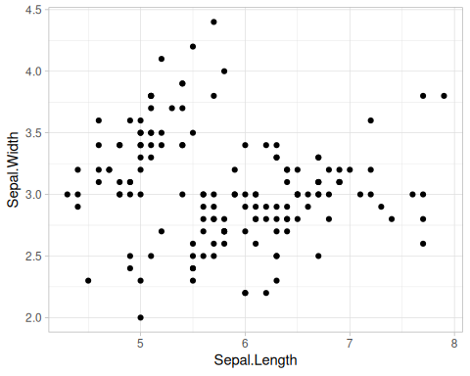
Figure 1: This is an example using the iris dataset.
For example purposes we use Quarto subfigures here, although this would be better as facets/small multiple plots.
iris |>
ggplot(aes(x = Sepal.Length)) +
geom_histogram(binwidth = 0.2)
iris |>
ggplot(aes(x = Sepal.Width)) +
geom_histogram(binwidth = 0.2)
  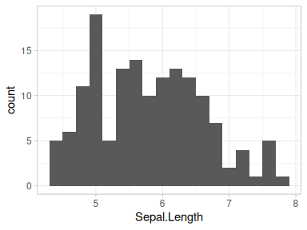
  (a) sepal length
  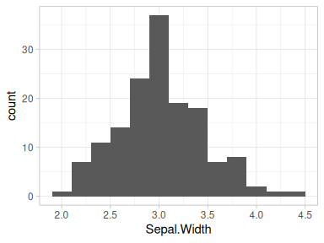
  (b) sepal width
Figure 2: This is the distribution of the variables.

3 Final section
We have some references (Zelenka et al. 2024).

4 Acknowledgments
These are the acknowledgements, a link to the Jean Golding Institute and its logo, with a caption but no figure numbering:

The JGI logo.
And with figure numbering as Figure 3:
Figure 3: The JGI logo.
Zelenka, Natalie R, Nina Di Cara, Kieren Sharma, Seeralan Sarvaharman, Jasdeep S Ghataora, Fabio Parmeggiani, Jeff Nivala, Zahraa S Abdallah, Lucia Marucci, and Thomas E Gorochowski. 2024. “Data hazards in synthetic biology.” Synthetic Biology, June, ysae010. https://doi.org/10.1093/synbio/ysae010.

This is a longer footnote. That can span over multiple paragraphs.
This is an inline footnote.

