Manuel Salazar
Screenshot 19 – Transaction History
Figure 19. Transaction History
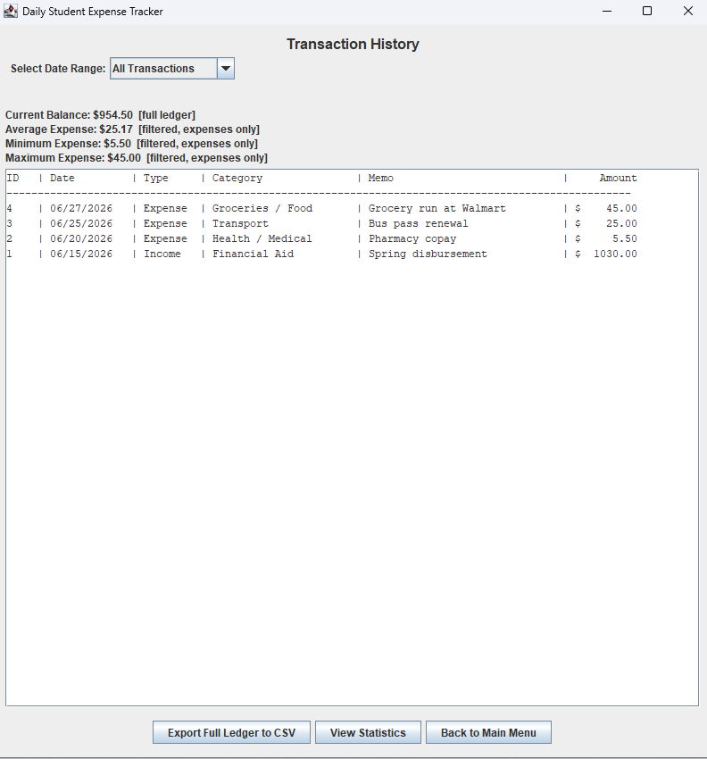
Description:
The Transaction History page displayed all recorded transactions sorted from the most recent date to the oldest date.
Status: PASS

Screenshot 20 – History Statistics
Figure 20. History Summary
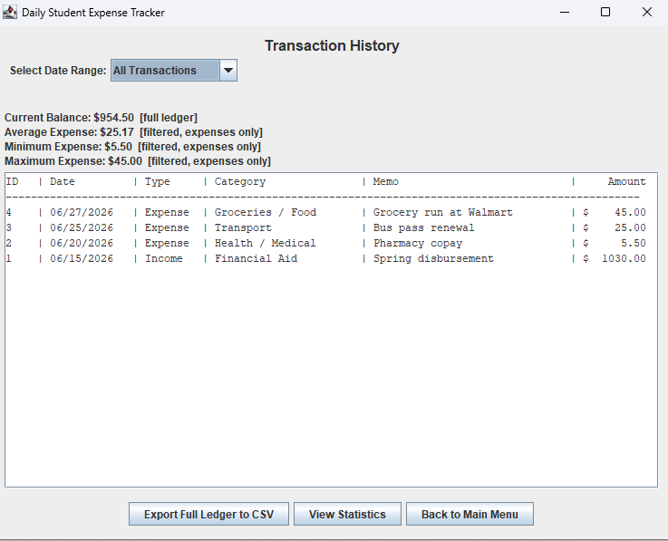
Description:
The application correctly calculated and displayed the current balance, average expense, minimum expense, and maximum expense.
Status: PASS

Screenshot 21 – Statistics Dashboard
Figure 21. Statistics Dashboard
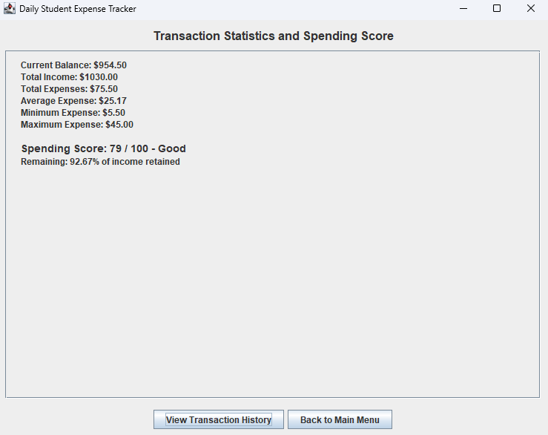
Description:
The Statistics page displayed the total income, total expenses, current balance, and additional expense statistics using the recorded transaction data.
Status: PASS

Screenshot 22 – Empty Statistics
Figure 22. Empty Statistics

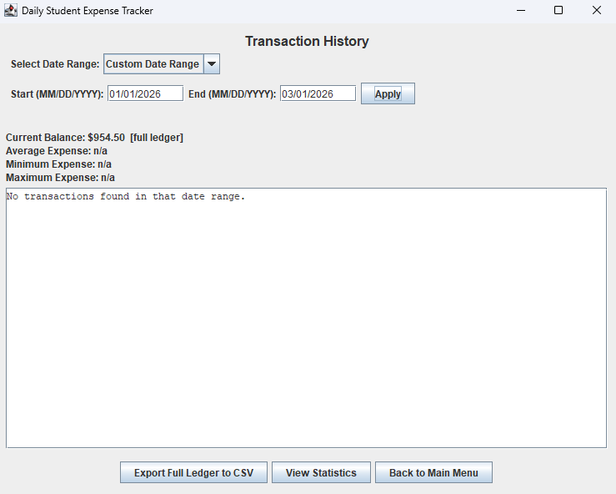
Description:
When no transactions were available, the application displayed an informational message instead of attempting to calculate statistics.
Status: PASS

Screenshot 23 – Export Confirmation
Figure 23. Export Ledger
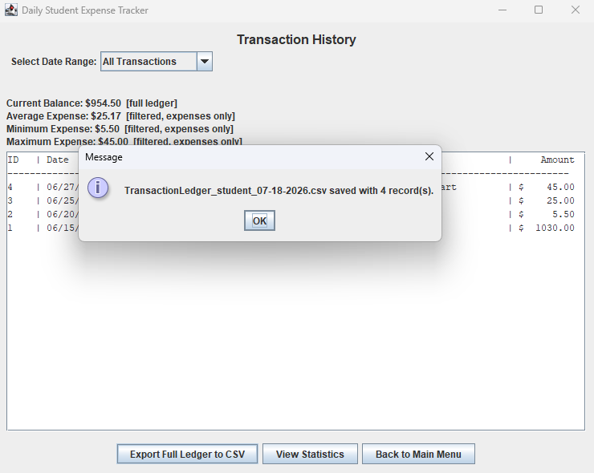

Description:
The Export Full Ledger feature successfully generated a CSV file containing the recorded transactions and displayed a confirmation message.
Status: PASS

Screenshot 24 – Exported CSV File
Figure 24. Exported Transaction File
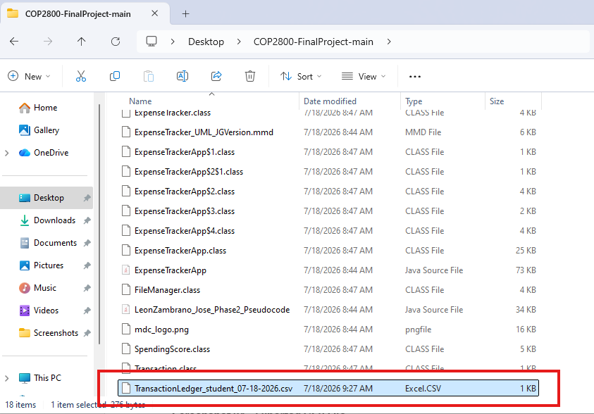
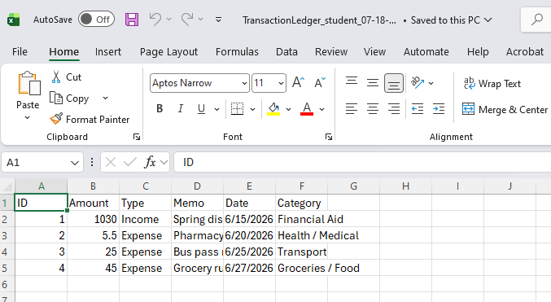
Description:
The exported CSV file was successfully created in the project directory using the expected file naming convention.
Status: PASS

Screenshot 25 – Last 60 Days Filter
Figure 25. Last 60 Days Filter
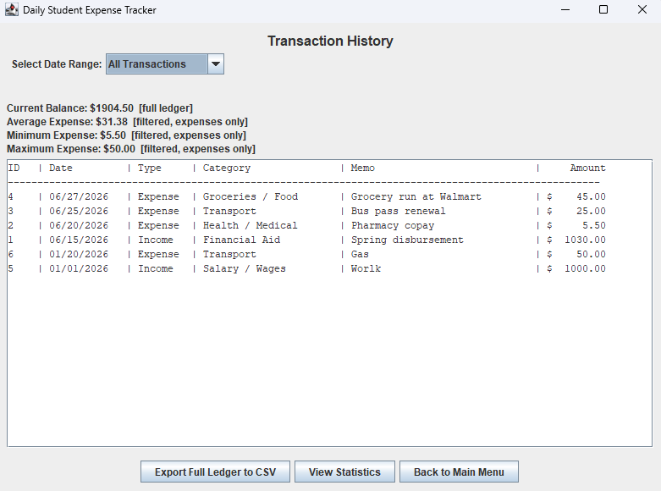
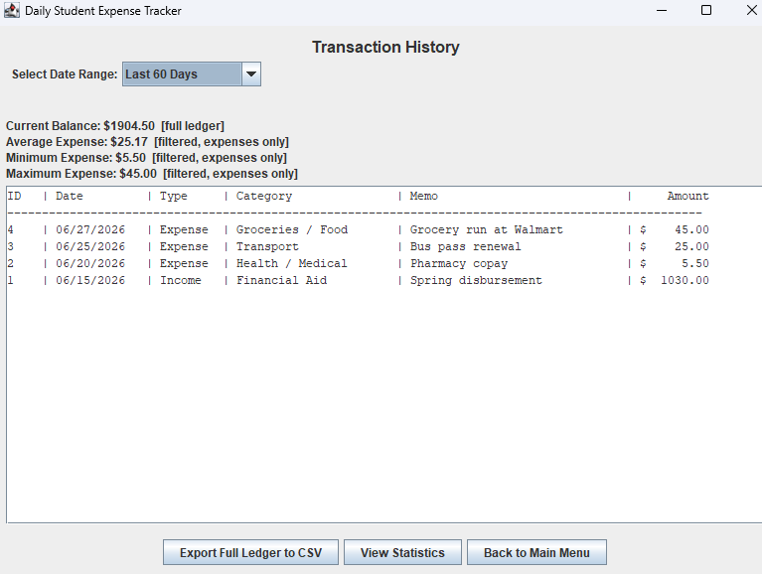
Description:
Applying the Last 60 Days filter displayed only transactions that occurred within the previous sixty days.
Status: PASS

Screenshot 26 – Custom Date Range
Figure 26. Custom Date Range
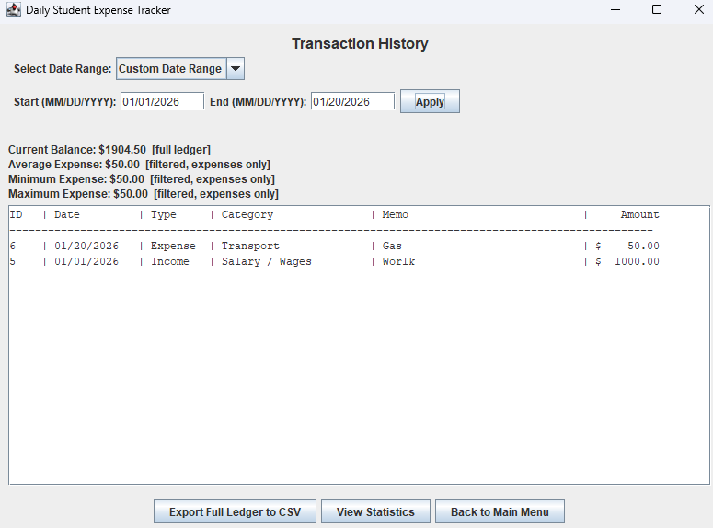
Description:
Selecting the Custom Date Range filter displayed the Start Date, End Date, and Apply controls for filtering transactions.
Status: PASS

Screenshot 27 – Invalid Date Filter
Figure 27. Date Validation
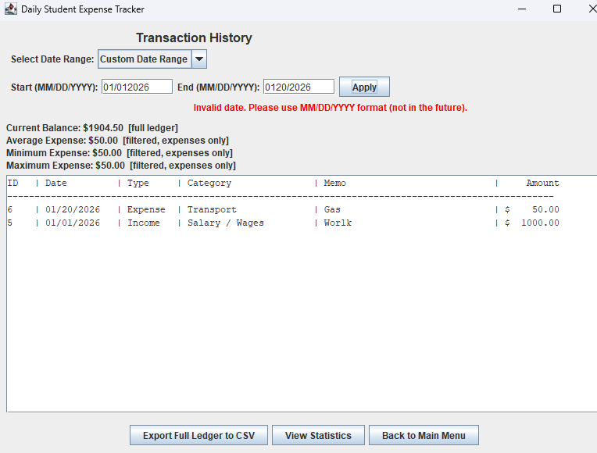
Description:
Entering an invalid custom date displayed an appropriate validation message and prevented the filter from being applied.
Status: PASS

Screenshot 28 – Full Ledger Balance
Figure 28. Full Ledger Balance
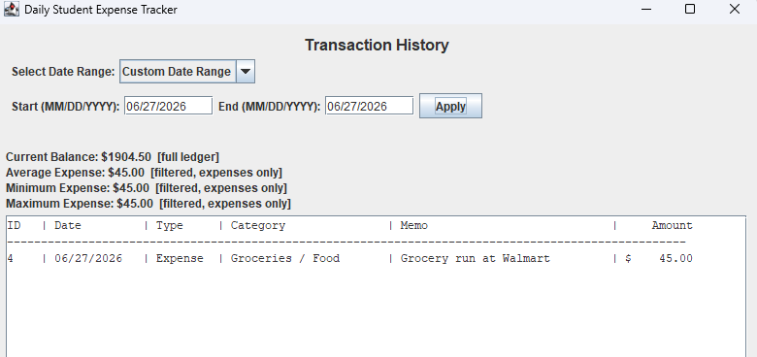
Description:
Even while a date filter was applied, the application continued displaying the current balance calculated from the complete transaction ledger.
Status: PASS

Screenshot 29 – Spending Score (Good)
Figure 29. Spending Score
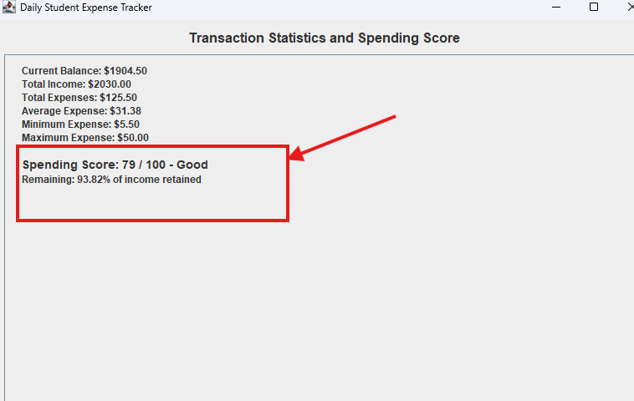
Description:
Using the sample transaction data, the application calculated the expected Spending Score and displayed the corresponding performance level.
Status: PASS

Screenshot 30 – Spending Score (Excellent)
Figure 30. Excellent Spending Score
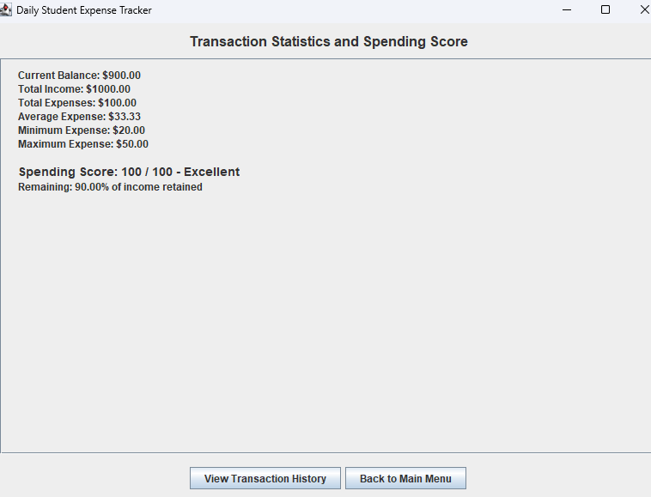
Description:
A balanced spending distribution produced a perfect Spending Score and displayed the "Excellent" performance rating.
Status: PASS

Screenshot 31 – Spending Anomaly
Figure 31. Spending Anomaly Detection
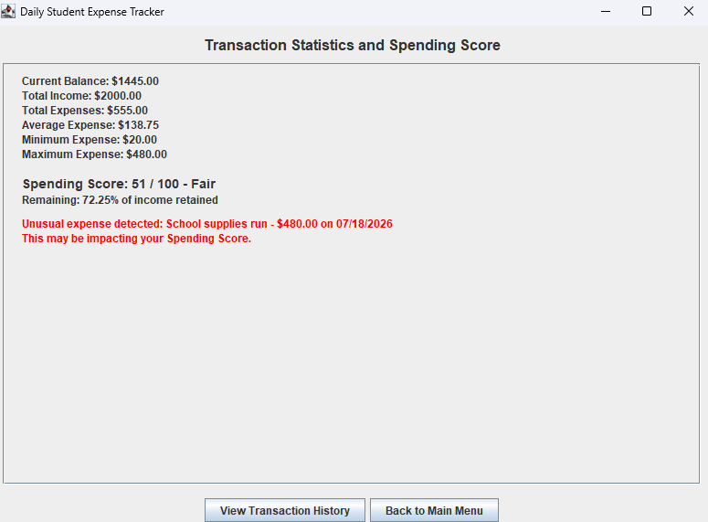
Description:
The application identified an unusually large expense and displayed a warning identifying the flagged transaction.
Status: PASS

Screenshot 32 – Student Assistance Resources
Figure 32. Student Resources
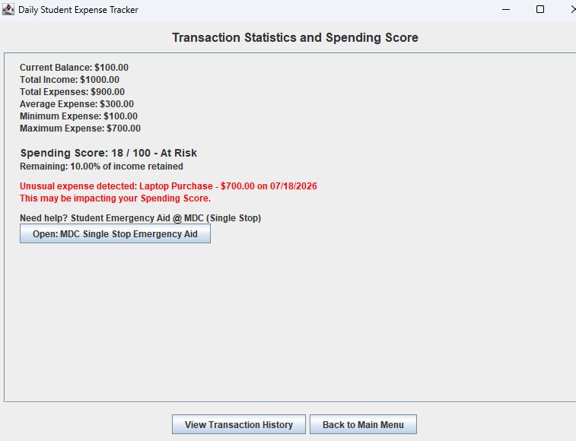
Description:
Based on the calculated Spending Score, the application displayed the appropriate Miami Dade College student assistance resources.
Status: PASS

Screenshot 33 – Student Parents Resources
Figure 33. Student Parents Resources
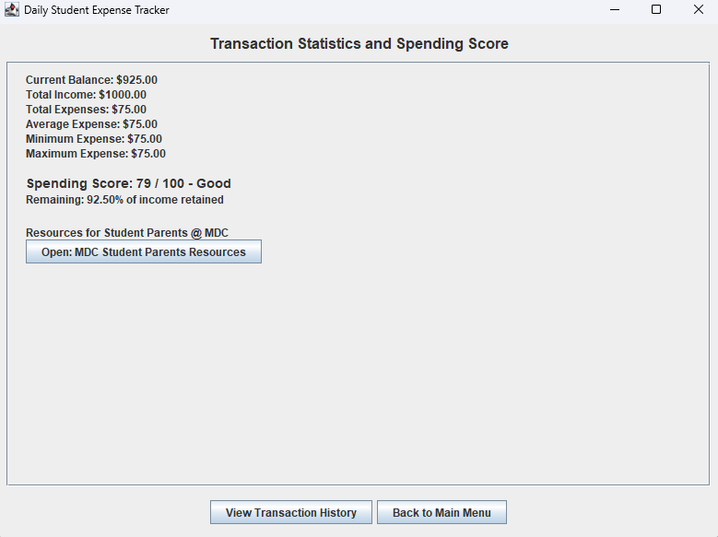
Description:
Adding a Family / Childcare expense displayed the Student Parents resource section with the corresponding MDC support information.
Status: PASS

Screenshot 35 – Large Amount Test
Figure 35. Large Amount Handling
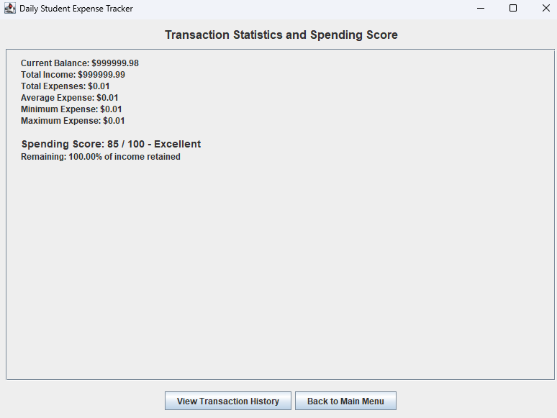
Description:
The application successfully processed very large transaction values and correctly calculated the resulting account balance without formatting errors.
Status: PASS

These descriptions are written in a formal style suitable for a software engineering or Java project report and can be copied directly into your testing documentation.

