# ***Homework03***

***Hwijong Im***

### ***Problem01***

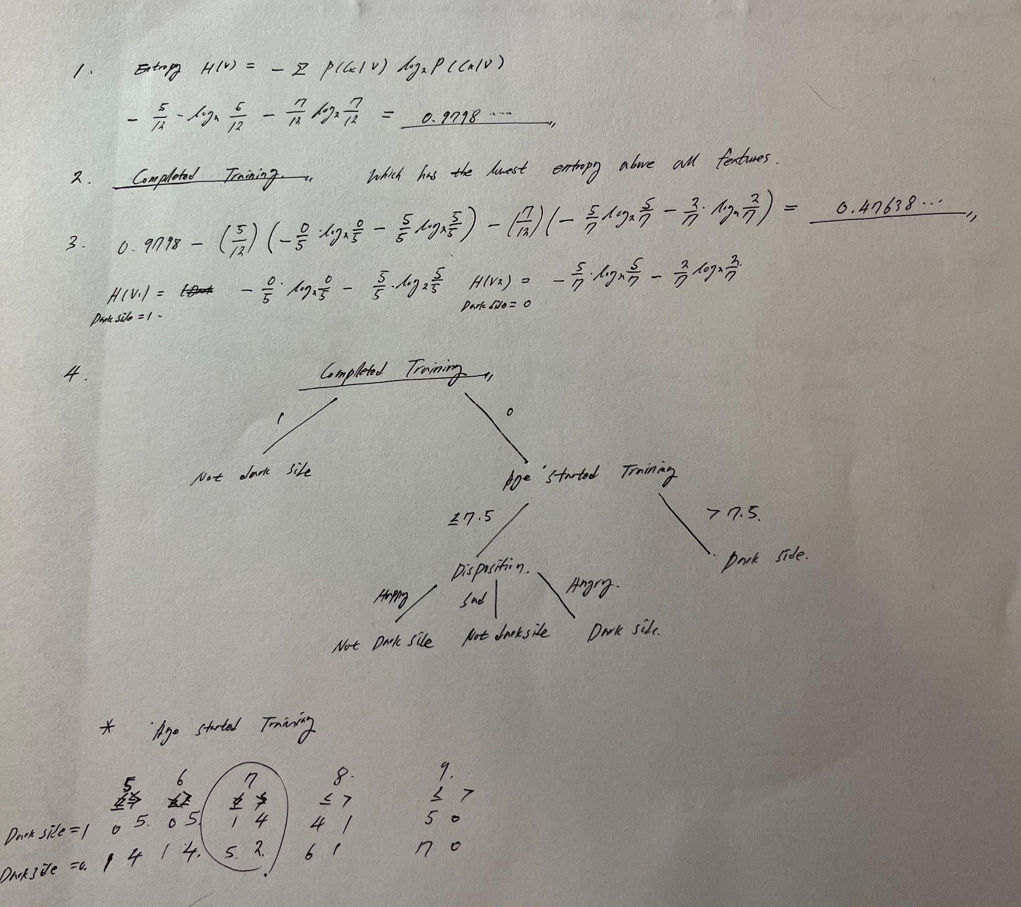

### ***Problem02***

The drawing of two trees is in the code. Compared to between two trees, The Decision Tree that I made did not use other features. It only uses Sepal width with various cut-off values. The other Sklearn Decision Tree also used most of one feature Petal width. However, it used another feature of Sepal width at the end of the branch.

### 

### ***Problem03***

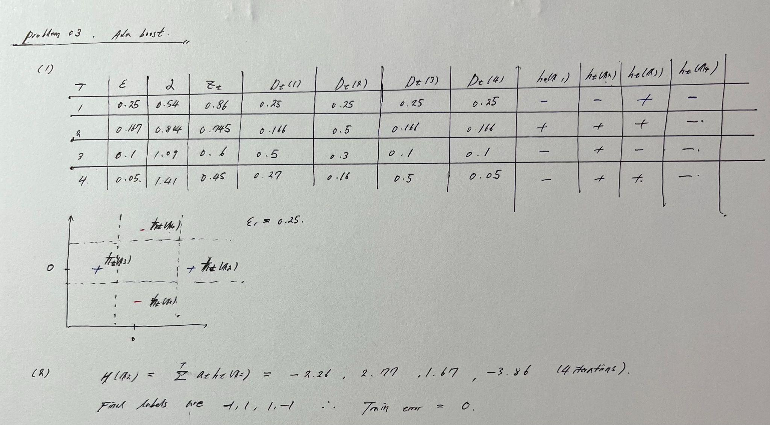

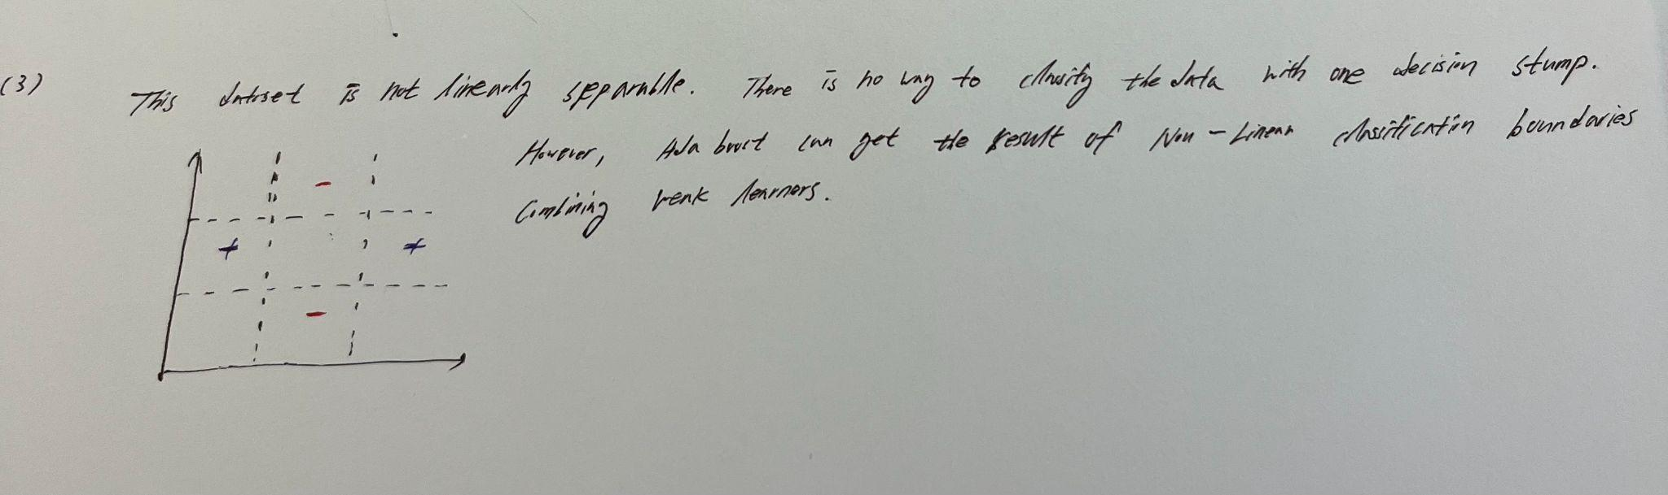

### ***Problem04***

