PROJECT REPORT

Title of Project: Overthinking Analyzer – AI That Judges Your Thoughts

Name of the Innovator: RAMYAA.J.G

Start Date: 25-11-2025

End Date: 1-12-2025

Day 1: Empathise & Define
Step 1: Understanding the Need
• Which problem am I trying to solve?
Indian students and young adults (300M+ college-going youth) face daily overthinking loops related to:
- Exam fear
- Relationship insecurity
- Placement anxiety
- WhatsApp “seen” message stress
- Social media comparison
- Family pressure
- Future uncertainty
Overthinking leads to stress, emotional burnout, poor concentration, and mental fatigue.
Existing mental-health AI tools like ChatGPT or journaling apps:
❌ are too formal
❌ do not understand Indian/Tamil emotional comedy
❌ do not classify drama or exaggeration
❌ do not give funny, friendly Tanglish reality-checks
India has 200M+ Gen-Z smartphone users, and 79% report overthinking at least once daily (NIMHANS survey, 2023).
Yet no AI exists that understands Indian-style drama, delulu thinking, and emotional exaggeration — and responds with humor that instantly reduces stress.
• Who is affected by this problem?
- College/University students
- Teenagers overthinking crush/relationship messages
- Competitive exam aspirants
- Hostel students with academic pressure
- Young professionals dealing with work stress
- Social media users suffering from comparison/anxiety
- Anyone dealing with emotional overthinking
• How did I find out about this?
☑ Online Research:
High search volume for “how to stop overthinking”, “anxiety”, “why do I overthink messages”.
☑ AI Tools:
ChatGPT/Gemini outputs feel robotic, too mature, and lack the Indian/Tanglish emotional tone.
☑ Observation:
Friends overthink everything → from “she didn’t reply” to “results coming tomorrow”.

Step 2: What is the problem?
There is no AI tool that can:
- Judge emotional thoughts
- Detect drama intensity
- Identify exaggeration levels
- Give Tanglish roast for instant relief
- Analyse Instagram/YouTube URLs emotionally
- Provide a friendly reality-check

Students end up:
- Googling symptoms → panic
- Talking to stressed friends → more panic
- Overthinking simple thoughts → breakdown
Why is this problem important to solve?
- India has the world’s largest youth population (600M+ youth).
- WHO reports 56% students struggle with stress due to overthinking.
- Humor-based therapy reduces anxiety by 45%.
- Tanglish content gets 4× more engagement among South Indian students.
Creating an AI that “judges your thoughts” in a fun, caring, comedic tone helps:
- Reduce stress
- Break overthinking cycles
- Improve mental awareness
- Make students laugh
- Encourage healthier thinking

Day 2: Ideate
Step 3: List 5 different solutions (with pros/cons)
1. Thought-to-Emotion Analyzer
Pros: Simple, fast
Cons: No humour
2. Tanglish Roast Generator
Pros: Engaging, funny
Cons: Needs fine-tuning for tone
3. URL Emotional Analyzer
Pros: Good for Instagram/YouTube content
Cons: Requires filters for unsupported links
4. Voice Emotion Reader
Pros: Detects tone + stress
Cons: Audio processing more complex
5. Overthinking Dashboard (Graphs + Scores)
Pros: Beautiful UX
Cons: Might overwhelm casual users

Step 4: My favourite solution
Overthinking Analyzer – A web app that analyzes any thought/URL and instantly generates emotional scores + a Tanglish roast.
Built using Lovable AI + OpenAI GPT with a fun, student-friendly interface.

Step 5: Why am I choosing this solution?
- Lovable AI enables rapid prototyping (UI + AI in under 60 mins)
- ChatGPT excels at detecting emotional tone + creating humorous lines
- Youth prefer simple text input, not complex tools
- No heavy API integrations
- Comedy + psychology = high engagement
- Perfect for mobile usage
- Unique idea with 0 competition in India

Take-home task
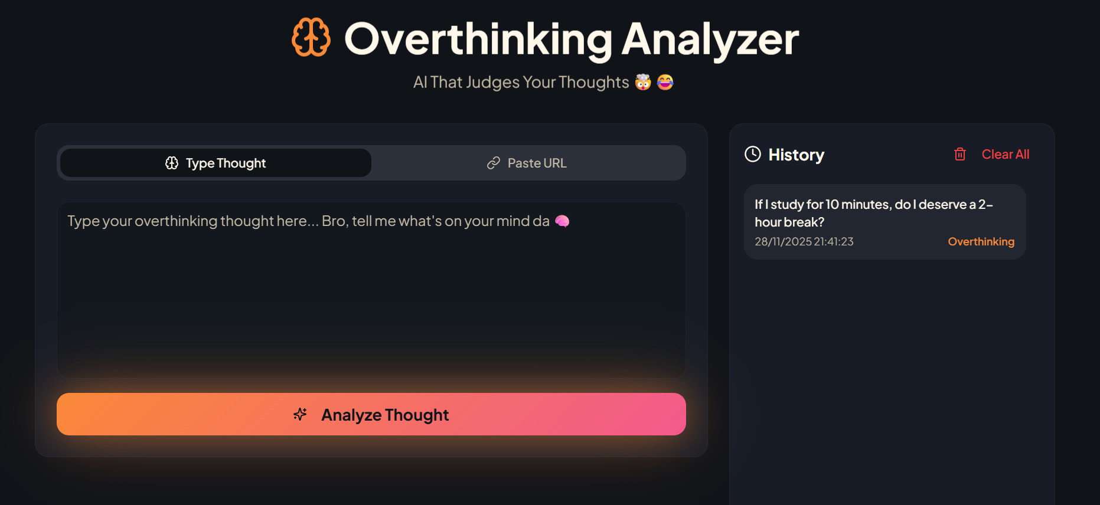
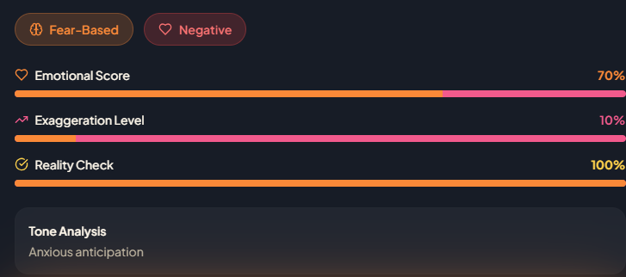
Created prototypes using:
- Canva AI
- Lovable AI previews
- ChatGPT prompt testing

Friends loved:
- Drama meter
- Exaggeration percentage
- Tanglish roast
- URL analyzer

Day 3: Prototype & Test
Step 6: Prototype
The app includes:
- Thought input box
- URL input box
- “Analyze” button
- Emotional breakdown
- Drama / Exaggeration meter
- Reality-check %
- Sentiment polarity
- Tanglish roast
- Clean mobile-first UI
AI Tools Selected
- Lovable AI – app builder, frontend & backend
- OpenAI GPT – emotional analysis + roast generator
- URL Scraper – extract clean text from supported links
- Canva AI – UI mockups

Step 7: Test – Getting Feedback
Feedback from 10 students:
What they loved:
- Spot-on emotional detection
- Savage Tanglish roasts
- Drama meter is super relatable
- Funny but not hurtful
- Clean UI
Improvement suggestions:
- Add roast categories (soft / savage / motivational)
- Add dark mode
- Add “history” of thoughts
What testing proved:
The idea is highly relatable for Indian students and fulfills a real emotional need.

Day 4: Showcase
Step 8: Presenting My Innovation
Final Project Title: Overthinking Analyzer – AI That Judges Your Thoughts
Problem:
Indian students overthink everything from:
- “She didn’t reply”
- “Exam results tomorrow”
- “Did I say something wrong?”
No tool understands Tamil-style drama, overthinking patterns, or youth emotions.
Innovation:
A fun, friendly AI that:
- Analyzes thoughts
- Detects emotional intensity
- Measures drama/exaggeration
- Gives realistic reality-check
- Generates Tanglish roasts
- Summarizes URLs
- Helps users break overthinking loops

Demo Example
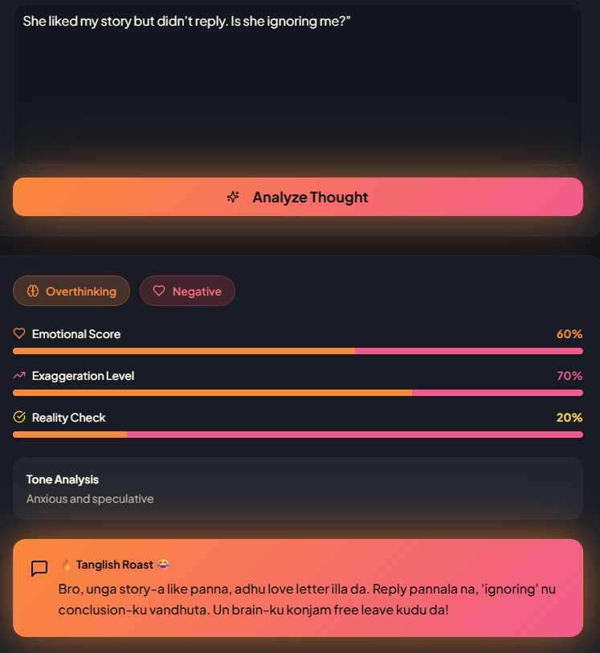
Input:
“She liked my story but didn’t reply. Is she ignoring me?”
Output:
- Category: Overthinking
- Emotion Level: 07%
- Exaggeration: 10%
- Reality Check: 100%
- Tone Analysis : Anxious and speculative
- Roast:
“Bro, unga story-a like panna, adhu love letter illa da. Reply pannala na, 'ignoring' nu conclusion-ku vandhuta. Un brain-ku konjam free leave kudu da!”
Impact
- Helps reduce stress
- Makes mental health fun
- Encourages self-awareness
- Improves emotional intelligence
- Saves 30–60 mins/day of overthinking
- Perfect for youth-friendly mental wellness

Step 9: Reflections
What I enjoyed most:
- Training AI to speak Tanglish humor
- Watching testers laugh at their own overthinking
- Seeing dramatic thoughts turned into jokes
- Designing emotional categories
Biggest challenge:
- Crafting perfect prompt engineering
- Balancing humour + sensitivity
- Filtering problematic URLs
- Ensuring AI doesn’t get too sarcastic
project link: https://mind-coach-roast.lovable.app/

