**Electrochemical Measurement Project: Proposal**

**Edward Mu** and **Gage Wright**

Goal

Investigate the effect of solvent dielectric on transport and kinetics of reversible and irreversible redox couples at two electrodes using cyclic voltammetry and electrochemical impedance spectroscopy.

Approach

We will test several redox couples, including Fc0/+, Fe3+/2+(acac)3 , and Co3+/2+(acac)3, (where acac = acetylacetonate). We expect Fc0/+ and Fe3+/2+(acac)3 to be quite reversible, while the Co3+/2+(acac)3 redox couple is expected to be irreversible by cyclic voltammetry.3

In both cases, we can determine the diffusion constants *D* from the peak potential via variable scan rate cyclic voltammograms by using the Randles-Sevik equation for a reversible redox couple and Equation 6.3.8 in Bard and Faulkner for an irreversible redox couple.4

If provided with suitable salts (FcPF6, [Bu4N][Fe(acac)3], [Bu4N][Co(acac)3] or analogs), we will determine the diffusion constants of both oxidized and reduced forms of each redox couple. Alternatively, we can perform stirred electrolyses of the analytes to prepare solutions of the redox partners, but we expect the error in the concentration determined by chronoamperometry (by integrating under the current vs. time curve) to be more significant in this case.

These redox couples will be analyzed on two electrodes with very different electron transfer rates: glassy carbon (GC) and fluorine-doped tin oxide (FTO).

For each redox couple, we also plan to determine the standard rate constant *k°*, the half-wave potential *E1/2*, and the activation free energy *ΔG‡* as a function of composition of in neat acetonitrile, neat acetone, and a 1:1 v/v mixture of acetonitrile/acetone. Any trend will be correlated to the change in the composite dielectric constant of the mixtures.

From a cyclic voltammogram (CV), we will determine the half-wave potential *E1/2*  and the peak separation *ΔEp*. Values of *E1/2* will be compared to literature values of the Fc0/+ redox couple.

For each solvent mixture, CVs must be corrected for uncompensated solution resistance (Ru), which will be measured prior to conducting the CV as the *ZRe*-intercept of an EIS spectrum. CVs will then be used to determine the standard exchange rate constants *k°* using Nicholson’s method from Ref. 2. *ΔG‡*can be computed from *k°* using Eqn. 5 in Ref. 1, and the values obtained will be compared to those reported in Ref. 1.

EIS spectra will be further analyzed using the Randles equivalent circuit and the equivalent circuit model described in Fig. 7 of Ref. 1. The relative fits to the EIS spectra and physical meaning of these circuits will be assessed to the extent possible.

**Relevant Equations**

* Randles-Sevik Equation (Equation 6.2.19 in Bard and Faulkner).4

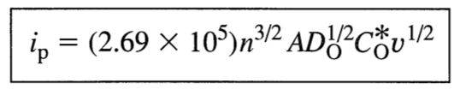

* Equation 6.3.8 in Bard and Faulkner for an irreversible redox couple.4

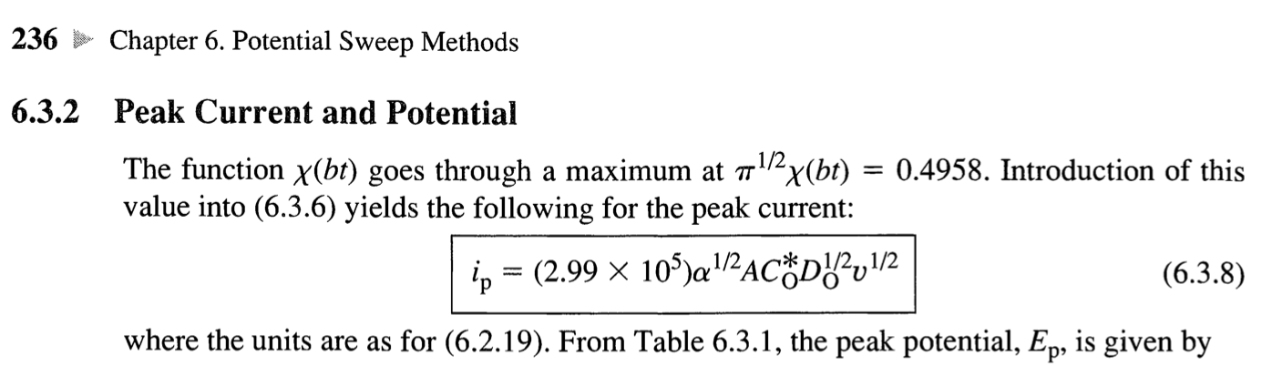

* Equation for the Nicholson dimensionless kinetic parameter (Bard and Faulkner p. 242).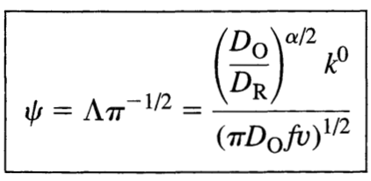
* Equation 5 from Ref. 1

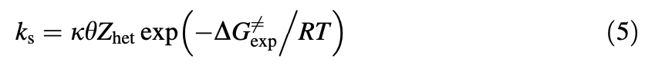

Required Materials

* Pure, dry solvents: Acetonitrile (MeCN) and Acetone (MeAc)
* 4Å Molecular sieves (activated), to dry solvents
* Analytes : Fc0/+, Fe3+/2+(acac)3 , and Co3+/2+(acac)3
* Supporting electrolyteBu4NPF6 (TBAF)
* For electrodes:
  + ~1mm diameter Glassy Carbon (GC) disk electrode
    - [Electrode polishing kit](https://safetynet.web.unc.edu/wp-content/uploads/sites/12158/2017/09/ElectrodePolishing_Miller_20160805.pdf) (including polishing pad and alumina slurry, or other polishing powder of 0.3 and 0.5 micron grit)
  + FTO electrode
    - Ultrasonicator (for [cleaning FTO electrode](https://www.ossila.com/products/fto-glass-unpatterned))
  + Double junction Ag/AgCl/sat. KCl reference electrode
  + Pt wire counter electrode
* Balance with sensitivity to ± 0.1 mg, or best offer.
* MyDAQ potentiostat/galvanostat

Optional Materials

* FcPF6
* [Bu4N][Fe(acac)3]
* [Bu4N][Co(acac)3]

Week 1

* Verify solubility of TBAF, Fc0/+, Fe3+/2+(acac)3, and Co3+/2+(acac)3. in each of the neat solvents. According to Ref. 1, TBAF and Fc should be soluble in MeCN and MeAc.
* Make solutions of 0.4 mM Fc with 100 mM TBAF in neat solvents and a 1:1 v:v mixture of MeCN:MeAc.
* Verify reproducibility of electrochemically-active surface-area (ECSA) upon electrode polishing by measuring double layer capacitance *CDL* in solutions of 100 mM TBAF in MeCN. We expect the solution to behave as a series RC circuit. *CDL* can be determined using EIS by fitting -*Zim* vs ω, using the equation -*Zim* = (ω*CDL*)-1
* Prepare 0.4 mM solutions of Fe3+/2+(acac)3 and Co3+/2+(acac)3 with 100 mM TBAF in neat solvents and mixtures of solvents. This may be delayed to a later week depending on reagent availability.

Week 2

* Measure *E1/2* and *ΔEp* of each couple in CV for each solvent.
* Additionally, extract peak currents *ip* at varying scan rates to determine diffusion coefficients *D* using the Randles-Sevik equation for a reversible redox couple, and Equation 6.3.8 in Bard and Faulkner for an irreversible redox couple.4 We will begin with Fc0/+ and use only the glassy carbon electrode because we expect the kinetics to be faster.
  + For Fc0/+, sweep positively from 0 to +1.0 V versus Ag/AgCl(sat. KCl) by applying scan rates (*v*) ranging from 0.02 to 0.12 V s-1 and applying a least-squares linear regression.
  + For Fe3+/2+(acac)3, sweep negatively from 0 to -1.3 V, with a return wave going to +1.3 V versus Ag/AgCl(sat. KCl).3
  + For Co3+/2+(acac)3, sweep negatively from 0 to -1.3 V, with a return wave going to +1.3 V versus Ag/AgCl(sat. KCl).3
* During CV experiments, take EIS spectra of each solution.
* Verify EIS operating frequencies reported in Ref. 1 (0.1 Hz to limit of DAQ) using the Kramers-Kronig Transform.
* Once these CVs have been collected, change to the FTO electrode, and repeat CVs at representative scan rates and EIS spectra.

Week 3

* Continue acquisition of CV and EIS data for each couple.
* If necessary, electrolyze analytes using chronoamperometry and determine the concentration of the redox partners by integration.
* Determine diffusion coefficients of electrolyzed redox partners using CV on glassy carbon.

Week 4

* Complete any additional experiments and conduct data analysis.

References

1. Tsierkezos, N. G.; Ritter, U. Electrochemical Impedance Spectroscopy and Cyclic Voltammetry of Ferrocene in Acetonitrile/Acetone System. *J. Appl. Electrochem.* **2010**, *40* (2), 409–417. [doi.org/10.1007/s10800-009-0011-3](https://doi.org/10.1007/s10800-009-0011-3).
2. Nicholson, R. S. Theory and Application of Cyclic Voltammetry for Measurement of Electrode Reaction Kinetics. *Anal. Chem.* **1965**, *37* (11), 1351–1355.<https://doi.org/10.1021/ac60230a016>.
3. Anderson, C. W.; Lung, K. R.; Nile, T. A. Electrochemistry of Homogeneous Catalysts: Correlation of the Electrochemistry and the Ziegler—Natta Catalytic Activity of Metal Acetylacetonate Complexes. *Inorganica Chimica Acta* **1984**, *85* (1), 33–36.<https://doi.org/10.1016/S0020-1693(00)81022-1>.
4. Bard, A. J.; Faulkner, L. R. *Electrochemical Methods: Fundamentals and Applications*, 2. edition.; Wiley: New York Weinheim, **2001**.