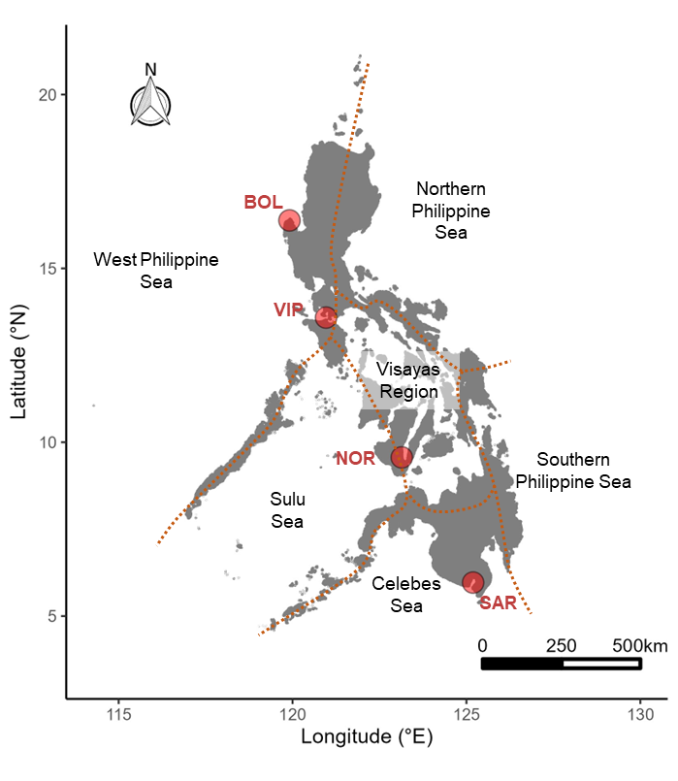**Body of Proposal**

*Project Overview*

Regions with high marine biodiversity are often prioritized as focal areas for conservation. The most comprehensive biodiversity information from tropical regions often comes from marine fishes and corals, while other taxa have not been studied as rigorously. Consequently, focus on reef fishes bias biodiversity drivers towards anthropogenic factors (e.g., fishing pressure and overexploitation) while discounting the effects of ecological factors. Therefore, this project will use environmental DNA (eDNA) metabarcoding to fill in the knowledge gaps on whether the patterns and drivers of marine biodiversity are consistent across different taxonomic groups. We aim to conduct the research at the epicenter of marine biodiversity – the Philippines. Spatiotemporal trends in fish biodiversity are well reported in the country, providing a good foundation with which hypotheses on other taxonomic groups can be tested. We plan to compare the biodiversity of different taxa within and among selected marine biogeographic regions. We also plan to determine which between anthropogenic and environmental variables contribute more to the observed patterns of diversity across taxa.

*Context*

Biodiverse regions provide important socio-economic and ecological services both at local and global scales, such as/ for example …_______ (Cite). Identifying the threats brought about by direct and indirect anthropogenic activities, such as climate change, is critical to inform management, conservation, and restoration efforts1. Developing and utilizing rapid biomonitoring methods in the Indo-Malay Pacific Archipelago (IMPA) are therefore necessary since this is where the highest concentration of global marine biodiversity is located, along with countries that are most vulnerable to biodiversity threats. One of the most vulnerable regions is the Philippines, which is characterized as the epicenter of marine biodiversity ~~and evolution~~ and thus warrant special attention for conservation efforts2,3.

Spatial variation in biodiversity, geomorphology, and oceanography across the Philippine archipelago characterize its six marine biogeographic regions4–6 (Figure 1) which provide the geographical framework upon which management and conservation of marine resources are implemented7,8. While historical records indicated that the greatest marine biodiversity was concentrated centrally within the Philippines in the Visayas Region (VR, Figure 1), reef fish surveys suggested otherwise. Intense fishing pressure and habitat degradation have resulted to biodiversity loss in VR, which underscores the need to refocus management and conservation efforts elsewhere5,9,10. However, there are knowledge gaps on which such recommendations were based on. First, these observations were limited only to commercially important reef fishes. Observing similar patterns across a wide range of taxa would result in a more reliable estimate of biodiversity and thus provide a stronger support in identifying regions of conservation priority. Second, loss of biodiversity was primarily attributed to fishing pressure and other anthropogenic disturbances; however, patterns of biodiversity are likewise influenced by ecological factors (e.g., sea surface temperature) that should be considered when informing spatial management areas1. We therefore ask the following questions: (1) Is the low species richness of reef fishes observed in VR relative to other marine biogeographic regions concordant with other taxonomic groups? (2) Are the patterns of diversity (i.e., community composition) in the different marine biogeographic regions consistent across taxa? (3) Which factors most strongly correlate with the geographic patterns in diversity?

Relying on conventional monitoring methods (e.g., underwater visual census, market surveys) to answer our questions would be difficult and resource intensive, but such limitations can be circumvented with the use of environmental DNA (eDNA) metabarcoding. eDNA metabarcoding involves isolating the trace amounts of eDNA in water samples, amplifying that eDNA with PCR, sequencing the eDNA samples to depths of 10,000-100,000 reads per sample, bioinformatically classifying the reads into operational taxonomic units (OTU), and assigning the OTU to specific taxa using public databases, such as the Barcode of Life Database11,12. eDNA has many advantages over observational biodiversity assessment methods, e.g. it is less labor intensive, less invasive, and more cost effective and it is at the forefront in marine conservation efforts12–14. It has been used widely used for biomonitoring marine systems to inform management14–18. However, there have been no published studies of eDNA in the Philippines.

We propose to test for patterns in, and drivers of, marine biodiversity of fishes, _____, ____, and _____ among the different marine biogeographic regions in the Philippines using eDNA metabarcoding. ~~We will do so by simultaneously looking at the patterns observed across different taxonomic groups.~~ First, we will test for differences in biodiversity (Chao1 estimator of species richness; Cite, find the citation in vegan manual if you are unsure) and taxonomic composition in relation to four biogeographic regions, 12 locations within each region, and taxonomic group. Second, we will test for a relationship between biodiversity and covariates that potentially shape diversity. In performing these tests, we can address whether (1) marine biodiversity in VR is lower than the other regions, as was previously documented in observational surveys of economically important fishes (CITE); (2) if different marine biogeographic regions have different community compositions and if variation in biodiversity is greater within or among regions; and (3) if observed patterns of biodiversity are strongly correlated with factors associated with direct and/or indirect anthropogenic activities, such as fishing activity, human population size, eutrophication, and climate change and if those relationships vary by taxonomic group. The methodology for this research proposal is detailed in Appendix I and Appendix Figure 2.

*Impact/Explanation of Innovative Nature of the Project*

The impact and innovative nature of the project is twofold. First, it can inform spatial management and conservation priorities by identifying regions of high biodiversity. eDNA metabarcoding enables simultaneous surveys of diversity patterns across different taxonomic groups, thus the inferences will be tranformational. It will be the first time that this will be done in the epicenter of marine biodiversity. Second, it fosters international scientific collaboration, especially in the emerging field of eDNA metabarcoding. The use of eDNA is still confined to high-income countries, and one way for developing countries to have access to this technology is through cohesive international collaboration with developed countries to encourage technical exchange, develop capacity, and share facilities and resources19. The partnerships formed from this seed grant will be instrumental for future research projects with Filipino collaborators.

*Expected Career Impact*

Securing funding from the National Science Foundation, and other federal sources, is a critical factor in earning Promotion and Tenure for Assistant Professors, such as Dr. Lin, and Associate Professors such as Dr. Bird. It will also help Ph.D. student, Kevin Labrador, conduct research for his dissertation. The work of Dr. Bird in the Philippines has led to career development opportunities for himself and his students such as invited presentations, membership in the Philippines Fishes Genomics Working Group, a collaborative proposal to NSF DEB, and consistently being selected to represent TAMUS LSAMP since 2017 at the Louis Stokes Alliance for Minority Participation – NSF International Center of Excellence meetings, which was instrumental in securing funding from the NSF IRES program. This seed grant will develop the framework for our eDNA research in the Philippines, which can be leveraged in a grant proposal to the National Science Foundation (NSF) Biological Oceanography Program (BioOce) where international collaboration is highly encouraged. In this project, we will foster and expand existing collaborations with Silliman University and University of the Philippines (UP) – Mindanao as well as establish collaborations with the UP-Marine Science Institute, Batangas State University, and the Philippines National Fisheries Research and Development Institute. Collaborations with Filipino institutions are mandatory to secure the collection permits required to complete the proposed work. Demonstrating that TAMU-CC can lead such an effort will be an important consideration by NSF program officers and reviewers in making funding decisions.

*Timeline of Deliverables*



**References**

1. Bani, A. *et al.* Informing marine spatial planning decisions with environmental DNA. in *Advances in Ecological Research* vol. 62 375–407 (Academic Press Inc., 2020).

2. Carpenter, K. E. & Springer, V. G. The center of the center of marine shore fish biodiversity: the Philippine Islands. *Environ Biol Fishes* **72**, 467–480 (2005).

3. Sanciangco, J. C., Carpenter, K. E., Etnoyer, P. J. & Moretzsohn, F. Habitat Availability and Heterogeneity and the Indo-Pacific Warm Pool as Predictors of Marine Species Richness in the Tropical Indo-Pacific. *PLoS One* **8**, e56245 (2013).

4. Aliño, P. M. & Gomez, E. D. Philippine coral reef conservation: its significance to the South China Sea. in *Dev. Conserv. Asia-Pacific Reg. Proc. Reg. Conf. East-West Cent. Assoc.* 222–229 (1994).

5. Nañola, C. L., Aliño, P. M. & Carpenter, K. E. Exploitation-related reef fish species richness depletion in the epicenter of marine biodiversity. *Environ Biol Fishes* **90**, 405–420 (2011).

6. Lowry, G. K., White, A. T. & Christie, P. Scaling Up to Networks of Marine Protected Areas in the Philippines: Biophysical, Legal, Institutional, and Social Considerations. *Coastal Management* **37**, 274–290 (2009).

7. Bureau of Fisheries and Aquatic Resources. *Fisheries Administrative Order No. 263, Series of 2019: Establishment of Fisheries Management Areas (FMA) for the Conservation and Management of Fisheries in Philippine Waters*. 1–44 (2019).

8. Biodiversity  Management  Bureau  (BMB)  Department  of  Environment  and  Natural  Resources  (DENR). *Philippine Biodiversity Strategy and Action Plan (2015-2028): Bringing Resilience to Filipino Communities*. (2016).

9. Muallil, R. N., Tambihasan, A. M., Enojario, M. J., Ong, Y. N. & Nañola, C. L. Inventory of commercially important coral reef fishes in Tawi-Tawi Islands, Southern Philippines: The Heart of the Coral Triangle. *Fish Res* **230**, 105640 (2020).

10. Balisco, R. A. T. *et al.* Marine fishes of Palawan, Philippines: Species diversity, new records, and conservation status. *Reg Stud Mar Sci* **60**, 102825 (2023).

11. Cordier, T. *et al.* Multi-marker eDNA metabarcoding survey to assess the environmental impact of three offshore gas platforms in the North Adriatic Sea (Italy). *Mar Environ Res* **146**, 24–34 (2019).

12. Ruppert, K. M., Kline, R. J. & Rahman, M. S. Past, present, and future perspectives of environmental DNA (eDNA) metabarcoding: A systematic review in methods, monitoring, and applications of global eDNA. *Glob Ecol Conserv* **17**, e00547 (2019).

13. van der Loos, L. M. & Nijland, R. Biases in bulk: DNA metabarcoding of marine communities and the methodology involved. in *Molecular Ecology* vol. 30 3270–3288 (John Wiley and Sons Inc, 2021).

14. Aylagas, E., Borja, Á., Muxika, I. & Rodríguez-Ezpeleta, N. Adapting metabarcoding-based benthic biomonitoring into routine marine ecological status assessment networks. *Ecol Indic* **95**, 194–202 (2018).

15. Gelis, E. R. E. *et al.* Environmental biomonitoring of reef fish community structure with eDNA metabarcoding in the Coral Triangle. *Environ Biol Fishes* **104**, 887–903 (2021).

16. Rourke, M. L. *et al.* Environmental DNA (eDNA) as a tool for assessing fish biomass: A review of approaches and future considerations for resource surveys. *Environmental DNA* **4**, 9–33 (2022).

17. Miya, M., Sado, T., Oka, S. & Fukuchi, T. ﻿The use of citizen science in fish eDNA metabarcoding for evaluating regional biodiversity in a coastal marine region: A pilot study. *Metabarcoding Metagenom* **6**, 133–144 (2022).

18. Lin, Y. *et al.* Specific eukaryotic plankton are good predictors of net community production in the Western Antarctic Peninsula. *Sci Rep* **7**, 14845 (2017).

19. Wee, A. K. S. *et al.* Prospects and challenges of environmental DNA (eDNA) metabarcoding in mangrove restoration in Southeast Asia. *Front Mar Sci* **10**, (2023).

20. Jeunen, G. *et al.* Species‐level biodiversity assessment using marine environmental DNA metabarcoding requires protocol optimization and standardization. *Ecol Evol* **9**, 1323–1335 (2019).

21. Bessey, C. *et al.* Maximizing fish detection with eDNA metabarcoding. *Environmental DNA* **2**, 493–504 (2020).

22. Cruaud, P. *et al.* Open the Sterivex TM casing: An easy and effective way to improve DNA extraction yields. *Limnol Oceanogr Methods* **15**, 1015–1020 (2017).

23. Lin, Y., Gifford, S., Ducklow, H., Schofield, O. & Cassar, N. Towards Quantitative Microbiome Community Profiling Using Internal Standards. *Appl Environ Microbiol* **85**, (2019).

24. Rachel, N. M. & Gieg, L. M. Preserving Microbial Community Integrity in Oilfield Produced Water. *Front Microbiol* **11**, (2020).

25. Fukuzawa, T. *et al.* Environmental DNA extraction method from water for a high and consistent DNA yield. *Environmental DNA* (2023) doi:10.1002/edn3.406.

26. Glenn, T. C. *et al.* Adapterama II: universal amplicon sequencing on Illumina platforms (TaggiMatrix). *PeerJ* **7**, e7786 (2019).

27. Singer, G. A. C., Fahner, N. A., Barnes, J. G., McCarthy, A. & Hajibabaei, M. Comprehensive biodiversity analysis via ultra-deep patterned flow cell technology: a case study of eDNA metabarcoding seawater. *Sci Rep* **9**, 5991 (2019).

28. Yeh, Y.-C. & Fuhrman, J. A. Contrasting diversity patterns of prokaryotes and protists over time and depth at the San-Pedro Ocean Time series. *ISME Communications* **2**, 36 (2022).

29. Xiong, F. *et al.* Methodology for fish biodiversity monitoring with environmental DNA metabarcoding: The primers, databases and bioinformatic pipelines. *Water Biology and Security* **1**, 100007 (2022).

30. R Core Team. R: A Language and Environment for Statistical Computing. Preprint at https://www.R-project.org/ (2023).

31. Oksanen, J. *et al.* vegan: Community Ecology Package. Preprint at https://CRAN.R-project.org/package=vegan (2022).

32. Paradis, E. & Schliep, K. ape 5.0: an environment for modern phylogenetics and evolutionary analyses in R. *Bioinformatics* **35**, 526–528 (2019).

33. Wickham, H. *et al.* Welcome to the tidyverse. *J Open Source Softw* **4**, 1686 (2019).

34. Wangensteen, O. S., Palacín, C., Guardiola, M. & Turon, X. DNA metabarcoding of littoral hard-bottom communities: high diversity and database gaps revealed by two molecular markers. *PeerJ* **6**, e4705 (2018).