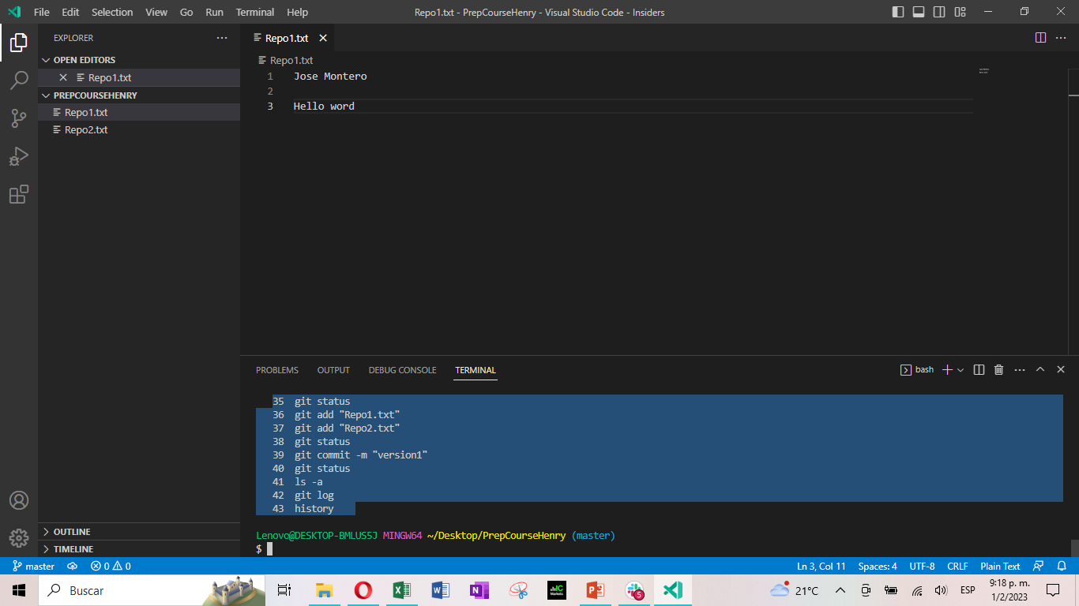

1 git --version

2 mkdir PrepCourseHenry

3 cd PrepCourseHenry

4 touch "MiPrimerRepositorio.txt"

5 code

6 code vscode

7 code "MiPrimerRepositorio.txt"

8 help code

9 code help

10 code "MiPrimerRepositorio.txt"

11 pwd

12 code "MiPrimerRepositorio.txt"

13 clear

14 code

15 code MiPrimerRepositorio.txt

16 code "MiPrimerRepositorio.txt"

17 help

18 clear

19 ls

20 rm MiPrimerRepositorio.txt

21 ls

22 clear

23 touch "Repo1"

24 ls

25 ls

26 code Repo1

27 rm Repo1

28 touch "Repo1.txt"

29 ls -l

30 touch "Repo2.txt"

31 code "Repo2.txt"

32 clear

33 git clone https://github.com/JGeorgiveMontero/PrepCourseHenry.git

34 git clone

35 clear

36 git clone https://github.com/JGeorgiveMontero/PrepCourseHenry.git

37 git clone https://github.com/JGeorgiveMontero/PrepCourseHenry.git

38 git clone https://github.com/JGeorgiveMontero/PrepCourseHenry.git

39 git clone https://github.com/JGeorgiveMontero/PrepCourseHenry.git

40 git clone https://github.com/JGeorgiveMontero/PrepCourseHenry.git

41 git clone https://github.com/JGeorgiveMontero/PrepCourseHenry.git

42 cd PrepCourseHenry

43 code .

44 code.

45 pwd

46 git add README.md

47 git commit -m "prueba de clonacion de repositorio en mi escritorio"

48 git push origin main

49 pwd

50 cd ..

51 pwd

CREACION DE REPOSITORIO LOCAL

52 mkdir PrepCourseHenry1

53 cd prepCourseHenry1

54 git init

55 touch prueba.txt

56 git add prueba.txt

57 git commit -m "Prueba repo"

58 git status

59 cd prepCourseHenry1

60 ls

61 cd prepCourseHenry1/prueba.txt

62 cd prepCourseHenry1

63 ls –l

CLONAR REPOSITORIO GITHUB EN REPO LOCAL Y ENVIAR A GITHUB

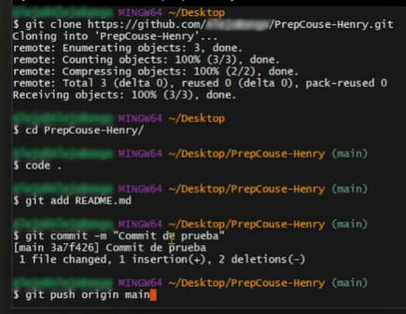

Clonar, Modificar y enviar repo a github con opción sin readme

